**Principal Login**

**Principal Home page consist of 8 modules. They are:**

1. **Admission**
2. **Post Exam**
3. **Academic**
4. **Assessment**
5. **Pre-Examination**
6. **Results**
7. **Student Services**
8. **Digital Signature**

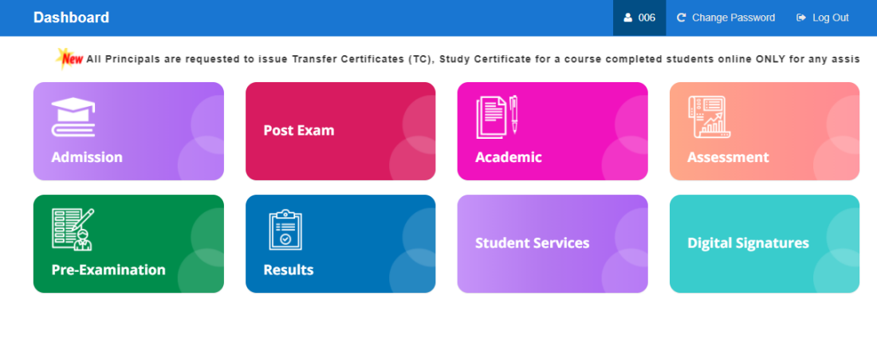

**Module Name: Admission**

**Module Description:**

Admission Module contains Re-Admission, Register, Attendance, Category Reports.

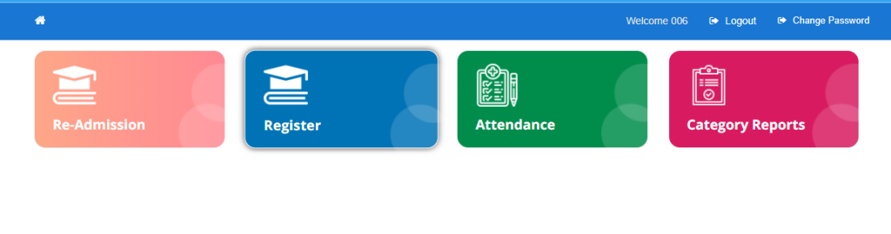

**Navigation steps to Admission Module:**

STEP 1: Click on Admission Module.

STEP 2: User can view the as above-mentioned modules.

**1)Module Name: Re-Admission**

**Module Description:**

Re-Admission module is used for to view the detained students details to move from here to Register Data of that particular college.

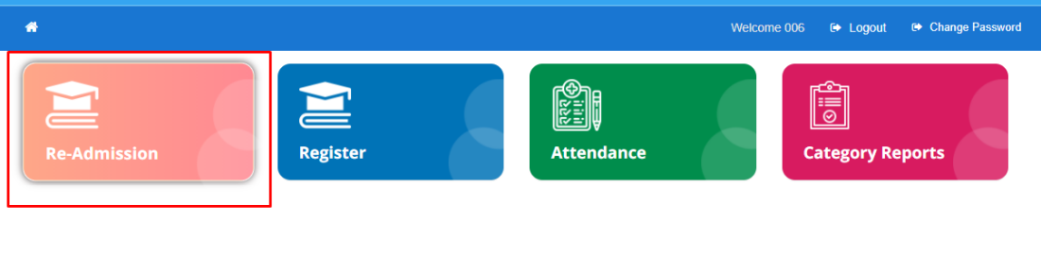

**Navigation steps to Re-Admission Module:**

STEP 1: Click on Re-Admission Module.

STEP 2: User can view the data of detained students of that particular college of all the academic years of all the students.

STEP 3: The data contains Academic year, Scheme, Semester, Branch, Detained Count and View.

STEP 4: To get in-detail about detained students click on View.

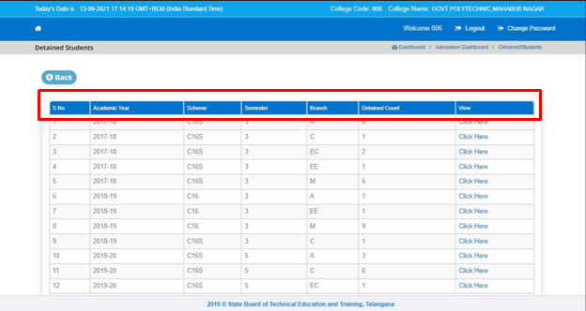

STEP 5: Click on Re-Admit button to move the students to Register Data.

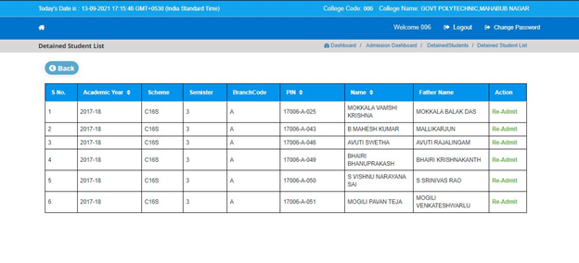

**2)Module Name: Register**

**Module Description:**

Report Module is used to view the current academic data of students of their respective college

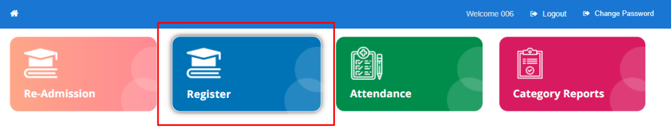

**Navigation steps to Register Module:**

STEP 1: Click on Register Module

STEP 2: User can view the College and Student Details of their respective College.

STEP 3: College Details contains College Name, Principal, Phone number, Email, College Established Date

STEP 4: Student Details contains Scheme, Semester, Branch, Allotted, On Roll, Data Not Updated, Aadhar Not Verified, Attendee Id Not Generated and Pin Not Generated.

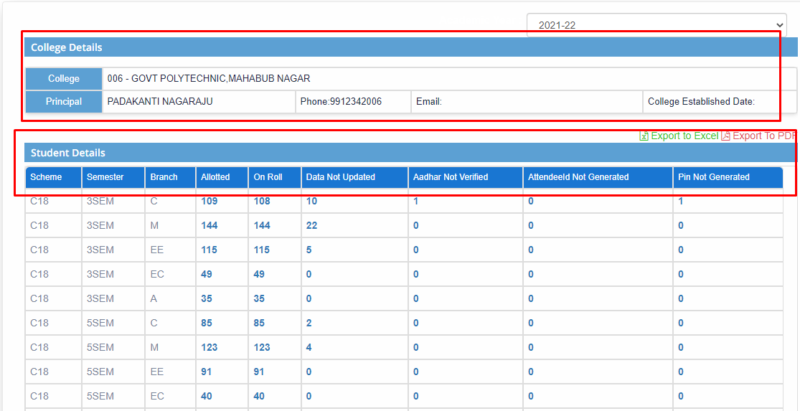

STEP 5: To get each row details click on that particular row. The data includes PIN, Attendee Id, Student Name, Birth Date, Admission Type and Aadhaar Status.

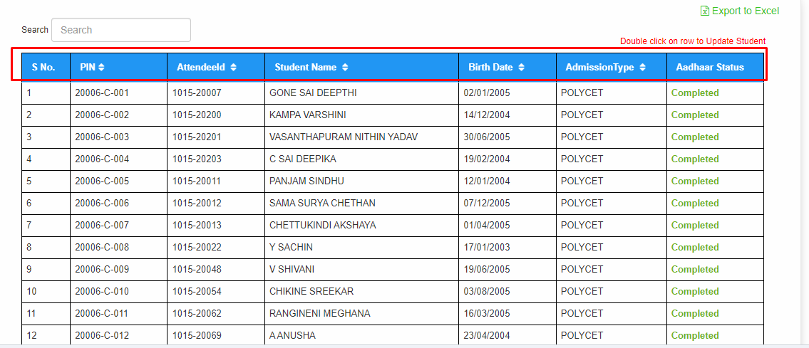

STEP 6: To Update the Student details user should double-click on that particular row.

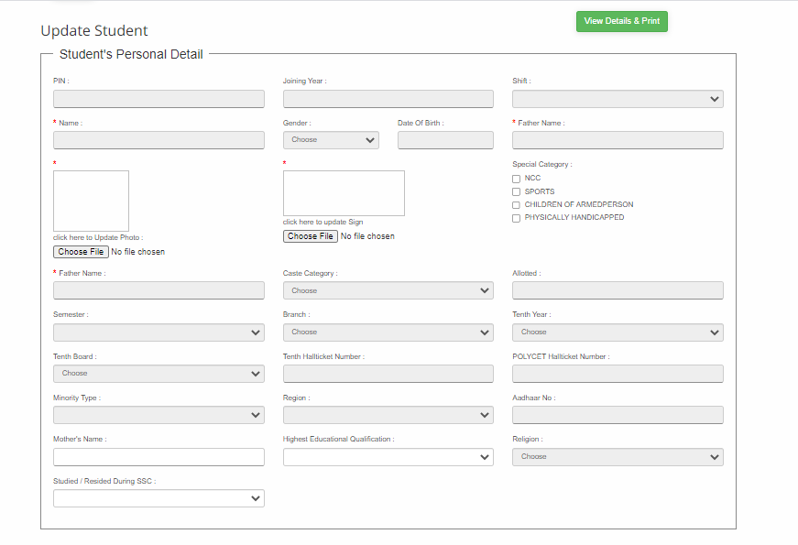

STEP 7: Click on **Update Student Details** which will be present at the bottom after updating the student details

STEP 8: User can download the report in the form of excel by clicking on **Import to Excels**

**3)Module Name: Attendance**

**Module Description:**

Attendance Module is used to get the overall attendance percentage of students of their respective college.

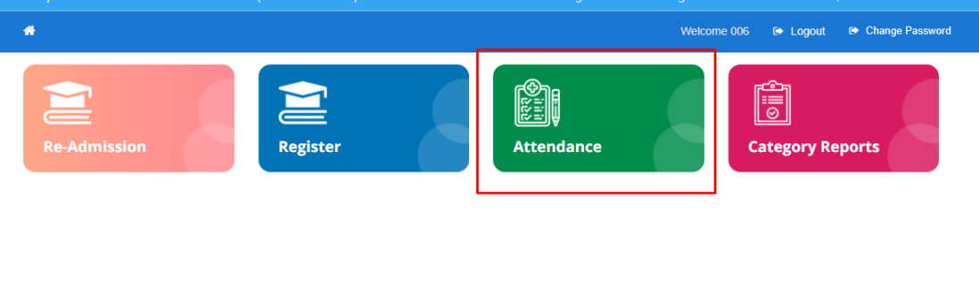

**Navigation steps to Attendance Module:**

STEP 1: Click on Attendance Module.

STEP 2: User can view the Attendance Details contains Scheme, Semester, Branch, On Roll, the overall attendance percentage of students which is <65%, 65% to 75% and >75%.

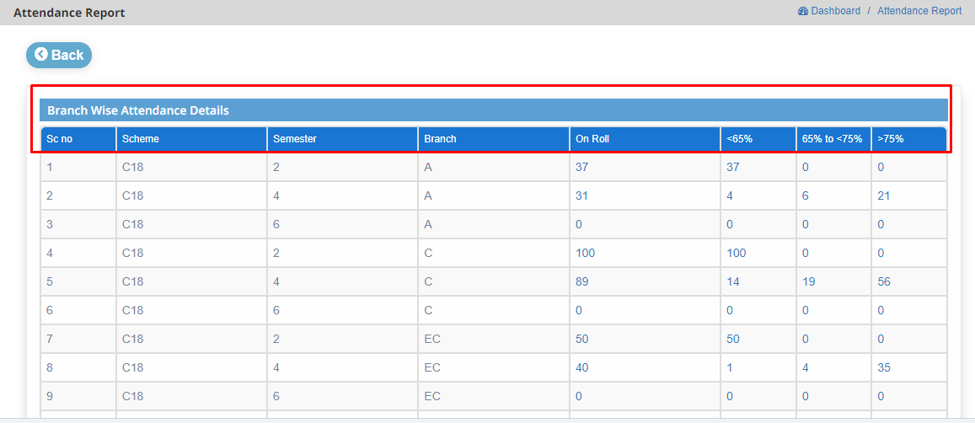

STEP 3: To get In-detail about the row, user should click on that particular row. The data contains PIN, Name, Working Days, Present and overall percentage.

: 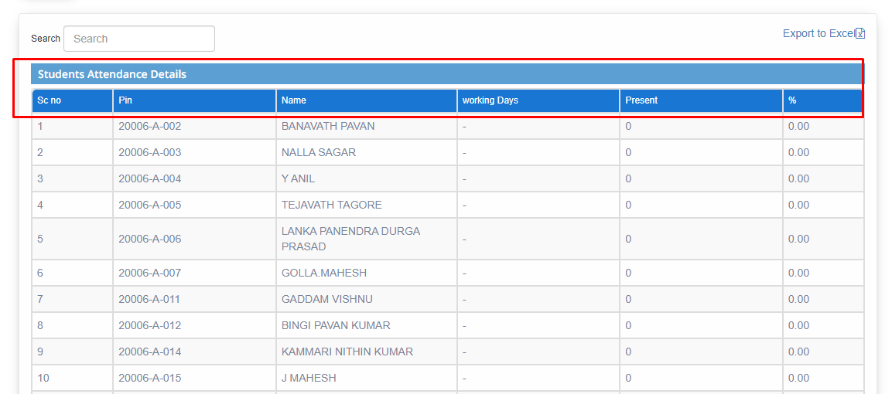

STEP 4: To get attendance of each student by month and date, click on that particular row.

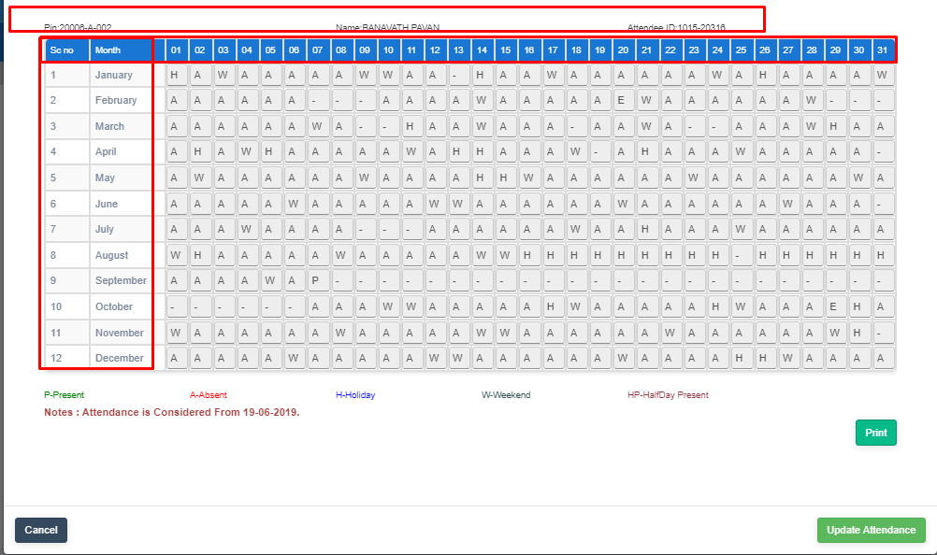

**NOTE: Government College Principal user has right to change the attendance of student from Present to Absent only.**

**4)Module Name: Category Reports**

**Module Description:**

Category Reports is used to get the report by category of all the branches of their respective college.

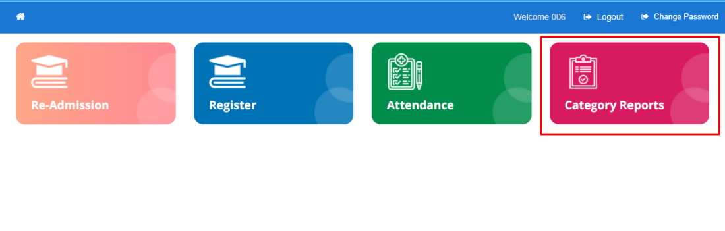

**Navigation steps to Category Reports Module:**

STEP 1: Click on Category Reports.

STEP 2: User can view the report by category of all the branches.

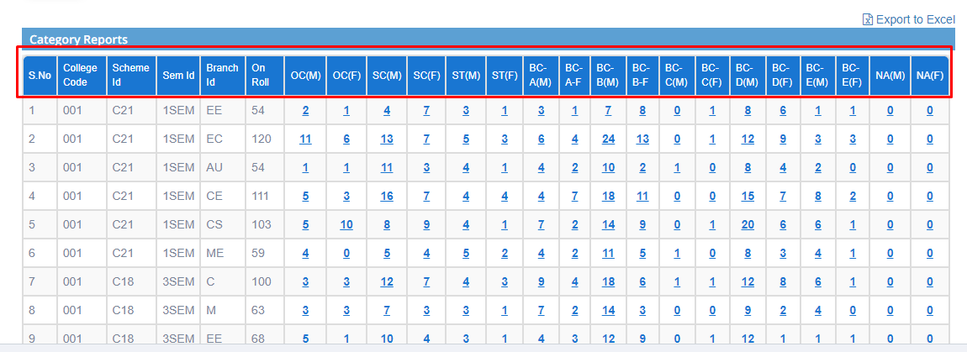

STEP 3: To get in-details about the row. User should click on that particular row. The data contains PIN, Student Name and Category.

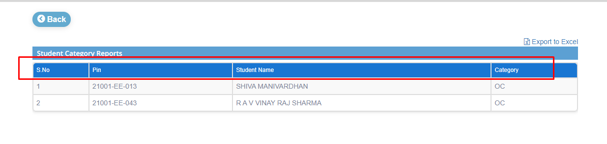

**HOD Login**

**HOD Home page consist of 6 modules. They are:**

1. **Admission**
2. **Post Exam**
3. **Academic**
4. **Assessment**
5. **Pre-Examination**
6. **Results**

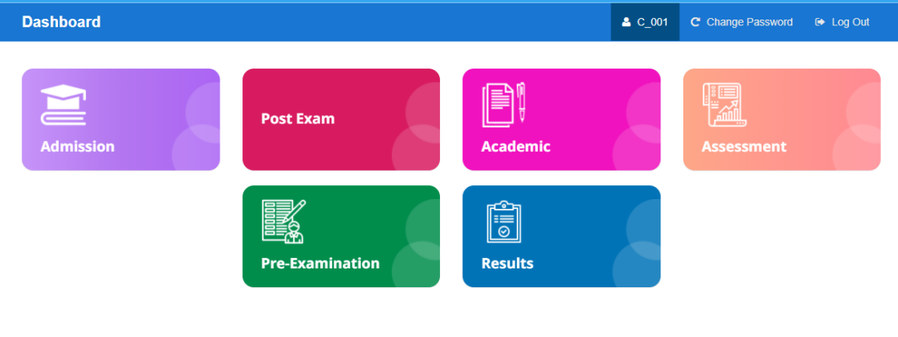

**Module Name: Admission**

**Module Description:**

Admission Module contains Register, Attendance and Category Reports of their respective branches.

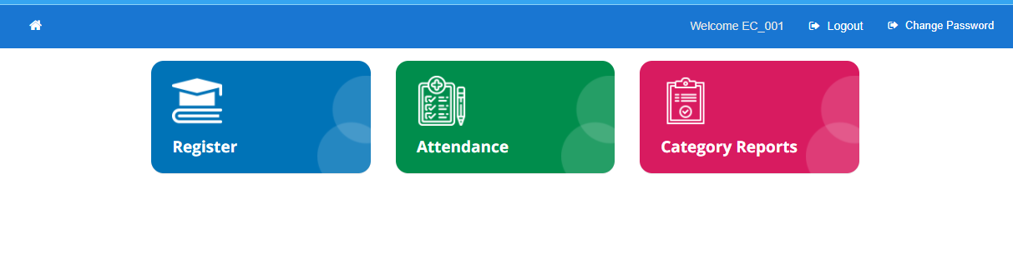

**Navigation steps to Admission Module:**

STEP 1: Click on Admission Module.

STEP 2: User can view the as mentioned above modules.

**1)Module Name: Register**

**Module Description:**

Registration module is used to get the student current academic data of their respective branch.

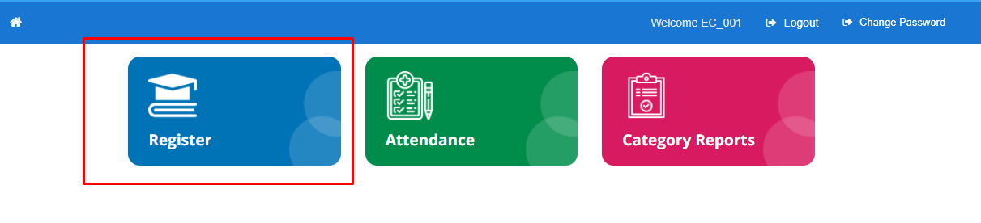

**Navigation steps to Register Module:**

STEP 1: Click on Register Module.

STEP 2: User can view the College and Student Details.

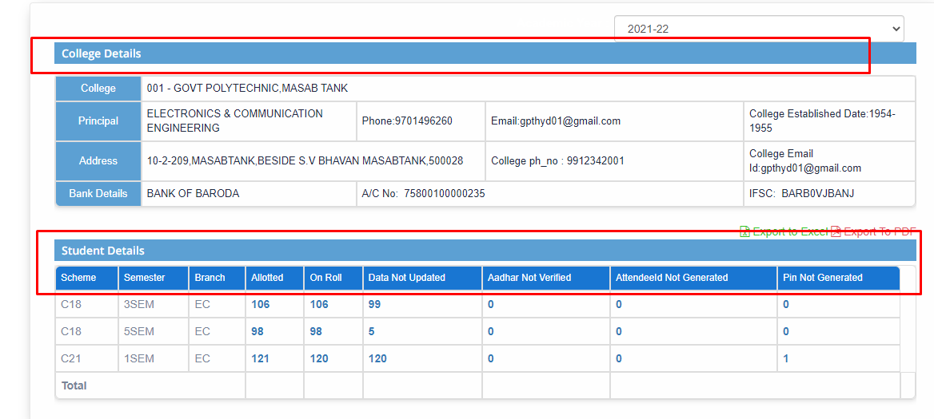

STEP 3: To get in-details about the row, user should click on that particular row. The data contains PIN, Attendee Id, Student Name, Birth Date, Admission Type, Aadhaar Status and Generate Pin.

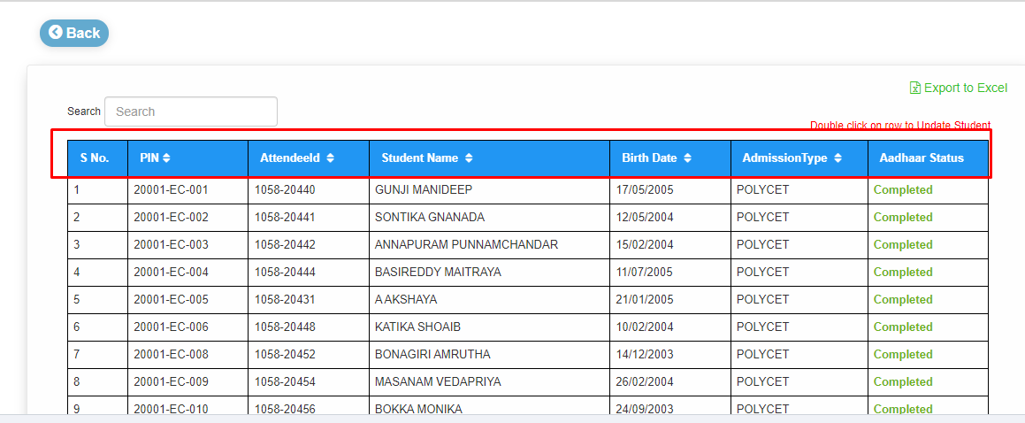

STEP 4: To update the student details user should double-click on that particular row.



STEP 5: Click on **Update Student Details** which will be present at the bottom after updating the student details

STEP 6: User can download the report in the form of excel by clicking on **Import to Excels/Import to Pdf.**

**2)Module Name: Attendance**

**Module Description:**

Attendance Module is used for, to get the overall attendance percentage of students of their respective branch.

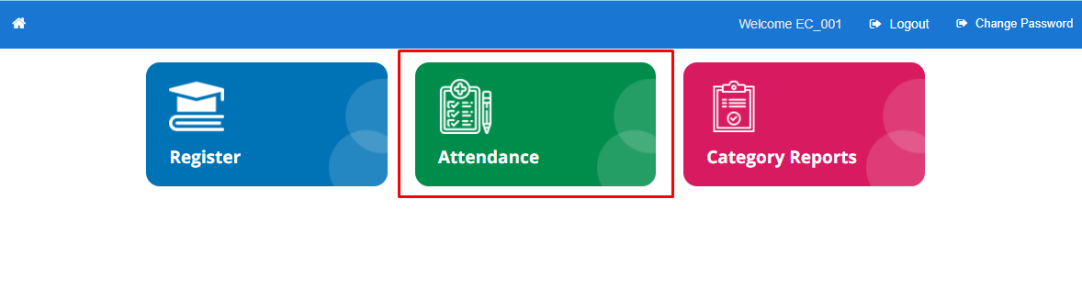

**Navigation steps to Attendance Module:**

STEP 1: Click on Attendance Module.

STEP 2: User can view the attendance details of students. The data contains Scheme, Semester, Branch, On Roll and the overall attendance percentage of students which is <65%, 65% to 75% and >75%.

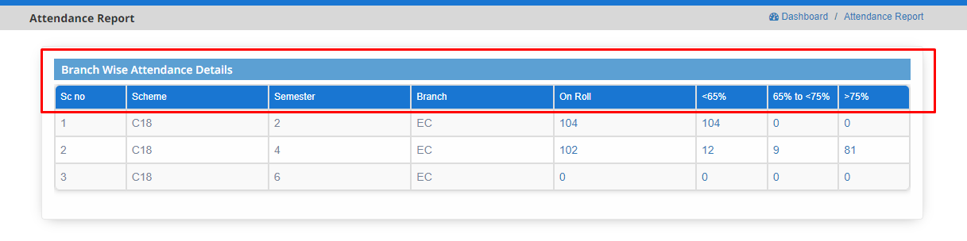

STEP 3: To get the attendance details of students click on that particular row who are having <65%, 65% to 75% and >75. The data contains Pin, Name, Working days, Present and overall percentage.

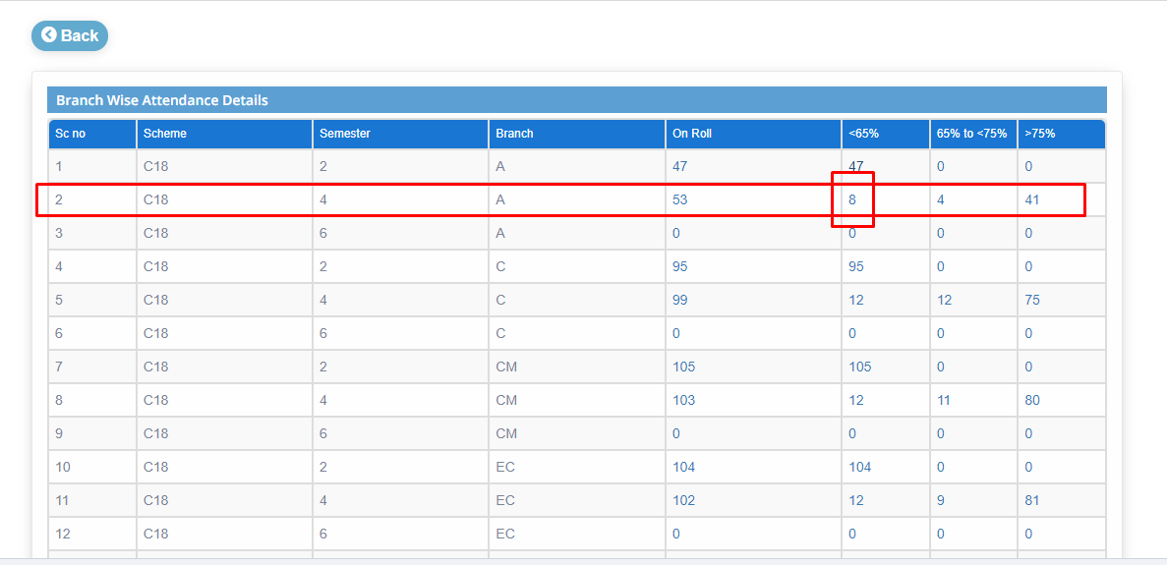

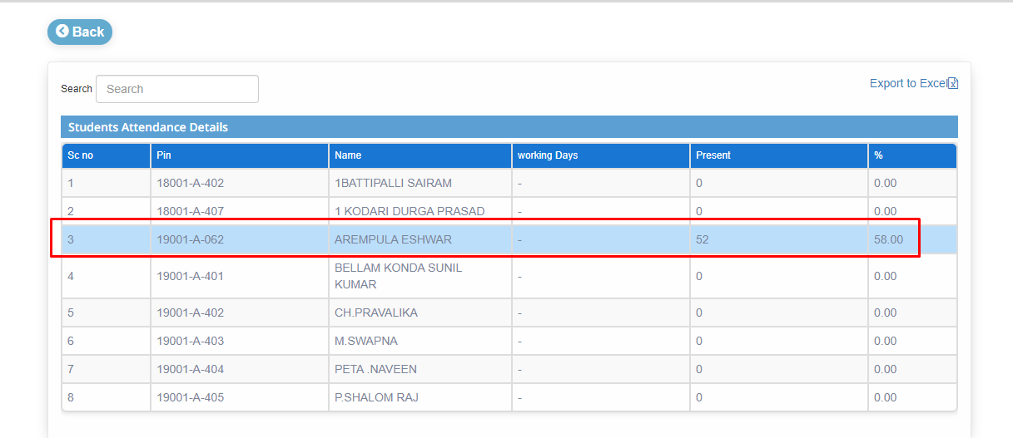

STEP 6: To get attendance of each student by month and date, click on that particular row.



**3)Module Name: Category Reports**

**Module Description:**

Category Reports is used to get the report by category of their respective branch.

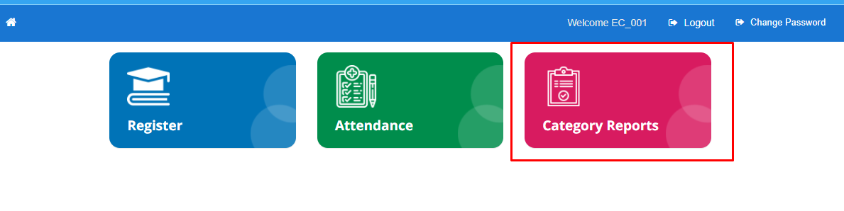

**Navigation steps to Category Reports Module:**

STEP 1: Click on Category Reports Module

STEP 2: User can view the report by category of all the students in their respective branch.