**Principal login**

**Module Name: Assessment**

**Module Description:**

Assessment Module contains the Reports module. It is a place where user can see the reports of all students irrespective of branch.

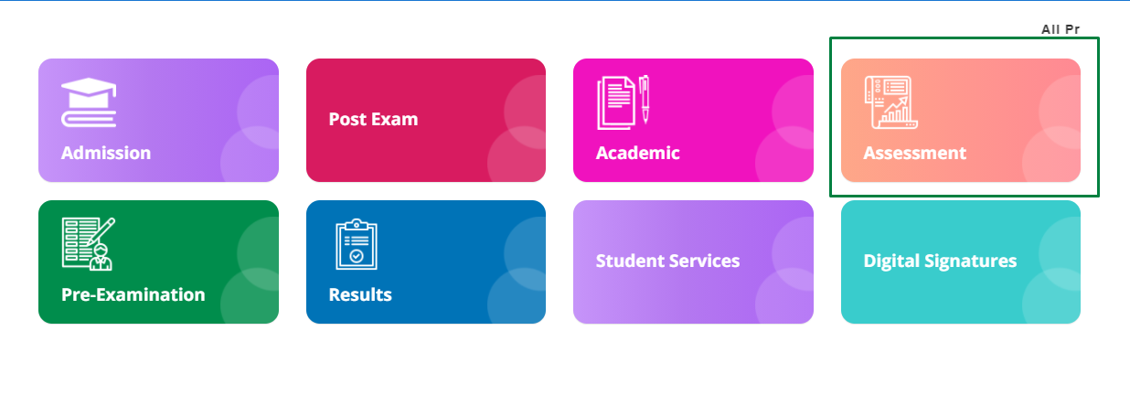

**Navigation steps to Reports Module:**

STEP 1: Click on Assessment Module

STEP 2: There user can view the Report Module

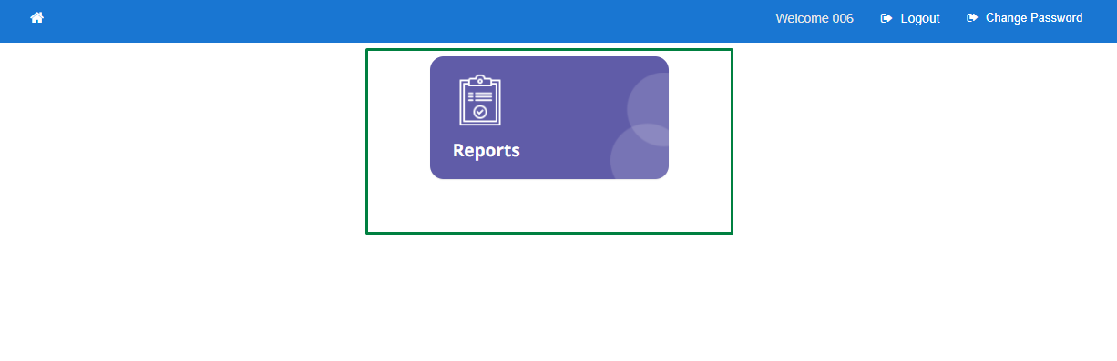

STEP 3: Click on Report Module

STEP 4: Choose the data from drop down as per requirement.

STEP 5: User will get the report of all the students irrespective of branches of that particular organization which includes Scheme, College code, Branch Code, Semester, Subject Code, Total, Not posted, Absent, Malpractice, Detained, Discontinued and TC Taken.

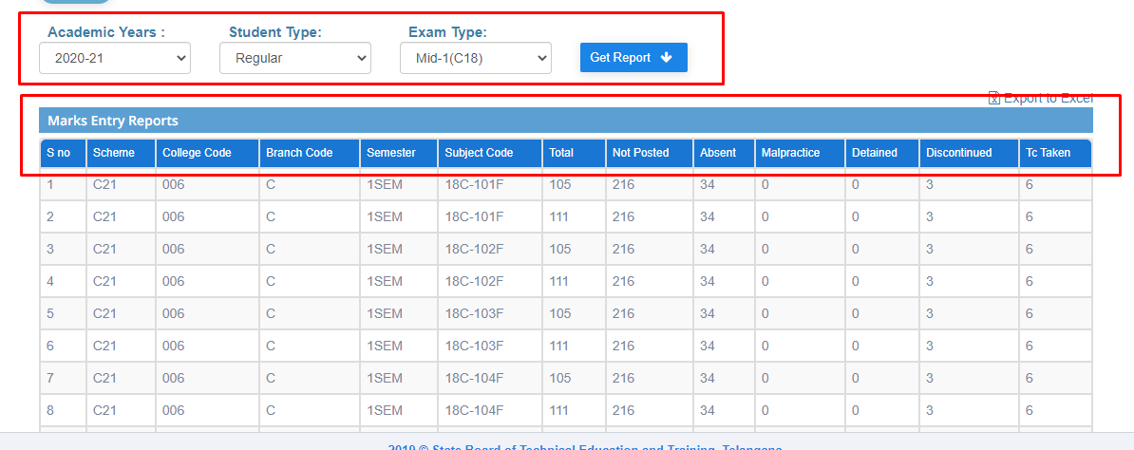

STEP 6: User can download the report in the form of excel by clicking on **Import to Excels.**

**HOD Login**

**Module Name: Assessment**

**Module Description:**

Assessment Module contains the Marks Entry, Reports Modules.

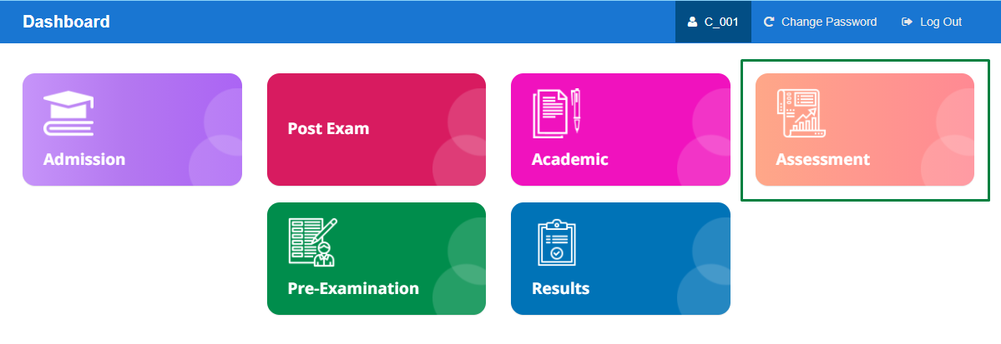

**Navigation steps to Assessment Module:**

STEP 1: Click on Assessment Module

STEP 2: User can view the Assessment Consolidated, Marks Entry and Report Modules

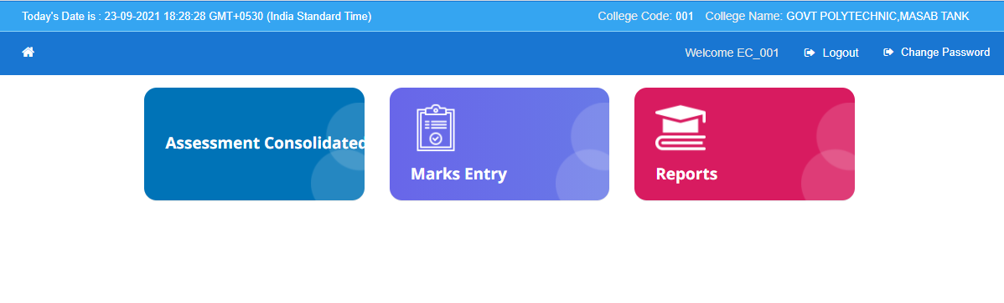

**Module Name: Assessment Consolidated**

**Module Description:**

Assessment Consolidated Module is used for get the data of marks of each student of their respective branch.

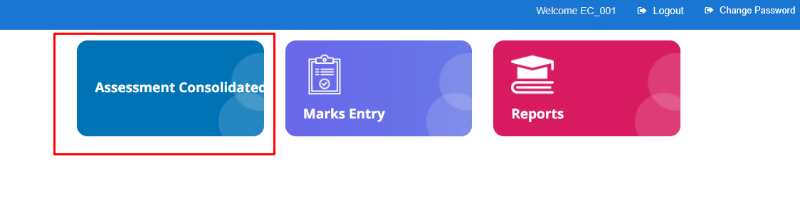

**Navigation steps to Assessment Consolidated Module:**

STEP 1: Click on Assessment Consolidated Module

STEP 2: Choose the data from dropdown as per requirement

STEP 3: Click on submit

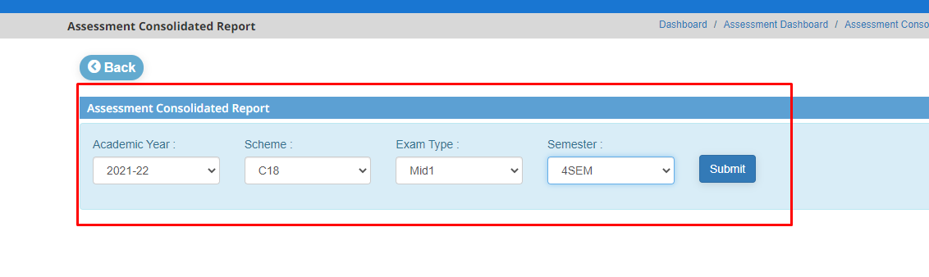

STEP 4: An Excel will be downloaded. It contains marks of each student of choosed data.

**Module Name: Marks Entry**

**Module Description:**

Marks Entry module is used for entering the marks of students.

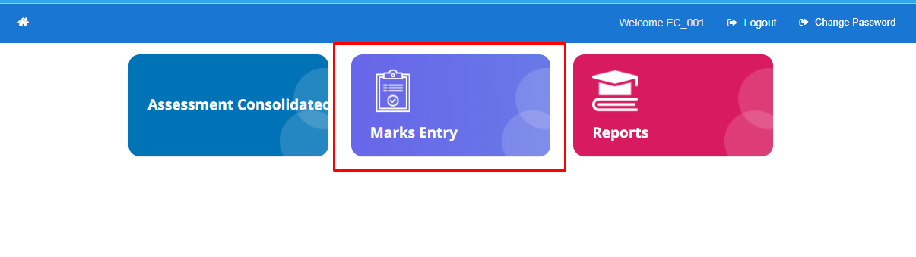

**Navigation steps to Marks Entry Module:**

SEPT 1: Select data from dropdown as per requirement

STEP 2: User can view the Theory and Practical modules.

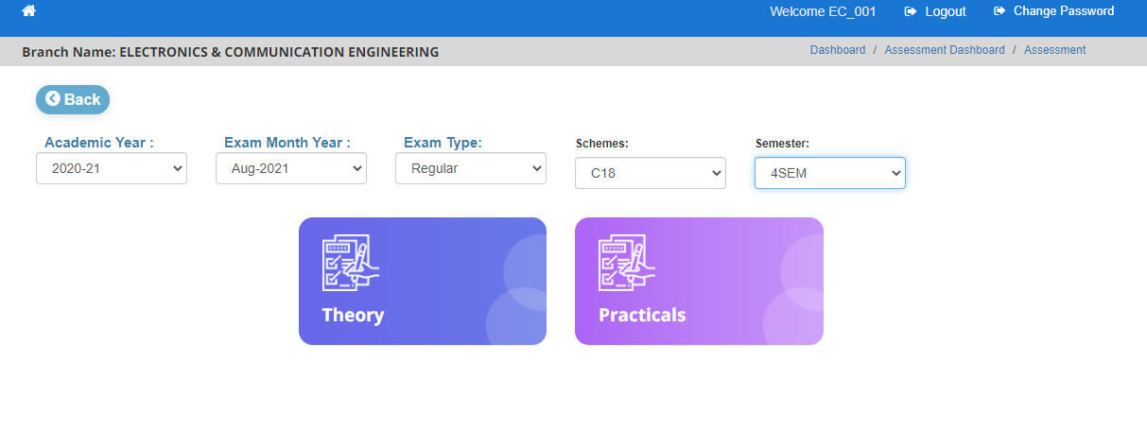

STEP 4: Click on Theory Module.

STEP 5: User can view the Internals Module. Click on internals Module

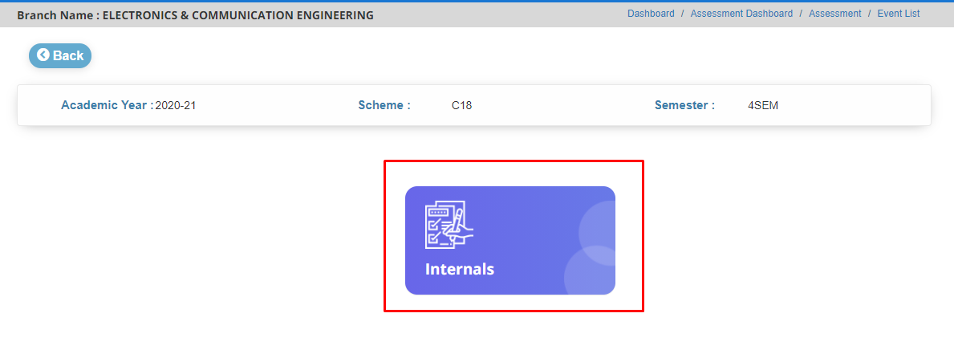

STEP 6: User can view the Subject Code, Subject Name, Total, Not Posted, Absent and Malpractice of each subject of Internals.

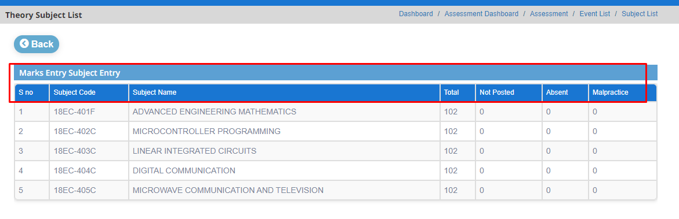

STEP 7: Click on Practicals Module (Repeat the step 1 and 2 in Entry module to navigate the practicals module.

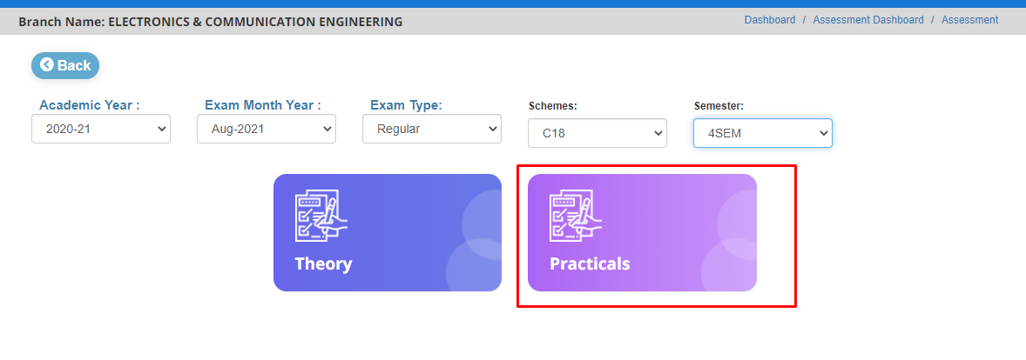

STEP 8: Click on practicals Module. User can view the End Exams, Internals, Mid 1 and Mid 2 Modules

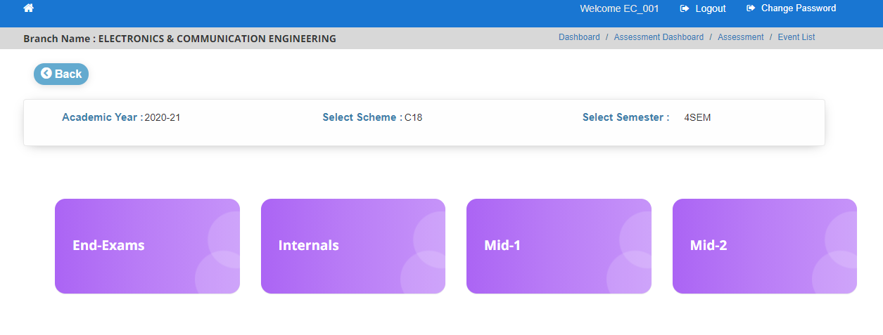

STEP 9: Click on End Exams Module. User can view the Subject Code, Subject Name, Total, Not Posted, Absent and Malpractice of each practical Subject of End- Exams

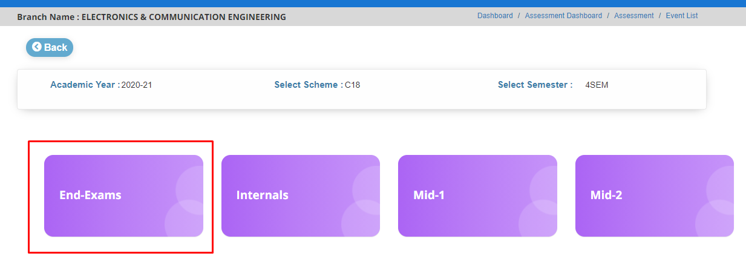

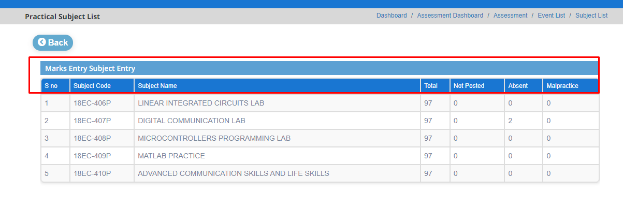

STEP 10: Click on Internal Module. User can view the Subject Code, Subject Name, Total, Not Posted, Absent and Malpractice of each practical Subject of Internals.

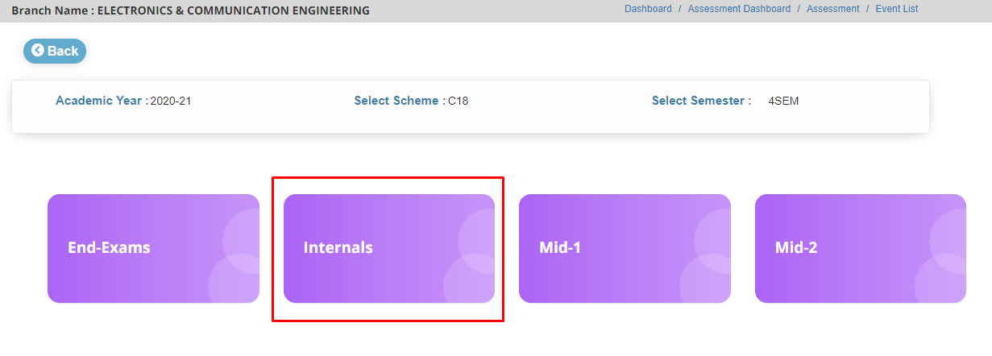

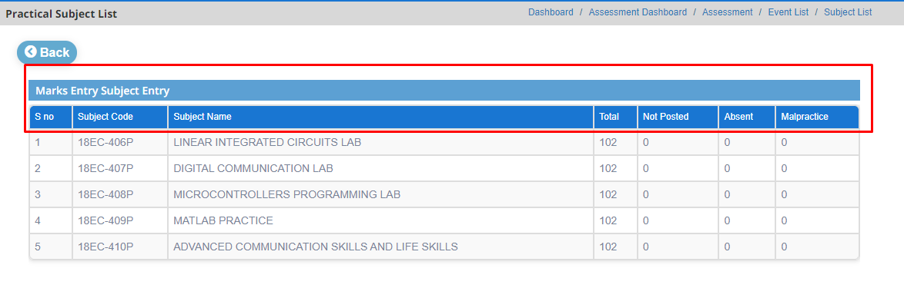

STEP 11: Follow the Internal Module steps for Mid-1 and Mid-2 Modules for entering the marks of students in practical module.

**Module Name: Reports**

**Module Description:**

Report Module is used to view the marks of each student by subject wise in theory and practicals.

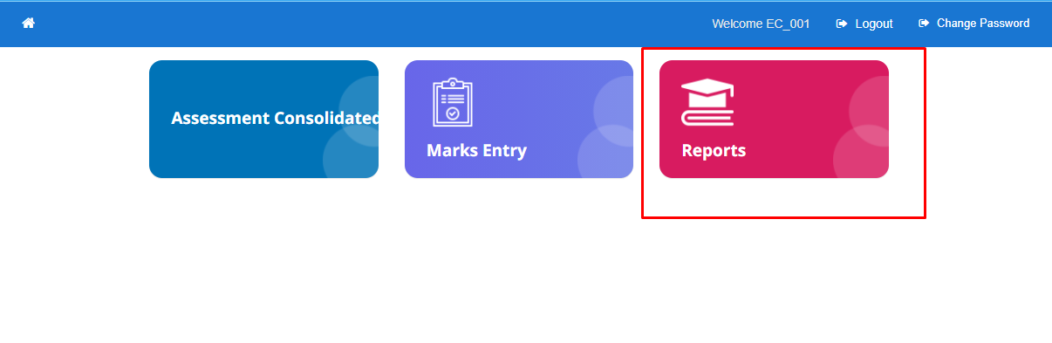

**Navigation Steps to Reports:**

STEP 1: Click on Reports Module.

STEP 2: Select data from drop down as per requirement. User can view the Theory and Practicals Modules.

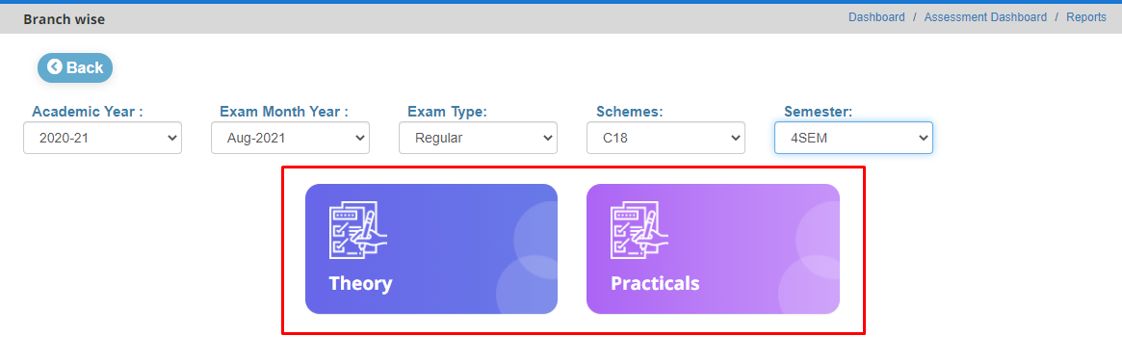

STEP 3: Click on Theory Module. User can view the Internal Module.

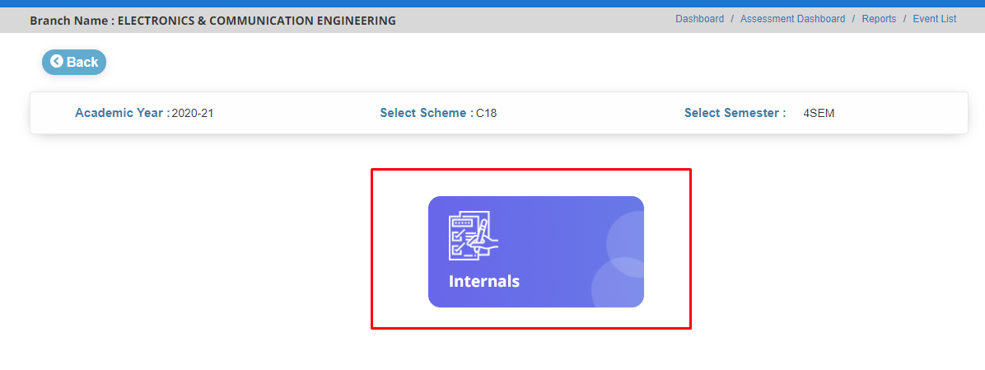

STEP 4: Click on Internals Module. User can view the Subject Code, Subject Name, Total, Not Posted, Absent and Malpractice of each practical Subject of Internals.

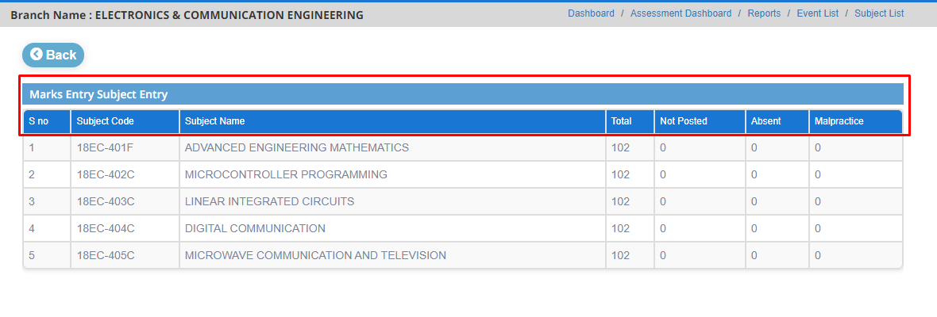

STEP 5: To get in detail of each subject of each student click on that particular subject. The data contains PIN, Name and Marks.

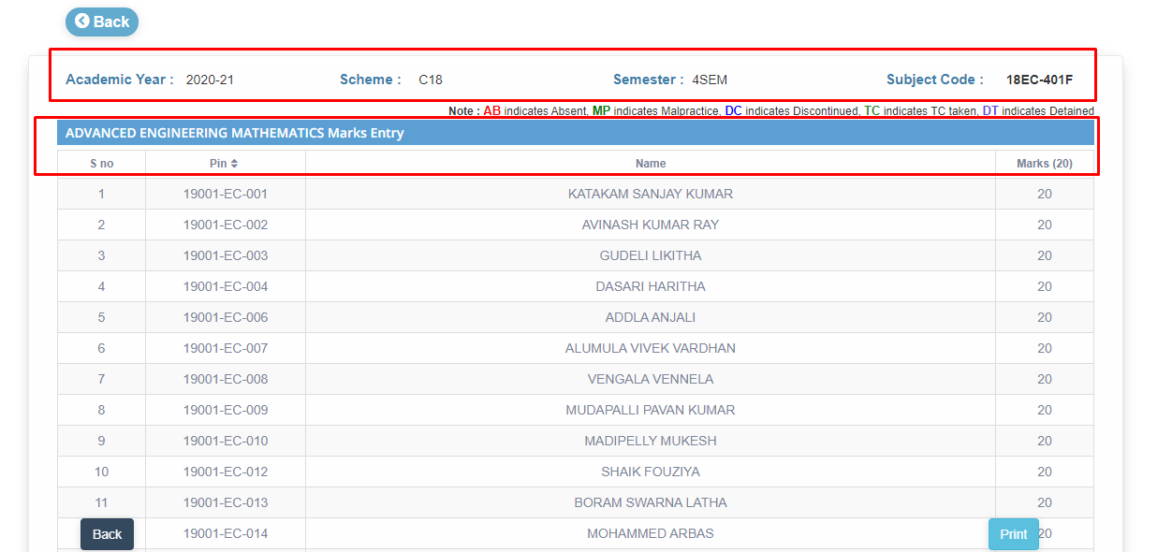

STEP 6: Click on Practicals Module. (Repeat the steps 1 and 2 in reports module to navigate the practical module)

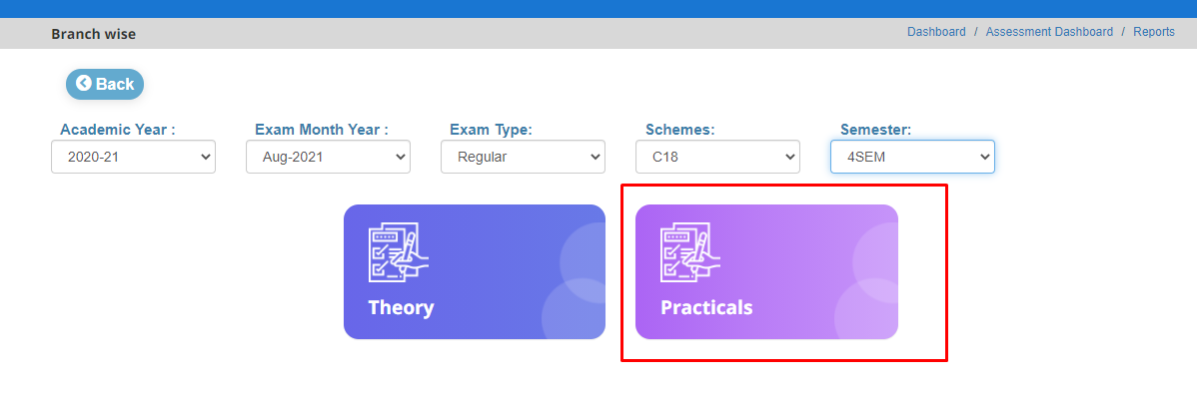

STEP 7: User can view the End-Exams, Internals, Mid-1 and Mid-2 Modules.

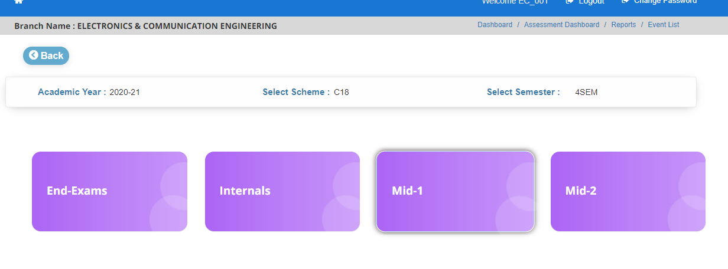

STEP 8: Click on End-Exams Module. User can view the Subject Code, Subject Name, Total, Not Posted, Absent and Malpractice of each practical Subject of End- Exams

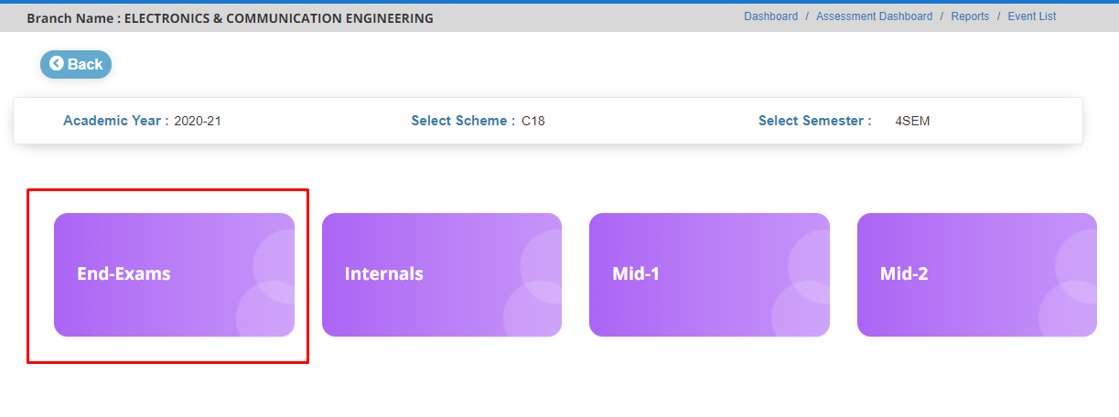

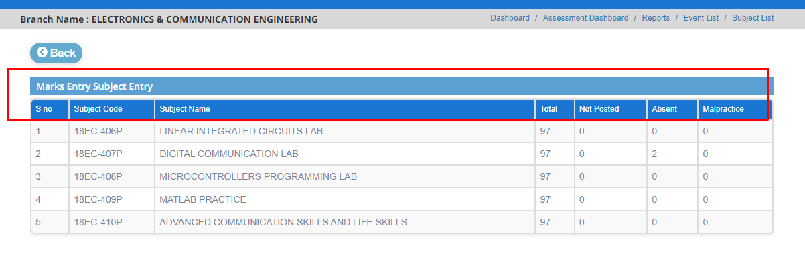

STEP 9: To get in detail of each practical subject of each student click on that particular practical subject. The data contains PIN, Name and Marks.

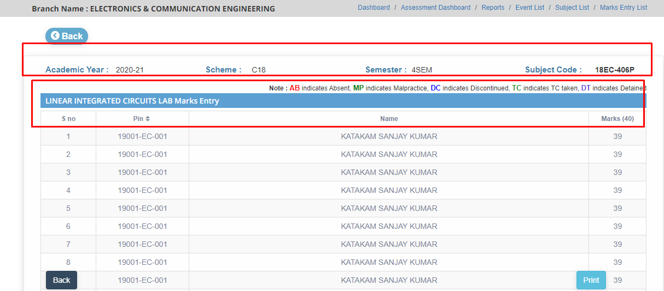

STEP 10: Follow the End-Exams module steps for Internals, Mid-1 and Mid-2 Modules.