**HOD Login**

**HOD Home page contains 6 modules. They are**

**1. Admission**

**2. Academic**

**3. Assessment**

**4. Pre – Examination**

**5. Results**

**6. Student services**

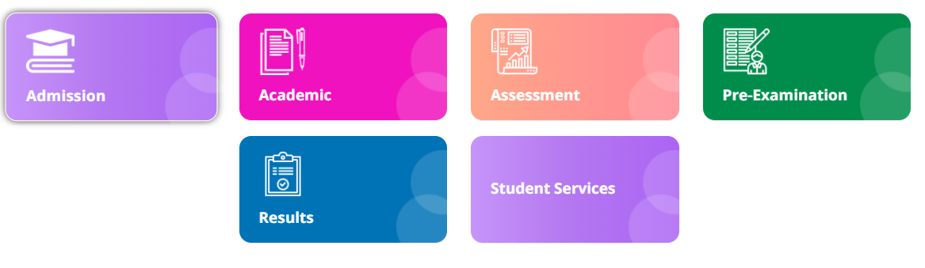

**Module Name: Pre – Examination**

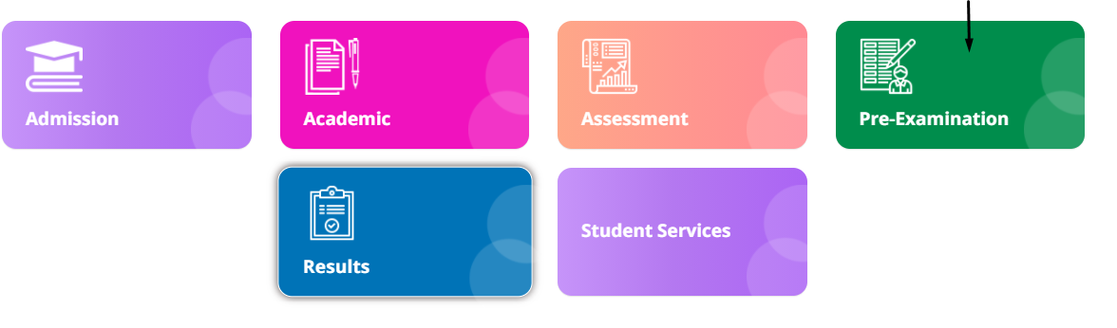

**Module Description:**

**Pre-Examination** module consists sub-modules namely **Admission, Academic**

**Assessment, Pre – Examination, Results, Student services**

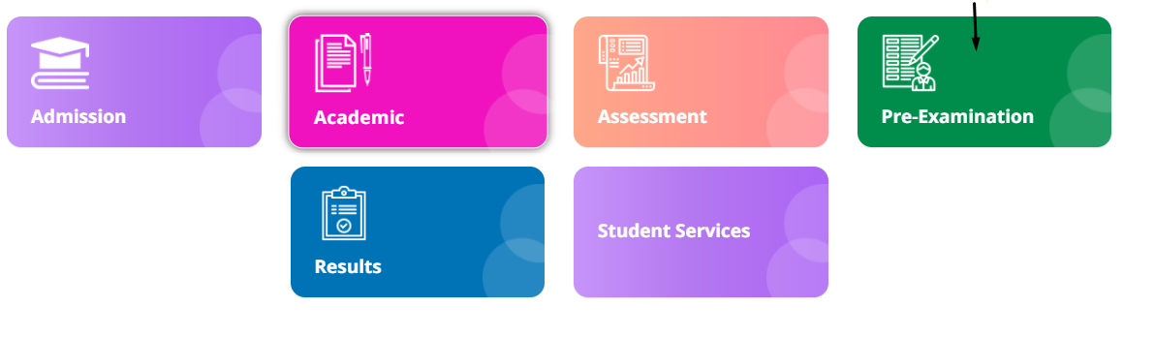

**1) Sub module name: Fee Payment**

**Description:**

This sub module is used to get the reports of the student who have paid the fees

**Navigation steps**

**Step1: Open Fee Payment**

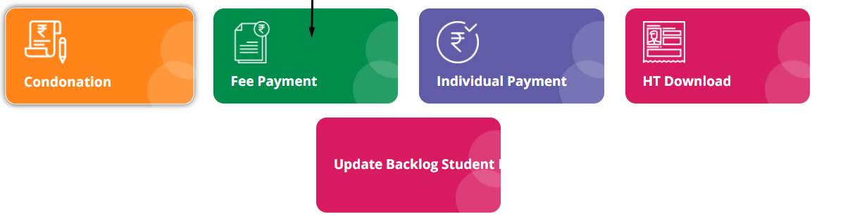

**Step2: Fill up the mandatory details.**

**By default, academic year will be current year**

**Click on show results**

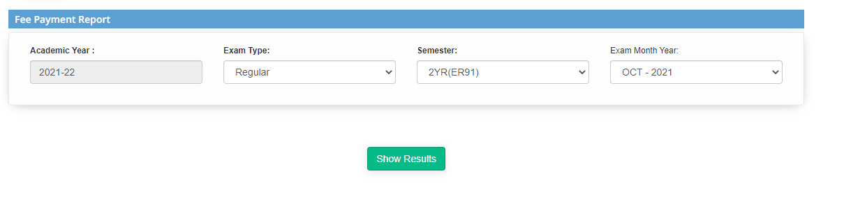

**Step3: The list of the students paid will be displayed**

**2) Sub module name: Individual Payment**

**Description:**

This sub module is used to retrieve the details of the individual payment done by the student

**Navigation steps**

**Step1: Open Individual Payment**

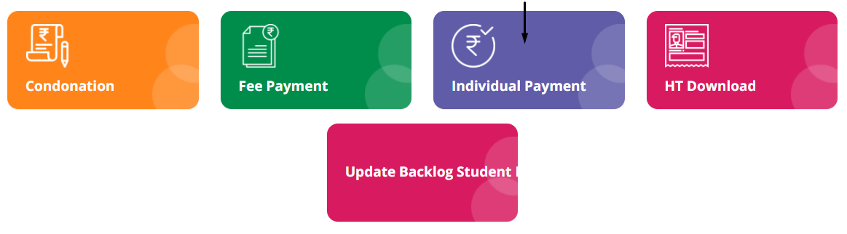

**Step2: Fill up the mandatory details**

**Enter the captcha properly**

**Click on Get details**

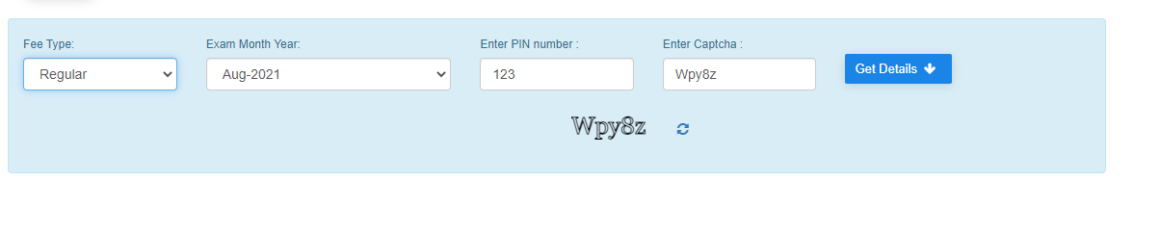

**Step3: The payment details will be displayed for particular student**

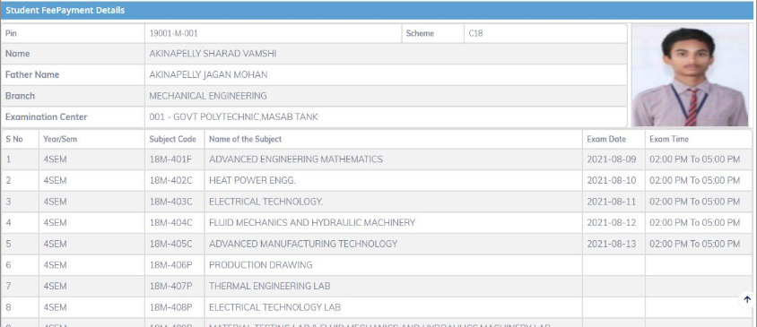

**Step4: Confirm the details and click on Pay amount which is in the bottom**

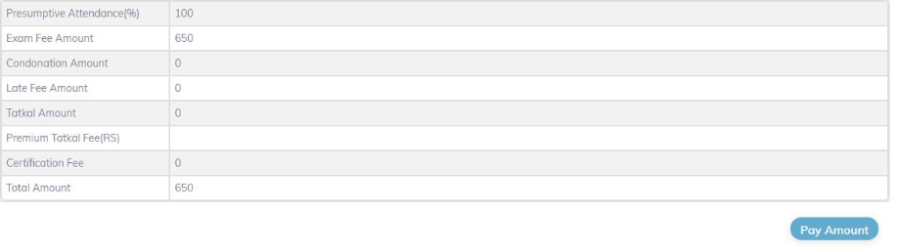

**Step5: Check the details**

**Select the checkbox**

**Click on Proceed**

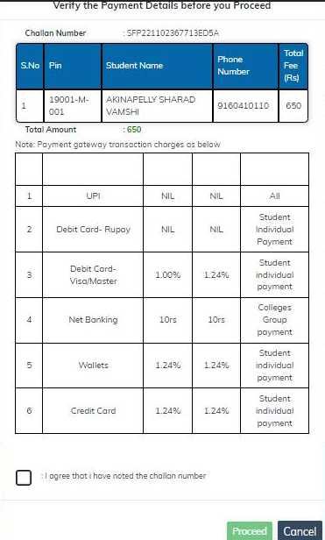

**Step6: Fill the payment details**

**Proceed to make payment**

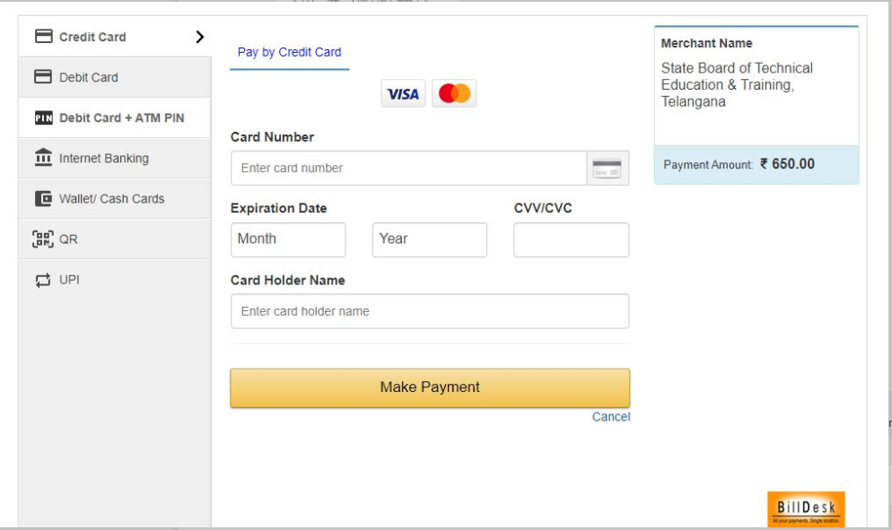

**3) Sub module name: HT download**

**Description:**

This sub module is used to download the hall ticket for examination

**Navigation steps**

**Step1: Open HT download**

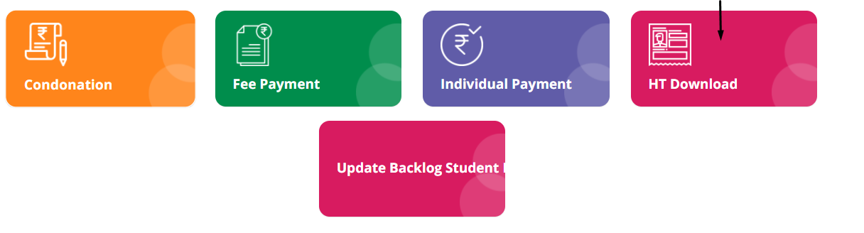

**Step2: Enter the PIN**

**Select exam type and exam month year from the dropdown list**

**Click on view Hall ticket**

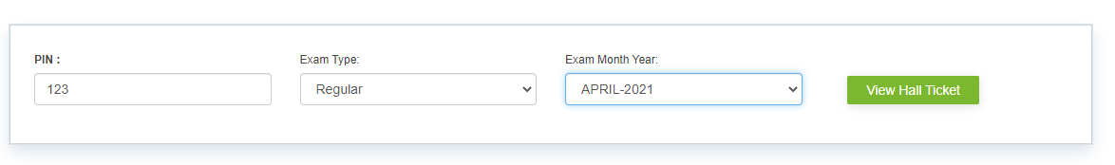

**Step3: The hall ticket for the particular student will be displayed**

**You can also print the hall ticket by clicking on Print**

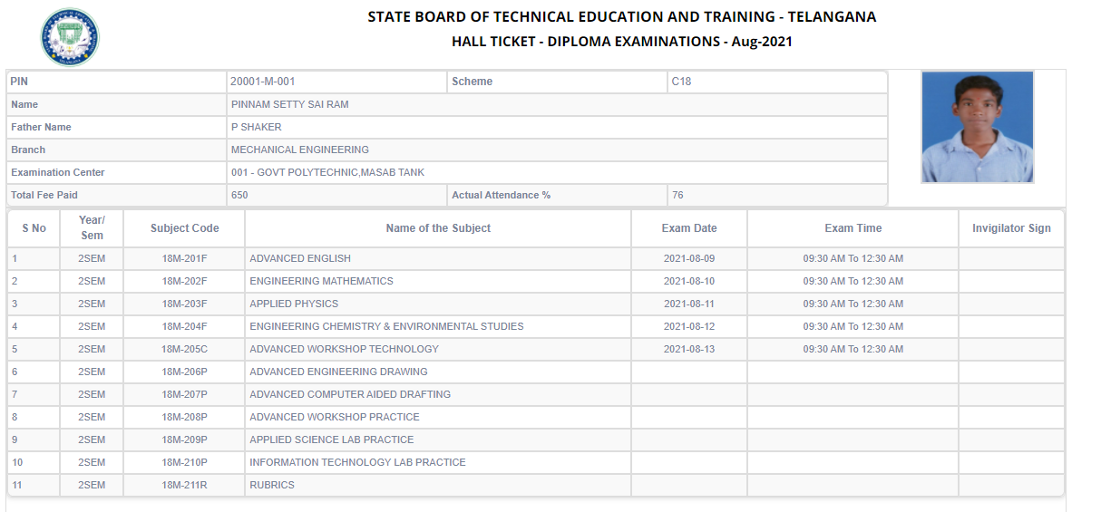

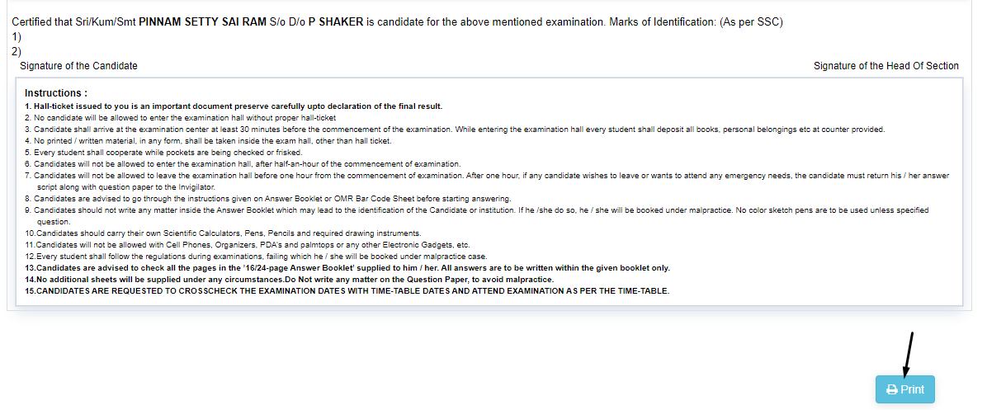

**4) Sub module name: Update backlog student list**

**Description:**

This sub module is used to update the changes of backlog students list only

**Navigation steps**

**Step1: Open Update backlog student list**

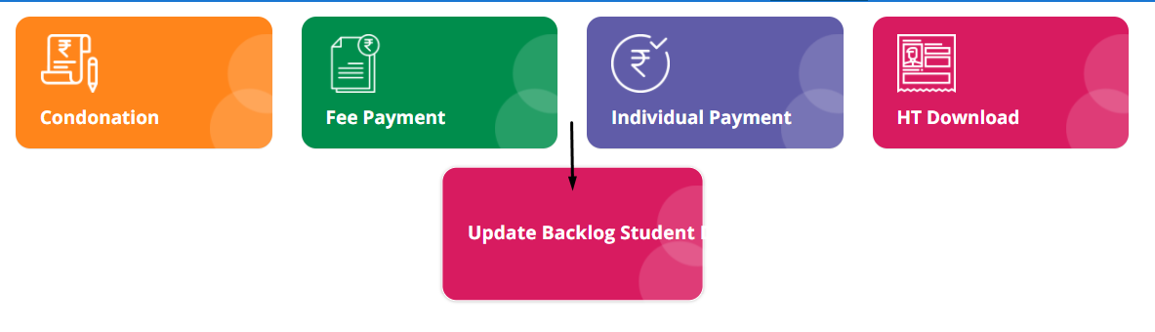

**Step2: Enter the pin number which will be generated to registered mobile number**

**Click on Get details**

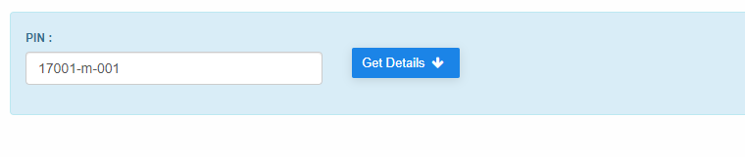

**Step3: The student details will be displayed**

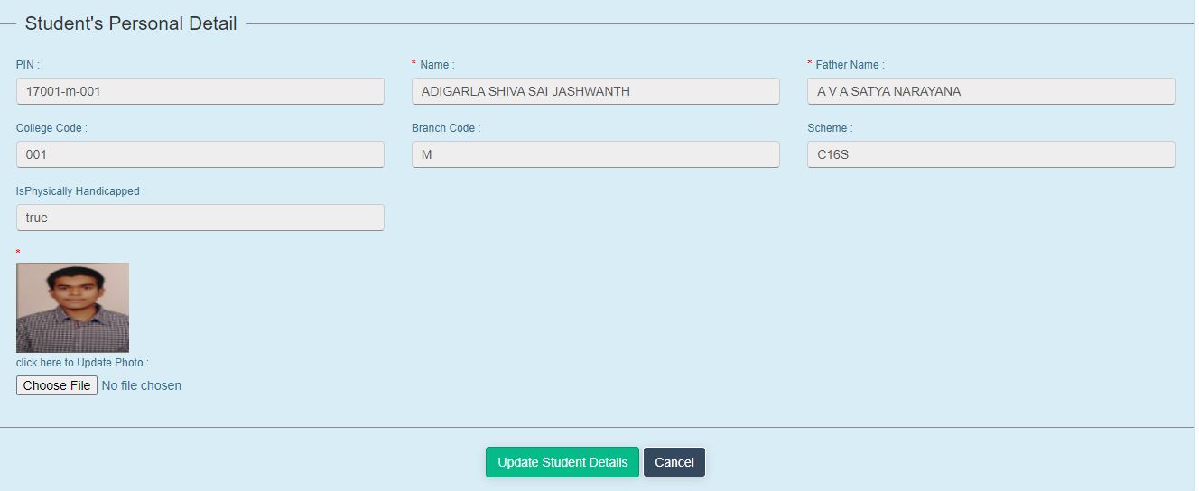

**Step4: Select update student details if any changes are to be made else click on Cancel**

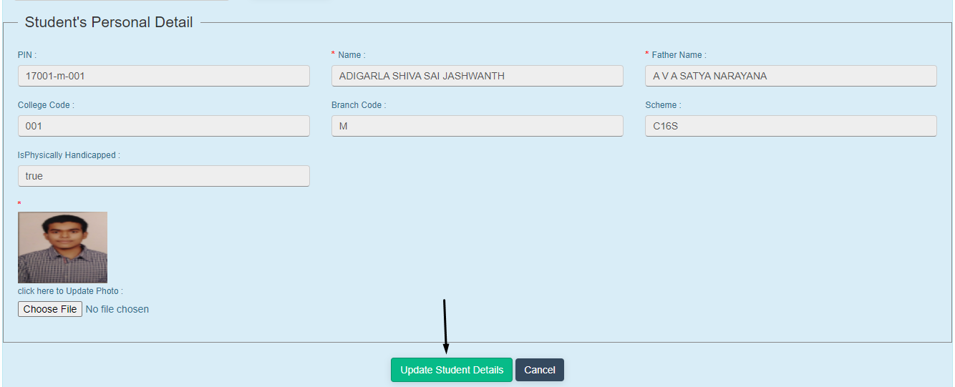

**5) Sub module name: Condonation**

**Description:**

This sub module is used to enrol and recommend if any semester students need to be included

**Navigation steps**

**Step1: Open Condonation**

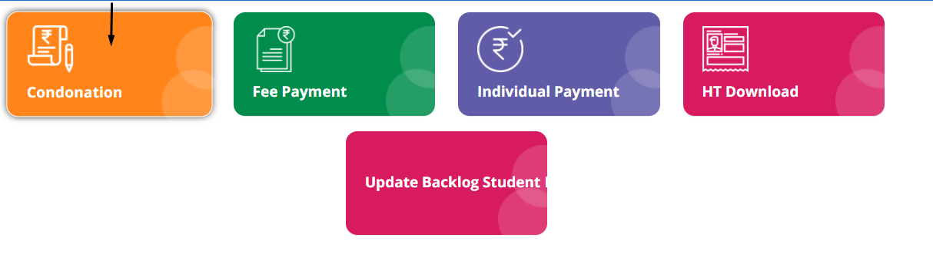

**Step2: Select the exam type**

**Click on Show details**

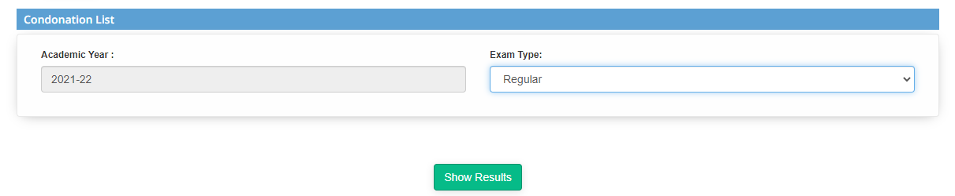

**Step3: The enrolled list will be displayed**

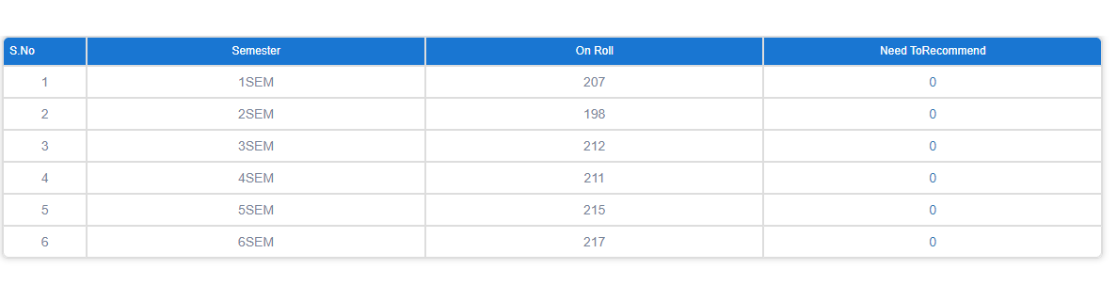

**Step4: If any semester students have to be enrolled:**  
**Click on particular row. It will redirect to next page**  
**List which needs to be recommended will be displayed**  
**Click on recommend**

**Principal Login**

**HOD Home page contains 6 modules. They are**

**1. Admission**

**2. Post Exam**

**3. Academic**

**4. Assessment**

**5. Pre-Examination**

**6. Results**

**7. Student Services**

**8. Digital Signatures**

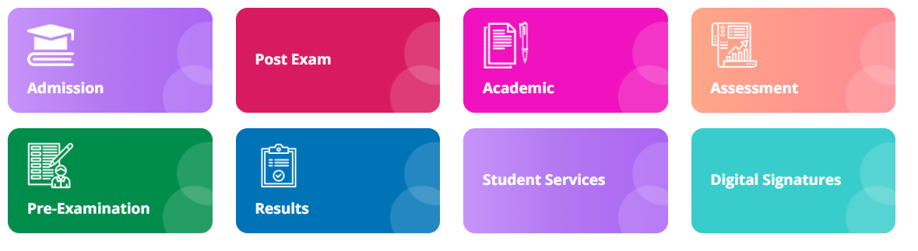

**Module Name: Pre-Examination**

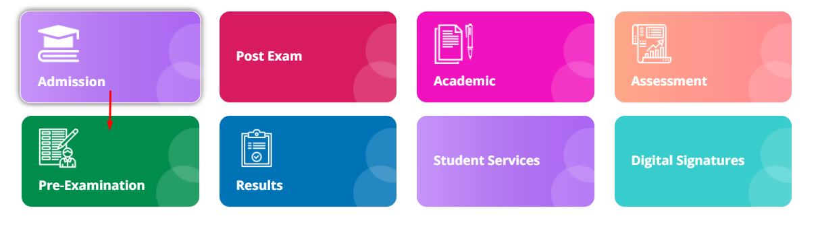

**Module Description:**

**Pre-Examination** module consists sub-modules namely **Condonation, Seating Arrangement, Reports, NR Download, NR Excel Report, Time table.**

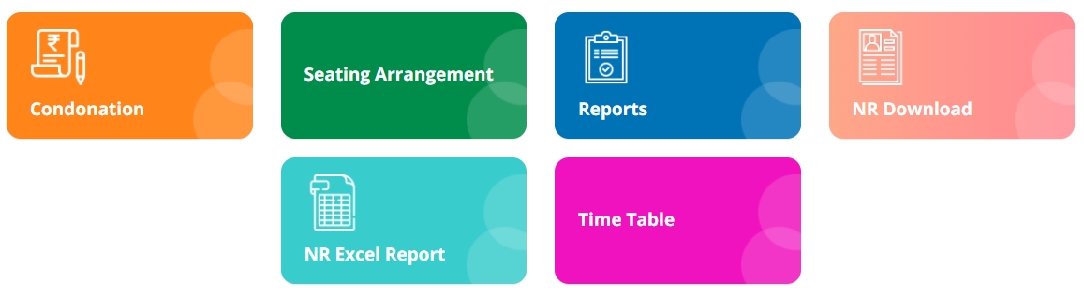

**1) Sub module name: Reports**

**Description:**

This sub module is used get the fee payment reports

**Navigation steps**

**Step1: Open Reports**

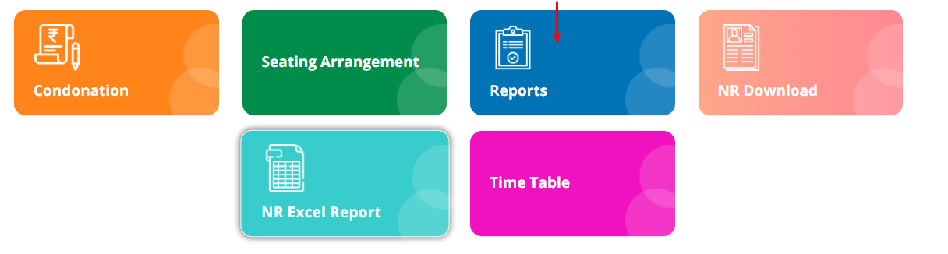

**Step2: To get the fee payment reports, fill in the details which are given in dropdown. The academic year will be the current year by default.**  
**Then click on Show results.**

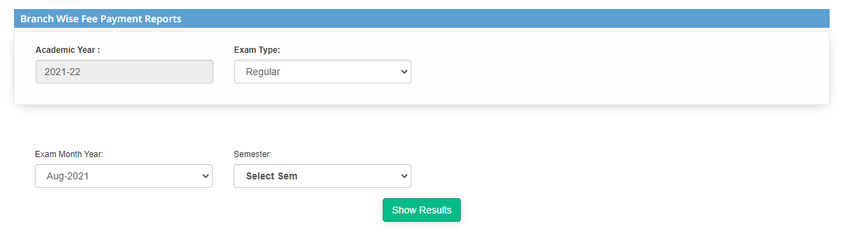

**Step3: The results of the fee payments are displayed as shown below**

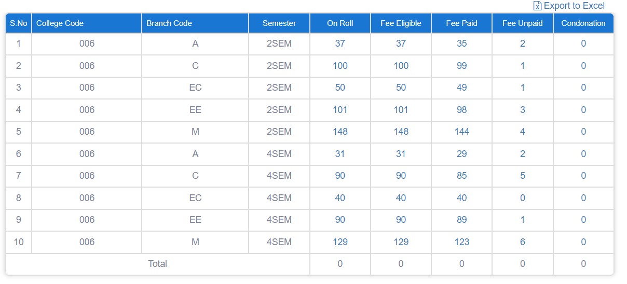

**Note:**   
The reports can be downloaded by clicking on **Export to Excel.**

**2) Sub module name: NR Download**

**Description:**

This sub module is used to get NR reports

**Navigation steps**

**Step1: Open NR download**

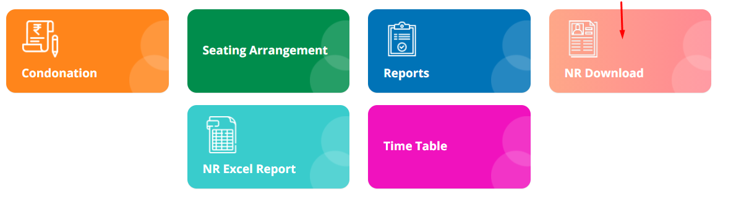

**Step2: Fill the details from the dropdown. Then click on Get details**

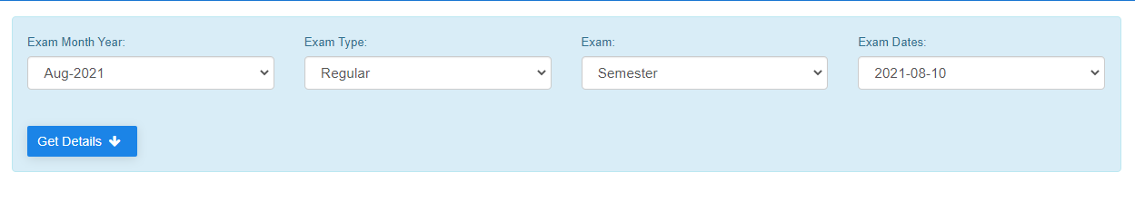

**Step3: The details given by the principal are listed as shown below**

**3) Sub module name: NR Excel Report**

**Description:**

This sub module is used to get NR reports in the excel format

**Navigation steps**

**Step1: Open NR Excel Report**

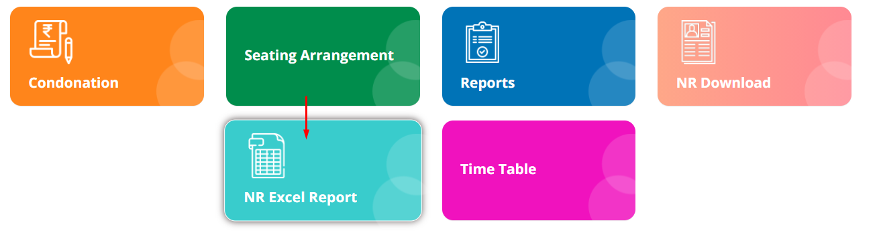

**Step2: Enter the exam type and exam from dropdown. Then click on Get NR details.**

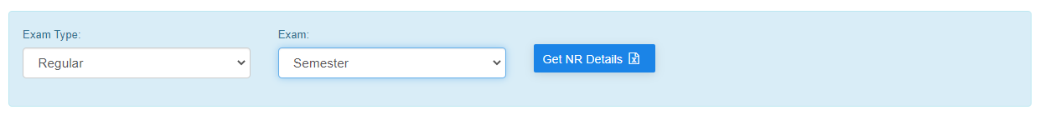

**Step3: The NR excel will be downloaded. When you open the excel, the details are displayed as shown below.**

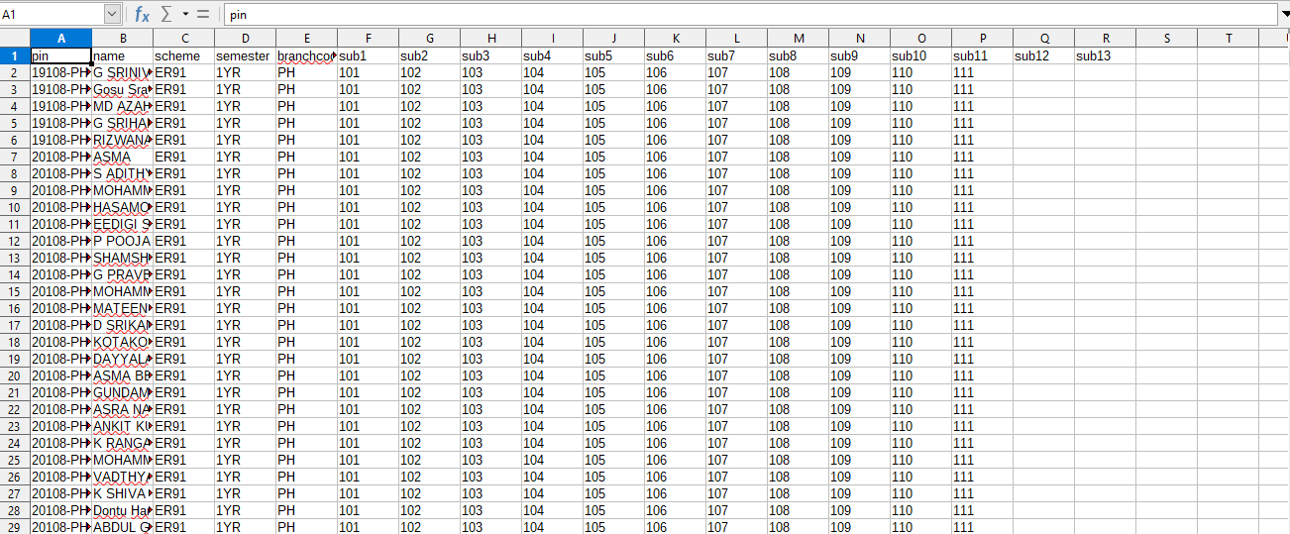

**4) Sub module name: Time table**

**Description:**

This sub module is used to get the updated time table of particular student.

**Navigation steps**

**Step1: Open Time table**

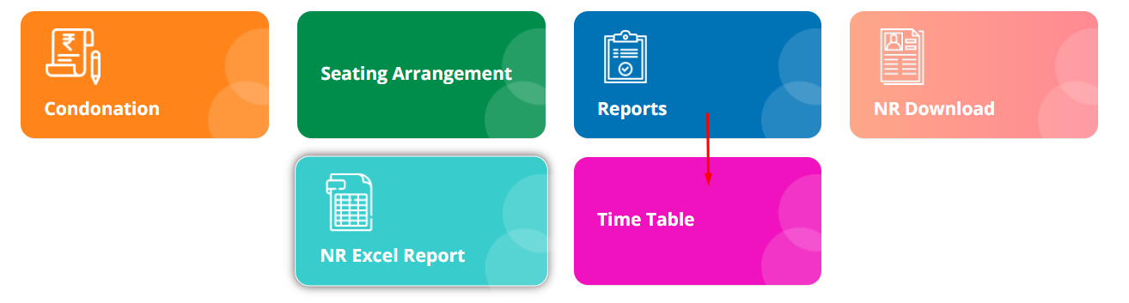

**Step2: Fill the mandatory fields which are academic year, exam month/year, student type, scheme, exam name from the dropdown**

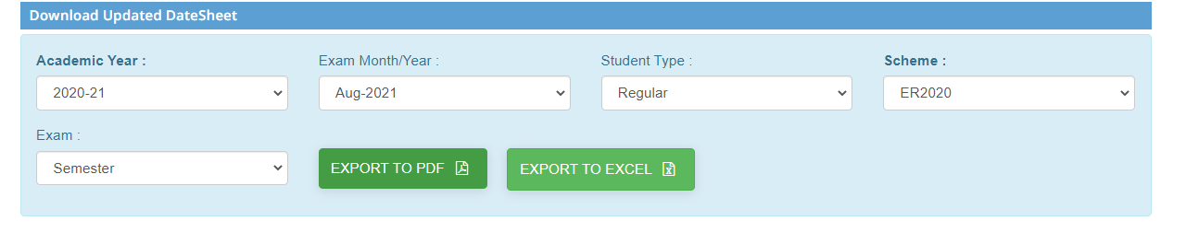

**Step3: Now you can either choose pdf format or excel format to get the updated timetable.**

**5) Sub module name: Seating arrangements**

**Description:**

This sub module is used to arrange the seats to write the exam for the students.

**Navigation steps**

**Step1: Open Seating arrangements**

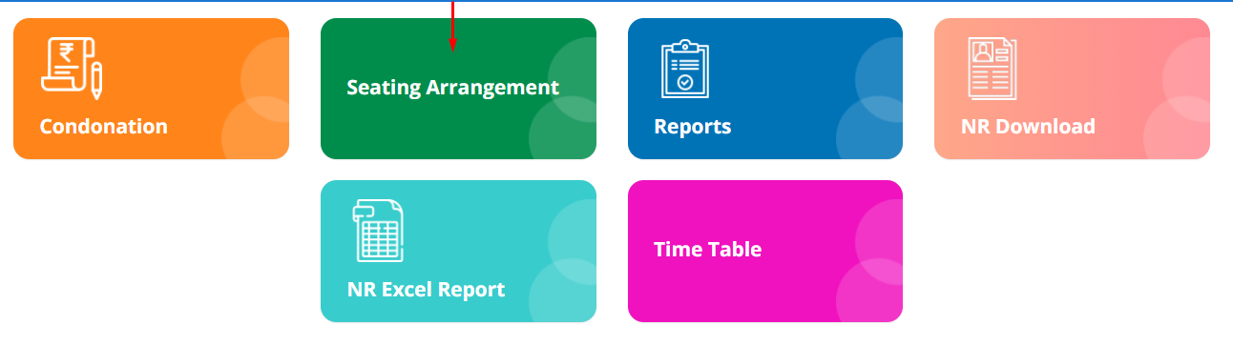

**Step2: To plan the seating arrangements:**

* **Select Generate seating plan**
* **You will be navigated to planning page**
* **Fill the mandatory fields from dropdown options**
* **When any examination hall is selected, you have to mention the number of students for each bench**
* **After mentioning the students click on generate setting plan**
* **The seating arrangement plan will be created**

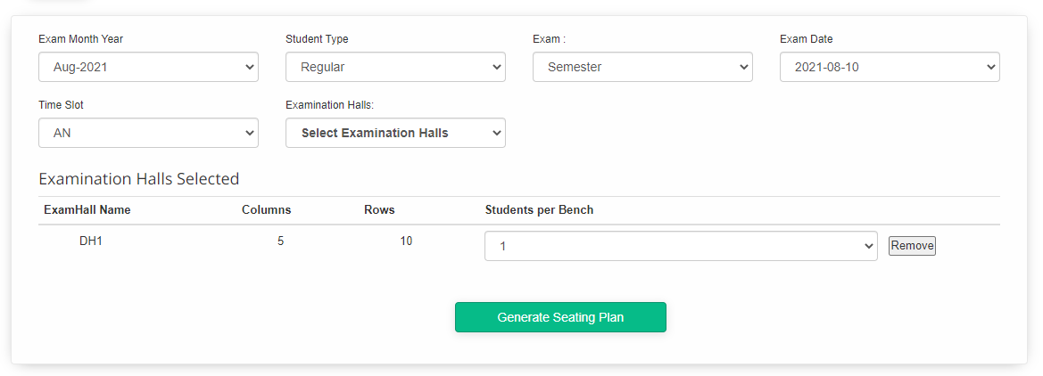

**Step3: You can add new examination hall by clicking Add Exam Hall. Provide the details by selecting from the dropdown given. Then click on Add Exam Hall**

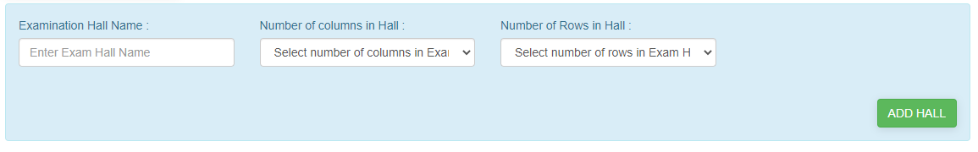

**Step4: The added exam halls will be displayed. If the changes need to be done, then select edit and update the changes.**

