**Principal Login**

**Module Name: Results**

**Module Description:**

Results module consists of Consolidate Result, Branch Results, Student Results.

**1) Sub module name: Consolidate Result**

**Description:**

This sub module is used to display the overall result.

**Navigation steps:**

**Step1:** Open Consolidate Result

**Step2:** Select Scheme. Enter PIN and captcha given and click on **Get Report**

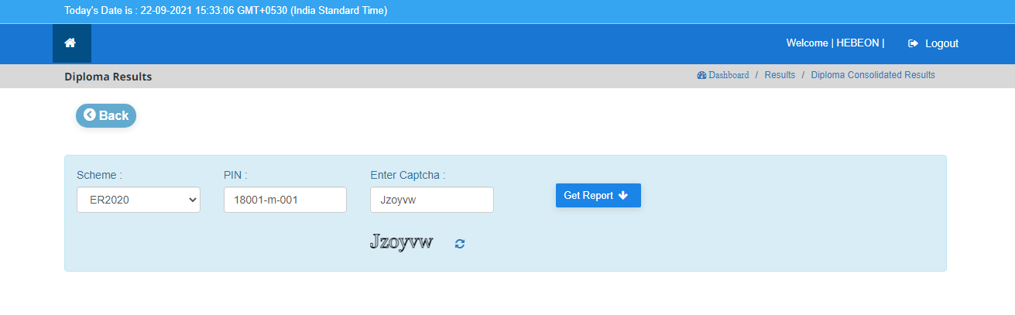

**Step 3:** When we click on **Get Report** the **Result History Marks Card** is displayed as per the given PIN No and scheme.

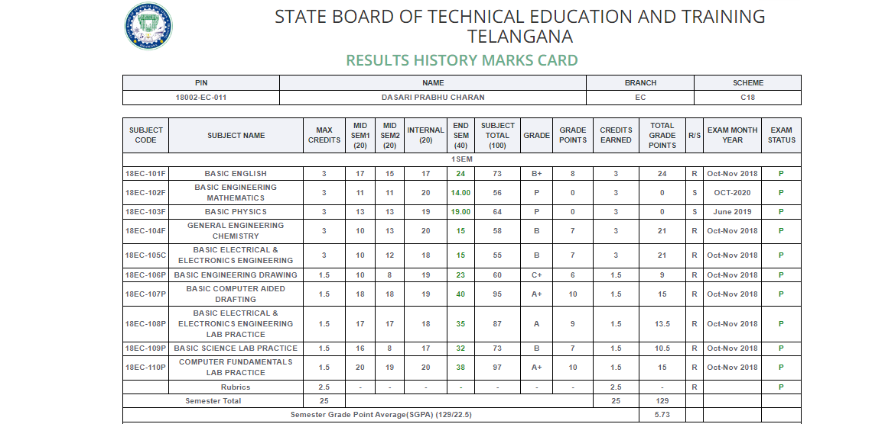

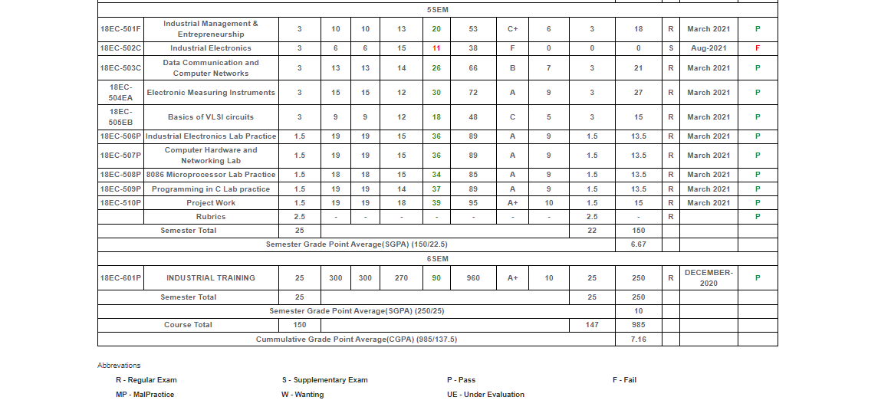

* Here we can see the fields as
* Semester wise subject code
* Subjects
* Credits based on subject
* Mid, Internal and External marks
* Grade and Grade points that we got
* Credits that we earned
* Overall Result - (R/S)   
   R – Regular  
   S – Supplementary
* Total grade points
* Exam month & year
* Exam Status - (P/F)  
   P – Pass  
   F – Fail
* The Semester Wise Grade Point Average (SGPA) was to be given for each semester.
* At the last semester the overall Cumulative Grade Point Average (CGPA) was given totally.
* We also get the total grade points to the credits user earned.

**2) Sub module name: Branch Results**

**Description:**

This sub module is used to displays the result based on branch wise.

**Navigation steps:**

**Step1:** Open **Branch Results.**  
  
**Step-2:** Select Scheme, Exam Month/Year, Sem & Year, Exam, Branch and click on  **Get Results**

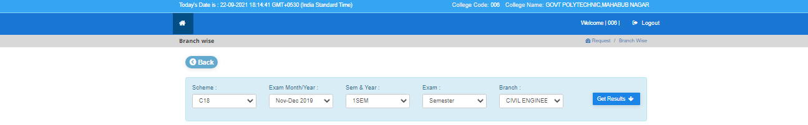

**Step 3:** When we click on **Get Results** the results of the student mid –1 and mid-2 marks with grades and total marks of all students were displayed according to the branch code, scheme, college name and semester.

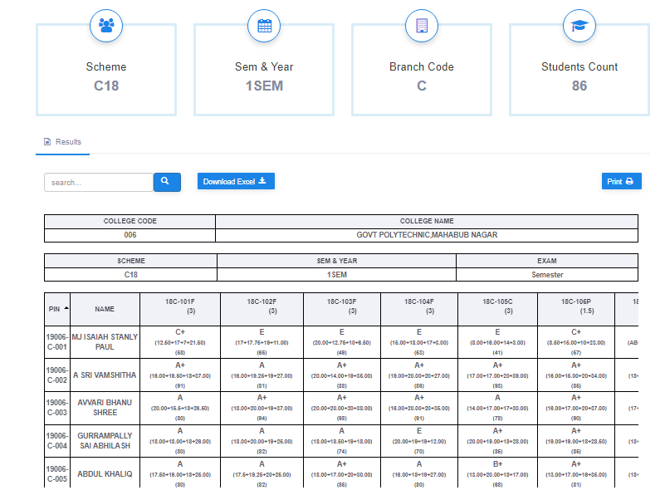

**3) Sub module name: Student Results**

**Description:**

This sub module is used to displays the result based on branch wise.

**Navigation steps:**

**Step 1:** Open Student Results.

**Step 2:** Select College, Scheme, Exam Pass Type, Sem & Year, Exam, Exam Month/Year, Pin Number and click on  **Get Report.**

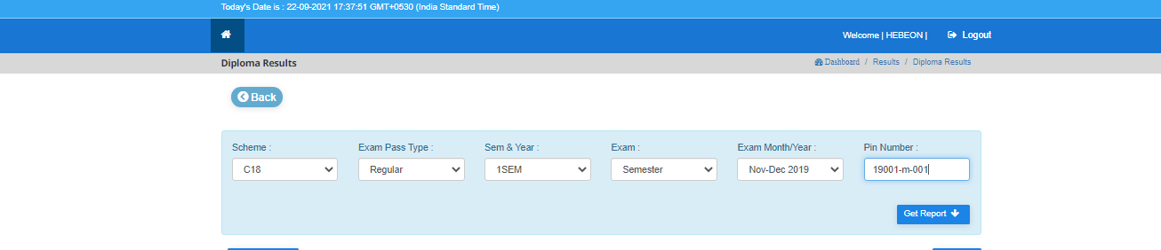

**Step 3:** When we click on **Get Report** the marks card were displayed according to the PIN number, branch, scheme, college name and semester.

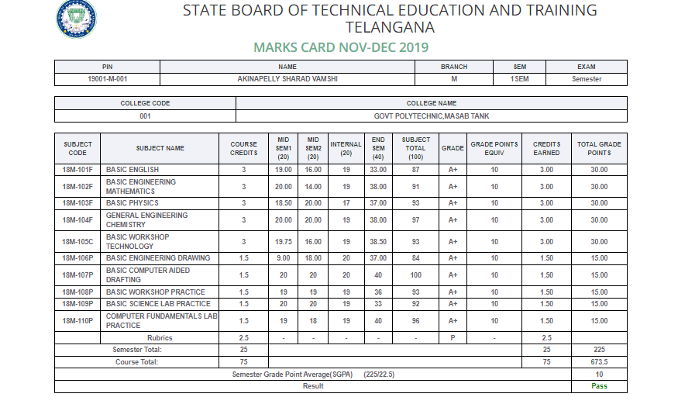

**HOD Login**

**Module Name: Results**

**Module Description:**

Results module consists of Consolidate Result, Branch Results, Student Results.

**1) Sub module name: Consolidate Result**

**Description:**

This sub module is used to display the overall result.

**Navigation steps:**

**Step1:** Open Consolidate Result

**Step2:** Select Scheme. Enter PIN and captcha given and click on **Get Report**



**Step 3:** When we click on **Get Report** the **Result History Marks Card** is displayed as per the given PIN No and scheme.





* Here we can see the fields as
* Semester wise subject code
* Subjects
* Credits based on subject
* Mid, Internal and External marks
* Grade and Grade points that we got
* Credits that we earned
* Overall Result - (R/S)   
   R – Regular  
   S – Supplementary
* Total grade points
* Exam month & year
* Exam Status - (P/F)  
   P – Pass  
   F – Fail
* The Semester Wise Grade Point Average (SGPA) was to be given for each semester.
* At the last semester the overall Cumulative Grade Point Average (CGPA) was given totally.
* We also get the total grade points to the credits user earned.

**2) Sub module name: Branch Results**

**Description:**

This sub module is used to displays the result based on branch wise.

**Navigation steps:**

**Step1:** Open **Branch Results.**  
  
**Step-2:** Select Scheme, Exam Month/Year, Sem & Year, Exam, Branch and click on  **Get Results**



**Step 3:** When we click on **Get Results** the results of the student mid –1 and mid-2 marks with grades and total marks of all students were displayed according to the branch code, scheme, college name and semester.



**3) Sub module name: Student Results**

**Description:**

This sub module is used to displays the result based on branch wise.

**Navigation steps:**

**Step 1:** Open Student Results.

**Step 2:** Select College, Scheme, Exam Pass Type, Sem & Year, Exam, Exam Month/Year, Pin Number and click on  **Get Report.**



**Step 3:** When we click on **Get Report** the marks card were displayed according to the PIN number, branch, scheme, college name and semester.

