**1)Process of Approval for Study Certificate**

**I)Administrative login**

STEP 1: Login to Administrative login id.

STEP2: Administrative Home page contains only Post Exam Module.

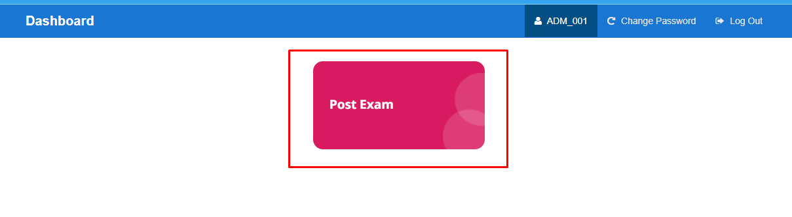

STEP 3: Click on Post Exam module.

STEP 4: User can view the Study Cert Approval and Tc Approval modules.

**Name of the Module: Study Cert Approval**

**Module Description:**

Study Cert Approval module is used for approving the study certificate, the students who are applied and also It displays the students list approval.

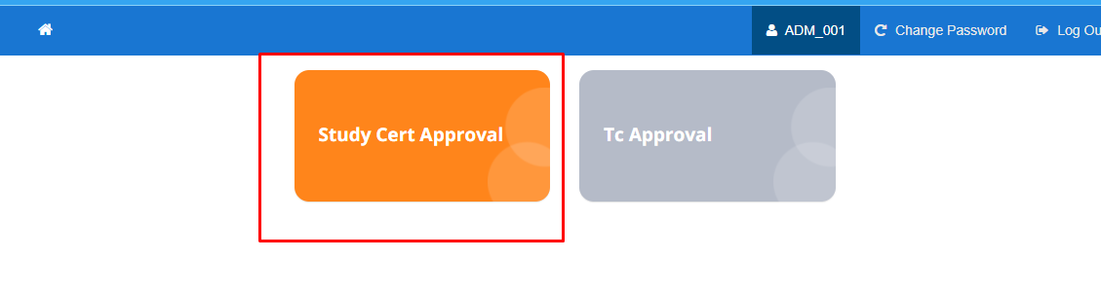

**Navigation steps to Study Cert Approval:**

STEP 1: Click on Study Cert Approval Module.

STEP 2: User can view the student list for approvals containing the Scheme, Approval Pending, Approved, Rejected and Total.

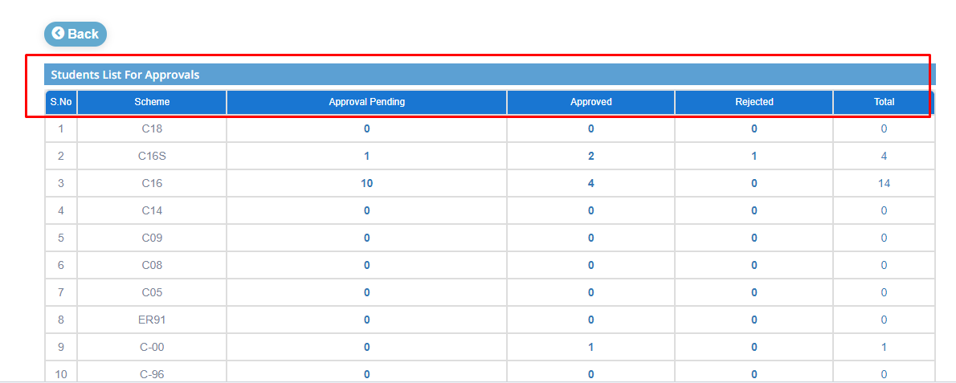

STEP 3: Admin can approve the certificate from the list of Approval pending column.

**Before Approval List**

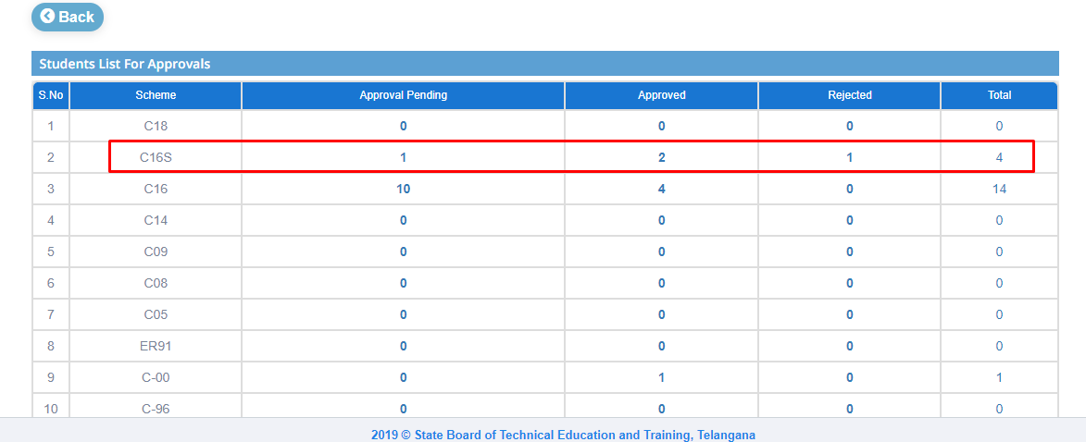

STEP 4: Click on Approval pending numbers. So, user can view the student certificate study list contains the Scheme, College Code, Pin, Name, Phone Number, Applied Date, Bonafide Preview and Status.

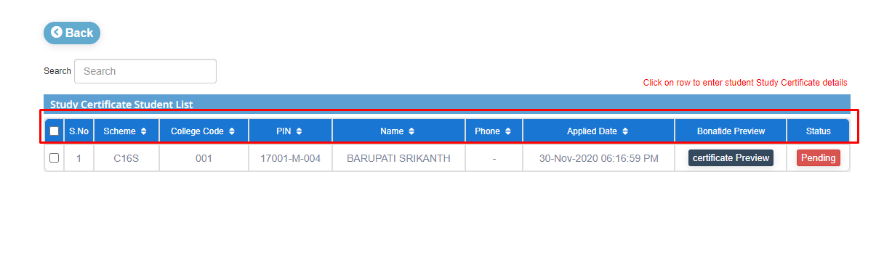

STEP 5: By clicking on Certificate preview, user can preview the Certificate of student.

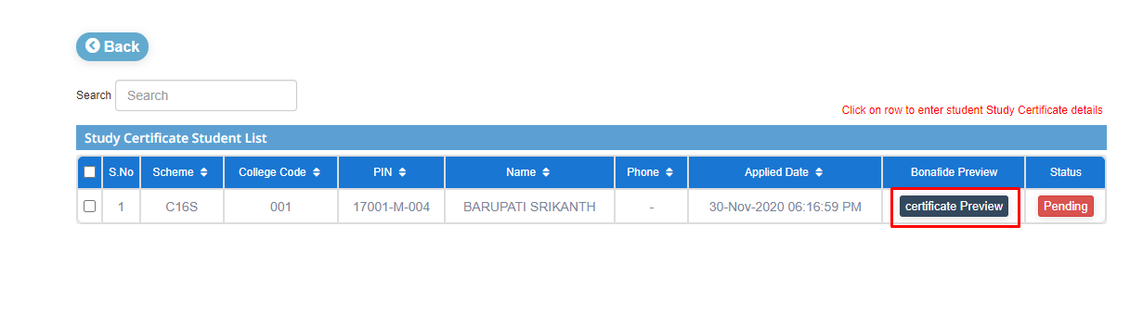

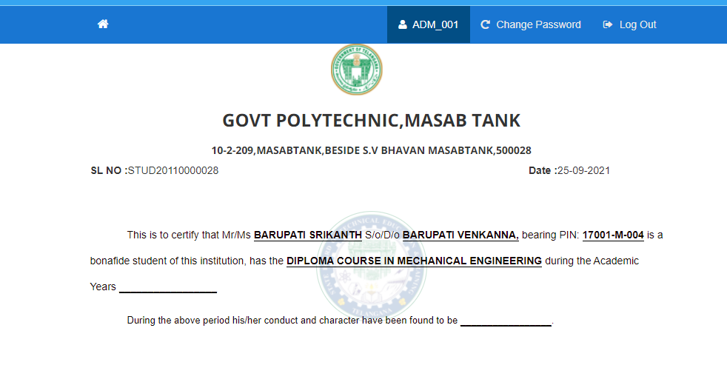

STEP 6: Click on particular row that user want to approve the certificate. User can view the study certificate status popup. Select the certificate (Study/Bonafide), From and To Academic Years. And then click on verify and submit. User will get a popup that student got verified.

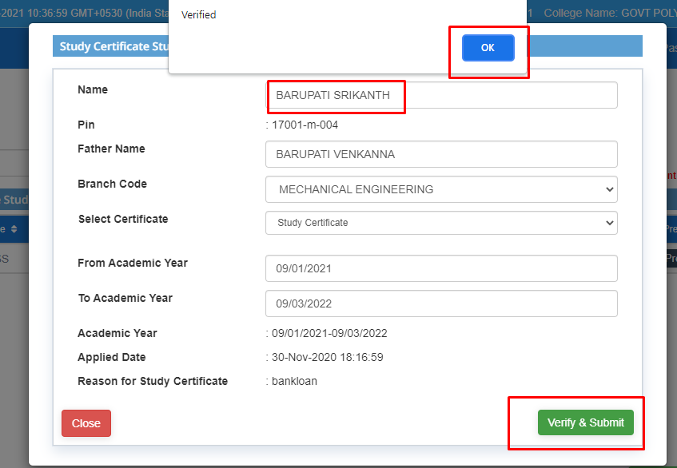

STEP 7: Click on Ok. Status column will be changed from pending to verified.

STEP 8: Select the checkbox beside the S.No column, then click on Recommended to Study/Bonafide Certificate.

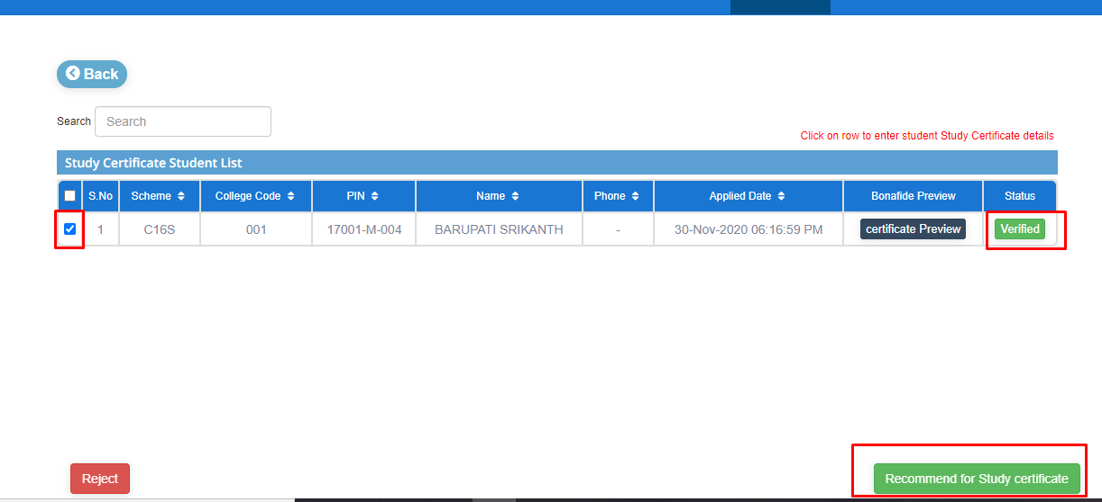

STEP 9: User will get a popup that “Forwarded to Next Level”. Click on Ok. Student data will be moved from Approval pending list to Approval list.

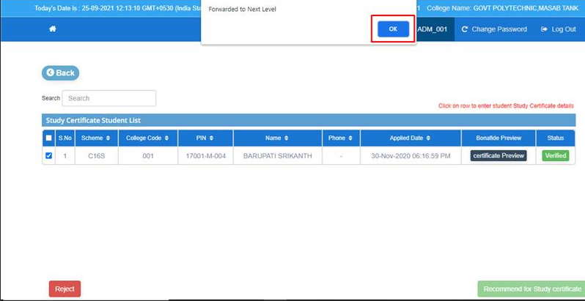

**After Approval List**

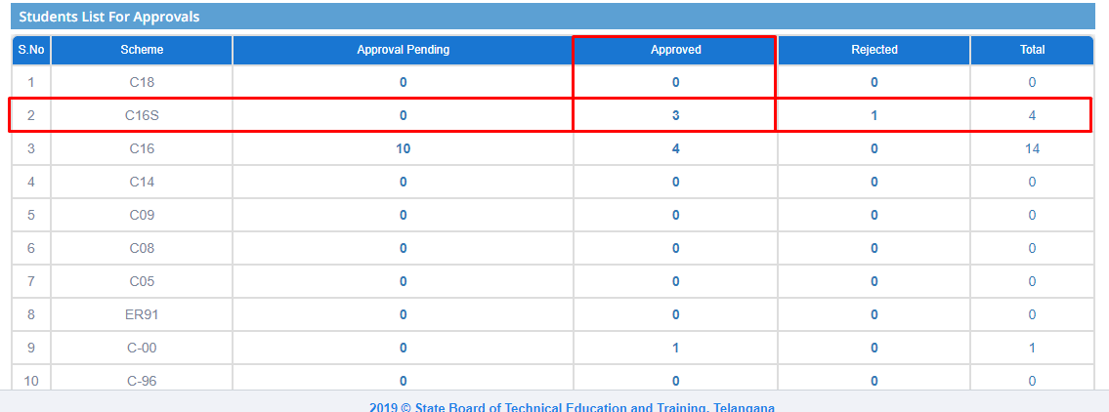

STEP 10: Admin can Reject the Study/Bonafide certificate of student. User should select the checkbox beside the S.No column and then click on Reject.

**Before Rejecting list**

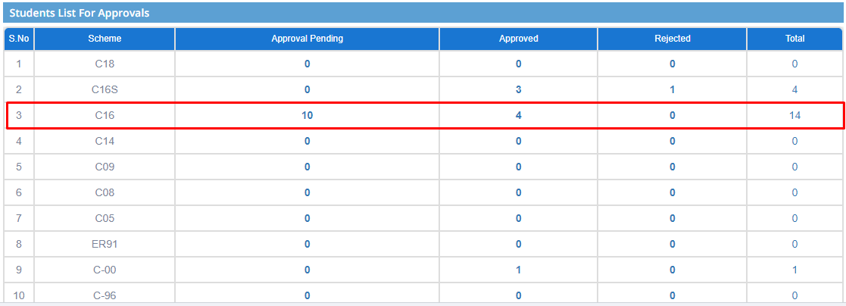

STEP 11: User can able to view the popup that “Are you Sure You want to reject". Give the remarks into the remarks field then click on Yes.

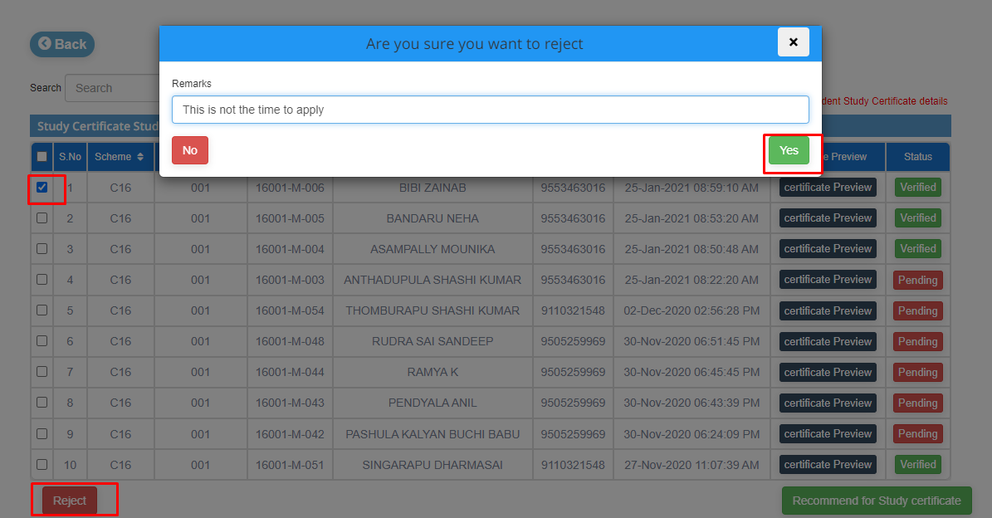

STEP 12: Student certificate can be rejected by admin.This particular user will be moved from Approval pending list to Rejected List.

**After Rejecting List**

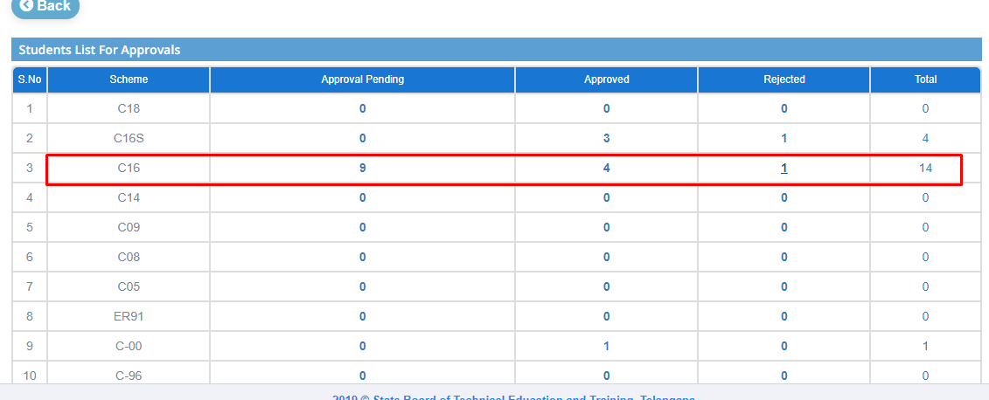

.

**Note: Student Cert Approval got from Admin. Need further Approvals of HOD and Principal.**

**II)HOD Login:**

STEP 1: Login to HOD.

STEP 2: HOD Home page contains list of modules. They are Admission, Post Exam, Assessment, Academic, Pre-Examination and Results.

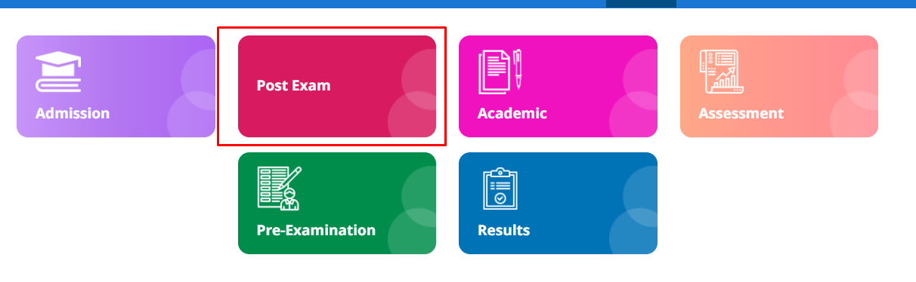

STEP 3: Click on Post Exam. User can view the Results Reports, Study Cert Approval and TC Approval.

STEP 4: Click on Study Cert Approval.

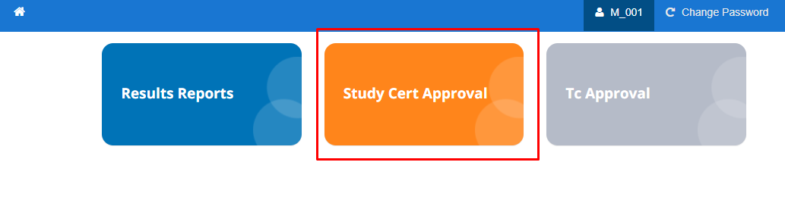

STEP 4: User can view the Students List For Approval contains Scheme, Approval Pending, Approved, Rejected and Total. Here Approval pending data will be comes under the students who were approved from admin side.

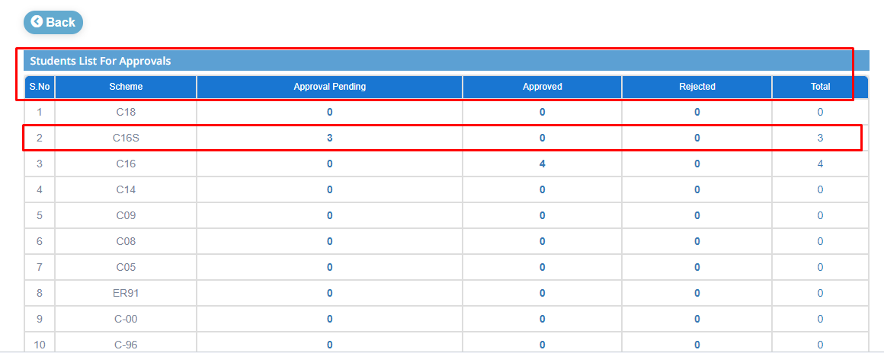

STEP 5: STEP 3: Admin can approve the certificate from the list of Approval pending column.

**Before Approval List**



STEP 4: Click on Approval pending numbers. So, user can view the student certificate study list contains the Scheme, College Code, Pin, Name, Phone Number, Applied Date, Bonafide Preview and Status.



STEP 5: By clicking on Certificate preview, user can preview the Certificate of student.





STEP 6: Click on particular row that user want to approve the certificate. User can view the study certificate status popup. Select the certificate (Study/Bonafide), From and To Academic Years. And then click on verify and submit. User will get a popup that student got verified.



STEP 7: Click on Ok. Status column will be changed from pending to verified.

STEP 8: Select the checkbox beside the S.No column, then click on Recommended to Study/Bonafide Certificate.



STEP 9: User will get a popup that “Forwarded to Next Level”. Click on Ok. Student data will be moved from Approval pending list to Approval list.



**After Approval List**



STEP 10: Admin can Reject the Study/Bonafide certificate of student. User should select the checkbox beside the S.No column and then click on Reject.

**Before Rejecting list**



STEP 11: User can able to view the popup that “Are you Sure You want to reject". Give the remarks into the remarks field then click on Yes.



STEP 12: Student certificate can be rejected by admin.This particular user will be moved from Approval pending list to Rejected List.

**After Rejecting List**



**3)Principal Login**

STEP 1: Login to Principal.

STEP 2: Principal Home page contains Results Reports, Study Cert Approval and TC Approval.

STEP 3: Click on Study Cert Approval.

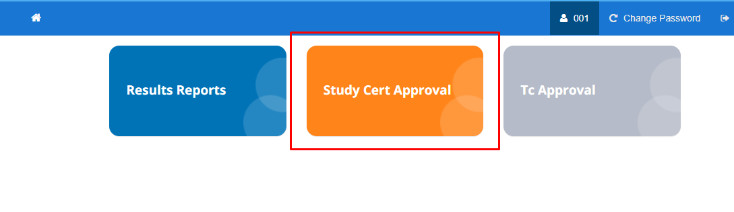

STEP 4: User can view the Student List For Approval that contains Scheme, Approval pending, Approved, Rejected and Total. Here Approval pending data will be comes under the students who were approved from HOD side

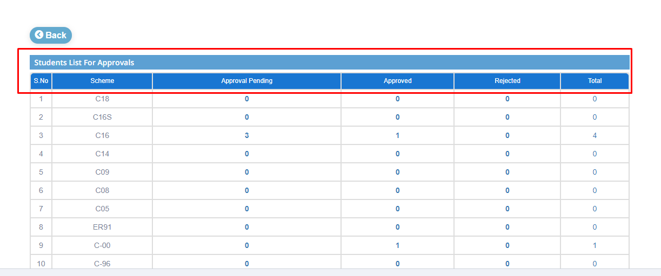

STEP 5: STEP 3: Admin can approve the certificate from the list of Approval pending column.

**Before Approval List**



STEP 4: Click on Approval pending numbers. So, user can view the student certificate study list contains the Scheme, College Code, Pin, Name, Phone Number, Applied Date, Bonafide Preview and Status.



STEP 5: By clicking on Certificate preview, user can preview the Certificate of student.





STEP 6: Click on particular row that user want to approve the certificate. User can view the study certificate status popup. Select the certificate (Study/Bonafide), From and To Academic Years. And then click on verify and submit. User will get a popup that student got verified.



STEP 7: Click on Ok. Status column will be changed from pending to verified.

STEP 8: Select the checkbox beside the S.No column, then click on Recommended to Study/Bonafide Certificate.



STEP 9: User will get a popup that “Forwarded to Next Level”. Click on Ok. Student data will be moved from Approval pending list to Approval list.



**After Approval List**



STEP 10: Admin can Reject the Study/Bonafide certificate of student. User should select the checkbox beside the S.No column and then click on Reject.

**Before Rejecting list**



STEP 11: User can able to view the popup that “Are you Sure You want to reject". Give the remarks into the remarks field then click on Yes.



STEP 12: Student certificate can be rejected by admin.This particular user will be moved from Approval pending list to Rejected List.

**After Rejecting List**



STEP 13: Click on Send SMS to send message to student that certificate got approved.

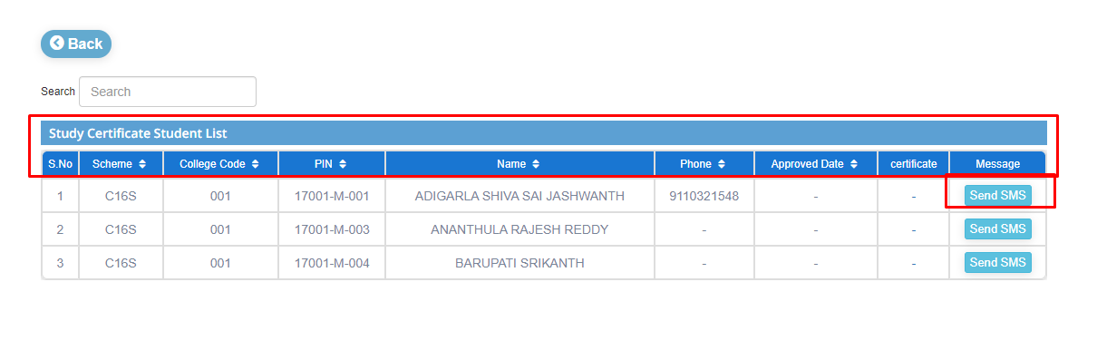

**Note: Process is same for applying Bonafide certificate, study cert Approval certificate.**

**2)Process Of Approval for TC**

**Name of the Module: TC Approval**

**Module Description:**

TC Approval Module is used for approving the TC, the students who are applied and also It displays the students list approval.

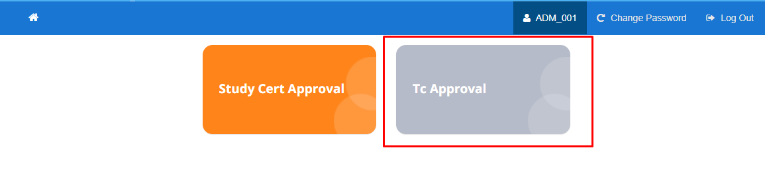

**Navigation steps to TC Approval:**

STEP 1: Click on Tc Approval. User can view the student list for approvals that contains Scheme, Approval Pending, Approved, Rejected and Total.

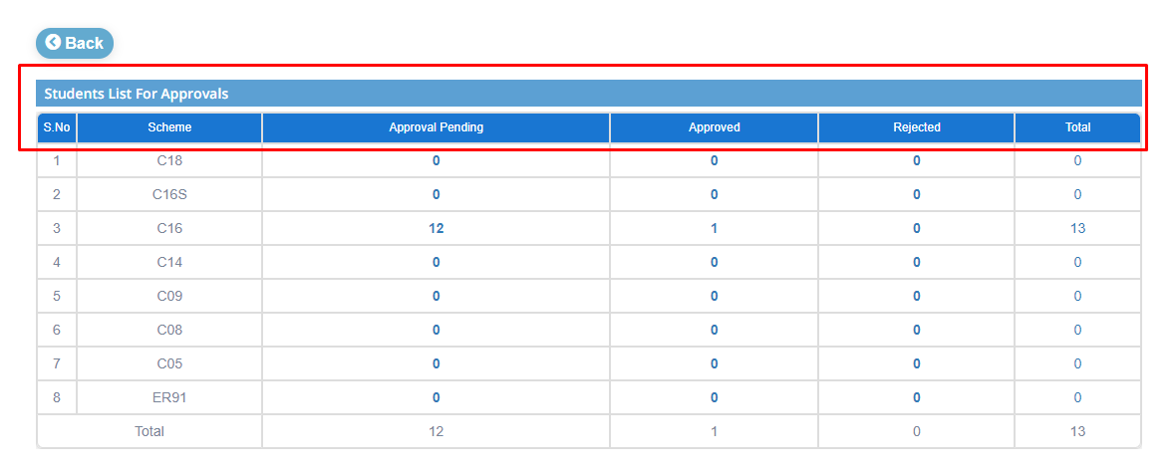

STEP 2: Admin can approve the certificate from the list of Approval pending column.

**Before Approval List**

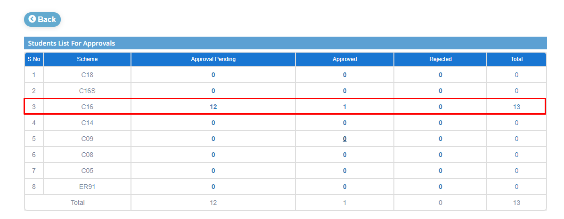

STEP 3: Click on Approval pending numbers. So, user can view the student certificate study list contains the Scheme, College Code, Pin, Name, Phone Number, Applied Date, TC Preview and Status.

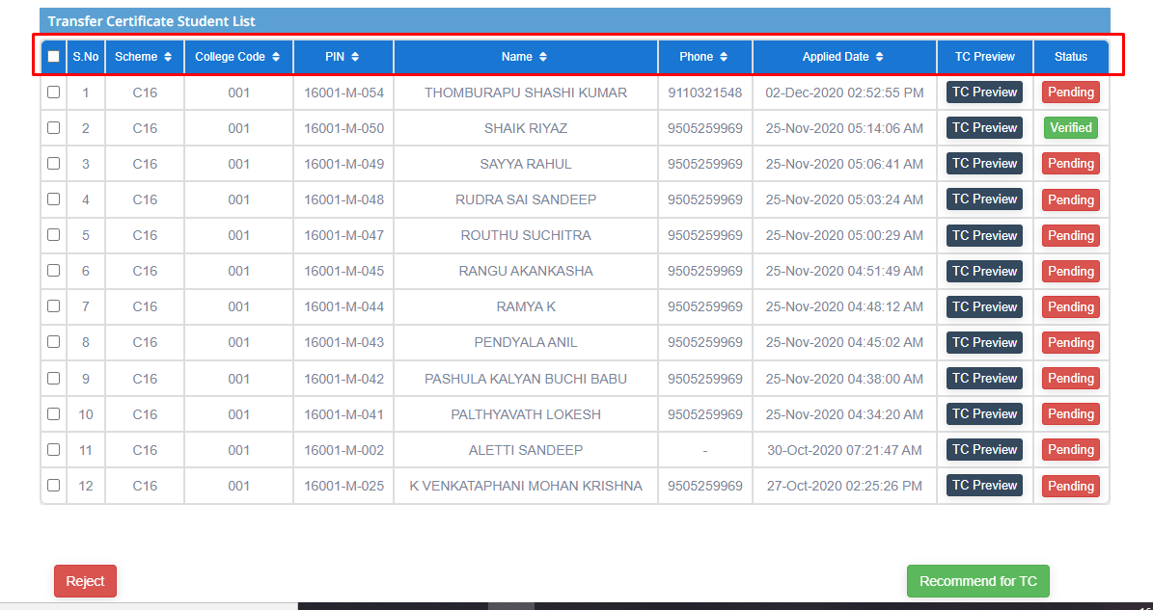

STEP 4: By clicking on TC preview, user can preview the Certificate of student.

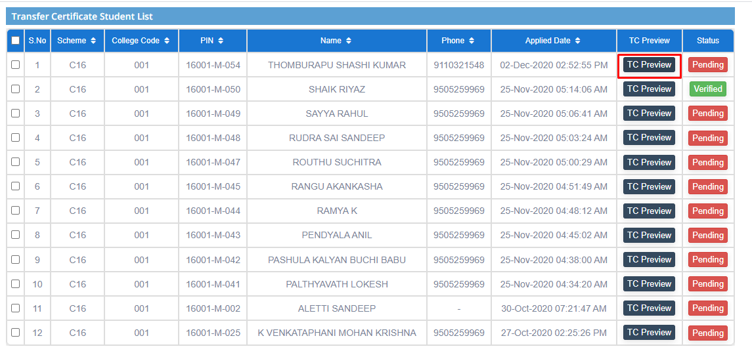

STEP 5: Click on particular row that user want to approve the certificate. User can view the TC status popup. Fill the required fields. And then click on verify and submit. User will get a popup that student got verified.

STEP 6: Click on Ok. Status column will be changed from pending to verified.

STEP 7: Select the checkbox beside the S.No column, then click on Recommended to TC

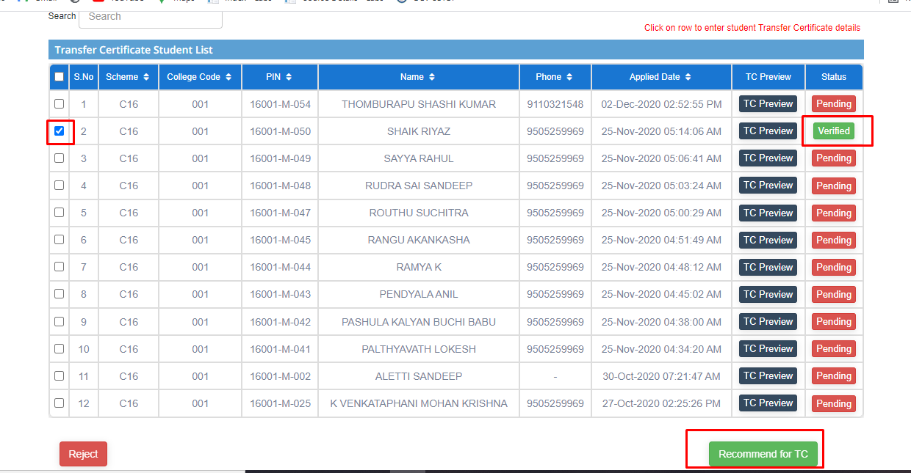

STEP 8: User will get a popup that “Forwarded to Next Level”. Click on Ok. Student data will be moved from Approval pending list to Approval list.

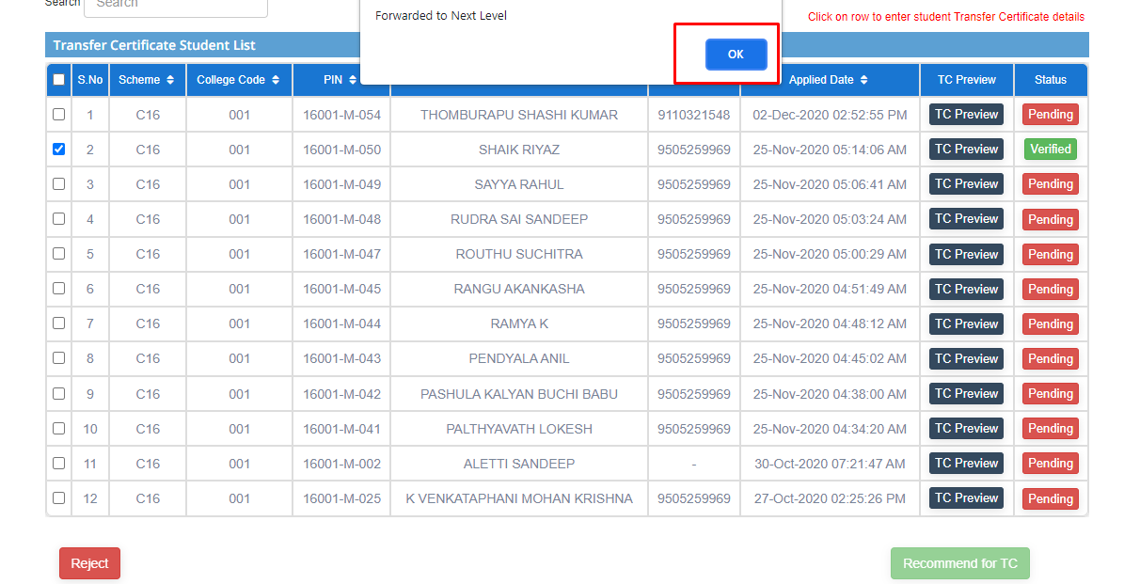

**After Approval List**

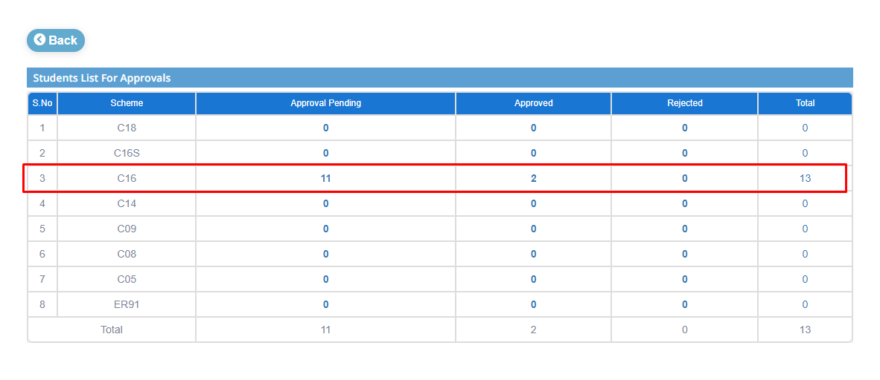

STEP 10: Admin can Reject the TC of student. User should select the checkbox beside the S.No column and then click on Reject.

STEP 11: User can able to view the popup that “Are you Sure You want to reject". Give the remarks into the remarks field then click on Yes.

STEP 12: Student certificate can be rejected by admin.This particular user will be moved from Approval pending list to Rejected List.

STEP 13: After completion of Approval by Admin. Admin can send SMS to student to that your certificate got approved from admin side by clicking on approved count list. Admin can view the data of Study certificate list contains Scheme, College Code, Pin, Name, Phone Number, Approved date, Certificate and SMS.

**Note: Student Cert Approval got from Admin. Need further Approvals of HOD and Principal.**

**2)HOD Login:**

STEP 1: Login to HOD.

STEP 2: HOD Home page contains list of modules. They are Admission, Post Exam, Assessment, Academic, Pre-Examination and Results.



STEP 3: Click on Post Exam module. User can view the Results Reports, Study Cert Approval and TC Approval.

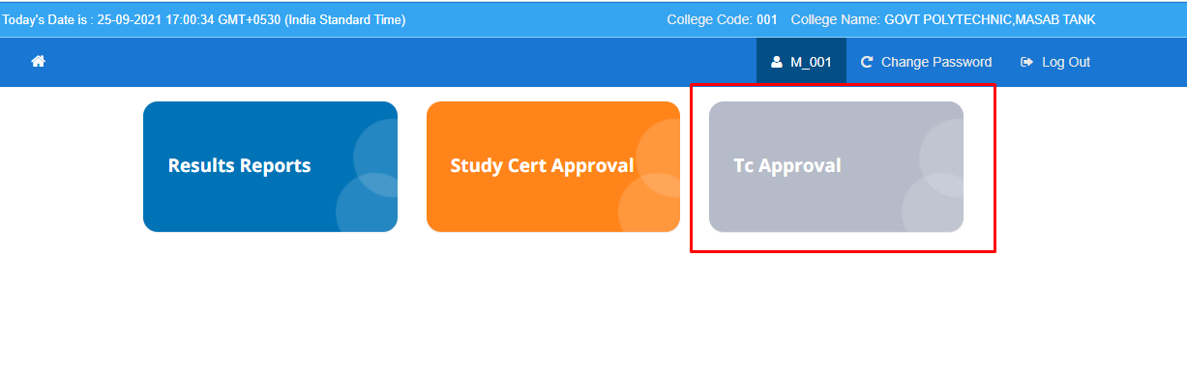

STEP 4: Click on TC Approval. User can view the student's approval list that contains Scheme, Approval Pending, Approved, Rejected and Total.Here Approval pending list contains the students who were approved from admin

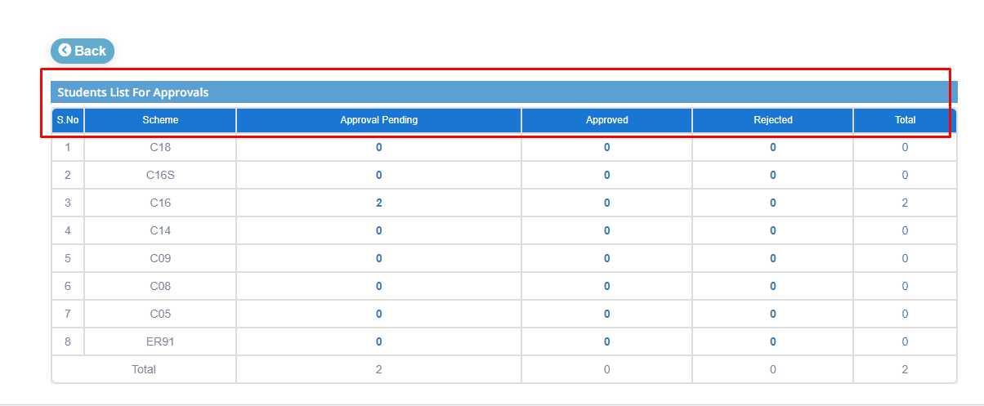

STEP 5: By clicking on TC preview, user can preview the Certificate of student.



STEP 6: Click on particular row that user want to approve the certificate. User can view the TC status popup. Fill the required fields. And then click on verify and submit. User will get a popup that student got verified.

STEP 7: Click on Ok. Status column will be changed from pending to verified.

STEP 8: Select the checkbox beside the S.No column, then click on Recommended to TC



STEP 9: User will get a popup that “Forwarded to Next Level”. Click on Ok. Student data will be moved from Approval pending list to Approval list.



**After Approval List**



STEP 10: User can reject the TC of student. User should select the checkbox beside the S.No column and then click on Reject.

STEP 11: User can able to view the popup that “Are you Sure You want to reject". Give the remarks into the remarks field then click on Yes.

STEP 12: Student certificate can be rejected by admin.This particular user will be moved from Approval pending list to Rejected List.

**3)Principal Login**

STEP 1: Login to Principal.

STEP 2: Principal Home page contains Results Reports, Study Cert Approval and TC Approval.

STEP 3: Click on Study Cert Approval.



STEP 4: User can view the Student List for Approval that contains Scheme, Approval pending, Approved, Rejected and Total.Here Approval Pending list contains the students who were approved from HOD.

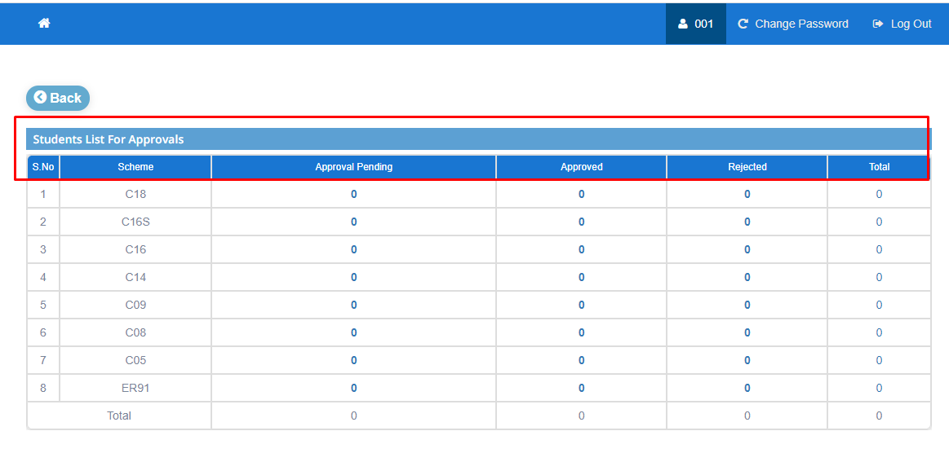

STEP 5: By clicking on TC preview, user can preview the Certificate of student.



STEP 6: Click on particular row that user want to approve the certificate. User can view the TC status popup. Fill the required fields. And then click on verify and submit. User will get a popup that student got verified.

STEP 7: Click on Ok. Status column will be changed from pending to verified.

STEP 8: Select the checkbox beside the S.No column, then click on Recommended to TC



STEP 9: User will get a popup that “Forwarded to Next Level”. Click on Ok. Student data will be moved from Approval pending list to Approval list.



**After Approval List**



STEP 10: Admin can Reject the TC of student. User should select the checkbox beside the S.No column and then click on Reject.

STEP 11: User can able to view the popup that “Are you Sure You want to reject". Give the remarks into the remarks field then click on Yes.

STEP 12: Student certificate can be rejected by admin.This particular user will be moved from Approval pending list to Rejected List.

STEP 13: After completion of Approval. User can send SMS to student to that your certificate got approved.