AI-Based Drug Safety and Adverse Effect
Analysis System: Pharmacovigilance Analytics
and Evidence-Grounded Question Answering

Submitted in partial fulfillment of the requirements of the degree
BTECH IN INFORMATION TECHNOLOGY
By
Akhil Mahadik — 23101B____
Diyansh Jain — 23101B____

Supervisor
Prof. Neha Kudu

Department of Information Technology
Vidyalankar Institute of Technology
Vidyalankar Educational Campus,
Wadala(E), Mumbai - 400 037
University of Mumbai
(AY 2026-27)
CERTIFICATE

This is to certify that the Mini Project entitled “AI-Based Drug Safety and Adverse Effect Analysis System: Pharmacovigilance Analytics and Evidence-Grounded Question Answering” is a bona fide work of Akhil Mahadik (23101B____) and Diyansh Jain (23101B____), submitted to the University of Mumbai in partial fulfillment of the requirements for the award of the degree of Bachelor of Technology in Information Technology.

Prof. Neha Kudu
Supervisor
Internal Examiner  Name & Sign | External Examiner  Name & Sign
Table of Contents
Section | Page
Abstract | 4
1. Introduction | 5
2. Problem Statement | 7
3. Objectives | 8
4. Tools & Technologies Used | 9
5. System Architecture | 11
6. Methodology / Workflow | 13
7. Implementation | 16
8. Sample Code / Configuration | 33
9. Results | 36
10. Advantages of the System | 43
11. Limitations of the System | 44
12. Future Scope | 45
13. Conclusion | 46
14. References | 47
Appendix A: Issues Found and Fixed During Development | 49
Appendix B: Viva Preparation – Likely Questions and Answers | 50
Appendix C: Running the Project and API Reference | 52

Abstract
The AI-Based Drug Safety and Adverse Effect Analysis System is a locally runnable pharmacovigilance workbench built on the U.S. FDA Adverse Event Reporting System (FAERS) quarterly extract for January–March 2025: 400,514 spontaneous reports with 2.0 million drug rows and 1.43 million reaction rows. Raw FAERS data cannot be analysed directly – cases appear in several versions, some are deleted, the same event is reported more than once, units are mixed and many fields are empty – and a reporting association is easily misread as risk. This mini-project builds a reproducible DuckDB/Parquet pipeline that ingests, cleans and de-duplicates the extract (7,784 probable duplicates flagged; analysis population 392,729 cases), measures data quality, and screens 241,675 drug–reaction pairs with three disproportionality methods (reporting odds ratio, proportional reporting ratio and the Bayesian information component) with sparse-cell correction, false-discovery-rate q-values and an indication-bias flag. A FastAPI back end and a React/TypeScript dashboard with nine pages expose every result together with its limitations.
The analytics are extended with natural language processing (NLP) so that the system is more than a data dashboard. A pretrained biomedical language model (SapBERT) groups the 12,678 MedDRA reaction terms into 23 body-system categories with explicit abstention and supports search by meaning; on an independent reference (NCI CTCAE v5.0, 499 held-out terms) it reaches 62.7% top-1 accuracy against 43.1% for a character n-gram baseline. A retrieval-augmented question-answering module (“Ask the data”) links drug and reaction names in a free-text question, retrieves the stored FAERS statistics and passages from FDA documentation, 135 FDA drug labels, 42 FDA Drug Safety Communications and 424 PubMed reviews (8,590 passages, BGE-small embeddings), and answers only from that evidence, keeping observed reports separate from established evidence. 99.3% of 750 templated questions retrieved exactly the stored statistics, dense retrieval found FDA’s own gold label section first for 81.2% of 886 test questions (keyword search 51.0%), and the system declines 91.6% of questions that no source can answer.
A controlled comparison on 89 held-out drugs showed that small local generative models (0.5–3 billion parameters) were less reliable than quoting the retrieved evidence for factual safety questions (boxed-warning question: 92.1% extractive against 43.8–69.7% generated), mainly because of confident yes/no errors; generation is therefore optional and passes through a verifier with citation, number, quotation, structure and entailment checks, which removed the verified polarity errors. All statistics are computed without any language model, all model output is labelled provisional, and no result in this report is a causal or incidence estimate.
Keywords: pharmacovigilance, FAERS, disproportionality analysis, data visualization, natural language processing, SapBERT, retrieval-augmented generation, DuckDB, FastAPI, React.
1. Introduction
Clinical trials are too small and too short to reveal rare or delayed adverse drug reactions, so medicines regulators rely on post-marketing surveillance. In the United States, manufacturers must, and health professionals and consumers may, report suspected adverse events to the FDA, which publishes the reports every quarter as the FAERS Quarterly Data Extract. Signal detection in such databases relies on disproportionality analysis: comparing how often a reaction is reported with a drug against how often it is reported with all other drugs. The results are hypotheses for clinical review, not proof that a drug causes a reaction.
Data Analytics and Visualization (DAV) is well suited to this problem: the raw extract is large, multi-table and messy, and its value appears only after careful cleaning, aggregation and visual exploration. This mini-project builds a complete, locally runnable application on one FAERS quarter, with emphasis on correct case handling, transparent statistics, honest interpretation, and an NLP layer that lets a non-specialist ask questions in plain language and see the evidence behind every answer.
Dataset overview
The primary source is the file faers_ascii_2025q1.zip (67.5 MB, SHA-256 51c1dc44…6b69) from the FDA FAERS Quarterly Data Extract page. It contains seven $-delimited tables and a list of deleted cases. All tables were loaded with DuckDB with every column read as text, so no value was coerced or lost; 0 lines were rejected.
Table | Content | Rows
DEMO | One row per case version: dates, age, sex, weight, reporter, country | 400,514
DRUG | Drugs per case with role (primary suspect, secondary suspect, concomitant, interacting), names, route, dose | 2,008,162
REAC | Reactions per case as MedDRA Preferred Terms (PTs) | 1,432,926
OUTC | Outcome codes (death, hospitalisation, life-threatening, …) | 304,027
INDI | Indications (reasons for use) per drug | 1,205,861
THER | Therapy start and end dates | 520,395
RPSR | Report sources | 11,033
DELETE | Case IDs deleted by the FDA | 5,732

Additional resources are used by the NLP components: the FDA’s own FAERS documentation shipped inside the zip (README, FAQ with 52 questions, and the ASCII data description), the NCI Common Terminology Criteria for Adverse Events v5.0 (837 terms) as an independent evaluation reference, and an external evidence corpus collected once for the 150 most-reported suspect drugs: FDA structured product labels from openFDA (selected through NLM DailyMed), FDA Drug Safety Communications from fda.gov, and PubMed reviews and meta-analyses published since 2015.
Scope
The project covers one quarter (2025 Q1) of FAERS data: ingestion, cleaning and de-duplication, data-quality assessment, descriptive analysis, disproportionality screening with subgroup views, reaction categorisation and semantic search, evidence-grounded question answering, an interactive dashboard, a JSON API and automated tests. Drug-level analysis uses suspect drugs (primary or secondary suspect). Because FAERS has no exposure denominator, incidence and risk estimation are out of scope, as are time trends across quarters and clinical causality assessment. Model outputs are presented as provisional and are not clinical advice.
2. Problem Statement
Raw FAERS data cannot be analysed directly. A case can appear in several versions, the FDA deletes some cases, the same patient event can be reported independently by a manufacturer and a physician, ages are recorded in years, months, weeks, days or decades, weights in kilograms, pounds or grams, and many fields are empty (age is missing for 39.2% of cases and weight for 82.8%). Counting rows directly therefore counts some events several times and mixes units.
Disproportionality statistics are easy to compute but easy to misread. A high reporting odds ratio means that a drug and a reaction were reported together more often than expected; it does not show that the drug causes the reaction, and it is not an incidence or a risk. Reports are also distorted by known biases: a reaction may be the very condition the drug treats (confounding by indication), and many frequent terms such as “Off label use” or “Drug ineffective” are not clinical reactions at all.
Finally, reaction terms are fine-grained MedDRA Preferred Terms – 12,678 distinct terms in one quarter – so a reviewer interested in a clinical concept such as “liver injury” has to find dozens of related terms by hand, and a non-specialist who simply asks “Does Ozempic cause pancreatitis?” cannot use the data at all: the question must be translated into an ingredient name, a MedDRA term and the right table, and the answer needs both the statistics and what the drug label and the literature actually state.
The problem is to build an analysis application that is correct by construction, lets users explore the data and ask questions without knowing these conventions, and communicates what spontaneous-report data can and cannot show about drug safety.
3. Objectives
The project aims to make every number traceable to its source and every model output recognisable as provisional. A dashboard that only produces plausible-looking charts is insufficient if its statistics cannot be reproduced or if a language model can silently change them.
- Build a reproducible ingestion, cleaning, de-duplication and data-quality pipeline for FAERS 2025 Q1, with missing values disclosed rather than imputed.
- Implement disproportionality statistics (ROR, PRR, IC) with confidence intervals, sparse-cell handling, multiplicity-adjusted q-values, an indication-bias flag and subgroup analysis, and present them with an explicit distinction from causality and risk.
- Add a genuine NLP component with a locally runnable pretrained biomedical language model for provisional reaction categorisation and semantic search, with abstention, provenance and an evaluation against independent ground truth and baselines.
- Let users ask questions in natural language and receive answers grounded in, and citing, the retrieved statistics, FDA documentation, drug labels, FDA safety communications and literature, keeping observed reports separate from established evidence.
- Compare extractive and generative answering by small local language models under identical retrieval, and verify generated text before it is shown.
- Deliver an interactive dashboard and a documented API that keep statistical outputs independent of model outputs, run on a laptop without paid APIs, and are covered by automated tests.
These objectives are evaluated at the level of the implemented system: the pipeline is checked against hand-calculable synthetic data and positive controls; the NLP components are evaluated on held-out references that were not written by the project or by a model; and the dashboard is checked by automated front-end tests and by running it on the full quarter.
4. Tools & Technologies Used
The technologies serve different roles and are not interchangeable. DuckDB and Parquet store and query the data; NumPy and SciPy compute the statistics; PyTorch and Hugging Face Transformers run the language models; FastAPI defines the interface between data and browser; React and Plotly draw the dashboard; and pytest and Vitest verify the logic. Versions are those installed on the development laptop.
Layer | Technology | Role in the project
Data storage and query | DuckDB 1.5, Apache Parquet (PyArrow 26) | Loading the $-delimited tables, SQL cleaning and de-duplication, columnar storage of processed tables, in-process queries from the API
Data processing and statistics | Python 3.13, pandas 3.0, NumPy 2.5, SciPy 1.18 | Unit conversion, vectorised 2×2 statistics for all pairs, χ² tests, Benjamini–Hochberg q-values
NLP | PyTorch 2.14 (CUDA 12.6), Transformers 5.20, scikit-learn 1.9, pypdf 6.21 | Language-model inference on GPU or CPU, TF-IDF baselines, BM25, reading FDA PDF documentation
Back end | FastAPI 0.150, Uvicorn 0.54, Pydantic 2.14 | 30 typed JSON endpoints, input validation, caching, automatic OpenAPI documentation at /docs
Front end | React 18.3, TypeScript 5.6, Vite 5.4, Tailwind CSS 3.4, Radix UI, TanStack Query 5 | Nine-page single-page application, filter state, light/dark themes, responsive layout
Visualization | Plotly.js 2.35 (front end), Matplotlib 3 (report figures) | Interactive bar, line, forest and pyramid charts with hover and zoom; analytical figures in Section 9
Testing and quality | pytest, Ruff, Vitest 2.1, Testing Library | 110 back-end tests, lint, 18 front-end tests, type check
Launcher | Windows PowerShell 5.1 (run.cmd) | One command: environment setup, data build, start API and dashboard, open browser, clean stop
Hardware | NVIDIA GeForce RTX 3050 Laptop GPU (4 GB) | Embedding and generator experiments; every component also runs on the CPU

4.1 Pretrained models
No model was trained or fine-tuned in this project. All models are used as downloaded (zero-shot); only decision settings such as thresholds and the retrieval mode were chosen on development data. Each model folder stores a provenance file with the model id, revision and weights checksum.
Model | Parameters | Licence | Used for
cambridgeltl/SapBERT-from-PubMedBERT-fulltext | 110 M | Apache-2.0 | Reaction categorisation, semantic search, reaction linking in questions
BAAI/bge-small-en-v1.5 | 33 M | MIT | Dense embeddings of 8,590 evidence passages and of questions
Qwen/Qwen2.5-0.5B-Instruct, Qwen2.5-1.5B-Instruct | 0.5 B, 1.5 B | Apache-2.0 | Optional generated answers; generator comparison
HuggingFaceTB/SmolLM2-1.7B-Instruct | 1.7 B | Apache-2.0 | Generator comparison (second model family)
Qwen/Qwen2.5-3B-Instruct (4-bit) | 3.1 B | Qwen Research (non-commercial) | Larger-model comparison only
cross-encoder/nli-deberta-v3-small | ~140 M | Apache-2.0 | Entailment check in the answer verifier
BAAI/bge-reranker-base | ~280 M | MIT | Re-ranking experiment (rejected, Section 9.6)

DuckDB was chosen because it queries Parquet files in-process with SQL, so no database server is needed; FastAPI because it gives typed validation and self-documenting endpoints with little code; and React with Plotly because they provide interactive, accessible charts. Keeping the statistics on the server means the browser never downloads the 90 MB of processed tables, and every page draws from the same computed results.
5. System Architecture
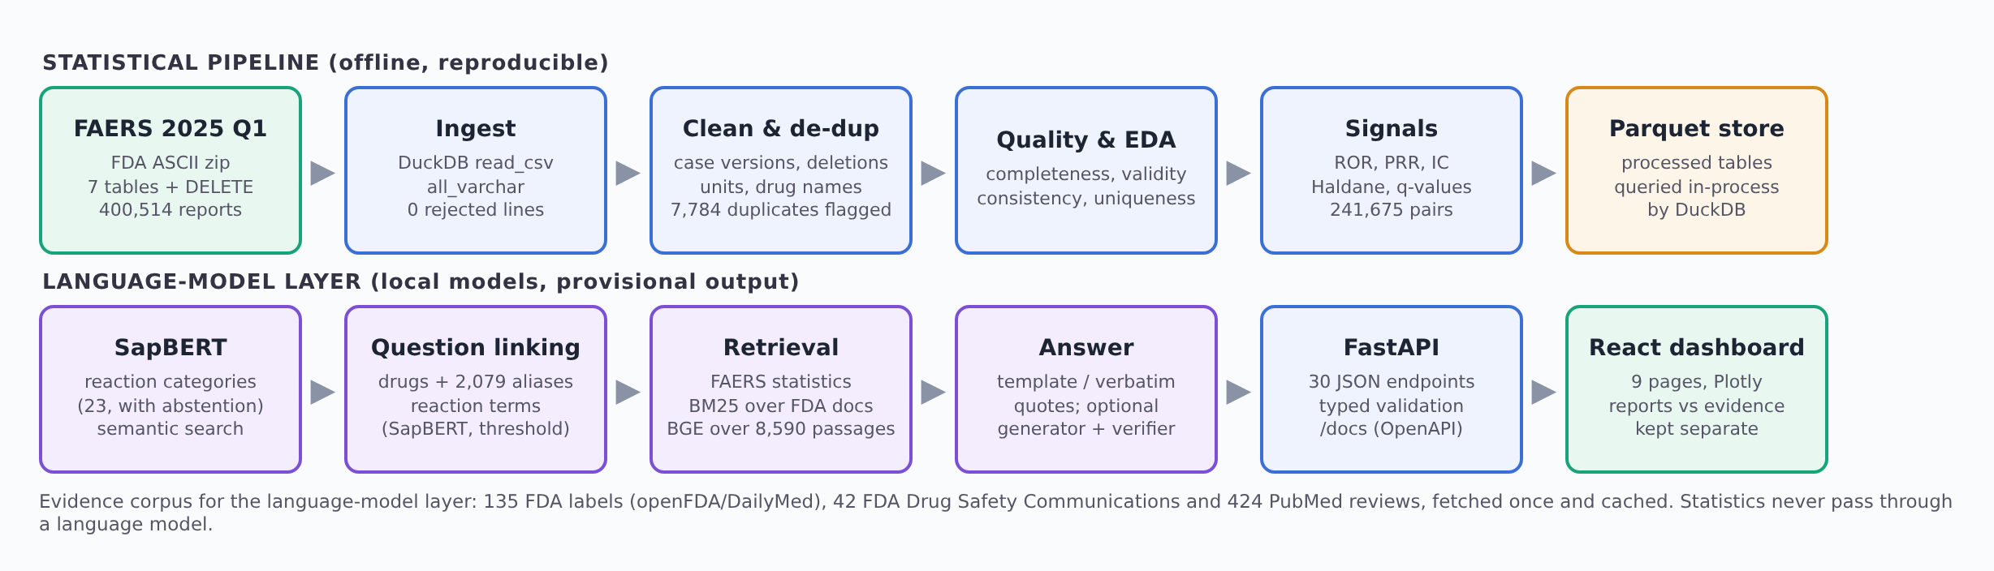
Figure 1. System data flow: the statistical pipeline (top) and the language-model layer (bottom).
The architecture has two layers that meet only in the API. The statistical pipeline turns the raw zip into processed Parquet tables and precomputed statistics; it never imports the NLP package. The language-model layer reads those results and the evidence corpus to categorise terms and answer questions; its output is joined at query time and always labelled provisional. A model error can therefore never change a reporting odds ratio.
Module | File(s) | Responsibility
Ingest | backend/pvsys/ingest.py | Download or locate the FAERS zip, verify its checksum, load the seven tables and the DELETE list with DuckDB, write raw Parquet and a manifest
Clean and de-duplicate | clean.py | Deleted cases, latest version per case, unit conversion, drug-name normalisation, reaction de-duplication, probable-duplicate flag
Quality and EDA | quality.py, eda.py | Completeness, validity, consistency and uniqueness checks; descriptive snapshot
Signals | signals.py | Case-level 2×2 tables, ROR/PRR/IC, Haldane correction, χ², q-values, indication-bias flag, subgroup analysis
NLP: categories | nlp/encoder.py, classify.py, categories.py | SapBERT embeddings, prototype classifier with abstention, TF-IDF baseline, provenance, review log
NLP: question answering | nlp/kb.py, rag.py, generator.py, checks.py | Knowledge base and BM25, question understanding, retrieval, deterministic answers, optional generator and verifier
External evidence | evidence/sources.py, chunking.py, embed.py, index.py, rerank.py | Labels, FDA communications and PubMed; section-aware chunks; BGE index; routing and re-ranking
Evaluation | evidence/evaluate.py, compare_generators.py, nlp/evaluate.py, nlp/rag_eval.py | Dev/test splits, retrieval and threshold evaluation, generator comparison, verifier ablation
API | backend/api/main.py | 30 endpoints for overview, quality, demographics, drugs, signals, NLP, question answering and evidence
Front end | frontend/src/pages/*.tsx | Nine dashboard pages, charts and tables
Launcher and scripts | run.cmd, scripts/*.ps1 | Setup and start; evidence build; generator comparison; overnight improvement run

5.1 Request flow
When a user opens a page, the browser requests the relevant endpoint (for example /api/signals with the drug, reaction, method and minimum-case filters). The API runs a parameterised DuckDB query over the Parquet files, caches the result, and returns JSON that the page draws with Plotly. For a question on the “Ask the data” page, the browser sends one POST /api/rag/ask request; the server links the drug and reaction, retrieves the stored statistics and the documentation and evidence passages, composes the answer with citations, and returns the answer, the evidence, how the question was read and the provenance in a single response.
6. Methodology / Workflow
6.1 Cleaning and de-duplication
- Remove every case listed in the quarter’s DELETE file (1 report removed in 2025 Q1).
- Keep one version per case: the row with the latest FDA receipt date, ties broken by the highest PRIMARYID, as the FDA README recommends. In this quarter every case already appeared once, so 0 older versions were removed; the rule is still enforced and unit-tested.
- Convert ages to years from their unit code (YR, MON, WK, DY, HR, DEC) and weights to kilograms (KG, LBS, GMS); implausible values (age outside 0–120 years, 7 cases; weight outside 0.2–400 kg, 44 cases) are set to missing, never imputed.
- Normalise drug names to the active ingredient (prod_ai, available for 98.4% of drug rows), otherwise to the upper-cased verbatim name with dose strings removed.
- Collapse repeated reaction terms within the same report (18,571 rows) and derive outcome flags (serious, death, hospitalisation, life-threatening).
- Flag probable duplicates: reports with different case IDs but identical sex, age, event date, occurrence country, set of suspect drugs and set of reaction terms. The most recent report is kept and the others are flagged (7,784 cases). Flagged reports stay in descriptive counts and are excluded from disproportionality.
The result is 400,513 de-duplicated cases and an analysis population of 392,729 cases for signal detection.
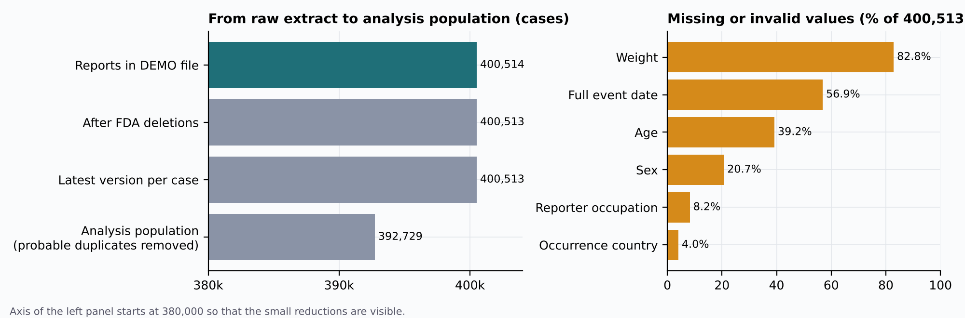
Figure 2. Case flow from the raw extract to the analysis population (left) and missing or invalid values per field (right).
6.2 Disproportionality analysis
For each suspect drug D and reaction term R a case-level 2×2 table is built over the analysis population: a = cases with D and R, b = D without R, c = R without D, d = neither. Pairs with a ≥ 3 are tested (241,675 of 648,090 observed pairs).
Measure | Definition | Signal rule
Reporting odds ratio (ROR) | (a/b)/(c/d); 95% CI = exp(ln ROR ± 1.96·√(1/a + 1/b + 1/c + 1/d)) | Lower 95% CI > 1 and a ≥ 3
Proportional reporting ratio (PRR) | [a/(a+b)] / [c/(c+d)], with χ² (Yates correction) | PRR ≥ 2, χ² ≥ 4 and a ≥ 3 (Evans criteria)
Information component (IC) | log₂((a+0.5)/(E+0.5)), E = (a+b)(a+c)/N; IC025 ≈ IC − 3.3(a+0.5)^{−½} − 2(a+0.5)^{−3/2} | IC025 > 0 and a ≥ 3
Sparse cells | If any cell is 0, 0.5 is added to all four cells (Haldane–Anscombe) and the row is flagged | 4,201 rows corrected
Multiplicity | Benjamini–Hochberg q-values over all tested pairs | Reported, not used as a flag
Indication bias | Share of the a cases in which the reaction is also listed as the indication | ≥ 20% flags possible indication bias
Subgroups | 2×2 table recomputed within sex, age group or reporter type | Strata with a < 3 not interpreted

6.3 Reaction categorisation with a biomedical language model
Each of the 12,678 reaction terms is embedded with SapBERT (the [CLS] vector, L2-normalised). The project defined 23 body-system categories (for example cardiovascular, hepatobiliary, skin, and product use/errors/efficacy), each with a description and 6–14 anchor phrases (251 in total) written before the evaluation reference was inspected. A category’s anchors are averaged into a prototype; a term is assigned to the most similar prototype unless the top similarity is too low or the margin over the runner-up is too small, in which case the model abstains. The categories are deliberately not MedDRA System Organ Classes, which require a licence. The same embeddings provide search by meaning over the reaction vocabulary.
6.4 Evidence-grounded question answering (RAG)
- Understanding. Drug names are matched longest-first against 5,015 normalised suspect drugs and 2,079 brand or verbatim aliases learnt from FAERS itself (e.g. OZEMPIC → SEMAGLUTIDE); reaction phrases are matched to MedDRA terms exactly, otherwise linked with SapBERT and accepted only at cosine similarity ≥ 0.70.
- Retrieval of observed reports. The stored ROR/PRR/IC row for the linked pair and up to five closely related terms, or the drug’s or reaction’s strongest signals; documentation passages from the FDA README, FAQ and data description and NCI CTCAE definitions are ranked with BM25 (942 passages).
- Retrieval of established evidence. Passages from the drug’s FDA label, FDA communications and PubMed reviews are retrieved by dense similarity (BGE-small), with a bonus for the label section the question asks about (“who should not take” → Contraindications). A deterministic check reports whether the label text mentions the linked reaction and in which sections.
- Sufficiency. If the best similarity is below 0.73 (calibrated on development drugs), the system declines to make an established-evidence statement.
- Answer. Sentences are filled from retrieved values or quoted verbatim, and every sentence cites its evidence (S = statistics, D = documents; L, P and R = label, PubMed and FDA-communication passages). An optional local generator can write the clinical-evidence part; its draft is shown only if it passes the verifier (Section 8.5).
6.5 Evaluation protocol
No evaluation label was written by the authors or by a model. Categorisation is evaluated against NCI CTCAE v5.0 (712 terms after removing “Other, specify” entries and terms identical to an anchor; 30% development, 70% test). Question answering is evaluated on FDA’s own FAQ answers, NCI definitions linked to FAERS terms, and 750 templated questions over random real signal pairs. External-evidence retrieval uses FDA’s structured-product-labeling section coding as ground truth: the 127 drugs with an indexed label are split, with a fixed seed, into 38 development and 89 test drugs; every setting is chosen on development drugs and every reported number comes from the test drugs.
6.6 Definitions
Metric | Definition
Case | One de-duplicated FAERS report (latest version of a CASEID)
Serious | A case with any outcome code (death, life-threatening, hospitalisation, disability, congenital anomaly, required intervention, other serious)
Analysis population | De-duplicated cases that are not probable duplicates and have a suspect drug and a reaction (392,729)
Signal (flagged pair) | A drug–reaction pair meeting the rule of a method (Section 6.2); “all three” = flagged by ROR, PRR and IC
Top-1 accuracy / recall@k | Share of items whose correct answer is ranked first / within the first k
MRR | Mean reciprocal rank of the first correct item
Abstention / coverage | Declining to answer when evidence is weak; coverage = share of items answered
Extractive / generative answer | Quoting retrieved text verbatim / text written by a language model from retrieved passages

Interpretation rule: FAERS is a spontaneous reporting system. Counts reflect reports, not patients or incidence, and disproportionality measures indicate reporting associations that warrant review; they do not establish causality or absolute risk. Language-model output is provisional and is never used to compute a statistic.

7. Implementation
7.1 Back end
The back end is a Python package (pvsys) whose stages can be re-run from one command line (python -m pvsys.pipeline all). Ingestion records the source checksum, row counts and ingest time in a manifest; cleaning, quality checks, the descriptive snapshot and the signal computation write Parquet files and small JSON summaries. The API module (backend/api/main.py) opens the Parquet files as DuckDB views through a thread-safe wrapper and exposes 30 endpoints. Query parameters are typed and range-checked, sort columns are whitelisted and SQL is parameterised, so user text is never inserted into a query; errors return HTTP 404, 409, 422 or 503 with an actionable message. Aggregates are cached, and the question-answering engine warms up in a background thread when the API starts.
Two safeguards keep statistics and models apart: the statistics modules never import the NLP package (a test asserts that importing them loads neither PyTorch nor pvsys.nlp), and running the NLP stage leaves signals.parquet byte-identical (also tested). Without model weights the NLP stage falls back to a lexical method, says so in the interface, and all statistical pages keep working.
7.2 Front end
The dashboard is a React and TypeScript single-page application with nine pages grouped as Data (Overview, Data quality, Demographics), Analysis (Drug explorer, Signal detection), Language model (Ask the data, Reaction categories, Model & evaluation) and About (Methods & limits). Charts are drawn with Plotly; server data are fetched and cached with TanStack Query. Model output is always drawn with a dashed violet outline and a “Provisional” badge. The layout supports light and dark themes, keyboard navigation and phone-width screens. All screenshots in this section were captured from the running application on the full FAERS 2025 Q1 data at 1440 px width.
7.3 Overview
The overview shows four key figures (400,513 cases after de-duplication, 56.1% with a serious outcome, 32,408 with death reported, and 5,018 distinct suspect drugs / 12,678 reaction terms), the case flow from the raw extract to the analysis population, the reported outcomes and the number of reports received per day. The weekly dips in the daily chart are weekends, and spikes usually reflect batch submissions by manufacturers; the chart therefore shows receipt behaviour, not when events happened.
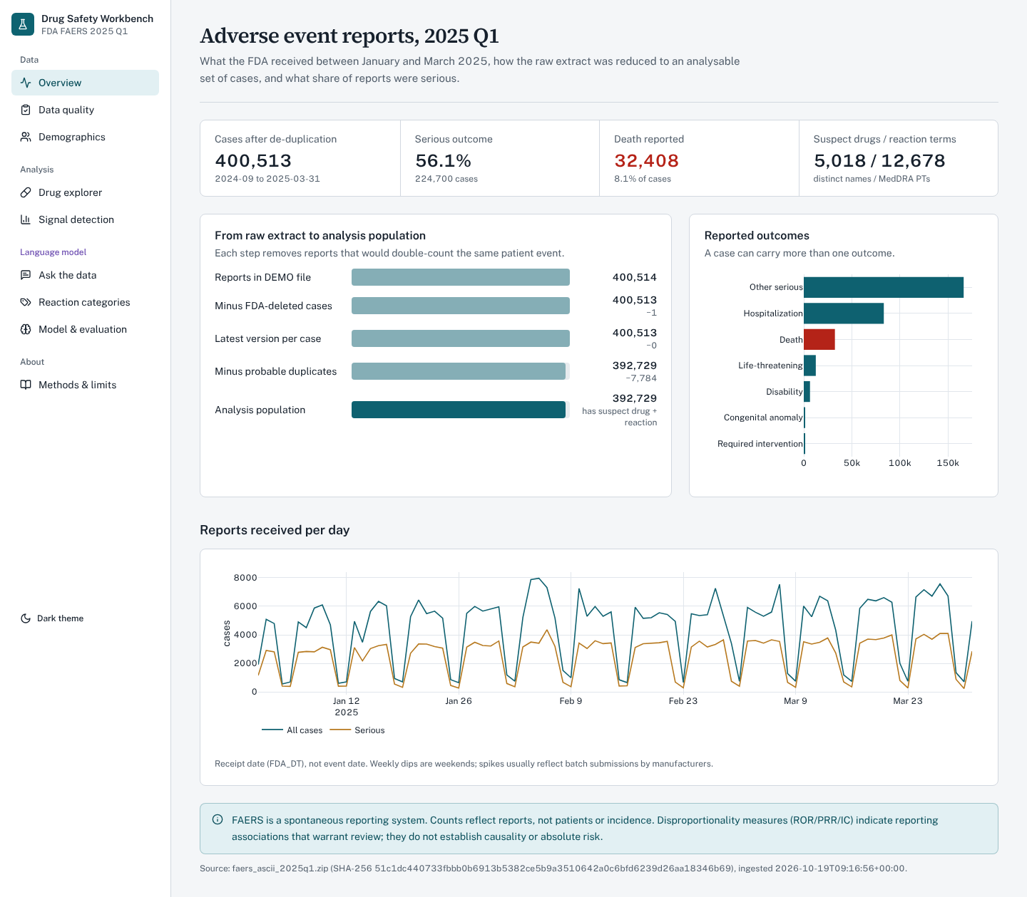
Figure 3. Overview page: key figures, case flow, reported outcomes and reports received per day.
7.4 Data quality
The data-quality page lists every check with its dimension, value and status (11 pass, 5 warnings, 6 information items). Missing values are shown per field and are never imputed; the largest gaps are weight (82.8%), the full event date (56.9%) and age (39.2%).
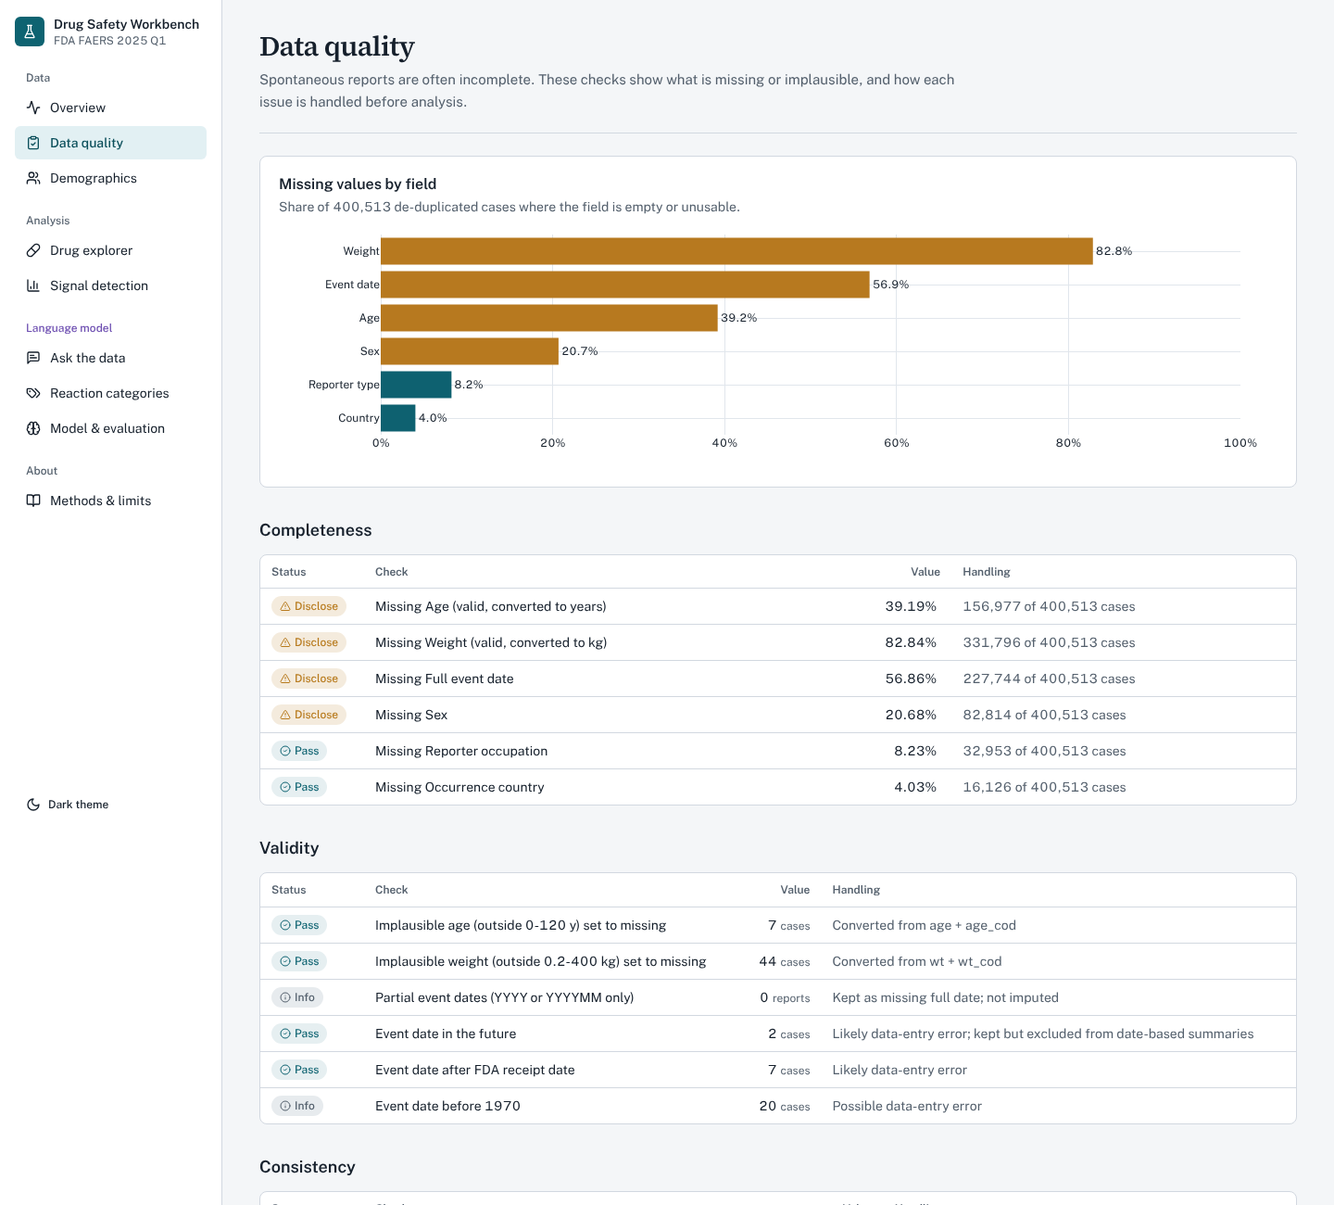
Figure 4. Data-quality page: missing values by field and the completeness and validity checks.
7.5 Demographics
The demographics page shows the age–sex pyramid, the serious share by age group, sex and seriousness with a χ² test and its effect size, reporter types and the countries where events occurred. Each chart notes that it describes reported cases, not the population.
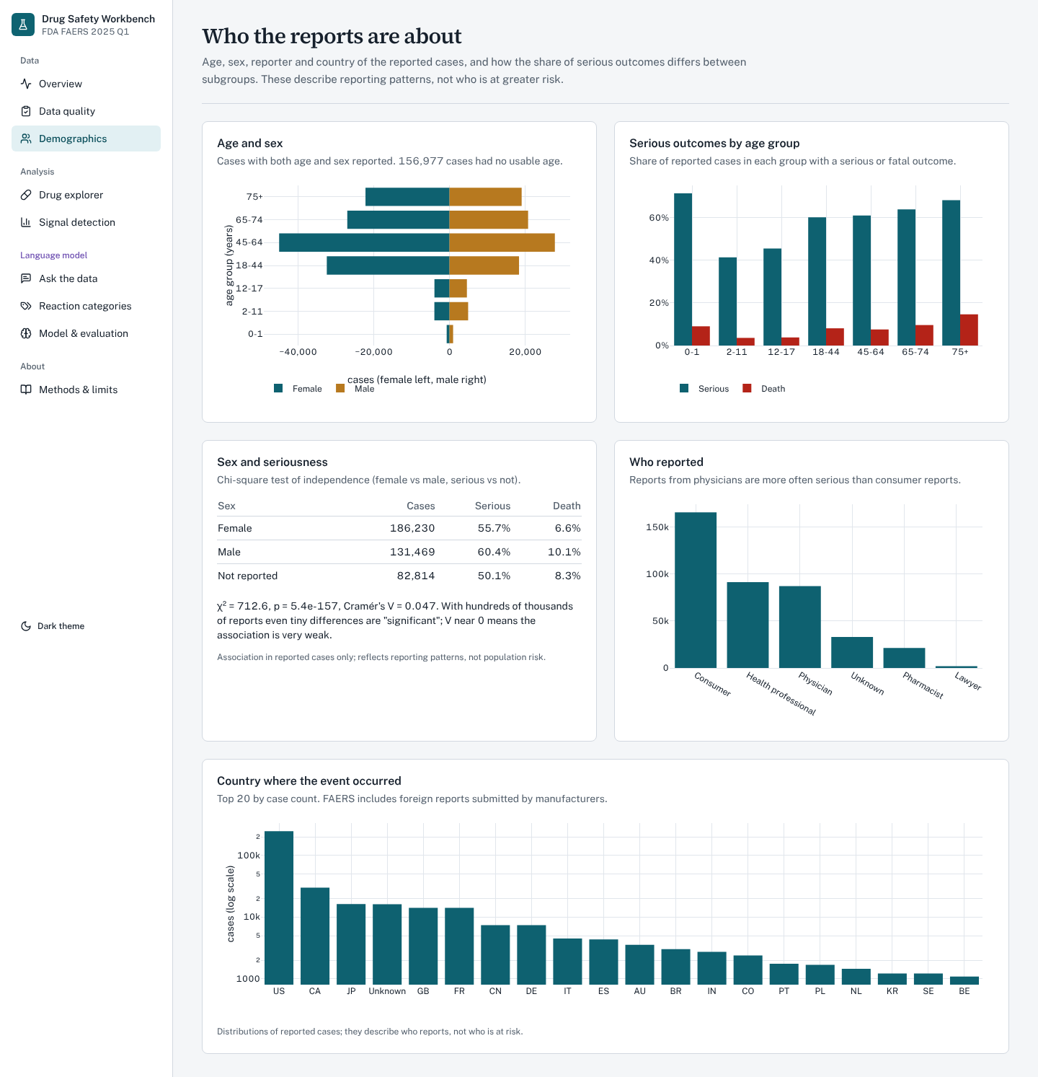
Figure 5. Demographics page: age and sex, serious outcomes by age group, reporter type and country.
7.6 Drug explorer
The drug explorer looks up a drug or active ingredient and shows its case count, serious share, deaths and median age, its most frequent reactions, its reported indications and its reaction mix by provisional category. For semaglutide it shows 3,256 suspect cases, 95.0% serious, 87 deaths and a median age of 59 years, and links to the drug’s signals.
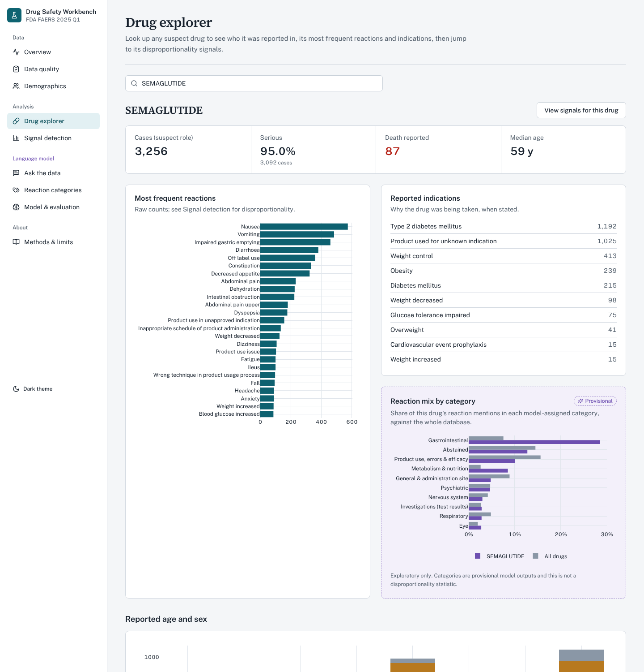
Figure 6. Drug explorer for semaglutide: key figures, most frequent reactions, indications and reaction mix.
7.7 Signal detection
The signal page filters the 241,675 tested pairs by drug, reaction text, method, minimum number of cases, provisional reaction category and sort order, hides likely indication bias by default, and draws a forest plot of reporting odds ratios with 95% confidence intervals next to a table with every measure. Selecting a row opens the 2×2 table and a subgroup forest plot by sex, age group or reporter type. Filtering semaglutide and “pancreatitis” returns five pairs, all flagged by the three methods, led by Pancreatitis (74 cases, ROR 12.48, 95% CI 9.80–15.89).
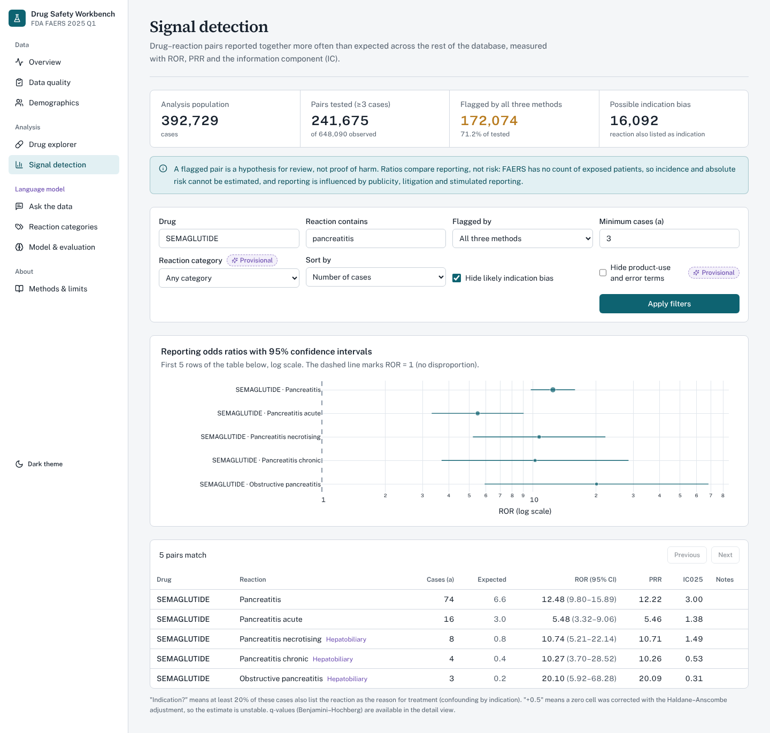
Figure 7. Signal detection filtered to semaglutide and reaction terms containing “pancreatitis”.
7.8 Ask the data (question answering)
The question page accepts a free-text question and shows the answer in two clearly separated panels: Observed in FAERS reports (counts and disproportionality, with the causality caveat) and Established clinical evidence (what the drug label, FDA communications and literature state). Every sentence carries citation badges that link to the evidence below, and side panels show how the question was read and the full provenance (model revisions, thresholds, knowledge-base and data checksums).
For “Does Ozempic cause pancreatitis?” the system maps the brand name OZEMPIC to SEMAGLUTIDE through an alias learnt from FAERS, links “pancreatitis” to the MedDRA term Pancreatitis, and reports 74 cases (about 6.62 expected), ROR 12.5 (95% CI 9.80–15.9), PRR 12.2 and IC025 3.00, plus related terms. The established-evidence panel confirms that the semaglutide label mentions pancreatitis (sections Adverse Reactions and Warnings and Precautions) and quotes the label passages with their sources.
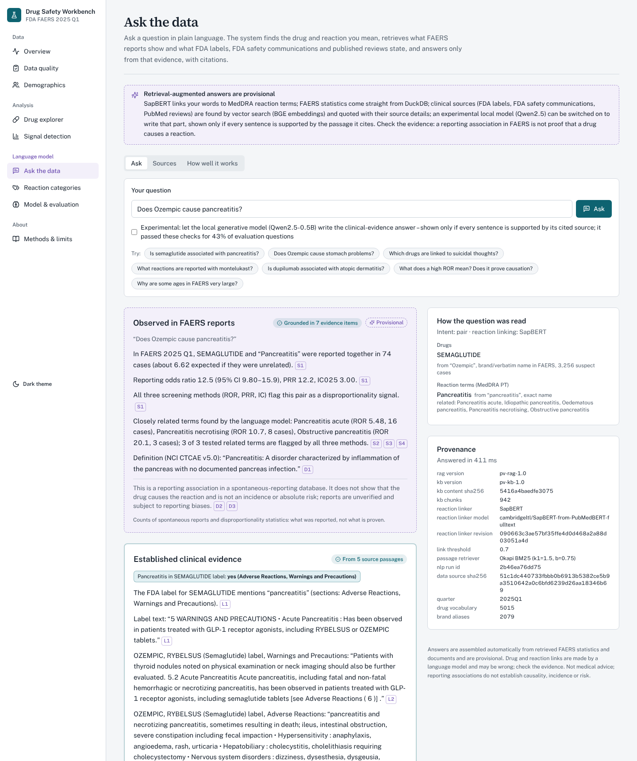
Figure 8. Answer to “Does Ozempic cause pancreatitis?”: observed reports, established evidence, how the question was read and provenance.
Lay questions are routed to the label section they ask about. For “Is it safe to take metformin while pregnant?” the observed-report panel finds only 3 co-reports (ROR 1.77, 95% CI 0.57–5.52, not flagged), while the established-evidence panel retrieves Pregnancy and Use in Specific Populations passages (best similarity 0.86 against the 0.73 threshold). Some retrieved passages come from a metformin combination-product label; because every passage names its source, the reader can see this and weigh it.
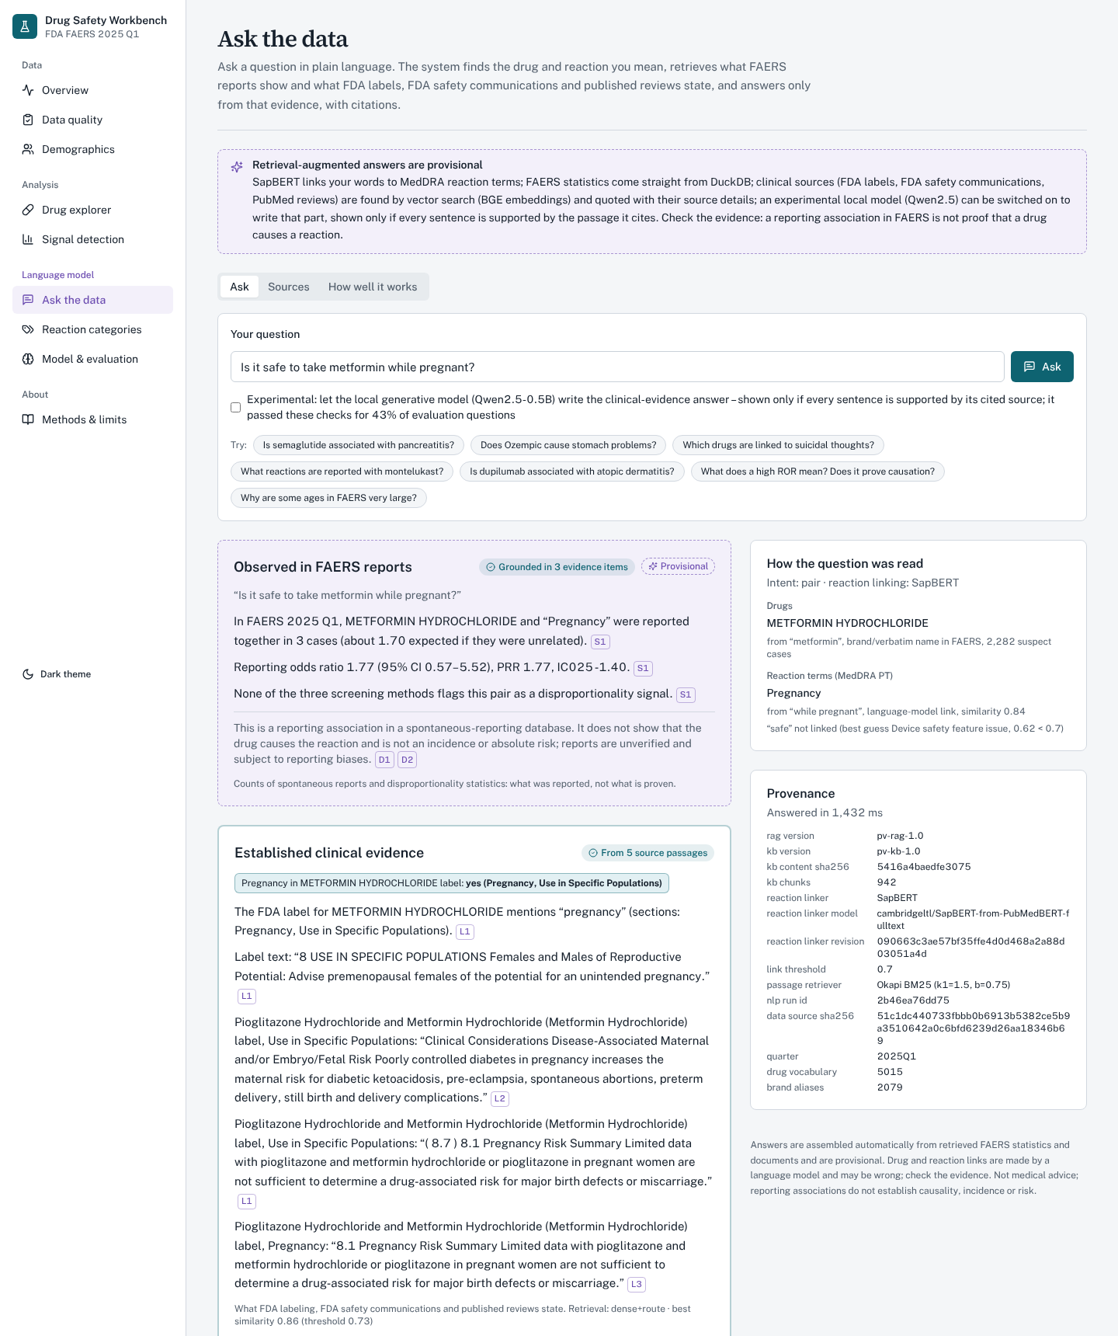
Figure 9. A lay question: few FAERS co-reports, while the label’s pregnancy sections are retrieved and quoted with their sources.
Documentation questions are answered by quoting the FDA’s own text: “Why are some ages very large?” returns the FAQ explanation that some manufacturers submit age in days. Questions with no drug, reaction or relevant documentation are declined rather than guessed.
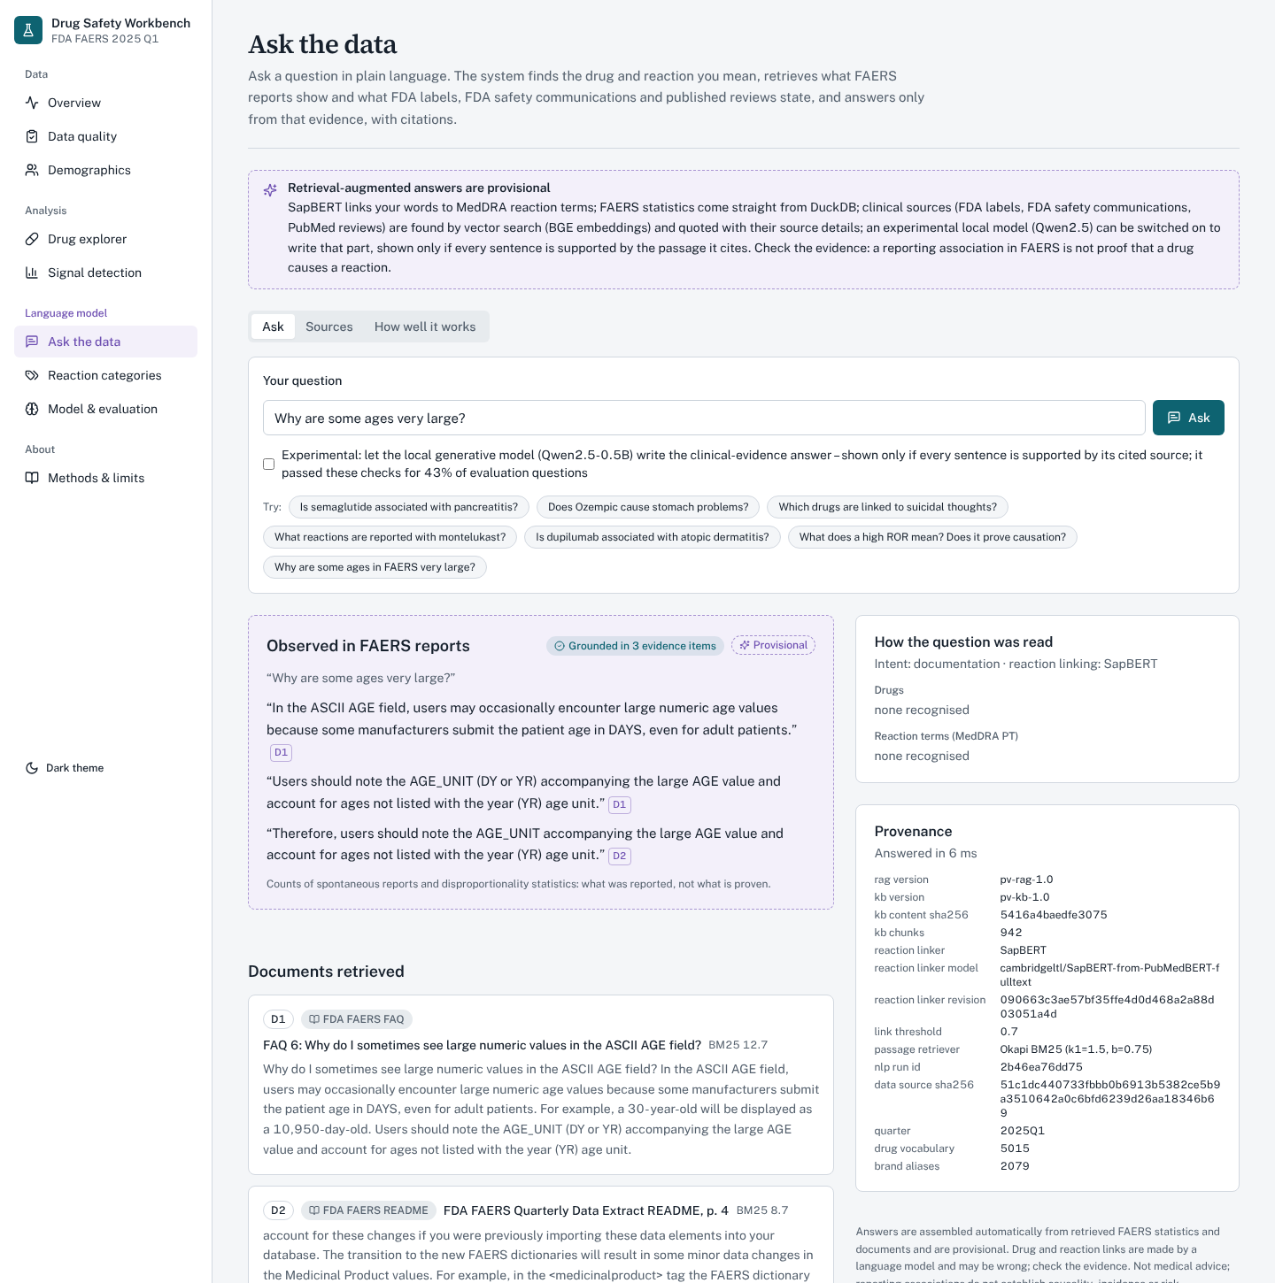
Figure 10. A documentation question answered with verbatim quotes from FDA’s FAERS FAQ and README.
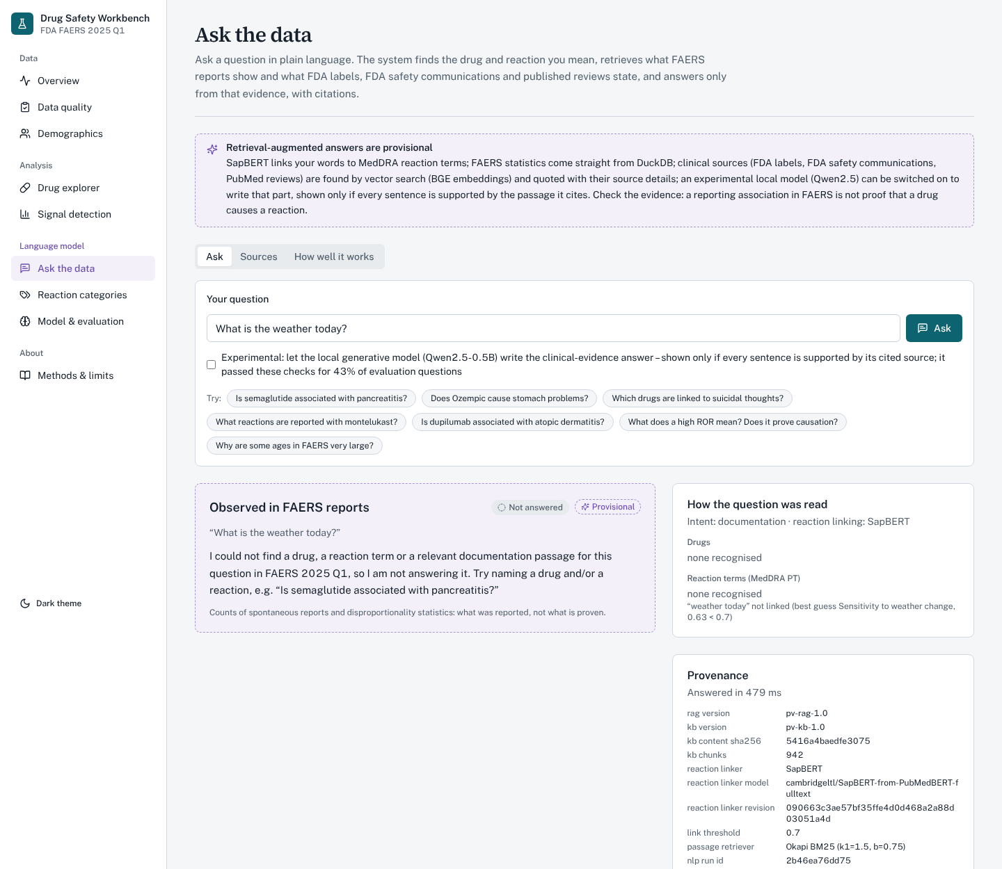
Figure 11. An unrelated question (“What is the weather today?”) is declined, with a hint on how to ask.
The Sources tab lists every indexed document with its type, title, publisher, date and link, and the How well it works tab shows the evaluation results of Section 9 inside the application.
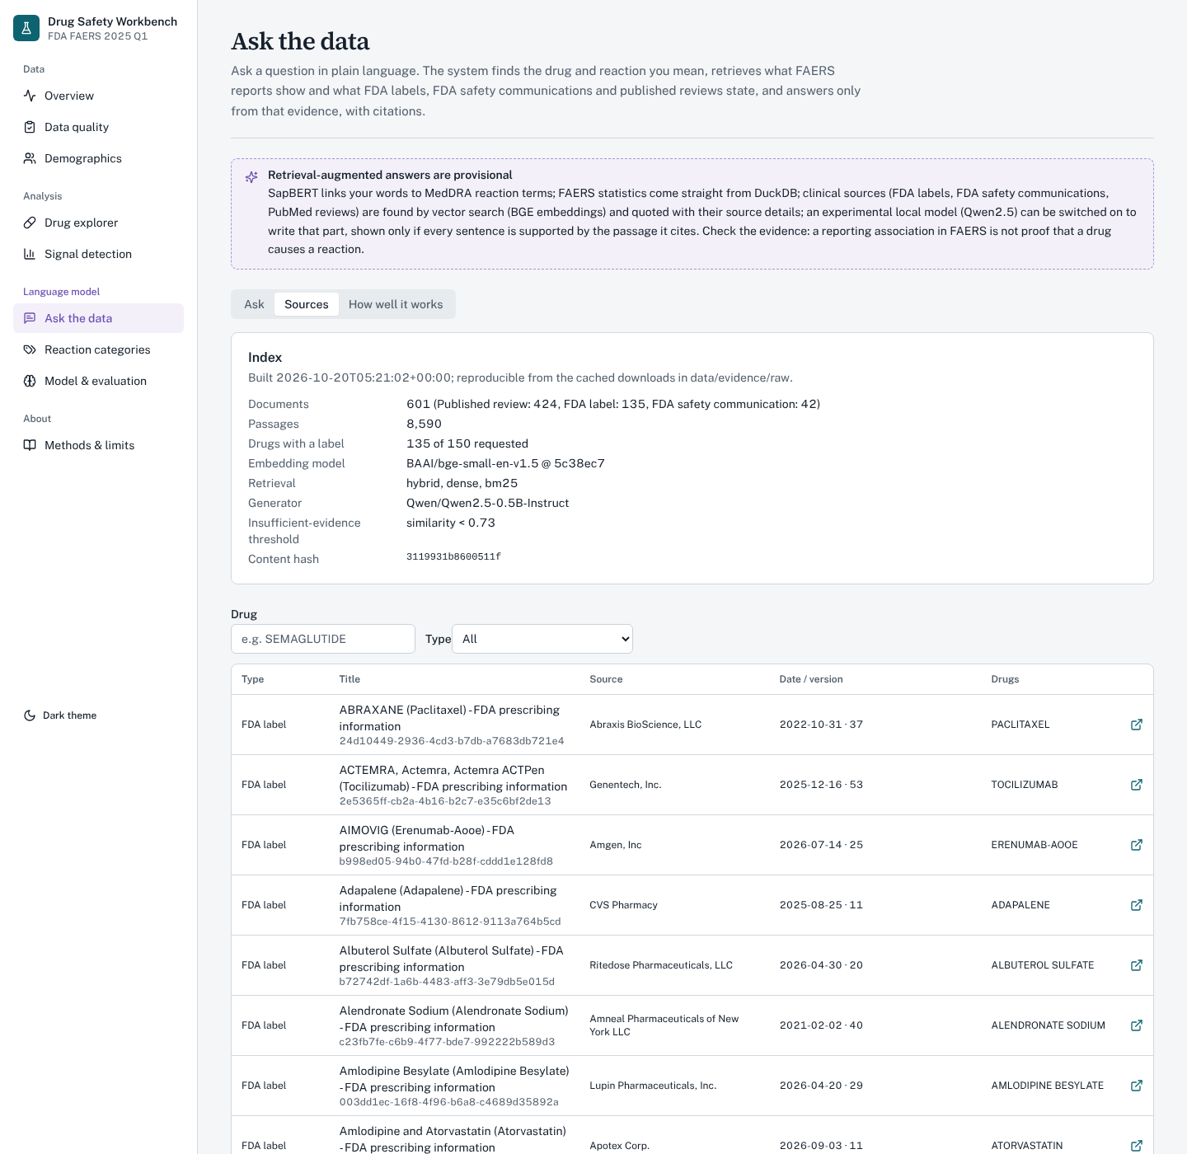
Figure 12. Sources tab: index summary and the list of indexed labels, FDA communications and reviews.
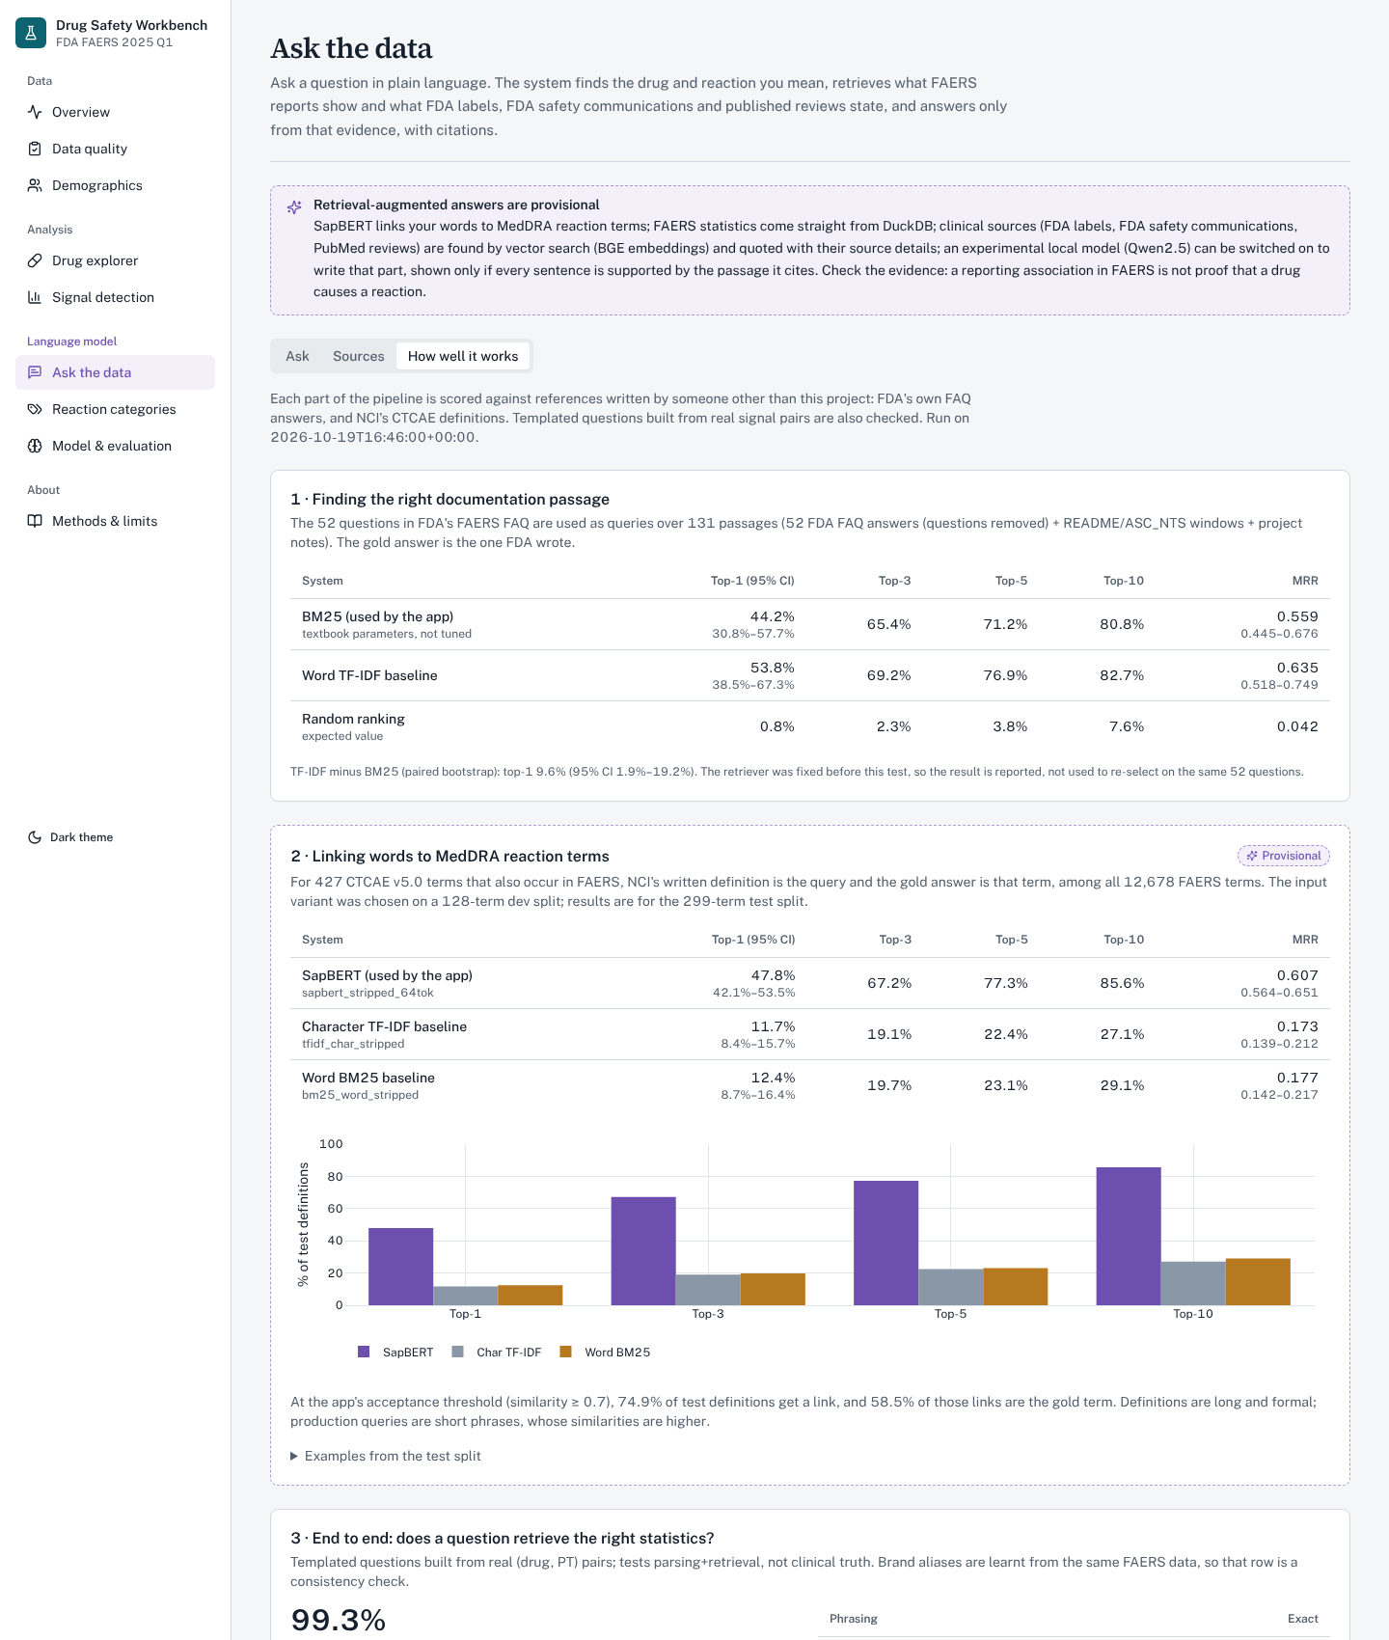
Figure 13. “How well it works” tab: retrieval, linking and end-to-end evaluation shown in the dashboard.
7.9 Reaction categories and search by meaning
The reaction-categories page shows the 23 provisional categories with their share of reaction mentions, the term-level predictions with score, margin and abstention reason (each can be reviewed: accept, correct, reject or unsure, with an audit log), a search by meaning, and signals for a concept. Searching “liver damage” returns Liver injury (similarity 0.82), Hepatocellular injury and related hepatic terms that a substring search would not find.
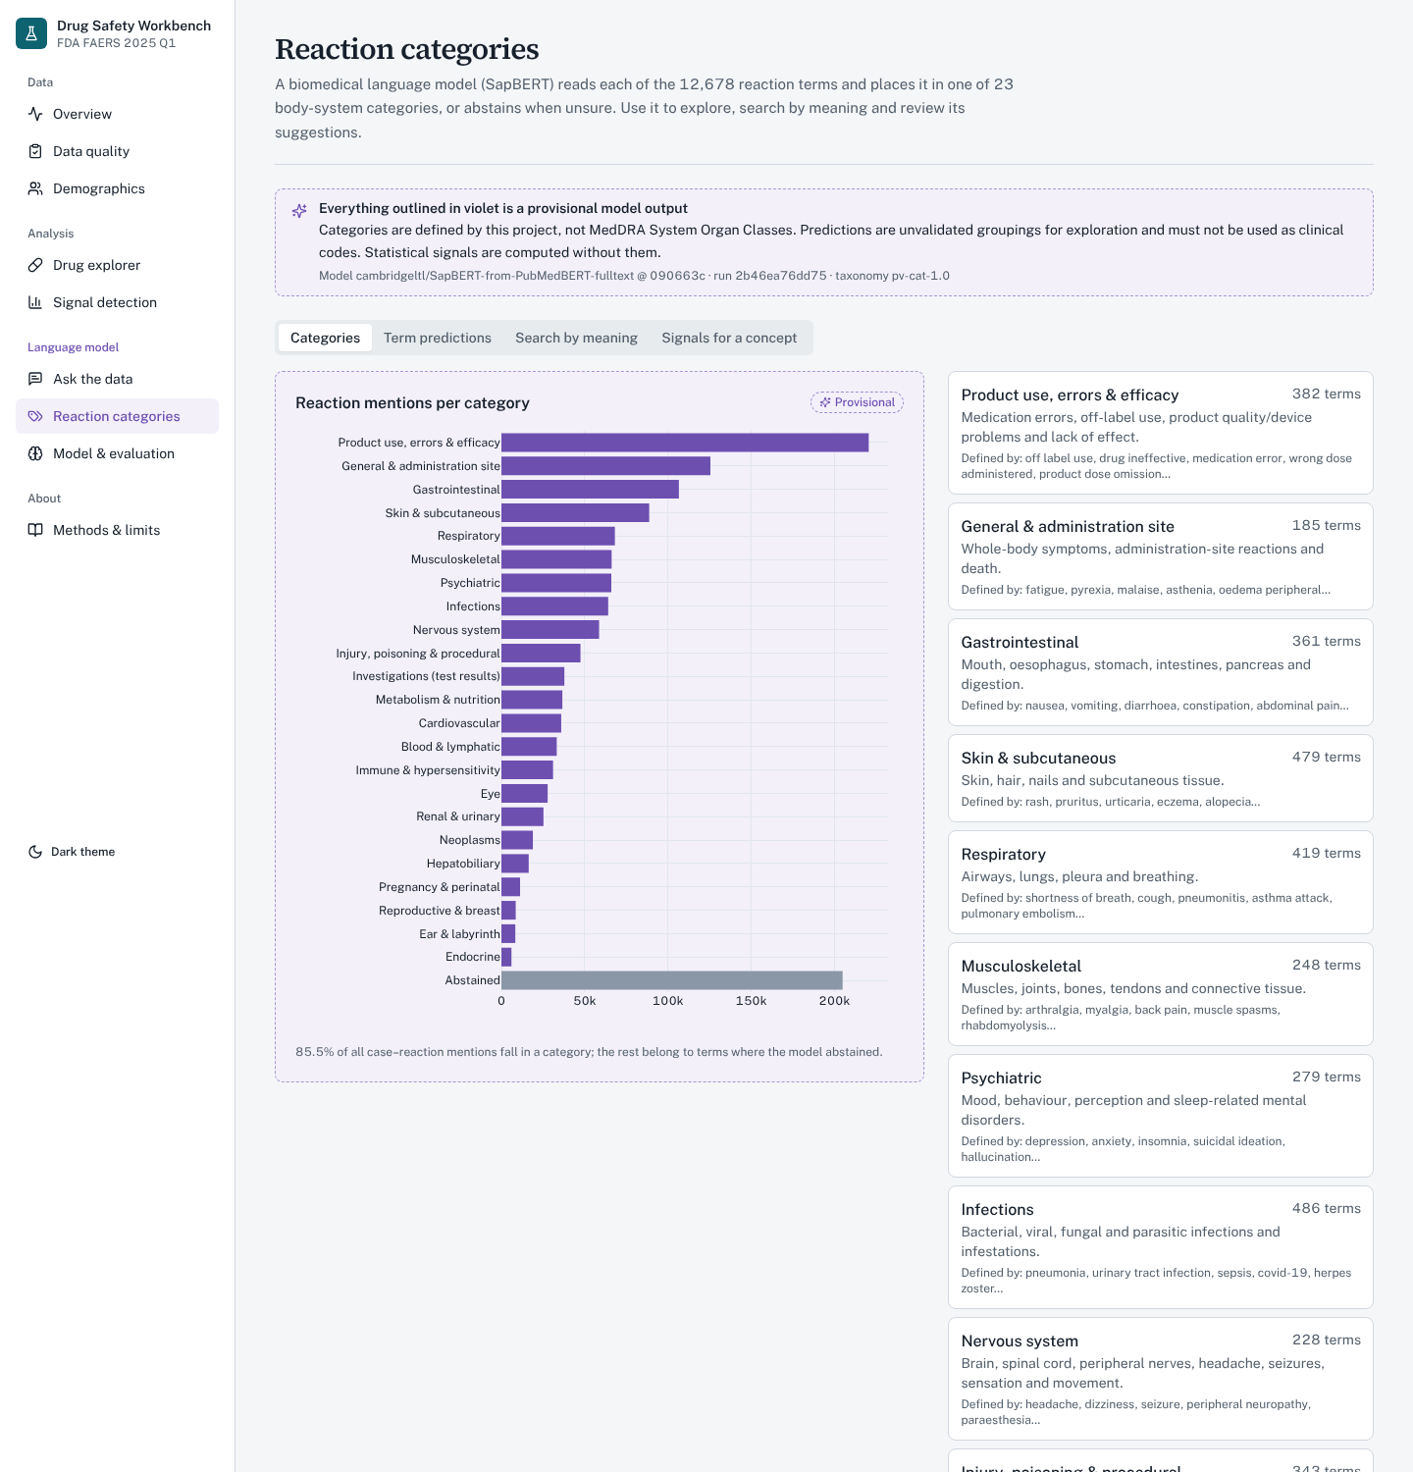
Figure 14. Reaction categories: share of reaction mentions per provisional category.
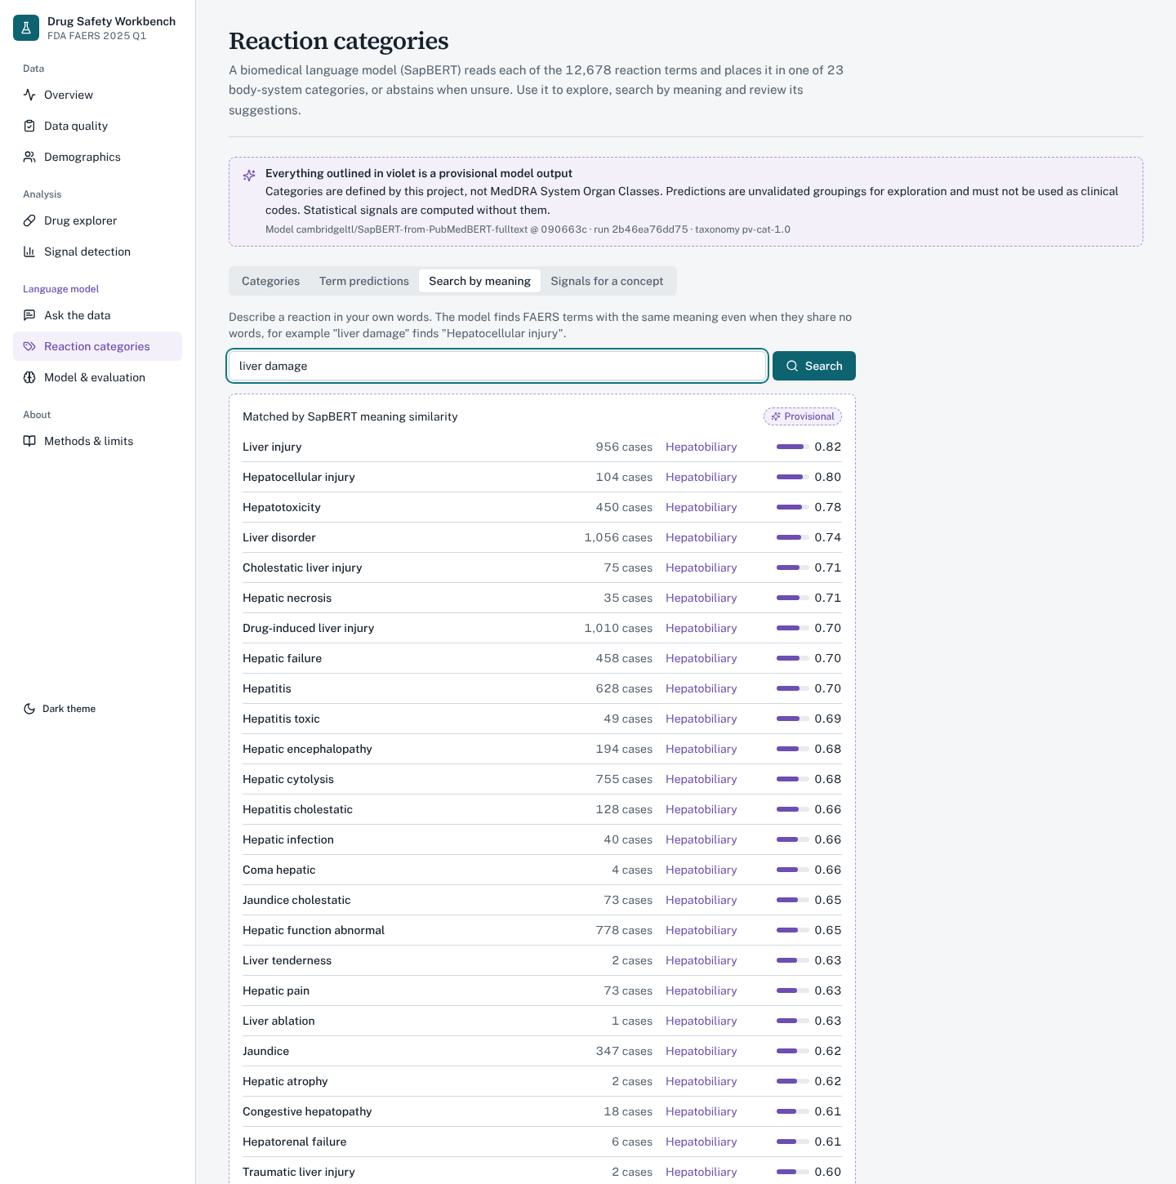
Figure 15. Search by meaning: “liver damage” returns hepatic reaction terms ranked by SapBERT similarity.
7.10 Model & evaluation and Methods & limits
The model page records the model id and revision, weights checksum, thresholds and run summary (7,333 terms assigned, 5,345 abstained, 85.5% of reaction mentions covered) and the evaluation against NCI CTCAE with baselines. The methods page documents the data handling, the statistics, the language-model components and the limits of each.
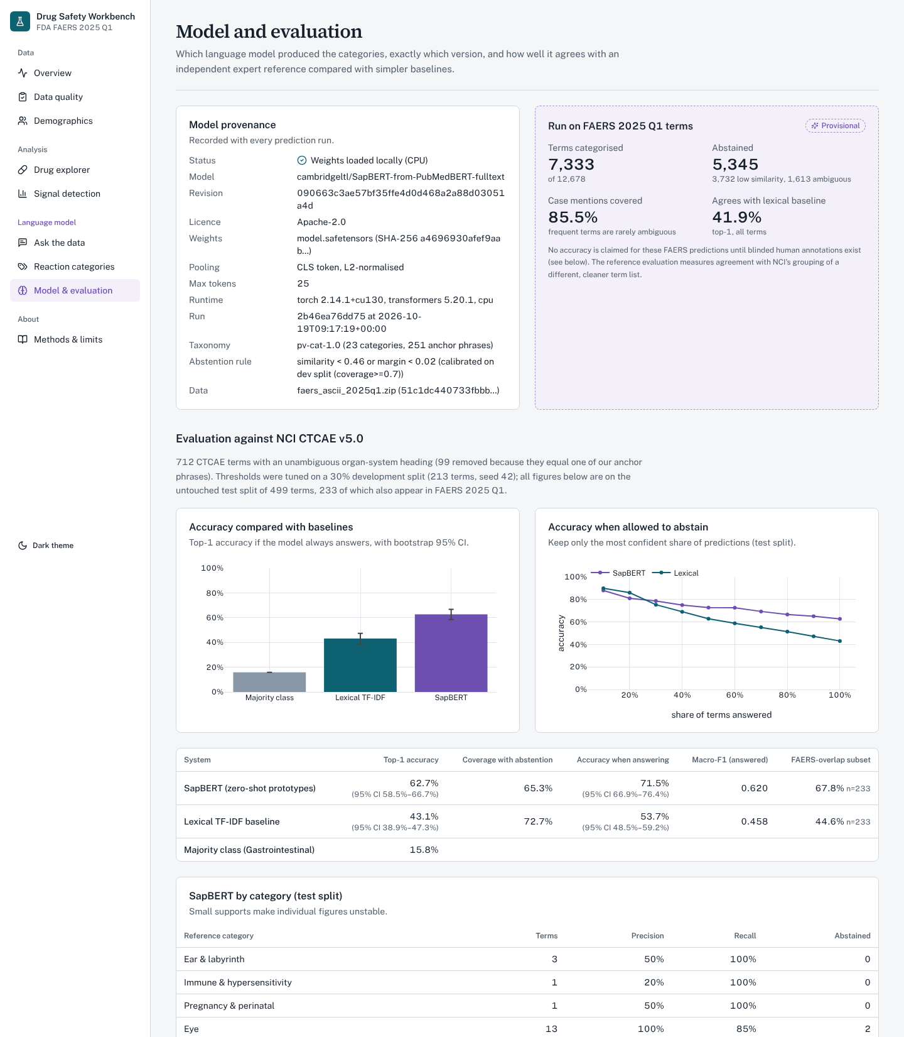
Figure 16. Model & evaluation page: provenance, FAERS run summary and evaluation against NCI CTCAE v5.0.
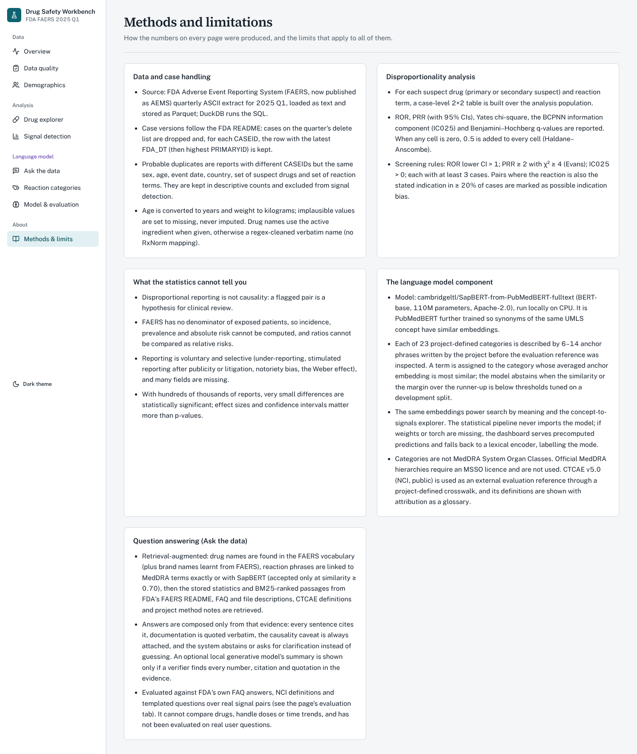
Figure 17. Methods & limits page.
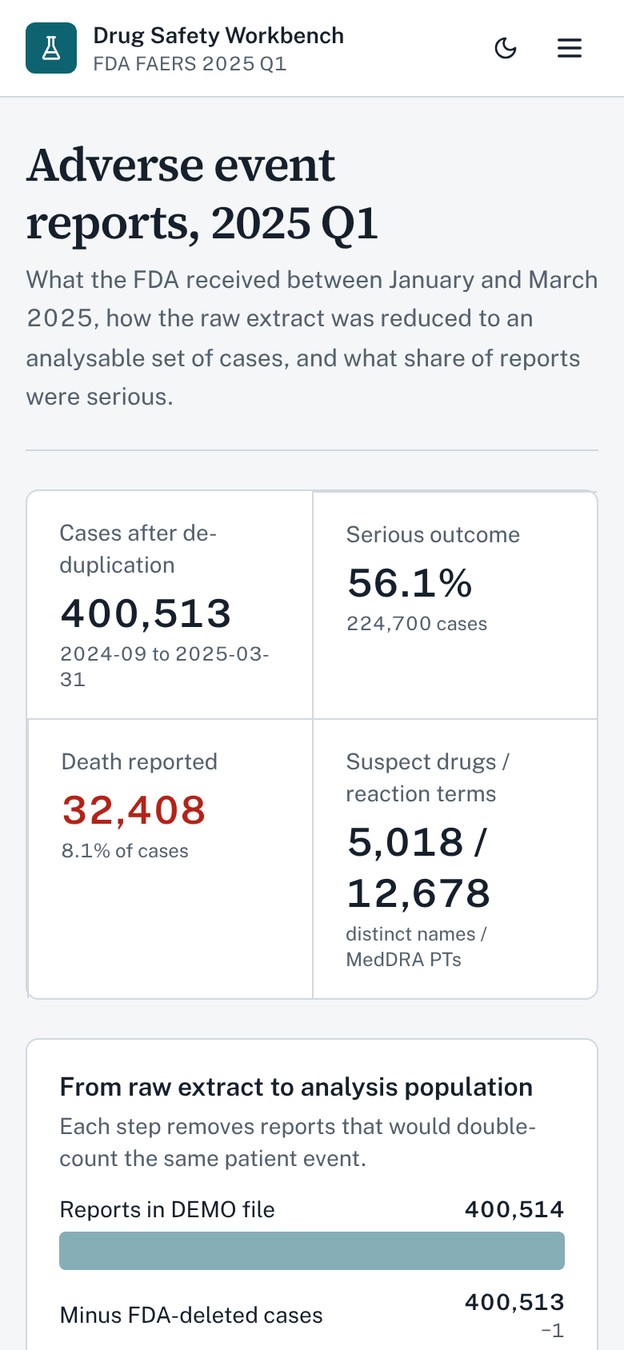
Figure 18. Phone-width layout (390 px).
8. Sample Code / Configuration
The listings below show the parts of the implementation that carry the project’s correctness guarantees: case-version handling, probable-duplicate detection, the disproportionality statistics, the abstaining classifier, section routing for retrieval, and the structure check in the answer verifier.
8.1 Latest version per case (backend/pvsys/clean.py, DuckDB SQL)
CREATE TEMP TABLE demo_dedup AS
SELECT * EXCLUDE (rn) FROM (
SELECT *, row_number() OVER (
PARTITION BY trim(caseid)
ORDER BY try_cast(fda_dt AS BIGINT) DESC NULLS LAST,
try_cast(primaryid AS BIGINT) DESC
) AS rn
FROM raw_demo
WHERE trim(caseid) NOT IN (SELECT trim(caseid) FROM raw_deleted_cases)
) WHERE rn = 1

8.2 Probable duplicates (clean.py)
-- same sex, age, event date, country, suspect-drug set and reaction set;
-- the most recently received report of each group is kept un-flagged
row_number() OVER (
PARTITION BY c.sex, c.age_years, c.event_date, c.occr_country, dr.drug_set, re.pt_set
ORDER BY c.fda_date DESC NULLS LAST, try_cast(c.primaryid AS BIGINT) DESC) AS rn
...
WHERE c.event_date IS NOT NULL AND c.age_years IS NOT NULL -- avoid over-matching sparse reports

8.3 Disproportionality for all pairs at once (signals.py)
zero = (a == 0) | (b == 0) | (c == 0) | (d == 0)
k = np.where(zero, cfg.continuity, 0.0) # Haldane-Anscombe: +0.5 if any cell is 0
ac, bc, cc, dc = a + k, b + k, c + k, d + k
ror = (ac / bc) / (cc / dc)
se_ror = np.sqrt(1 / ac + 1 / bc + 1 / cc + 1 / dc)
ror_lo = np.exp(np.log(ror) - cfg.z * se_ror)
prr = (ac / (ac + bc)) / (cc / (cc + dc))
num = n * np.square(np.maximum(np.abs(a * d - b * c) - n / 2, 0)) # Yates chi-square
chi2 = np.where(den > 0, num / den, 0.0)
expected = (a + b) * (a + c) / n
ic = np.log2((a + 0.5) / (expected + 0.5))
ic025 = ic - 3.3 * np.power(a + 0.5, -0.5) - 2 * np.power(a + 0.5, -1.5)
df["ror_signal"] = (a >= cfg.min_cases) & (df["ror_lower"] > 1)
df["prr_signal"] = (a >= cfg.min_cases) & (df["prr"] >= 2) & (df["chi2"] >= 4)
df["ic_signal"] = (a >= cfg.min_cases) & (df["ic025"] > 0)

The thresholds (min_cases = 3, ROR lower CI > 1, PRR ≥ 2, χ² ≥ 4) are fields of a configuration object; the listing shows their default values.
8.4 Classifier with abstention (nlp/classify.py)
order = np.argsort(-scores, axis=1) # cosine similarity to each category prototype
s1 = scores[rows, order[:, 0]]; s2 = scores[rows, order[:, 1]]
margin = s1 - s2
low = s1 < t.min_score # not close to any category
amb = (~low) & (margin < t.min_margin) # ambiguous between two categories
pred = np.where(low | amb, ABSTAIN, cats[order[:, 0]])

8.5 Section routing and the structure check (evidence/rerank.py, nlp/checks.py)
SECTION_ROUTES = [
(re.compile(r"boxed warning|black[- ]?box|most (serious|severe|important) (warning|risk|danger)", re.I),
("boxed_warning",)),
(re.compile(r"contraindicat|should(n't| not) (take|use|be given|receive)|...", re.I),
("contraindications",)),
...]
fused = minmax(dense) + beta * boost # bonus for passages of the routed label section

def structure_problems(text, items):
pol = boxed_polarity(text) # 'no', 'yes' or None
has_boxed = any(i.get("section_key") == "boxed_warning" for i in items)
if pol == "no" and has_boxed:
return ["contradicts label structure: denies a boxed warning ..."]
if pol == "yes" and not has_boxed:
return ["not supported by label structure: asserts a boxed warning ..."]
return []

A generated draft is shown only if it cites at least one passage and only existing ones, every number and quotation occurs in the cited passages, each sentence shares at least half of its content words with the passages it cites, it passes the structure check above, and the entailment model does not judge any sentence contradicted by its cited passage (P(contradiction) ≥ 0.5 and greater than P(entailment)). Otherwise the extractive answer is shown.
8.6 Run configuration
.\run.cmd # setup, build data if missing, start API + dashboard
# dashboard: http://localhost:5173 API docs: http://127.0.0.1:8000/docs
powershell -ExecutionPolicy Bypass -File scripts\build_evidence.ps1 # evidence corpus + index (once)
cd backend
python -m pvsys.pipeline all # ingest, clean, quality, EDA, signals, NLP
python -m pvsys.pipeline rag-eval # question-answering evaluation
python -m pvsys.pipeline evidence-eval-v2 # retrieval evaluation (dev/test drugs)
python -m pytest -q # 110 passed

The launcher creates a virtual environment, installs the pinned requirements, builds the processed data if they are missing, starts both services and opens the browser; pressing Enter in its window stops both. All downloads and caches are kept inside the project folder.
9. Results
Every number in this section was read from the files written by the pipeline and the evaluation scripts (data/processed/*.json, data/nlp/*.json, data/evidence/*.json) and cross-checked against the dashboard. FAERS counts describe reports, not patients; the results describe reporting patterns and model performance, not drug risk.
9.1 Descriptive analysis
The quarter contains 400,513 de-duplicated cases received between 1 January and 31 March 2025 (plus three stray earlier receipt dates). 224,700 cases (56.1%) were serious, 32,408 (8.1%) reported a death and 83,294 a hospitalisation. 46.5% of cases were female, 32.8% male and 20.7% did not report sex; the median age was 59 years. Most events occurred in the United States (246,922 cases), followed by Canada (30,004), Japan (16,260), the United Kingdom (14,119) and France (14,094).
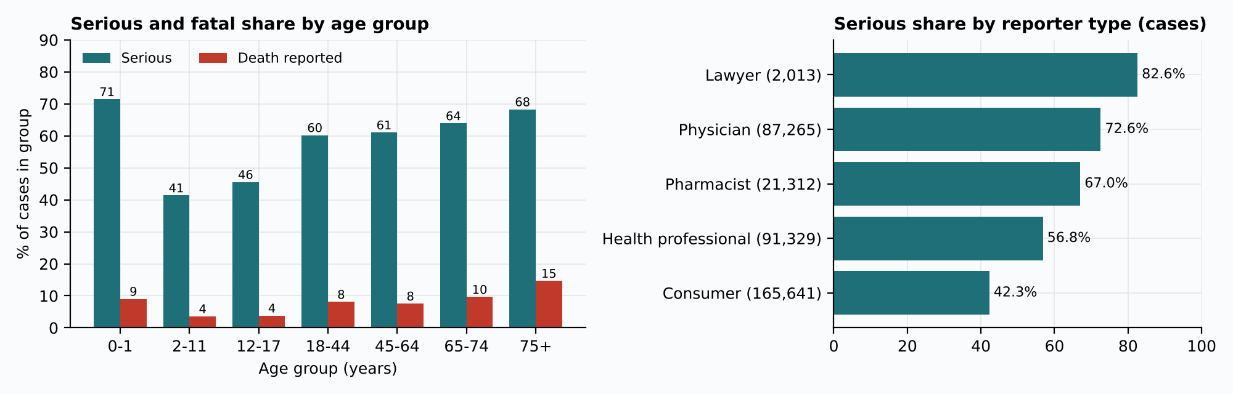
Figure 19. Serious and fatal share by age group, and serious share by reporter type.
The serious share rises with age (18–44 years: 60.2%; 75 years and over: 68.3%) and the death share most steeply (75+: 14.6%); infants aged 0–1 also have a high serious share (71.4%). Physicians’ reports were serious far more often than consumers’ (72.6% vs 42.3%). Male cases were more often serious than female cases (60.4% vs 55.7%; χ² = 712.6, p < 10⁻¹⁵⁶), but Cramér’s V was only 0.047: the difference is significant because the sample is huge, practically negligible, and a property of reports rather than patients.
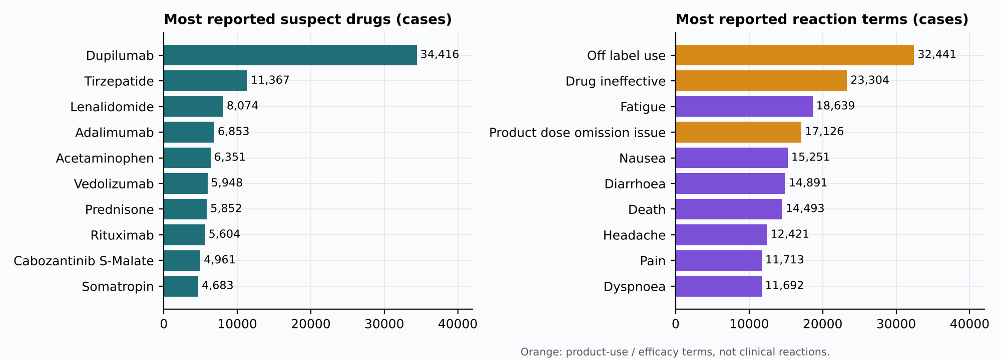
Figure 20. Most reported suspect drugs and reaction terms. Three of the top four terms are product-use or efficacy terms.
Dupilumab is by far the most reported suspect drug (34,416 cases), followed by tirzepatide (11,367), lenalidomide (8,074), adalimumab (6,853) and acetaminophen (6,351). The most frequent terms are non-clinical – “Off label use” (32,441) and “Drug ineffective” (23,304) – which is why the dashboard can hide product-use terms and why the categoriser has a product-use category.
9.2 Disproportionality
Of 648,090 observed suspect-drug–reaction pairs, 241,675 had at least three cases and were tested. ROR flagged 192,163 pairs, PRR 184,795 and IC 173,684; 172,074 (71.2%) were flagged by all three. This high share is expected with a background of about 390,000 cases: almost any co-reporting of a specific drug and term exceeds expectation, and many top pairs are product-use terms or indication artefacts. 16,092 pairs were flagged for possible indication bias, including dupilumab–atopic dermatitis (98.4% of the cases list it as the indication), and 4,201 rows needed the Haldane correction.
Drug | Reaction | a | ROR (95% CI) | PRR | IC025
Metformin hydrochloride | Lactic acidosis | 280 | 271.5 (226.7–325.1) | 233.9 | 6.29
Semaglutide | Pancreatitis | 74 | 12.5 (9.8–15.9) | 12.2 | 3.00
Tirzepatide | Pancreatitis | 88 | 4.2 (3.3–5.2) | 4.1 | 1.55
Levofloxacin | Tendon rupture | 5 | 18.1 (7.4–44.1) | 17.9 | 1.24
Montelukast sodium | Nightmare | 12 | 18.0 (10.1–32.1) | 17.6 | 2.41
Isotretinoin | Depression | 48 | 6.1 (4.5–8.2) | 5.8 | 1.98
Adalimumab | Tuberculosis | 19 | 6.3 (3.9–10.0) | 6.2 | 1.58
Dupilumab | Conjunctivitis | 256 | 8.4 (7.2–9.9) | 8.4 | 2.14

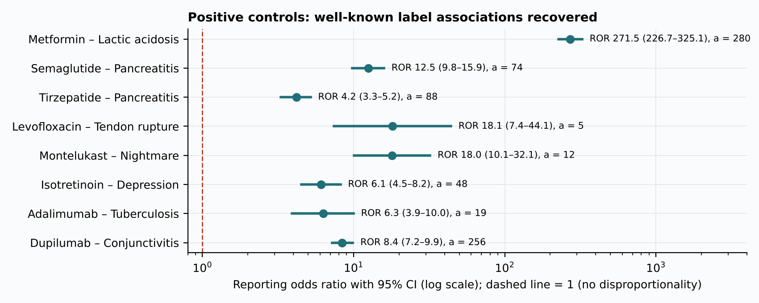
Figure 21. Positive controls: well-known label associations, all flagged by the three methods.
All eight positive controls were flagged by all three methods. This is a plausibility check of the implementation, not a measurement of the method’s sensitivity or specificity, which would need a reference set of positive and negative controls.
9.3 Reaction categorisation
System (499 held-out CTCAE terms) | Top-1 accuracy (95% CI) | Coverage | Accuracy on answered (95% CI)
SapBERT prototypes | 62.7% (58.5–66.7) | 65.3% | 71.5% (66.9–76.4)
TF-IDF character n-grams | 43.1% (38.9–47.3) | 72.7% | 53.7% (48.5–59.2)
Majority class | 15.8% | 100% | 15.8%

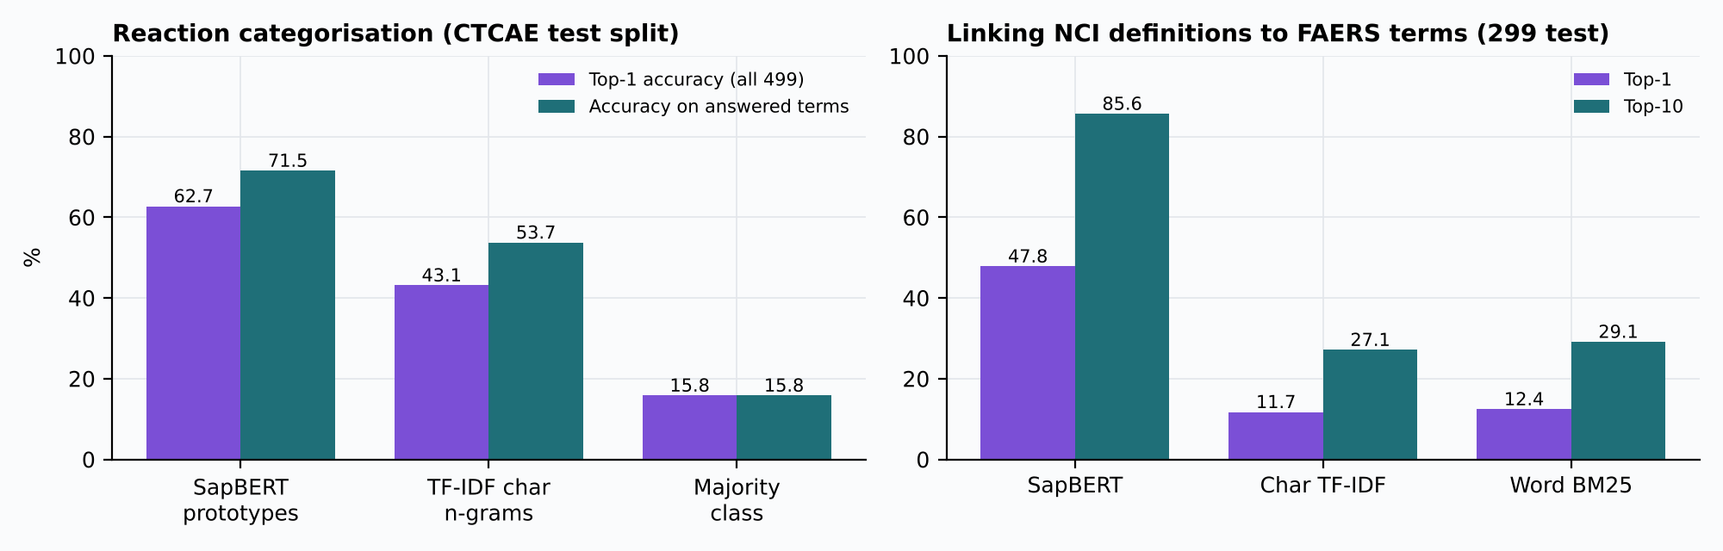
Figure 22. Reaction categorisation against NCI CTCAE (left) and linking NCI definitions to FAERS terms (right).
SapBERT cut the error rate of the lexical baseline by about a third (from 56.9% to 37.3%) without any training data, and the confidence intervals do not overlap. The scoring rule (category prototypes, 66.2% on development terms against 61.0% for the nearest anchor) and the abstention thresholds were chosen on the development split only. On the FAERS vocabulary, 7,333 of 12,678 terms were assigned and 5,345 abstained; because frequent terms are clearer, the assigned terms cover 85.5% of all case–reaction mentions. Abstention also prevents errors: “Pancreatitis” is abstained as ambiguous between hepatobiliary and gastrointestinal (margin 0.009).
9.4 Question answering
Evaluation (independent references) | Result
FDA FAQ passage retrieval (52 questions, 131 passages), BM25 | Top-1 44.2%, top-10 80.8%, MRR 0.559 (word TF-IDF: 53.8% / 82.7%; random 0.8%)
Linking NCI definitions to FAERS terms (299 test terms, 12,678 candidates), SapBERT | Top-1 47.8%, top-10 85.6% (character TF-IDF 11.7%, word BM25 12.4%)
End to end: 750 templated questions over 150 random real signal pairs | 745 (99.3%, 95% CI 98.7–99.9) returned exactly the stored statistics; all 5 failures are PLACEBO, which is deliberately excluded
Brand-alias questions | 55 of 55 correct
Numeric and citation grounding check | 805 of 805 answers passed
Latency | 117 ms mean per question on the CPU

TF-IDF beat BM25 on the FAQ benchmark (top-1 difference +9.6 points, 95% CI 1.9–19.2). BM25 had been fixed before the test, and switching on the evidence of the only benchmark would be selection on test data, so the result is reported and the change is left to future work. The first version of the engine scored only 78.0% end to end; the evaluation exposed three parsing defects (Appendix A) whose fixes raised it to 99.3%.
9.5 External evidence retrieval and abstention
The evidence corpus contains 601 documents – 135 FDA labels, 424 PubMed reviews and 42 FDA Drug Safety Communications – split into 8,590 passages and embedded in 110 s on the laptop GPU (13 of the 150 drugs, mostly vitamins and combination products, have no openFDA label).
Gold label section ranked first (89 test drugs, 886 questions) | Dense (BGE) | Hybrid (RRF) | BM25
All questions, top-1 | 81.2% | 67.2% | 51.0%
All questions, top-5 | 94.6% | 85.6% | 70.5%
Lay wording (“Who should not take Ozempic?”), top-1 | 67.7% | 39.5% | 18.5%
Label wording, top-1 | 94.6% | 94.8% | 83.5%
MRR, all questions | 0.871 | 0.750 | 0.595

Dense retrieval was chosen on the development drugs (MRR 0.850 against 0.752 for hybrid and 0.588 for BM25) and the test drugs confirm it. The gap is largest for lay questions, which share almost no words with label text. The sufficiency threshold of 0.73, chosen on development drugs, answered 93.3% of answerable test questions and declined 91.6% of unanswerable ones (price, packaging colour, unrelated topics), a balanced accuracy of 92.5%.
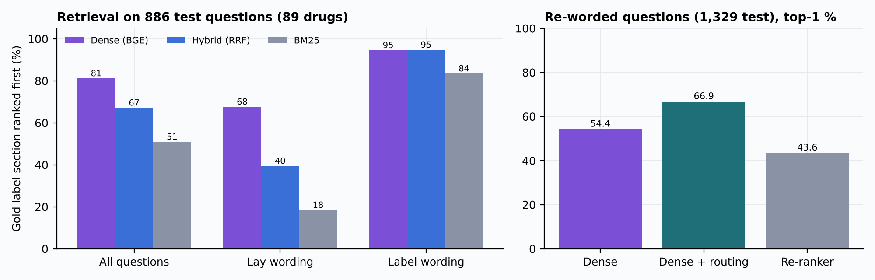
Figure 23. Retrieval methods on the template questions (left) and on 1,329 re-worded questions (right).
Two improvements were tested afterwards, again choosing on development drugs. Section routing raised top-1 on 1,329 re-worded test questions from 54.4% to 66.9% (MRR 0.644 → 0.733) and was adopted; on the original templates it reaches 100%, but only because the same authors wrote the templates and the rules, so that figure is not claimed. A cross-encoder re-ranker (bge-reranker-base) lowered top-1 on all 2,215 test questions from 65.1% to 52.0% and was rejected.
9.6 Extractive versus generative answering
To decide whether a small local language model should write the established-evidence answer, retrieval was run once and every system saw the same three passages for each of the 89 test drugs. On the factual question “Does X have a boxed warning?” (45 drugs with, 44 without a Boxed Warning section) the extractive answer was correct for 92.1% of drugs.
Boxed-warning question (89 test drugs) | Extractive | Qwen 0.5B | Qwen 1.5B | SmolLM2 1.7B
Generated answer correct | 92.1% | 43.8% | 69.7% | 49.4%
p vs extractive (exact McNemar) | – | 1.6×10⁻¹¹ | 8.8×10⁻⁵ | 3.2×10⁻⁸
Drafts passing the v1 verifier | – | 50.6% | 51.7% | 50.6%
Accuracy of verified drafts | – | 53.3% | 58.7% | 84.4%
System (verified draft, else extractive) | 92.1% | 74.2% | 76.4% | 87.6%

The verifier did not separate right from wrong answers: the dominant errors were confident polarity flips. Qwen2.5-1.5B answered “no” for 23 of the 45 drugs that have a boxed warning (e.g. “No, there is no boxed warning for Capecitabine [L1]”, citing the boxed warning itself), and 16 of these passed because the sentence shares its words with the cited passage; SmolLM2-1.7B answered “yes” for every drug. Generation helped only when choosing which passage answers a lay question, where Qwen2.5-1.5B with the verifier improved on extractive top-1 (77.5% vs 67.4%, p = 0.012).
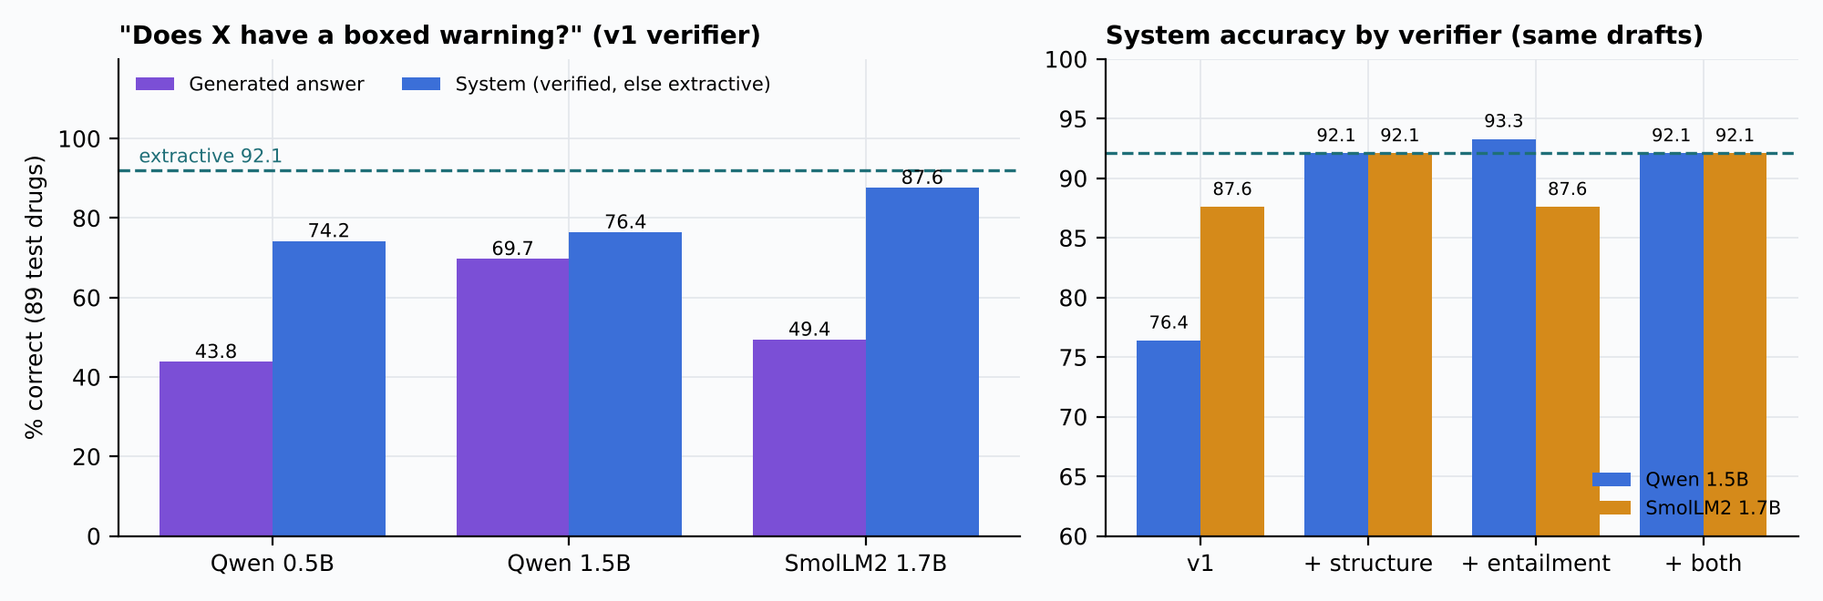
Figure 24. Boxed-warning question: generated and system accuracy (left), and system accuracy with the improved verifier on the same drafts (right). Dashed line: extractive answer.
Verifier on the same drafts | Qwen 1.5B system | Qwen 1.5B false “no” / “yes” | SmolLM2 system | SmolLM2 false “no” / “yes”
v1 (citation, number, quote, support) | 76.4% | 16 / 3 | 87.6% | 0 / 7
+ structure check | 92.1% | 2 / 0 | 92.1% | 0 / 0
+ entailment check | 93.3% | 0 / 2 | 87.6% | 0 / 7
+ both | 92.1% | 0 / 0 | 92.1% | 0 / 0

The two new checks are complementary: the entailment model removed every verified false “no”, the structure check every verified false “yes”, and with either check showing a verified draft no longer lowered accuracy below the extractive answer (p = 1.0). A larger model did not solve the problem: Qwen2.5-3B, loaded in 4-bit to fit the 4 GB GPU, was correct for 78.7% of drugs even with routed retrieval placing a Boxed Warning passage first for every drug that has one – no better than Qwen2.5-1.5B (79.8%) – and the v1 verifier still passed 4 false “no” and 4 false “yes” answers. Generation therefore stays optional, behind the full verifier.
9.7 Signal–label concordance
Among the 300 most-reported strong FAERS signals of drugs with an indexed label (all three methods, at least 10 cases, no indication-bias flag), the reaction term appears in the label text for 33.7% (42.8% excluding product-use terms). Among the 300 most disproportionate pairs the share is 1.7%, which mostly reflects unusual report clusters rather than new drug effects. Exact text matching misses synonyms, so both figures are lower bounds.
9.8 Validation
To confirm that the application computes and shows what the data contain, the following checks were run:
# | Check | Result
1 | All seven FAERS tables and the DELETE list loaded with every column as text | 0 rejected lines
2 | Case-version rule, deletions, unit conversion, duplicate flags, exact 2×2 cells and Haldane-corrected ROR on a synthetic quarter with hand-calculated answers | All tests pass
3 | Every formula against textbook values (ROR, PRR, χ², IC, q-values) | All tests pass
4 | Importing the statistics modules loads neither PyTorch nor the NLP package; running NLP leaves signals.parquet byte-identical | Holds
5 | Positive controls (Table in Section 9.2) | 8 of 8 flagged by all three methods
6 | Question answering returns exactly the stored statistics (750 questions) and passes the grounding check (805 answers) | 99.3% and 100%
7 | Dense-retrieval results reproduced in the second evaluation run | Identical (81.2% top-1, MRR 0.871)
8 | Back-end tests (pytest) and lint (Ruff) | 110 passed; all checks passed
9 | Front-end tests (Vitest), type check and production build | 18 passed; 0 errors; build succeeds

Manual acceptance checks were also performed: all nine pages open on the full quarter; filters refresh the charts and tables; the question page answers, cites and declines as described; the dark theme and the phone-width layout render; and the launcher starts and stops both services.
10. Advantages of the System
The advantages depend on the mechanisms that produce them: the statistics are trustworthy because they are computed in one place without any model, and the answers are checkable because they are built only from retrieved evidence.
- Correct case handling: deletions, case versions, unit conversion and probable duplicates are handled before any statistic is computed, and missing data are disclosed, not imputed.
- Transparent statistics: three established disproportionality methods with confidence intervals, sparse-cell correction, q-values, an indication-bias flag and subgroup views, all reproducible from one command.
- Independence: language-model output can never change a statistic; this is enforced by tests.
- Genuine, evaluated NLP: semantic categorisation and search, and question answering that links brand names and lay phrases, each measured on independent references with baselines and confidence intervals.
- Reports kept separate from evidence: answers show what FAERS reports and what labels and literature state in separate panels, with citations and sources for every sentence.
- Honest abstention: the categoriser, the reaction linker and the evidence retriever decline when evidence is weak instead of guessing.
- Safe generation: generated text is optional and shown only after citation, number, quotation, support, structure and entailment checks.
- Local and free: runs on a laptop with one command, uses only open data and permissively licensed models (the 3B model only for an experiment), and needs no paid API; a GPU speeds up model work but is not required.
11. Limitations of the System
These limitations concern the data, the methods and the implementation. They affect how far the results can be interpreted.
- Spontaneous reporting: under-reporting, stimulated and notoriety reporting, the Weber effect and missing fields; there is no exposure denominator, so no incidence, prevalence or risk can be estimated.
- Disproportionality is not causality: flagged pairs need clinical case review, literature and pharmacological plausibility. Screening flags are not FDR-controlled; q-values are reported alongside.
- One quarter: no time trends or cumulative analysis; three receipt dates fall before 2025.
- Drug normalisation: active ingredient and regular expressions only (no RxNorm), so salts and brands can split one substance; duplicate detection is an exact-match heuristic.
- NLP reference: CTCAE is oncology-oriented and cleaner than FAERS terms; 42% of distinct FAERS terms are abstained; accuracy on FAERS terms awaits blinded human annotation, which is implemented but not yet collected.
- Question answering: evaluated on templated and author-written questions, not real user questions; comparisons, doses and time trends are not supported; brand aliases come from FAERS verbatim names.
- External evidence: 150 drugs only; long label sections truncated at 25 passages; the label-mention check uses exact text and misses synonyms; PubMed abstracts only; a snapshot dated 20 October 2026.
- Generators: small models (0.5–3B) make confident yes/no errors; the structure check covers only the boxed-warning question type.
- Deployment: single-user, local design without authentication; suitable for coursework and exploration, not for public or clinical use as is.
12. Future Scope
Further work would extend the system from one quarter and screening statistics towards longitudinal, better-calibrated and clinically validated analysis.
- Ingest several quarters for time-to-signal and trend analysis, and add Bayesian shrinkage (EBGM/MGPS).
- Map drug names to RxNorm and add fuzzy duplicate detection.
- Estimate signal-detection performance on reference sets of positive and negative controls.
- Collect blinded annotations from pharmacists to evaluate the categoriser on FAERS terms, and evaluate against official MedDRA groupings with a licence.
- Build a held-out set of real user questions with pharmacist-written answers to evaluate question answering end to end.
- Extend the structure check beyond boxed warnings, add synonym-aware label matching, and fine-tune the retriever on development drugs only.
- Containerise the application and add authentication for multi-user deployment.
13. Conclusion
The AI-Based Drug Safety and Adverse Effect Analysis System turns a raw FAERS quarter of 400,514 reports into a reproducible, audited and explorable analysis. Its main contribution is methodological: careful case handling and three transparent disproportionality methods, computed independently of any model and verified against hand-calculated data and positive controls, are combined with an NLP layer whose every component is evaluated on independent references and which shows its evidence and declines when that evidence is weak.
Applied to the data, the system recovers well-known drug–reaction associations (for example metformin–lactic acidosis and semaglutide–pancreatitis), makes the main reporting biases visible, and lets a non-specialist ask a question in plain language and see both what was reported and what the label states. The comparison of answering methods showed that quoting well-retrieved evidence is more reliable than small generative models for factual safety questions, and that polarity-aware verification is needed before any generated claim is shown. The results describe reporting patterns and system performance; they do not establish causal effects, incidence or clinical readiness.
14. References
- U.S. Food and Drug Administration, “FDA Adverse Event Reporting System (FAERS) Quarterly Data Extract Files, 2025 Q1,” https://fis.fda.gov/extensions/FPD-QDE-FAERS/FPD-QDE-FAERS.html.
- S. J. W. Evans, P. C. Waller and S. Davis, “Use of proportional reporting ratios (PRRs) for signal generation from spontaneous adverse drug reaction reports,” Pharmacoepidemiology and Drug Safety, vol. 10, no. 6, pp. 483–486, 2001.
- E. P. van Puijenbroek et al., “A comparison of measures of disproportionality for signal detection in spontaneous reporting systems for adverse drug reactions,” Pharmacoepidemiology and Drug Safety, vol. 11, no. 1, pp. 3–10, 2002.
- A. Bate et al., “A Bayesian neural network method for adverse drug reaction signal generation,” European Journal of Clinical Pharmacology, vol. 54, pp. 315–321, 1998.
- G. N. Norén, J. Hopstadius and A. Bate, “Shrinkage observed-to-expected ratios for robust and transparent large-scale pattern discovery,” Statistical Methods in Medical Research, vol. 22, no. 1, pp. 57–69, 2013.
- W. DuMouchel, “Bayesian data mining in large frequency tables, with an application to the FDA spontaneous reporting system,” The American Statistician, vol. 53, pp. 177–190, 1999.
- M. Hauben and J. K. Aronson, “Defining ‘signal’ and its subtypes in pharmacovigilance based on a systematic review of previous definitions,” Drug Safety, vol. 32, no. 2, pp. 99–110, 2009.
- A. Bate and S. J. W. Evans, “Quantitative signal detection using spontaneous ADR reporting,” Pharmacoepidemiology and Drug Safety, vol. 18, pp. 427–436, 2009.
- Y. Gu et al., “Domain-specific language model pretraining for biomedical natural language processing,” ACM Transactions on Computing for Healthcare, vol. 3, no. 1, pp. 1–23, 2021.
- F. Liu, E. Shareghi, Z. Meng, M. Basaldella and N. Collier, “Self-alignment pretraining for biomedical entity representations,” in Proc. NAACL-HLT, 2021, pp. 4228–4238.
- P. Lewis et al., “Retrieval-augmented generation for knowledge-intensive NLP tasks,” in Advances in Neural Information Processing Systems, vol. 33, 2020, pp. 9459–9474.
- S. Robertson and H. Zaragoza, “The probabilistic relevance framework: BM25 and beyond,” Foundations and Trends in Information Retrieval, vol. 3, no. 4, pp. 333–389, 2009.
- S. Xiao, Z. Liu, P. Zhang and N. Muennighoff, “C-Pack: Packaged resources to advance general Chinese embedding (BGE),” arXiv:2309.07597, 2023.
- Qwen Team, “Qwen2.5 technical report,” arXiv:2412.15115, 2024.
- L. Ben Allal et al., “SmolLM2: When smol goes big – data-centric training of a small language model,” arXiv:2502.02737, 2025.
- P. He, J. Gao and W. Chen, “DeBERTaV3: Improving DeBERTa using ELECTRA-style pre-training with gradient-disentangled embedding sharing,” in Proc. ICLR, 2023.
- T. Dettmers, A. Pagnoni, A. Holtzman and L. Zettlemoyer, “QLoRA: Efficient finetuning of quantized LLMs,” in Advances in Neural Information Processing Systems, vol. 36, 2023.
- T. A. Kass-Hout et al., “OpenFDA: An innovative platform providing access to a wealth of FDA’s publicly available data,” Journal of the American Medical Informatics Association, vol. 23, no. 3, pp. 596–600, 2016.
- National Cancer Institute, “Common Terminology Criteria for Adverse Events (CTCAE) v5.0,” 2017.
- M. Raasveldt and H. Mühleisen, “DuckDB: an embeddable analytical database,” in Proc. ACM SIGMOD, 2019, pp. 1981–1984.
- S. Ramírez, FastAPI documentation, https://fastapi.tiangolo.com/.
- Plotly Technologies Inc., Plotly JavaScript Open Source Graphing Library, https://plotly.com/javascript/.
Appendix A: Issues Found and Fixed During Development
Running the evaluations on the full data, rather than on a handful of examples, exposed the following defects and design problems. Each was fixed or documented, and covered by tests where possible.
# | Issue | Impact | Fix
1 | Reaction words discarded as filler (“Troponin increased”, “Drug hypersensitivity”) in question parsing | End-to-end question answering scored only 78.0% | Exact MedDRA terms matched first and longest-first; regression tests
2 | Drug names containing “/” or “\” (combination products) never matched; drug look-up captured words inside reaction terms | Wrong or missing links for some drugs and reactions | Punctuation-insensitive matching; a longer exact reaction term overrides a drug word inside it. Score 94.7% → 99.3%
3 | The small generator (Qwen2.5-0.5B) was unreliable in the pilot: 35% correct vs 97.5% extractive on the boxed-warning question | Fluent but wrong safety answers | Generation made opt-in; sentence-support rule added to the verifier
4 | The verifier passed confident polarity errors (16 false “no boxed warning” answers from Qwen2.5-1.5B) | Verified generations lowered system accuracy to 76.4% | Structure check and entailment check added; verified false “no” 16 → 0
5 | Hybrid (BM25 + dense) retrieval and a cross-encoder re-ranker performed worse than dense retrieval alone | Lower retrieval accuracy | Retrieval mode chosen on development drugs: dense with section routing
6 | Signal–label concordance of 1.7% came from sampling only the most disproportionate pairs | Misleading summary figure | Most-reported sample added (33.7%); both reported with the explanation
7 | The launcher window closed immediately under Windows PowerShell 5.1: messages written by Python to stderr were treated as terminating errors | Application could not be started by double-click | Helper that runs such commands without failing on stderr; run.cmd pauses and shows the message on any error
8 | Security lint (Ruff) flagged MD5 hashing and unsafe XML parsing in the evidence code | Weak checksums; XML entity risk | SHA-256 content hashes; document-type declarations stripped before parsing

Two behaviours were documented rather than changed because they follow from the data or the method: the very high share of flagged pairs (Section 9.2) and the FAQ benchmark on which TF-IDF beat BM25 (Section 9.4), where switching retriever after seeing test results would have been selection on test data.
Appendix B: Viva Preparation – Likely Questions and Answers
1. What is the objective of your project?
To turn a raw FAERS quarter into a correct, reproducible and explorable drug-safety analysis, and to let users ask questions in plain language and get answers built only from cited evidence, while making clear that reporting associations are not proof of causation.
2. Describe the dataset.
The FDA FAERS 2025 Q1 extract: 400,514 reports in seven $-delimited tables (DEMO, DRUG, REAC, OUTC, INDI, THER, RPSR) plus a DELETE list of 5,732 case IDs, with 2.0 million drug rows and 1.43 million reaction rows. External evidence: 135 FDA labels, 42 FDA safety communications and 424 PubMed reviews (8,590 passages).
3. How did you clean and de-duplicate the data?
We removed deleted cases, kept the latest version of each case (latest FDA date, then highest PRIMARYID), converted ages and weights to standard units and set implausible values to missing, normalised drug names to the active ingredient, collapsed repeated terms, and flagged 7,784 probable duplicates with an identical clinical fingerprint. No value was imputed.
4. What is the reporting odds ratio and how do you flag a signal?
ROR = (a/b)/(c/d) from the 2×2 table of cases with and without the drug and the reaction. A pair is flagged when the lower 95% confidence limit exceeds 1 and there are at least 3 cases. We also compute the PRR (Evans criteria) and the information component (IC025 > 0).
5. Does a high ROR mean the drug causes the reaction?
No. It means the pair was reported together more often than expected. Reports are unverified, biased (notoriety, indication, under-reporting) and have no exposure denominator, so a signal is a hypothesis for clinical review, not a risk estimate.
6. Why are 71% of tested pairs flagged?
With about 390,000 cases in the background almost any co-reporting of a specific drug and term exceeds expectation, and many pairs are product-use terms or indications. The q-values, effect sizes, the minimum-case filter and the indication-bias flag help prioritise.
7. What is the NLP part of the project?
Two components. SapBERT, a biomedical language model, groups 12,678 reaction terms into 23 categories with abstention and powers search by meaning. A retrieval-augmented question-answering module links drugs and reactions in a question, retrieves statistics, FDA documentation, labels and literature, and answers only from that evidence with citations.
8. Did you train or fine-tune any model?
No. All models are pretrained and used as downloaded (zero-shot). Only decision settings – thresholds, the retrieval mode and the routing weight – were chosen on development data, and every result is reported on held-out test data. FAERS has no labelled training data, and our question is whether off-the-shelf local models are reliable.
9. How do you know the language model works?
On 499 held-out NCI CTCAE terms SapBERT reaches 62.7% top-1 accuracy against 43.1% for a character n-gram baseline and 15.8% for the majority class, and 71.5% on the terms it answers. For question answering, 99.3% of 750 templated questions returned exactly the stored statistics.
10. How do you evaluate retrieval without labelling data yourselves?
The FDA codes every label passage by section, so a question such as “Who should not take Ozempic?” must be answered from the Contraindications section. Dense retrieval ranks the right section first for 81.2% of 886 test questions, against 51.0% for keyword search.
11. Why not just let a language model write the answer?
We tested it. With identical passages, quoting the evidence answered the boxed-warning question correctly for 92.1% of 89 test drugs; small generators managed 43.8–69.7%, and a 3B model was no better than 1.5B. Their errors were confident yes/no flips, so generation is optional and passes a verifier with structure and entailment checks.
12. When does the system refuse to answer?
When no drug, reaction or relevant documentation is found; when a reaction phrase is not close enough to any MedDRA term (similarity below 0.70); and when the best evidence passage is below 0.73 similarity. The threshold answers 93.3% of answerable questions and declines 91.6% of unanswerable ones.
13. How do you keep statistics and model outputs apart?
The statistics modules never import the NLP package, and tests check that importing them loads neither PyTorch nor the NLP code and that running NLP leaves the signals file byte-identical. Model output is drawn with a dashed violet outline and a “Provisional” badge.
14. Why DuckDB and Parquet instead of a database server?
DuckDB runs SQL over Parquet files inside the Python process, so the whole system runs on a laptop with one command, the queries are fast enough for the dashboard, and the processed data are portable files.
15. What are the main limitations?
Spontaneous-report biases and no denominator; disproportionality is not causality; one quarter; no RxNorm; the NLP reference is a proxy; questions were templated rather than real; and small generators remain unreliable for factual claims.
16. How do you run it?
Double-click run.cmd (or run .\run.cmd in PowerShell). It sets up the environment, builds the data if needed, starts the API on port 8000 and the dashboard on port 5173, and opens the browser. Pressing Enter in the window stops both.
Appendix C: Running the Project and API Reference
Requirements: Windows with Python 3.10 or later (3.13 used) and Node.js 18 or later; no GPU and no paid API are needed. From the project folder, run .\run.cmd. The dashboard opens at http://localhost:5173 and the interactive API documentation is at http://127.0.0.1:8000/docs. Optional switches of scripts\run.ps1: -Rebuild (rerun the pipeline from the raw zip), -NoNlp (skip the language-model packages), -Test (run all tests before starting), -Stop (stop services left running).
Route | Purpose
GET /api/health | Liveness, available tables and NLP status
POST /api/admin/reload | Reload processed data after a pipeline run
GET /api/overview, /api/quality, /api/demographics, /api/trend | Overview figures, data-quality checks, demographic tables, daily receipts
GET /api/drugs/top, /api/reactions/top | Most reported suspect drugs and reaction terms
GET /api/drugs/search, /api/reactions/search | Name look-up for drugs and MedDRA terms
GET /api/drugs/{drug}/profile | Drug profile: counts, demographics, reactions, indications
GET /api/signals/summary, /api/signals | Signal totals; filtered, sorted and paginated signal table
GET /api/signals/stratified | Subgroup 2×2 statistics by sex, age group or reporter type
GET /api/nlp/status, /api/nlp/categories, /api/nlp/predictions | Model status and provenance, category summary, term predictions
GET /api/nlp/evaluation | Categorisation evaluation results
GET /api/nlp/search, /api/nlp/concept-signals, /api/nlp/drug-profile | Search by meaning, signals for a concept, a drug’s reaction mix by category
POST /api/nlp/review, GET /api/nlp/reviews | Record and list reviewer decisions on predictions
POST /api/rag/ask | Answer a question with evidence, understanding and provenance (optional generation)
GET /api/rag/status, /api/rag/evaluation | Question-answering status and evaluation
GET /api/evidence/status, /api/evidence/documents, /api/evidence/search, /api/evidence/evaluation | Evidence index status, document list, passage search and retrieval evaluation

The project code, tests and documentation are in the folder PharmacoVigilance/ (backend/, frontend/, scripts/, docs/); the processed data and evaluation results are in data/, and the local models in models/ (weights are not redistributed).

