Extractive or Generative? Small Local Language Models for Evidence-Grounded Pharmacovigilance Question Answering
Akhil Mahadik  Information Technology  Vidyalankar Institute of Technology  Mumbai, India  akhil.mahadik@vit.edu.in | Diyansh Jain  Information Technology  Vidyalankar Institute of Technology  Mumbai, India  diyansh.jain@vit.edu.in

Abstract—Retrieval-augmented generation (RAG) is attractive for drug-safety question answering, but privacy and cost often require small language models that run on local hardware, and a fluent wrong answer about a drug's safety is worse than no answer. We built a local pharmacovigilance assistant over the U.S. FDA Adverse Event Reporting System (FAERS, 2025 Q1) and an evidence corpus of FDA drug labels, FDA Drug Safety Communications and PubMed reviews (601 documents, 8,590 passages), and compared extractive answering with generation by three small instruction-tuned models (Qwen2.5-0.5B, Qwen2.5-1.5B, SmolLM2-1.7B) on a single 4 GB laptop GPU. All systems saw identical retrieved passages; ground truth came from FDA's own label section coding, so no item was hand-labelled. On a factual safety check (“Does drug X have a boxed warning?”, 89 held-out drugs) the extractive answer was correct for 92.1% of drugs, against 43.8%, 69.7% and 49.4% for the generators (all p < 10⁻⁴, exact McNemar). A citation-and-support verifier accepted 51–52% of generated drafts, yet 16–47% of accepted drafts were wrong; the dominant errors were polarity biases that lexical verification cannot see (Qwen2.5-1.5B denied 23 of 45 existing boxed warnings; SmolLM2-1.7B asserted one for all 44 drugs without). Allowing verified generations into the answer therefore lowered accuracy for both Qwen models (to 74.2% and 76.4%). Generation helped only for choosing which passage answers a lay question, where Qwen2.5-1.5B with verification outperformed extractive top-1 selection (77.5% vs 67.4%, p = 0.012). A larger model (Qwen2.5-3B, 4-bit) did not remove the polarity errors, but two polarity-aware checks did: a deterministic cross-check against label structure and an entailment model reduced Qwen2.5-1.5B's verified false negatives from 16 to 0 and restored system accuracy to the extractive level (93.3%). For factual safety claims with small local models, extractive answering is the safer default; generation should be confined to passage selection and presentation, behind polarity-aware verification.
Index Terms—pharmacovigilance, retrieval-augmented generation, small language models, faithfulness, abstention, drug labels, FAERS
I. Introduction
Post-marketing drug safety relies on spontaneous adverse-event reports. Disproportionality statistics such as the reporting odds ratio (ROR) and proportional reporting ratio (PRR) flag drug–reaction pairs that are reported together more often than expected [1]–[3], but such signals are hypotheses, not evidence of causation [4]. A user asking “Does Ozempic cause pancreatitis?” needs both what the reports show and what established sources—drug labelling and the literature—state, clearly kept apart.
Retrieval-augmented generation (RAG) [5] conditions a language model on retrieved passages and is a natural fit. Generated text, however, can be unfaithful to its sources [6], [7], and attributing statements to evidence remains difficult even for large models [8], [9]. In many health settings, data-protection rules, cost or connectivity rule out hosted large models, leaving small models on local hardware. Whether such models add value over simply quoting the retrieved evidence is an empirical question with safety consequences.
We study this question in a working system and make four contributions:
- A fully local RAG pipeline that joins FAERS statistics computed in DuckDB with FDA labels, FDA Drug Safety Communications and PubMed reviews, separates observed reports from established evidence, and declines when evidence is insufficient.
- A label-free evaluation protocol that uses FDA's structured product labeling (SPL) section coding as ground truth for retrieval and answering.
- A controlled, paired comparison of extractive answering against three small generators (0.5–1.7B parameters) under identical retrieval, with a citation-and-support verifier.
- Evidence that verification of this kind is necessary but not sufficient: it rejects unsupported text but passes confident polarity errors, so generation lowered accuracy on a factual safety task while helping on passage selection; and an ablation showing that structure and entailment checks close this gap where a larger model does not.
II. Related Work
RAG and faithfulness. RAG combines a retriever with a generator [5]. Abstractive generation frequently introduces content unsupported by its input [6]; a broad survey of such hallucinations is given in [7]. Citation-generating systems [8] and attribution metrics [9] evaluate whether statements are supported by cited sources, typically with large models or human/NLI judgments. We examine the small-model regime with a lightweight lexical verifier.
Retrieval. BM25 [10] remains a strong lexical baseline; dense sentence encoders such as BGE [11] capture paraphrase; reciprocal-rank fusion [12] combines rankers. Biomedical encoders include PubMedBERT [13] and SapBERT for entity linking [14].
Abstention. Selective prediction trades coverage for accuracy [15], and question-answering benchmarks include unanswerable questions to test it [16].
Pharmacovigilance data. FAERS is distributed as quarterly extracts [17]; openFDA exposes drug labels and other FDA data through an API [18].
III. System
A. Observed reports: FAERS statistics
The 2025 Q1 FAERS extract (400,514 reports) was de-duplicated following FDA's case-version rules, giving an analysis population of 392,729 cases; ROR, PRR and the information component were computed for 241,675 drug–reaction pairs with at least three reports. These statistics are retrieved from DuckDB unchanged and are never produced by a language model. Drug names in a question are matched against the FAERS vocabulary and brand aliases learnt from FAERS; reaction phrases are linked to MedDRA preferred terms with SapBERT [14].
B. Established evidence corpus
For the 150 most-reported suspect drugs we collected (Table I): openFDA SPL sections of the manufacturer's most-revised label set, selected via NLM DailyMed; up to four PubMed reviews or meta-analyses on adverse effects published since 2015; and the FDA Drug Safety Communications linked from fda.gov. Labels are chunked within SPL sections (160 words, 30-word overlap), so every passage carries its section, document version, date and URL. Passages were embedded with BGE-small-en-v1.5 (384 dimensions) [11] and searched by exact cosine similarity.
TABLE I
Evidence corpus (snapshot of 20 October 2026)
Source | Documents | Passages
FDA drug labels (openFDA SPL) | 135 | 7,100
PubMed reviews / meta-analyses | 424 | 759
FDA Drug Safety Communications | 42 | 731
Total | 601 | 8,590

C. Answering
For a question, passages are retrieved within the linked drug's sources; if the best cosine similarity is below a calibrated threshold, the system declines. Otherwise the answer is produced in one of two ways (Fig. 1).
Extractive. A deterministic check reports whether the drug's label mentions the linked reaction term and in which sections; the answer then quotes the best-matching sentence of each top passage verbatim, with its source details.
Generative. A small instruction-tuned model receives the top three passages, each tagged with an identifier, source title and SPL section, plus a system prompt and one worked example; it must write two or three sentences, each ending with a passage identifier. Decoding is greedy (at most 160 new tokens), fp16 on the GPU.
Verifier. A draft is shown only if (i) it cites at least one passage and only existing identifiers, (ii) every number it contains occurs in the passages, (iii) every quotation is verbatim, and (iv) each sentence shares at least half of its content words (after stemming and removal of reporting verbs) with the passages it cites. Otherwise the extractive answer is shown.
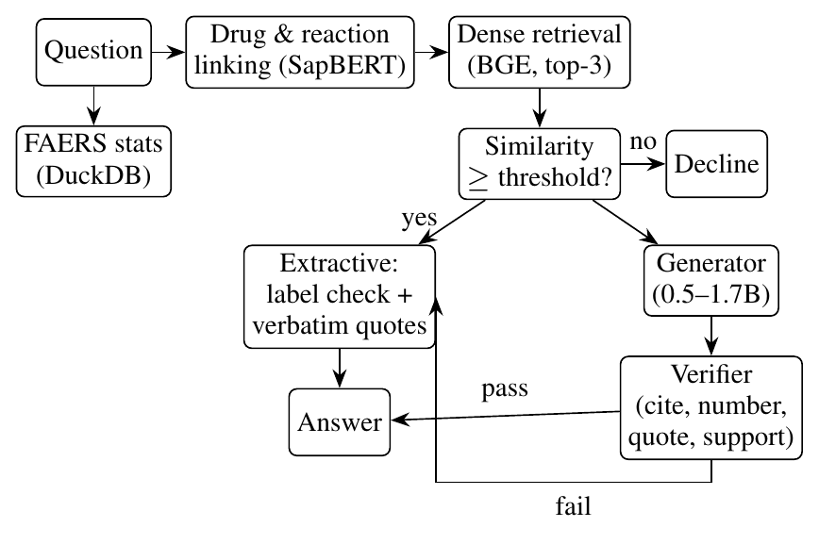
Fig. 1. Answering pipeline. FAERS statistics and external evidence are reported separately; generated drafts are shown only after verification.
IV. Evaluation Method
A. Ground truth from label structure
FDA codes every label passage by SPL section (Boxed Warning, Contraindications, Drug Interactions, …). We use this coding as ground truth, so no item was labelled by the authors or by a model. The 127 drugs with an indexed label were split, with a fixed seed, into 38 development and 89 test drugs; the retriever and abstention threshold were chosen on development drugs only; the prompt and verifier were fixed during system development, before this comparison was run, using a handful of drugs that were not excluded from the test set. All reported results use the 89 test drugs.
B. Retrieval and abstention
For each drug and each label topic present, a question was posed in label wording (“What are the contraindications of X?”) and in lay wording (“Who should not take X?”); a hit is relevant if it comes from that drug's gold section. The production retriever was selected on development drugs by mean reciprocal rank (MRR). The abstention threshold was chosen on development drugs to maximise balanced accuracy between answerable questions and templated unanswerable ones (price, packaging colour, unrelated topics).
C. Extractive versus generative answering
Retrieval was run once and cached, so every system saw identical passages (top three).
Task A (factual check): “Does X have a boxed warning?” for all 89 test drugs (45 with, 44 without a Boxed Warning section). The extractive answer is “yes” iff a retrieved passage comes from the Boxed Warning section. Generated answers were mapped to yes/no/undetermined with fixed patterns; undetermined counts as wrong.
Task B (passage selection): one lay question per drug on a randomly drawn topic (contraindications 18, pregnancy 24, adverse reactions 20, overdosage 16, interactions 11). The extractive answer is correct iff its first passage is from a gold section; a generated answer is correct iff it cites at least one passage and every cited passage is from a gold section. Task B therefore measures attribution, not the clinical content of the answer.
For each model we report raw accuracy, verifier pass rate, accuracy of verified answers, and system accuracy—what users would see: the generated answer if verified, otherwise the extractive one. Systems are compared on the same items with the two-sided exact McNemar test; intervals are Wilson 95%.
Models: Qwen2.5-0.5B-Instruct and Qwen2.5-1.5B-Instruct [19] (one family, two sizes) and SmolLM2-1.7B-Instruct [20] (a second family), all Apache-2.0, run on an NVIDIA GeForce RTX 3050 Laptop GPU (4 GB).
V. Results
A. Retrieval and abstention
Dense retrieval clearly outperformed BM25 and hybrid fusion (Table II); the gap is largest for lay questions, which share few words with label text. Fusion lowered dense performance, and dense retrieval was chosen on development drugs (MRR 0.850 vs 0.752 hybrid and 0.588 BM25). The abstention threshold (cosine 0.73) answered 93.3% of answerable and declined 91.6% of unanswerable test questions (balanced accuracy 92.5%).
TABLE II
Finding FDA's gold label section (89 test drugs, 886 questions, search within the drug)
 | Dense | Hybrid (RRF) | BM25
Top-1, all questions | 81.2% | 67.2% | 51.0%
Top-5, all questions | 94.6% | 85.6% | 70.5%
Top-1, lay wording | 67.7% | 39.5% | 18.5%
Top-1, label wording | 94.6% | 94.8% | 83.5%
MRR, all questions | 0.871 | 0.750 | 0.595

B. Task A: factual safety check
The extractive answer was correct for 82 of 89 drugs (92.1%, 95% CI 84.6–96.1%); its seven errors were all boxed warnings that retrieval did not surface. Every generator was significantly worse (Table III, Fig. 2). Scale helped within a family (Qwen 0.5B → 1.5B: 43.8% → 69.7%, McNemar p = 0.002), but the larger SmolLM2 model was worse than Qwen2.5-1.5B (p = 0.033).
Crucially, the verifier did not separate right from wrong answers. About half of all drafts passed it, but only 53.3%, 58.7% and 84.4% of accepted drafts were correct. As a result, using verified generations made the system less accurate than extractive answering alone for both Qwen models (74.2%, p = 1.4×10⁻⁴; 76.4%, p = 0.003); for SmolLM2 the drop to 87.6% was not significant (p = 0.34).
TABLE III
Task A, “Does X have a boxed warning?” (89 test drugs). p: exact McNemar vs extractive on the same items
 | Extractive | Qwen 0.5B | Qwen 1.5B | SmolLM2 1.7B
Raw accuracy | 92.1% | 43.8% | 69.7% | 49.4%
95% CI | 84.6–96.1 | 34.0–54.2 | 59.5–78.2 | 39.3–59.6
p vs extractive | – | 1.6×10⁻¹¹ | 8.8×10⁻⁵ | 3.2×10⁻⁸
Verifier pass rate | – | 50.6% | 51.7% | 50.6%
Accuracy if verified | – | 53.3% | 58.7% | 84.4%
System accuracy | 92.1% | 74.2% | 76.4% | 87.6%
p vs extractive | – | 1.4×10⁻⁴ | 0.003 | 0.34

C. Why verification fails: polarity errors
Table IV shows the errors are systematic. Qwen2.5-1.5B answered “no” for 23 of the 45 drugs that have a boxed warning, e.g. “No, there is no boxed warning for Capecitabine [L1]”; 16 of these false negatives passed verification, because the sentence shares the words boxed, warning and the drug name with its cited passage. SmolLM2-1.7B answered “yes” for every drug, including all 44 without a boxed warning; its high accuracy among verified answers reflects this yes-bias meeting a 45:44 class balance, not discrimination. Qwen2.5-0.5B mostly did not answer the question (42 undetermined drafts). A lexical support test cannot detect a flipped polarity; for safety, a verified false “no boxed warning” is the most dangerous error.
TABLE IV
Task A predictions by gold label, and verified wrong answers
 | Qwen 0.5B | Qwen 1.5B | SmolLM2 1.7B
Has warning (45): yes / no / undet. | 32 / 1 / 12 | 22 / 23 / 0 | 44 / 0 / 1
No warning (44): yes / no / undet. | 7 / 7 / 30 | 4 / 40 / 0 | 44 / 0 / 0
Verified false negatives | 1 | 16 | 0
Verified false positives | 2 | 3 | 7

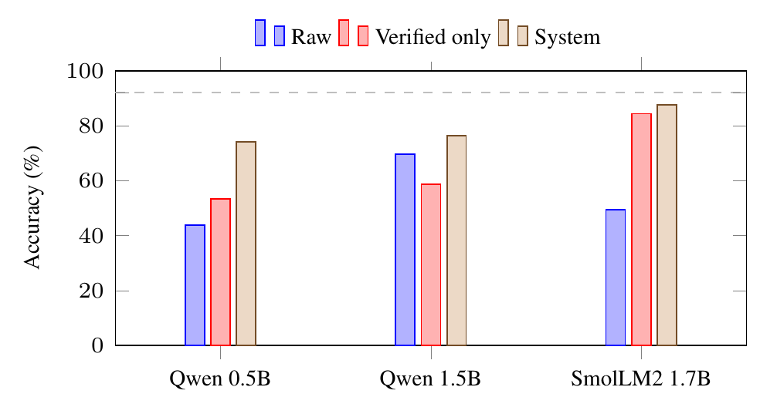
Fig. 2. Task A accuracy by model. The dashed line is extractive answering (92.1%); no generator configuration reaches it.
D. Task B: passage selection
For lay questions the picture differs (Table V). Extractive top-1 selection cited a gold-section passage for 67.4% of drugs. Qwen2.5-1.5B cited only gold passages in 71.9% of answers (p = 0.45 vs extractive) and passed verification for 68.5%; with fallback, system accuracy rose to 77.5%, a significant gain (p = 0.012; 10 items improved, 1 worsened). The model acts as a re-ranker over the three retrieved passages, gaining most on drug-interaction questions (8/11 vs 4/11). The other models did not help: Qwen2.5-0.5B reached 38.2% raw and SmolLM2 11.2% (frequently omitting citations), with system accuracy statistically indistinguishable from extractive. Because Task B scores attribution only, a verified answer can be correctly attributed yet uninformative (e.g. “None of the passages mention who should not take Humira [L1]”).
TABLE V
Task B, lay question per drug: cited passages from the gold label section (89 test drugs)
 | Extractive | Qwen 0.5B | Qwen 1.5B | SmolLM2 1.7B
Raw accuracy | 67.4% | 38.2% | 71.9% | 11.2%
p vs extractive | – | 1.3×10⁻⁵ | 0.45 | 2.4×10⁻¹⁴
Verifier pass rate | – | 37.1% | 68.5% | 18.0%
Accuracy if verified | – | 69.7% | 85.2% | 37.5%
System accuracy | 67.4% | 70.8% | 77.5% | 64.0%
p vs extractive | – | 0.38 | 0.012 | 0.38

E. Closing the gap: polarity-aware verification and scale
After the main comparison we tested three follow-up interventions, choosing every setting on development drugs.
Verifier v2. Two checks were added and applied to the same drafts as Tables III–IV, so only the verifier differs. The structure check rejects a draft that denies a boxed warning when a retrieved passage comes from the Boxed Warning section, or asserts one when none does. The entailment check scores each cited sentence against each passage it cites with a natural-language-inference cross-encoder (nli-deberta-v3-small [21], run on the CPU) and rejects it if P(contradiction) ≥ 0.5 and exceeds P(entailment); this threshold was fixed in advance. The checks are complementary (Table VI): entailment removed all 16 verified false negatives of Qwen2.5-1.5B but none of SmolLM2's false positives, which the structure check removed. With either check, showing verified generations no longer reduced accuracy (93.3% and 92.1% vs 92.1% extractive, p = 1.0). On Task B the checks changed no outcome.
TABLE VI
Verifier variants on identical Task A drafts: system accuracy and verified wrong answers (false “no” / false “yes”); extractive reference 92.1%
Verifier | Qwen 1.5B system | Qwen 1.5B FN / FP | SmolLM2 system | SmolLM2 FN / FP
v1 (citation, number, quote, support) | 76.4% | 16 / 3 | 87.6% | 0 / 7
+ structure check | 92.1% | 2 / 0 | 92.1% | 0 / 0
+ entailment check | 93.3% | 0 / 2 | 87.6% | 0 / 7
+ both | 92.1% | 0 / 0 | 92.1% | 0 / 0

Retrieval. A cross-encoder re-ranker (bge-reranker-base [11]) over the top 20 dense candidates lowered top-1 on all 2,215 test questions (templates and re-wordings) from 65.1% to 52.0% and was rejected on development drugs. Rule-based section routing (e.g. “who should not take” → Contraindications), which adds a bonus to passages of the routed section, was selected. Because we wrote both the routing rules and the question templates, routing reaches 100% on the templates by construction, and we do not count this as a gain. On 1,329 re-worded test questions (three per topic and drug, written after the rules) it raised top-1 from 54.4% to 66.9% (MRR 0.644 → 0.733), although it routed only 32% of them correctly and 7% to a wrong section.
Scale. We repeated Task A with Qwen2.5-3B-Instruct loaded in 4-bit NF4 [22] (2.2 GB, 17.5 tokens/s) and the routed retriever, which surfaced a Boxed Warning passage for every drug that has one (extractive accuracy 100%). Even with the right passage in front of it, the 3B model was correct for 78.7% of drugs, no better than Qwen2.5-1.5B under the same retrieval (79.8%), and the v1 verifier passed 4 false negatives and 4 false positives. Within the 0.5–3B range, scale did not remove polarity errors; verification did.
F. Cost
Peak GPU memory was 1.1, 3.1 and 3.6 GB and throughput 33.0, 20.5 and 22.9 tokens/s for the 0.5B, 1.5B and 1.7B models; median time per answer was 0.7–3.3 s. All fit a 4 GB laptop GPU in fp16. The extractive answer needs no generator and responds in about 0.1 s after retrieval.
VI. Discussion
Extractive answering is the safer default for factual safety claims. On a question with a verifiable yes/no answer, no small generator came close to quoting the retrieved label, and adding verified generations made the system worse. A pilot with Qwen2.5-0.5B on 40 drugs, using hybrid retrieval and four passages, showed the same pattern (35% vs 97.5%).
Verification is necessary but not sufficient. The verifier removed drafts without citations, invented numbers or misquotes (in the pilot it also blocked an unsupported claim that metformin should be avoided in pregnancy), but word-overlap support is blind to negation. Errors were systematic biases—denying or asserting a warning regardless of evidence—rather than random noise, so they pass any test that looks only at shared vocabulary. Polarity-aware checks are needed before generated safety claims can be shown, and our ablation shows they work: an entailment model and a cross-check against label structure each brought system accuracy back to the extractive level, catching different errors.
Generation can help where it selects rather than asserts. On lay questions, Qwen2.5-1.5B improved attribution by choosing among retrieved passages, a role in which an error is visible (the cited passage is shown) rather than hidden in fluent prose.
Model family matters as much as size. SmolLM2-1.7B was larger than Qwen2.5-1.5B but worse on both tasks, mainly through format non-compliance and a uniform “yes” answer, and doubling Qwen to 3B parameters did not improve the factual task.
Negative results. A general-purpose cross-encoder re-ranker hurt retrieval on drug labels, where the section a passage belongs to matters more than topical overlap; this is why routing helped and re-ranking did not.
Limitations. One FAERS quarter and 150 drugs; three models from two families, all below 2B parameters; templated questions rather than real user queries; one factual task with a binary answer; ground truth at the level of label sections, so Task B measures attribution, not clinical correctness; and pattern-based mapping of generated text to yes/no. The structure check covers only the boxed-warning question type; routing rules and paraphrases were written by the authors; and the 3B model was quantised to 4 bits while the others ran in fp16. The evidence corpus is a snapshot and covers PubMed abstracts only.
VII. Conclusion
In a local pharmacovigilance RAG system, extractive answering over well-retrieved FDA label passages was more accurate than generation by small language models on a factual safety question, and a citation-and-support verifier could not prevent confident polarity errors from reaching the answer. Small generators were useful only for selecting which passage answers a lay question, and a 3B model was no more reliable than a 1.5B one. Polarity-aware verification—an entailment model plus a cross-check against label structure—removed the verified polarity errors and brought the system back to extractive accuracy. We recommend that local drug-safety assistants state factual safety claims extractively, reserve small generators for selection and presentation, and adopt polarity-aware verification before allowing generated claims. Future work will extend structure checks beyond boxed warnings and evaluate on real user questions with expert-judged answers.
References
[1] S. J. W. Evans, P. C. Waller, and S. Davis, “Use of proportional reporting ratios (PRRs) for signal generation from spontaneous adverse drug reaction reports,” Pharmacoepidemiology and Drug Safety, vol. 10, no. 6, pp. 483–486, 2001.
[2] E. P. van Puijenbroek, A. Bate, H. G. M. Leufkens, M. Lindquist, R. Orre, and A. C. G. Egberts, “A comparison of measures of disproportionality for signal detection in spontaneous reporting systems for adverse drug reactions,” Pharmacoepidemiology and Drug Safety, vol. 11, no. 1, pp. 3–10, 2002.
[3] G. N. Norén, J. Hopstadius, and A. Bate, “Shrinkage observed-to-expected ratios for robust and transparent large-scale pattern discovery,” Statistical Methods in Medical Research, vol. 22, no. 1, pp. 57–69, 2013.
[4] M. Hauben and J. K. Aronson, “Defining ‘signal’ and its subtypes in pharmacovigilance based on a systematic review of previous definitions,” Drug Safety, vol. 32, no. 2, pp. 99–110, 2009.
[5] P. Lewis et al., “Retrieval-augmented generation for knowledge-intensive NLP tasks,” in Advances in Neural Information Processing Systems, vol. 33, 2020, pp. 9459–9474.
[6] J. Maynez, S. Narayan, B. Bohnet, and R. McDonald, “On faithfulness and factuality in abstractive summarization,” in Proc. 58th Annual Meeting of the Association for Computational Linguistics, 2020, pp. 1906–1919.
[7] Z. Ji et al., “Survey of hallucination in natural language generation,” ACM Computing Surveys, vol. 55, no. 12, pp. 248:1–248:38, 2023.
[8] T. Gao, H. Yen, J. Yu, and D. Chen, “Enabling large language models to generate text with citations,” in Proc. 2023 Conf. Empirical Methods in Natural Language Processing, 2023, pp. 6465–6488.
[9] H. Rashkin et al., “Measuring attribution in natural language generation models,” Computational Linguistics, vol. 49, no. 4, pp. 777–840, 2023.
[10] S. Robertson and H. Zaragoza, “The probabilistic relevance framework: BM25 and beyond,” Foundations and Trends in Information Retrieval, vol. 3, no. 4, pp. 333–389, 2009.
[11] S. Xiao, Z. Liu, P. Zhang, and N. Muennighoff, “C-Pack: Packaged resources to advance general Chinese embedding,” arXiv:2309.07597, 2023.
[12] G. V. Cormack, C. L. A. Clarke, and S. Büttcher, “Reciprocal rank fusion outperforms Condorcet and individual rank learning methods,” in Proc. 32nd Int. ACM SIGIR Conf. Research and Development in Information Retrieval, 2009, pp. 758–759.
[13] Y. Gu et al., “Domain-specific language model pretraining for biomedical natural language processing,” ACM Transactions on Computing for Healthcare, vol. 3, no. 1, pp. 1–23, 2021.
[14] F. Liu, E. Shareghi, Z. Meng, M. Basaldella, and N. Collier, “Self-alignment pretraining for biomedical entity representations,” in Proc. 2021 Conf. North American Chapter of the Association for Computational Linguistics (NAACL-HLT), 2021, pp. 4228–4238.
[15] Y. Geifman and R. El-Yaniv, “Selective classification for deep neural networks,” in Advances in Neural Information Processing Systems, vol. 30, 2017.
[16] P. Rajpurkar, R. Jia, and P. Liang, “Know what you don't know: Unanswerable questions for SQuAD,” in Proc. 56th Annual Meeting of the Association for Computational Linguistics, 2018, pp. 784–789.
[17] U.S. Food and Drug Administration, “FDA Adverse Event Reporting System (FAERS) quarterly data extract files, 2025 Q1,” 2025. [Online]. Available: https://fis.fda.gov/extensions/FPD-QDE-FAERS/FPD-QDE-FAERS.html
[18] T. A. Kass-Hout et al., “OpenFDA: An innovative platform providing access to a wealth of FDA's publicly available data,” Journal of the American Medical Informatics Association, vol. 23, no. 3, pp. 596–600, 2016.
[19] Qwen Team, “Qwen2.5 technical report,” arXiv:2412.15115, 2024.
[20] L. Ben Allal et al., “SmolLM2: When smol goes big — Data-centric training of a small language model,” arXiv:2502.02737, 2025.
[21] P. He, J. Gao, and W. Chen, “DeBERTaV3: Improving DeBERTa using ELECTRA-style pre-training with gradient-disentangled embedding sharing,” in Proc. 11th Int. Conf. Learning Representations (ICLR), 2023.
[22] T. Dettmers, A. Pagnoni, A. Holtzman, and L. Zettlemoyer, “QLoRA: Efficient finetuning of quantized LLMs,” in Advances in Neural Information Processing Systems, vol. 36, 2023.

