## **ADMIN MODULE**

**Dashboard Section**

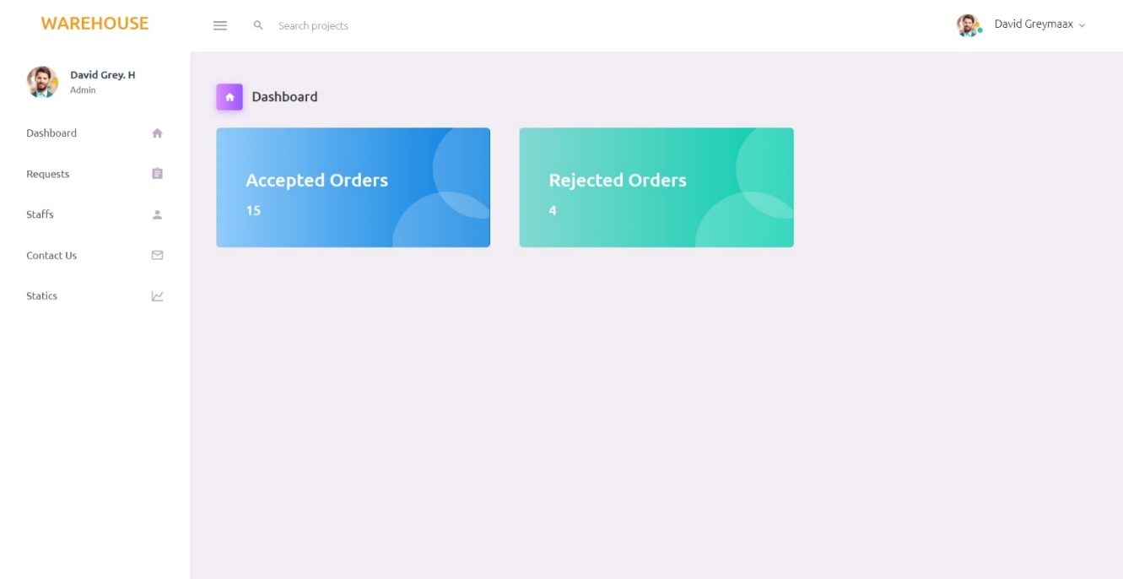

1.When you click on the dashboard option in the sidebar, you will see this page.

2.This page contains two cards, Accepted orders and Rejected orders.

3.Above the cards the page have a heading Dashboard.

4. Click anywhere in the Accepted orders card then redirect Accepted orders page.

5. Click anywhere in the Rejected orders card then redirect into Rejected orders page.

**Accepted Orders Table:**

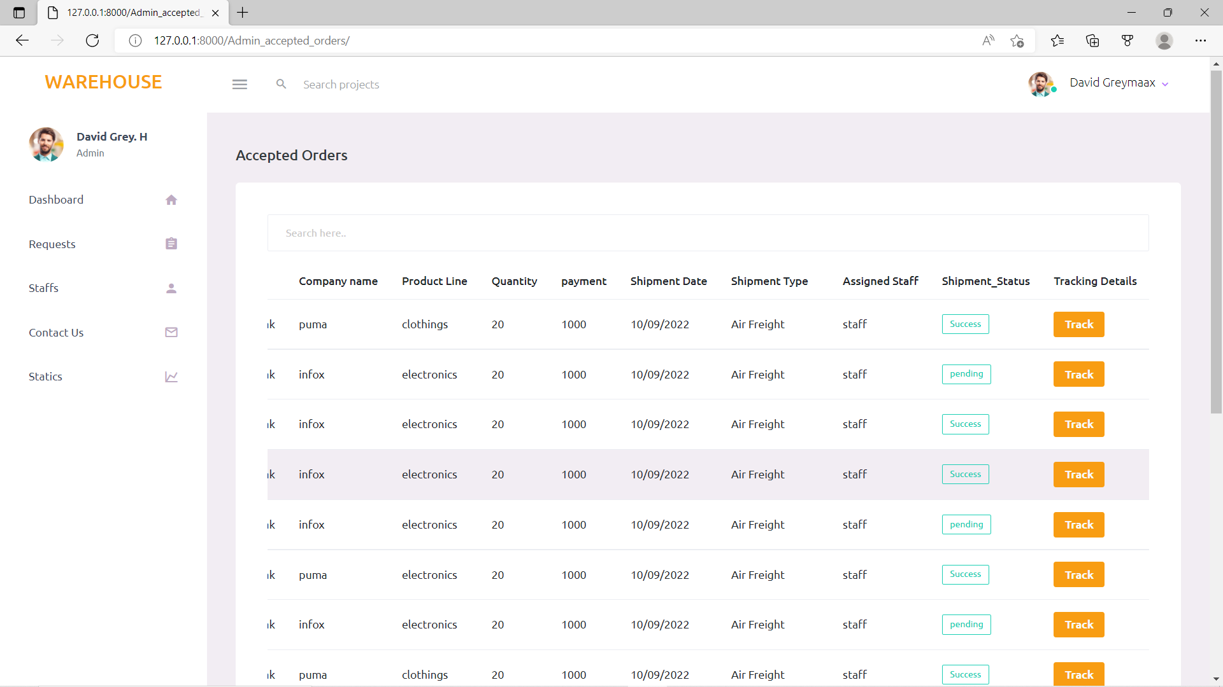

1.When you click on the Accepted orders card in the dashboard you will see this page.

2.You can see the Accepted orders details like Name, Company Name, Product line, Quantity, Payment, Shipment, Shipment Date, Assigned Staff, Shipment Status and Tracking Details here

3.Table ordered in the last assigned details are coming first.

4.Here you can see the order’s tracking details by clicking the track button

5.When you click on the tracking button you can see a modal. In that modal you can see the tracking details given by staff.

6. The search option is included in the table. You can search the order by company name using the search box.

**Rejected Orders Page:**

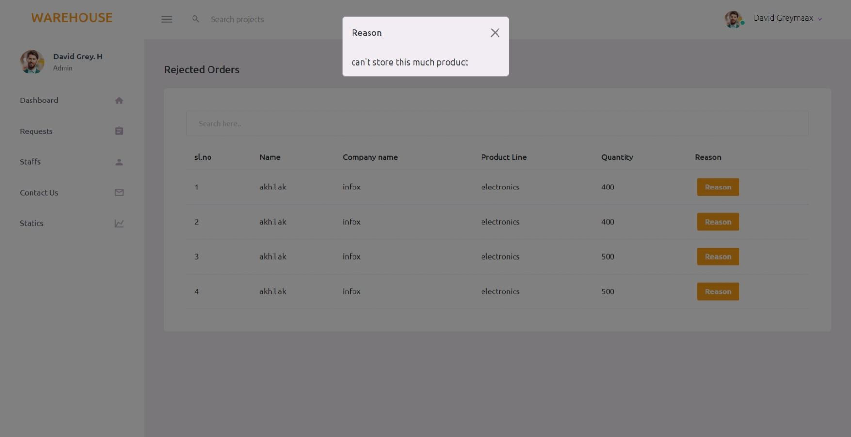

1.When you click on the Rejected orders card in the dashboard you will see this page.

2.You can see the Rejected orders details like Name, Company Name, Product line, Quantity and Rejected reason here

3.Table ordered in the last assigned details are coming first.

4.Here you can see the order’s rejected reason by clicking the reason button

5.When you click on the reason button you can see a modal. In that modal you can see the reason why the order is rejected. This is reason is sent from staff.

6. The search option is included in the table. You can search the order by company name using the search box.

**Request Section**

**Department Cards:**

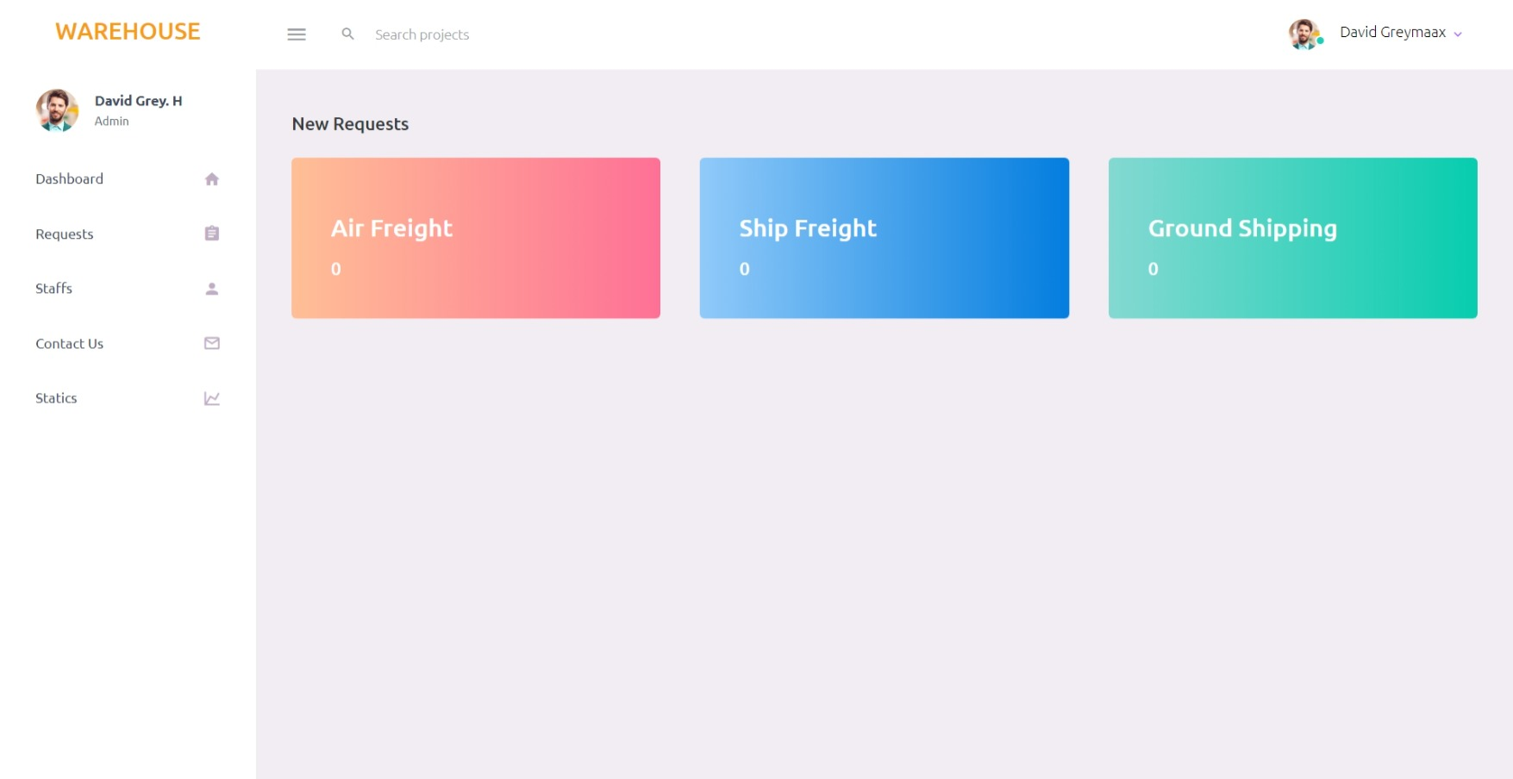

1.When you click on the Requests option in the sidebar, you will see this page.

2.This page contains 3 cards, Air Freight, Ship Freight and Ground Shipping.

3.Above the cards the page has a heading new request.

4.By clicking any of the card you can see the requests send by users for that department.

**New Request:**

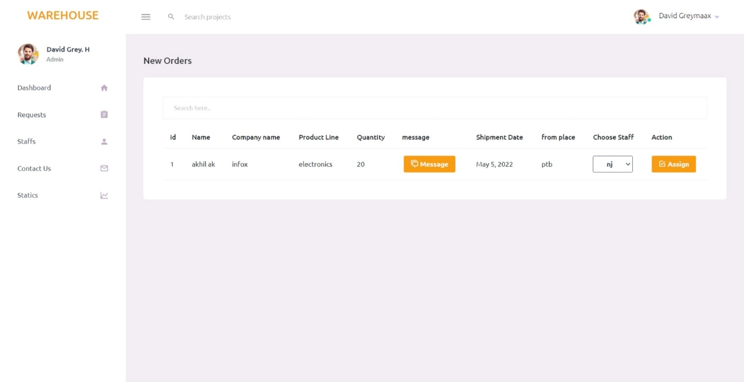

1.When you click on any department in the previous page, you will see this page.

2.You can see the new order details like Name, Company Name, Product line, Quantity, message, Shipment Date and from place here

3.Table ordered in the last assigned details are coming first.

4.Here you can choose the staff in that specific department and assign the order to them.

5.By clicking the assign button the order will assign to that selected staff

6. The search option is included in the table. You can search the order by company name using the search box.

**Staff Section**

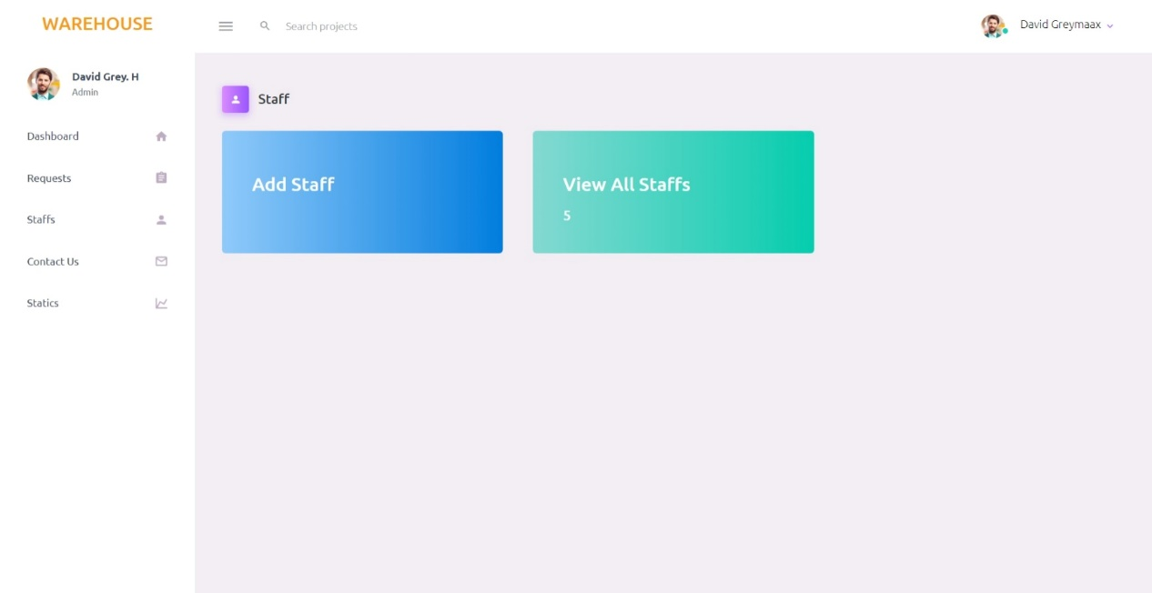

1.When you click on the staff option in the sidebar, you will see this page.

2.This page contains 2 cards, add staff and view all staff.

3.Above the cards the page has a heading staff.

4.By clicking on the add staff card you can add a new staff.

5.By clicking the view all staffs card you can see all the staffs details currently available

**Add Staffs:**

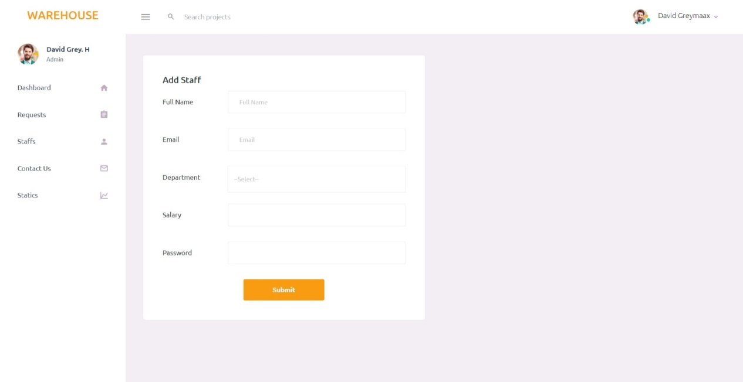

1.When you click on add staff card, you will see this page.

2.You can add a new a staff here by filling the form. form contains staff name, email, department, salary, password.

3.You can choose the department that staff need to be working by selecting options in the dropdown menu.

4.By clicking the submit button a new staff will be create.

6. The created staff can login to the website using email and password entered here.

**View All Staffs:**

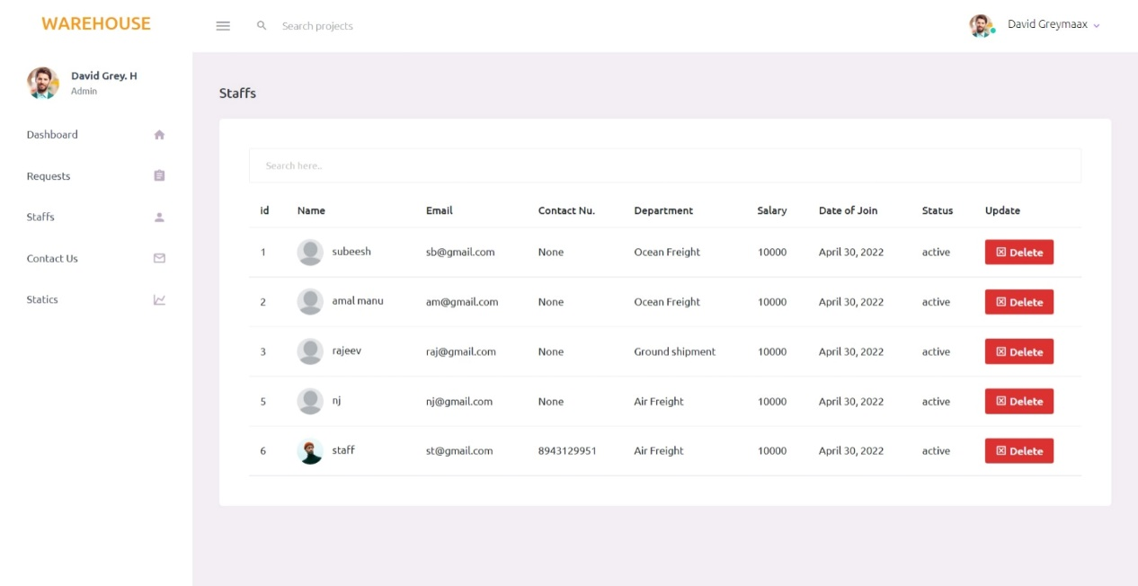

1.When you click on the view all staff card, you will see this page.

2.You can see the staff’s details like Name, Email, Contact Number, Department, Salary, Date Of Join and their status here

3.Table ordered in the last assigned details are coming first.

4. A delete option is given to delete the staff

5. The search option is included in the table. You can search the order by company name using the search box.

**Statics Section**

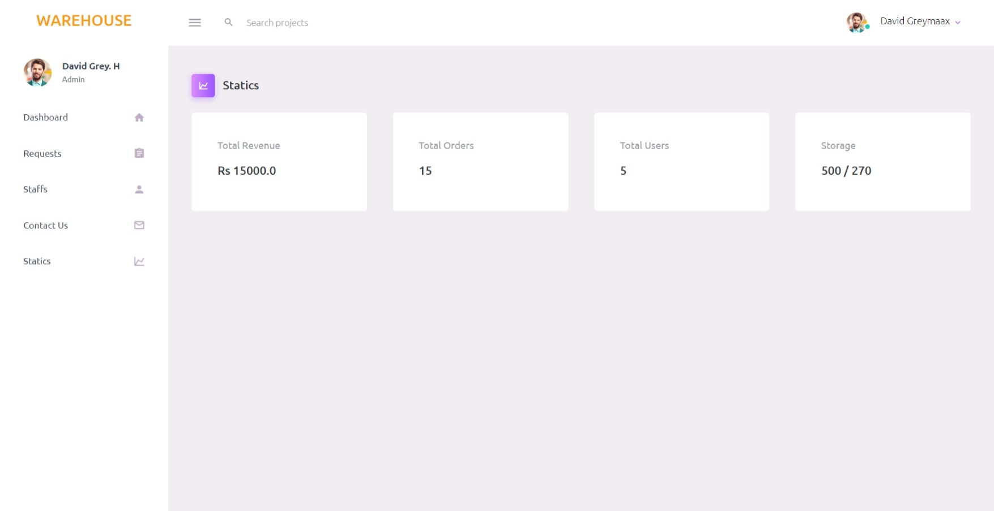

1.When you click on the statics option in the sidebar, you will see this page.

2.This page contains 4 cards, Total revenue, Total orders Total Users and Storge.

3.Above the cards the page has a heading Statics.

4.The first card shows the total revenue so far.

5.The second card shows the total orders done.

6.The third card shows the total count of users registered on the website.

7.The forth card shows the total storage warehouse have and how much storage currently used.