A Project Report

On

**“**TOURISM MANAGEMENT SYSTEM**”**

Submitted By

Mr. AKHIL PANDEY

&

Mr. RITIK MEHTA

Guided By

Dr. JYOTI RANA

Submitted To



NaranLala College of Professional and Applied Sciences,

Veer Narmad South Gujarat University, Surat.

Year: 2021-2022



**NARANLALA**

**COLLEGE OF PROFESSIONAL & APPLIED SCIENCES**

**BHAGVATI SANKUL, NEAR ERU CHAR RASTA,**

**NAVSARI – 396 450**

**CERTIFICATE**

This is to certify that **Mr. AKHIL PANDEY,** Exam No.2019008796 and **Mr. RITIK MEHTA,** Exam No.2019008781 students of **B.C.A. 6th** **semester** of our college have successfully prepared and submitted Project Report on “E-Library Management System” as a partial fulfilment for the course of **Bachelor of Computer Application** during the academic year **2021-2022**.

21-04-2022 Jyoti R. Rana

**DATE Guide: Ms.**

_________________ __________________

**Dr. S. M. NAIK Dr. A. B. PATEL**

**(I/C PRINCIPAL, NLCPAS) (DEPT. HEAD, BCA)**

________________

**(EXTERNAL EXAMINER)**

**Index**

|  |  |  |
| --- | --- | --- |
| ***No.*** | ***Topic name*** | ***Page No.*** |
| **1** | **Abstract** | **3** |
| **2** | **Preface** | ***4*** |
| **3** | **Project Profile** | ***5*** |
| **4** | **Objective** | ***6*** |
| **5** | **Existing System** | **7** |
| **6** | **Proposed System** | **8** |
| **7** | **System Environment** | **10** |
| **8** | **Modules** | **12** |
| **9** | **Software Development Life Cycle** | **15** |
| **10** | **Data Flow Diagram** | **18** |
| **11** | **Data Dictionary** | **22** |
| **12** | **ER Diagram** | **30** |
| **13** | **Screen Short of Project** | **35** |
| **14** | **Testing & Conclusion** | **48** |
| **15** | **Reference** | **53** |

**Abstract**

As the name specifies “TOURISM MANAGEMENT SYSTEM” is software developed for managing tour booking.

Identification of the drawbacks of the existing system leads to the designing of computerized system that will be compatible to the existing system with the system which is more user friendly and more GUI oriented. We can improve the efficiency of the system, thus overcome the drawbacks of the existing system.

· Less human error

· Strength and strain of manual Labor can be reduced

· High security

· Data redundancy can be avoided to some extent

· Data consistency

· Easy to handle

· Easy data updating

· Easy record keeping

· Backup data can be easily generated

**Preface**

It is great pleasure for us as a student of **NaranLala College of Professional & Applied Sciences** to project on the “**Tourism Management System**” for the partial fulfillment of the requirement of **BCA** (Bachelor of Computer Application) semester 6 from **Veer Narmad South Gujarat University, Surat**.

As a student of computer/IT field we encouraged by growth and rapid development in the software industries, keeping in mind that increase demand for software, web application & software engineers, the university has arranged project work for the final year.

Thus, it is our Moral & mandatory duty to take this project as a part of our studies with great enthusiasm & seriousness. For this we have gone through a development program of 3 months.

The document describes each of the phases of development of the software lifecycle.

**Project profile**

|  |  |
| --- | --- |
| **Project Profile** | |
| **Project Name** | Tourism Management System |
| **Project Type** | Website |
| **Team Strength** | 2 Developers |
| **Front End** | PHP, JAVASRCIPT, CSS,HTML |
| **Back End** | MYSQL |
| **Operating System** | Windows10 |
| **Submitted To** | Naran Lala College Of Professional And Applied Science |
| **Internal Guide** | Dr. Jyoti Rana |
| **Submitted By** | Mr. Akhil Pandey  Mr. Ritik Mehta |

***Objective***

* The objective of the project is to develop a system that automates the processes and activities of a travel and tourism agency.
* The purpose is to design a system using which one can perform all operations related to traveling and sight-seeing.

***Existing System***

* In the present system a customer has to approach various agencies to find details of places and to book tickets.
* This often requires a lot of time and effort.
* A customer may not get the desired information from these offices and often the customer may be misguided.

It is tedious for a customer to plan a particular journey and have it executed properly

***Proposed system***

* The proposed system is a web based application and maintains a centralized repository of all related information.
* The system allows one to easily access the relevant information and make necessary travel arrangements.
* Users can decide about places they want to visit and make bookings online for travel and accommodation.

**Advantages of Proposed System:-**

* Customers can book tickets from anywhere and at any place.
* Save time and efforts.
* Choose any location for visiting faster and easier at one place.
* Save time of travelling to the shop.
* Comparing and researching products and their prices is so much easier online.
* So many option to plan preferred place for traveling.
* Get detailed information about the place of visiting.
* Good and tension free booking services.

## SYSTEM ENVIRONMENT

1. **Software Requirement**

Software is necessary as well as hardware to run system. The software that is used for the system may be in the form of application software or operating system. Certain software which is used in the website is listed below:

|  |  |
| --- | --- |
| **Front End** | PHP |
| **Back End** | MySQL |
| **Platform** | Core PHP |
| **Web Server** | WAMP SERVER |
| **Operating System** | Windows 10 |
| **IDE** | Notepad++ |
| **Browser** | Google Chrome |
| **Script** | Java Script |
| **Style** | CSS, Bootstrap |
| **Client Side Scripting** | HTML |

**2) Hardware Requirement**

Hardware product is necessary part to run a system. Here, we describe different hardware used in computerized system.

|  |  |
| --- | --- |
| **Processor** | AMD A9-9420 RADEON R5, 5 COMPUTE CORES 2C+3G, 3000 MHz, 2 Core(s), 2 Logical Processor(s) |
| **RAM** | 8 GB |
| **Back up** | Pen drive |

**Modules**

After careful analysis the system has been identified to have the following modules:

##### **Administrator module**

1. **User(Traveler) module**
2. **Guest user**

##### **Administrator module**

This module provides administrator related functionality. Administrator manages all information and has access rights to add, delete, edit and view the data related to places, travels, routes, bookings, Enquiries etc.

* **Packages—**Admin will create the packages and Manage the packages(Create ,Update, delete)
* **Users-** Admin view all Information of all users.
* **Booking-** Admin will responsible for manage booking. Admin can confirm and cancel a booking of traveler.
* **Manage issues/ Complaints**—Admin can take action on any issue /complaint raised by user (traveler) and Put remark.
* **Manage Enquiries—**admin can manage all enquiries raised by users (Traveler).
* **Manage pages-** Admin can edit the info of all pages that are display on the website,
* **Change password---** Admin can change own password.

##### **USER (TRAVELLER) MODULE:**

* + - **Signup-** User can register yourself for Booking.
    - **Sign in-** Here user can login with valid username and password.
    - **Forgot Password—**User can recover his/her own password.
    - **My Profile-** user can update own profile.
    - **Tour history-**After login user can book any tour that will show in Tour history. User can cancel his/her booking before 24hr of travelling.

##### **Change Password** User can own Password.

* + - **Write-use—**Here user can raise any issue related to booking, Cancelation etc.

1. **Guest Module**

* Guest user can visit the website and view the all content of website. Guest user can also Enquiry.

**Software Development Life Cycle**

**SPIRAL MODEL:**

SPIRAL MODEL was defined by Barry Boehm in his 1988 article, “A spiral Model of Software Development and Enhancement. This model was not the first model to discuss iterative development, but it was the first model to explain why the iteration models.

As originally envisioned, the iterations were typically 6 months to 2 years long. Each phase starts with a design goal and ends with a client reviewing the progress thus far. Analysis and engineering efforts are applied at each phase of the project, with an eye toward the end goal of the project.

**The steps for Spiral Model can be generalized as follows**:

The new system requirements are defined in as much details as possible. This usually involves interviewing a number of users representing all the external or internal users and other aspects of the existing system.

A preliminary design is created for the new system.

A first prototype of the new system is constructed from the preliminary design. This is usually a scaled-down system, and represents an approximation of the characteristics of the final product.

A second prototype is evolved by a fourfold procedure:

1. Evaluating the first prototype in terms of its strengths, weakness, and risks.
2. Defining the requirements of the second prototype.
3. Planning a designing the second prototype.

**Advantage:**

* Estimates (i.e. budget, schedule etc.) become more realistic as work progresses, because important issues discover earlier.
* It is more able to cope with the changes that are software development generally entails.

Software engineers can get their hands in and start woring on the core of a project earlier

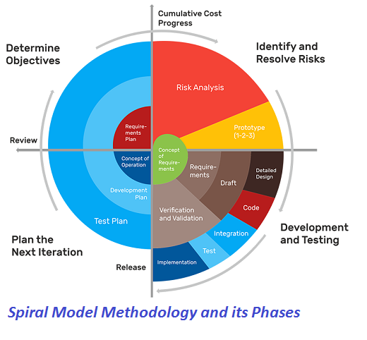

Data flow diagram :

DFD are used to graphically represent the flow of data in a business information system. DFD describes the processes that are involved in system to transfer data from the input to the file storage and reports generation. DFD graphically representing the function or processes which capture, manipulate, store and distribute data between a system and its environment and between components of a system.

**Symbol used in DFD**

|  |  |
| --- | --- |
| **Symbols** | **Description** |
|  | **Process:** Here flow of data is transformed. |
|  | Entity: A source or destination of data which is external to the system. |
|  | **Data Flow:** It is a packet of data. It may be in the form of a document, letter, telephone call etc. |
|  | **Data Store:** Any store data but with no reference to the physical method of storing. |

Response Request

User

Admin

Request Response

CONTEX level dfd

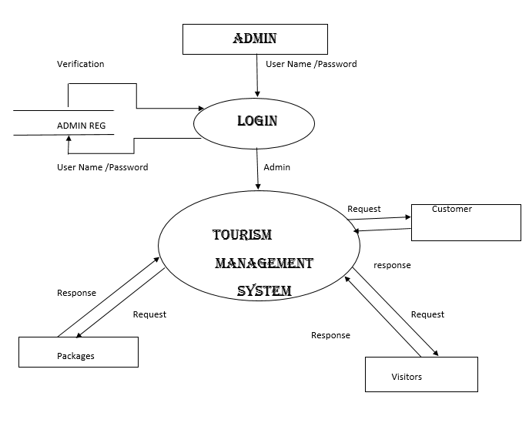

FIRST LEVEL DFD FOR ADMIN

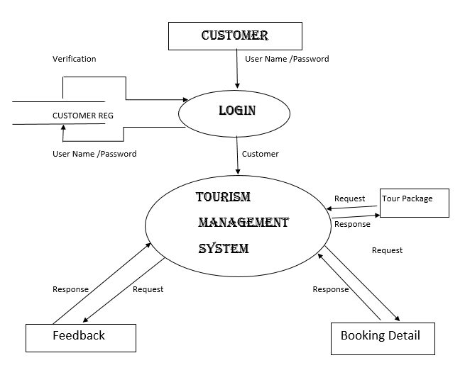

First level dfd for customer

**Data Dictionary**

The Data Dictionary is a responsibility of various data files in DFD. The associated data dictionary states precisely the structure of each data flow in the DFD.

DFD Dictionary stores description of data and structure as well as system processes. It is intended to be used understand the system by analyst who retrieves the details and description are store.

They also perform cross reference checking and error detection. Automated at dictionary system are becoming the development of computer information system.

**Table structure**

* **Table Name** : Admin
* **How to use :** For Admin Login

|  |  |  |  |  |
| --- | --- | --- | --- | --- |
| **Field Name** | **Data Type** | **Size** | **Description** | **Constraint** |
| ID | Integer | 11 | For ID of Admin | Primary |
| User Name | Varchar | 100 | Admin Name | Not Null |
| Password | Varchar | 100 | Admin Password | Not Null |
| Updationdate | timestamp |  | For last update of password of admin | Not Null |

* **Table Name** : TBL Booking
* **How to use :** For Booking

|  |  |  |  |  |
| --- | --- | --- | --- | --- |
| **Field Name** | **Data Type** | **Size** | **Description** | **Constraint** |
| Booking ID | Integer | 11 | For Booking ID | Not Null |
| Package ID | Integer | 11 | For Package ID | Not Null |
| User Email | Varchar | 100 | For User Email | Not Null |
| From Date | Varchar | 100 | For Date of going for tour | Not Null |
| To date | Varchar | 100 | For last date of tour | Not Null |
| Comment | MediumText |  | Comment of user for package | Not Null |
| RegDate | Time Stamp |  | Registration date of package | Current Timestamp |
| Status | Integer | 11 | Status of booking confirm or not | Not Null |
| Cancelled by | Varchar | 5 | Cancellation of package | Not Null |
| Updation Date | Time Stamp |  | Updation of Package | Not Null |

* **Table Name** : TBLenquiry
* **How to use :** Here User can Enquire of Their Question

|  |  |  |  |  |
| --- | --- | --- | --- | --- |
| **Field Name** | **Data Type** | **Size** | **Description** | **Constraint** |
| ID | Integer | 11 | ID of enquiry | Primary Key |
| Full Name | Varchar | 100 | Name of user | Not Null |
| Email ID | Varchar | 100 | Email ID of user | Not Null |
| Mobile No. | Number | 10 | User Mobile Number | Not Null |
| Subject | Varchar | 100 | Enquiry Subject | Not Null |
| Description | Medium Text |  | Description of enquiry | Not Null |
| Posting Date | Time stamp |  | Current time stamp of posting enquiry | Time stamp |
| Status | Integer | 1 | Status of enquiry | Not Null |

* **Table Name** : TBLissues
* **How to use :** Here user can raise their issues

|  |  |  |  |  |
| --- | --- | --- | --- | --- |
| **Field Name** | **Data Type** | **Size** | **Description** | **Constraint** |
| ID | Integer | 11 | ID of enquiry | Primary Key |
| Email ID | Varchar | 100 | Email ID of user | Not Null |
| Issues | Varchar | 100 | User’s Issues | Not Null |
| Description | Medium Text |  | Description of issues | Not Null |
| Posting Date | Time stamp |  | Current time stamp of posting enquiry | Time stamp |
| Admin Remark | Medium Text |  | Admin ‘s Remark | Null |
| Admin Remark Date | Time Stamp |  | Admin Remark’s date | Null |

* **Table Name** : TBLpage
* **How to use :** Admin uses to create information pages

|  |  |  |  |  |
| --- | --- | --- | --- | --- |
| **Field Name** | **Data Type** | **Size** | **Description** | **Constraint** |
| ID | Integer | 11 | Page of ID | Primary Key |
| Type | Varchar | 255 | Type of page | Not Null |
| Detail | Long Text |  | Detail of Page | Not Null |

* **Table Name** : TBLtourpackages
* **How to use :** To create tour Packages

|  |  |  |  |  |
| --- | --- | --- | --- | --- |
| **Field Name** | **Data Type** | **Size** | **Description** | **Constraint** |
| Package ID | Integer | 11 | ID of Package | Primary Key |
| Package Name | Varchar | 200 | Name of Package | Not Null |
| Package Type | Varchar | 150 | Type of Package | Not Null |
| Package Location  Locat | Varchar | 100 | Location of Package | Not Null |
| Package Price | Integer | 11 | Price of Package | Not Null |
| Package Feature | Medium Text | 255 | Feature of Package | Not Null |
| Package Detail | Medium Text |  | Detail of Package | Not Null |
| Package Images | Varchar | 100 | Image of Package | Not Null |
| Creation Date | Time Stamp |  | Creation Date of Package | Currrent Timestamp |
| Updation Date | Time Stamp |  | Updation Date of Package | Not Null |

* **Table Name** : TBLusers
* **How to use :** information of users saved here

|  |  |  |  |  |
| --- | --- | --- | --- | --- |
| **Field Name** | **Data Type** | **Size** | **Description** | **Constraint** |
| ID | **Integer** | **11** | **ID of user** | **Primary Key** |
| Full Name | **Varchar** | **100** | **Name of user** | **Not Null** |
| Mobile Number | **Number** | **10** | **Mobile Number of user** | **Not Null** |
| Email | **Varchar** | **70** | **Email of user** | **Not Null** |
| Password | **Varchar** | **100** | **Password of user** | **Not Null** |
| Reg Date | **Time Stamp** |  | **Registration Date of user** | **Current Timestamp** |
| Updation Date | **Time Stamp** |  | **Updation Date of user** | **Current Time Stamp** |
| Otp | **Float** |  | **For otp** | **Null** |

**Entity Relational Model**

It is also called as Entity Relationship Diagram, is graphical representation of entities and their relationship to each other.

It is a graphical representation of logical structure of database.

An ER model is model typically implemented as a database.

An ER model is model is based on the concept of real world.

It consists of collection of objects known as Entities and Relationship among those Entities.

* **Major Components of ER Model**

1. **Entity** :

An Entity is a “Thing” or “object” that exist in real world and which is unique from other objects.

It can be anything like person, car, place, building etc.

1. **Attributes** :

Each Entity is described by a set of feature or properties.

All Attributes have values.

These attributes identifier each Entity uniquely.

Ex attribute of student Entity is Roll no, Name, DOB, Age, Add etc.

1. **Relationship** :

A Relationship describes relations between entities.

Each participating entity performs a function or role in a relationship.

**The symbol and the notation used in ER-Diagram are as follows:**

* 1. Rectangle

It represents entity set.

* 1. Ellipse

It represents attributes.

* 1. Diamonds

It represents entity relationship among the entity set.

* 1. Line

It line link between entity sets and their relationship.

**ER DIAGRAM FOR USER**

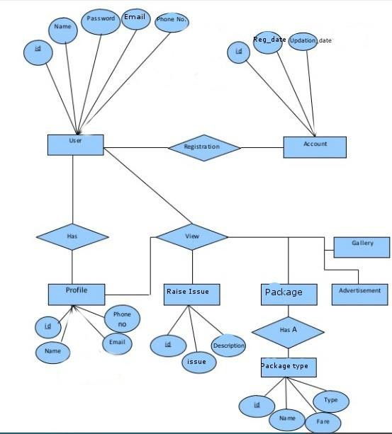

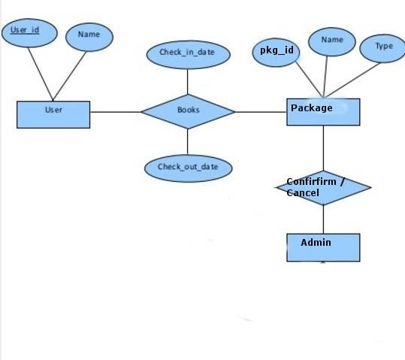

**ER DIAGRAM FOR ADMIN**

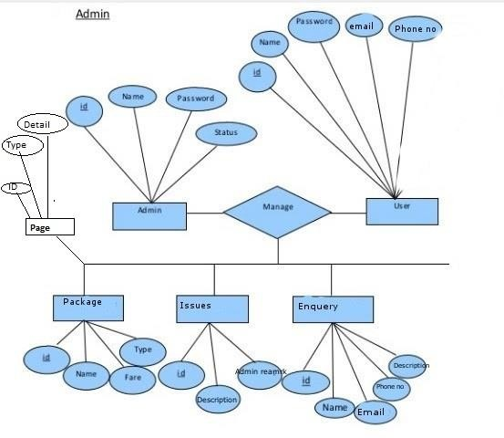

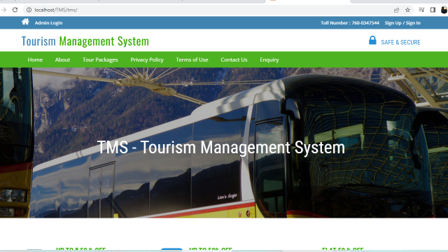

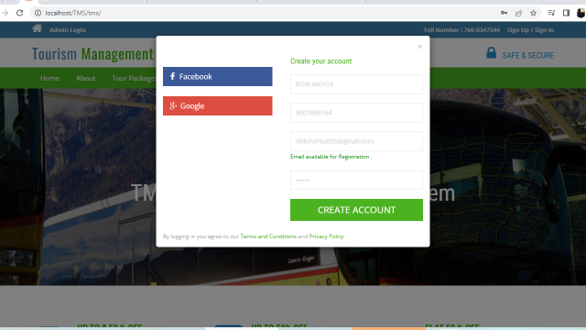

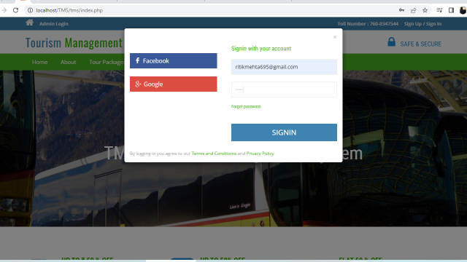

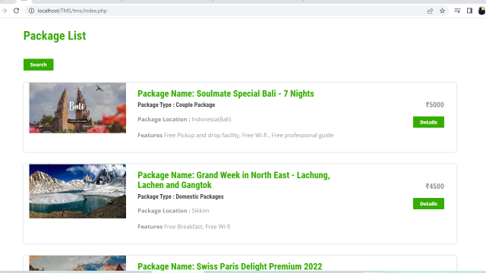

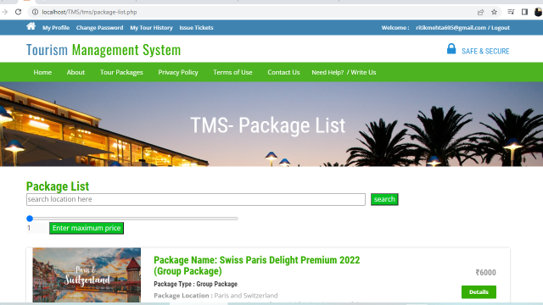

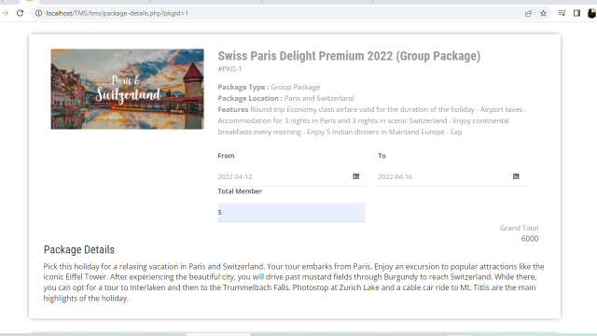

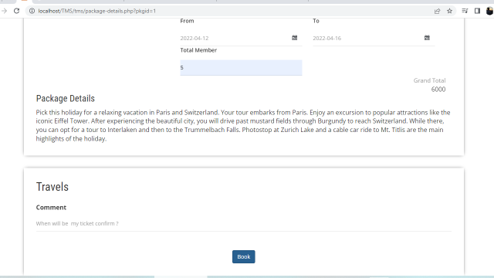

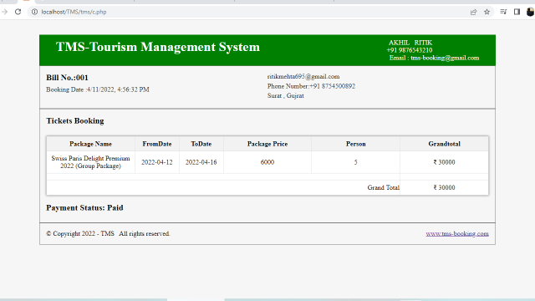

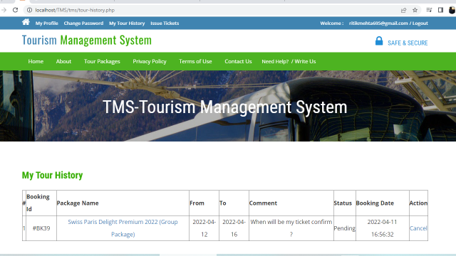

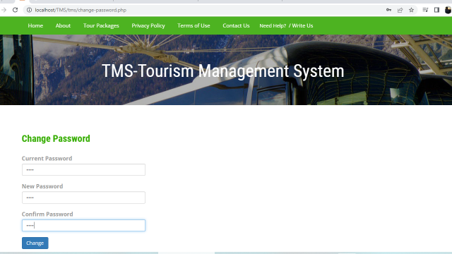

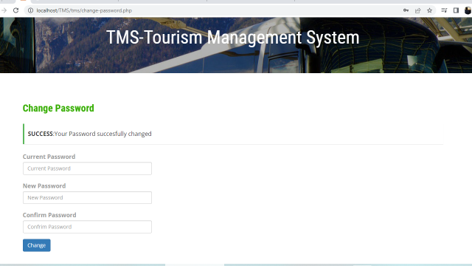

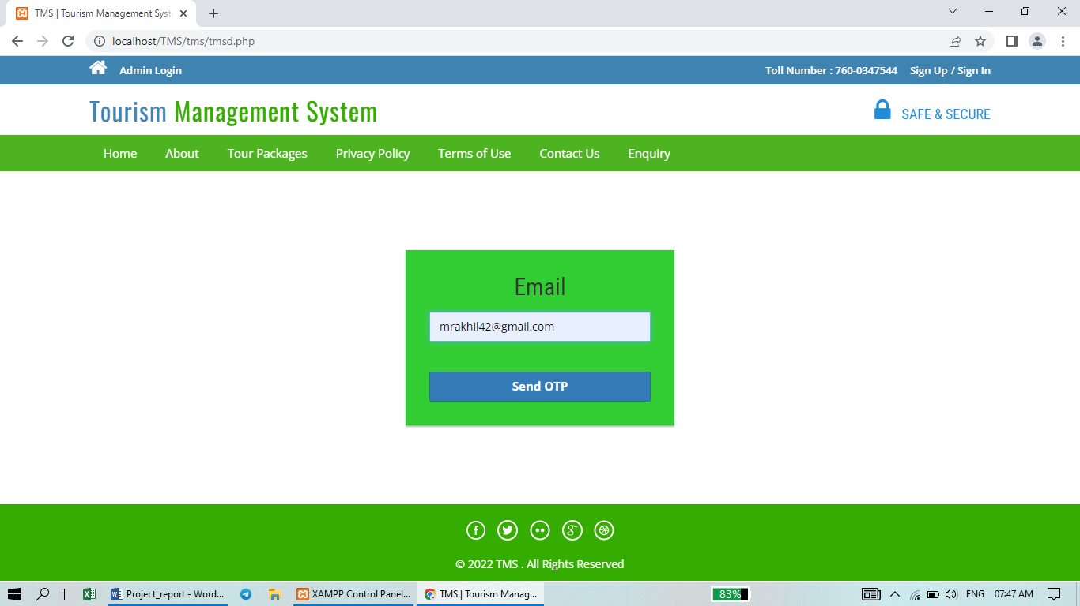

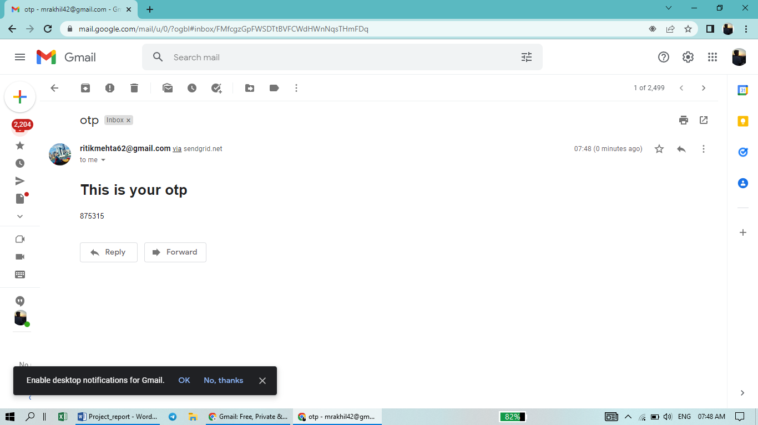

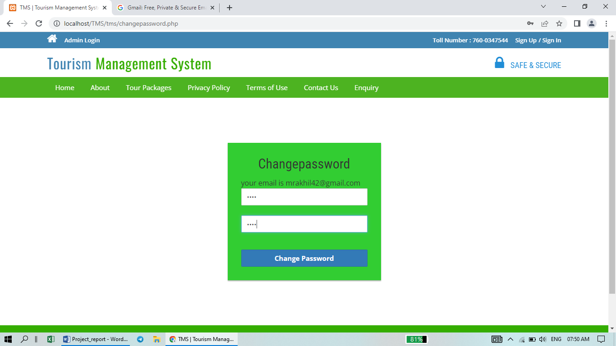

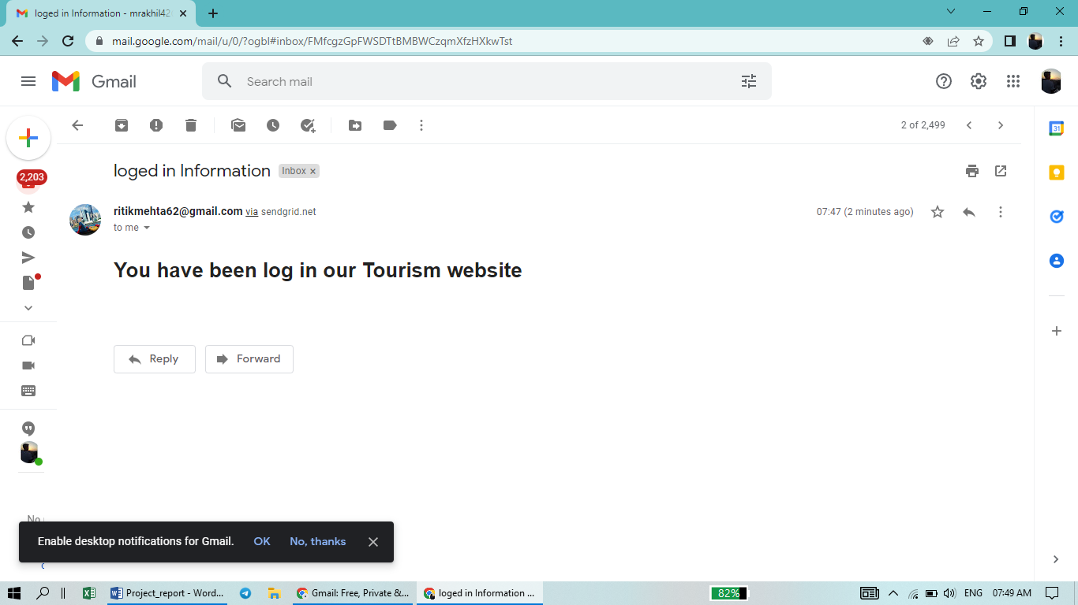

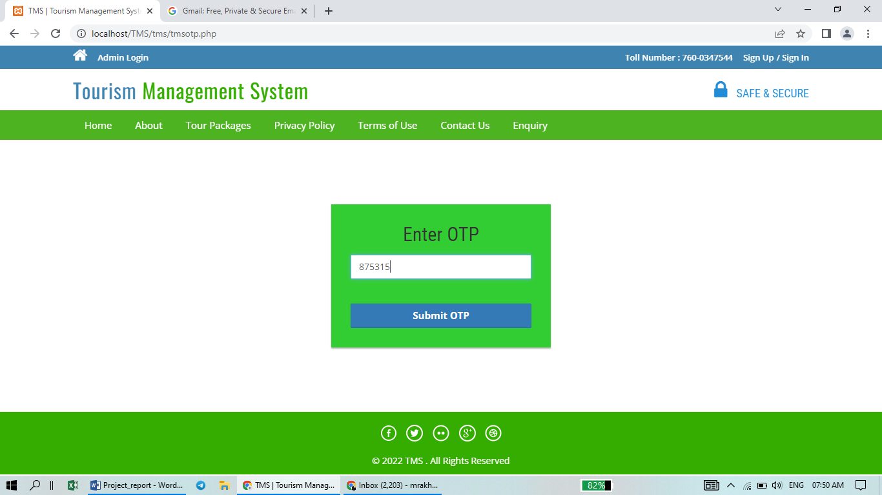

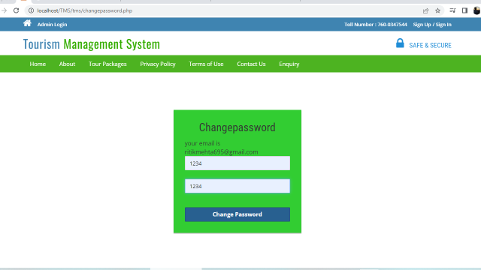

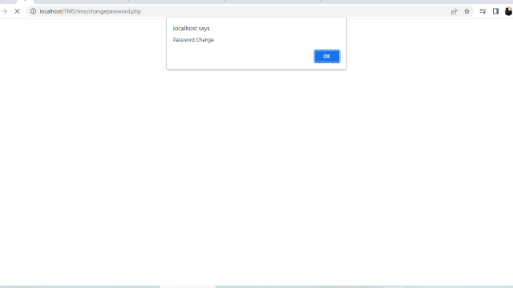

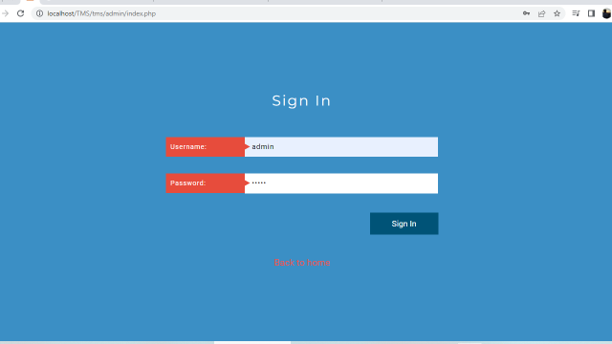

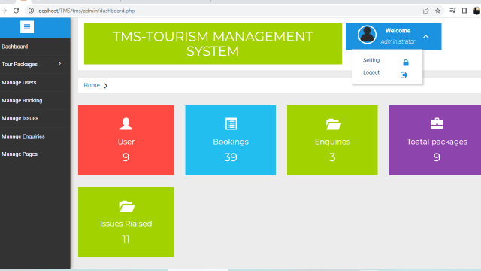

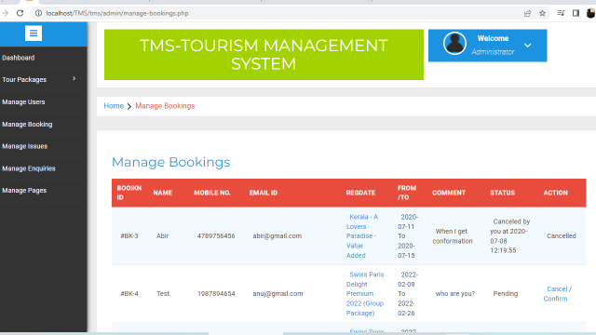

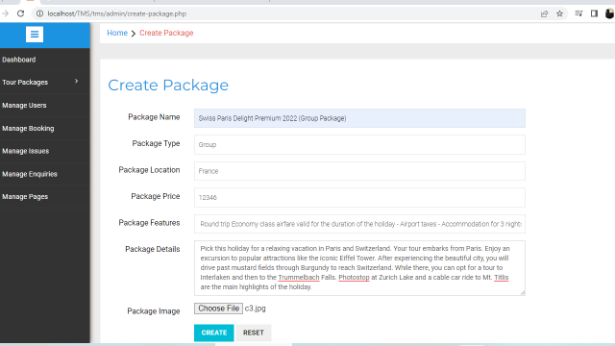

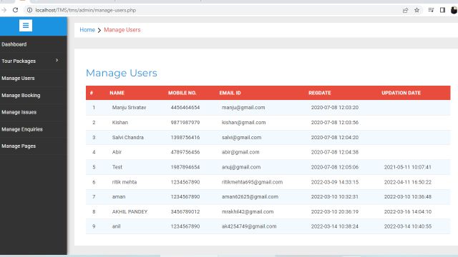

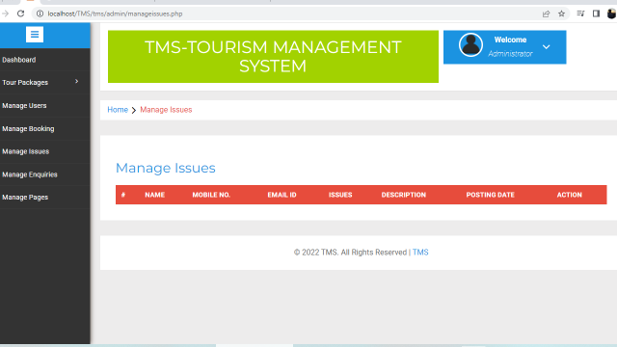

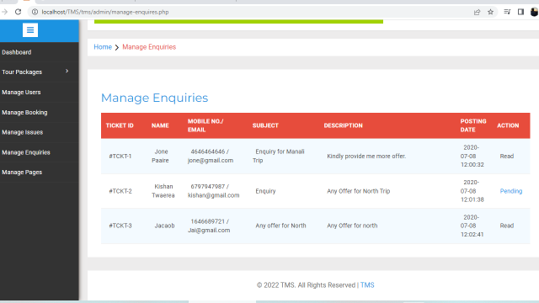

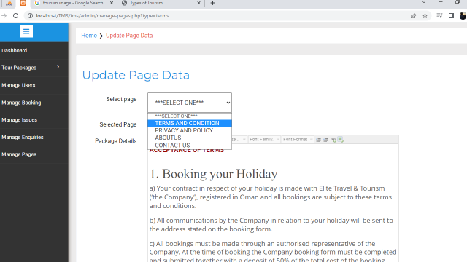

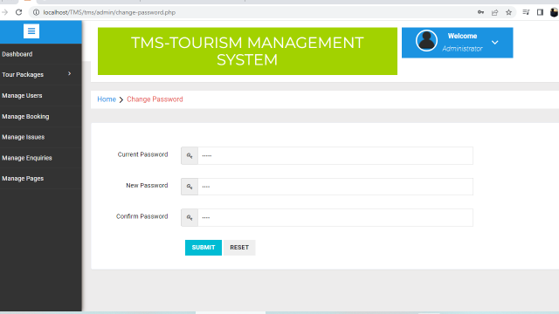

**Testing**

**Testing Plan**

The role of the test plan is to guide all testing activities. It describes what is to be tested and what is to be overlooked, how the testing is to be performed and by whom. It is therefore a managerial document, not technical one-in essence; it is a project plan for testing. Therefore the target audience of the plan should be a manager with a decent grasp of the technical issues involved. You can find information about test plans that good planning can save a lot of time, even in an exercise, so do not under estimate the efforts required for this phase

**The testing process:**

Developer tests the software process activities such as design, and requirement engineering. As, design error are quite costly to repair once system has been started to operate, therefore, it is quite obvious to repair them at early stage of the system. So analysis is the most important of any project. Requirement traceability:

At most interested portion is whether the system is meaning its requirements or not, for that testing should be planned so that all the requirements are individually tested.

Developer checked the output of concern combination of inputs, which gives desirable results, or not. Strictly sticking to your requirement specification, gives you the path to get desirable results from the system.

Tested items:

The tested items are:

* Adding new record
* Update the details
* Cancel / delete detail
* View details

**Testing Schedule:**

Developer has tested each procedure back-to-back so that errors and omission can be found as early as possible. Once the system has been developed fully, developer tested it on other machines, which differ in configuration.

**Conclusion**

To conclude the description about the project. The project, developed using PHP and MySQL is based on the requirement specification of the user and the analysis of the existing system, with flexibility for future enhancement.

The expanded functionality of today’s software requires an appropriate approach towards software development. This tour management software is designed for people who want to manage various tour of customer. For the past few years the number of people who want to travel around the world or within the country has increase. Thereby the number of tourism has increase drastically. And hence there is a lot of strain on the person who are running the tour company and software’s are not usually used in this context. This particular project deals with the problems on managing a Tour booking and avoids the problems which occur when carried manually.

Identification of the drawbacks of the existing system leads to the designing of computerized system that will be compatible to the existing system with the system which is more user friendly and more GUI oriented.

It is extremely wonderful moment while we are concluding this report. This is our first experience to perform such professional work. Objective of this system is to design a user friendly and easy to operate system.

At last we are very thankful to the Veer Narmada South Gujarat

University to include this project work as part of our Bachelor in Computer Application. This project work really gives chance to earn something out of typical reference books.

**Reference**

* www.w3schools.com
* in.php.net
* en.wikipedia.org/wiki/PHP
* www.hotscripts.com/category/php
* www.apache.org
* www.mysql.com/click.php?e=35050
* www.php.net/manual/en/mysqliquickstart .prepared-statements.php