TalkPro
AI-Powered Interactive English Learning Platform
First Draft Project Report
Student: Akhil (TalkPro Development)
Submission Date: September 25, 2026
Technology Stack: Python, Flask, SQLite, HTML5/CSS3
Current Status: Authentication and Homepage completed

1. Project Abstract and Objectives
TalkPro is an interactive web-based educational platform designed to help users improve their English communication skills, grammar, vocabulary and overall speech confidence. The project combines structured learning materials with generative AI capabilities to provide an accessible and personalized learning experience.
For this first draft, the basic application structure has been implemented. This includes user registration, login using a SQLite database, session handling and the main homepage that acts as the entry point for the learning modules.

2. Modules Implemented
The current first draft includes the following modules:
User Login: Accepts email and password, validates the credentials against the SQLite database, maintains the user session and shows an error message when authentication fails.
User Registration: Allows a new user to create an account using name, email, password, age, profession and English level. Email uniqueness is also handled.
Homepage: Provides the main navigation area for Grammar, Vocabulary, Reading, Video Lessons and the AI Tutor.

3. Database and Architecture
The backend uses an SQLite database named elib.db. The database is initialized through database.py.
The users table stores registered user information such as:
- id (Primary Key)
- name
- email (Unique)
- password
- age
- profession
- english_level
- reset_token
The user_test table is used to store quiz scores for different learning modules. It contains:
- id (Primary Key)
- user_email
- module
- score

4. Login and Authentication
The login page accepts the user's email and password. Flask receives the login details and checks them against the registered user information stored in SQLite. If the credentials are valid, the application maintains the login session and allows the user to continue to the homepage. If the credentials are not valid, an error notification is displayed.
The first draft document confirms credential validation and session persistence. The exact password hashing method is not described in this report.

5. Application Screenshots
The following screenshots show the current working interfaces of the TalkPro application.
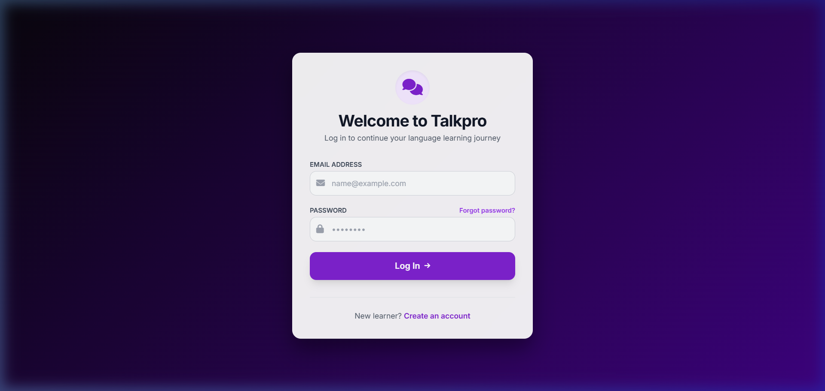
Figure 1: TalkPro User Login Screen
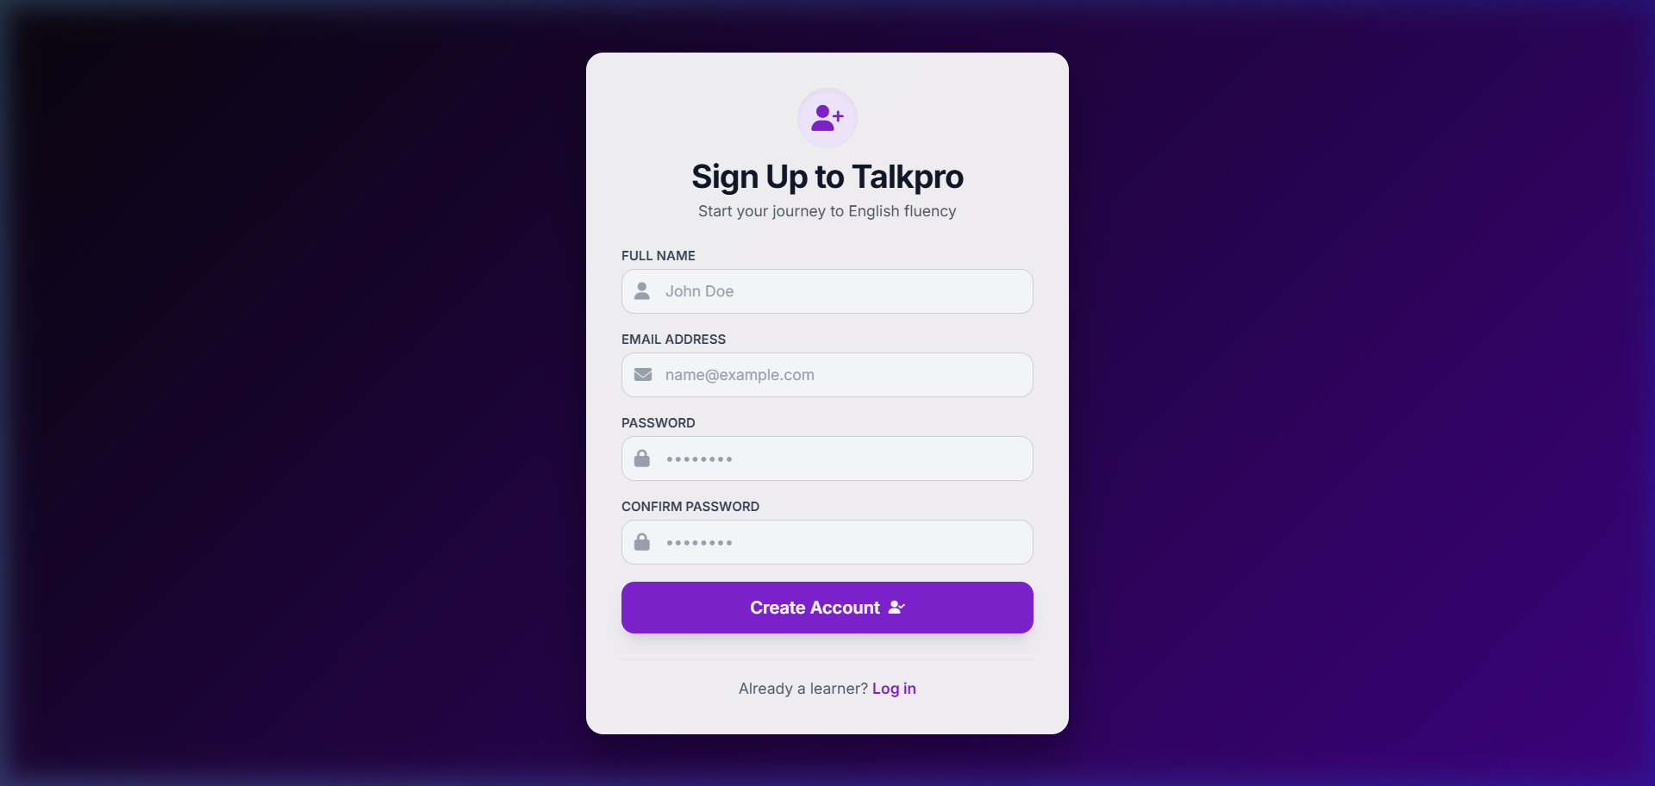
Figure 2: TalkPro User Registration Screen
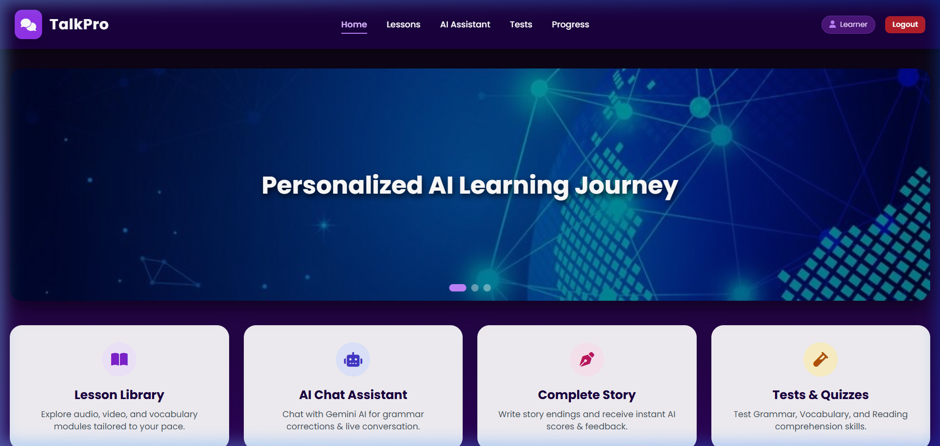
Figure 3: TalkPro Main Homepage Dashboard

6. Future Scope
- AI Tutor Integration: Expand Google Gemini integration for real-time conversation feedback.
- Interactive Assessment Quizzes: Complete interactive tests for Grammar, Reading and Vocabulary.
- Progress Visualization: Add graphical progress charts to the User Profile dashboard.

7. Conclusion
The first draft establishes the basic foundation of TalkPro. User registration, login, database connectivity, session handling and the main homepage are in place. The next stage will focus on completing the learning activities, AI Tutor and progress tracking features.

