TalkPro
AI-Powered Interactive English Learning Platform
Second Draft Project Report
Student Name: | Akhil (TalkPro Development)
Submission Date: | October 17, 2026
Project : | Second Draft Report (Interactive Core Modules & AI Engine)
Technology Stack: | Python 3.14, Flask, SQLite3, HTML5, CSS3, JavaScript (ES6+), Chart.js, Web Speech API (STT & TTS), Google Gemini REST API & Intelligent NLP Engine

1. Executive Summary and Project Progression
TalkPro is an intelligent, web-based educational platform engineered to accelerate English language proficiency, grammar competence, situational conversation, and communicative confidence. By combining structured self-paced pedagogy with modern generative AI capabilities, TalkPro offers an accessible, interactive, and personalized learning ecosystem.
The First Draft established the foundational architectural groundwork of TalkPro, encompassing user authentication, database initialization, session tracking, and the structural landing dashboard. Building upon that foundation, this Second Draft represents a transformative progression: transitioning the platform from an initial prototype into a fully interactive, feature-complete learning suite.
Second Draft Achievements: Key milestones accomplished in the Second Draft include:
- AI Grammar & Conversation Tutor: A fully integrated natural language conversational partner supporting dual practice modes, Web Speech API microphone input, real-time speech synthesis (TTS), and intelligent grammatical error diagnosis.
- Interactive Assessment Center: Comprehensive timed diagnostic quizzes for Grammar, Vocabulary, and Reading Comprehension, equipped with per-question countdown timers, instant pedagogical explanations, and automated database scoring.
- Creative Story Evaluation Lab: A dynamic scenario-driven writing studio featuring rotating prompt generation, real-time word counting, and an automated multi-criteria evaluation engine assessing lexical variety, punctuation, and coherence.
- Dynamic Skill Radar Analytics: A personalized analytics dashboard featuring a Chart.js 5-axis Skill Radar Chart, high-level KPI proficiency statistics, test history logs, and profile management capabilities.
- Multimedia Academy & Vocabulary Directory: A trilingual video lesson repository (English, Hindi, Marathi) paired with an interactive 5-category vocabulary directory equipped with native one-click speech pronunciation.
2. System Architecture and Technology Stack
TalkPro adheres to a modular Model-View-Controller (MVC) architectural design pattern, ensuring clean separation of concerns, scalability, and maintainability across the software stack:
- Backend Application Controller: Powered by Python 3.14 and Flask, managing RESTful endpoints, asynchronous AJAX requests, cryptographic password validation, session tokens, and route authorization.
- Dual-Tier AI Processing Engine: Combines direct REST connectivity to Google Gemini Generative AI (gemini-1.5-flash) with an embedded, zero-dependency Rule-Based Natural Language Processing (NLP) engine for real-time grammar diagnosis.
- Client Presentation Tier: Built with modern HTML5, Vanilla CSS3 with Tailwind-compatible utility aesthetics, FontAwesome 6 icons, Google Fonts (Poppins), and responsive glassmorphic cards.
- Client Voice & Audio Processing: Employs native Web Speech API interfaces - Speech Recognition for voice-to-text dictation and SpeechSynthesis for real-time vocal feedback.
- Data Tier & Persistence: Utilizes SQLite3 (elib.db), providing lightweight, reliable, zero-configuration relational storage for user profiles, test evaluation metrics, and creative story submissions.

Layer | Technology / Framework
Backend Framework | Python 3.14 / Flask 3.x
Database Engine | SQLite3 (elib.db)
AI & NLP Engine | Google Gemini REST API + Local NLP Engine
Frontend & Audio | HTML5, CSS3, JS (ES6+), Web Speech API
Data Visualization | Chart.js 4.x

3. Detailed Modules and Feature Implementation
3.1 AI Grammar & Conversation Tutor (chatbot)
The AI Tutor serves as an intelligent personal English instructor capable of natural two-way conversation and immediate grammar diagnosis. Operating through a unified chat interface, the module provides:
- Dual Operation Modes: Users can toggle between 'Free Conversation Practice' (engaging in contextual roleplay, professional discussions, and everyday scenarios) and 'Grammar Correction Mode' (focusing on strict structural precision).
- Speech-to-Text Input: Integrated browser Speech Recognition allows learners to speak through their microphone. An animated recording pulse indicates active listening, seamlessly converting spoken input to text for conversational practice.
- Text-to-Speech Vocalization: Every response generated by the AI tutor features a one-click audio playback button utilizing the browser's native SpeechSynthesis API, allowing learners to hear correct English pronunciation and cadence.
- Intelligent Grammar Diagnosis: When grammatical discrepancies occur, the tutor produces a structured response detailing: (1) Original Sentence, (2) Refined Sentence, (3) Grammatical Rule Explanation, and (4) Spoken English Practice Tip.
3.2 Interactive Assessment Center (/modules, /grammar, /vocabulary, /reading)
TalkPro features a full-fledged assessment suite divided across three vital English domains: Grammar, Vocabulary, and Reading Comprehension. Each module delivers a rigorous yet engaging evaluation experience:
- Dynamic Question Engine: Each module presents 5 curated multiple-choice questions testing fundamental competencies such as subject-verb agreement, irregular tenses, idiomatic usage, context clues, and passage inference.
- Per-Question Countdown Timer: An interactive 20-second countdown timer with dynamic progress bar visual feedback encourages prompt decision-making, replicating real-world language assessment conditions.
- Detailed Answer Review Modal: Upon completing the quiz, learners receive an interactive results modal displaying their overall percentage score alongside detailed pedagogical explanations for every question.
- Database Persistence & Badge Reflection: Test scores are automatically transmitted via AJAX to the /submit_test endpoint, storing records in the user_test table. The Modules hub instantly displays updated score percentage badges.
3.3 Creative Story Writing & Automated Evaluation Lab (/story)
Writing fluency requires active synthesis rather than passive multiple-choice selection. The Story Writing Lab provides an immersive narrative sandbox:
- Dynamic Prompt Generator: Offers 4 culturally engaging and imaginative writing challenges (e.g., 'The Little Lamp's Big Diwali', 'The Darjeeling Toy Train Mystery', 'The Midnight Innovation Hackathon').
- Writing Studio & Live Word Counter: Learners compose their continuing paragraphs in a spacious text editor equipped with a real-time word counter and structure guidelines.
- Multi-Factor Evaluation Engine: Upon submission, the /review_story endpoint evaluates the composition based on word count depth, unique lexical diversity ratio (unique words vs. total words), dialogue punctuation, and syntactic variety.
- Database Logging: Every authored story, along with its numerical score (1-10) and feedback commentary, is persisted in the user_stories table.
3.4 User Profile & Skill Radar Analytics (/profile)
The User Profile dashboard provides clear visual feedback on learner growth, transforming raw test numbers into actionable insights:
- 5-Axis Skill Radar Chart: Powered by Chart.js, the radar chart visually plots proficiency across Grammar, Vocabulary, Reading Comprehension, Sentence Structure, and Writing Fluency.
- Core Performance KPI Cards: Displays high-level aggregate metrics: Overall English Proficiency %, Total Tests Completed, Average Quiz Score %, and Stories Authored.
- Profile Details & In-Place Editing: Displays the learner's Name, Somaiya Email, Age, Profession, and English Level, accompanied by an interactive modal (/update_profile) to update personal details dynamically.
- Historical Records: Maintains chronological log tables for both completed diagnostic assessments and evaluated creative stories.
3.5 Multimedia Video Academy & Categorized Directory (/video, /directory)
Complementing interactive exercises, TalkPro provides rich multimedia and reference resources:
- Trilingual Video Lessons: 4 video lectures (/video through /video3) featuring interactive language toggles (English, Hindi, Marathi) and structured bullet summaries.
- Categorized Vocabulary Directory: A searchable directory organized into 5 curated tabs (All, Business English, Daily Conversation, Academic Terms, Emotions & Moods), with one-click native audio pronunciation.

5. Application Interfaces and System Screenshots
The following screenshots depict the live, operational interfaces of TalkPro as captured from the active application during comprehensive system validation.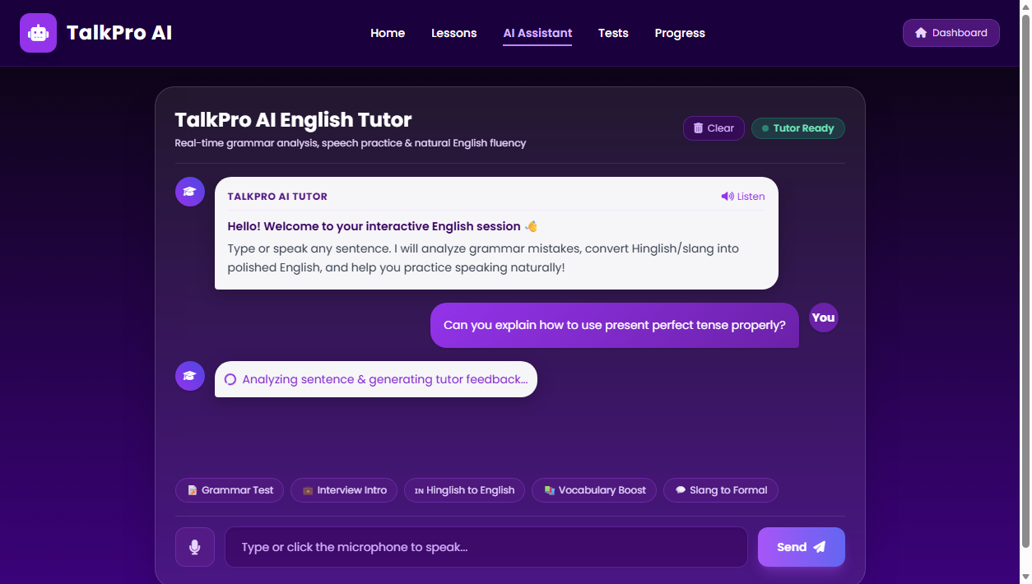
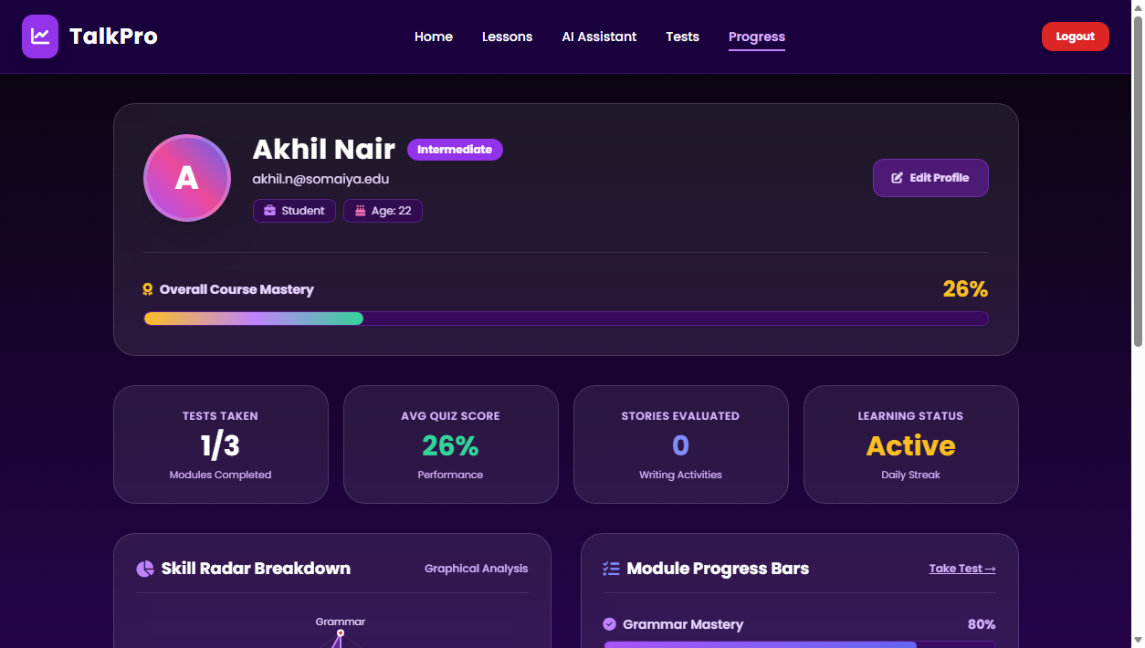
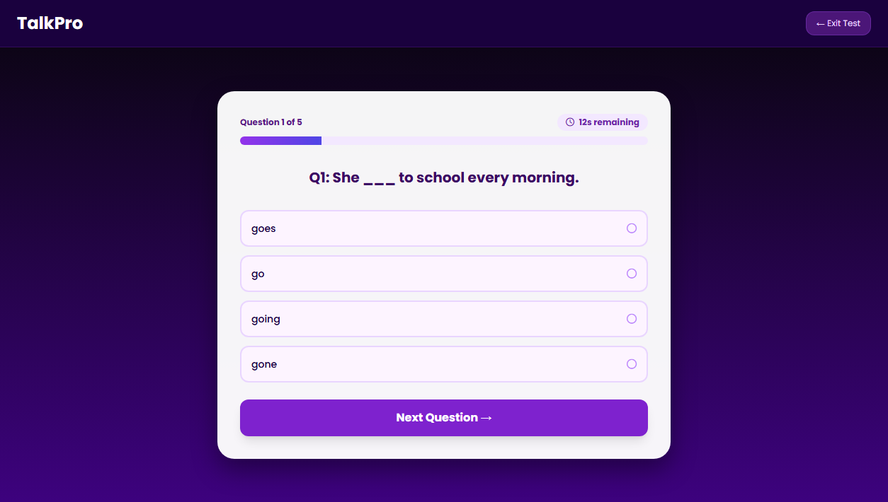
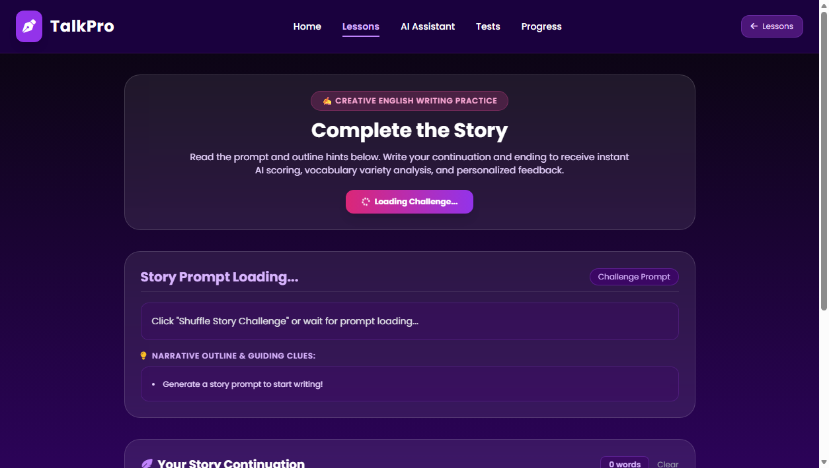
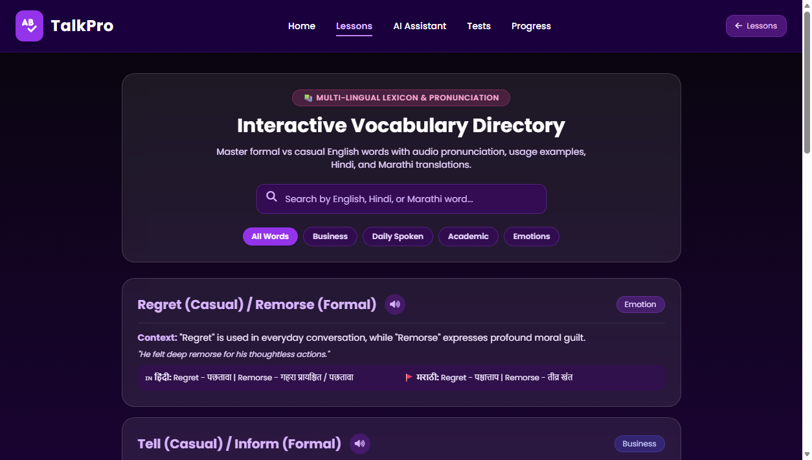
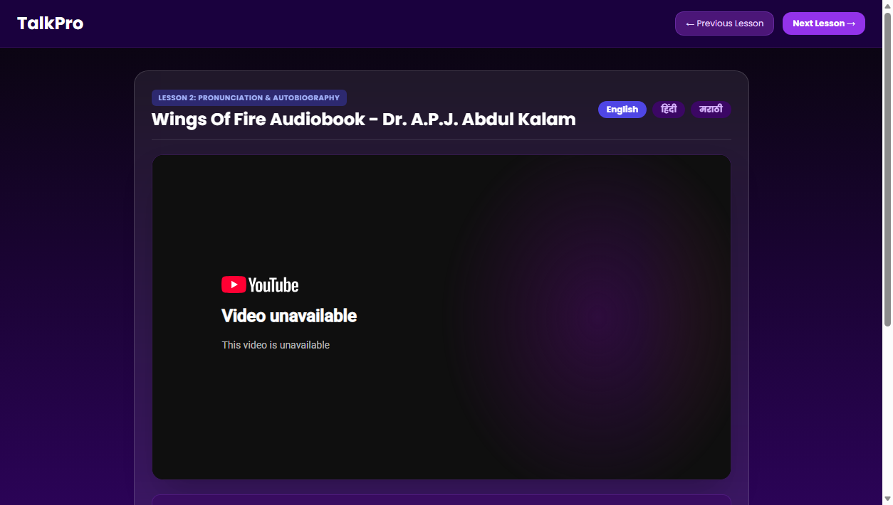
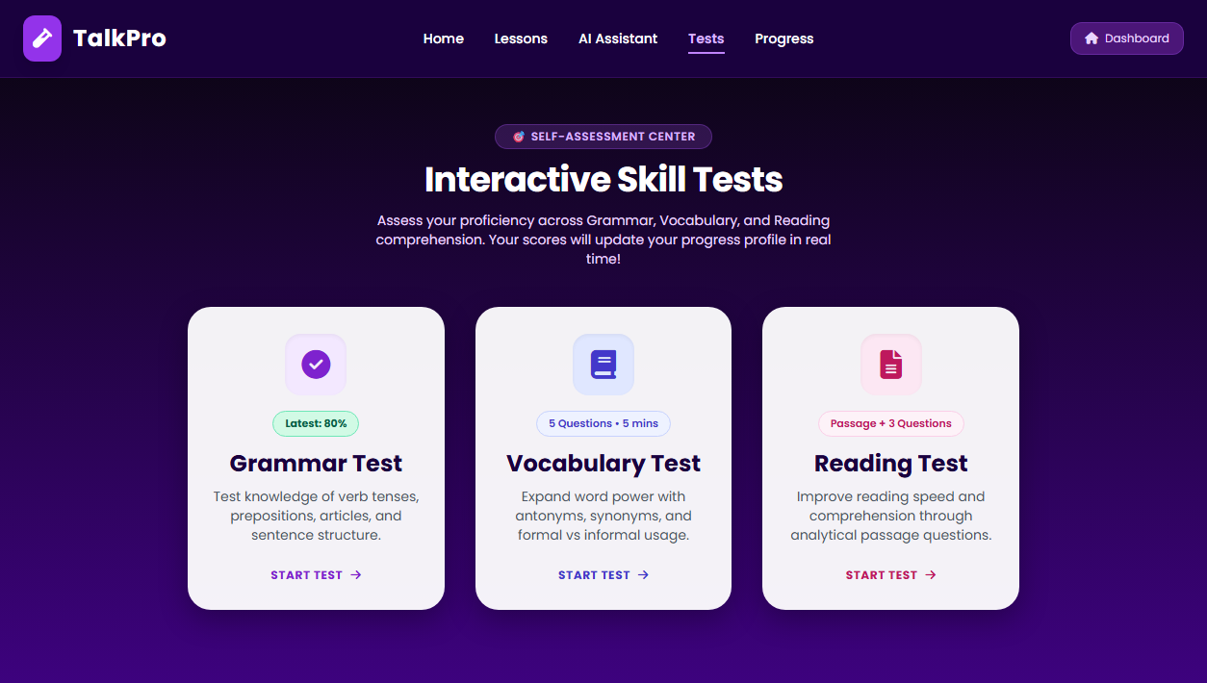

9. Conclusion
The Second Draft represents a pivotal milestone in the development of TalkPro. What commenced as an authentication prototype in the First Draft has matured into a sophisticated, highly engaging, and intelligent English learning platform. By unifying modern web technologies, SQLite persistence, natural language processing, audio synthesis, and interactive visual analytics, TalkPro fulfills its core objective: providing learners with a comprehensive, personalized, and motivating digital environment to master the English language with confidence.

