Anti-Cheat / Bot / Fraud Detection Platform on AWS
Three-page executive summary — anomaly detection on player telemetry, with a continuous drift -> retrain loop
What it is. A real-time platform that watches player telemetry — aim/input events, match state, logins and payments — and flags cheating, automation and fraud across three tiers: instant signature/rule checks, real-time statistical rules, and trained SageMaker detectors (aimbot, bot, payment fraud, account takeover). Because cheaters adapt, it runs a continuous drift -> retrain loop, with human review before any hard ban so legitimate players are not wrongly punished.
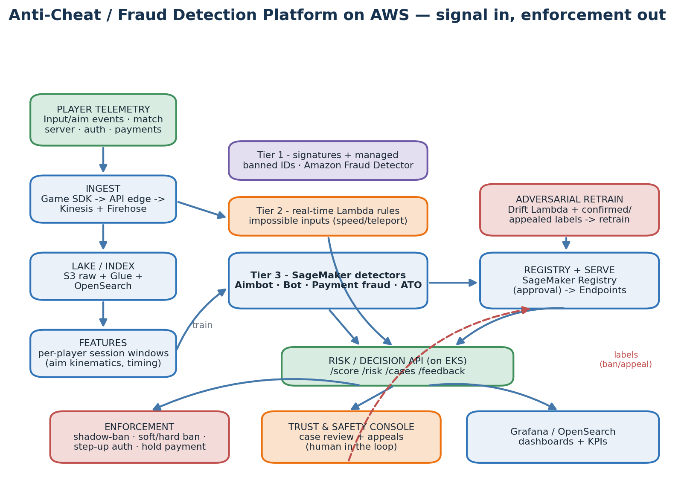
The 7-layer pipeline — what each layer does
L1 Sources | Game-client telemetry (mouse/aim deltas, fire, movement), match-server events, auth/login events, payment & refund events, chat/social graph.
L2 Ingest | Client SDK -> API edge -> Kinesis Data Streams (real-time input telemetry) + Firehose -> S3; high-volume via MSK.
L3 Lake / Index | S3 raw (KMS, partitioned by game/source) + Glue/Athena; OpenSearch for investigator search & case lookup.
L4 Features | Per-player, per-session 5-min windows: aim kinematics, reaction-time stats, input-timing entropy, account & payment velocity.
L5 Detection | Tier1 signatures + Amazon Fraud Detector; Tier2 real-time Lambda rules; Tier3 four SageMaker ML detectors -> risk score.
L6 Registry+Deploy | SageMaker Model Registry (approval gate) -> CodePipeline -> real-time + batch Endpoints; Risk API on EKS.
L7 Monitoring | Drift Lambda on inputs + CloudWatch + EventBridge -> retrain; labels from confirmed bans & appeals close the loop.
The detection tiers — speed vs sophistication
Tier | What it catches
Tier 1 — signatures & managed | Known cheat signatures, banned device/IP lists, and Amazon Fraud Detector for payments. Instant, no training.
Tier 2 — real-time Lambda | Hard physics/limits: aim angular-velocity > human limit, teleport/speed-hack, sub-100 ms reactions repeated, fire-rate over weapon cap. Seconds.
Tier 3 — SageMaker ML | Learns subtle, adaptive patterns the rules cannot describe; scores in milliseconds, trained over days. The four detectors below.
The four ML detectors
Detector | Signal / features | Method | Gate
Aimbot / aim-assist | flick-to-kill time, angular velocity, headshot ratio, reaction-time distribution | gradient boosting + anomaly | precision >= 0.99 (auto-ban)
Bot / automation | input-timing entropy, click-interval regularity, action-sequence patterns | LSTM auto-encoder | P@1% >= 0.80
Payment fraud | txn velocity, billing/geo mismatch, chargeback history, new-device purchase | gradient boosting / Fraud Detector | precision >= 0.95
Account takeover | login geo/device velocity, impossible travel, credential-stuffing patterns | unsupervised anomaly | recall-focused, low FP
Enforcement ladder — graded, human in the loop
Response scales with risk and confidence: observe (log + raise risk score) -> shadow/soft ban (match cheaters together, throttle matchmaking, open a case) -> step-up auth (force MFA on an account-takeover signal) -> hold/reverse payment (fraud) -> hard device/account ban for high-confidence, usually reviewed cases, always with an appeals path.
Why continuous retraining is non-negotiable here
Cheaters are an adversary: every ban wave teaches them what to avoid, so 'normal' and 'cheating' both drift constantly (concept drift). A drift Lambda compares live feature distributions to a frozen S3 baseline (KL / KS); on drift, EventBridge starts CodePipeline, which retrains the affected detector. Crucially, the labels come back from the loop itself — confirmed bans, manual-review verdicts, and overturned appeals — so the model relearns the new meta. Cadence: fraud/ATO daily, aimbot/bot weekly, plus event-driven retrains after any detected adaptation.
Build & deploy — the steps, in order
0-1 Bootstrap + Terraform | State bootstrap (S3 + DynamoDB), then apply infra: VPC, S3 lake, Kinesis/Firehose/MSK, OpenSearch, SageMaker, EKS, RDS, Fraud Detector, WAF, Cognito, CI/CD.
2-3 Ingest | Build & push images to ECR; wire the game-client telemetry SDK to the API edge -> Kinesis; verify events land in S3.
4 Add-ons + API | Install cluster add-ons; deploy the Risk/Decision API + Trust-and-Safety console (Helm/ArgoCD).
5-6 Features + train | Backfill telemetry; SageMaker Processing builds session features; run the 4 pipelines on labelled cheaters + clean play.
7 Approve + serve | Approve in the registry; deploy real-time (in-match) + batch (offline sweep) endpoints.
8 Shadow mode | Point the API at the endpoints; score but DON'T ban first — measure the false-positive rate.
9 Go live | Enable graded enforcement; route low-confidence hits to human review; watch KPIs.
Key components — service / module map
ingest/ | Telemetry SDK + API edge (API Gateway/ALB) -> Kinesis Data Streams + Firehose -> S3; MSK for high-volume.
lake/ (S3+Glue) | Raw partitioned by game/source/date; Athena for investigation; OpenSearch index for case search.
features/ | SageMaker Processing: per-player session windows — aim kinematics, timing entropy, account & payment velocity.
streaming/ (Lambda) | Real-time physics/limit rules (impossible inputs) -> instant risk events + SNS.
pipelines/ | 4 detectors x {feature_extract, train, evaluate, pipeline}; high-precision gates for auto-ban tiers.
fraud/ | Amazon Fraud Detector for payments + ATO; integrates with the payment service.
monitoring/ | Drift detector on inputs + label ingestion from bans/appeals -> EventBridge -> retrain.
api/risk/ | FastAPI on EKS: /score (in-match), /risk, /cases, /feedback, /appeal; Cognito-auth; SageMaker invoker.
console/ | Trust-and-Safety case-review UI + appeals; Grafana + OpenSearch Dashboards for KPIs.
Data you need (and how much)
Signal: per-event input/aim telemetry, match outcomes, logins and transactions. Labels: confirmed cheaters/fraud (bans, chargebacks, review verdicts) plus clean players — the adversary supplies fresh labels continuously. Volume: fraud/ATO is usable in days of transactions; aimbot/bot wants ~1-2 weeks of varied play (maps, skill levels, hardware). Cold start: tier-1 signatures + tier-2 physics rules protect you on day 0 while the ML tiers warm up.
KPIs & SLOs that define success
Auto-ban precision >= 0.99 (false bans are the cardinal sin — they cost trust and revenue). In-match scoring p99 < 50-100 ms. Time-to-detect: rules instant, ML < a few minutes. Appeal-overturn rate < 1% (a proxy for false positives). Cheater prevalence and chargeback rate trending down. Detector availability >= 99.5%.
Critical rules & risks
- Precision over recall for auto-ban: better to miss a cheat than ban an innocent player; low-confidence hits go to humans.
- Human-in-the-loop + appeals are mandatory; keep a full audit trail (CloudTrail) of every enforcement action.
- Privacy: minimise and hash PII where enforcement does not require identity; respect GDPR/data-retention.
- Adversarial hygiene: never expose exact thresholds; rotate models; red-team with your own cheats.
- Detect drift on detector INPUTS; retrain on fresh ban/appeal labels; shadow-test every new model before it can ban.

