monitoring-mlops (AWS)
Deep-Dive Illustrated Guide
AI · ML · MLOps · AIOps · Data Engineering · AWS Cloud · Observability

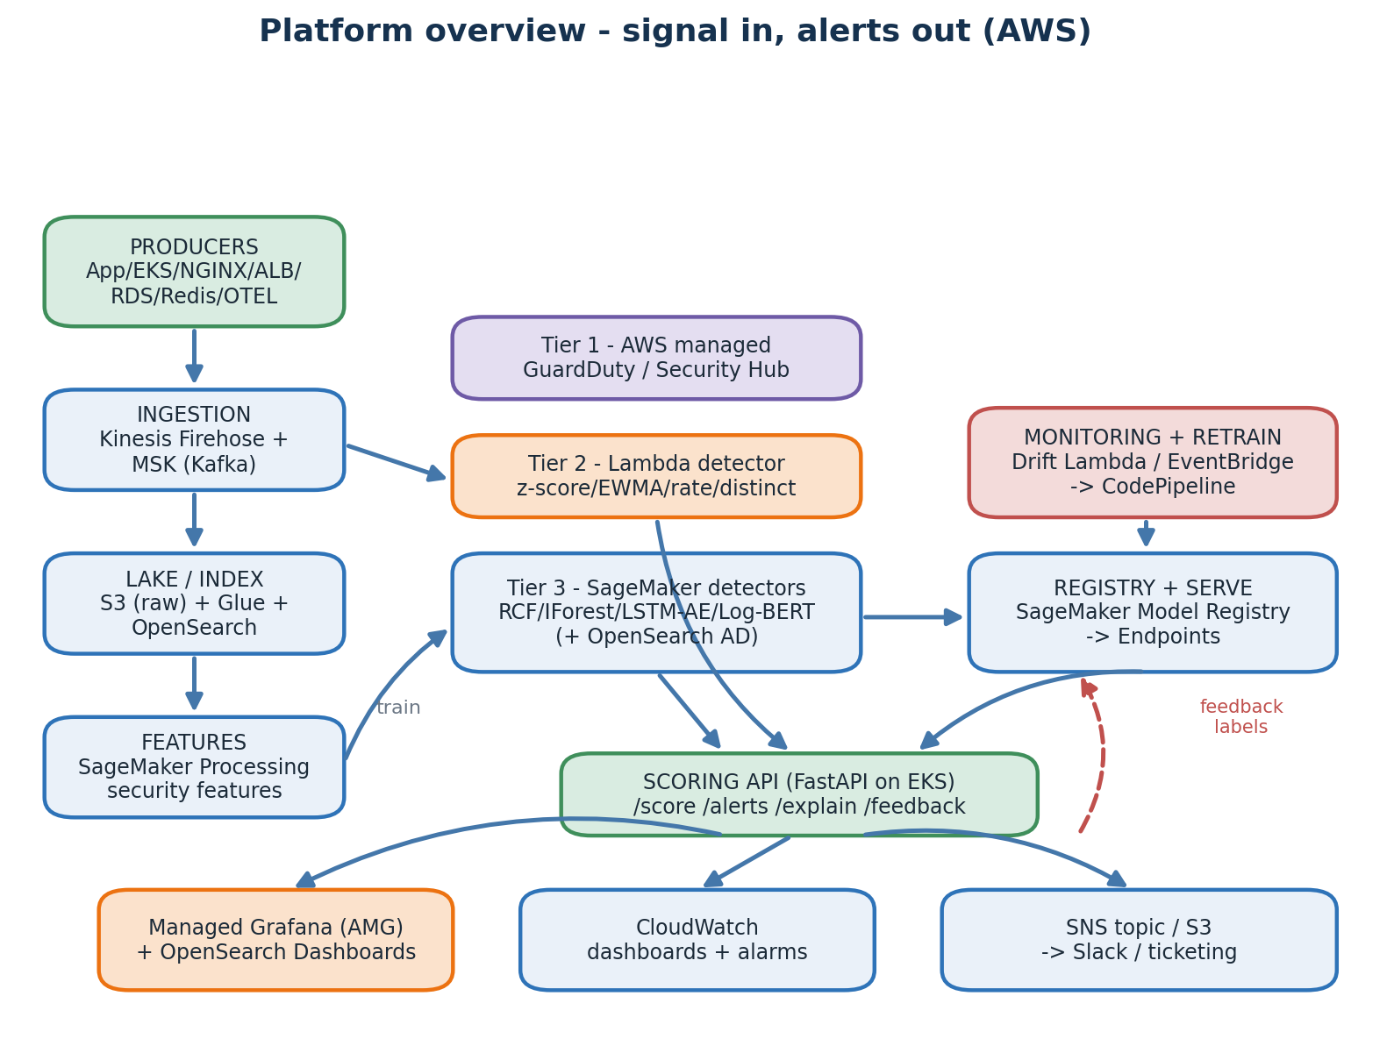
Every chapter is taught from first principles, illustrated with a diagram, and mapped back to a concrete file in the repository.

Owner: Akhil · Cloud: AWS (ap-south-1, Mumbai) · EKS · SageMaker · Kinesis + MSK · OpenSearch · S3 + Glue

How to read this guide
This guide is a single sequential thread. Read it top to bottom. Each chapter teaches one concept from first principles, shows you a diagram of how that concept is wired, points to the exact files in the repository that implement it, and ends with a short "Stitch" box that names precisely which problem the next chapter solves. The order is the lesson — skip nothing.
The platform it describes is an end-to-end AIOps / MLOps / Security-Analytics system on Google Cloud. It ingests logs, metrics and traces from across a stack and runs anomaly and threat detection in three layered tiers: managed GCP detectors that fire in seconds, a streaming statistical Cloud Function, and four trained machine-learning detectors served from Vertex AI. All three feed one alert console. The same design exists as an AWS sibling; this is the GCP port.
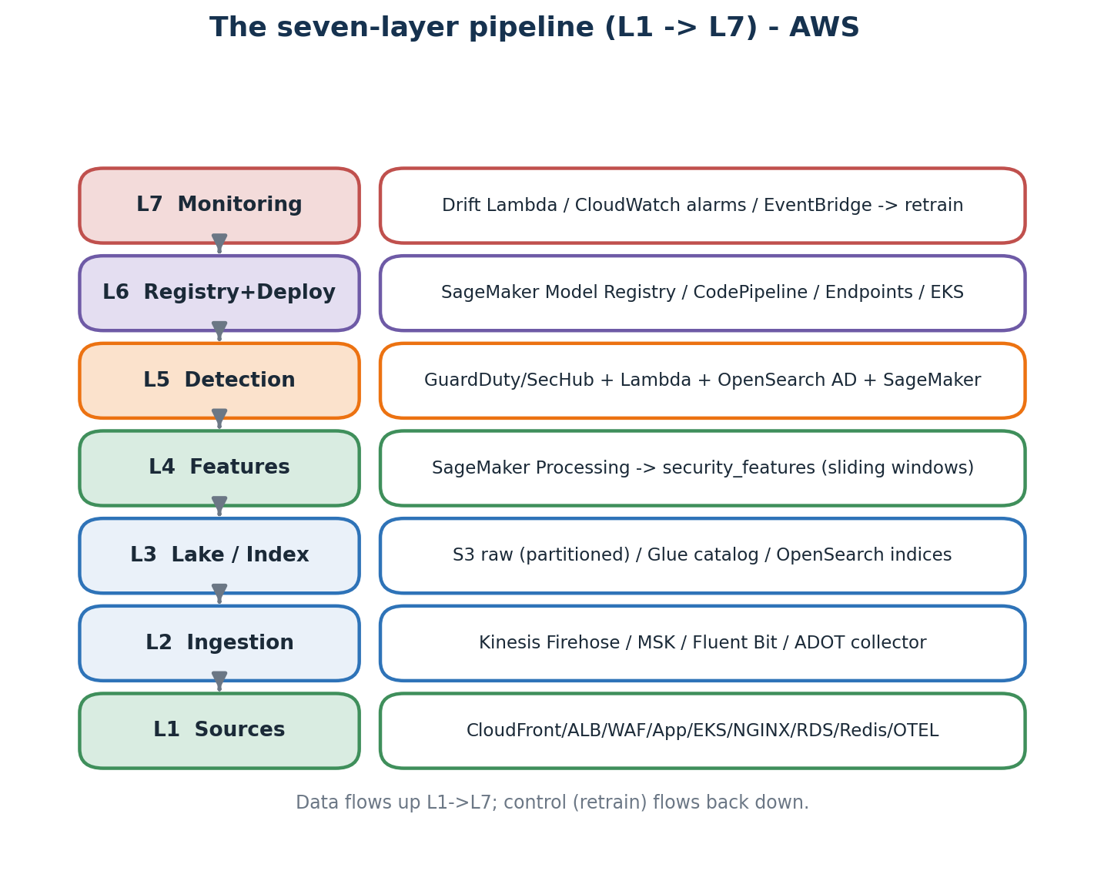
The seven processing layers. Data flows up L1->L7; the retrain control loop flows back down.

Table of contents
1. How software became impossible to watch by eye
2. The cloud, AWS, Terraform, and the state bootstrap
3. Networking and identity — VPC, subnets, IAM, IRSA
4. Containers — the universal shipping unit (ECR)
5. Kubernetes and Amazon EKS
6. Producers — applications that emit signals
7. The three pillars of observability (CloudWatch, AMP, X-Ray)
8. Streaming ingest — Kinesis Firehose and MSK (Kafka)
9. The S3 data lake — partitioned raw, Glue, Athena
10. OpenSearch — index and built-in anomaly detection
11. Schema and parsers — turning many formats into one
12. Statistics 101 — what 'anomaly' actually means
13. Streaming statistical detectors (AWS Lambda)
14. Machine Learning crash course
15. Feature engineering — turning events into model inputs
16. Training pipelines (SageMaker Pipelines)
17. Model registry and the approval gate
18. Online endpoints (SageMaker Endpoints)
19. The Scoring API — one HTTP surface over the detectors
20. AIOps dashboards — Managed Grafana and OpenSearch
21. Drift, retraining, and the closed loop
22. Security across the stack — defence in depth
23. Cost engineering — knobs that decide your bill
24. The full deploy walk-through — step by step
25. Failure modes you will hit, and how to fix them
26. Glossary
27. A four-week study plan

Chapter 1 — How software became impossible to watch by eye
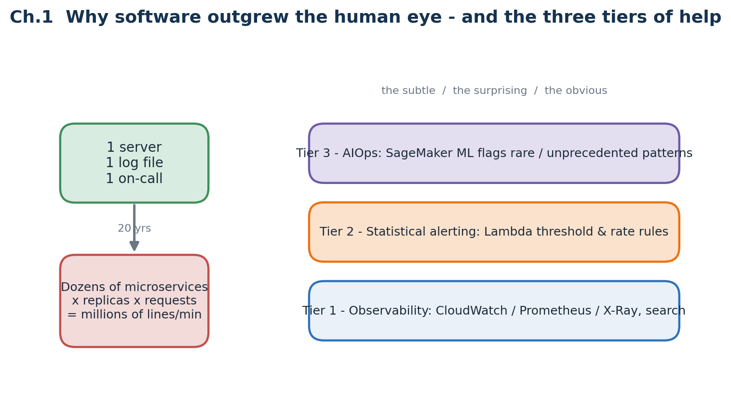
Telemetry grows roughly with the square of team size. Three layered tiers of help answer it.

1.1 The shape of a modern application
Twenty years ago a website was one program on one server: one log file, one CPU graph, one engineer on call. Today the same product is split into dozens of small services (microservices), each running several copies (replicas), each emitting its own logs, metrics and traces. The amount of telemetry grows roughly with the square of team size — more services times more replicas times more requests. What used to be a glance at one dashboard is now an impossible staring contest with millions of lines per minute.

1.2 Why humans cannot keep up
A single production cluster now produces millions of log lines a minute, and the nastiest bugs hide between services rather than inside any one of them. A single user click can pass through ten services and four databases before returning. Old-style threshold rules — 'page someone when CPU passes 80%' — miss the subtle failures that cause real outages: p99 latency creeping up, a queue slowly backing up, or a brand-new error line that has never appeared before but now appears once a second.

1.3 Three layers of help
- Observability — collect logs, metrics and traces so a human can search them. Raw material; without it there is nothing to reason about.
- Statistical alerting — write threshold and rate-of-change rules and alert the instant one is breached. Cheap, fast, and good against the obvious.
- AIOps — train models on historical signal so they can shout when something rare or unprecedented happens, even when nobody wrote a rule for it.

1.4 Why combine all three
Tier 1 catches the obvious, tier 2 the merely surprising, tier 3 the subtle long tail. This AWS project layers all three: AWS-managed detectors such as GuardDuty and Security Hub (tier 1), a streaming Lambda with statistical rules (tier 2), and four trained ML models on SageMaker (tier 3), all funnelled into one alert surface a human can triage and label.
Mental model to carry forward
Signal in on the left, alerts out on the right. Everything in between is plumbing whose only job is to carry telemetry to a place where progressively smarter detectors look at it.

Where this lives in the repo
Concept | Where in this repo | Why it matters
Four-pillar architecture | README.md · CLAUDE.md · docs/architecture.md | They describe the tiered design and the deploy steps this guide unpacks.
Tiered detection table | CLAUDE.md (Detection latency reality check) | Names the latency and cold-start of each tier — return to it often.

Stitch -> You now know why this platform exists. The next chapter explains the substrate it runs on — what AWS is, how Terraform builds it, and the one-time state bootstrap you must do before anything else.

Chapter 2 — The cloud, AWS, Terraform, and the state bootstrap
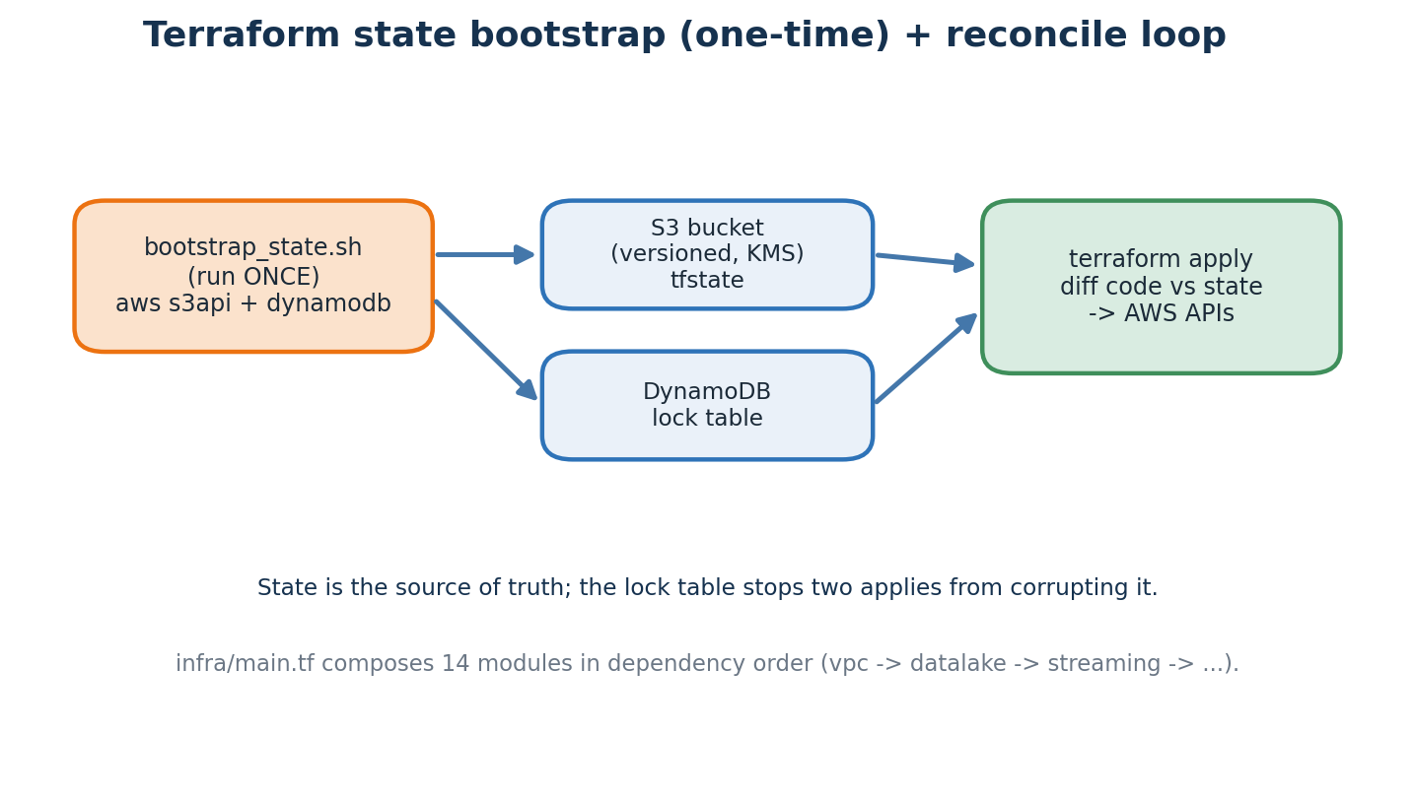
Before any Terraform runs, a one-time script creates the S3 state bucket and DynamoDB lock table.

2.1 From physical servers to APIs
A cloud provider is a data centre exposed over HTTPS. Instead of buying and racking hardware you call an API to get a virtual machine, a database, a queue or a managed service. The three big providers are AWS (the largest), Azure and Google Cloud. This project runs on AWS, in the ap-south-1 (Mumbai) region. Pick the region closest to your users.

2.2 The four primitives every cloud provides
- Compute — EC2 VMs, containers (EKS/ECS) and functions (Lambda).
- Storage — S3 (object store), EBS (disks) and databases such as RDS and DynamoDB.
- Networking — VPCs, load balancers (ALB) and security groups.
- Identity — IAM users, roles and policies, plus KMS keys for encryption.

2.3 Infrastructure as code with Terraform
Every AWS resource here is declared as Terraform code (HCL). Terraform reads the current state, compares it to your code, and calls AWS APIs to make reality match. Re-running with no code change does nothing — this idempotence is what makes the whole stack reproducible. The root module infra/main.tf composes 14 sub-modules in dependency order.

2.4 Step zero — the state bootstrap (do this once)
Terraform needs somewhere to store its state file — the record of what exists. If two people run apply against shared local state they corrupt it. The fix is a remote backend: an S3 bucket for the state and a DynamoDB table for a lock. But Terraform cannot create the bucket it stores its own state in (a chicken-and-egg problem), so a small shell script does it once.
# infra/bootstrap_state.sh (run exactly once)
aws s3api create-bucket --bucket mlops-learning-tfstate --region ap-south-1 \
--create-bucket-configuration LocationConstraint=ap-south-1
aws s3api put-bucket-versioning --bucket mlops-learning-tfstate \
--versioning-configuration Status=Enabled
aws dynamodb create-table --table-name mlops-learning-tfstate-lock \
--attribute-definitions AttributeName=LockID,AttributeType=S \
--key-schema AttributeName=LockID,KeyType=HASH --billing-mode PAY_PER_REQUEST
Why each part matters: versioning lets you roll back a corrupted state file; KMS encryption protects the secrets state can contain; a public-access block prevents accidental exposure; and the DynamoDB lock makes concurrent applies wait rather than collide. Run it once, then never again — from here on, Terraform uses this backend automatically (declared in backend.tf).

2.5 The root module and provider aliases
infra/main.tf wires the modules together with explicit depends_on edges so they build in the right order (VPC first, then the data lake, then streaming, and so on). One subtlety worth knowing: most resources live in ap-south-1, but AWS billing metrics only emit from us-east-1, so a second provider with the alias 'useast1' is declared and handed to the billing module. Optional pieces such as the ALB use count = condition ? 1 : 0 to create themselves only when you supply a hostname and certificate.

Where this lives in the repo
Concept | Where in this repo | Why it matters
State backend | infra/backend.tf · infra/bootstrap_state.sh | S3 bucket + DynamoDB lock; created once before the first terraform init.
Root orchestration | infra/main.tf composes 14 modules with depends_on ordering | Two providers (ap-south-1 + us-east-1 for billing); conditional ALB module.

Stitch -> You now have a state backend and a mental model of Terraform. The next chapter covers the two foundations every workload sits on — networking and identity.

Chapter 3 — Networking and identity — VPC, subnets, IAM, IRSA
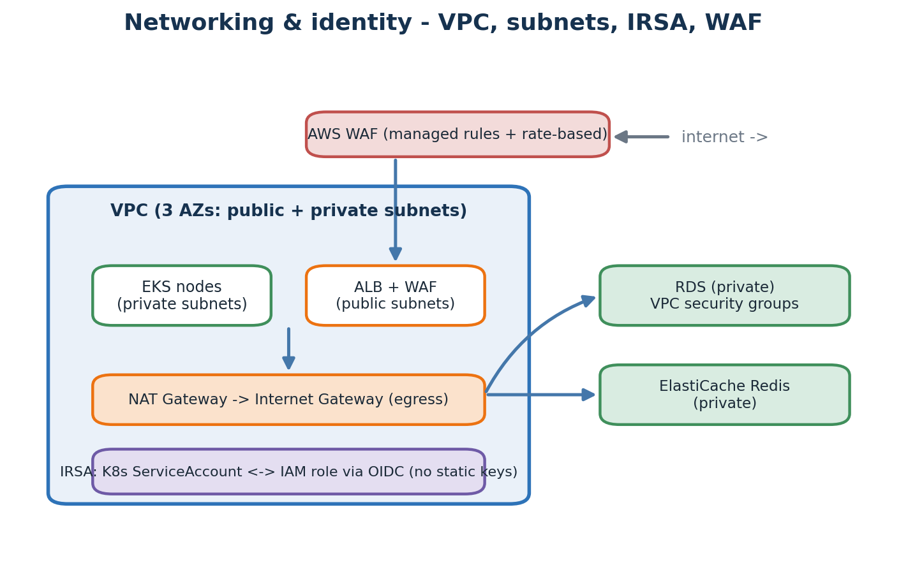
A multi-AZ VPC with public and private subnets; IRSA gives pods IAM roles without static keys.

3.1 The VPC and its subnets
A VPC (Virtual Private Cloud) is your own private network inside AWS. This project uses the community terraform-aws-modules/vpc module to build one across three Availability Zones, each with a public subnet (for internet-facing things like the load balancer) and a private subnet (for everything else — EKS nodes, RDS, ElastiCache). A NAT Gateway lets private resources reach the internet for updates without being reachable from it.

3.2 Security groups
A security group is a stateful firewall attached to a resource. The pattern here is least privilege: the database security group only accepts traffic from the EKS node security group on the database port, and nothing else can reach it. This is how RDS and ElastiCache stay private.

3.3 IAM — the heart of AWS security
IAM (Identity and Access Management) decides who may do what. A policy is a JSON document listing allowed (or denied) actions on resources; a role is an identity that bundles policies and can be assumed by a principal. The guiding rule is least privilege: grant the smallest set of actions on the narrowest resource that still works.

3.4 IRSA — IAM Roles for Service Accounts
The clever bit for Kubernetes. Instead of baking AWS access keys into a pod (which leak), IRSA lets a Kubernetes ServiceAccount assume an IAM role through the cluster's OIDC provider. You annotate the ServiceAccount with the role ARN; AWS hands the pod short-lived credentials at runtime. The result is zero static keys in the cluster — the scoring API pod, for example, gets exactly the SageMaker-invoke and Secrets-read permissions it needs and nothing more.

3.5 WAF and ACM at the edge
AWS WAF (Web Application Firewall) sits in front of the load balancer with managed rule groups (SQL-injection, cross-site-scripting) plus a rate-based rule to blunt floods. ACM (AWS Certificate Manager) issues the TLS certificate so traffic is HTTPS-only, and Route 53 provides the DNS name that points at the load balancer.

Where this lives in the repo
Concept | Where in this repo | Why it matters
IRSA role | infra/modules/eks/main.tf — IRSA role for the recommendation-api ServiceAccount | Pods assume an IAM role via OIDC; no static AWS keys anywhere in the cluster.
Edge protection | infra/modules/waf · infra/modules/alb · Route53 + ACM | WAF managed rules + rate limit; ALB terminates TLS from an ACM certificate.

Stitch -> You now have a network and an identity model. The next chapter covers the lowest-level unit a workload ships as — the container — and where its image is stored (ECR).

Chapter 4 — Containers — the universal shipping unit (ECR)
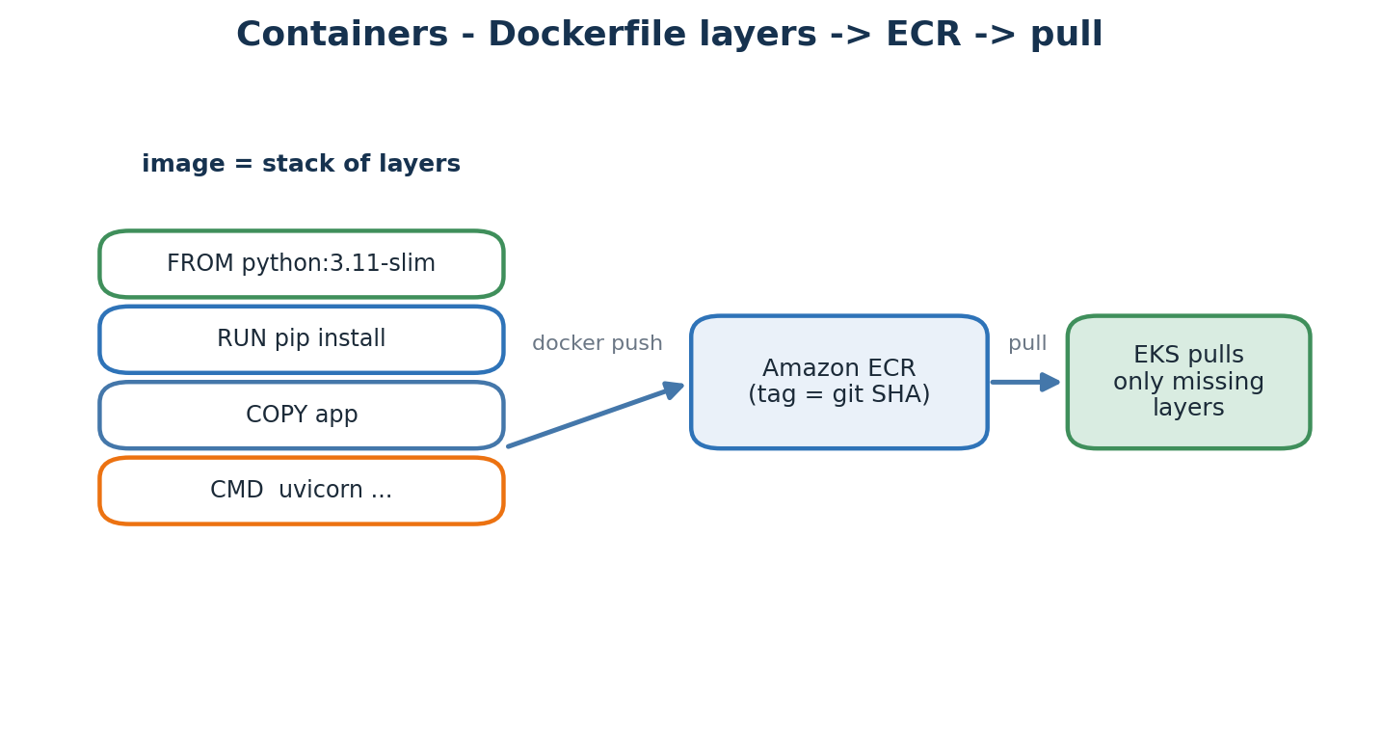
An image is a stack of layers; only the layers a node lacks are pulled from Amazon ECR.

4.1 Why containers
Before containers, deploying meant copying code to a server and praying its library versions matched your laptop. A container is essentially a tar file bundling the code, the libraries and the OS user-space — everything except the kernel. Docker is the most common format and runtime. The promise is simple: it runs the same on your laptop, in CI, and on the cluster.

4.2 Anatomy of a Dockerfile
FROM python:3.11-slim
ENV PYTHONUNBUFFERED=1
WORKDIR /app
COPY requirements.txt /tmp/
RUN pip install -r /tmp/requirements.txt
COPY app /app/app
CMD ["uvicorn", "app.main:app", "--host", "0.0.0.0", "--port", "8000"]
- FROM — the base image; layers stack on layers.
- RUN — run a build-time command, cached unless its inputs change.
- COPY — copy files from your project into the image.
- CMD — the single foreground process to run when the container starts.

4.3 Amazon ECR
Built images are pushed to Amazon ECR (Elastic Container Registry), AWS's private Docker registry. Each image carries a tag, usually the git commit SHA. When EKS schedules a pod it pulls only the layers the node does not already have, which is why thin, well-ordered layers make deploys fast. Authentication is via IAM, so nodes pull images using their instance role.

4.4 Build best practices we follow
- Pin the base tag — never 'latest' in FROM, so builds are reproducible.
- Run as non-root and add a HEALTHCHECK so the orchestrator can self-heal.
- Install dependencies before copying code so a code change does not bust the dependency cache.

Where this lives in the repo
Concept | Where in this repo | Why it matters
Dockerfiles | api/scoring/Dockerfile · demo-app/*/Dockerfile | Built in CI and pushed to ECR; EKS pulls them by tag at deploy time.

Stitch -> You now have an image holding one process and its dependencies. The next chapter explains the system that runs hundreds of them, restarts the crashed ones, and exposes them — Amazon EKS.

Chapter 5 — Kubernetes and Amazon EKS
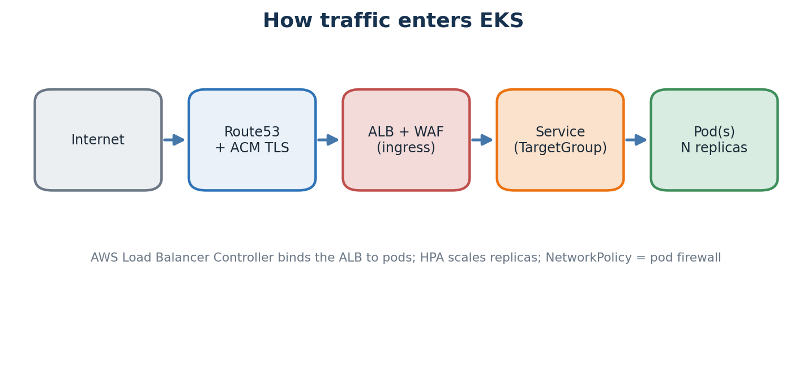
A request's path: internet -> Route53 + ACM -> ALB + WAF -> Service/TargetGroup -> Pod.

5.1 Why an orchestrator
With many machines and many container types you do not want to SSH around running containers by hand. Kubernetes runs containers across a fleet, restarts crashed ones, scales them, exposes them behind a stable address, and spreads them across Availability Zones — all declaratively. Amazon EKS is AWS's managed Kubernetes: AWS runs the control plane, you run the worker nodes (or use Fargate).

5.2 Core objects you must know
- Pod — one or more containers sharing a network namespace; the smallest unit.
- Deployment — declares 'I want N replicas of this pod template'.
- Service — a stable virtual IP and DNS name for a set of pods.
- Ingress — HTTP routing rules; on EKS the AWS Load Balancer Controller turns an Ingress into a real ALB.
- ConfigMap / Secret / HPA / NetworkPolicy — configuration, credentials, autoscaling, and pod-level firewalls.

5.3 How traffic reaches a pod
Route 53 resolves your domain to the ALB; ACM gives it a TLS certificate; AWS WAF inspects the request; the ALB forwards to a target group that the Load Balancer Controller keeps bound to the healthy pods of the scoring API Service. A TargetGroupBinding (a custom resource) is what links the Kubernetes Service to the ALB target group.

5.4 Helm and ArgoCD
A Helm chart is a templated bundle of Kubernetes YAML; values.yaml fills the template and you install with 'helm upgrade --install'. This repo ships charts for the scoring API, Fluent Bit and the ADOT collector. ArgoCD then keeps the cluster in sync with the charts in git — GitOps, where the desired state lives in a repository and a controller continuously reconciles the cluster to match.

5.5 Cluster add-ons
A handful of add-ons make the cluster useful: the AWS Load Balancer Controller (ALB from Ingress), the External Secrets Operator (syncs Secrets Manager into Kubernetes Secrets), Fluent Bit (ships container logs), and the ADOT collector (OpenTelemetry metrics and traces). They are installed from helm/cluster-addons before the app charts.

Where this lives in the repo
Concept | Where in this repo | Why it matters
Scoring API chart | helm/charts/anomaly-scoring-api/ (ingress, targetgroupbinding, hpa, externalsecret) | Ingress + TargetGroupBinding wire the ALB to pods; ExternalSecret pulls DB creds from Secrets Manager.
GitOps | argocd/applications/*.yaml | ArgoCD continuously reconciles the cluster to the charts declared in git.

Stitch -> You now have a cluster that runs and exposes containers. The next chapter covers the workloads inside it that emit signal — the demo application.

Chapter 6 — Producers — applications that emit signals
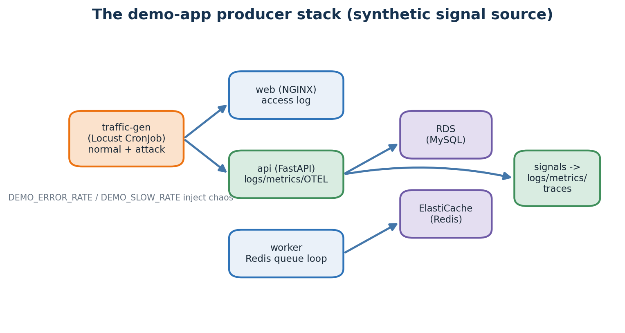
The demo-app stack: a Locust generator drives web/api/worker, which talk to RDS and ElastiCache.

6.1 Why a fake e-commerce stack
An anomaly-detection platform needs raw signal. The demo-app directory exists so you can run an end-to-end demo without pointing the platform at real production traffic. It has three service roles plus a traffic generator that can behave normally or launch simulated attacks.

6.2 The three demo services
- web — an NGINX reverse proxy serving a static page, producing a combined access log.
- api — a FastAPI backend emitting JSON logs, a /metrics endpoint and OTEL traces, talking to RDS MySQL.
- worker — a Python loop that polls an ElastiCache Redis queue and processes synthetic jobs.

6.3 Realism knobs
The api reads environment variables that inject controlled chaos so detectors have something to fire on: DEMO_ERROR_RATE (fraction of requests that deliberately return 500), DEMO_SLOW_RATE (fraction that get extra latency) and DEMO_SLOW_LATENCY (how much). Turning these up is how you stage a believable incident on demand.

6.4 Traffic generator (Locust)
The traffic-gen Locust file defines both normal-mode and attack-mode behaviours — brute-forcing /login, DDoS bursts, SQL-injection probes. A Kubernetes CronJob re-spawns it on a schedule so the platform always has a living workload to watch.

Where this lives in the repo
Concept | Where in this repo | Why it matters
Demo producer stack | demo-app/{web,api,worker} · demo-app/traffic-gen/locustfile.py | Synthetic but realistic signal source; chaos knobs let you trigger incidents deliberately.

Stitch -> You now have applications producing structured signal. The next chapter covers the three formats that signal travels in — logs, metrics and traces — and how AWS captures each.

Chapter 7 — The three pillars of observability (CloudWatch, AMP, X-Ray)
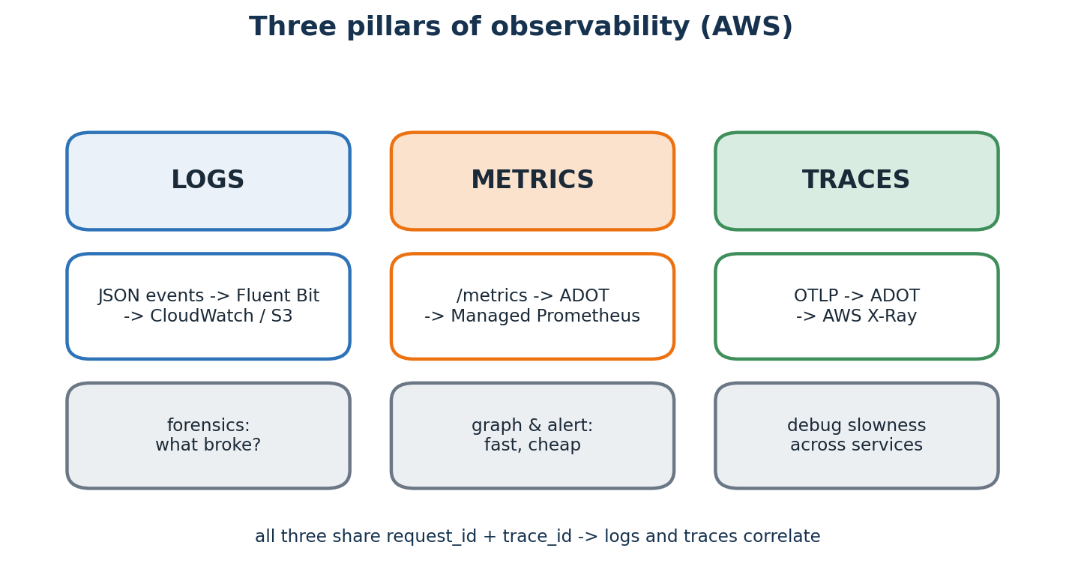
Each pillar has an AWS capture path; a shared request_id and trace_id tie them together.

7.1 Logs
Logs are discrete, time-stamped events — JSON lines on stdout. Fluent Bit (a DaemonSet) tails every container's output and ships it to CloudWatch Logs and to S3 (via the streaming path) for long-term analysis. Logs are the forensic record: when you need to know exactly what a broken request looked like, you read the log line.
{"ts":"2026-06-20T09:30:14Z","level":"INFO","msg":"GET /api/products/5 -> 200 (12.3ms)",
"service":"demo-api","request_id":"u-7f","trace_id":"a91..."}

7.2 Metrics
Metrics are numerical time-series in three shapes: a Counter that only goes up, a Gauge that moves both ways, and a Histogram that buckets a distribution. Apps expose them at /metrics in Prometheus format; the ADOT collector scrapes them and remote-writes to Amazon Managed Prometheus (AMP). Histograms are the secret weapon — you compute p50, p95 and p99 server-side, on the fly.

7.3 Traces
A trace is a tree of spans, each span one operation in one service. Spans share a trace_id, so you can replay a request that hopped api -> worker -> RDS -> Redis as a single timeline. Apps emit OpenTelemetry (OTLP); the ADOT collector exports to AWS X-Ray. Traces are how you debug slowness that spans many services.

7.4 Why all three
Metrics are fastest to graph and cheapest to store; logs are best for forensics; traces are best for cross-service slowness. Because all three carry the same request_id and trace_id, a single alert can pivot from a metric spike to the exact logs and trace behind it.

Where this lives in the repo
Concept | Where in this repo | Why it matters
Observability wiring | helm/charts/fluent-bit · helm/charts/adot-collector · api/scoring/services/observability.py | Fluent Bit -> CloudWatch/S3; ADOT -> AMP + X-Ray; shared IDs make them correlate.

Stitch -> You now have three telemetry streams from every workload. The next chapter explains the bus that moves them at scale and decouples producers from consumers — Kinesis Firehose and MSK.

Chapter 8 — Streaming ingest — Kinesis Firehose and MSK (Kafka)
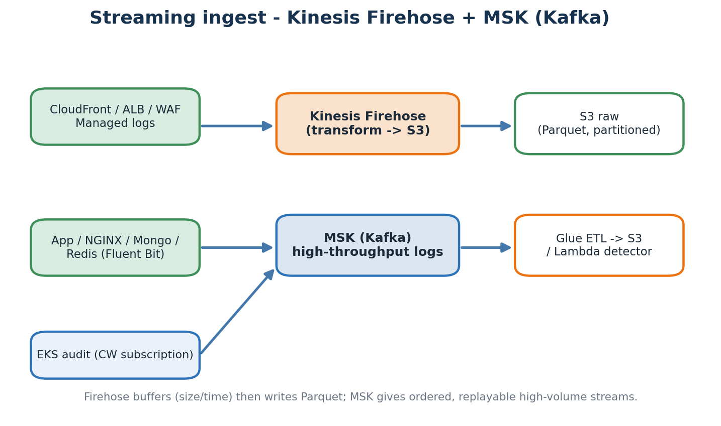
Managed AWS logs flow through Firehose to S3; high-volume app logs flow through MSK (Kafka).

8.1 Two ingest paths, by design
Different sources have different shapes, so the platform uses two complementary buses. Kinesis Firehose is a fully managed delivery stream: you point AWS service logs (CloudFront, ALB, WAF) at it, it buffers by size or time, optionally transforms records, and writes them to S3 as Parquet. MSK (Managed Streaming for Kafka) is a managed Kafka cluster for high-throughput, ordered, replayable application and NGINX logs that arrive via Fluent Bit.

8.2 Firehose — the simple path
Firehose needs almost no operation: there are no shards to size for the managed-log volumes here, it handles retries and backpressure, and a small transform Lambda can reshape records before they land. You trade a little control for a lot of simplicity, which is the right trade for managed AWS logs.

8.3 MSK — when you need Kafka semantics
When you need ordering, replay, or many independent consumers of the same high-volume stream, Kafka earns its keep. MSK runs the brokers for you across AZs. Application and NGINX logs go here because their volume is high and multiple downstream jobs (the lake writer, the Lambda detector) want to read the same stream independently.

8.4 Why a bus at all
A bus decouples producers from consumers. Producers write; consumers read; neither needs to know about the other. Adding a new consumer (say, a Slack notifier) is a new subscription, not a change to every producer. Both paths land their data in the same S3 layout so everything downstream reads from one place.

Where this lives in the repo
Concept | Where in this repo | Why it matters
Firehose | infra/modules/firehose/main.tf | Managed delivery streams: CloudFront/ALB/WAF -> transform -> S3 raw Parquet.
MSK | infra/modules/msk/main.tf | Managed Kafka for high-throughput app/NGINX logs; ordered and replayable.

Stitch -> You now have a fan-in bus holding every signal. The next chapter explains where it all lands — the S3 data lake.

Chapter 9 — The S3 data lake — partitioned raw, Glue, Athena
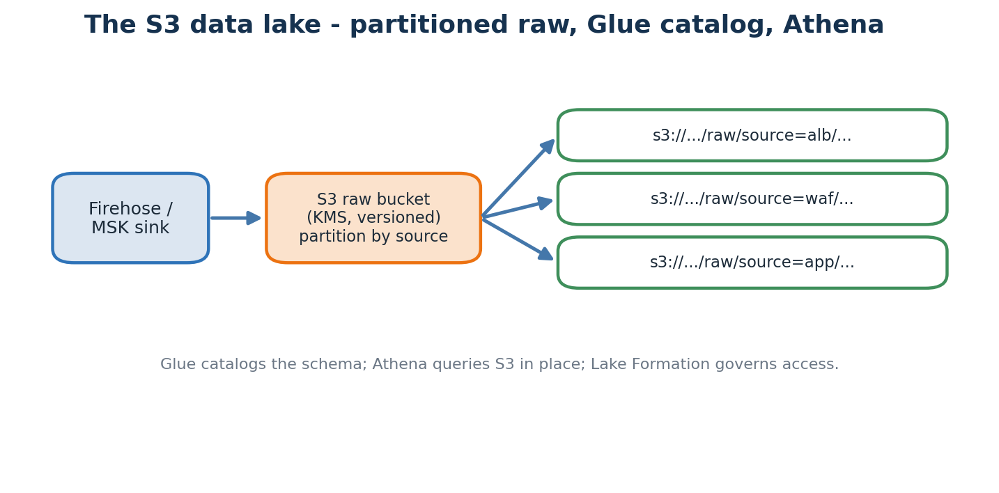
Raw events land in KMS-encrypted, versioned S3 buckets, partitioned by source; Glue catalogs them.

9.1 Why a lake
A data lake is raw, schema-on-read, cheap and effectively infinite — just files in S3. It is the source of truth from which everything else (features, training data, ad-hoc queries) is derived. The datalake module creates several KMS-encrypted, versioned, fully access-blocked S3 buckets, plus a Glue catalog and Lake Formation registration for governance.

9.2 Partitioning
Files are written under s3://bucket/raw/source=alb/..., source=waf/..., source=app/.... This Hive-style layout lets query engines skip whole directories when a query filters by source — a large cost and speed win, because you scan only the files you need.

9.3 Glue and Athena
AWS Glue is a managed data catalog and ETL service; it records the schema of the S3 data so other tools can query it without copying it. Amazon Athena then runs ordinary SQL directly against S3, billed per terabyte scanned — which is why partition filters matter so much. Lake Formation adds fine-grained, table- and column-level access control on top.

9.4 Encryption and lifecycle
Every bucket uses KMS encryption at rest, versioning (so a bad write can be rolled back) and a public-access block. A lifecycle rule expires old raw partitions after a retention window so storage cost does not grow without bound.

Where this lives in the repo
Concept | Where in this repo | Why it matters
Datalake module | infra/modules/datalake/main.tf | KMS-encrypted, versioned S3 buckets + Glue catalog + Lake Formation; partitioned by source.

Stitch -> You now have raw data durably stored and queryable in SQL. The next chapter covers the search and near-real-time anomaly layer on top of it — OpenSearch.

Chapter 10 — OpenSearch — index and built-in anomaly detection
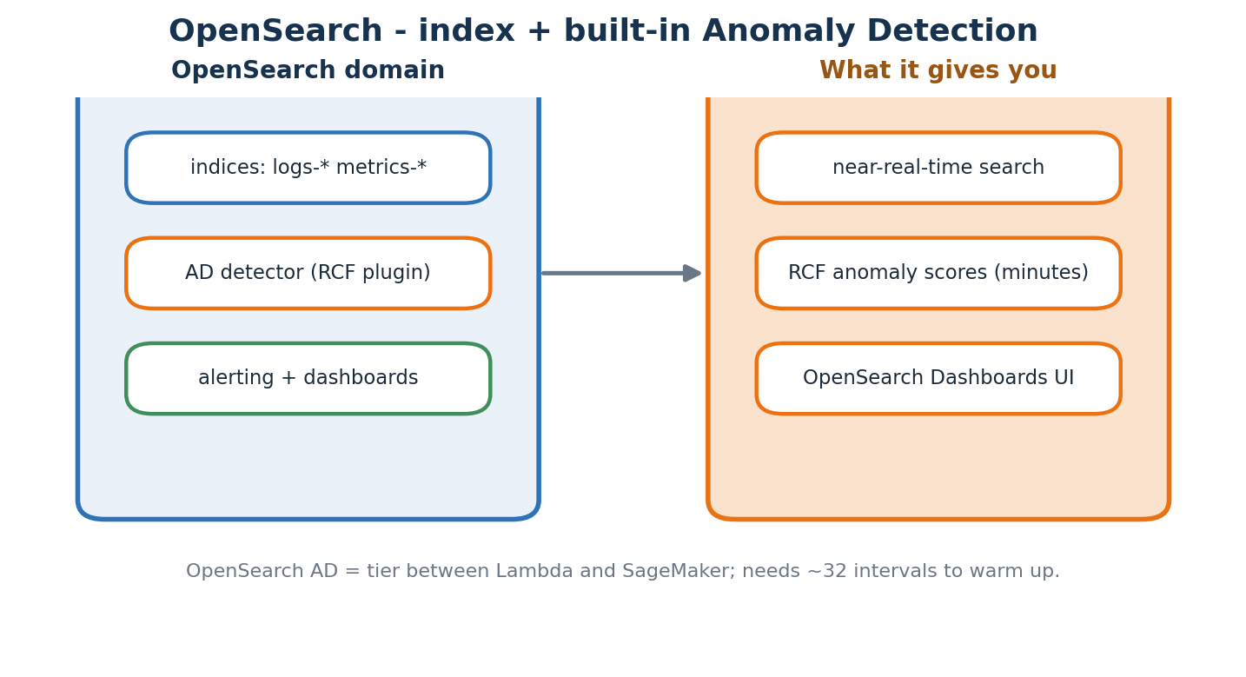
OpenSearch indexes logs/metrics for fast search and runs an RCF anomaly detector in minutes.

10.1 What OpenSearch adds
S3 is cheap but slow to search interactively. Amazon OpenSearch Service indexes logs and metrics so analysts can search them in near real time and build dashboards. Crucially, it also ships an Anomaly Detection plugin that runs Random Cut Forest over indexed time-series — a detection tier that sits between the instant Lambda rules and the heavier SageMaker models.

10.2 The anomaly-detection tier
An OpenSearch AD detector needs a warm-up — roughly 32 intervals of data — before it can score. Once warm it produces anomaly grades within minutes, with no model training pipeline to manage. It is the cheapest way to get learned (not just threshold-based) anomaly scores on indexed metrics, and it powers alerting and dashboards directly inside OpenSearch.

10.3 Dashboards and access
OpenSearch Dashboards is the built-in UI for searching logs, drilling into individual alerts and visualising AD output. Access is gated through Cognito so only authenticated analysts, responders or admins can see it. This is one of the two human surfaces of the platform; the other is Managed Grafana for metrics, covered later.
Sensitive area
OpenSearch index mappings are hard to change once data exists. Evolve schemas with index aliases plus reindexing rather than editing a live index in place.

Where this lives in the repo
Concept | Where in this repo | Why it matters
OpenSearch module | infra/modules/opensearch/main.tf — domain + AD detectors | Near-real-time search + RCF anomaly detection; Dashboards UI gated by Cognito.

Stitch -> You now have raw data on disk, queryable in SQL and searchable in OpenSearch. The next chapter explains the schema discipline that lets many sources share one shape — parsers and CommonEvent.

Chapter 11 — Schema and parsers — turning many formats into one
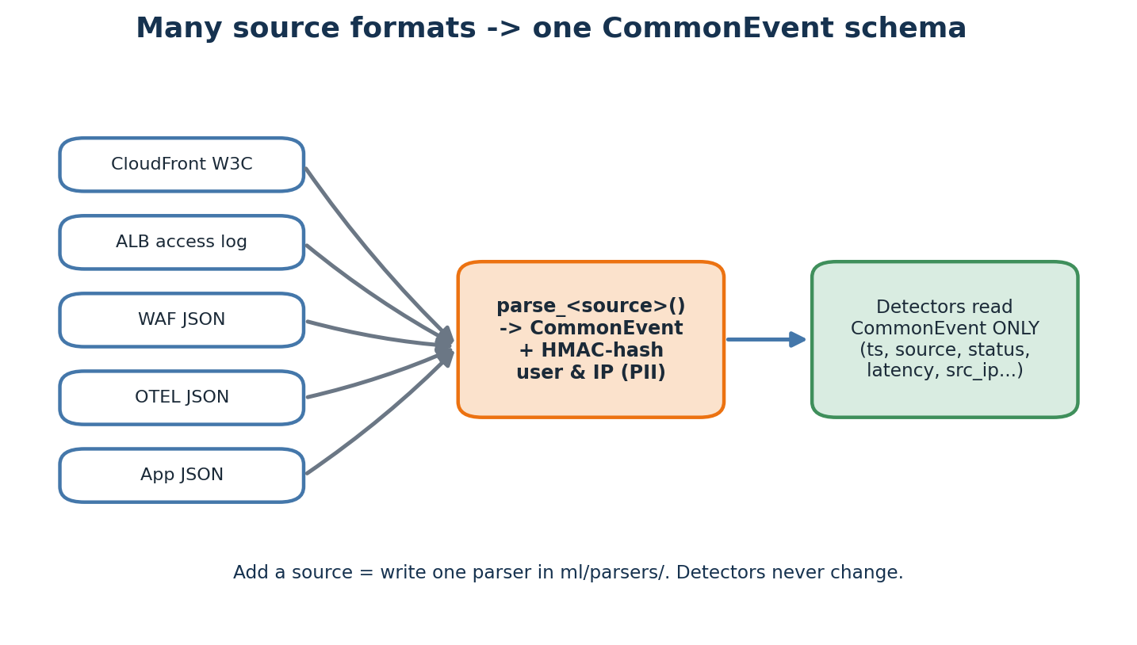
Per-source parsers normalise every format into one CommonEvent shape and hash PII on the way through.

11.1 Why a canonical schema
Each source emits a different shape — a CloudFront W3C log, an ALB access line, WAF JSON, OTEL JSON. If every detector had to understand every shape, adding one source would force a change to every detector. The solution is one CommonEvent schema plus per-source parsers that adapt into it; detectors read CommonEvent only.

11.2 CommonEvent shape
{ ts, ingest_ts, source: 'cloudfront|alb|waf|app|eks|nginx|...',
host, severity, status, latency_ms, bytes, src_ip, user,
path, user_agent, message, attrs }

11.3 One file per source
The ml/parsers directory has a small module per source — alb.py, waf.py, cloudfront.py, otel.py, nginx.py and so on — each exposing a parse function that returns a CommonEvent. Adding a new source is genuinely one new file plus a line in the dispatcher; nothing downstream changes.

11.4 PII handling
Critical rule one: hash usernames and IPs with HMAC inside the parser, so detectors only ever see hashes. This lets you analyse rate-per-user or distinct-IP counts without storing an identifier — you cannot leak data you never keep. (Raw IPs are allowed only where they are the data being analysed, such as WAF and CloudFront.)

Where this lives in the repo
Concept | Where in this repo | Why it matters
Parsers | ml/parsers/ — one module per source + a CommonEvent dispatcher | Adding a source = one new parser file; detectors are untouched.

Stitch -> You now have data normalised to one shape. The next chapter explains the math that decides which CommonEvent rows are anomalous.

Chapter 12 — Statistics 101 — what 'anomaly' actually means
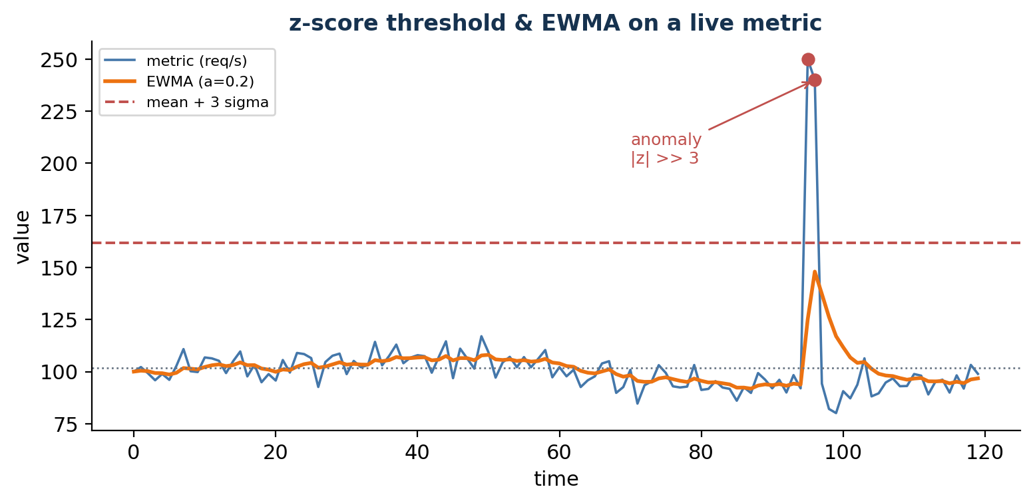
A live metric with its EWMA and a mean+3-sigma threshold; the spike is many standard deviations out.

12.1 Mean and standard deviation
The mean (mu) is the centre of a distribution; the standard deviation (sigma) is the typical distance from it. If a metric's recent mean is 100 requests/second with sigma = 15, then 250 req/s is ten standard deviations away — extraordinarily unlikely under normal behaviour.

12.2 Z-score
The z-score is z = (x - mu) / sigma; an absolute value above 3 is a common anomaly threshold. It is cheap and robust on stationary data, which makes it the default first rule.

12.3 EWMA — exponentially weighted moving average
A plain mean treats yesterday and last week identically. EWMA weights recent points more heavily: EWMA_t = alpha * x_t + (1 - alpha) * EWMA_(t-1). The baseline adapts to slow drift instead of flagging every gradual shift.

12.4 Rate-of-change and distinct counters
If a counter doubles in thirty seconds, that is news even if the absolute value still looks normal — rate-of-change rules catch sudden spikes a slow baseline would miss. Distinct counters track unique values: a jump from 50 to 5000 unique source IPs in a minute is the signature of a DDoS even before total request rate explodes.

12.5 Why these still are not enough
Three reasons. Seasonality: traffic is not stationary, so a lunch peak is not a midnight anomaly. Multi-variate signals: error rate alone may be fine, but error rate AND latency AND queue depth rising together means something specific is breaking. Cold start: a z-score on the first thirty minutes of data is meaningless — exactly the gap the trained ML detectors cover.

Where this lives in the repo
Concept | Where in this repo | Why it matters
Statistical methods | ml/streaming/detector.py (z-score, ewma, rate, distinct rules) | Pure-Python rules with no training; the basis for the tier-2 Lambda detector.

Stitch -> You now have the basic statistical tools. The next chapter wires them into a live, sub-second alerting pipeline — the streaming AWS Lambda.

Chapter 13 — Streaming statistical detectors (AWS Lambda)
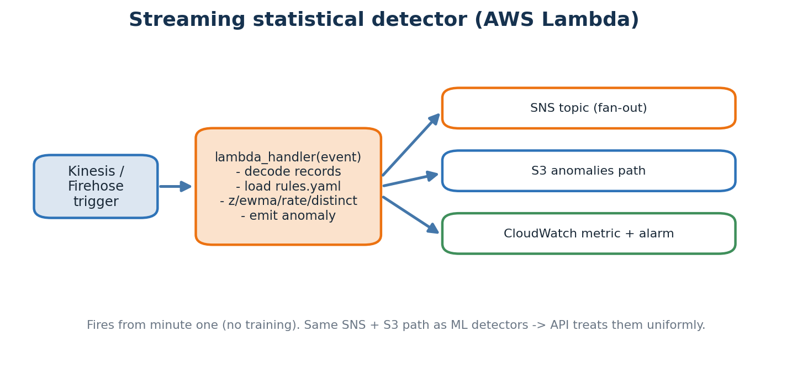
A Kinesis record triggers the Lambda; matching rules emit to SNS, S3 and CloudWatch.

13.1 AWS Lambda
Lambda is a managed runtime that runs a small piece of code in response to an event — here a batch of Kinesis records. It auto-scales from zero to thousands of concurrent executions and you pay only for the milliseconds it runs. That makes it perfect for a cheap, always-on first-line detector.

13.2 Entry point
def lambda_handler(event, context):
for record in event['Records']:
payload = decode(record['kinesis']['data'])
for rule in load_rules():
if check(rule, payload):
emit_anomaly(payload, rule)

13.3 Rules
The detector logic lives in ml/streaming/detector.py and the AWS wiring in lambda_handler.py. Each rule names a metric, a method (z-score / ewma / rate / distinct), thresholds and a severity. Keeping rules as data rather than scattered code is what lets on-call tune thresholds without a redeploy.

13.4 The cold-state caveat
A fresh Lambda execution environment has no rolling history, so the first roughly thirty minutes after a scale-out can produce noisy z-scores. This is an accepted trade-off: the function is extremely cheap and the ML detectors cover that early gap.

13.5 Where anomalies go
Every anomaly is published to an SNS topic for fan-out, written to an S3 anomalies path, and recorded as a CloudWatch custom metric with an alarm. Critically, the ML detectors emit to the same SNS topic and S3 path, so the scoring API treats statistical and ML anomalies uniformly.
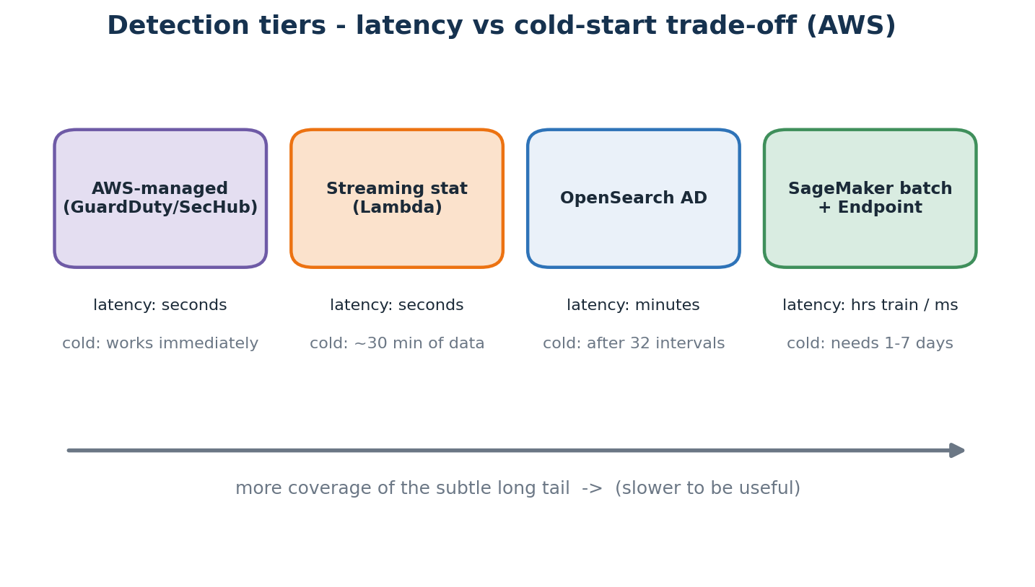
The four detection tiers ranked by latency and cold-start. The Lambda is tier 2; OpenSearch AD is the middle tier.

Where this lives in the repo
Concept | Where in this repo | Why it matters
Streaming detector | ml/streaming/detector.py + ml/streaming/lambda_handler.py | Kinesis-triggered Lambda; emits to the same SNS + S3 path as the ML detectors.

Stitch -> You now have a tier-2 detector that fires in seconds with no training. The next chapter lays the foundation for tier 3 — just enough machine learning to follow the rest.

Chapter 14 — Machine Learning crash course
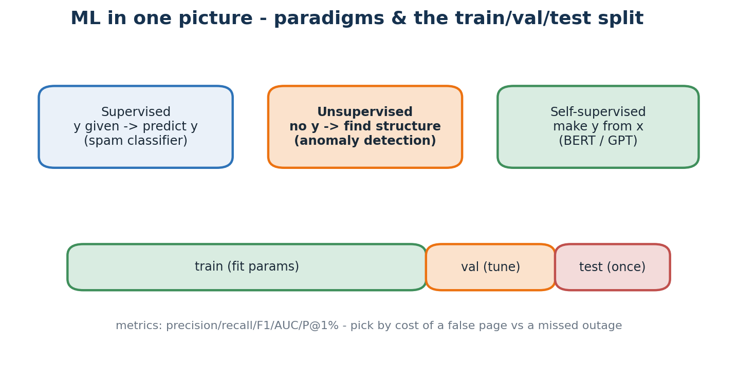
Three learning paradigms and the train/validate/test split that keeps evaluation honest.

14.1 What is a model
A model is a function f(x) -> y whose parameters are fit from data. Training means choosing parameters that minimise a loss on a dataset; inference means calling f on new x. Everything else is detail around those two ideas.

14.2 Three paradigms
- Supervised — the label y is given; predict y from x (a spam classifier).
- Unsupervised — no labels; find structure such as density or clusters (anomaly detection).
- Self-supervised — manufacture y from x, e.g. mask a word and predict it (BERT, GPT).

14.3 Train / validate / test
Split the data three ways: fit on train, tune on validation, and estimate real-world performance on test, which you touch exactly once at the end. This stops a model from looking good simply because it memorised the data you evaluated it on.

14.4 Metrics that matter
- Precision — of the things flagged, how many were real — keeps you from paging on noise.
- Recall — of the real problems, how many were caught — keeps you from missing outages.
- F1 / AUC / P@1% — harmonic mean of precision and recall; ranking quality; and precision in the top 1% of scores — the detector-evaluation favourite.

14.5 The four detectors
- rcf_metrics — SageMaker Random Cut Forest over numerical metrics; gate F1 >= 0.70.
- iforest_logs — Isolation Forest over tabular log-window features; gate P@1% >= 0.80.
- lstm_autoencoder_traces — an LSTM auto-encoder on trace sequences via reconstruction error; gate AUC > 0.80.
- log_embedding_anomaly — a LogBERT-lite transformer over free-text log lines; gate P@1% >= 0.75.

Where this lives in the repo
Concept | Where in this repo | Why it matters
Detector catalogue | ml/pipelines/{rcf_metrics,iforest_logs,lstm_autoencoder_traces,log_embedding_anomaly} | Each folder holds feature_extract, train, evaluate and the pipeline definition.

Stitch -> You now have a vocabulary for ML and the four algorithms in use. The next chapter covers the first concrete step in any pipeline — turning raw events into model inputs.

Chapter 15 — Feature engineering — turning events into model inputs
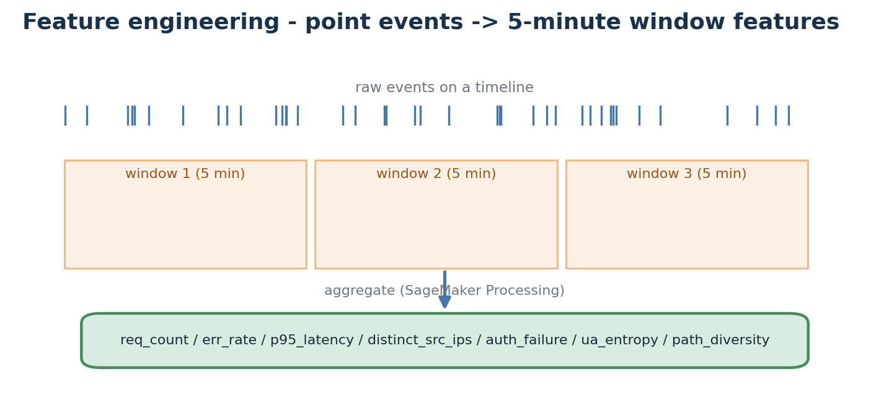
Point-in-time events are aggregated over 5-minute windows into the security feature columns.

15.1 Why features matter more than the algorithm
Two competent practitioners using the same algorithm get wildly different results depending on their features. Garbage in, garbage out is the most-cited rule in applied ML for a reason — most of the win comes from how you represent the data, not which model you pick.

15.2 Sliding windows
Raw events are point-in-time, but the most useful features are over a window: requests in the last five minutes, distinct IPs in the last five minutes, p95 latency in the last five minutes. This project uses 5-minute fixed windows; overlapping rolling windows are smoother but several times more expensive. The work runs as a SageMaker Processing job.

15.3 The security features computed
- req_count_5m — total requests by source and host.
- err_count_5m / err_rate_5m — 4xx + 5xx counts and their ratio.
- p95_latency_5m — the 95th-percentile latency over the window.
- distinct_src_ips_5m — unique source IPs — a DDoS signature.
- auth_failure_count_5m — 401/403/login-failed counts — a brute-force signature.
- ua_entropy_5m / path_diversity_5m — Shannon entropy of user-agents and count of distinct paths.

Where this lives in the repo
Concept | Where in this repo | Why it matters
Feature builder | ml/feature_engineering/security_features.py | Reads raw events from S3, computes 5-min features, writes them back; all four trainers consume them.

Stitch -> You now have model-ready feature tables. The next chapter explains the orchestration that turns them into a trained, registered model — SageMaker Pipelines.

Chapter 16 — Training pipelines (SageMaker Pipelines)
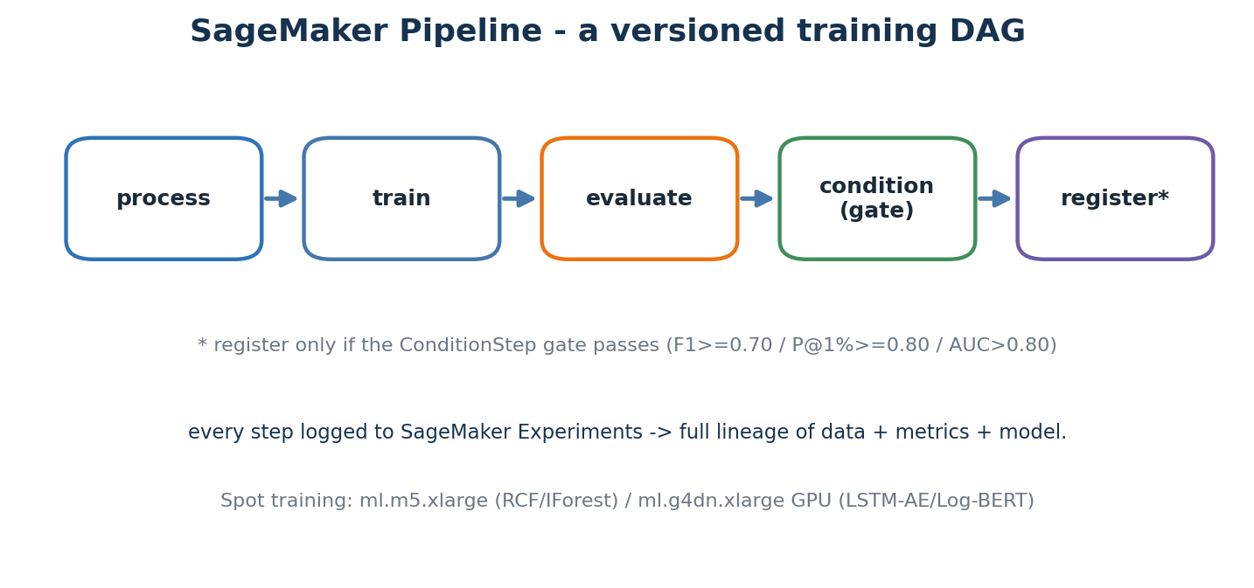
A pipeline is a versioned DAG: process -> train -> evaluate -> condition gate -> register.

16.1 Why a pipeline framework
A real training run has many steps — process data, train, evaluate, gate on quality, register, maybe deploy. Doing them in a notebook is fine for a prototype; in production you need versioned, parameterised, reproducible runs that record their inputs, outputs and metrics. SageMaker Pipelines is AWS's offering, defined with the SageMaker Python SDK.

16.2 Steps
Each detector's pipeline.py defines a ProcessingStep (feature extraction), a TrainingStep, an evaluate step, a ConditionStep (the quality gate) and a RegisterModel step. The DAG is compiled and submitted to SageMaker, which schedules each step on the right instance type.

16.3 Lineage
Every step is logged to SageMaker Experiments, and each registered model version links back to the run that produced it, the data it used and the metrics it achieved. When a detector misbehaves in production you can answer 'which run made this model?' immediately.

16.4 Compute and the quality gate
RCF and Isolation Forest train on ml.m5.xlarge Spot instances; the LSTM auto-encoder and LogBERT train on ml.g4dn.xlarge GPU Spot instances. Spot is three-to-four times cheaper, with restart logic for interruptions. The ConditionStep is the safety valve: a model is registered only if it clears its gate (for example F1 >= 0.70), so a bad training run never reaches production.

Where this lives in the repo
Concept | Where in this repo | Why it matters
The four pipelines | ml/pipelines/*/pipeline.py + run_pipeline.py + _shared/ | process -> train -> evaluate -> condition -> register; Spot instances; per-detector gate.

Stitch -> You now have trained model artefacts with metadata. The next chapter covers the catalogue that makes them discoverable and approvable — the SageMaker Model Registry.

Chapter 17 — Model registry and the approval gate
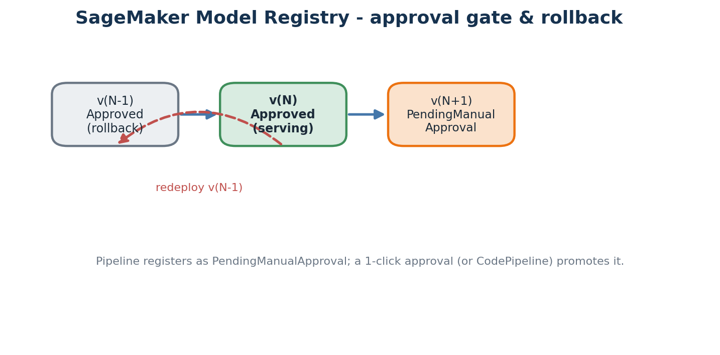
New versions register as PendingManualApproval; a one-click approval (or CodePipeline) promotes them.

17.1 What the registry holds
The SageMaker Model Registry organises models into model-package groups (one per detector). Each version records the container image used to serve it, the S3 location of the artefact, the evaluation metrics, and an approval status: PendingManualApproval, Approved or Rejected.

17.2 The approval gate
When a pipeline registers a model it lands as PendingManualApproval. A human (or an automated CodePipeline policy) reviews the metrics and approves it. Only an Approved version is deployed to an endpoint. This deliberate gate is what stops an automated retrain from silently shipping a worse model.

17.3 Why versioning matters operationally
The day a detector starts paging on-call uselessly, you do not want to retrain in a panic — you want to redeploy the previous Approved version in minutes. Because every version is kept with its metrics, rollback is a known, fast, low-risk operation rather than an emergency.

Where this lives in the repo
Concept | Where in this repo | Why it matters
Registry | infra/modules/sagemaker/ + ml/pipelines/*/pipeline.py (RegisterModel step) | Model-package groups with approval status; only Approved versions reach an endpoint.

Stitch -> You now have a versioned, approvable catalogue of detectors. The next chapter explains the live endpoints that actually run inference — SageMaker Endpoints.

Chapter 18 — Online endpoints (SageMaker Endpoints)
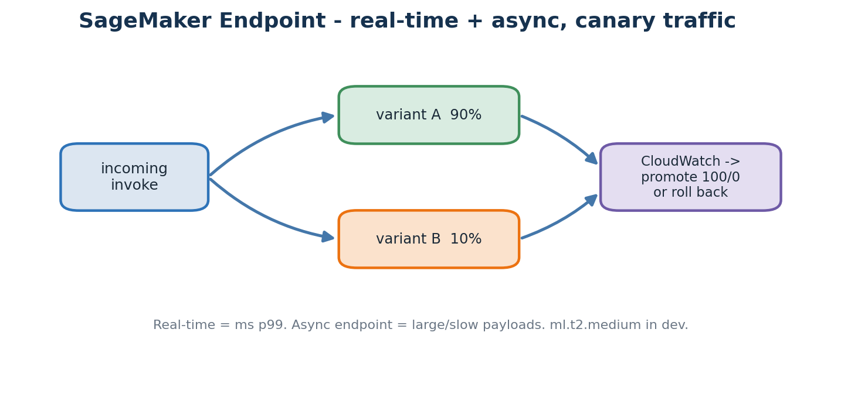
An endpoint hosts model variants with a traffic split; real-time serves ms, async serves large jobs.

18.1 What an endpoint is
A SageMaker endpoint is an always-on HTTPS service hosting one or more model variants. You call InvokeEndpoint with a JSON instance and it returns a prediction in milliseconds. SageMaker handles the container, autoscaling and health checks. There are two flavours: real-time endpoints for low-latency scoring, and async endpoints for large or slow payloads that you submit and collect later.

18.2 Instance types per detector
In dev the CPU detectors serve on ml.t2.medium and the heavier models on ml.c5.large; production scales these up. Cost rule two caps GPU at ml.g4dn.xlarge — no larger GPUs in this project.

18.3 Production variants and canary
An endpoint can host several production variants with a traffic split — for example 90% to the current model and 10% to a challenger. You watch CloudWatch for an hour, then shift to 100/0 or roll back. This is canary deployment applied to machine-learning models, and it is how a new version proves itself on real traffic before taking it all.

18.4 Real-time path latency
Training is batch and slow; inference is online and fast. A real-time endpoint serves p99 in the tens-to-low-hundreds of milliseconds. The drift-retrain loop keeps the model behind it fresh without changing the endpoint's address.

Where this lives in the repo
Concept | Where in this repo | Why it matters
Endpoints | infra/modules/sagemaker/main.tf + scripts/import_pretrained_model.py | Real-time + async endpoints; import_pretrained_model.py lets you bring your own model.

Stitch -> You now have a stable endpoint per detector. The next chapter explains the service that calls them, picks the winner, stores the alert and authenticates the caller — the Scoring API.

Chapter 19 — The Scoring API — one HTTP surface over the detectors
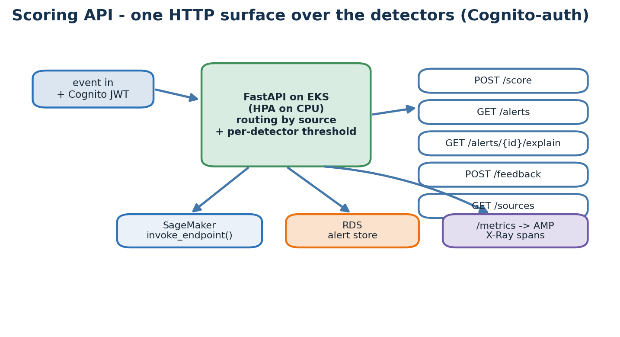
A FastAPI gateway on EKS authenticates with Cognito, routes by source, and persists alerts.

19.1 Why a thin gateway
The SageMaker endpoints are private. A gateway in front adds public routing, WAF and authentication; decides which detector to call based on the event source; applies per-detector thresholds; persists alerts for the dashboards; and receives feedback labels. It is deliberately thin — orchestration, not modelling.

19.2 Authentication with Cognito
Every request carries a Cognito-issued JWT. Amazon Cognito manages the user pool and the three groups — analyst, responder, admin — and the API validates the token and enforces group-based access. This is how only authorised humans and services can score events or read alerts.

19.3 The five HTTP routes
- POST /api/v1/score — score a single event.
- GET /api/v1/alerts — list alerts with since/source/severity filters.
- GET /api/v1/alerts/{id}/explain — feature contributions for one alert.
- POST /api/v1/feedback — record a true-positive or false-positive label.
- GET /api/v1/sources — last-seen heartbeat per source.

19.4 Internals
FastAPI on uvicorn, autoscaled by an HPA on CPU. The SageMaker invoker wraps boto3 invoke_endpoint; the alert store persists to RDS; a /metrics endpoint exposes counters for AMP; and X-Ray spans wrap each scoring call. Database credentials arrive via the External Secrets Operator from Secrets Manager — never baked into the image.
result = sagemaker_invoker.invoke(event.source, event.dict())
is_anom = result["is_anomaly"] or result["score"] >= ANOMALY_THRESHOLD

Where this lives in the repo
Concept | Where in this repo | Why it matters
Scoring API | api/scoring/main.py + services/{sagemaker_invoker,alert_store,auth,observability}.py | Deployed by helm/charts/anomaly-scoring-api with Ingress (ALB) + WAF + Cognito + ExternalSecret.

Stitch -> You now have an authenticated HTTP service producing alerts. The next chapter covers the human surfaces those alerts appear in — Managed Grafana and OpenSearch Dashboards.

Chapter 20 — AIOps dashboards — Managed Grafana and OpenSearch
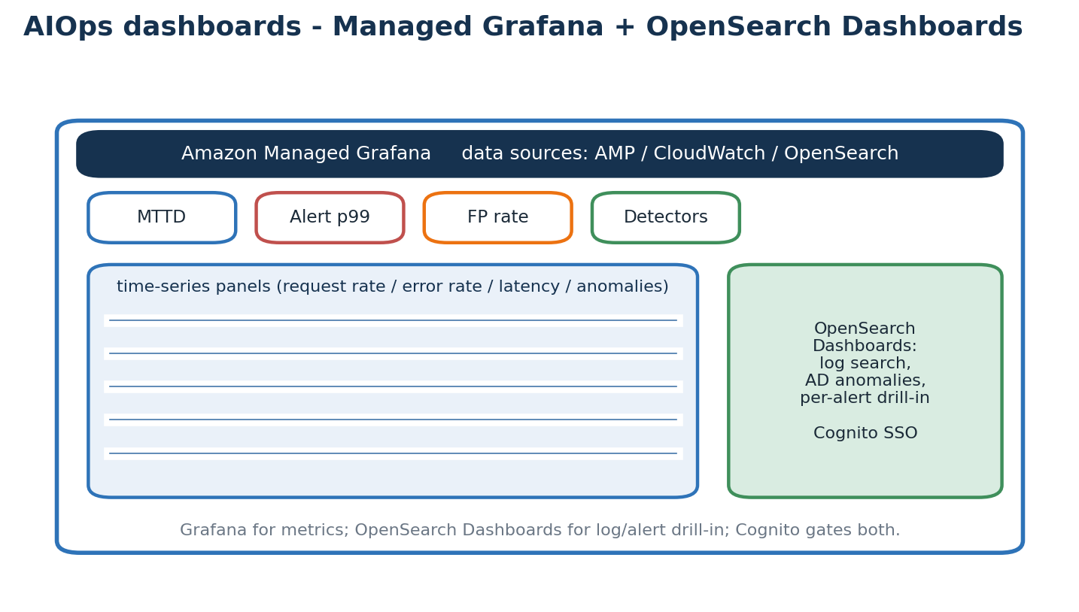
Grafana visualises AMP/CloudWatch metrics; OpenSearch Dashboards handles log and alert drill-in.

20.1 Two complementary surfaces
Rather than build a bespoke console, the AWS platform uses two managed UIs. Amazon Managed Grafana (AMG) is the metrics surface: it reads from Managed Prometheus and CloudWatch and shows request rate, error rate, latency percentiles, detection rates and the SLO headline numbers. OpenSearch Dashboards is the log-and-alert surface: full-text log search, anomaly-detection output, and per-alert drill-in.

20.2 What you watch
The Grafana dashboards track the SLOs that define 'healthy': mean time to detect, alert latency p99, false-positive rate after the first month of feedback, ingest backlog, and detector availability. When one drifts out of band, a CloudWatch alarm fires and — for model-quality drift — can kick the retrain loop.

20.3 Access and single sign-on
Both surfaces sit behind Cognito, so the same analyst / responder / admin groups that gate the API also gate the dashboards. An analyst can search logs and view anomalies; a responder can act; an admin can configure. No dashboard is open to the public internet.

Where this lives in the repo
Concept | Where in this repo | Why it matters
Dashboards | infra/modules/amg (Managed Grafana) · infra/modules/opensearch (Dashboards) · infra/modules/cognito | Grafana for metrics, OpenSearch Dashboards for logs/alerts; Cognito gates both.

Stitch -> You now have human surfaces for the alerts. The next chapter explains the lifecycle that keeps detectors useful as the world changes — drift, retraining and the closed loop.

Chapter 21 — Drift, retraining, and the closed loop
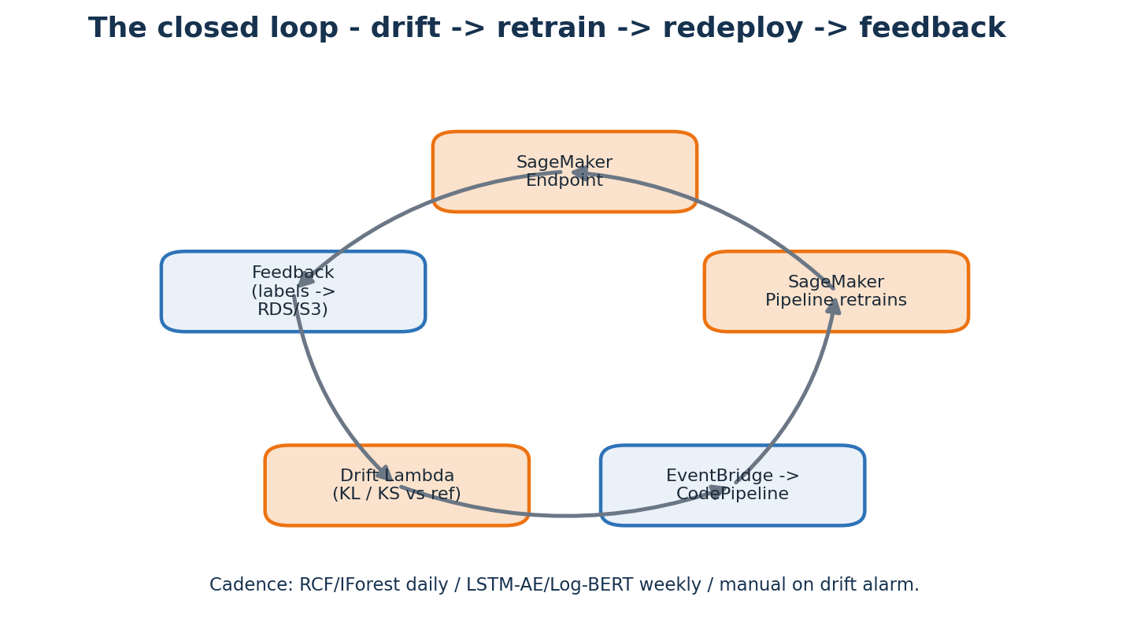
Serve -> feedback -> drift Lambda -> EventBridge -> CodePipeline retrain -> redeploy.

21.1 Drift
Models age in two ways. Data drift is when the input distribution changes — your traffic mix shifts or a new feature rolls out. Concept drift is when the relationship between input and label changes — what counted as normal yesterday is not normal today. Both quietly erode accuracy.

21.2 Detect drift on inputs, not predictions
Rule five: watch the inputs. It is far faster to notice that a feature's mean has shifted by three sigma than to wait for a precision dip in outcomes. A drift Lambda computes a statistical distance (KL divergence or a KS test) between the current feature distribution and a frozen reference captured at training time, comparing against a baseline stored in S3.

21.3 Retraining cadence
- RCF / Isolation Forest — daily, because they are cheap and fast.
- LSTM-AE / LogBERT — weekly, because they need a GPU and take hours.
- Manual / event-driven — a drift alarm raises an EventBridge event that starts CodePipeline, which re-runs the matching SageMaker pipeline.

21.4 The feedback loop
Every feedback label from the API (true positive / false positive) is stored and fed into the next training run as ground truth for evaluation and weighting. This is the mechanism by which the platform learns from its operators over time rather than going stale.

Where this lives in the repo
Concept | Where in this repo | Why it matters
Drift + retrain | ml/monitoring/{baseline,drift_detector,lambda_handler}.py · infra/modules/monitoring/drift_lambda.tf · modules/cicd | Drift Lambda -> EventBridge -> CodePipeline re-runs the matching SageMaker pipeline.

Stitch -> You now have a closed lifecycle that keeps detectors current. The next chapter covers the security posture protecting every layer — defence in depth.

Chapter 22 — Security across the stack — defence in depth
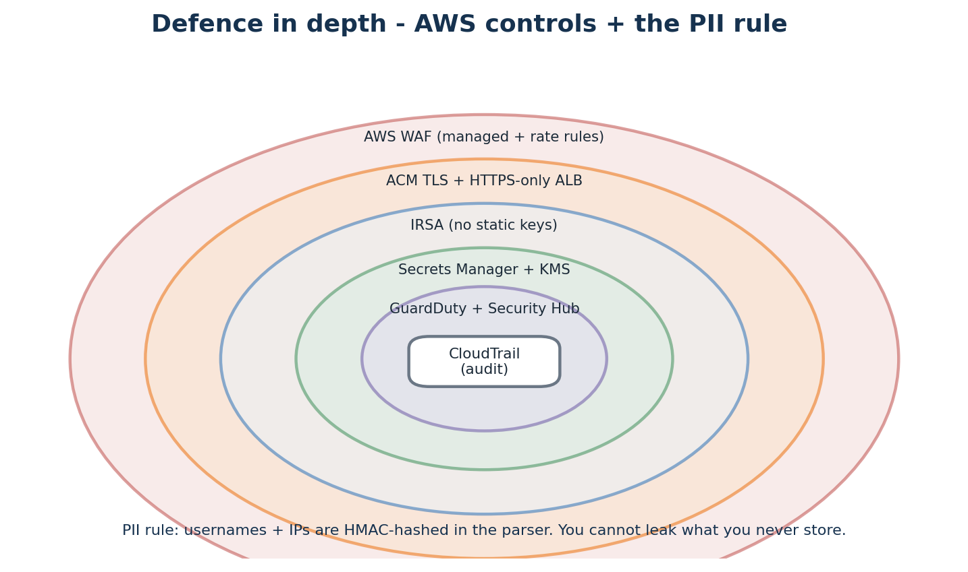
Concentric AWS controls plus the PII rule: many overlapping walls beat one tall wall.

22.1 Many weak walls beat one strong wall
Defence in depth assumes any single control can fail and layers several so a breach of one is not a breach of all. This project applies a stack of AWS controls plus a data-minimisation rule.
- AWS WAF at the edge — managed SQLi/XSS rule groups plus a rate-based rule.
- ACM TLS, HTTPS-only ALB — encryption in transit terminated at the load balancer.
- IRSA — pods assume IAM roles via OIDC; no static AWS keys in the cluster.
- Secrets Manager + KMS — credentials versioned, encrypted, synced into the cluster by External Secrets.
- GuardDuty + Security Hub — managed threat intelligence and findings aggregation.
- CloudTrail — an immutable audit log of every AWS API call in the account.

22.2 The PII rule
Rule one: all usernames and IPs are HMAC-hashed inside the parser, so detectors see only hashes. You cannot leak data you do not store — data minimisation is itself a security control, not only a privacy one. Raw IPs survive only where they are the object of analysis, such as WAF and CloudFront logs.
Sensitive area
Disabling GuardDuty leaves you blind to AWS-side threats, and WAF rule edits have a public blast radius. Change both deliberately and test before merging.

Where this lives in the repo
Concept | Where in this repo | Why it matters
Security controls | infra/modules/{waf,guardduty,securityhub,cloudtrail,cognito} + Secrets Manager + KMS | Layered edge, identity, secrets, threat-intel and audit controls; PII hashed in the parser.

Stitch -> You now have a layered security posture. The next chapter covers the pragmatic side of running this on a credit card — what drives the bill and which knobs lower it.

Chapter 23 — Cost engineering — knobs that decide your bill
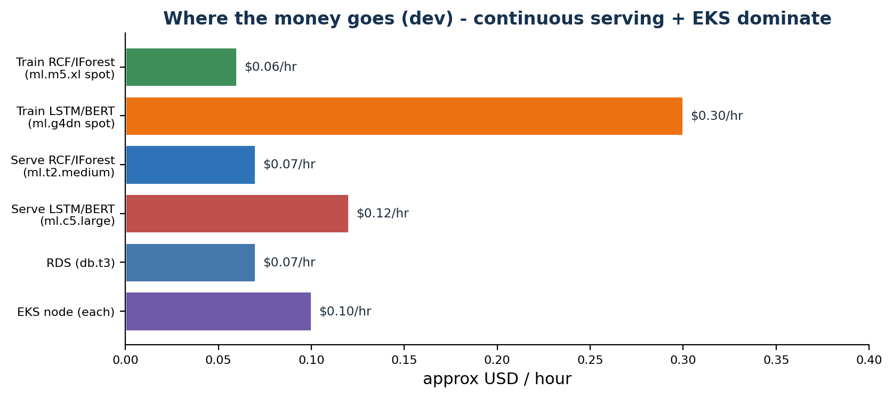
Approximate dev-environment hourly costs. Continuous serving and EKS nodes dominate; training is bursty.

23.1 Where the money goes (dev)
Training is cheap and bursty: RCF/IForest on Spot run for minutes a day, and the GPU models on ml.g4dn Spot run weekly. Serving is the opposite — it is continuous, so the always-on endpoints and EKS nodes are the steady cost. RDS, S3, Kinesis and CloudWatch add a modest baseline. Athena and any OpenSearch queries are charged on what they scan, so cost there is about query and retention hygiene.

23.2 The cost rules we follow
- Spot for all training — three-to-four times cheaper; pipelines carry restart logic.
- ml.g4dn.xlarge is the GPU ceiling — no larger GPUs anywhere in this project.
- ml.t2.medium endpoints in dev — scale serving up only for production.
- Stop RDS off-hours and let S3 lifecycle rules expire old raw partitions.
- Always filter the partition — Athena and Glue queries should filter by source/date before scanning.

23.3 Guardrails
The billing module emits AWS budget alarms (from us-east-1, where billing metrics live) so a runaway cost trips an alert before it trips your card. Treat teardown as part of the workflow: an idle SageMaker endpoint or a forgotten MSK cluster is the most common surprise on the bill.

Where this lives in the repo
Concept | Where in this repo | Why it matters
Cost guardrails | infra/modules/billing/main.tf (us-east-1 provider) · CLAUDE.md rule 2 | Budget alarms + Spot training + capped GPUs + modest endpoints keep dev affordable.

Stitch -> You now know where dollars go and how to control them. The next chapter is the hands-on part — the exact, ordered steps to bring the whole stack up.

Chapter 24 — The full deploy walk-through — step by step
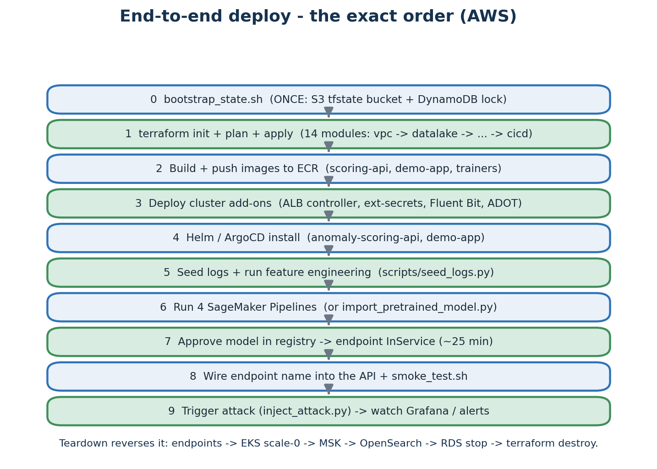
The exact order, from the one-time state bootstrap to a live, attack-tested system.

24.1 Prerequisites
Install the AWS CLI, Terraform, kubectl, helm and Docker, and configure an AWS profile with rights to create the resources. Confirm your account's service quotas in ap-south-1 — especially GPU instances for training and any vCPU limits — and raise them in the Service Quotas console if needed. Everything below assumes you are authenticated (aws sts get-caller-identity should return your account).

24.2 The ordered steps
- Step 0 — Bootstrap state (once): run infra/bootstrap_state.sh to create the S3 state bucket and DynamoDB lock table. Never run it again.
- Step 1 — Terraform: from infra/, run terraform init (it finds the S3 backend), then terraform plan and terraform apply. This builds all 14 modules — VPC, data lake, streaming (Firehose + MSK), SageMaker, EKS, RDS, OpenSearch, monitoring, WAF, Cognito, GuardDuty, Security Hub, CloudTrail and CI/CD. The EKS and OpenSearch creations are the slow parts.
- Step 2 — Images to ECR: build the scoring-api, demo-app and trainer images and docker push them to the ECR repositories Terraform created.
- Step 3 — Cluster add-ons: update your kubeconfig (aws eks update-kubeconfig), then install the AWS Load Balancer Controller, External Secrets Operator, Fluent Bit and the ADOT collector from helm/cluster-addons.
- Step 4 — App charts: helm install (or let ArgoCD sync) the anomaly-scoring-api and demo-app charts. The ALB and TLS certificate come up here; the ALB may take a few minutes to become healthy.
- Step 5 — Seed + features: run scripts/seed_logs.py to generate synthetic events, then the feature-engineering job to build the 5-minute feature tables in S3.
- Step 6 — Train or import: run the four SageMaker pipelines (run_pipeline.py per detector), or shortcut with scripts/import_pretrained_model.py to bring your own model.
- Step 7 — Approve + deploy: approve the registered model in the SageMaker console (one click), then wait for the endpoint to reach InService — roughly 25 minutes.
- Step 8 — Wire + smoke test: set the endpoint name in the API config and run scripts/smoke_test.sh to confirm /health, /score and /alerts all respond.
- Step 9 — Trigger an attack: run scripts/inject_attack.py (or the attack-mode Locust job) and watch anomalies appear in Grafana, OpenSearch Dashboards and the /alerts endpoint.

24.3 Teardown — order matters
Deletion runs in the reverse order of cost and dependency: delete SageMaker endpoints first (highest hourly cost and they block Feature Group deletion), scale EKS nodes to zero, stop RDS (preserving a snapshot), then run terraform destroy for everything else, and finally do the manual checks (versioned S3 buckets, CloudWatch log groups, ECR images). scripts/teardown.sh encodes this exact order so you do not learn it the hard way.

Where this lives in the repo
Concept | Where in this repo | Why it matters
Deploy + teardown | infra/bootstrap_state.sh · terraform · helm/cluster-addons · scripts/{seed_logs,import_pretrained_model,smoke_test,inject_attack,teardown}.py/sh | Bootstrap once, terraform apply, push images, install add-ons + charts, train/import, approve, smoke-test.

Stitch -> You now have a deployed, attack-tested stack. The next chapter covers the most likely things to break while you operate it, and how to recover.

Chapter 25 — Failure modes you will hit, and how to fix them
Operating any distributed system means meeting its failure modes. These are the ones you are most likely to hit on this AWS platform, with the root cause and the fix for each.
Symptom | Root cause | Fix
terraform apply fails on backend | State bucket / lock table not bootstrapped | Run infra/bootstrap_state.sh once, then terraform init again.
EKS create fails (quota) | vCPU or GPU quota not raised in ap-south-1 | Service Quotas console -> request an increase; re-apply.
Pods can't reach AWS APIs | IRSA annotation missing or wrong role ARN | Check the ServiceAccount annotation and the IAM trust policy on the role.
ALB has no address | AWS Load Balancer Controller not installed / IngressClass wrong | Install the controller add-on; check Ingress events with kubectl describe.
ExternalSecret not syncing | External Secrets Operator IRSA lacks secretsmanager:GetSecretValue | Grant the policy to the operator's role; check the ExternalSecret status.
SageMaker pipeline fails | Quality gate failed or training image missing in ECR | Open the pipeline run; fix the gate/features or push the image and re-run.
Endpoint stuck Creating | Wrong instance type / model artefact path | Check the endpoint events; verify the registered model's container + S3 artefact.
OpenSearch AD has no scores | Detector still warming up (needs ~32 intervals) | Wait for the warm-up window; confirm the index is receiving data.
Athena query is slow/expensive | No partition filter -> full scan | Filter by source/date partition; confirm Glue partitions are registered.
Worker CrashLoopBackOff | Wrong Redis endpoint or security group blocks it | Check the ElastiCache endpoint env var and the node-to-cache security group.
Stitch -> You now have operational confidence. The next chapter gathers every term used here into one alphabetical place — the glossary.

Chapter 26 — Glossary
ACM | AWS Certificate Manager — issues and renews TLS certificates.
ADOT | AWS Distro for OpenTelemetry — the collector for metrics and traces.
ALB | Application Load Balancer — layer-7 HTTP load balancer.
AMG / AMP | Amazon Managed Grafana / Amazon Managed Prometheus.
Anomaly | A data point unlike the majority — usually rare or fresh.
Athena | Serverless SQL over data in S3, billed per terabyte scanned.
CloudTrail | Immutable audit log of every AWS API call.
CodePipeline | AWS CI/CD service used here for model promotion / retrain.
Cognito | Managed user pools and JWT auth (analyst / responder / admin).
CommonEvent | The project's canonical event schema (ml/parsers/).
DAG | Directed Acyclic Graph — pipelines are DAGs of steps.
Drift (data / concept) | Inputs, or the input-output relationship, changing over time.
DynamoDB lock | The table Terraform uses to prevent concurrent state writes.
ECR | Elastic Container Registry — AWS's private Docker registry.
EKS | Elastic Kubernetes Service — AWS-managed Kubernetes.
ElastiCache | Managed Redis / Memcached.
EventBridge | Event bus that routes events (e.g. drift -> retrain).
EWMA | Exponentially Weighted Moving Average.
Firehose | Kinesis Data Firehose — managed delivery stream to S3.
Fluent Bit | Lightweight log shipper run as a DaemonSet.
Glue | Managed data catalog and ETL service over S3.
GuardDuty | Managed threat-detection service.
HPA | HorizontalPodAutoscaler; scales pods on CPU or custom metrics.
IAM | Identity & Access Management — roles, policies, principals.
IRSA | IAM Roles for Service Accounts — pods assume IAM roles via OIDC.
KMS | Key Management Service — encryption keys for S3, RDS, state, etc.
Lake Formation | Fine-grained governance layer over the S3 lake / Glue.
Lambda | Event-triggered serverless functions (the tier-2 detector).
MSK | Managed Streaming for Apache Kafka.
OpenSearch | Search + analytics service with a built-in Anomaly Detection plugin.
Precision / Recall / F1 / AUC / P@1% | Classification quality metrics.
RDS | Relational Database Service — managed MySQL/Postgres.
Random Cut Forest | Ensemble of random trees for streaming anomaly detection.
Route 53 | AWS DNS service.
SageMaker | AWS umbrella for ML training, pipelines, registry and endpoints.
Secrets Manager | Managed store for passwords and API keys.
Security Hub | Aggregates security findings across AWS services.
Spot instance | Preemptible EC2 capacity at a steep discount.
TargetGroupBinding | Custom resource linking a K8s Service to an ALB target group.
Terraform state | The record of what exists; stored in S3 with a DynamoDB lock.
VPC | Virtual Private Cloud — a private network in AWS.
WAF | Web Application Firewall.
X-Ray | AWS distributed tracing service.
Z-score | (x - mean) / stddev; larger absolute value means a rarer point.

Chapter 27 — A four-week study plan
Reading this guide is the start; the discipline only sticks once you build, break and retrain the thing yourself. This four-week plan pairs the chapters with hands-on work in the repo.

Week 1 — Foundations
- Days 1-2: read chapters 1-5; open every file named in a 'Where this lives' box.
- Day 3: install aws-cli, terraform, kubectl, helm and docker; run aws sts get-caller-identity.
- Day 4: run infra/bootstrap_state.sh, then terraform init/plan in a sandbox account.
- Day 5: terraform apply the VPC, data lake and streaming modules; watch them appear in the console.

Week 2 — Data + ML
- Day 1: read chapters 6-11; trace one event from demo-api -> Fluent Bit -> Firehose/MSK -> S3.
- Day 2: query the raw lake with Athena, filtered by source partition.
- Day 3: read chapters 12-14; run a SageMaker pipeline and watch it in the console.
- Day 4: read ml/pipelines/rcf_metrics/pipeline.py step by step.
- Day 5: add a metric to the evaluate step and re-run.

Week 3 — Serving + dashboards
- Day 1: read chapters 15-20; deploy add-ons + the scoring-api chart.
- Day 2: import a pre-trained model, approve it, wait for InService, wire the endpoint name in.
- Day 3: curl /api/v1/alerts with a Cognito token; POST an event to /score.
- Day 4: open Managed Grafana and OpenSearch Dashboards; find a real anomaly.
- Day 5: run inject_attack.py and watch the alert appear end to end.

Week 4 — Hardening + extending
- Day 1: read chapters 21-23; trigger a manual retrain via EventBridge / CodePipeline.
- Day 2: add a fifth detector with its own pipeline and endpoint.
- Day 3: add a Slack notifier as a Lambda subscribed to the anomalies SNS topic.
- Day 4: tighten WAF to restrict by source IP and test from a blocked address.
- Day 5: run scripts/teardown.sh in order, then recreate from scratch.

Recommended reading
- Designing Machine Learning Systems — Chip Huyen.
- The Site Reliability Workbook — Google (the observability chapter is gold).
- AWS Well-Architected Framework — especially the Security and Cost pillars.
- Data Science on AWS — Fregly & Barth (SageMaker end to end).
- Kubernetes Up & Running — Kelsey Hightower; and the OpenTelemetry docs at otel.io.
When you finish week four you will not just have read about MLOps on AWS — you will have built, broken, retrained and shipped one. That is the only way to learn this discipline.

