AIOps / MLOps on GCP
End-to-End Learning Guide
Project: monitoring-mlops-gcp | Region: asia-south1 (Mumbai)
Owner: Akhil | June 2026

Covers: Architecture · Ingestion · Feature Engineering · 4 ML Detectors · Vertex Pipelines · GKE Deployment · Retraining · Security · Cost

1. Mental Model — What This Platform Does
The platform answers one question continuously: Is this event anomalous? It does this across four parallel detection tiers, because no single approach can cover all timescales.

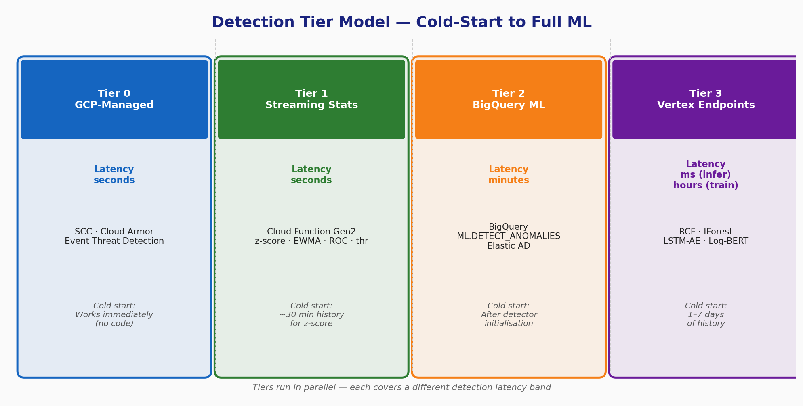
Figure 1 — Detection Tier Model: from GCP-managed to full ML

Why Four Tiers?
On day one you have no trained model and no labelled data. The streaming statistical detector catches obvious attacks immediately. As data accumulates, trained detectors come online and catch subtler, slower anomalies that threshold rules miss.

Tier | Latency | What | Technology | Cold-Start
Tier 0 | Seconds | GCP-native threat detection | SCC · Cloud Armor · Event Threat Detection | Works immediately
Tier 1 | Seconds | Streaming statistical rules | Cloud Function Gen2 + rules.yaml | ~30 min history for z-score
Tier 2 | Minutes | Batch statistical AD | BigQuery ML.DETECT_ANOMALIES / Elastic AD | After detector initialisation
Tier 3 | ms (infer)  hours (train) | Trained ML detectors | Vertex AI Endpoints (RCF, IForest, LSTM-AE, Log-BERT) | 1-7 days of history

2. Architecture Overview
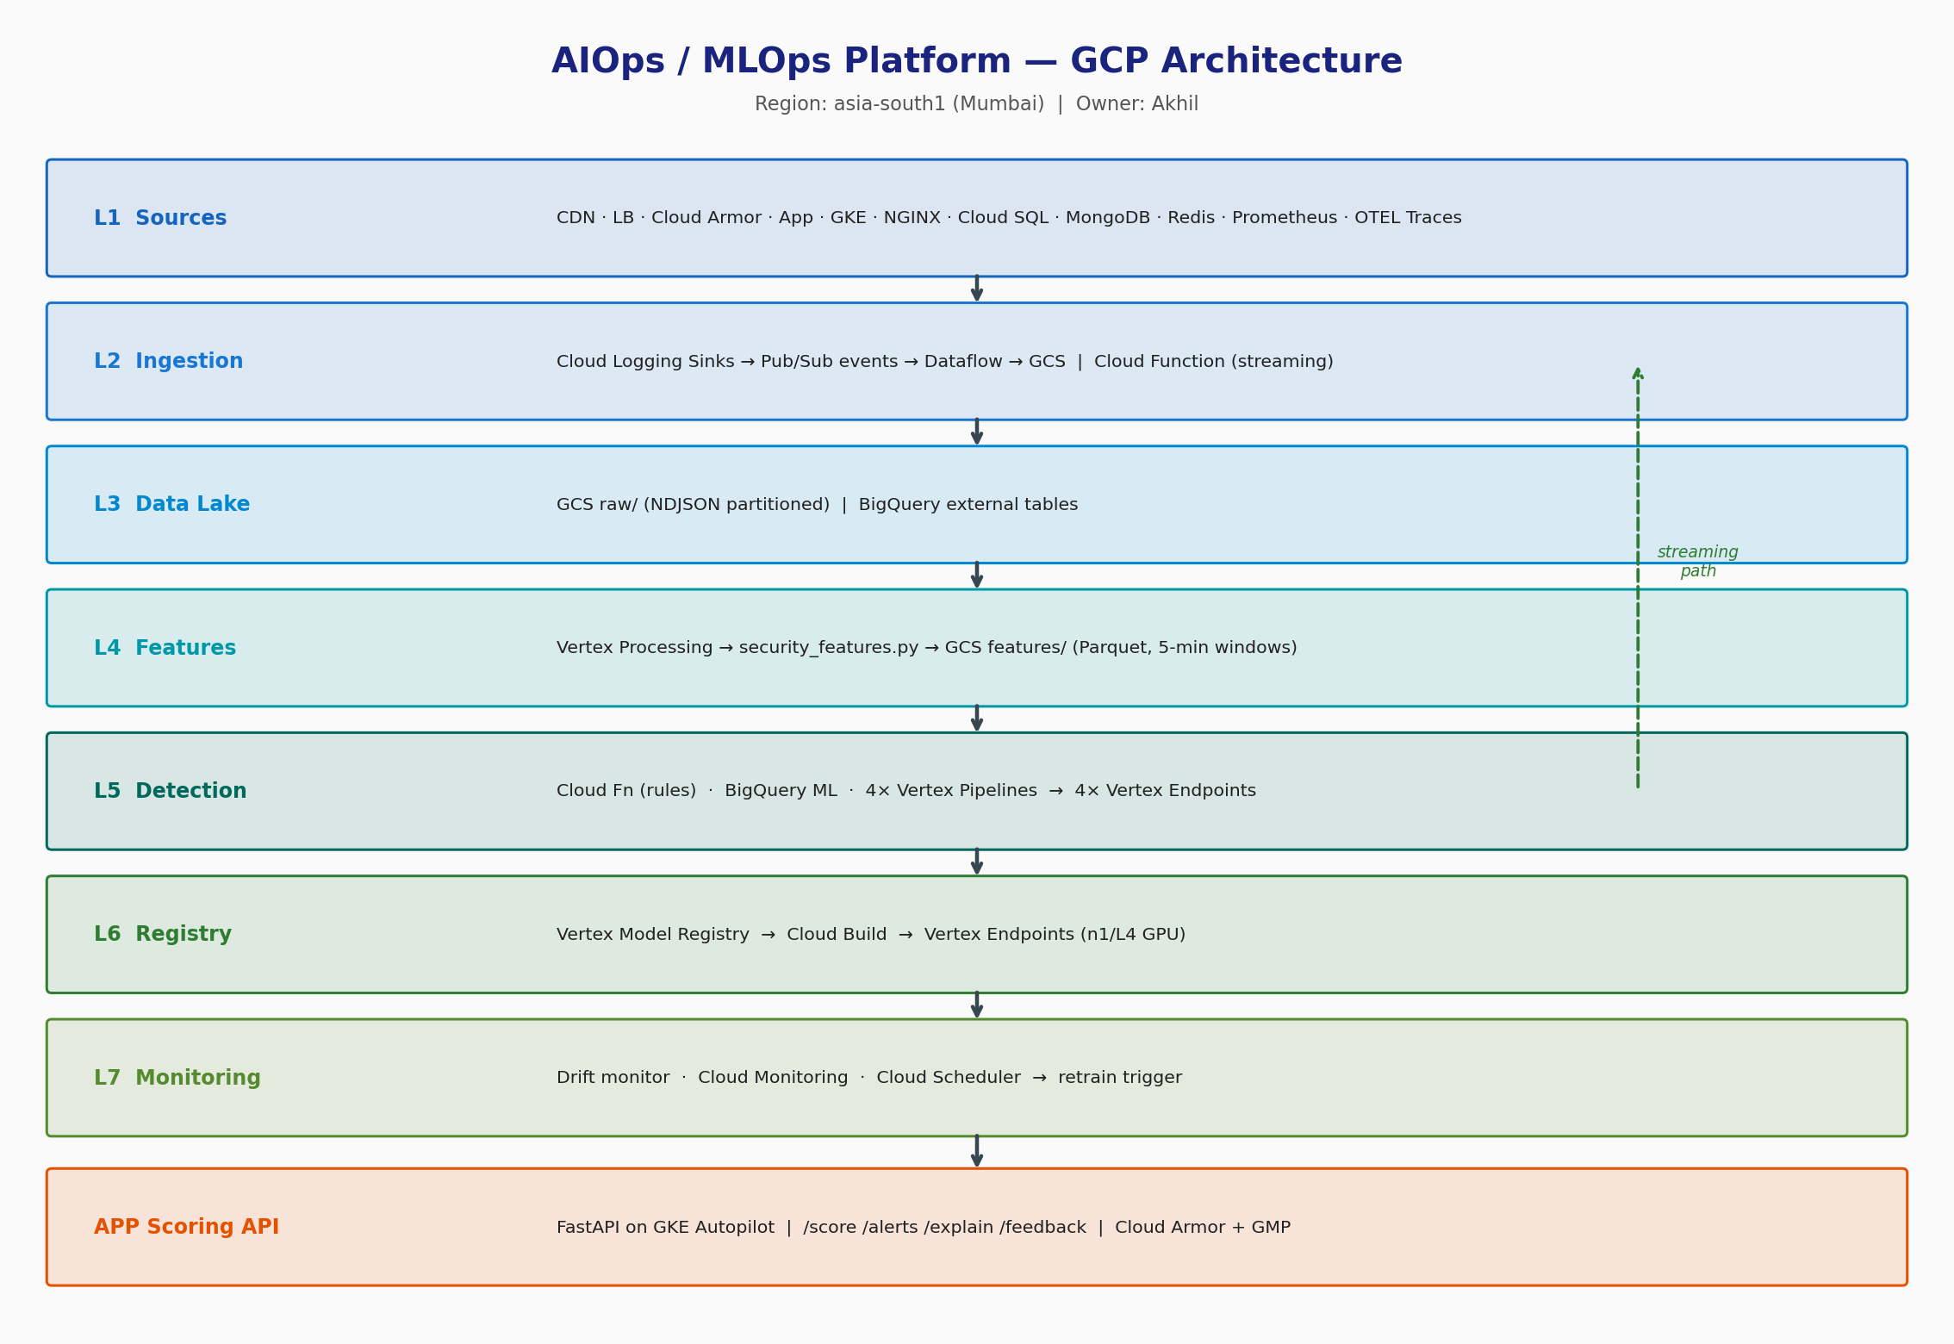
Figure 2 — Full L1-L7 Platform Architecture (GCP, asia-south1)

Layer Summary
Layer | Name | Components
L1 | Sources | CDN · LB · Cloud Armor · App · GKE · NGINX · Cloud SQL · MongoDB · Redis · Prometheus metrics · OTEL traces
L2 | Ingestion | Cloud Logging sinks → Pub/Sub events → Dataflow → GCS | Cloud Function (streaming path)
L3 | Data Lake | GCS raw/ (NDJSON, partitioned by source/date) | BigQuery external tables
L4 | Feature Eng | Vertex Processing / security_features.py → GCS features/ (Parquet, 5-min windows)
L5 | Detection | Cloud Fn (rules) · BigQuery ML · 4× Vertex Pipelines → 4× Vertex Endpoints
L6 | Registry/Deploy | Vertex Model Registry → Cloud Build → Vertex Endpoints (n1 CPU / n1+L4 GPU)
L7 | Monitoring | Drift monitor · Cloud Monitoring alerts · Cloud Scheduler → retrain triggers
APP | Scoring API | FastAPI on GKE Autopilot · /score /alerts /explain /feedback · Cloud Armor + GMP

3. End-to-End Data Flow
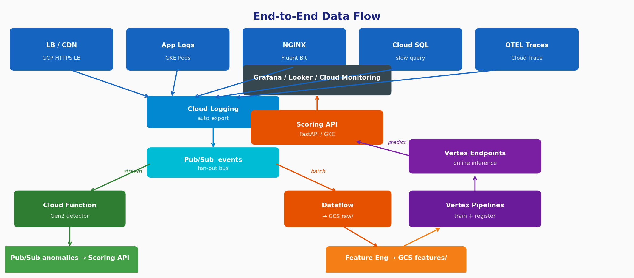
Figure 3 — End-to-End Data Flow (sources → lake → features → detectors → API)

3.1 Ingestion Path
Every log source auto-exports to Cloud Logging. A Terraform-managed log sink forwards to Pub/Sub topic events. This topic has two subscriptions:
- events-streaming — triggers the Cloud Function Gen2 streaming detector (real-time path, seconds latency)
- Dataflow job — archives raw CommonEvent NDJSON to GCS, partitioned by source and date (batch path)

3.2 CommonEvent Schema
Every parser normalises to a single shared shape before anything is emitted to Pub/Sub. Key fields:
Field | Type | Description
ts / ingest_ts | ISO-8601 str | Event time and ingestion time
source | enum | One of: cdn, lb, cloud_armor, app, gke, nginx, cloudsql, mongo, redis, node_metrics, container_metrics, prom_app, otel_traces
host | str | GKE pod, LB backend, VM name, database ID
message | str | Raw log line or JSON-stringified payload
severity | enum | DEBUG / INFO / WARN / ERROR / CRITICAL
status | int? | HTTP status code (or None for non-HTTP sources)
latency_ms | float? | Request latency in milliseconds
bytes | int? | Response size in bytes
src_ip | str? | HMAC-SHA256[:16] of raw IP — never stored in plain text
user | str? | HMAC-SHA256[:16] of username — never stored in plain text
attrs | dict | Source-specific extras (e.g. WAF action, slow_query flag)

3.3 PII Handling
Raw IPs and usernames are HMAC-masked before leaving the parser:
# ml/parsers/__init__.py
def hmac_pii(value: str | None) -> str | None:
if not value: return value
return hmac.new(PII_HMAC_KEY, value.encode(), hashlib.sha256)
.hexdigest()[:16] # 16 hex chars — enough for cardinality counting
PII_HMAC_KEY is injected at startup from Secret Manager via Workload Identity. The same IP always hashes to the same 16-char token, so you can count distinct IPs in a window without ever storing the raw address.

4. Feature Engineering
ml/feature_engineering/security_features.py aggregates raw CommonEvents into 5-minute tumbling windows per (source, host), producing Parquet feature files. It runs as a Vertex Custom Job in the pipeline and can also run locally.

4.1 Security Features (9 columns)
Feature | What it captures | Threat signal
request_rate | Requests/second in window | DDoS / traffic spike
rate_4xx | Fraction of 4xx responses | Scanning / path bruteforce
rate_5xx | Fraction of 5xx responses | Service degradation / attack impact
auth_failure_rate | Fraction of 401 / 403 responses | Credential stuffing / brute-force login
distinct_ips | Unique HMAC'd source IPs | Distributed attack (botnet)
distinct_paths | Unique URL paths | Path enumeration / fuzzing
p99_latency | 99th percentile latency ms | Slowloris / resource exhaustion
bytes_p99 | 99th percentile response size | Data exfiltration
entropy_path | Shannon entropy of path distribution | Abnormal access-pattern diversity

4.2 Why These Features Are Sensitive
The feature set is detector-agnostic — all four detectors (streaming rules, IForest, LSTM-AE, Log-BERT) consume the same Parquet files. Changing any feature definition invalidates all trained baselines and requires retraining every detector. Treat changes here like a database schema migration.

5. Detection — Streaming + ML Detectors

5.1 Streaming Statistical Detector (Cloud Function Gen2)
File: ml/streaming/detector.py — runs inside Cloud Function Gen2, triggered by Pub/Sub events subscription. No training required. Rules are evaluated at runtime from rules.yaml.

Rule Types
Type | Logic | Notes
threshold | Fire if value op threshold | Immediate — no history needed. E.g. rate_5xx > 0.05
zscore | Fire if |(value - rolling_mean) / rolling_std| > thr | Needs 30 samples (~2.5 min at 5-sec windows)
rate_of_change | Fire if |delta/prev| x 100 > threshold_pct | Detects sudden jumps regardless of absolute level
ewma | Fire if deviation from EWMA > deviation_sigma std | Smooth exponential average; catches slow drift

Active Rules
Rule Name | Metric | Severity | Trigger
error_rate_spike | rate_5xx | HIGH | threshold > 5%
distinct_ip_burst | distinct_ips | HIGH | threshold > 10,000 unique IPs
latency_z_spike | p99_latency | MEDIUM | z-score > 4.0 (30-min window)
auth_fail_burst | auth_failure_rate | HIGH | rate-of-change > 200%
4xx_creep | rate_4xx | LOW | EWMA deviation > 3 sigma (alpha=0.3)

When a rule fires: (1) anomaly dict published to Pub/Sub anomalies, (2) structured log written to Cloud Logging at rule severity, (3) custom metric custom.googleapis.com/aiops/streaming/anomalies emitted to Cloud Monitoring.

5.2 Vertex AI Pipelines — Shared DAG
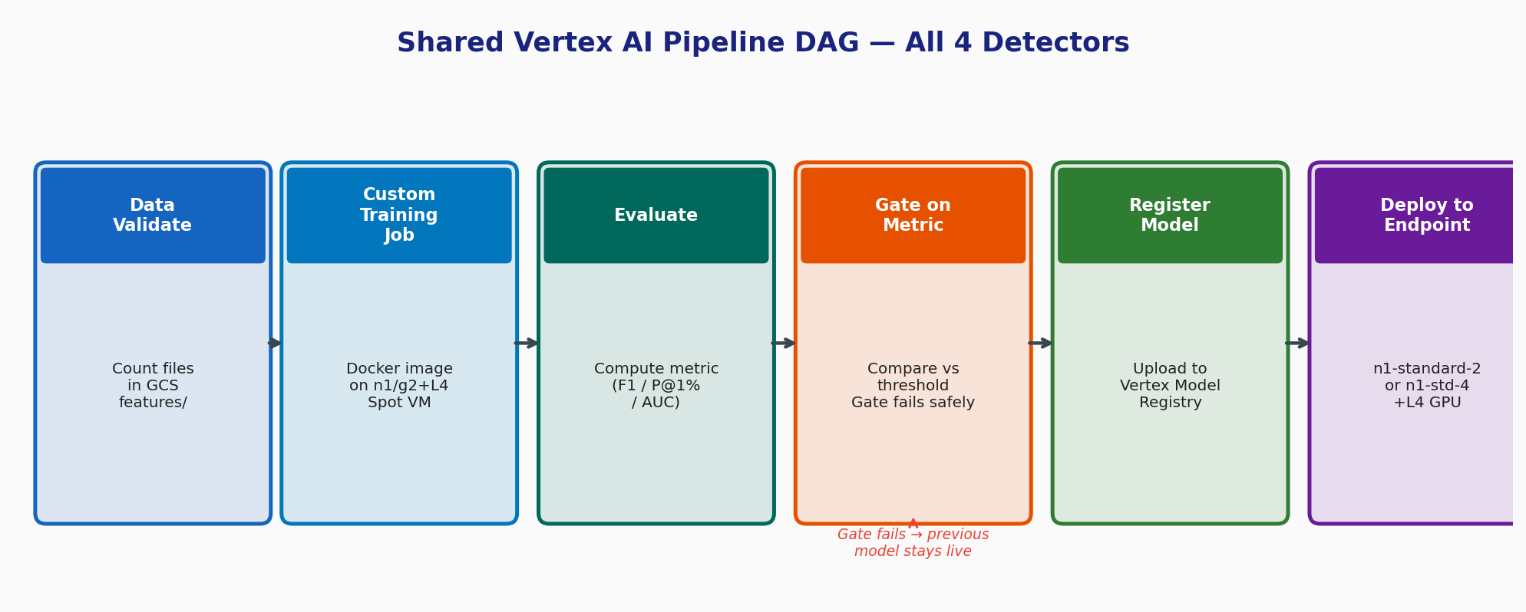
Figure 4 — Shared Vertex AI Pipeline DAG (all 4 detectors)
All four trained detectors share one KFP v2 DAG defined in ml/pipelines/_shared/builder.py. Per-detector files only declare: the training Docker image, the evaluate() component, and the metric gate threshold.

DAG Steps Explained
- DataValidate — counts files and rows in GCS features/. Raises RuntimeError if no files are found, preventing training on an empty dataset.
- CustomTrainingJobOp — launches a Vertex Custom Training Job with the detector training image. Reads features from GCS, fits the model, uploads model.joblib + metadata back to GCS.
- Evaluate — KFP component that reads labelled eval Parquet, computes the primary metric, uploads evaluation.json alongside the model, returns metrics as JSON.
- GateOnMetric — parses evaluation JSON. If metric >= threshold, registers the model. If gate fails, step returns GATE_FAILED without raising — the previous endpoint stays live.
- Register — calls aiplatform.Model.upload() with the serving container URI and GCS artifact path. Model version appears in Vertex Model Registry.

5.3 The Four Detectors
Detector | Algorithm | Sources | Train HW | Serve HW | Gate Metric
RCF Metrics | IsolationForest (sklearn) | node_metrics, container_metrics, prom_app | n1-standard-4 Spot | n1-standard-2 | F1 >= 0.70
IForest Logs | IsolationForest (sklearn) | lb, cdn, cloudsql, nginx | n1-standard-4 Spot | n1-standard-2 | P@1% >= 0.80
LSTM-AE Traces | LSTM Autoencoder (Keras) | otel_traces | g2-standard-8 + L4 Spot | n1-standard-4 | AUC >= 0.80
Log-BERT Anomaly | TF-IDF + IForest embed | app | g2-standard-8 + L4 Spot | n1-standard-4 | P@1% >= 0.75

6. Model Registry and Endpoints
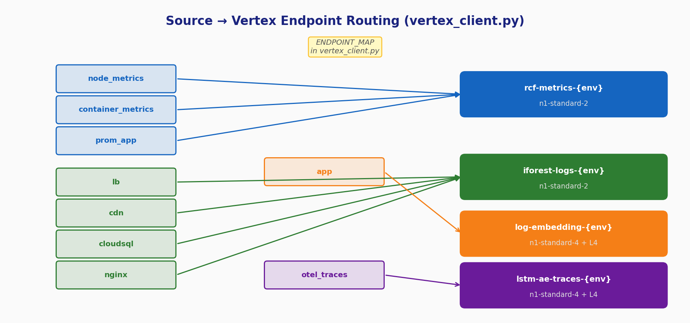
Figure 5 — Source-to-Endpoint Routing Map (vertex_client.py)

6.1 Source-to-Endpoint Routing
The Scoring API's vertex_client.py holds a static ENDPOINT_MAP dict that routes each source string to the right Vertex Endpoint numeric ID. If a source has no mapping, the API returns score=0.0, is_anomaly=False with a note field — never a 500 error.

6.2 Endpoint Specifications
Endpoint | Sources | Machine | Replicas
rcf-metrics-{env} | node_metrics, container_metrics, prom_app | n1-standard-2 | min 1, max 2
iforest-logs-{env} | lb, cdn, cloudsql, nginx | n1-standard-2 | min 1, max 2
lstm-ae-traces-{env} | otel_traces | n1-standard-4 + L4 | min 1, max 2
log-embedding-anomaly-{env} | app | n1-standard-4 + L4 | min 1, max 2

7. Scoring API (FastAPI on GKE)
File: api/scoring/main.py — FastAPI application deployed on GKE Autopilot, 2-8 replicas, HPA at 70% CPU. Protected by Cloud Armor via BackendConfig on the GCE Ingress.

7.1 API Routes
Route | Purpose
GET /health | Liveness probe — returns {status: ok}
GET /metrics | Prometheus-format metrics for GMP scrape
POST /api/v1/score | Score a single CommonEvent; returns {score, is_anomaly, detector, explanation}
GET /api/v1/alerts | List anomaly alerts filtered by since / source / severity / limit
GET /api/v1/alerts/{id}/explain | Full explanation: top features, baseline vs observed, similar past alerts
POST /api/v1/feedback | Label an alert as true/false positive (written to Firestore for retraining)
GET /api/v1/sources | Per-source heartbeat / health status

7.2 Scoring Flow
- Start an OTEL trace span named score with source attribute
- Call vertex_client.predict(event.source, event.model_dump()) — routes to correct Vertex Endpoint
- Classify: is_anomaly = True if result score >= ANOMALY_THRESHOLD (default 3.0) or endpoint returns is_anomaly=True
- Increment Prometheus counters: scoring_requests_total{source, is_anomaly}
- If anomaly: write alert to Firestore with UUID, severity, score, explanation
- Return ScoreResponse to caller

7.3 Workload Identity — Secretless Auth
The FastAPI pod authenticates to all GCP services without a key file or GOOGLE_APPLICATION_CREDENTIALS:
- Kubernetes ServiceAccount anomaly-scoring-api is annotated with iam.gke.io/gcp-service-account=aiops-runner@<project>.iam.gserviceaccount.com
- GKE Autopilot + Workload Identity Pool projects the GSA token into the pod
- aiops-runner GSA holds roles: aiplatform.user, storage.objectAdmin, secretmanager.secretAccessor, cloudsql.client, pubsub.publisher, logging.logWriter, monitoring.metricWriter, cloudtrace.agent, bigquery.dataEditor

8. Infrastructure as Code (Terraform)
All GCP resources are declared in infra/main.tf. Terraform enables APIs, creates resources, and wires IAM bindings in a single apply. Every resource carries the label set {project, owner, environment, managed-by}.

8.1 GCP APIs Enabled
Terraform enables 22 APIs on first apply: aiplatform, artifactregistry, bigquery, cloudbuild, cloudfunctions, cloudresourcemanager, cloudscheduler, cloudtrace, compute, container, containerscanning, dataflow, eventarc, firestore, logging, monitoring, pubsub, secretmanager, securitycenter, servicenetworking, sqladmin, storage.

8.2 Key Resources
Resource | Spec | Purpose
GCS bucket | Versioned, UAC | Data lake: raw/, features/, eval/, models/, pipeline-staging/
Artifact Registry | Docker, regional | All detector training + serving container images
Pub/Sub events | topic + subscription | Raw event stream; fan-out to Cloud Function + Dataflow
Pub/Sub anomalies | topic | Anomaly output from streaming detector + scored events
Pub/Sub retrain | topic | Scheduler emits here; Cloud Function triggers pipeline
Service Account | aiops-runner, 12 IAM roles | Single SA for GKE pods, Cloud Functions, Vertex Jobs
GKE Autopilot | asia-south1, WLI enabled | Hosts Scoring API, OTEL collector, Fluent Bit
Cloud SQL Postgres | 15, db-custom-1-3840, private | Alert metadata, analyst labels, feedback store
Cloud Armor | security policy | WAF on HTTPS LB; default-deny with allow rule
Cloud Scheduler | 2 cron jobs | RCF daily 02:00 UTC; LSTM-AE weekly Sat 20:30 UTC
Monitoring alert | precision < 0.75 for 1h | Fires when detector precision drops, triggers investigation

9. Kubernetes and Helm
The Scoring API is deployed via helm/charts/anomaly-scoring-api/. The chart creates everything needed to run and auto-scale the API on GKE Autopilot.

9.1 Objects Created by the Chart
- Deployment — 2 replicas minimum, requests {cpu:250m, memory:512Mi}, limits {cpu:1, memory:1Gi}
- Service — ClusterIP on port 80, target port 8080
- ServiceAccount — annotated with GCP SA for Workload Identity
- Ingress (GCE class) — static IP aiops-scoring-ip, managed TLS certificate
- PodMonitoring — GMP custom resource, scrapes /metrics every 30s
- HorizontalPodAutoscaler — 2-8 replicas, CPU target 70%

9.2 Helm Values (key settings)
image:
repository: asia-south1-docker.pkg.dev/<project>/monitoring-mlops/anomaly-scoring-api
tag: latest
replicaCount: 2
autoscaling:
minReplicas: 2 maxReplicas: 8 targetCPUUtilizationPercentage: 70
env:
GCP_PROJECT_ID: "" GCP_REGION: asia-south1
ANOMALY_THRESHOLD: "3.0"
ENDPOINT_RCF_METRICS: "" # Vertex endpoint numeric ID
ENDPOINT_IFOREST_LOGS: ""
ENDPOINT_LSTM_AE: ""
ENDPOINT_LOG_BERT: ""

10. Security Model

10.1 No Credentials on Disk
Every component authenticates via managed identity. GKE pods use Workload Identity → aiops-runner GSA. Cloud Functions specify --service-account=aiops-runner@.... Vertex Training Jobs use service_account=cfg.service_account. No JSON key files anywhere in the system.

10.2 PII Masking
Raw IPs and usernames are HMAC-SHA256-masked at parse time (truncated to 16 hex chars). The same input always produces the same token, preserving cardinality for counting distinct IPs while never storing the actual address. The HMAC key lives in Secret Manager.

10.3 Network Security
- Cloud SQL has no public IP — access via Private Services Access (PSA) within the VPC
- GKE Autopilot nodes are not directly internet-accessible
- The only internet ingress is the HTTPS LB, protected by Cloud Armor
- Cloud Armor policy restricts src_ip_ranges — tighten to your CIDR ranges in production

10.4 Security Command Center (SCC)
SCC is the platform's GCP-side threat intelligence layer. It provides Event Threat Detection (IAM abuse, cryptocurrency mining, data exfiltration), Security Health Analytics (public GCS buckets, overly permissive IAM), and Container Threat Detection (GKE). SCC works from day one with zero instrumentation. Do not disable it.

11. End-to-End Deployment Walkthrough

Prerequisites
Tools required: gcloud >= 460, terraform >= 1.6, helm >= 3.13, kubectl >= 1.28, python 3.11, docker. Quotas to raise: 1x L4 GPU for Vertex training, 1x L4 GPU for Vertex serving, GKE Autopilot vCPU (at least 4).

Step 1 — Terraform: Bootstrap the Platform
cd infra
cat > terraform.tfvars <<EOF
project_id = "$GCP_PROJECT_ID"
region = "$GCP_REGION"
environment = "$ENV"
domain = "aiops.example.com"
EOF
terraform init && terraform apply -auto-approve
export BUCKET=$(terraform output -raw bucket)
export RUNNER_SA=$(terraform output -raw service_account)
export GKE=$(terraform output -raw gke_cluster_name)
Provisions: GCS bucket, Artifact Registry, 3 Pub/Sub topics, aiops-runner SA + 12 IAM roles, GKE Autopilot cluster, Cloud SQL Postgres, Cloud Armor, Cloud Scheduler cron jobs, Cloud Monitoring alert policy.

Step 2 — Build and Push Containers
gcloud auth configure-docker $GCP_REGION-docker.pkg.dev
TAG="$GCP_REGION-docker.pkg.dev/$GCP_PROJECT_ID/$AR_REPO"
# Scoring API
docker build -t $TAG/anomaly-scoring-api:latest -f api/scoring/Dockerfile .
docker push $TAG/anomaly-scoring-api:latest
# Detector training images
for d in rcf_metrics iforest_logs lstm_ae_traces log_embedding_anomaly; do
docker build -t $TAG/${d//_/-}-train:latest -f ml/pipelines/$d/Dockerfile . && \
docker push $TAG/${d//_/-}-train:latest
done

Step 3 — Seed Synthetic Data
export PYTHONPATH=$(pwd)
python scripts/seed_logs.py \
--project $GCP_PROJECT_ID \
--topic monitoring-mlops-${ENV}-events \
--n 5000 --rate 100

Step 4 — Deploy Streaming Detector
gcloud functions deploy monitoring-mlops-${ENV}-streaming-detector \
--gen2 --runtime=python311 --region=$GCP_REGION \
--source=ml/streaming --entry-point=handler \
--trigger-topic=monitoring-mlops-${ENV}-events \
--service-account=$RUNNER_SA \
--memory=1Gi --timeout=120s \
--set-env-vars="GCP_PROJECT_ID=$GCP_PROJECT_ID,ANOMALY_TOPIC=..."

Step 5 — Feature Engineering and Train Detectors
# Generate features
python ml/feature_engineering/security_features.py \
--input-uri gs://$BUCKET/$ENV/raw/ \
--output-uri gs://$BUCKET/$ENV/features/security/ \
--window-minutes 5
# Submit all four detector pipelines
for d in rcf_metrics iforest_logs lstm_ae_traces log_embedding_anomaly; do
python -m ml.pipelines.$d.pipeline
done

Step 6 — Deploy to Vertex Endpoints
# Create endpoint, find model, deploy model (repeat per detector)
gcloud ai endpoints create --display-name="rcf-metrics-${ENV}" --region=$GCP_REGION
gcloud ai endpoints deploy-model $EID --region=$GCP_REGION \
--model=$MODEL_ID --machine-type=n1-standard-2 \
--min-replica-count=1 --max-replica-count=2 \
--service-account=$RUNNER_SA --traffic-split=0=100

Step 7 — Deploy Scoring API on GKE
gcloud container clusters get-credentials $GKE --region=$GCP_REGION
helm upgrade --install anomaly-scoring-api helm/charts/anomaly-scoring-api \
--set image.repository=$TAG/anomaly-scoring-api \
--set env.GCP_PROJECT_ID=$GCP_PROJECT_ID \
--set env.ENDPOINT_RCF_METRICS=<rcf-id> \
--set env.ENDPOINT_IFOREST_LOGS=<iforest-id> \
--set env.ENDPOINT_LSTM_AE=<lstm-id> \
--set env.ENDPOINT_LOG_BERT=<logbert-id> \
--set "serviceAccount.annotations.iam\.gke\.io/gcp-service-account=$RUNNER_SA"

Step 8 — Wire Weekly Retrain
gcloud functions deploy monitoring-mlops-${ENV}-pipeline-trigger \
--gen2 --runtime=python311 --region=$GCP_REGION \
--source=ml/pipelines/_shared --entry-point=cloud_event_trigger \
--trigger-topic=monitoring-mlops-${ENV}-retrain \
--service-account=$RUNNER_SA
Cloud Scheduler jobs (created by Terraform in Step 1) fire automatically: RCF daily at 02:00 UTC, LSTM-AE weekly Saturday 20:30 UTC (Sunday 02:00 IST).

Step 9 — Smoke Test
SCORING_HOST=aiops.example.com bash scripts/smoke_test.sh
# Tests: /health, /score (normal), /score (attack), /alerts

End-to-End Success Checklist
Check | Expected
gcloud ai endpoints list | 4 endpoints, status DEPLOYED
kubectl get pods -l app=anomaly-scoring-api | All Running, 2+ replicas
/api/v1/score p99 latency | < 250 ms
/api/v1/alerts after inject_attack.py | items array non-empty
Cloud Monitoring metric aiops/streaming/anomalies | Datapoints visible
Cloud Trace | score spans visible in Trace Explorer
Cloud Scheduler last run status | SUCCESS for both jobs

12. Operating the Platform

12.1 Checking Detector Health
# Vertex Endpoints status
gcloud ai endpoints list --region=$GCP_REGION
# API pod health
kubectl get pods -l app=anomaly-scoring-api
kubectl logs -l app=anomaly-scoring-api --tail=50
# Streaming detector logs
gcloud logging read 'logName=".../logs/aiops-streaming-detector"' --limit=20

12.2 Rolling Back a Bad Model
Every model version is in Vertex Model Registry. Rollback without retraining:
gcloud ai models list --region=$GCP_REGION --filter="displayName=rcf-metrics-detector"
gcloud ai endpoints deploy-model $ENDPOINT_ID --region=$GCP_REGION \
--model=$PREVIOUS_MODEL_ID --traffic-split=0=100

12.3 Updating Streaming Rules
Edit ml/streaming/rules.yaml, then redeploy the Cloud Function. No pipeline retraining needed — rules are evaluated at runtime:
gcloud functions deploy monitoring-mlops-${ENV}-streaming-detector \
--gen2 --runtime=python311 --source=ml/streaming --entry-point=handler \
--trigger-topic=monitoring-mlops-${ENV}-events --service-account=$RUNNER_SA

12.4 Teardown Order
Order matters — wrong order leaves orphan resources or causes Terraform failures:
- Undeploy models from all 4 Vertex Endpoints
- helm uninstall anomaly-scoring-api
- Delete both Cloud Functions (streaming detector + pipeline trigger)
- cd infra && terraform destroy -auto-approve
Or run the convenience script: bash scripts/teardown.sh dev

13. Cost Management

13.1 Cost Breakdown
Resource | Type | ~Cost/hr | Cadence
RCF / IForest training | n1-standard-4 Spot | ~$0.05 | Daily, 10-30 min
LSTM-AE / Log-BERT train | g2-standard-8 Spot + L4 | ~$0.30 | Weekly, 1-3 hrs
RCF / IForest serving | n1-standard-2 x2 replicas | ~$0.10 | Continuous
LSTM-AE / Log-BERT serve | n1-standard-4 + L4 x2 | ~$0.95 | Continuous
GKE Autopilot (API) | per-pod | ~$0.04 | 2-8 replicas
Cloud SQL | db-custom-1-3840 | ~$0.07 | Continuous (stop off-hours in dev)
GCS + Pub/Sub + Logging | volume-based | < $5/day dev | Continuous

13.2 Cost Rules
- Spot for ALL training jobs — saves ~70%. Vertex Pipelines auto-retry on preemption.
- Max GPU: L4. Never A100 or H100 in this project.
- n1-standard-2 for CPU serving endpoints in dev; scale up only for prod.
- Stop Cloud SQL during off-hours in dev: gcloud sql instances patch $INSTANCE --activation-policy NEVER

14. Key Concepts Glossary
Term | Definition
Vertex AI Pipeline (KFP v2) | A DAG of containerised steps managed by Vertex AI. Each step runs in its own Docker container. The DAG is compiled to JSON, submitted to Vertex, which handles scheduling, retries, and artifact lineage.
KFP Component (@dsl.component) | A Python function decorated to become a reusable DAG step. KFP serialises it, wraps it in a container, and manages typed artifact inputs/outputs.
Vertex Custom Training Job | A one-off job that runs your Docker image on specified hardware. Used for the Train step in each pipeline. Billed from start to container exit 0.
Vertex Endpoint | An HTTPS endpoint backed by deployed model versions. Handles autoscaling, health checks, and traffic splitting. Billed per replica-hour.
Vertex Model Registry | Version-controlled store of model artifacts + metadata. Each entry points to a GCS URI and serving container image. The gate_and_register step uses it as the promotion gate.
Workload Identity (WIF) | GCP mechanism letting a Kubernetes Service Account impersonate a GCP Service Account without a key file. Binding: {project}.svc.id.goog[{ns}/{ksa}] → GSA.
GKE Autopilot | GKE mode where Google manages node provisioning and patching. You define only Pods/Deployments; the cluster scales nodes automatically.
Google Managed Prometheus | Managed Prometheus-compatible backend. Deploy a PodMonitoring CRD; GMP scrapes /metrics and stores in Cloud Monitoring. No Prometheus server to operate.
Pub/Sub | GCP managed message bus. Topics receive messages; subscriptions deliver to consumers. At-least-once delivery. Multiple subscriptions on one topic = fan-out.
Cloud Function Gen2 | Serverless functions backed by Cloud Run. Gen2 has faster cold starts and native Pub/Sub event triggers via the functions_framework @cloud_event decorator.
Cloud Armor | GCP WAF and DDoS protection, attached to HTTPS Load Balancers. Rules match on IP ranges, geo, rate, or custom expressions.
HMAC PII masking | HMAC-SHA256(key, value)[:16] over sensitive fields before storage. Preserves cardinality (same input → same token) without storing the raw value.
Isolation Forest | Unsupervised anomaly detection via random feature-space partitioning. Anomalies are isolated in fewer splits → shorter average path length → higher anomaly score.
LSTM Autoencoder | Neural network that encodes a sequence into a compressed representation then decodes it. Trained on normal sequences. High reconstruction error = anomaly.
KFP Metric Gate | gate_and_register compares the evaluation metric to a threshold. If it fails, the pipeline completes without registering the model — previous endpoint stays live.

