monitoring-mlops-gcp
Deep-Dive Illustrated Guide
AI · ML · MLOps · AIOps · Data Engineering · Cloud · Observability

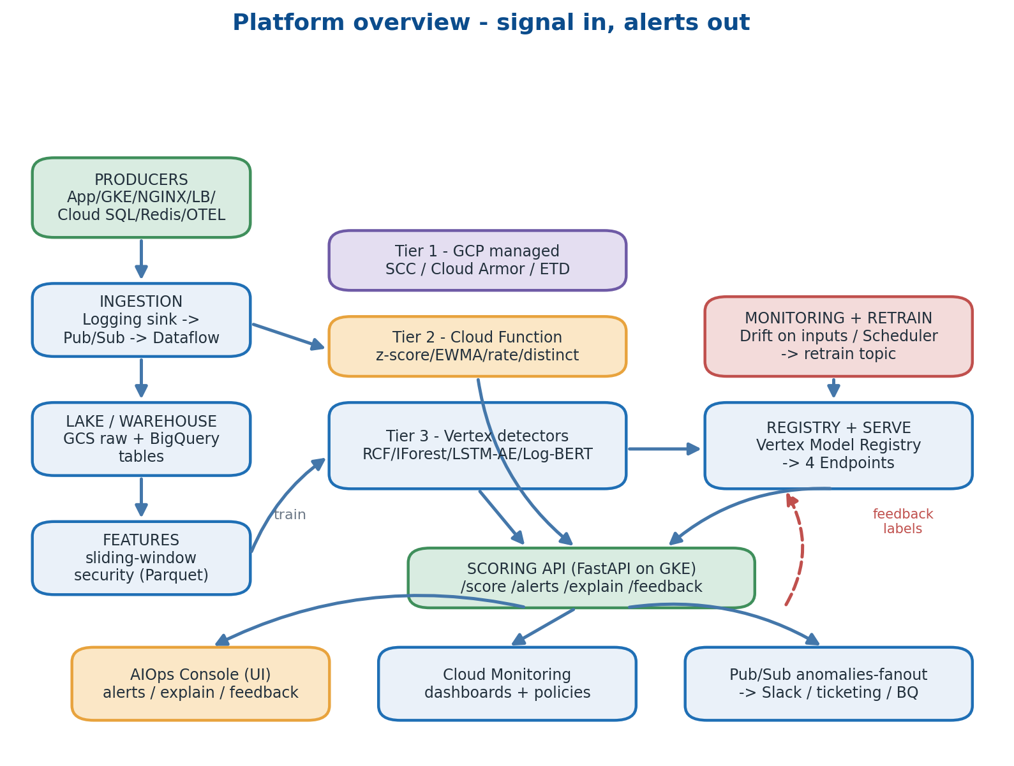
Every chapter is taught from first principles, illustrated with a diagram, and mapped back to a concrete file in the repository.

Owner: Akhil · Cloud: GCP (asia-south1, Mumbai) · GKE Autopilot · Vertex AI · Pub/Sub · Dataflow · BigQuery

How to read this guide
This guide is a single sequential thread. Read it top to bottom. Each chapter teaches one concept from first principles, shows you a diagram of how that concept is wired, points to the exact files in the repository that implement it, and ends with a short "Stitch" box that names precisely which problem the next chapter solves. The order is the lesson — skip nothing.
The platform it describes is an end-to-end AIOps / MLOps / Security-Analytics system on Google Cloud. It ingests logs, metrics and traces from across a stack and runs anomaly and threat detection in three layered tiers: managed GCP detectors that fire in seconds, a streaming statistical Cloud Function, and four trained machine-learning detectors served from Vertex AI. All three feed one alert console. The same design exists as an AWS sibling; this is the GCP port.
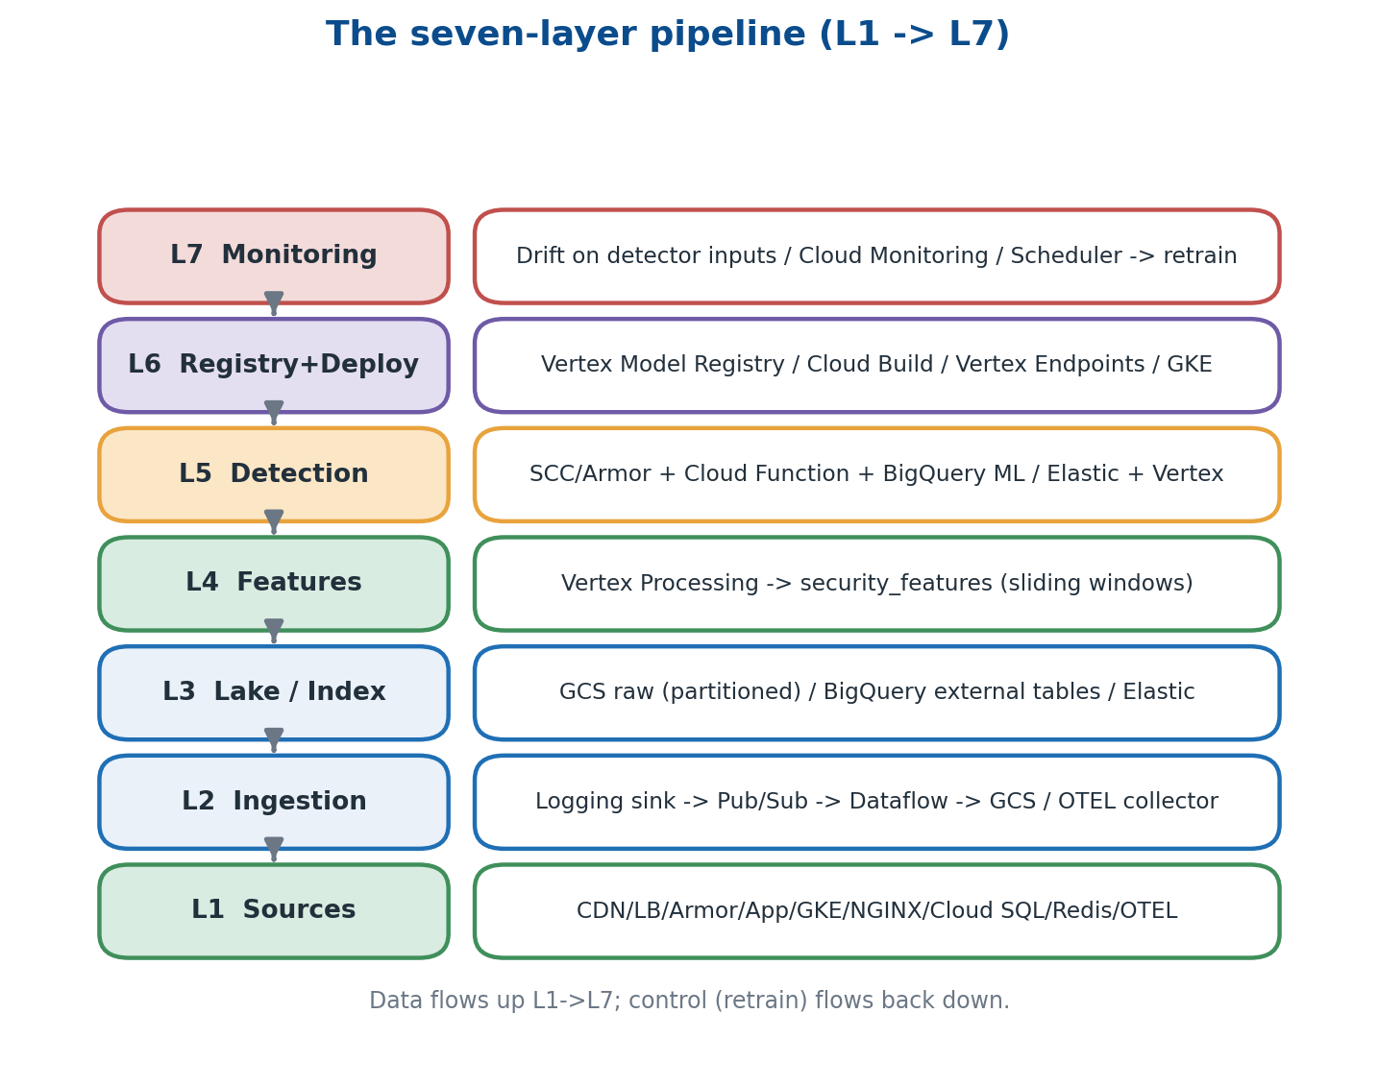
The seven processing layers. Data flows up L1->L7; the retrain control loop flows back down.

Table of contents
1. How software became impossible to watch by eye
2. Computers, the cloud, and what GCP is
3. Networking, identities, and why both matter first
4. Containers — the universal shipping unit
5. Kubernetes and GKE Autopilot
6. Producers — applications that emit signals
7. The three pillars of observability — logs, metrics, traces
8. Pub/Sub — decoupling producers from consumers
9. Streaming ETL with Dataflow
10. The data lake (GCS) and the warehouse (BigQuery)
11. Schema and parsers — turning many formats into one
12. Statistics 101 — what 'anomaly' actually means
13. Streaming statistical detectors (Cloud Function Gen2)
14. Machine Learning crash course
15. Feature engineering — turning events into model inputs
16. Training pipelines (Vertex Pipelines / KFP v2)
17. Model registry and versioning
18. Online endpoints (Vertex AI Endpoints)
19. The Scoring API — one HTTP surface over the detectors
20. The AIOps Console — the human-facing UI
21. Drift, retraining, and the closed loop
22. Security across the stack — defence in depth
23. Cost engineering — knobs that decide your bill
24. The full deploy walk-through (scripts/deploy_all.sh)
25. Failure modes you will hit, and how to fix them
26. Glossary
27. A four-week study plan

Chapter 1 — How software became impossible to watch by eye
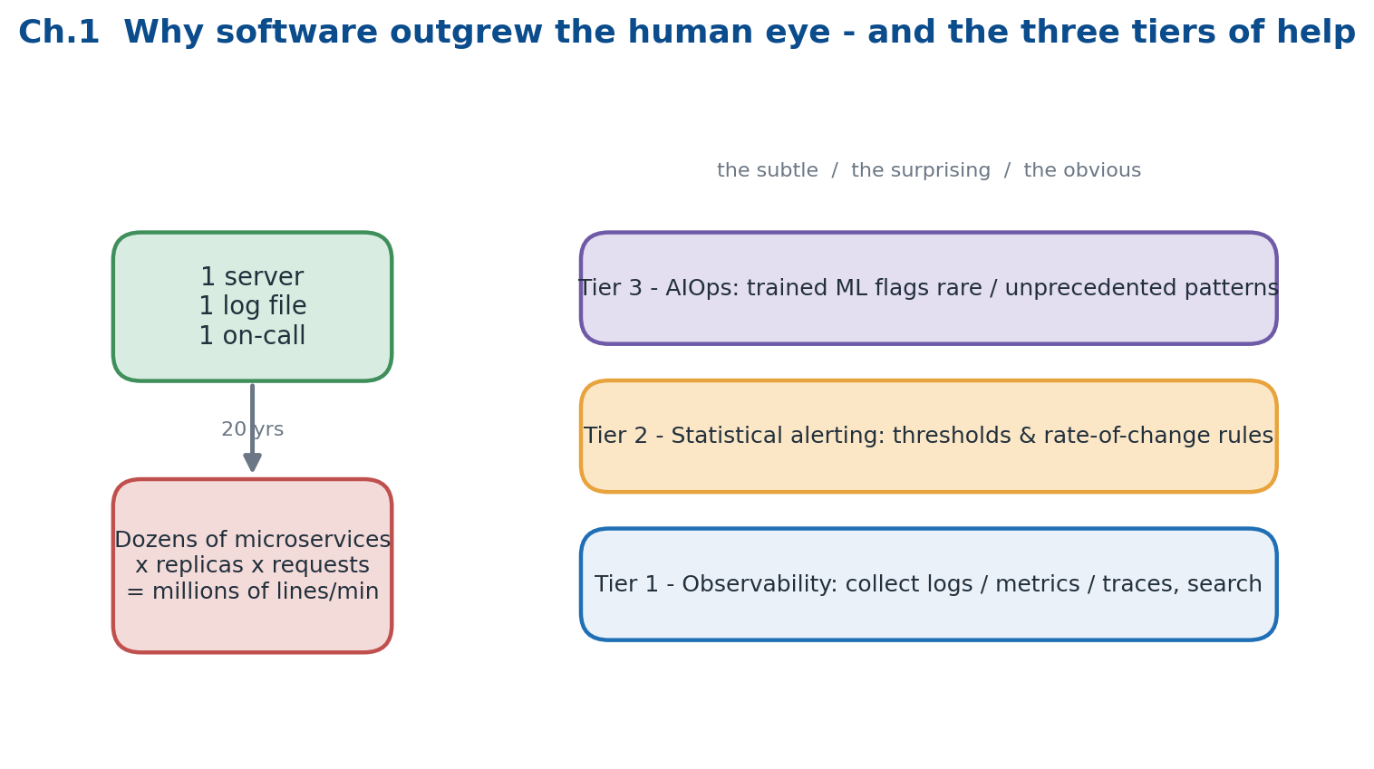
Telemetry volume grows roughly with the square of team size. Three layered tiers of help answer it.

1.1 The shape of a modern application
Twenty years ago a typical website was one binary on one server: one log file, one CPU graph, one engineer on call. Today the same product is split into dozens of small services (microservices), each running several replicas, each emitting its own logs, metrics and traces. The volume of telemetry grows roughly with the square of team size — more services multiplied by more replicas multiplied by more requests. What was once a glance at a single dashboard is now an unwinnable staring contest with millions of lines per minute.

1.2 Why humans cannot keep up
A single production cluster now produces millions of log lines per minute. Bugs hide between services rather than inside any one of them. A single user request can hop through ten services and four databases before returning. Traditional threshold dashboards — "page someone when CPU exceeds 80%" — miss the subtle failures that actually cause outages: p99 latency creeping upward, a queue lag growing slowly, or a brand-new error message that has never appeared before but now appears once per second.

1.3 Three layers of help
- Observability — collect logs, metrics and traces and let humans search them. This is the raw material; without it there is nothing to reason about.
- Statistical alerting — define thresholds and rate-of-change rules and alert the moment a rule is breached. Cheap, fast, and effective against the obvious.
- AIOps — train models on historical signal so they can shout when something rare or unprecedented happens, even when no human wrote a rule for it.

1.4 Why combine all three
Tier 1 catches the obvious, tier 2 catches the merely surprising, and tier 3 catches the subtle long tail. A serious platform layers all three rather than betting on one. This repository is exactly that layering: managed GCP detectors (tier 1) plus a Cloud Function with statistical rules (tier 2) plus four trained ML models (tier 3), all funnelled into a single alert console where a human can triage, explain and give feedback.
Mental model to carry forward
Signal in on the left, alerts out on the right. Everything between is plumbing whose only job is to move telemetry to a place where progressively smarter detectors can look at it.

Where this lives in the repo
Concept | Where in this repo | Why it matters
Four-pillar architecture | README.md · CLAUDE.md · docs/DEPLOY.md | They describe the tiered design and the deploy steps this guide unpacks.
Tiered detection table | CLAUDE.md (Detection latency reality check) | Names the latency and cold-start of each tier — return to it often.

Stitch -> You now know why a platform like this must exist. The next chapter explains the compute substrate it runs on — what 'the cloud' actually is, and which GCP primitives recur in every later chapter.

Chapter 2 — Computers, the cloud, and what GCP is
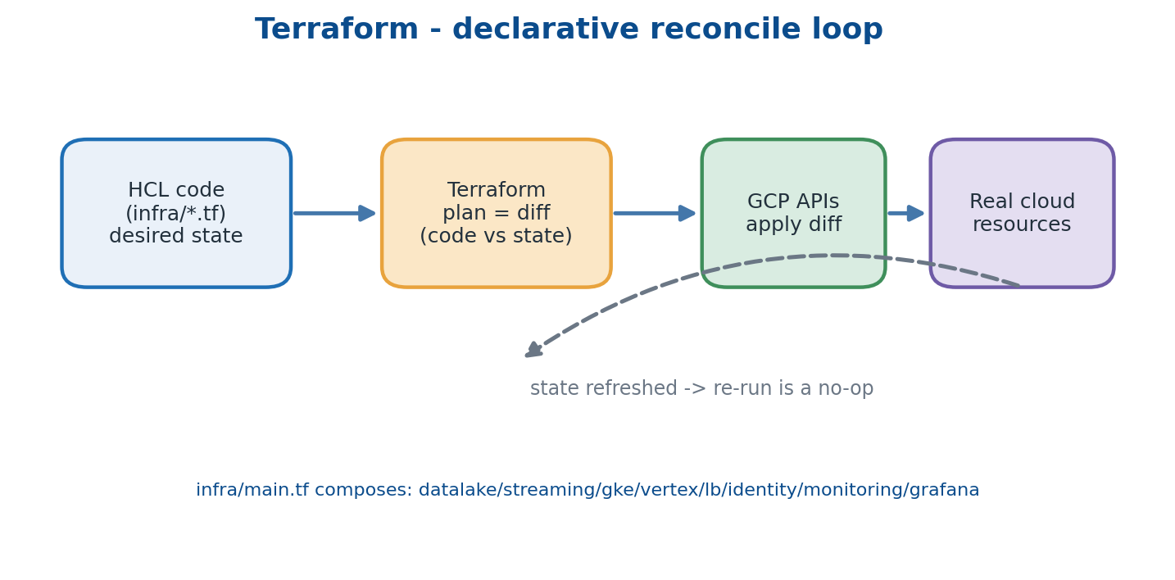
Every resource is declared as code. Terraform diffs code against reality and calls GCP APIs to converge.

2.1 From physical servers to APIs
A cloud provider is, at heart, a data centre exposed over HTTPS. Instead of buying and racking hardware you call an API to get a virtual machine, a database, a queue or a fully managed service. Three large public providers exist: AWS (the largest), Azure (Microsoft) and GCP (Google). All three offer the same primitives under different names and with different defaults.

2.2 The four primitives every cloud provides
- Compute — VMs, containers and functions; anything that runs code.
- Storage — object stores for file blobs, block stores for disks, and databases (SQL and NoSQL).
- Networking — VPCs, load balancers and firewalls that connect and protect the above.
- Identity — service accounts, IAM roles and encryption keys that decide who may do what.

2.3 Why GCP for this project
GCP shines for data-heavy ML workloads. BigQuery and Vertex AI are best-in-class, Pub/Sub is simpler to operate than a self-managed Kafka, and Workload Identity is cleaner than AWS's IRSA. The region used here is asia-south1 (Mumbai) — the rule of thumb is to pick the region closest to your users to minimise latency and egress.

2.4 The GCP services we will keep meeting
Cloud Storage (object store, like S3), Pub/Sub (message bus, like Kinesis/Kafka), Dataflow (managed Apache Beam, like Spark Streaming), BigQuery (serverless SQL warehouse, like Snowflake), GKE Autopilot (managed Kubernetes, like EKS), Vertex AI (train and serve ML, like SageMaker), Cloud Functions Gen2 (tiny event-triggered code, like Lambda), Cloud SQL and Memorystore (managed Postgres/MySQL and Redis), Cloud Logging and Cloud Trace, Google Managed Prometheus and Cloud Monitoring, Cloud Armor (WAF + DDoS), Artifact Registry (Docker images), Secret Manager, and IAM with Workload Identity. Each appears in its own chapter below.

2.5 Anatomy of a Terraform resource
Every GCP resource in this repo is declared as Terraform code. Terraform reads the current state, compares it to the code, and calls the GCP API to make reality match. Re-running with no code change is a no-op — this idempotence is what makes infrastructure reproducible.
resource "google_storage_bucket" "lake" {
name = "monitoring-mlops-gcp-dev"
location = "asia-south1"
uniform_bucket_level_access = true
versioning { enabled = true }
}

Where this lives in the repo
Concept | Where in this repo | Why it matters
Terraform module pattern | infra/main.tf composes infra/modules/{datalake,streaming,gke,...} | Splitting into modules keeps the codebase readable, testable and reusable across dev/stage/prod.

Stitch -> You now have a vocabulary of GCP services and a model of how Terraform creates them. The next chapter covers the two foundations every workload sits on — networking and identity. Skip these two and nothing later will work.

Chapter 3 — Networking, identities, and why both matter first
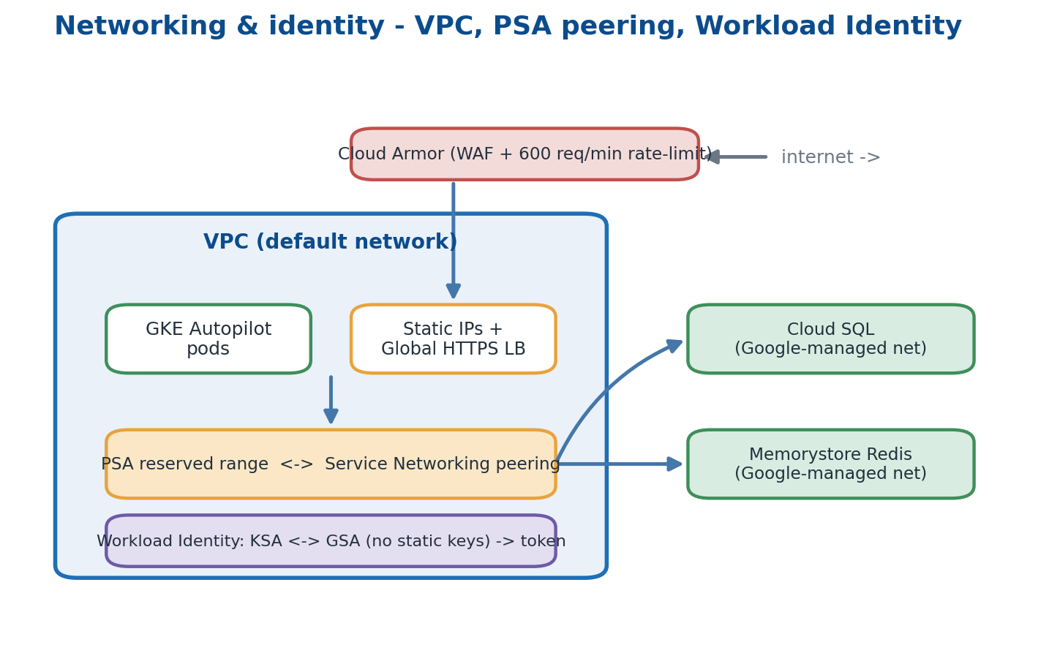
The VPC, private peering to managed services, Workload Identity for pods, and Cloud Armor at the edge.

3.1 VPCs and the default network
A VPC (Virtual Private Cloud) is a private network inside GCP. Resources placed in it share a private IP space and can talk to each other without crossing the public internet. Every GCP project starts with a 'default' network, which is fine for learning and is what this project uses; real production replaces it with custom-designed VPCs and subnets.

3.2 Private Service Access (PSA)
Cloud SQL and Memorystore live inside Google-managed networks, not yours. To reach them privately you reserve an IP range and peer it through the Service Networking API. In this repo that is exactly what google_compute_global_address.psa and google_service_networking_connection.psa do in the database module — without them the demo database is unreachable on a private IP.

3.3 Static IPs and load balancers
External users hit a global static IP, which forwards to a Google global HTTPS load balancer, which routes to a backend — here a GKE Service. The IPs are named (aiops-scoring-ip, aiops-ui-ip, demo-app-ip) so DNS records stay stable across redeploys.

3.4 IAM — three identity types
- User accounts — humans, e.g. akhil@example.com.
- Service accounts — robots, e.g. aiops-runner@PROJECT.iam.gserviceaccount.com.
- Workload Identity — a GKE pod that acts as a service account without any static key file.

3.5 Roles versus permissions
A permission is one tiny capability such as storage.objects.create. A role is a named bag of permissions such as roles/storage.objectAdmin. You bind a role to a principal on a scope — a project, a bucket, a secret. The guiding rule is least privilege: grant the smallest scope that still works.

3.6 Workload Identity end to end
The cluster has a Workload Identity pool (PROJECT.svc.id.goog). Each Kubernetes Service Account (KSA) maps to a GCP Service Account (GSA) via an annotation; the GSA grants iam.workloadIdentityUser to the KSA. At runtime the pod receives a short-lived OIDC token, which the in-cluster metadata server exchanges for a real GCP access token. The result: zero static credentials anywhere in the cluster.

3.7 Cloud Armor — perimeter security
Cloud Armor is a WAF and DDoS rate-limiter that sits in front of the global load balancer, attached via a BackendConfig CRD on the Service. Two rule families are used: a rate limit of 600 requests/minute/IP, and the pre-built WAF rulesets sqli-v33-stable and xss-v33-stable.

Where this lives in the repo
Concept | Where in this repo | Why it matters
Workload Identity bindings | infra/modules/gke/main.tf · demo-app/infra/main.tf | Every pod that calls a GCP API uses WLI — no static keys live in the cluster.
PSA peering | infra/modules/database/main.tf | Reserves the range and peers it so Cloud SQL is reachable on a private IP.

Stitch -> You now have a network for the workloads and an identity model for them. The next chapter explains the lowest-level unit a workload ships as — the container.

Chapter 4 — Containers — the universal shipping unit
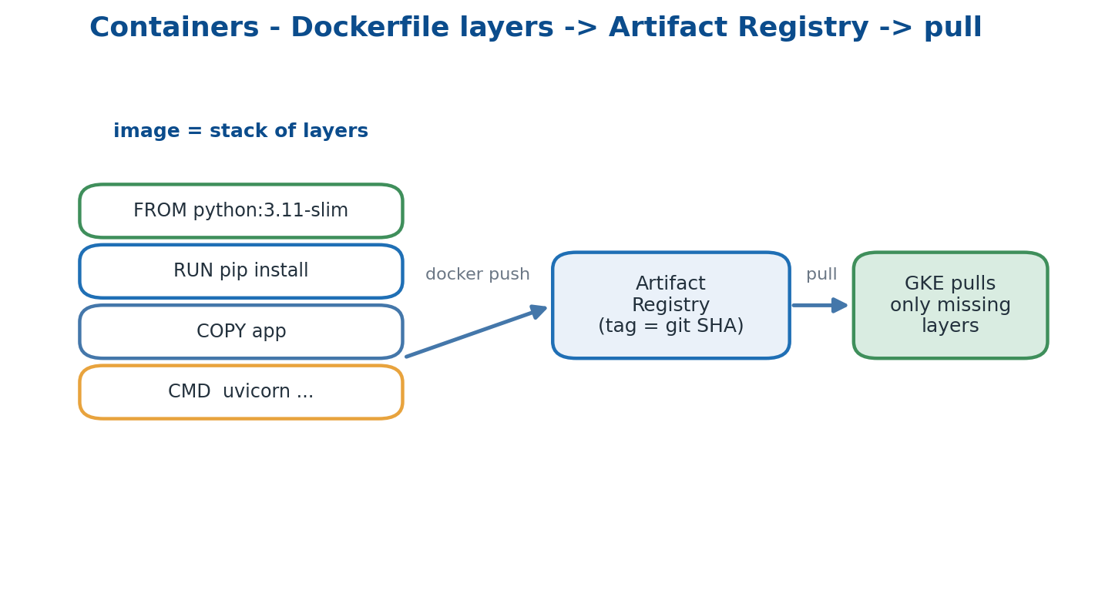
An image is a stack of layers; only the layers a node lacks are pulled from Artifact Registry.

4.1 Why containers
Before containers, deploying meant copying code to a server and hoping its library versions matched your laptop's — and patching painfully when they did not. A container is essentially a tar file that bundles the code, the libraries and even the OS user-space; everything except the kernel. Docker is the most common container format and runtime.

4.2 Anatomy of a Dockerfile
FROM python:3.11-slim
ENV PYTHONUNBUFFERED=1
WORKDIR /app
COPY requirements.txt /tmp/
RUN pip install -r /tmp/requirements.txt
COPY app /app/app
CMD ["uvicorn", "app.main:app", "--host", "0.0.0.0", "--port", "8000"]
- FROM — the base image; layers stack on top of layers.
- RUN — execute a build-time command, cached unless its inputs change.
- COPY — pull files from the build context into the image.
- CMD — the single foreground process to run when a container starts.

4.3 Image registries
Built images are pushed to a registry — a content-addressable store of layers. GCP's registry is Artifact Registry. Each image carries a tag, usually the git SHA plus 'latest'. Pulling by tag downloads only the layers a node does not already have, which is why thin, well-ordered layers make deploys fast.

4.4 Build best practices we follow
- Multi-stage builds for compiled languages, so the final image stays small.
- Pin the base tag — never 'latest' in the FROM line, so builds are reproducible.
- Run as non-root — the scoring-api Dockerfile creates an 'appuser'.
- Add a HEALTHCHECK so orchestrators can self-heal a wedged container.
- Install deps before copying code so a code change does not bust the dependency cache.

Where this lives in the repo
Concept | Where in this repo | Why it matters
Dockerfiles | api/scoring/Dockerfile · api/ui/Dockerfile · demo-app/*/Dockerfile · ml/pipelines/rcf_metrics/Dockerfile | Each is built and pushed by Stage 2 of scripts/deploy_all.sh.

Stitch -> You now have an image that holds one process and its dependencies. The next chapter explains the system that runs hundreds of those images, restarts the crashed ones, and exposes them — Kubernetes / GKE.

Chapter 5 — Kubernetes and GKE Autopilot — running many containers safely
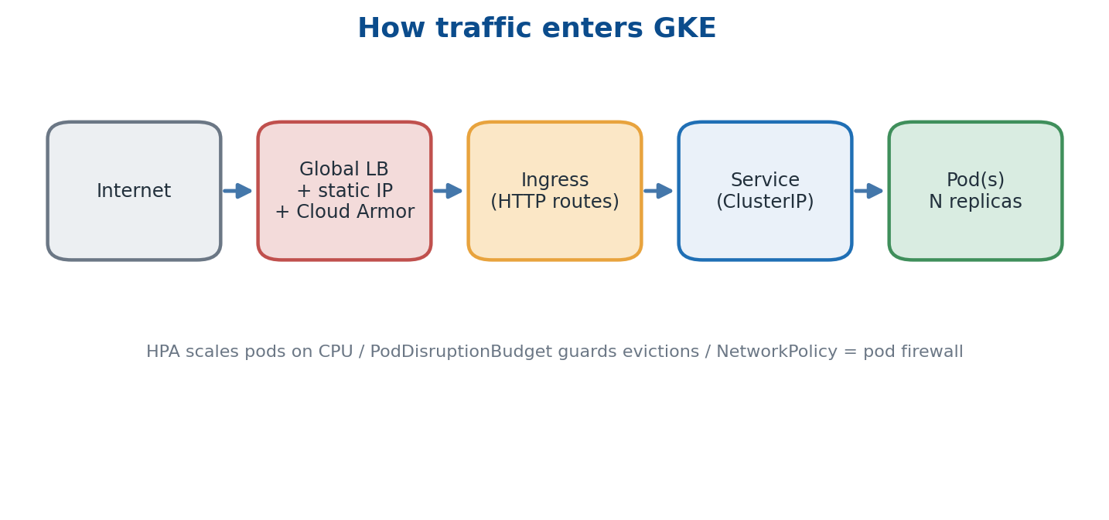
How a request reaches a pod: internet -> global LB + Cloud Armor -> Ingress -> Service -> Pod.

5.1 Why an orchestrator
With ten machines and twenty container types you do not want to SSH around running 'docker run' by hand. Kubernetes runs containers across a fleet, restarts crashed ones, scales them, exposes them behind a virtual IP, and spreads them across failure zones — declaratively.

5.2 Core objects you must know
- Pod — one or more containers sharing a network namespace; the smallest unit.
- Deployment — declares 'I want N replicas of this pod template'.
- Service — a stable virtual IP and DNS name for a set of pods.
- ConfigMap / Secret — env vars and credentials mounted into pods.
- Ingress — HTTP routing rules from the outside world to a Service.
- HPA / PodDisruptionBudget / NetworkPolicy — autoscaling, eviction guards, and pod-level firewalls.

5.3 GKE Autopilot specifically
Autopilot is a GKE mode where Google manages the underlying nodes; you declare only pods and pay per pod-second. The cluster scales in one to two minutes. A few privileged options are blocked, but everything this project needs works within those constraints.

5.4 Helm — the package manager
A Helm chart is a templated bundle of YAML; values.yaml fills the template and you install with 'helm upgrade --install'. Helm is to Kubernetes what apt is to Debian. This repo ships charts for the scoring API, the AIOps UI, the OTEL collector, and a generic demo-service chart parameterised per role.

5.5 How traffic enters the cluster
Only three charts have a public face — the scoring API, the UI, and the demo app. Each pairs a global Ingress with a static IP, a Google ManagedCertificate and a Cloud Armor BackendConfig. Everything else is ClusterIP, reachable only inside the cluster.

Where this lives in the repo
Concept | Where in this repo | Why it matters
Ingress definitions | helm/charts/aiops-ui · helm/charts/anomaly-scoring-api · demo-app/helm/demo-service | These three charts are the only public surfaces; the rest are internal ClusterIP services.

Stitch -> You now have a cluster that runs containers and exposes them. The next chapter covers the workloads we put inside it — applications that emit signals. Without signal the AIOps half has nothing to do.

Chapter 6 — Producers — applications that emit signals
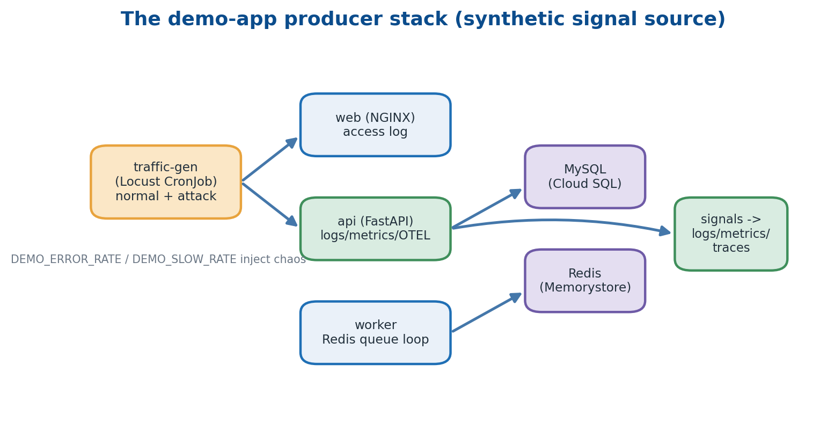
The demo-app stack: a Locust traffic generator drives web/api/worker, which talk to MySQL and Redis.

6.1 Why a fake e-commerce stack
An anomaly-detection platform needs raw signal. The demo-app directory exists so you can run an end-to-end demo without pointing the platform at real production traffic. It has three service roles plus a traffic generator that can behave normally or launch simulated attacks.

6.2 The three demo services
- web — an NGINX reverse proxy serving a static index page, producing a combined access log.
- api — a FastAPI backend emitting JSON logs, a /metrics endpoint and OTEL traces, talking to MySQL.
- worker — a Python loop that polls a Redis queue and processes synthetic jobs.

6.3 Realism knobs
The api reads environment variables that inject controlled chaos so detectors have something to fire on: DEMO_ERROR_RATE (fraction of requests that deliberately return 500), DEMO_SLOW_RATE (fraction that get extra latency) and DEMO_SLOW_LATENCY (how much extra). Turning these up is how you stage a believable incident on demand.

6.4 Traffic generator (Locust)
The traffic-gen Locust file defines both normal-mode and attack-mode user behaviours — brute-forcing /login, DDoS bursts, SQL-injection probes. A Kubernetes CronJob re-spawns it every thirty minutes so the platform always has a living workload to watch.

Where this lives in the repo
Concept | Where in this repo | Why it matters
Demo producer stack | demo-app/{web,api,worker} · demo-app/traffic-gen/locustfile.py | Synthetic but realistic signal source; chaos knobs let you trigger incidents deliberately.

Stitch -> You now have applications producing structured signal continuously. The next chapter explains the three formats that signal travels in — logs, metrics and traces — and how each is captured.

Chapter 7 — The three pillars of observability — logs, metrics, traces
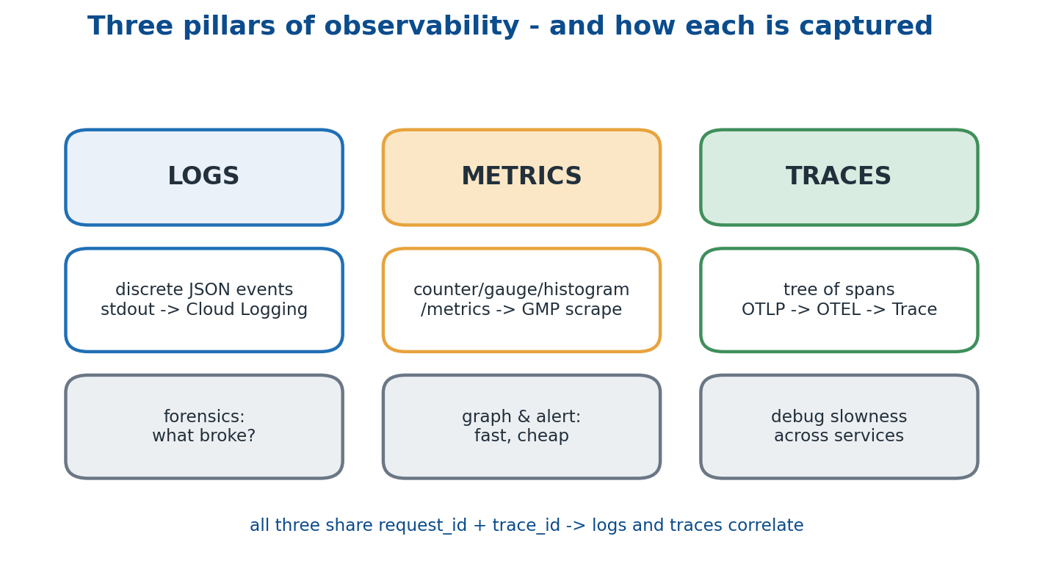
Each pillar has a capture path and a job it does best; a shared request_id and trace_id tie them together.

7.1 Logs
Logs are discrete, time-stamped events — JSON lines written to stdout. GKE captures every container's stdout into Cloud Logging automatically, where they are searchable and exportable to BigQuery, GCS or Pub/Sub via log sinks. Logs are the forensic record: when you need to know exactly what a broken request looked like, you read the log line.
{"ts":"2026-06-20T09:30:14Z","level":"INFO","msg":"GET /api/products/5 -> 200 (12.3ms)",
"service":"demo-api","request_id":"u-7f","trace_id":"a91..."}

7.2 Metrics
Metrics are numerical time-series and come in three shapes: a Counter that only goes up (requests_total), a Gauge that moves both ways (inflight_requests) and a Histogram that buckets a distribution (request_latency_seconds). Apps expose them at /metrics in Prometheus text format; Google Managed Prometheus scrapes them via PodMonitoring CRDs. Histograms are the secret weapon — you can compute p50, p95 and p99 server-side, on the fly.

7.3 Traces
A trace is a tree of spans, where each span is one operation in one service — a SQL SELECT, a POST /score, a redis.lpop. Spans share a trace_id, so you can replay a request that hopped api -> worker -> MySQL -> Redis as a single timeline. OpenTelemetry is the vendor-neutral SDK; apps emit OTLP and the OTEL collector exports to Cloud Trace.

7.4 Why all three
Metrics are fastest to graph and alert on and cheapest to store. Logs are best for forensics. Traces are best for debugging slowness that spans many services. Because all three share the request_id and trace_id, a single alert can pivot from a metric spike to the exact logs and trace behind it.

Where this lives in the repo
Concept | Where in this repo | Why it matters
Where each pillar is wired | demo-app/api/app/observability.py + PodMonitoring + OTEL exporters | Logs, metrics and traces share request_id/trace_id so they correlate cleanly.

Stitch -> You now have three streams of telemetry from every workload. The next chapter explains the bus that moves them at scale and decouples producers from consumers — Pub/Sub.

Chapter 8 — Pub/Sub — decoupling producers from consumers
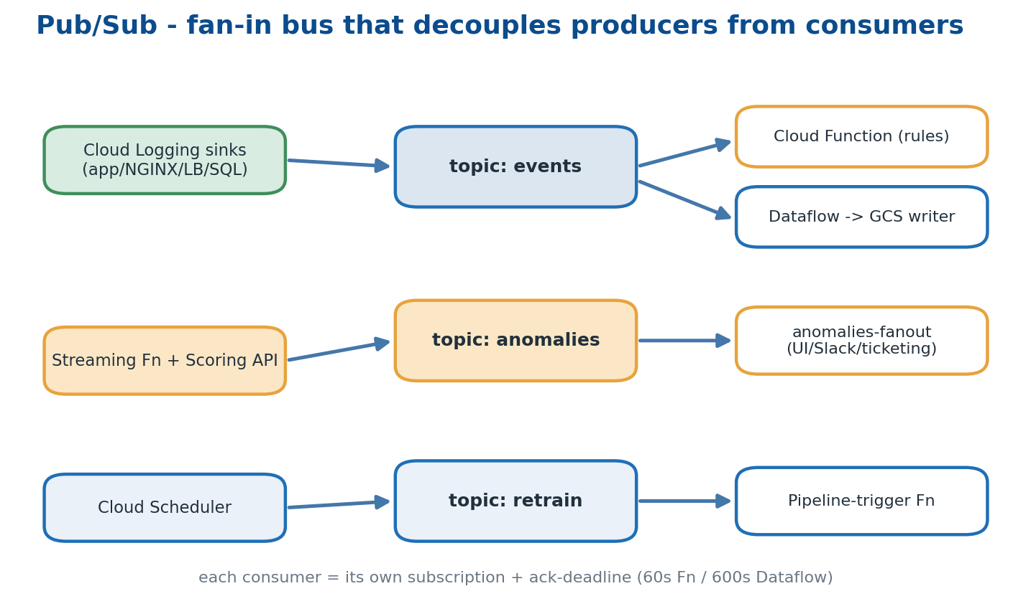
Three topics fan signal in from many producers out to many independent consumers.

8.1 The publish / subscribe pattern
Producers send messages to a topic; consumers create a subscription on that topic and pull messages. Producers do not know who consumes and consumers do not know who produced. Adding a new consumer is one new subscription with no change to any producer — this decoupling is what makes the architecture extensible.

8.2 Three topics in this repo
- events — fed by Cloud Logging sinks; consumed by the streaming Cloud Function and the Dataflow GCS writer.
- anomalies — fed by the streaming Function and Scoring API; consumed by a fan-out subscription (UI / Slack / ticketing).
- retrain — fed by Cloud Scheduler; consumed by a pipeline-trigger Function.

8.3 Subscriptions and ack-deadline
Each consumer needs its own subscription. When you pull a message the broker starts an ack_deadline_seconds timer; you must acknowledge before it expires or the message is redelivered. Long jobs need long deadlines — the streaming Function uses 60 seconds, the Dataflow writer 600.

8.4 Cloud Logging sinks — the entry point
Cloud Logging captures every container's stdout. A 'sink' is a saved filter that routes matching lines to GCS, BigQuery or Pub/Sub. This project routes through Pub/Sub so every downstream path reads from one common bus rather than from the logging system directly.

Where this lives in the repo
Concept | Where in this repo | Why it matters
Log sink config | demo-app/infra/main.tf — google_logging_project_sink.mysql_slow_sink | Routes MySQL slow-query logs into the events topic; add more sinks the same way.

Stitch -> You now have a fan-in bus holding every signal. The next chapter explains the streaming ETL job that drains that bus into long-term storage — Dataflow.

Chapter 9 — Streaming ETL with Dataflow
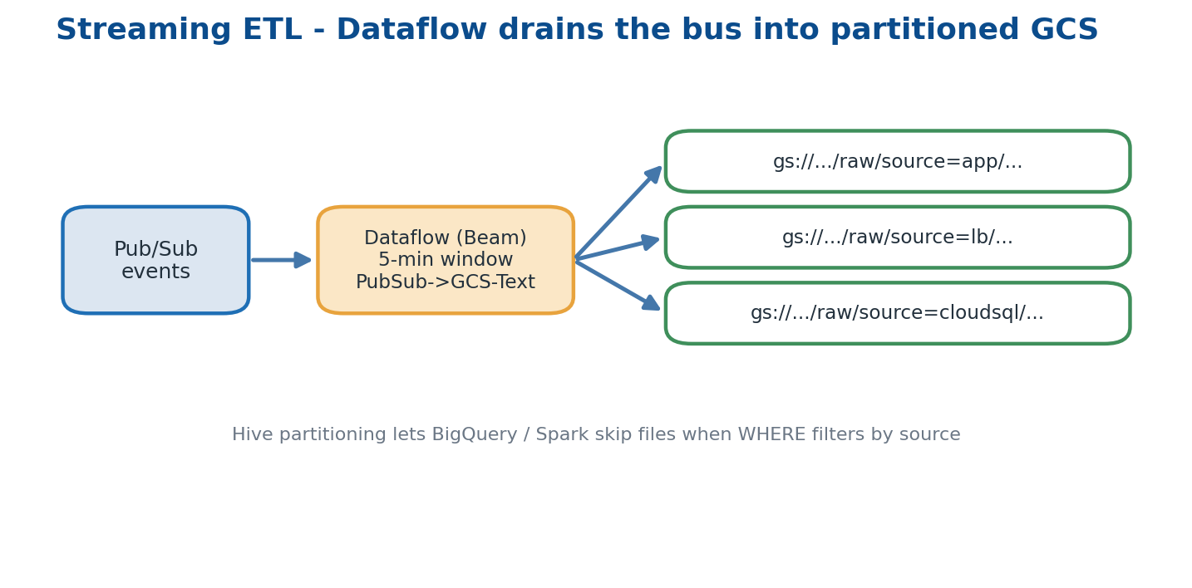
Dataflow reads the events subscription, windows into 5-minute files, and writes Hive-partitioned GCS.

9.1 ETL — what those three letters mean
Extract: read from the source (Pub/Sub). Transform: reshape — parse JSON, derive fields, tag with a partition. Load: write to the sink (GCS files here). Streaming ETL does this continuously rather than in nightly batches.

9.2 Apache Beam and Dataflow
Apache Beam is a unified programming model for batch and streaming pipelines; Dataflow is Google's managed runner for Beam, which autoscales workers and handles late data and exactly-once semantics. This project does not write Beam code — it launches Google's pre-built PubSub-to-GCS-Text flex template.

9.3 Windowing
Streaming jobs accumulate messages into windows before writing. A 5-minute fixed window is used: every five minutes the job flushes a file to GCS. Smaller windows mean more files and more overhead; larger windows mean more lag before data appears in the lake. Five minutes is the chosen balance.

9.4 Hive partitioning
Files are written under gs://bucket/{env}/raw/source=app/..., source=lb/..., source=cloudsql/.... BigQuery, Spark and most query engines understand this directory layout and can skip files entirely when a query filters by source — a large cost and speed win on big scans.

Where this lives in the repo
Concept | Where in this repo | Why it matters
Dataflow job | infra/modules/streaming/main.tf — google_dataflow_flex_template_job.events_to_gcs | Reads the events subscription and writes 5-minute partitioned files into the lake bucket.

Stitch -> You now have a process that durably stores every signal. The next chapter explains the storage layout itself — the data lake (raw) plus the warehouse view (BigQuery).

Chapter 10 — The data lake (GCS) and the warehouse (BigQuery)
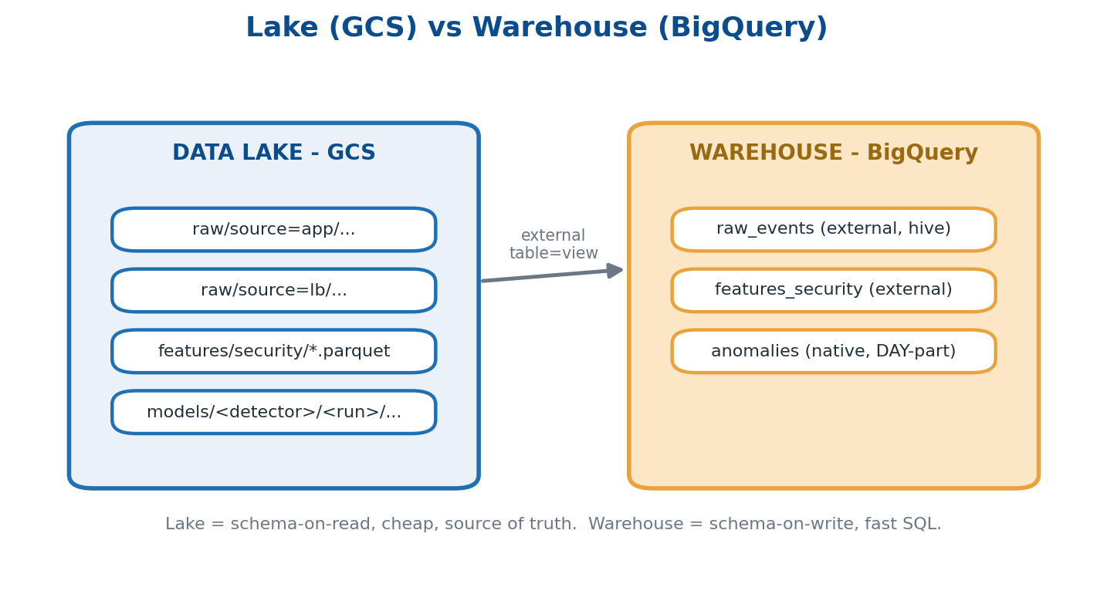
The lake holds raw partitioned files; the warehouse exposes them as external and native SQL tables.

10.1 Lake versus warehouse
A lake is raw, schema-on-read, cheap and effectively infinite — files in GCS. A warehouse is schema-on-write, query-optimised and more expensive per query — BigQuery. Modern systems use both: the lake is the source of truth, the warehouse is the analyst's fast playground.

10.2 Bucket layout
gs://monitoring-mlops-gcp-dev/
dev/raw/source=app/<date>/events-*.json
dev/raw/source=lb/...
dev/features/security/<date>/*.parquet
dev/models/<detector>/<run-id>/...

10.3 External tables
An external table is a BigQuery view over GCS files — no data is copied and the schema is auto-detected. Combined with Hive partitioning, a query with WHERE source='app' scans only the files beneath source=app/.

10.4 Native tables
A native table physically stores data in BigQuery's own columnar storage, giving fast aggregation, DAY partitioning and clustering. The anomalies table is native because the dashboard needs sub-second queries over it.

Where this lives in the repo
Concept | Where in this repo | Why it matters
Datalake module | infra/modules/datalake/main.tf — bucket + dataset 'monitoring' + 3 tables | raw_events (external, hive) · features_security (external Parquet) · anomalies (native, DAY).

Stitch -> You now have raw data on disk and queryable in SQL. The next chapter explains the schema discipline that lets many sources land in one table — parsers and CommonEvent.

Chapter 11 — Schema and parsers — turning many formats into one
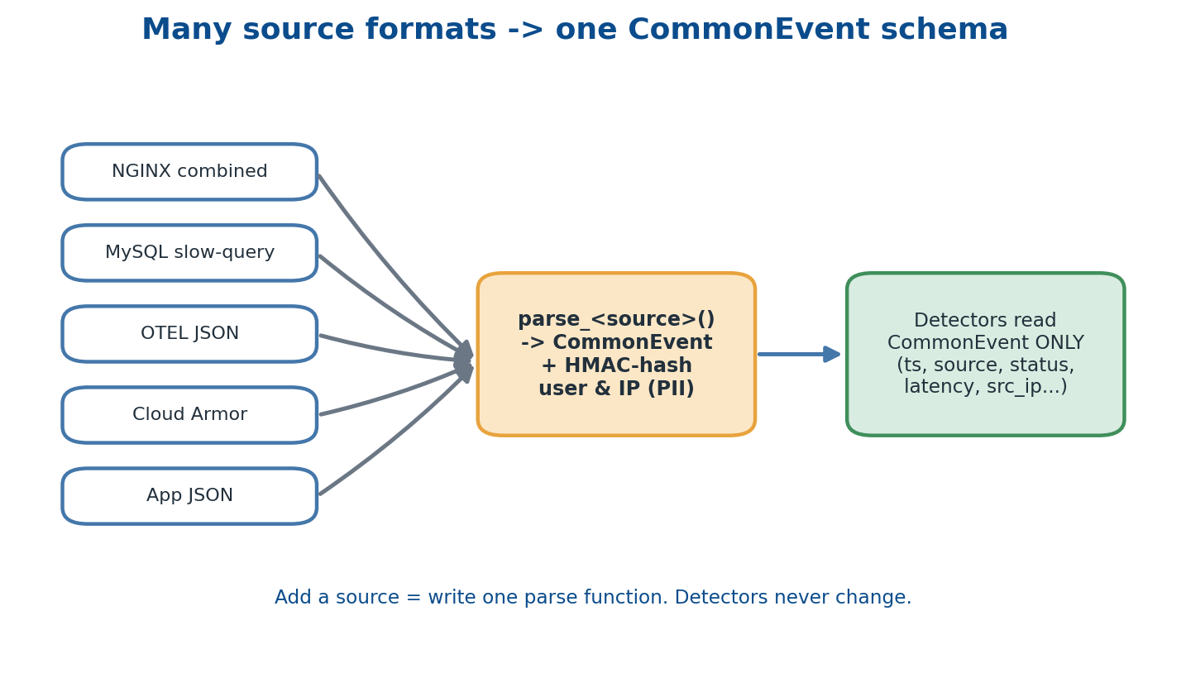
Per-source parsers normalise every format into one CommonEvent shape and hash PII on the way through.

11.1 Why a canonical schema
Each source emits a different shape — an NGINX combined log, a MySQL slow query, OTEL JSON, a Cloud Armor event. If every detector had to understand every shape, adding one source would force a change to every detector. The solution is one CommonEvent schema plus per-source parsers that adapt into it; detectors read CommonEvent only.

11.2 CommonEvent shape
{ ts, ingest_ts, source: 'cdn|lb|cloud_armor|app|gke|nginx|cloudsql|...',
host, severity, status, latency_ms, bytes, src_ip, user,
path, user_agent, message, attrs }

11.3 PII handling
Critical rule number one in CLAUDE.md: hash usernames and IPs with HMAC inside the parser, so detectors only ever see hashes. This lets you analyse rate-per-user or distinct-IP counts without ever storing or logging an identifier — you cannot leak data you never keep.

Where this lives in the repo
Concept | Where in this repo | Why it matters
Parsers | ml/parsers/__init__.py — CommonEvent dataclass + parse() dispatcher | Adding a source = one new parse_<source>() function; detectors are untouched.

Stitch -> You now have data normalised to one shape. The next chapter explains the math that decides which CommonEvent rows are anomalous.

Chapter 12 — Statistics 101 — what 'anomaly' actually means
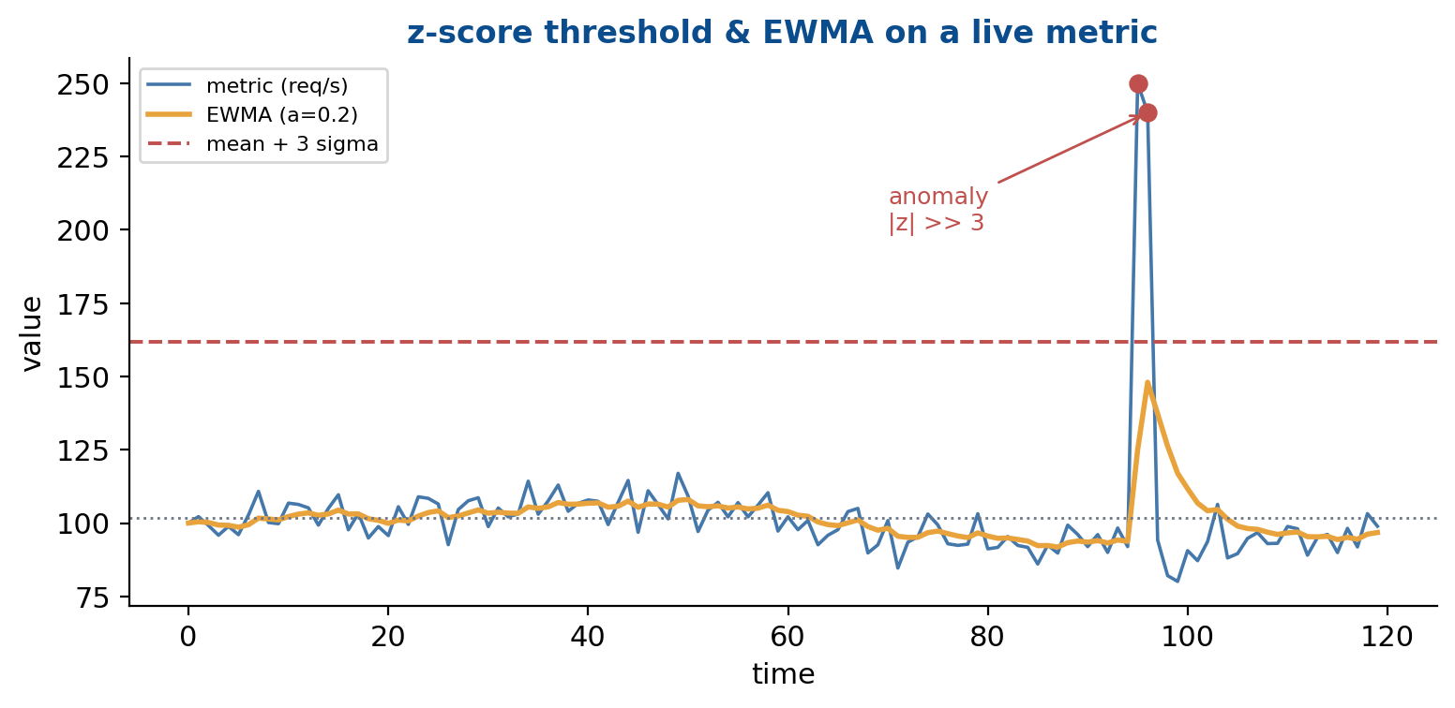
A live metric with its EWMA and a mean+3-sigma threshold; the spike is many standard deviations out.

12.1 Mean and standard deviation
The mean (mu) is the centre of a distribution; the standard deviation (sigma) is the typical distance from that centre. If a metric's recent mean is 100 requests/second with sigma = 15, then 250 req/s is (250-100)/15 = 10 standard deviations away — extraordinarily unlikely under normal behaviour.

12.2 Z-score
The z-score is z = (x - mu) / sigma; an absolute value above 3 is a common anomaly threshold. It is cheap and robust on stationary data, which makes it the default first rule.

12.3 EWMA — exponentially weighted moving average
A plain mean treats yesterday and last week identically. EWMA weights recent points more heavily: EWMA_t = alpha * x_t + (1 - alpha) * EWMA_(t-1). This lets the baseline adapt to slow drifts rather than flagging every gradual shift as an anomaly.

12.4 Rate-of-change and distinct counters
If a counter doubles in thirty seconds, that itself is news, even if the absolute value is still 'normal' — rate-of-change rules catch sudden spikes a slow baseline window would miss. Distinct counters track unique values: a jump from 50 to 5000 unique source IPs in a minute is the signature of a DDoS even before total request rate explodes, and is implemented with HyperLogLog or a bounded set.

12.5 Why these still are not enough
Three reasons. Seasonality: traffic is not stationary, so a lunch peak is not a midnight anomaly. Multi-variate signals: error rate alone may be fine, but error rate AND latency AND queue depth all rising together means something specific is breaking. Cold start: a z-score on the first thirty minutes of data is meaningless — and that is exactly the gap the trained ML detectors are built to cover.

Where this lives in the repo
Concept | Where in this repo | Why it matters
Statistical methods | ml/streaming/rules.yaml (z-score, ewma, rate, distinct) | Rules are plain YAML so thresholds can be tuned without code changes.

Stitch -> You now have the basic statistical tools of anomaly detection. The next chapter wires them into a live, sub-second alerting pipeline — the streaming Cloud Function.

Chapter 13 — Streaming statistical detectors (Cloud Function Gen2)
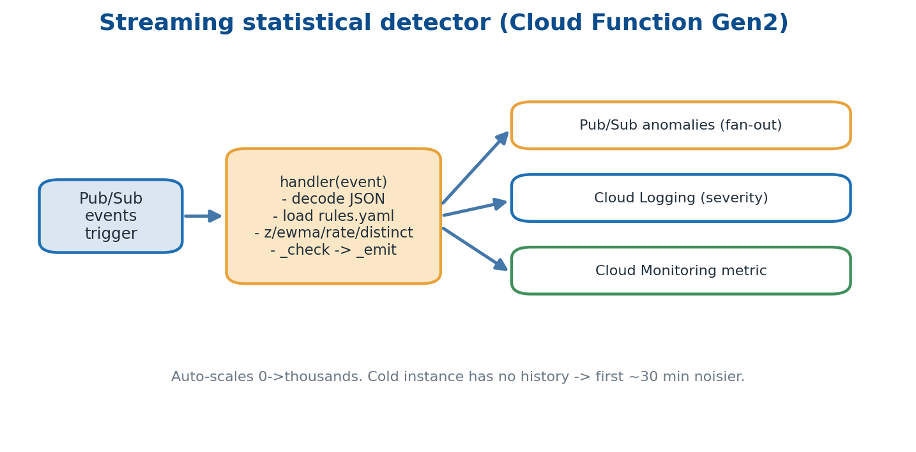
A Pub/Sub message triggers handler(); matching rules emit to Pub/Sub, Cloud Logging and Cloud Monitoring.

13.1 Cloud Functions Gen2
A Cloud Function Gen2 is a managed runtime that executes a small piece of code in response to an event — here a Pub/Sub message. It auto-scales from zero to thousands of concurrent instances and runs on Cloud Run under the hood, configured with 1 GB of RAM and a 120-second timeout.

13.2 Entry point
@functions_framework.cloud_event
def handler(event):
msg = base64.b64decode(event.data['message']['data']).decode()
record = json.loads(msg)
for rule in _rules():
if _check(rule, record['source'], record['host'], record['value']):
_emit(...)

13.3 Rules in YAML
Rules live in ml/streaming/rules.yaml, which is plain YAML and therefore far easier to tune than code. Each rule names a metric, a method (z-score / ewma / rate / distinct), thresholds and a severity. The function loads the YAML at cold start and keeps it resident on warm instances.

13.4 The cold-state caveat
A freshly started instance has no rolling history, so the first roughly thirty minutes after a scale-out can produce noisy z-scores. This is an accepted trade-off: the function is extremely cheap, and the ML detectors cover that early gap.

13.5 Where anomalies go
Every detected anomaly is written three places: the anomalies Pub/Sub topic for the fan-out subscription, Cloud Logging (indexed by detector and source at the rule's severity), and a Cloud Monitoring custom metric counter.
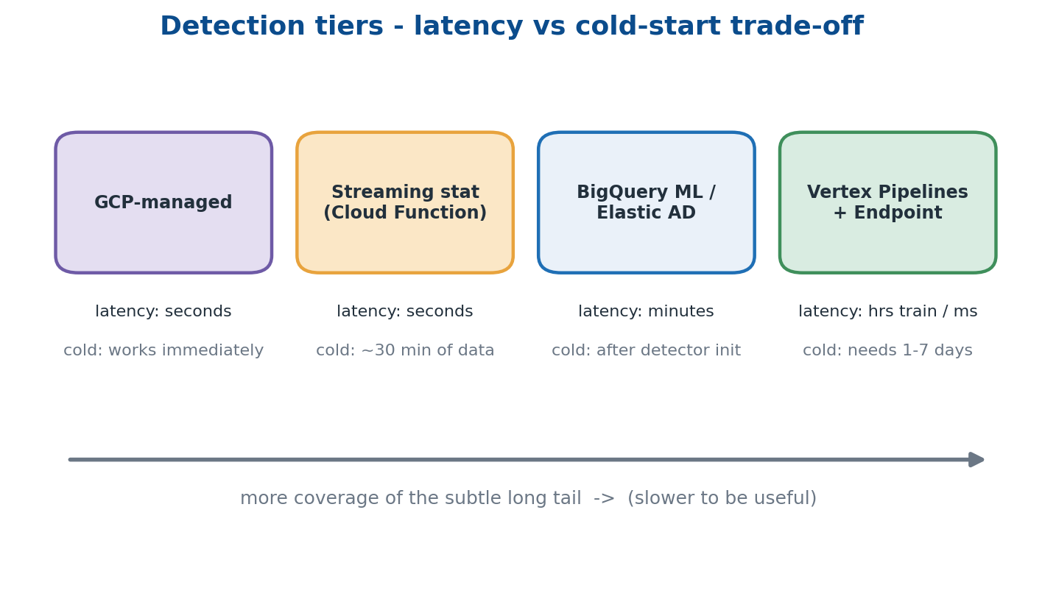
The four detection tiers ranked by latency and cold-start. The streaming Function is tier 2.

Where this lives in the repo
Concept | Where in this repo | Why it matters
Streaming detector | ml/streaming/detector.py + rules.yaml | Deployed by Stage 4 of scripts/deploy_all.sh as a Pub/Sub-triggered Cloud Function.

Stitch -> You now have a tier-2 detector that fires in seconds with no training. The next chapter lays the foundation for tier 3 — just enough machine learning to follow the rest of the project.

Chapter 14 — Machine Learning crash course
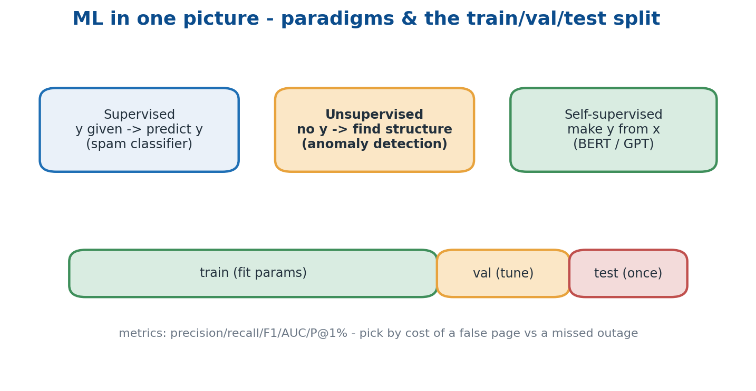
Three learning paradigms and the train/validate/test split that keeps evaluation honest.

14.1 What is a model
A model is a function f(x) -> y whose parameters are fit from data. Training means choosing the parameters that minimise a loss on a dataset; inference means calling f on new x. Everything else is detail around those two ideas.

14.2 Three paradigms
- Supervised — the label y is given; predict y from x (a spam classifier).
- Unsupervised — no labels; find structure such as clusters or density (anomaly detection).
- Self-supervised — manufacture y from x, e.g. mask a word and predict it (BERT, GPT pre-training).

14.3 Train / validate / test
Split the data three ways. Fit on train, tune hyperparameters on validation, and estimate real-world performance on test, which you touch exactly once at the end. This discipline stops a model from looking good simply because it memorised the data you evaluated it on.

14.4 Metrics that matter here
- Precision — of the things flagged, how many were real — keeps you from paging on noise.
- Recall — of the real problems, how many were caught — keeps you from missing outages.
- F1 / AUC / P@1% — the harmonic mean of precision and recall; ranking quality; and precision in the top 1% of scores — the detector-evaluation favourite.

14.5 The four detectors
- rcf_metrics — Random Cut Forest over numerical time-series metrics; gate F1 >= 0.70.
- iforest_logs — Isolation Forest over tabular log-window features; gate P@1% >= 0.80.
- lstm_ae_traces — an LSTM auto-encoder on trace sequences via reconstruction error; gate AUC > 0.80.
- log_embedding_anomaly — a Log-BERT transformer over free-text log lines; gate P@1% >= 0.75.

Where this lives in the repo
Concept | Where in this repo | Why it matters
Detector catalogue | ml/pipelines/{rcf_metrics,iforest_logs,lstm_ae_traces,log_embedding_anomaly} | Each folder holds the algorithm, its trainer image and its quality gate.

Stitch -> You now have a vocabulary for ML and the four algorithms in use. The next chapter covers the first concrete step in any pipeline — turning raw events into model inputs.

Chapter 15 — Feature engineering — turning events into model inputs
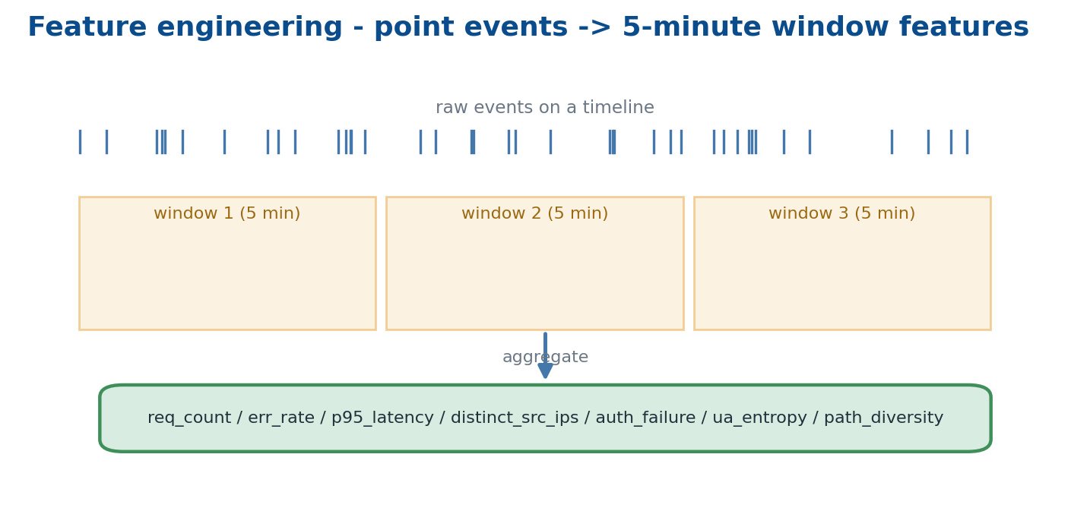
Point-in-time events are aggregated over 5-minute windows into the security feature columns.

15.1 Why features matter more than the algorithm
Two competent practitioners using the same algorithm will get wildly different results depending on their features. Garbage in, garbage out is the most-cited rule in applied ML for a reason — most of the win comes from how you represent the data, not which model you pick.

15.2 Sliding windows
Raw events are point-in-time, but the most useful features are computed over a window: requests in the last five minutes, distinct IPs in the last five minutes, p95 latency in the last five minutes. This project uses 5-minute fixed (tumbling) windows; overlapping rolling windows are smoother but roughly five times more expensive.

15.3 The security features computed
- req_count_5m — total requests by source and host.
- err_count_5m / err_rate_5m — 4xx + 5xx counts and their ratio.
- p95_latency_5m — the 95th-percentile latency over the window.
- distinct_src_ips_5m — unique source IPs — a DDoS signature.
- auth_failure_count_5m — 401/403/login-failed counts — a brute-force signature.
- ua_entropy_5m / path_diversity_5m — Shannon entropy of user-agents and count of distinct paths.

Where this lives in the repo
Concept | Where in this repo | Why it matters
Feature builder | ml/feature_engineering/security_features.py | Reads raw events from GCS, computes 5-min features, writes Parquet that all four trainers consume.

Stitch -> You now have model-ready feature tables on disk. The next chapter explains the orchestration that turns those features into a trained, registered model — Vertex Pipelines.

Chapter 16 — Training pipelines (Vertex Pipelines / KFP v2)
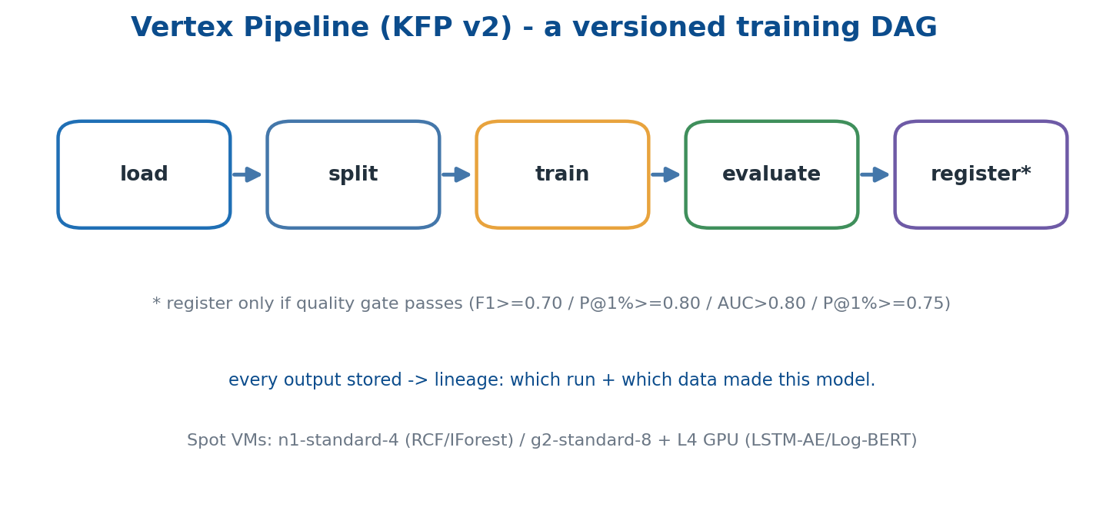
A pipeline is a versioned DAG: load -> split -> train -> evaluate -> register (only if the gate passes).

16.1 Why a pipeline framework
A real training run has many steps — load, split, train, evaluate, register, maybe deploy. Doing them in a notebook is fine for a prototype; in production you need versioned, parameterised, reproducible DAGs that record their inputs, outputs and metrics. Vertex Pipelines, built on the KFP v2 SDK, is Google's offering.

16.2 Components
A component is one Python function decorated with @kfp.dsl.component, with typed inputs and outputs (Datasets, Models, Metrics). The KFP compiler builds a YAML specification and uploads it to Vertex, which schedules each component as a containerised step.

16.3 Lineage
Every step's outputs are stored, and each model version is linked to the run that produced it, the data slices it used and the metrics it achieved. When a detector misbehaves in production you can answer 'which training run made this model?' in two clicks.

16.4 Compute per pipeline
RCF and Isolation Forest train on an n1-standard-4 Spot VM in under thirty minutes for around five cents a run. The LSTM auto-encoder and Log-BERT train on a g2-standard-8 with one L4 GPU, Spot, in one to three hours for around thirty cents. Spot (preemptible) VMs are three-to-four times cheaper, as mandated by cost rule two in CLAUDE.md.

Where this lives in the repo
Concept | Where in this repo | Why it matters
The four pipelines | ml/pipelines/*/pipeline.py + _shared/builder.py | Each defines load -> train -> eval -> register; trainer images sit alongside.

Stitch -> You now have trained model artefacts in storage with metadata. The next chapter covers the catalogue that makes them discoverable, comparable and rollback-able — the model registry.

Chapter 17 — Model registry and versioning
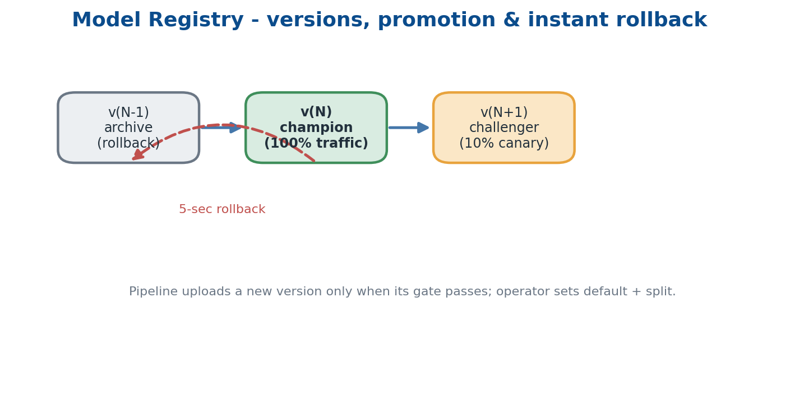
Versions flow archive -> champion -> challenger; rollback to the previous version is a one-line call.

17.1 What a registry holds
For each model the registry stores a display name (e.g. rcf-metrics-detector), an auto-incremented version, the container image used to serve it, the evaluation metrics linked from its run, and state labels such as champion, challenger or archive.

17.2 Promotion flow
A pipeline runs on schedule and, if its metrics pass the quality gate, uploads a new version. An operator or an automated policy then sets that version as the endpoint default, often with a traffic split — 10% first, then 100%. The previous version stays available for instant rollback.

17.3 Why versioning matters operationally
The day a detector starts paging on-call uselessly, you do not want to retrain in a panic — you want to roll back to v(N-1) in five seconds. With the registry that is a single gcloud call, which is the entire operational point of keeping versions.

Where this lives in the repo
Concept | Where in this repo | Why it matters
Registry | Vertex AI Model Registry (managed); pipelines call aiplatform.Model.upload(...) | Versioned catalogue of detectors with linked metrics and instant rollback.

Stitch -> You now have a versioned catalogue of detectors. The next chapter explains the live endpoints that actually run inference at request time — Vertex AI Endpoints.

Chapter 18 — Online endpoints (Vertex AI Endpoints)
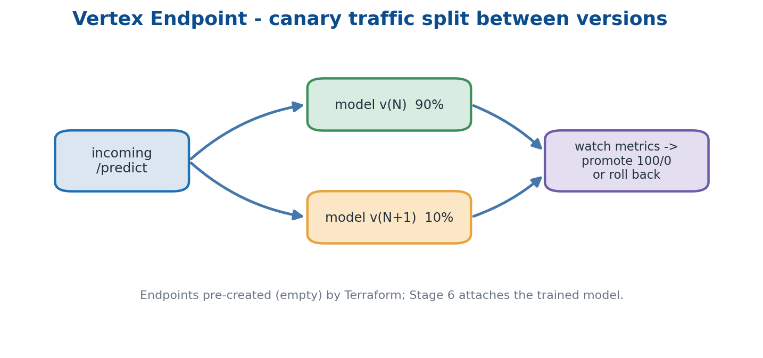
A canary split sends most traffic to the current model and a slice to the challenger before promotion.

18.1 What an endpoint is
An endpoint is an always-on HTTPS service hosting one or more model versions. You POST a JSON instance and it returns a prediction. Vertex handles autoscaling, GPU attachment, traffic splitting between versions, regional placement and IAM authentication for you.

18.2 Machine types per detector
The two CPU detectors (rcf-metrics, iforest-logs) serve on n1-standard-2. The two deep models (lstm-ae-traces, log-embedding) serve on n1-standard-4 with one L4 GPU. The L4 is the ceiling for this project — no A100 or H100, per the cost rules.

18.3 Traffic split for safe rollout
When a new version deploys you can split traffic, for example 90/10 between old and new. Watch the metrics for an hour, then promote to 100/0 or roll back. This is canary deployment applied to machine-learning models.

18.4 Infra versus model lifecycle
The endpoints are pre-created empty by Terraform; Stage 6 of the deploy script attaches the newest trained model to the matching endpoint with the right machine type. This split is intentional — endpoint lifecycle is infrastructure, model lifecycle is ML.

Where this lives in the repo
Concept | Where in this repo | Why it matters
Endpoints | infra/modules/vertex/main.tf — 4 google_vertex_ai_endpoint resources | Pre-created empty; Stage 6 attaches the trained model and sets traffic to the new version.

Stitch -> You now have a stable URL per detector that returns predictions. The next chapter explains the service that calls each endpoint, picks the winner, stores the alert and surfaces it — the Scoring API.

Chapter 19 — The Scoring API — one HTTP surface over the detectors
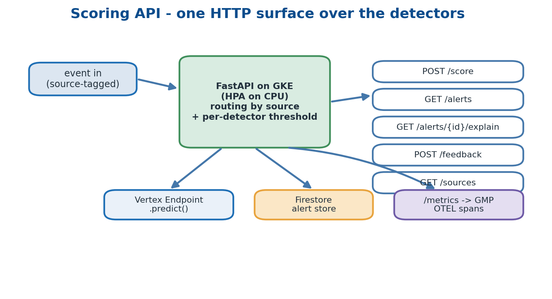
A thin FastAPI gateway routes by source to the right endpoint, persists alerts, and exposes five routes.

19.1 Why a thin gateway
The Vertex endpoints are private. A gateway in front adds public routing and Cloud Armor, decides which detector to call based on the event's source, applies per-detector thresholds, persists alerts for the UI, and receives feedback labels to write back. It is deliberately thin — orchestration, not modelling.

19.2 The five HTTP routes
- POST /api/v1/score — score a single event.
- GET /api/v1/alerts — list alerts with since/source/severity/limit filters.
- GET /api/v1/alerts/{id}/explain — feature contributions for one alert.
- POST /api/v1/feedback — record a true-positive or false-positive label.
- GET /api/v1/sources — last-seen heartbeat per source.

19.3 Internals
It is FastAPI on uvicorn, autoscaled by an HPA on CPU. The Vertex client wraps aiplatform.Endpoint(name).predict(instances=...). Firestore is the alert store — schemaless, horizontally scalable, and free-tier-friendly for a demo. A /metrics endpoint exposes scoring_requests_total and scoring_latency_seconds for GMP, and OTEL spans wrap each scoring call for tracing.
result = vertex_client.predict(event.source, event.model_dump())
is_anom = result["is_anomaly"] or result["score"] >= ANOMALY_THRESHOLD

Where this lives in the repo
Concept | Where in this repo | Why it matters
Scoring API | api/scoring/main.py + services/{vertex_client,store,telemetry}.py | Deployed by helm/charts/anomaly-scoring-api with Ingress + ManagedCertificate + Cloud Armor.

Stitch -> You now have an HTTP service that produces alerts. The next chapter explains the human surface those alerts appear in — the AIOps Console.

Chapter 20 — The AIOps Console — the human-facing UI
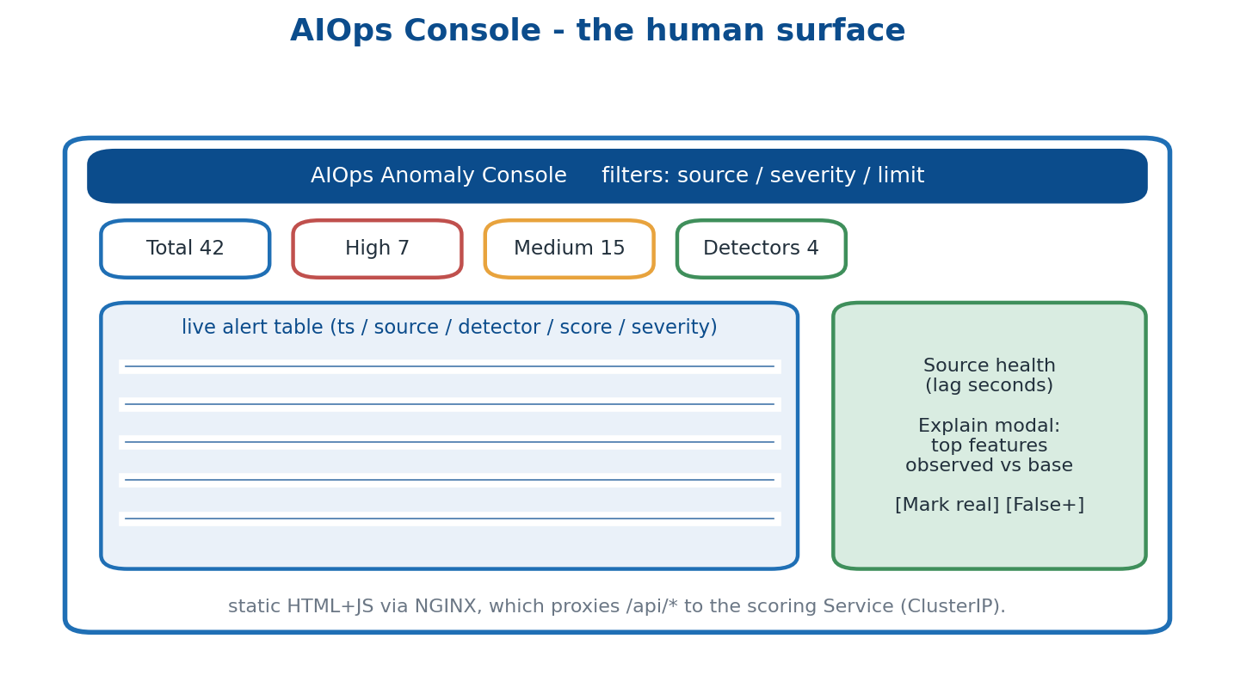
A focused console: stats cards, a filterable alert table, source-health sidebar, explain and feedback.

20.1 Why a custom UI
Cloud Monitoring dashboards are excellent for time-series but weak at per-alert drill-in, feedback loops, detector explanations and custom severity views. So the project ships a small static console that calls the Scoring API directly and is built around the alert, not the metric.

20.2 What it shows
- Live alert table — with source, severity and limit filters.
- Stats cards — last hour totals: total, high, medium, and detector count.
- Source-health sidebar — ingestion lag in seconds per source.
- Explain modal — top contributing features, observed versus baseline.
- Feedback buttons — 'Mark real' and 'Mark false positive', which POST to /feedback.

20.3 Architecture
It is plain HTML and JavaScript served by NGINX. The same NGINX proxies /api/* to the ClusterIP Service of the scoring API, so the browser only ever talks to one origin. It is deployed by the aiops-ui Helm chart with a GCE Ingress, a ManagedCertificate and Cloud Armor. One subtlety: renaming the scoring Service silently breaks the UI proxy, so that name is a sensitive area.

Where this lives in the repo
Concept | Where in this repo | Why it matters
Console | api/ui/site/index.html · api/ui/nginx.conf · helm/charts/aiops-ui/ | Open https://$DOMAIN_AIOPS after deploy; NGINX proxies /api/* to the scoring Service.

Stitch -> You now have a working alert console. The next chapter explains the lifecycle that keeps detectors useful as the world changes — drift, retraining and the closed loop.

Chapter 21 — Drift, retraining, and the closed loop
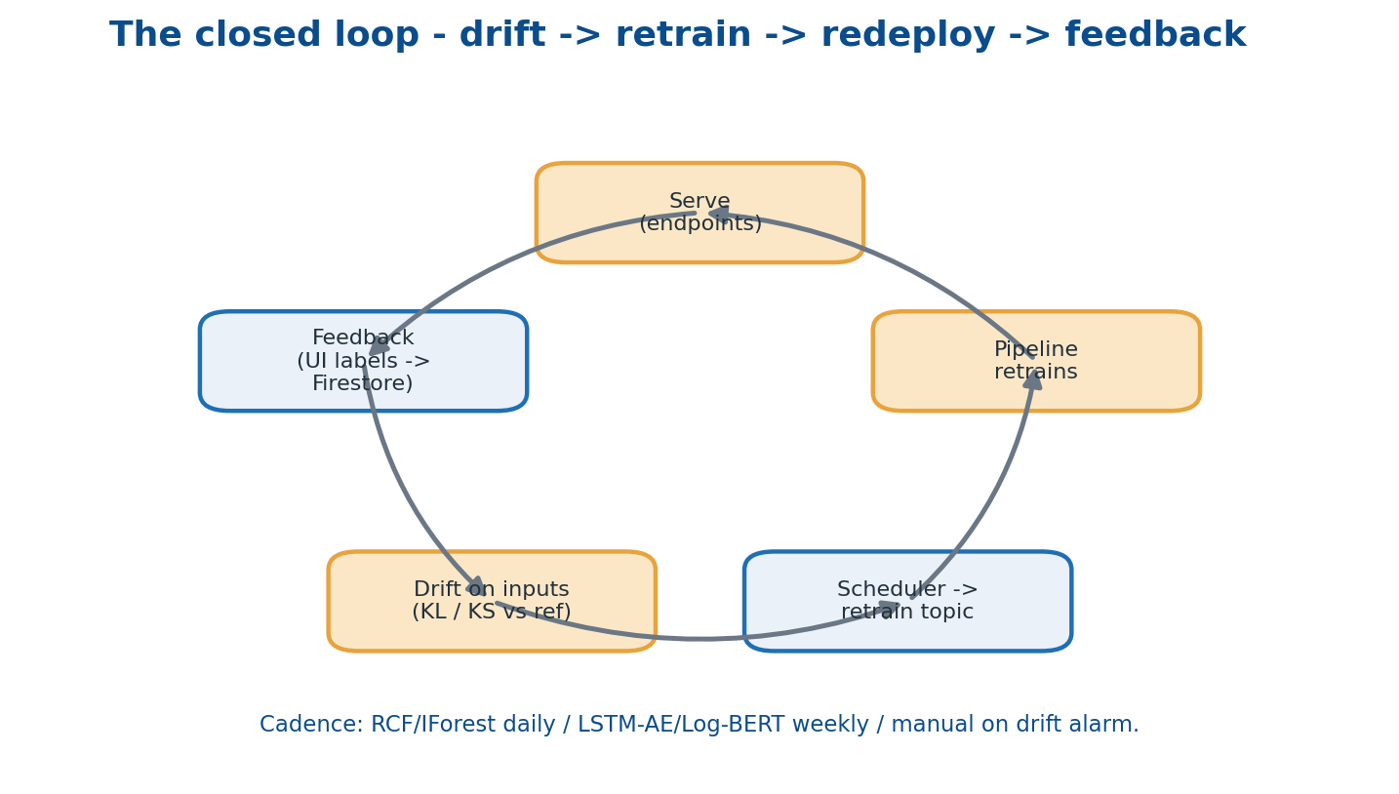
Serve -> feedback -> drift check -> scheduled retrain -> redeploy: the loop that keeps detectors current.

21.1 Drift
Models age in two ways. Data drift is when the input distribution changes — your traffic mix shifts, or a new feature rolls out. Concept drift is when the relationship between input and label changes — what counted as normal yesterday is not normal today. Both quietly erode a detector's accuracy.

21.2 Detect drift on inputs, not predictions
Rule five in CLAUDE.md: watch the inputs. It is far faster to notice that req_count_5m's mean has shifted by three sigma than to wait for a precision dip to show up in outcomes. The platform computes a statistical distance (KL divergence or a KS test) between the current feature distribution and a frozen reference distribution captured at training time.

21.3 Retraining cadence
- RCF / IForest — daily, because they are cheap and fast.
- LSTM-AE / Log-BERT — weekly, because they need a GPU and take hours.
- Manual trigger — a drift alarm or an operator publish to the retrain topic.

21.4 The feedback loop
Every feedback click in the UI writes a row to Firestore (alert_id, label). Future training runs read those labels and use them as ground truth for evaluation, weighting and — for supervised refinement — labelled training. This is the mechanism by which the platform actually learns from its operators over time.

Where this lives in the repo
Concept | Where in this repo | Why it matters
Schedules + alarm | infra/modules/monitoring/main.tf — 4 Cloud Scheduler jobs + precision_drop policy | Schedulers publish to the retrain topic; a Function re-runs the matching pipeline.

Stitch -> You now have a closed lifecycle that keeps detectors current. The next chapter explains the security posture protecting every layer — defence in depth.

Chapter 22 — Security across the stack — defence in depth
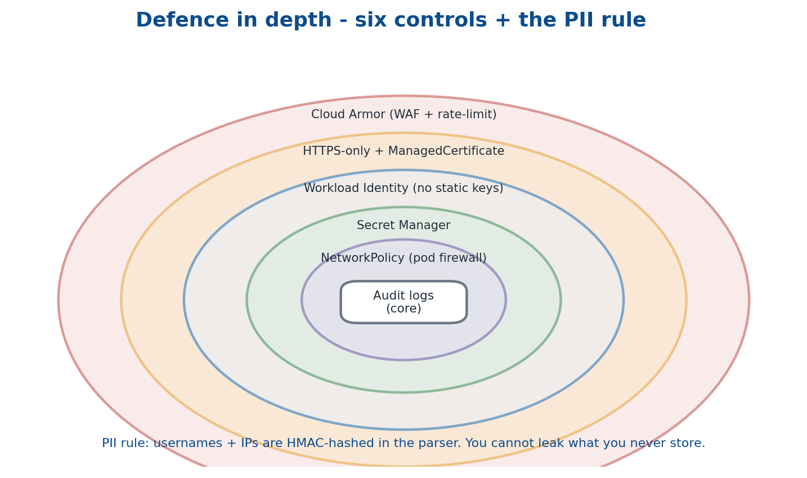
Six concentric controls plus the PII rule: many overlapping walls beat one tall wall.

22.1 Many weak walls beat one strong wall
Defence in depth assumes any single control can fail and layers several so a breach of one does not become a breach of all. This repo applies six controls plus a data-minimisation rule.
- Cloud Armor at the edge — WAF rulesets (sqli, xss) plus a 600 req/min/IP rate limit.
- HTTPS-only + ManagedCertificate — TLS terminates at the global load balancer.
- Workload Identity — no static service-account keys anywhere in the cluster.
- Secret Manager — passwords and keys versioned, IAM-controlled, never in YAML or git.
- NetworkPolicy — a pod-level firewall that blocks egress to the metadata server (169.254.169.254).
- Audit logs — Cloud Audit Logs capture every IAM call automatically.

22.2 The PII rule
Rule one in CLAUDE.md: all usernames and IPs are HMAC-hashed inside the parser, so detectors only ever see hashes. You cannot leak data you do not store — data minimisation is itself a security control, not just a privacy one.
Sensitive area
Cloud Armor policy edits in infra/modules/lb/main.tf have a public blast radius. Change rate-limit and WAF rules carefully and test from a throwaway IP before merging.

Where this lives in the repo
Concept | Where in this repo | Why it matters
Cloud Armor policy | infra/modules/lb/main.tf — google_compute_security_policy.armor | Three rule families: rate_limit, sqli WAF, xss WAF — public blast radius, edit with care.

Stitch -> You now have a layered security posture. The next chapter covers the pragmatic side of running this on a credit card — what drives the bill and which knobs lower it.

Chapter 23 — Cost engineering — knobs that decide your bill
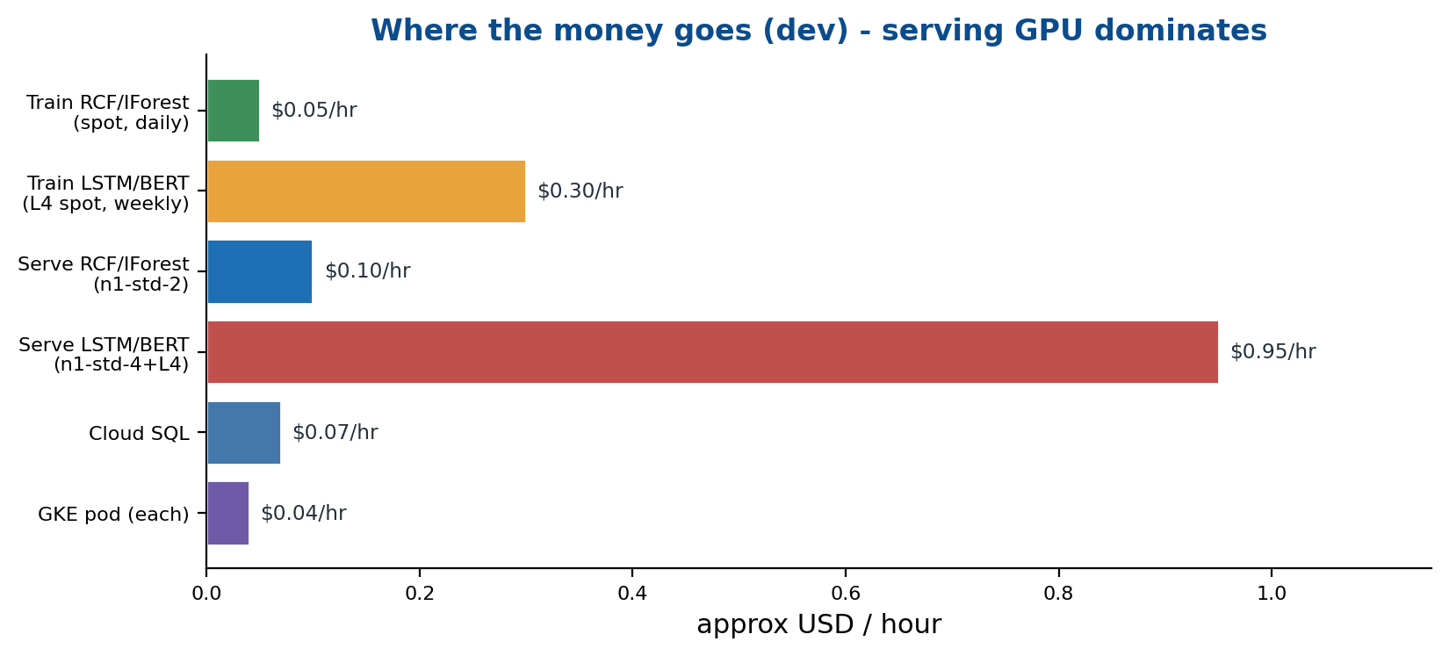
Approximate dev-environment hourly costs. Continuous GPU serving dominates; training is cheap and bursty.

23.1 Where the money goes (dev)
Training is cheap and bursty: RCF/IForest on Spot run for minutes a day at around five cents, and the GPU models on L4 Spot run weekly for around thirty cents. Serving is the opposite — it is continuous. The two CPU endpoints cost roughly ten cents an hour, but the two GPU endpoints cost close to a dollar an hour each, around the clock. GKE Autopilot bills per pod (about four cents per pod-hour across two to eight replicas), Cloud SQL is a few cents an hour, and GCS / Pub/Sub / Logging together stay under a few dollars a day. BigQuery is charged per terabyte scanned, so cost there is entirely about query hygiene.

23.2 The cost rules we follow
- Spot for all training — three-to-four times cheaper; pipelines carry restart logic for preemption.
- L4 is the GPU ceiling — no A100 or H100 anywhere in this project.
- n1-standard-2 endpoints in dev — scale serving up only for production.
- Stop Cloud SQL off-hours and let a GCS lifecycle rule delete raw partitions after 90 days.
- Always filter the partition — put WHERE on the partition column before SELECT; never scan a whole table.

Where this lives in the repo
Concept | Where in this repo | Why it matters
Cost controls | CLAUDE.md rule 2 · GCS lifecycle · BigQuery partition filters | Spot training, capped GPUs, modest endpoints, and partition-pruned queries keep dev affordable.

Stitch -> You now know where dollars go and how to control them. The next chapter covers the single command that brings the whole stack up — the deploy walk-through.

Chapter 24 — The full deploy walk-through (scripts/deploy_all.sh)
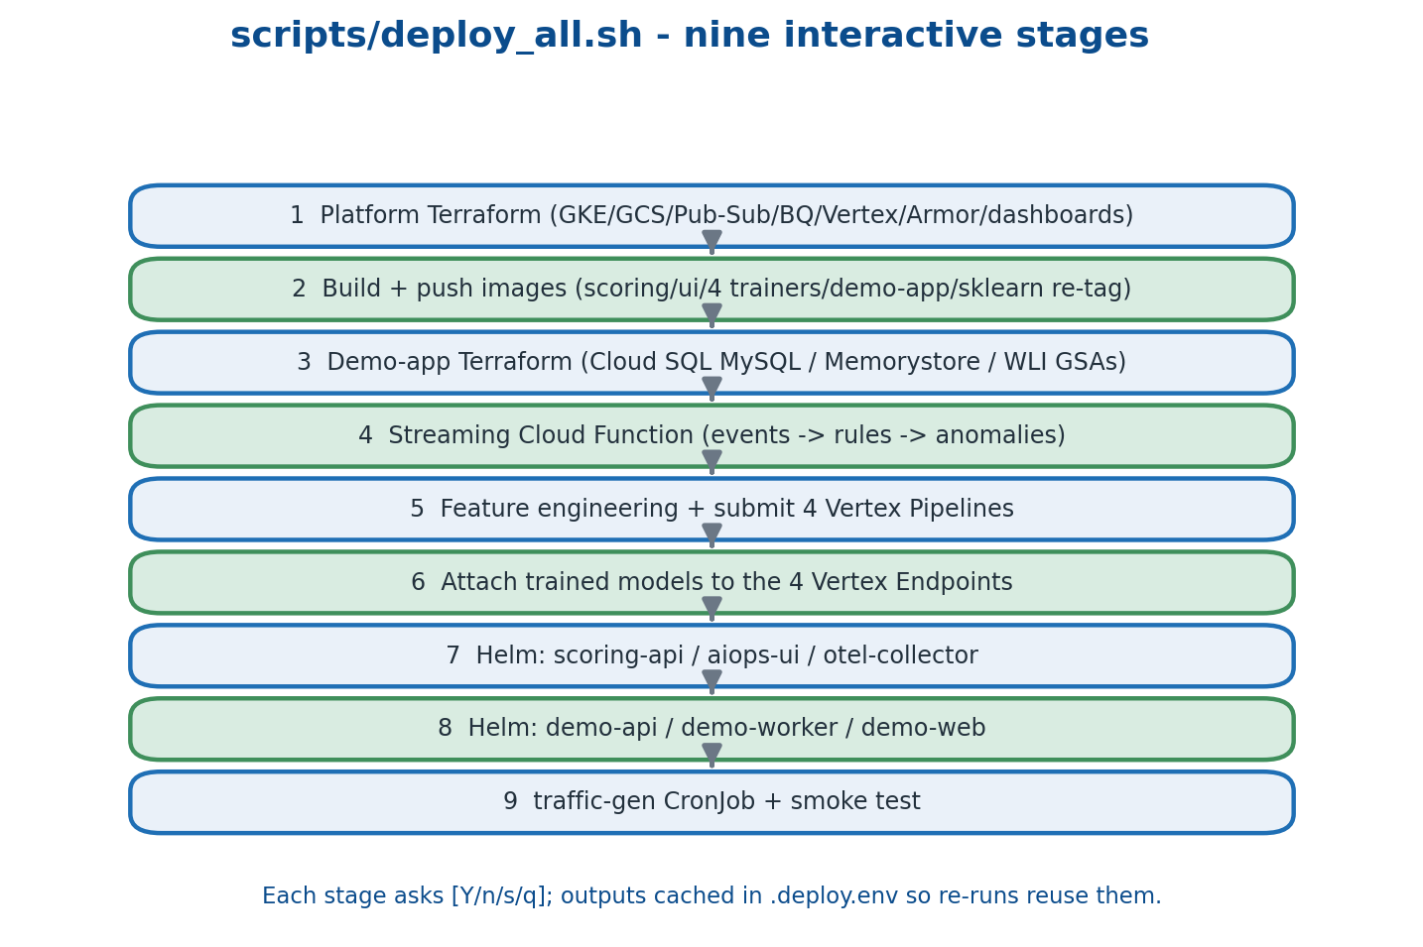
Nine interactive stages; each asks [Y/n/s/q] and caches outputs in .deploy.env so re-runs reuse them.

24.1 One command, nine stages
The entire platform comes up from a single interactive script. Each stage prints a label and asks whether to run it (Yes), skip it (no), drop to a shell (s) or quit (q). Outputs from earlier stages are cached in .deploy.env so a re-run reuses them rather than recomputing.
- Stage 1 — Platform Terraform: GKE Autopilot, GCS, Pub/Sub, Artifact Registry, Cloud SQL, Cloud Armor, the BigQuery dataset and three tables, four empty Vertex endpoints, the retrain schedulers and two dashboards. The slow part (~10 min) is Autopilot bring-up.
- Stage 2 — Build + push images: scoring-api, ui, four trainers and the demo-app trio; re-tags the Vertex pre-built sklearn image as the serve image for the two CPU detectors.
- Stage 3 — Demo-app Terraform: Cloud SQL MySQL with a slow-log sink, Memorystore Redis, and the demo GSAs with Workload Identity and Secret Accessor IAM.
- Stage 4 — Streaming Cloud Function: deploys ml/streaming with entry point handler, subscribed to the events topic, emitting to anomalies + Monitoring + Logging.
- Stage 5 — Features + 4 pipelines: seeds 5000 synthetic events, builds 5-min features in GCS, and submits the four KFP pipelines; each registers a model on success.
- Stage 6 — Attach models: finds the newest registered model per display name and deploys it to the matching endpoint with the right machine type and 100% traffic.
- Stage 7 — Helm platform: scoring-api (with endpoint IDs as env vars), aiops-ui (with the domain) and the OTEL collector exporting to Cloud Trace and GMP.
- Stage 8 — Helm demo-app: pulls the SQL password from Secret Manager into a k8s Secret, then deploys the demo trio with WLI annotations and DB/Redis connection details.
- Stage 9 — Traffic + smoke test: applies the Locust CronJob, kicks one job immediately, and runs scripts/smoke_test.sh against the AIOps domain.

24.2 End-state surfaces
After a full run you have the AIOps Console at https://$DOMAIN_AIOPS, the Scoring API JSON at /api/v1/alerts, the AIOps Overview and Detector Health dashboards in Cloud Monitoring, the BigQuery 'monitoring' dataset (raw_events, features_security, anomalies), an anomalies-fanout subscription for external consumers, and OTEL spans flowing into Cloud Trace.

Where this lives in the repo
Concept | Where in this repo | Why it matters
Deploy orchestrator | scripts/deploy_all.sh (+ seed_logs.py, inject_attack.py, smoke_test.sh) | Interactive 9-stage bring-up; .deploy.env caches Terraform outputs across re-runs.

Stitch -> You now have a deployed stack. The next chapter covers the most likely things to break while you operate it, and how to recover.

Chapter 25 — Failure modes you will hit, and how to fix them
Operating any distributed system means meeting its failure modes. These are the ones you are most likely to encounter on this platform, with the root cause and the fix for each.
Symptom | Root cause | Fix
Cluster create fails (quota) | L4 / vCPU quota not raised in the region | IAM & Admin -> Quotas -> request increase for asia-south1.
Vertex pipeline fails ('no images') | Trainer image not pushed | Re-run Stage 2; verify the image exists in Artifact Registry.
Endpoint deploy fails ('no model') | Pipeline did not register a model (gate failed or crashed) | Open Vertex -> Pipelines -> run; fix the gate or features and re-run.
Ingress has no IP | ManagedCertificate provisioning takes 15-60 min on first request | Wait; kubectl describe managedcertificate aiops-ui-cert.
UI shows 502 | Scoring API not Ready, usually an empty endpoint env var | kubectl get pods + logs; confirm the Vertex endpoint env var is set.
Streaming Function not firing | Pub/Sub subscription missing or wrong topic | gcloud pubsub topics list; gcloud functions describe; verify the trigger.
Cloud SQL private IP unreachable | PSA peering missing or network mismatch | Apply parent infra first; confirm the service-networking connection exists.
OTEL traces missing | Workload Identity annotation on otel-collector SA missing | kubectl annotate sa -n observability otel-collector iam.gke.io/gcp-service-account=$RUNNER_SA.
BigQuery scans cost a fortune | WHERE missing on the partition column | Always filter the partition (hive WHERE, or _PARTITIONTIME on native).
Worker CrashLoopBackOff | Wrong Redis URL or Memorystore not in the same VPC | Check REDIS_URL; confirm the authorized network is 'default'.
Stitch -> You now have operational confidence. The next chapter gathers every term used here into one alphabetical place — the glossary.

Chapter 26 — Glossary
Anomaly | A data point unlike the majority — usually a rare or fresh pattern.
Artifact Registry | GCP-managed Docker image registry.
Autopilot (GKE) | GKE mode where Google manages the nodes; you declare only pods.
BackendConfig | GKE CRD that attaches Cloud Armor or a health-check to a Service.
BigQuery external table | SQL table whose data lives in GCS and is read on demand.
CommonEvent | The project's canonical event schema (ml/parsers/__init__.py).
Counter / Gauge / Histogram | The three Prometheus metric shapes.
DAG | Directed Acyclic Graph — pipelines are DAGs of steps.
Dataflow | Managed Apache Beam runner on GCP.
Drift (data / concept) | Inputs, or the input-output relationship, changing over time.
EWMA | Exponentially Weighted Moving Average.
Endpoint (Vertex) | Always-on HTTPS URL hosting one or more model versions.
Feature engineering | Turning raw events into model-ready columns.
Flex template (Dataflow) | A containerised Beam pipeline launched with parameters.
GMP | Google Managed Prometheus.
Helm chart | A templated Kubernetes manifest bundle.
Hive partitioning | A source=app/ directory layout that lets engines skip irrelevant files.
HMAC | Keyed hash used to scrub PII without losing distinct-count utility.
HPA | HorizontalPodAutoscaler; scales pods on CPU or custom metrics.
IAM | Identity & Access Management — roles, bindings, principals, scopes.
Ingress | Kubernetes object mapping external HTTP routes to Services.
KFP v2 | Kubeflow Pipelines v2 — the Vertex Pipelines DSL.
Lake / Warehouse | Lake = raw files; warehouse = SQL-optimised store.
Log sink | Cloud Logging routing rule exporting filtered logs to a destination.
ManagedCertificate | GKE CRD for Google-issued TLS certificates.
MLOps | DevOps for ML — versioning, deployment and monitoring of models.
OTEL / OTLP | OpenTelemetry SDK and wire format for telemetry.
PodMonitoring | GMP CRD declaring which pods to scrape for /metrics.
Precision / Recall / F1 / AUC / P@1% | Classification quality metrics.
PSA | Private Service Access — VPC peering for Google-managed services.
Pub/Sub | GCP publish-subscribe message bus.
Random Cut Forest | Ensemble of random trees for streaming anomaly detection.
Scoring API | FastAPI gateway over the Vertex endpoints.
Spot VM | Preemptible VM at a steep discount.
Trace / Span / Trace ID | OpenTelemetry data model — a tree of spans tied by an ID.
Vertex AI | GCP umbrella for ML training, registry, serving and pipelines.
VPC | Virtual Private Cloud — a private network in GCP.
WAF | Web Application Firewall (Cloud Armor).
Workload Identity | Binds a KSA to a GSA without static keys.
Z-score | (x - mean) / stddev; larger absolute value means a rarer point.

Chapter 27 — A four-week study plan
Reading this guide is the start; the discipline only sticks once you build, break and retrain the thing yourself. This four-week plan pairs the chapters with hands-on work in the repo.

Week 1 — Foundations
- Days 1-2: read chapters 1-5; open every file named in a 'Where this lives' box.
- Day 3: install gcloud, terraform, kubectl, helm and docker; run gcloud auth login.
- Day 4: build the demo-api image locally and run it against a local MySQL.
- Day 5: run deploy_all.sh stages 1-3 in a sandbox project and watch resources appear.

Week 2 — Data + ML
- Day 1: read chapters 6-11; trace one event from demo-api -> Logging -> Pub/Sub -> GCS.
- Day 2: query monitoring.raw_events in BigQuery, filtered by source.
- Day 3: read chapters 12-14; run Stage 5 and watch the pipelines in the Vertex console.
- Day 4: read ml/pipelines/rcf_metrics/pipeline.py component by component.
- Day 5: add a feature-value histogram to the eval step and re-run.

Week 3 — Serving + UI
- Day 1: read chapters 15-20; run Stages 6-9.
- Day 2: curl /api/v1/alerts and POST a synthetic event to /api/v1/score.
- Day 3: open the console and trigger an attack via the demo-traffic-attack CronJob.
- Day 4: click Explain on a real alert and follow the call path in api/scoring/main.py.
- Day 5: add a new severity badge or column to the UI table.

Week 4 — Hardening + extending
- Day 1: read chapters 21-23; trigger a manual retrain by publishing to the retrain topic.
- Day 2: add a fifth detector (e.g. seasonal-decompose on metrics) with its own endpoint.
- Day 3: add a Slack notifier as a Cloud Function on the anomalies topic.
- Day 4: tighten Cloud Armor to restrict by source IP and test from a blocked address.
- Day 5: run teardown.sh and recreate from scratch — the second deploy should be muscle memory.

Recommended reading
- Designing Machine Learning Systems — Chip Huyen.
- The Site Reliability Workbook — Google (the observability chapter is gold).
- Coursera MLOps Specialization — Andrew Ng and Robert Crowe.
- Google Cloud Skill Boosts — Build and Deploy ML Solutions on Vertex AI.
- Kubernetes Up & Running — Kelsey Hightower; and the OpenTelemetry data-model docs at otel.io.
When you finish week four you will not just have read about MLOps — you will have built, broken, retrained and shipped one. That is the only way to learn this discipline.

