7PAM2000 Applied Data Science - 1

**Student Name: AKHIL KUMAR MATALA**

**Student ID: 21073209**

Assignment 1: Visualization

Contents

Dataset Link 2

Plot 1 3

Graph 3

Conclusion 3

Plot 2 4

Graph 4

Conclusion 4

Plot 3 5

Graph 5

Conclusion 5

Reference 6

# Dataset Link

<https://www.data.gov.uk/dataset/1dd12e1d-dbdf-48e5-b36c-c0cd762c4536/organogram-of-staff-roles-and-salaries-december-2021>

This dataset is downloaded from the official government data source portal. This data is of the Animal and Plant Health Agency’s staff roles and their salaries for December 2021.

# Plot 1

By the given Instruction In the first Produce the Line Plot which is based on the multiple columns of the dataset with proper labels and well-titled.

## Line Graph

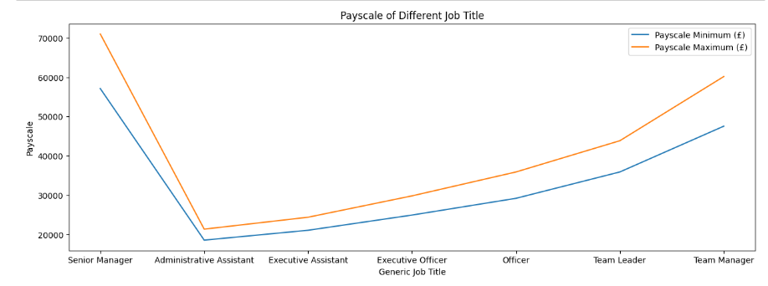

Figure 1

## Conclusion

In above Figure 1, the PayScale of the different job titles employees is plotted in the graph. The type of graph that is used in figure 1 plotting is the Line Plot. The plotting is done in the multiple variables, the variable given in the dataset is “Payscale Minimum” and “Payscale Maximum”. After plotting the graph, we can see the Payscale to visualize which job title has the maximum and the minimum pay scale. According to this graph, we can easily find administrative assistants has the minimum pay scale(M, 2022).

# Plot 2

## Pie Graph

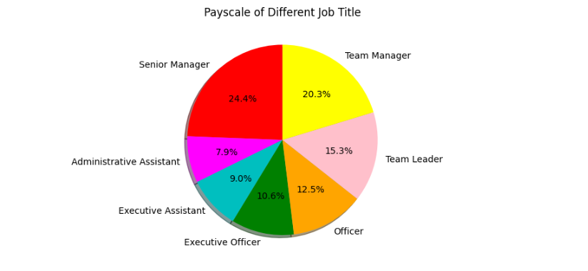

Figure 2

## Conclusion

In the above Figure 2, The pie chart graph is used for showing the data. The pie chart is very good to plot and it is easy to understand for all because it divides all the data into the percentage format. In the above dataset, there are minimum and maximum pay scales columns of the different job titles and that is plotted in the graph. The graph shows the percentage of the pay scale of the senior Manager is 24.4%, it higher than all the job titles and the minimum pay scale is for the Administrative Assistant job role which is in 7.9% only. So, this plotting technique is more suitable for plotting the data to understand(Madan, 2022).

# Plot 3

## Bar Graph

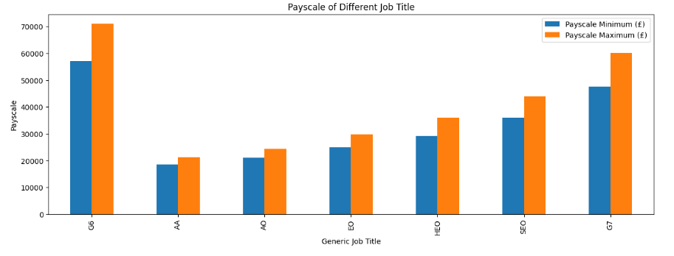

Figure 3

## Conclusion

In the above graph, I use the bar graph to plot the data of the above dataset. The dataset has two types of salary 1st one is the minimum Payscale of the employee and the 2nd one is the maximum Payscale of the employee. I select this graph because it plots both columns’ data in this graph. The bar Payscale of the employee of a plot on the basis of the employee group column.

# Reference

M, R. (2022) *How to display a plot in python using Matplotlib*. ActiveState. [Online] [Accessed on November 9, 2022]https://www.activestate.com/resources/quick-reads/how-to-display-a-plot-in-python/.

Madan, K. (2022) *Matplotlib Pie Chart*. Scaler Topics. [Online] [Accessed on November 9, 2022]https://www.scaler.com/topics/matplotlib/matplotlib-pie-chart/.