

Experiment-:1

Q1=Write a PL/SQL code to accept the value of A, B & C display which is greater.

Code-:

DECLARE

a NUMBER := 10;

b NUMBER := 25;

c NUMBER := 15;

BEGIN

IF a > b AND a > c THEN

DBMS_OUTPUT.PUT_LINE('A is greatest: ' || a);

ELSIF b > a AND b > c THEN

DBMS_OUTPUT.PUT_LINE('B is greatest: ' || b);

ELSIF c > a AND c > b THEN

DBMS_OUTPUT.PUT_LINE('C is greatest: ' || c);

ELSE

DBMS_OUTPUT.PUT_LINE('Two or more numbers are equal and greatest.');

END IF;

END;

/

Output-:

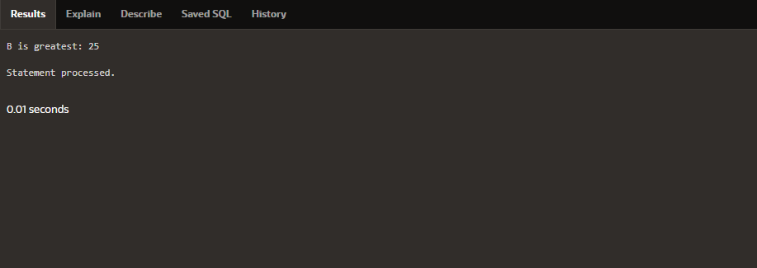

Q2=Using PL/SQL Statements create a simple loop that display message “Welcome to PL/SQL Programming” 20 times.

Code-:

BEGIN

FOR i IN 1..20 LOOP

DBMS_OUTPUT.PUT_LINE('Welcome to PL/SQL Programming');

END LOOP;

END;

/

Output-:

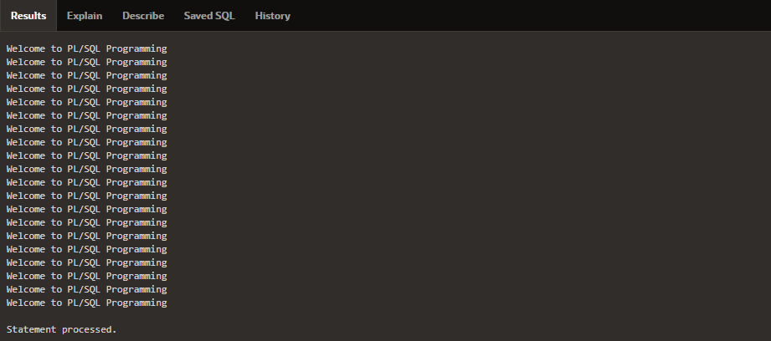

Q3=Write a PL/SQL code block to find the factorial of a number.

Code-:

DECLARE

n NUMBER := 5;

fact NUMBER := 1;

BEGIN

IF n < 0 THEN

DBMS_OUTPUT.PUT_LINE('Factorial not defined for negative numbers');

ELSE

FOR i IN 1..n LOOP

fact := fact * i;

END LOOP;

DBMS_OUTPUT.PUT_LINE('Factorial of ' || n || ' is ' || fact);

END IF;

END;

/

Output-:

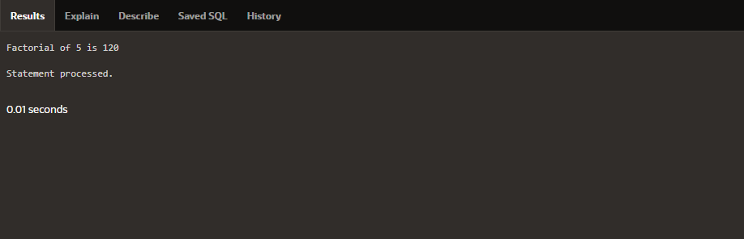

Q4=Write a PL/SQL program to generate Fibonacci series.

Code-:

DECLARE

n NUMBER := 10;

a NUMBER := 0;

b NUMBER := 1;

c NUMBER;

BEGIN

IF n <= 0 THEN

DBMS_OUTPUT.PUT_LINE('n must be positive');

ELSIF n = 1 THEN

DBMS_OUTPUT.PUT_LINE(a);

ELSE

DBMS_OUTPUT.PUT_LINE(a);

DBMS_OUTPUT.PUT_LINE(b);

FOR i IN 3..n LOOP

c := a + b;

DBMS_OUTPUT.PUT_LINE(c);

a := b;

b := c;

END LOOP;

END IF;

END;

/

Output-:

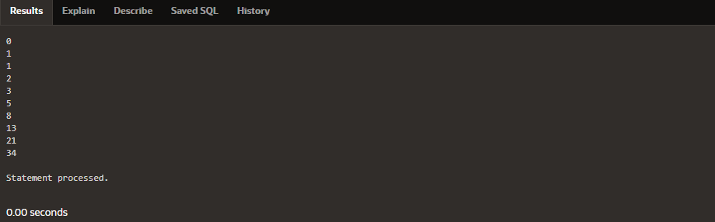

Q5=Write a PL/SQL code to fund the sum of first N numbers.

Code-:

DECLARE

n NUMBER := 10;

s NUMBER := 0;

BEGIN

FOR i IN 1..n LOOP

s := s + i;

END LOOP;

DBMS_OUTPUT.PUT_LINE('Sum of first ' || n || ' numbers is ' || s);

END;

/

Output-:

