**Usecase Diagram**

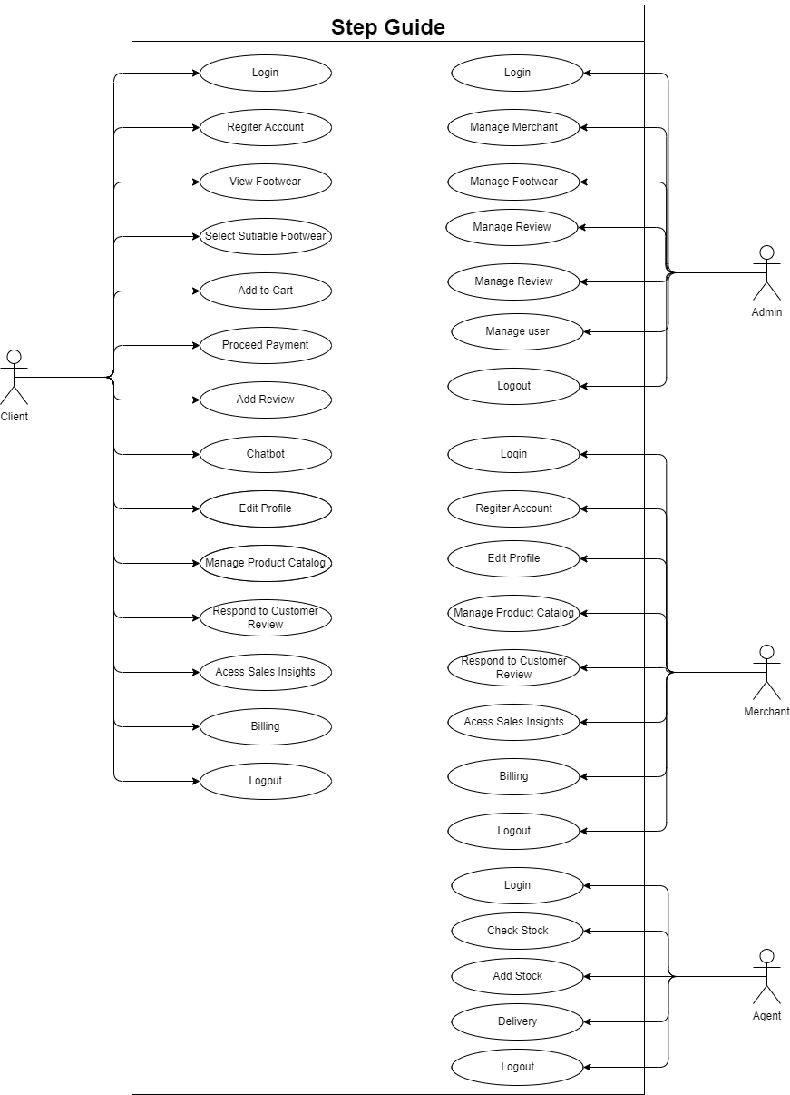

**Sequence diagram**

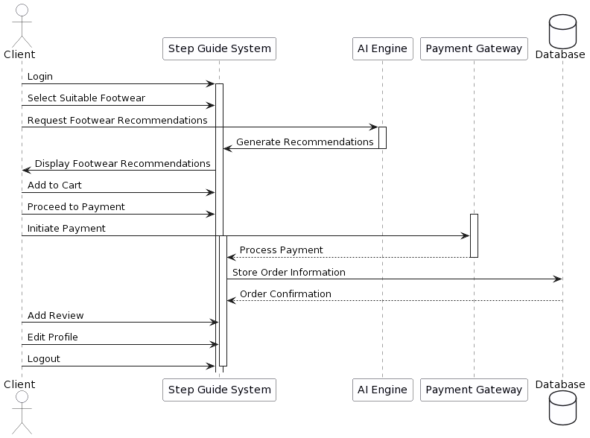

**State Diagram**

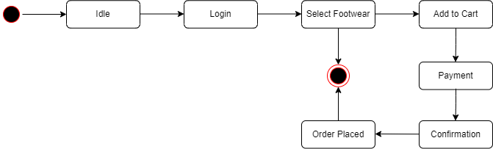

## Activity Diagram

## 

**Class Diagram**

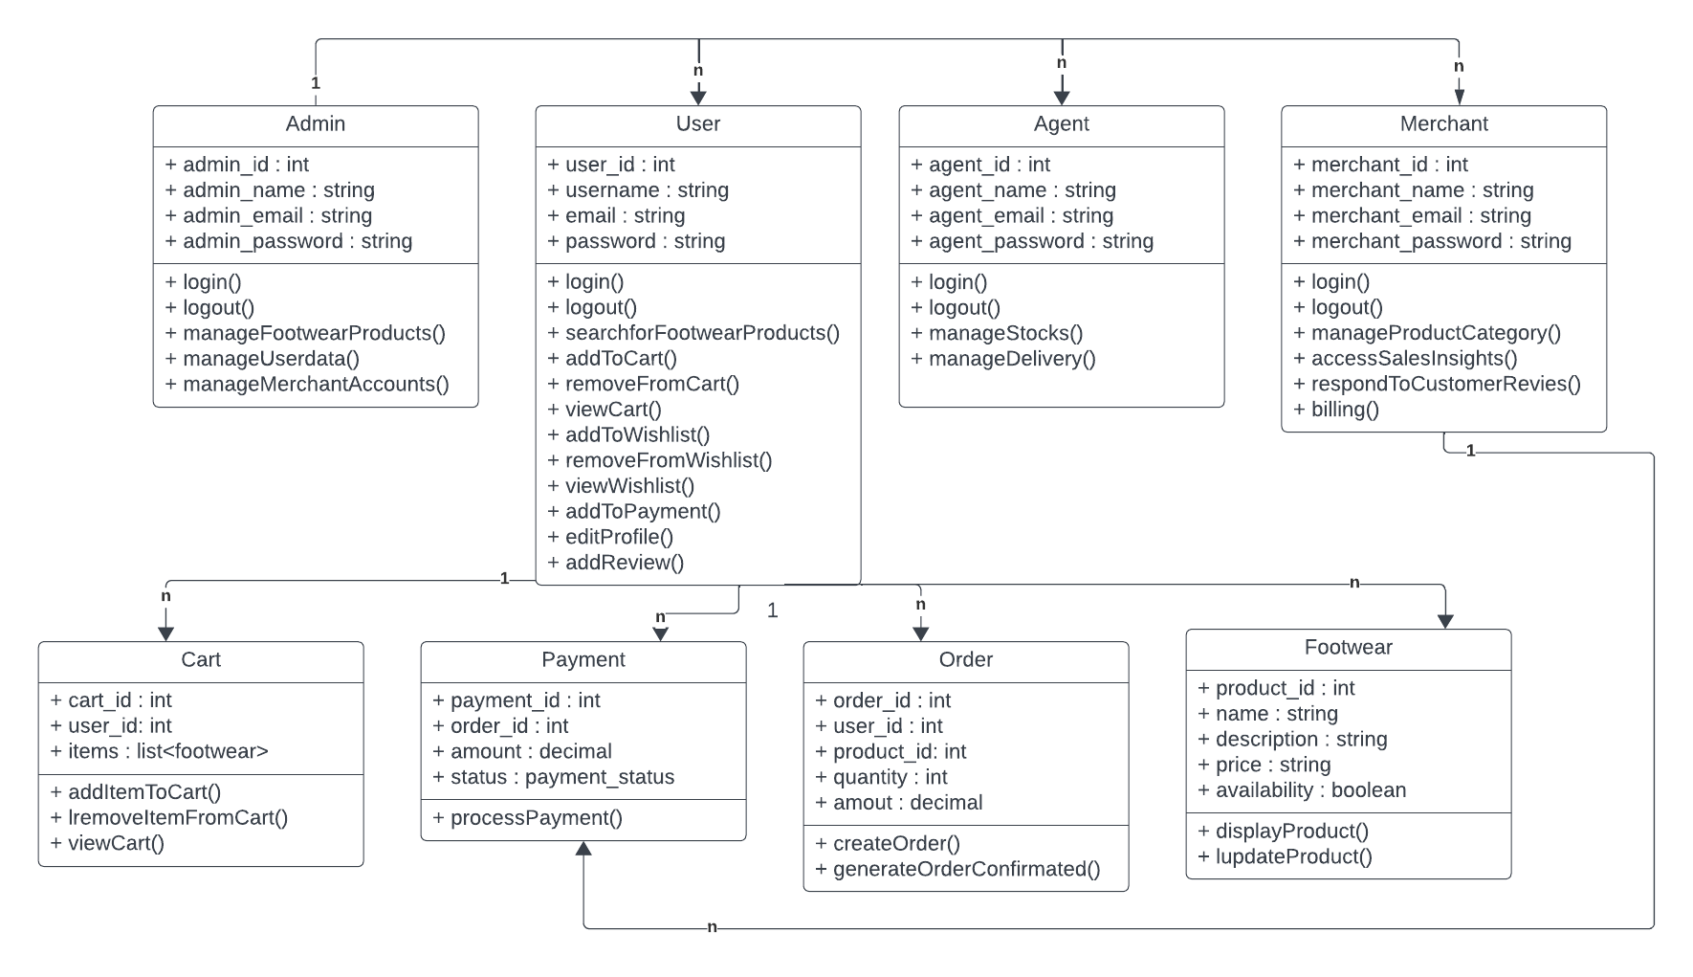

**Object Diagram**

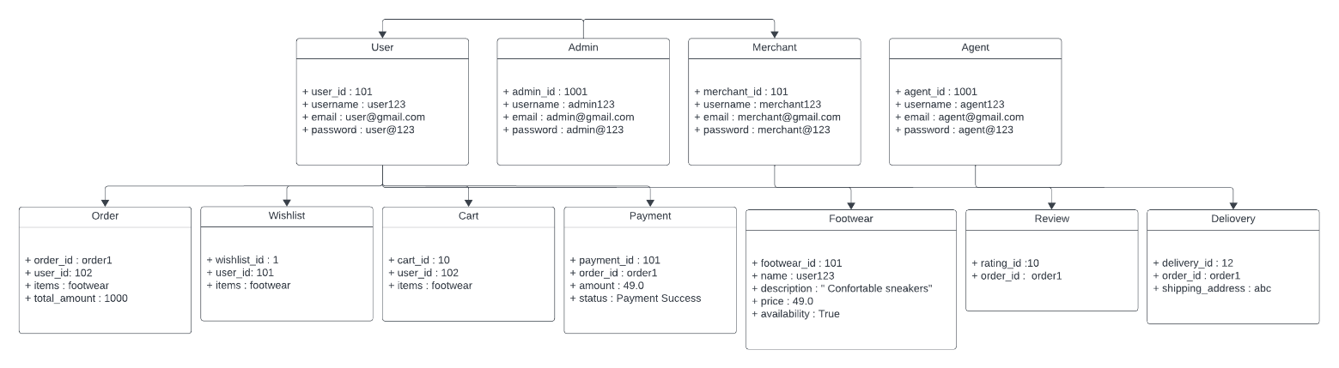

**Deployment Diagram**

