**SYNOPSIS ON**

**“CAMPUS CODE NEXUS”**

Submitted in

Partial Fulfilment of requirements for the Award of Degree of

Bachelor of Technology

*In*

Computer Science and Engineering

By

**(Project Id: 25_CS_4B_05 )**

**Akshat Nigam (2101640100028)**

**Akhil Tiwari (2101640100026)**

**Adit Srivastava (2101640100014)**

**Adarsh Tandon (2101640100013)**

**Alok Sachan (2101640100031)**

Under the supervision of

**Mr. Kumar Saurabh**

**(Assistant Professor)**



**Pranveer Singh Institute of Technology**.

Kanpur - Agra - Delhi National Highway - 19 Bhauti -Kanpur - 209305.

(Affiliated to Dr. A.P.J. Abdul Kalam Technical University)

1. **Introduction**

## In today's fast-paced software development environment, the role of Online Code Editors (OCEs) has become increasingly vital, transforming how teams collaborate on coding projects. Traditional local Integrated Development Environments (IDEs) often present challenges in facilitating seamless collaboration due to their complex setups and limited accessibility. In contrast, OCEs provide a web-based platform that can be accessed from any device, enabling real-time collaboration among geographically dispersed teams. This capability is particularly important in the context of the growing trend toward remote work and the global nature of development teams.

## Our project seeks to revolutionize collaborative coding by developing an OCE that harnesses the latest web development technologies. We aim to create a user-friendly interface, implement real-time collaboration features, integrate version control with Git, and incorporate principles of compiler design for enhanced code analysis and execution. The technologies we are employing include HTML, CSS, JavaScript, and React for frontend development, along with Node.js and Express for backend functionality. WebSocket technology will ensure robust and scalable real-time communication, laying a solid foundation for our platform.

Learning programming languages has become an essential skill in the digital age, and our platform is designed to support both beginners and experienced coders. Programming involves activities such as analysis, algorithm development, verification of requirements, and implementation of code in a target language. While coding can be challenging, it is a skill that improves with time and practice. As the marketplace shifts increasingly toward digital commerce, coding knowledge is becoming crucial for professionals across various industries. Whether for personal growth, career advancement, or managing a younger workforce, the ability to contribute to software development is invaluable. Our OCE platform offers a unified environment where students and professionals alike can learn, practice, and improve their coding skills. By providing a single platform for coding, we aim to standardize the learning experience and ensure that users have access to the tools they need to succeed in today's technology-driven world.

1. **Project Objective**

The primary objective of the **Campus Code Nexus** project is to create a cutting-edge and intuitive online coding platform designed to enhance collaborative coding practices within diverse development teams. Named **Campus Code Nexus**, our goal is to transform the coding experience for students, developers, and educators by providing a unified, web-based environment that fosters real-time collaboration, streamlined version control, and advanced code analysis. This platform aims to improve coding efficiency, accessibility, and learning outcomes, ultimately reshaping how coding is taught and practiced in both educational and professional settings.

1. **Develop a User-Friendly Interface:** Design and implement an intuitive and accessible interface that simplifies the coding experience for users of all skill levels, from beginners to advanced developers.
2. **Implement Real-Time Collaboration Features:** Enable multiple users to collaborate on code in real-time, allowing geographically dispersed teams to work together seamlessly. This includes features like live editing, chat functionality, and collaborative debugging.
3. **Integrate Version Control with Git:** Incorporate Git-based version control into the platform, allowing users to track changes, manage branches, and collaborate on code efficiently. This integration will also support seamless syncing with remote repositories.
4. **Enhance Code Analysis and Execution:** Utilize principles of compiler design to provide advanced code analysis, error detection, and optimization tools. The platform will support the execution of code in multiple programming languages, offering users immediate feedback on their work.
5. **Ensure Robust Real-Time Communication:** Implement WebSocket technology to support real-time communication between users, ensuring low latency and high reliability.
6. **Build a Scalable and Secure Backend:** Develop a backend infrastructure using Node.js and Express that is scalable, secure, and capable of handling a large number of simultaneous users. This will involve ensuring data integrity, user authentication, and protection against potential security threats.
7. **Support Continuous Learning and Practice:** Provide features that encourage continuous learning and practice, such as coding challenges, tutorials, and progress tracking. The platform will be designed to support users in developing their skills over time.
8. **Create a Unified Learning Environment:** Offer a single platform where students and professionals can learn, practice, and develop their coding skills, eliminating the need to use multiple platforms. This will promote uniformity in the learning process and provide a consistent user experience.
9. **Feasibility Study:**

The feasibility study for Campus Code Nexus, an innovative online coding platform designed to enhance collaborative coding practices, aims to evaluate the practicality and viability of implementing this solution. This study will encompass several critical aspects, including technical feasibility, economic viability, operational feasibility, and legal considerations, to assess the project's likelihood of success and its potential impact on students, educators, and developers within the coding community.

**3.1.** **Technical Feasibility**:

**3.1.** **Technology Stack:** The project utilizes a robust technology stack, including HTML, CSS, JavaScript, React.js for frontend development, and Node.js with Express.js for backend services. WebSocket will be used for real-time communication, ensuring the platform's responsiveness and scalability**.**   
  
**3.1.2 Development Tools:** The development process will employ Visual Studio Code, Git and GitHub for version control, and Postman for API testing. These tools are widely used and well-supported, which enhances the feasibility of the project.

**3.1.3. Integration Capabilities:** Integrating version control with Git and incorporating compiler design principles for code analysis is technically feasible with existing libraries and APIs, such as JDoodle or Compiler Explorer. Real-time collaborative features will be supported by WebSocket technology.

**3.2. Operational Feasibility:**

**3.2.1.** **User Interface:** The design aims to be user-friendly and accessible, catering to a wide range of users, from beginners to advanced programmers. The interface will be intuitive, facilitating easy navigation and use of features.

**3.2.2.Real-Time Collaboration:** Implementing real-time collaboration features is operationally feasible with WebSocket technology, which supports live editing, chat functionality, and shared coding sessions.

**3.**2.3 **Version Control:** Integrating Git-based version control will streamline code management and collaboration, which is a common and well-supported practice in software development.

**3.3.Economic Feasibility:**

**3.3.1.Cost Estimation:** The costs associated with developing the Campus Code Nexus platform include software development, infrastructure setup, and maintenance. Utilizing open-source technologies and cloud-based services can help minimize initial costs.  
  
**3.3.2. Funding and Budget:** An initial budget estimate will be prepared to cover development, testing, and deployment phases. Potential funding sources could include educational grants, institutional support, or partnerships with tech companies.

**3.3.3 Cost-Benefit Analysis:** The benefits of the platform, such as enhanced learning outcomes, improved collaboration, and streamlined coding practices, are expected to outweigh the development and operational costs. A detailed cost-benefit analysis will be conducted to validate this assumption.

**3.4.Schedule Feasibility:**

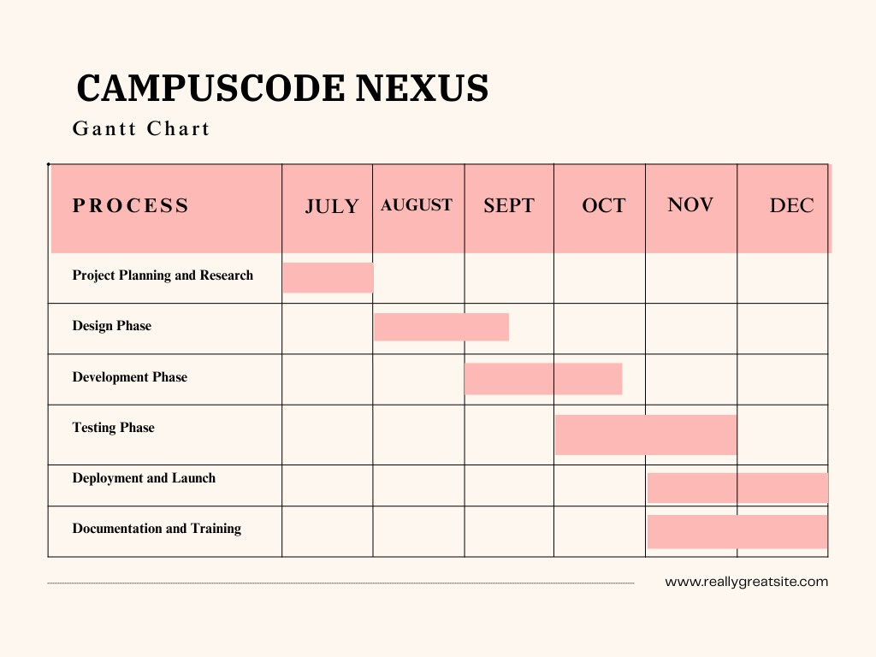

**3.5. Legal Feasibility:**

**3.5.1. Compliance**: The platform will adhere to legal requirements regarding data privacy and security. Measures will be implemented to ensure compliance with regulations such as GDPR or CCPA.  
 **3.5.2. Intellectual Property Rights:** The project will ensure that any third-party libraries or APIs used are appropriately licensed. Intellectual property rights for custom-developed features will be clearly defined.

## 4. Methodology/ Planning of work

**4.1. Project Planning and Requirement Analysis:**

**Define Objectives:** Establish clear project objectives, including user needs, desired features, and functionality for the Campus Code Nexus platform.

**Stakeholder Consultation**: Engage with stakeholders, such as students, educators, and developers, to gather requirements and expectations. Conduct surveys, interviews, and focus groups to ensure the platform meets user needs.

**Feasibility Assessment:** Perform a feasibility study to evaluate the technical, economic, operational, and legal aspects of the project.

**4.2 System Design:**

**Architecture Design:** Develop the overall system architecture, including frontend, backend, and database components. Define the interaction between different system modules and services.

**UI/UX Design:** Create wireframes and prototypes for the user interface. Focus on designing a user-friendly and accessible interface that enhances user experience**.**

**Feature Specification**: Detail the features to be implemented, such as real-time collaboration, version control integration, and code analysis tools. Define user stories and functional requirements.

**4.3 Development:**

**Frontend Development**: Utilize HTML, CSS, JavaScript, and React.js to build the user interface and implement frontend functionality.

**Backend Development:** Develop the backend using Node.js and Express.js. Implement API endpoints, user authentication, and database interactions.

**Real-Time Communication:** Integrate WebSocket technology to enable real-time collaboration features, such as live code editing and chat functionality.

**4.4 Testing:   
Unit Testing:** Conduct unit tests for individual components to ensure they function correctly. Use testing frameworks compatible with the technologies used (e.g., Jest for JavaScript).

**Integration Testing:** Test the integration of frontend and backend components, as well as third-party services and APIs.

**User Testing:** Perform usability testing with real users to gather feedback and identify areas for improvement. Conduct both alpha and beta testing phases.

**Performance Testing:** Assess the platform's performance under various conditions, including high user loads, to ensure scalability and reliability.

**4.5 Deployment:**

**Infrastructure Setup:** Configure the deployment environment, including servers, databases, and cloud services. Ensure the infrastructure can support the expected user load and provide adequate security measures.

**Continuous Integration/Continuous Deployment (CI/CD**): Implement CI/CD pipelines to automate the deployment process and ensure that new features and updates are delivered efficiently.

**4.6 Maintenance and Support:**

**Monitoring:** Continuously monitor the platform for performance issues, security vulnerabilities, and user feedback. Implement logging and alerting mechanisms to detect and address issues promptly.

**Updates and Enhancements**: Regularly update the platform with new features, bug fixes, and performance improvements based on user feedback and technological advancements.

**User Support:** Provide ongoing support to users through documentation, tutorials, and helpdesk services.

**4.7 Evaluation and Reporting:**

**Impact Assessment:** Evaluate the impact of the platform on users' coding practices and learning outcomes. Gather feedback to measure the success of the project and identify areas for improvement.

**Project Reporting:** Document the development process, challenges faced, and solutions implemented. Prepare a final report summarizing the project's achievements and lessons learned.

By following this methodology, the Campus Code Nexus project aims to develop a robust, user-centric coding platform that enhances collaborative coding practices and meets the needs of its users.

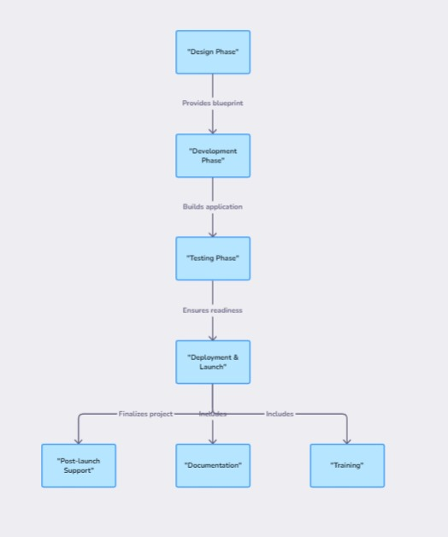

**5. Tools/Technology Used:**

* 1. **Minimum Hardware Requirements**
* **Processor:** Intel Core i3 or higher
* **Hard Disk:** 10 GB available space
* **Memory:** 4 GB RAM
* **OS:** Windows 10 or higher / macOS / Linux

**Minimum Software Requirements**

* **Frontend:**
  + HTML5
  + CSS3
  + JavaScript
  + React.js
* **Backend:**
  + Node.js
  + Express.js
* **Database:**
  + MongoDB or PostgreSQL
* **Compiler Integration:**
  + API services like JDoodle or Compiler Explorer
* **Code Conversion:**
  + Abstract Syntax Tree (AST) manipulation libraries
  + Custom parsers
* **Development Tools:**
  + Visual Studio Code (or any code editor)
  + Git and GitHub (for version control)
  + Postman (for API testing)

**References: [IEEE format]:**

**Online Compilers and Integrated Development Environments (IDEs):**

* *Davis, R. (2020). "Online Compilers and IDEs: Benefits and Challenges." Journal of Computer Science Education, 15(2), 101-115.*  
  This article discusses the advantages and challenges of using online compilers and IDEs in educational settings, highlighting their impact on learning and teaching programming.

**Automated Code Conversion:**

* *Gonzalez, M., & Rivera, J. (2019). "Automated Code Translation and Its Impact on Learning Programming Languages." International Conference on Software Engineering Education, 85-96.*  
  This paper explores the use of automated code translation tools and their effectiveness in helping students transition between different programming languages.

**User-Friendly Programming Tools for Education:**

* *Smith, A. J., & Lee, K. H. (2021). "Designing User-Friendly Tools for Programming Education." Educational Technology Research and Development, 69(4), 617-634.*  
  This research focuses on the design and implementation of user-friendly programming tools and their role in enhancing the educational experience for students.

**Challenges in Programming Education:**

* *Jones, R., & Thomas, L. (2022). "Addressing Common Challenges in Programming Education: A Review of Recent Advances." Computers in Education Journal, 32(1), 45-60.*  
  This review article examines common challenges faced in programming education and discusses recent advancements in addressing these issues.

**Improving Programming Learning Experiences:**

* *Martinez, P., & Hernandez, T. (2023). "Enhancing Programming Learning Experiences through Integrated Platforms." Journal of Educational Technology and Society, 26(3), 77-89.*  
  This article discusses various strategies and technologies for improving the programming learning experience, including the use of integrated platforms.