Experiment 1: Case Study
ROLL NO:2420030496
Problem Statement: Choose a real-world case study such as an E-Commerce System or College ERP System, create user stories, select an appropriate software development process model, identify a suitable programming language, and propose an implementation and evaluation strategy.
Real-World case study a College ERP Management System
1. Functional Requirements
Student
- Secure registration and login
- Online course registration
- View class timetable
- Attendance tracking
- View examination results
- Online fee payment
- Download study materials
Faculty
- Secure login
- Attendance management
- Upload study materials
- Upload internal marks
- View timetable
Administrator
- Secure login
- User management
- Academic records management
- Report generation
- Course & timetable management
2. User Stories
User ID | User Story | Priority
US-01 | As a student, I want to log in securely so that I can access my academic information. | High
US-02 | As a student, I want to register for courses so that I can enroll in the current semester. | High
US-03 | As a student, I want to view my attendance so that I can track my eligibility for exams. | High
US-04 | As a student, I want to view my examination results. | High
US-05 | As a student, I want to pay my fees online. | Medium
US-06 | As a faculty member, I want to log in securely. | High
US-07 | As a faculty member, I want to mark student attendance. | High
US-08 | As a faculty member, I want to upload study materials. | Medium
US-09 | As a faculty member, I want to upload internal marks. | High
US-10 | As an administrator, I want to manage user accounts. | High
US-11 | As an administrator, I want to manage academic records. | High
US-12 | As an administrator, I want to generate reports. | Medium

3. Selected Software Development Process Model
Agile Scrum
Reason for Selection
- Requirements change frequently.
- Continuous feedback from students, faculty, and administration.
- Incremental feature delivery.
- Faster development cycles.
- Easy bug fixing.
- Suitable for web-based applications.
Sprint Plan
Sprint | Features
Sprint 1 | Authentication (Login & Roles)
Sprint 2 | Student Module
Sprint 3 | Faculty Module
Sprint 4 | Attendance
Sprint 5 | Examination
Sprint 6 | Administration
Sprint 7 | Testing & Deployment

4. Programming Language Selection
Backend
- Java (Spring Boot)
Reasons
- Secure
- Scalable
- Enterprise-level applications
- REST API support
- Excellent database connectivity
Frontend
- HTML5
- CSS3
- JavaScript
- React.js
Database
- MySQL
Other Technologies
- REST API
- JWT Authentication
- Razorpay/Paytm Payment Gateway
- Git
- Docker
- AWS Cloud
5. System Architecture
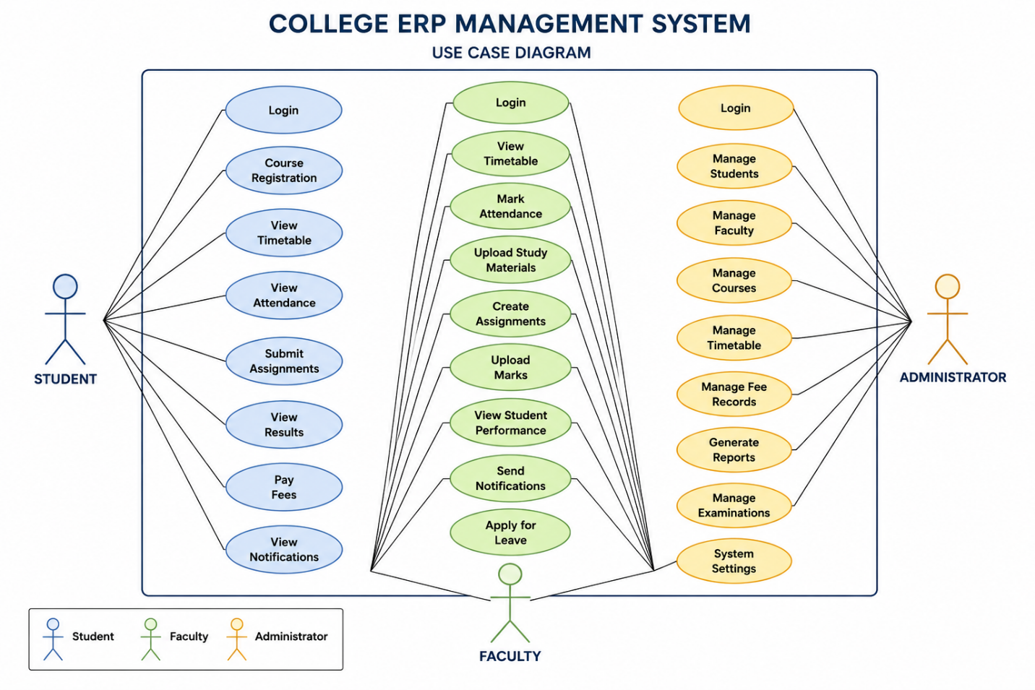

6. Implementation Strategy
Phase 1 – Requirement Analysis
- Gather requirements from students, faculty, and administration.
- Create Software Requirement Specification (SRS).
- Prepare use case diagrams.
Phase 2 – System Design
- Design database schema.
- Design UI wireframes.
- Create UML diagrams.
- Develop system architecture.
Phase 3 – Development
- Implement user authentication.
- Develop student and faculty modules.
- Build attendance and examination modules.
- Build administrator dashboard.
Phase 4 – Testing
Unit Testing
- Login
- Registration
- Attendance marking
Integration Testing
- Attendance + Examination
- Fee Payment + Records
System Testing
- Complete application testing
User Acceptance Testing (UAT)
- Verify institutional requirements.
Phase 5 – Deployment
- Docker Container
- AWS EC2
- MySQL Database
- Nginx Web Server
7. Evaluation Strategy
Evaluation Parameter | Method
Functional Accuracy | Requirement verification
Performance | Load testing using JMeter
Security | Authentication and penetration testing
Reliability | Continuous monitoring
Usability | User feedback survey
Scalability | Concurrent user testing
Maintainability | Code review and documentation

8. Expected Outcomes
- Secure college ERP platform.
- Fast, self-service access for students.
- Reliable attendance and examination management.
- Accurate academic records.
- Secure online fee payments.
- Improved satisfaction for students, faculty, and administration.
- Scalable architecture for future enhancements.

