RetailIQ: An Adaptive Data Analytics Framework for Automated Dataset Profiling, Exploratory Analysis and Insight Recommendation
Veluru Maneesh Kumar Reddy
Department of Computer Science and Engineering (AI & ML), KLH University
Research Paper — RetailIQ

ABSTRACT
Retail analytics workflows commonly require users to manually inspect unfamiliar tabular data, determine suitable preprocessing operations, select analytical views, and decide whether supervised or unsupervised analysis is appropriate. This paper presents RetailIQ, an adaptive analytics framework designed to reduce that configuration burden through an integrated pipeline for data ingestion, dataset profiling, conservative cleaning, data-quality assessment, adaptive KPI and visualization generation, recommendation of next analytical steps, export, and an optional machine-learning evaluation layer. The framework uses semantic target detection and task inference to route datasets to classification, regression, or unsupervised analysis while avoiding automatic selection when evidence is weak. A reproducible research suite was evaluated on ten datasets comprising public benchmark datasets and clearly labeled synthetic retail-domain datasets. Supervised experiments used five repeats of five-fold cross-validation with preprocessing fitted within each training fold. Across the benchmark suite, automatic routing achieved 100% accuracy (10/10 datasets). Logistic Regression achieved the strongest weighted F1 on the Breast Cancer (0.9778), Wine (0.9843), Iris (0.9532), and synthetic retail churn (0.6793) datasets, while Random Forest achieved the highest F1 on Digits (0.9759). Linear Regression produced the lowest RMSE on Diabetes (54.93) and synthetic retail sales (4656.44). Friedman tests followed by Holm-corrected Wilcoxon comparisons identified statistically significant model differences on most supervised datasets. The results support the feasibility of a lightweight adaptive analytics workflow while also defining clear boundaries: the benchmark does not establish global model optimality, and quantitative validation of recommendation quality and data-quality detection remains future work.
Keywords: adaptive analytics; exploratory data analysis; data quality; visualization recommendation; machine learning; automated profiling; tabular data; retail analytics
1. INTRODUCTION
1.1 Background
Modern organizations increasingly work with tabular data originating from transactional systems, spreadsheets, exports, operational applications, and heterogeneous business sources. Before predictive modeling or decision support can begin, analysts must understand schema, missingness, duplicates, variable roles, distributions, relationships, and suitable visualization forms. Data quality is broader than simple accuracy and includes dimensions that affect how data consumers judge whether information is fit for use [1], while data cleaning is a recurring part of analytical and ETL workflows [2], [3].
1.2 Problem Statement
Most analytical workflows still place substantial responsibility on the analyst at the beginning of a project: identifying useful fields, selecting preprocessing operations, choosing visualizations, deciding whether a target exists, and determining the next analytical step. Existing research provides sophisticated solutions for individual components such as data cleaning, visualization recommendation, and automated exploratory analysis, but these approaches are often specialized. The research problem addressed in this work is therefore: how can a lightweight, transparent framework integrate early-stage profiling, conservative preprocessing, exploratory analytics, recommendation, and optional ML benchmarking so that unfamiliar tabular datasets can be analyzed with less manual configuration?
1.3 Research Gap
Prior data-quality research has developed systematic quality dimensions and increasingly advanced repair systems [1]–[8]. Visualization research has also produced systems for automatic presentation and recommendation [9]–[16]. More recent automated EDA systems extend automation toward insight generation [16]. However, these strands do not directly provide a single lightweight workflow that combines dataset profiling, conservative cleaning, quality diagnostics, adaptive analytical routing, interactive business analytics, next-step recommendations, and reproducible baseline evaluation. RetailIQ addresses this integration gap rather than proposing a new state-of-the-art predictive algorithm.
1.4 Research Objectives
- Design an adaptive workflow for unfamiliar tabular datasets.
- Implement profiling, conservative cleaning and data-quality diagnostics.
- Automatically select an analytical path using high-confidence target semantics and task inference.
- Provide interactive KPIs, visual analytics and next-step recommendations.
- Evaluate routing and analytical components using reproducible multi-dataset experiments and statistical comparisons.
1.5 Research Questions
- RQ1: Can RetailIQ correctly route benchmark datasets to classification, regression, or unsupervised analysis?
- RQ2: How do standard baseline models perform across heterogeneous benchmark and synthetic retail datasets when executed through the framework's preprocessing pipeline?
- RQ3: Are model-performance differences consistent enough to justify retaining multiple baselines rather than a single fixed model?
- RQ4: To what extent does the framework provide a practical, integrated workflow for early-stage analytics on unfamiliar tabular data?
1.6 Contributions
- An integrated adaptive analytics framework spanning ingestion, profiling, quality assessment, cleaning, EDA, visualization, recommendation and ML evaluation.
- A reproducible ten-dataset research suite with public and synthetic datasets clearly separated.
- A repeated cross-validation benchmark comparing standard supervised baselines plus unsupervised clustering metrics and non-parametric statistical tests.
- A practical interactive implementation that makes the analytical workflow inspectable rather than hiding decisions behind an opaque automated model.
1.7 Organization of the Paper
Section 2 reviews related work on data quality, cleaning, visualization recommendation and automated EDA. Section 3 describes the RetailIQ methodology and architecture. Section 4 presents the experimental design and metrics. Section 5 reports routing, supervised and unsupervised results. Section 6 discusses their interpretation and relation to prior work. Section 7 states limitations, and Section 8 concludes the study and identifies future work.
2. RELATED WORK
2.1 Data Quality and Data Cleaning
Wang and Strong established a broad, consumer-oriented view of data quality rather than reducing quality to accuracy alone [1]. Pipino et al. subsequently described quantitative data-quality assessment through multiple dimensions and measurement approaches [2]. Rahm and Do organized common cleaning problems and solution approaches and emphasized the role of cleaning in data integration and ETL [3]. Wrangler demonstrated interactive specification of data transformations [4]. BigDansing, SampleClean and ActiveClean investigated scalable or interactive approaches to cleaning and reliable analytics [5]–[7]. HoloClean further demonstrated probabilistic holistic repair using constraints, external knowledge and statistical properties [8].
2.2 Visualization and Visual Analytics
Automatic visualization has a long history in systems such as Polaris and Show Me, which reduced manual specification and supported rapid visual exploration [9], [10]. SEEDB introduced data-driven visualization recommendations based on interestingness, while Voyager supported mixed-initiative browsing of recommended views [11], [12]. DeepEye formalized visualization recognition, ranking and selection as computational problems [13]. Interactive visual analysis research emphasizes rapid filtering, exploration, and refinement rather than static charts alone [14]. These systems motivate RetailIQ's use of adaptive chart selection and interactive exploration.
2.3 Automated EDA and Insight Recommendation
Visualization recommendation has increasingly incorporated learning-based methods. Qian et al. proposed an end-to-end ML-based visualization recommendation system trained from datasets and associated visualizations [15]. More recent automated EDA research, including QUIS, explores question generation and iterative insight generation without requiring manually curated examples for each new dataset [16]. RetailIQ is intentionally more lightweight: it uses interpretable schema and analytical signals rather than a large learned recommendation model.
2.4 Machine Learning and Benchmarking
RetailIQ does not claim a new predictive learning algorithm. Instead, standard and interpretable baselines are included to evaluate whether the framework can consistently route and execute common analytical tasks. Logistic/linear models provide simple baselines, decision trees provide nonlinear rule-based baselines, and Random Forest provides an ensemble baseline [17], [21]. Scikit-learn provides the implementation environment used for preprocessing and model evaluation [18].
2.5 Critical Comparison
Representative prior work is compared in Table 1. The common pattern is specialization: data cleaning systems optimize repair, visualization systems optimize view selection, and automated EDA systems optimize insight generation. RetailIQ instead focuses on the integration of these early-stage analytical functions in a single transparent workflow.

Study | Focus | Contribution | Limitation
Wang & Strong (1996) | Data quality dimensions | Establishes multidimensional, consumer-oriented quality | Not an end-to-end analytics workflow
Rahm & Do (2000) | Data cleaning taxonomy | Frames cleaning as a major ETL problem | Cleaning-focused
Kandel et al. (2011) | Interactive transformation | Makes transformations accessible | Transformation-focused
Krishnan et al. (2016) | Interactive cleaning | Connects cleaning with modeling | Requires iterative interaction
Rekatsinas et al. (2017) | Probabilistic repair | Holistic repair using inference | More complex and repair-focused
Mackinlay et al. (2007) | Automatic presentation | Reduces manual visualization specification | Visualization-centric
Vartak et al. (2015) | Visualization recommendation | Ranks useful visualizations | Does not cover cleaning/routing
Wongsuphasawat et al. (2016) | Mixed-initiative browsing | Supports exploration of unseen data | Visualization recommendation focus
Luo et al. (2018) | Automatic visualization | Recognition, ranking and selection | Visualization selection focus
Qian et al. (2021) | ML visualization recommendation | Learns recommendations from data and views | Requires recommendation corpus
Manatkar et al. (2024) | Automated EDA | Question-guided insight generation | More computationally involved
Table 1. Critical comparison of representative prior work.

2.6 Research Gap (Summary)
The literature demonstrates substantial progress in individual automation tasks, but a practical gap remains between specialized research systems and a lightweight end-to-end workflow for unfamiliar tabular datasets. RetailIQ targets this gap through explicit schema profiling, conservative preprocessing, adaptive analytical routing, interactive exploration and reproducible baseline evaluation. The framework is designed as an orchestration layer rather than as a replacement for specialized state-of-the-art systems.
3. PROPOSED METHODOLOGY
3.1 Overall Framework
RetailIQ accepts CSV, XLSX and XLS tabular files and processes them through six connected stages: ingestion, profiling, quality assessment and conservative cleaning, adaptive analytics, visualization, and recommendation/export/ML analysis. The framework first characterizes rows, columns, data types, missing values, duplicates, uniqueness and possible analytical roles. Cleaning is intentionally conservative: column names are standardized, completely empty columns and exact duplicate rows are removed, whitespace is trimmed, and suitable date-like fields are converted. The framework logs cleaning actions so that transformations remain inspectable. Figure 1 summarizes the architecture.

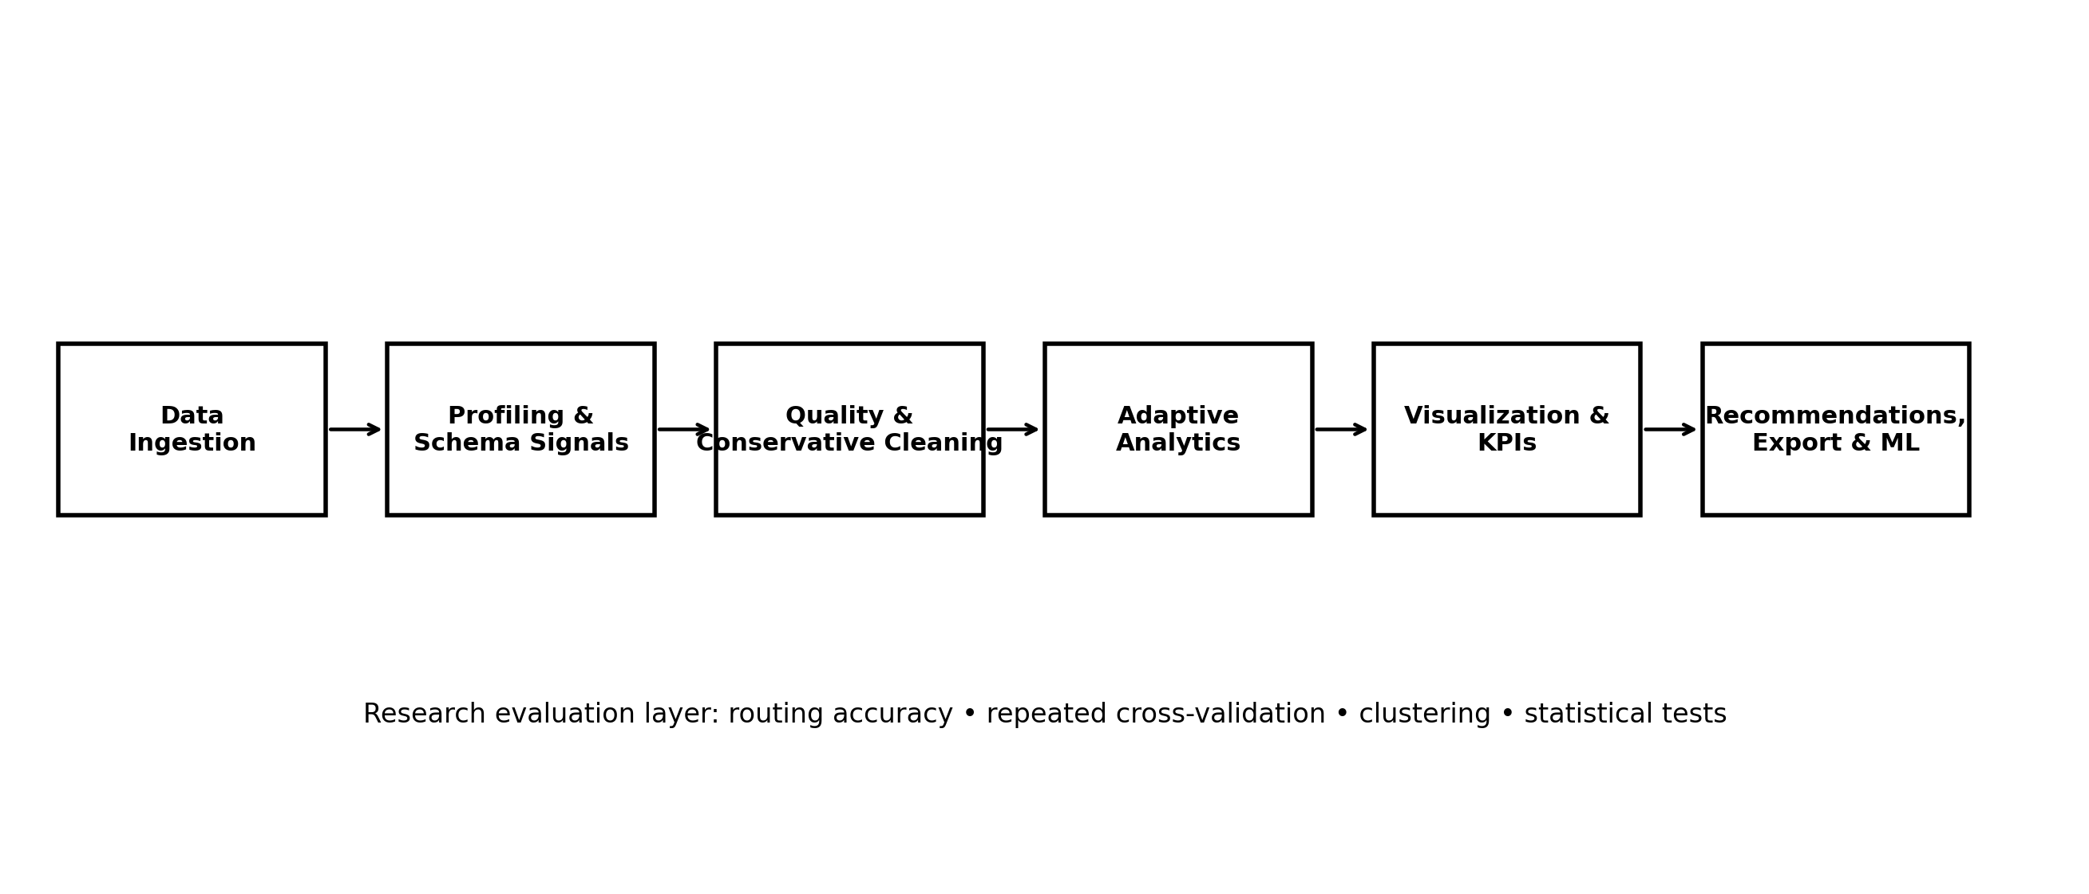
Fig. 1. Overall RetailIQ architecture and research evaluation layer.

3.2 Dataset(s)
The expanded research suite contains ten datasets. Eight are public benchmark datasets packaged through scikit-learn, including classification, regression and unsupervised variants. Two are synthetic retail-domain datasets generated deterministically with seed 42. The synthetic datasets are explicitly treated as validation data rather than external real-world evidence. Table 2 summarizes the datasets.

Dataset | Task | Rows | Cols. | Target | Evidence type
Breast Cancer | Classification | 569 | 31 | target | Public benchmark
Wine | Classification | 178 | 14 | target | Public benchmark
Iris | Classification | 150 | 5 | target | Public benchmark
Digits | Classification | 1797 | 65 | target | Public benchmark
Diabetes | Regression | 442 | 11 | target_value | Public benchmark
Iris (unsup.) | Unsupervised | 150 | 4 | — | Public benchmark
Wine (unsup.) | Unsupervised | 178 | 13 | — | Public benchmark
Digits (unsup.) | Unsupervised | 1797 | 64 | — | Public benchmark
Synthetic retail sales | Regression | 600 | 7 | sales | Synthetic
Synthetic retail churn | Classification | 600 | 8 | churn | Synthetic
Table 2. Research datasets used in the expanded evaluation suite.

3.3 Data Preprocessing
Numerical missing values are imputed with the training-fold median; categorical values use the most-frequent category; categorical features are one-hot encoded; and numerical scaling is applied where required by the model pipeline. Date-like fields may be expanded into calendar components. Constant, identifier-like and near-unique fields are excluded from ML feature matrices to reduce leakage and irrelevant noise. Importantly, preprocessing is fitted inside each training fold during research evaluation.
3.4 Exploratory Analysis and Feature Signals
RetailIQ calculates summary statistics and analytical signals before visualization. Numeric fields support distributions, relationships, trends and contribution analysis; categorical fields support breakdowns and filtering; date-like fields support temporal analysis. The adaptive KPI layer prioritizes common measure names such as sales, revenue, profit, amount, value and quantity, while falling back to available numeric measures when such names are absent. These rules are deliberately transparent.
3.5 Proposed Methods and Baselines
The framework itself is the proposed method. Its ML evaluation layer uses Logistic Regression, Decision Tree and Random Forest for classification, and Linear Regression, Decision Tree Regressor and Random Forest Regressor for regression. K-Means is used for unsupervised clustering with K from 2 through 6. The algorithms are established baselines rather than novel models.
3.6 Algorithmic / Mathematical Formulation
Let D denote an input table and S(D) its profiled schema. The routing function is R(D) = classification if a high-confidence categorical/binary target is identified, R(D) = regression if a high-confidence continuous numerical target is identified, and R(D) = unsupervised otherwise. For classification, weighted F1 is F1w = Σk (nk/N)·F1k. For regression, RMSE = sqrt[(1/N)·Σi(yi − ŷi)²] and MAE = (1/N)·Σi|yi − ŷi|. Clustering quality is assessed using silhouette score, where larger values indicate better separation and cohesion [19]. Statistical comparison uses the Friedman test across repeated folds followed, when significant, by pairwise Wilcoxon signed-rank tests with Holm correction.
4. EXPERIMENTAL SETUP
4.1 Hardware and Software
The system was implemented in Python using Pandas and NumPy for data processing, Streamlit for the interactive application, Plotly for interactive visualization, OpenPyXL/XLRD for spreadsheet ingestion, and scikit-learn/SciPy for the research evaluation layer. The experiments are designed for ordinary development hardware and do not require specialized GPU resources.
4.2 Dataset Split / Design
Supervised evaluation uses five repeats of five-fold cross-validation. Classification uses shuffled stratified folds, while regression uses shuffled K-folds. This produces 25 fold-level observations per dataset/model configuration. Unsupervised datasets are evaluated separately across K=2,3,4,5,6. The benchmark contains five classification datasets, two regression datasets, and three unsupervised datasets.
4.3 Hyperparameter Configuration
Models are used as transparent baselines with restrained configuration. Logistic Regression and Linear Regression use standard library defaults with deterministic random state where applicable. Decision Trees use maximum depth 8. Random Forest classifiers and regressors use 100 trees in the expanded research suite and random state 42. K-Means is evaluated for K=2–6 with deterministic random state 42. No extensive hyperparameter search is performed because the objective is framework benchmarking rather than maximizing each model's standalone performance.
4.4 Validation Strategy
All preprocessing transformations used by supervised models are learned inside each training fold through a pipeline. The same fixed random seed is used throughout the benchmark. The routing result is compared with the known task label in the dataset manifest. This design tests reproducibility and routing correctness while limiting information leakage.
4.5 Evaluation Metrics
- Classification: accuracy, weighted precision, weighted recall and weighted F1 (primary comparison metric); higher values are preferable.
- Regression: MAE, RMSE (primary) and R²; lower MAE/RMSE and higher R² are preferable.
- Clustering: silhouette, Davies–Bouldin, Calinski–Harabasz, inertia and runtime; higher silhouette/Calinski–Harabasz and lower Davies–Bouldin are preferable.
4.6 Statistical Testing
Friedman tests are used to test whether repeated model ranks differ across the fold-level observations for each supervised dataset. When the omnibus test is significant, pairwise Wilcoxon signed-rank tests are performed and Holm-adjusted p-values are reported. This non-parametric design avoids relying on normality assumptions for repeated benchmark scores.
5. RESULTS
The results below report confirmed empirical outcomes from the completed ten-dataset research suite rather than anticipated or targeted values.
5.1 Overall Performance
The expanded research suite completed on ten datasets with five repeats and five folds. Automatic routing achieved 100% accuracy (10/10), correctly identifying classification, regression and unsupervised tasks. This result demonstrates successful routing on the selected benchmark suite, but it is not interpreted as a universal accuracy guarantee.
5.2 Classification Results
Table 3 summarizes weighted F1 performance. Logistic Regression was strongest on Breast Cancer (0.9778), Wine (0.9843), Iris (0.9532) and synthetic retail churn (0.6793). Random Forest was strongest on Digits (0.9759). Decision Tree was the lowest-performing baseline on all five classification datasets. The variation illustrates why a framework should expose multiple baseline paths rather than assume that one model dominates across all datasets.

Dataset | Model | Weighted F1 | Accuracy
Breast Cancer | Decision Tree | 0.9305 | 0.9307
Breast Cancer | Logistic Regression | 0.9778 | 0.9779
Breast Cancer | Random Forest | 0.9562 | 0.9564
Wine | Decision Tree | 0.8894 | 0.8907
Wine | Logistic Regression | 0.9843 | 0.9842
Wine | Random Forest | 0.9752 | 0.9752
Iris | Decision Tree | 0.9384 | 0.9387
Iris | Logistic Regression | 0.9532 | 0.9533
Iris | Random Forest | 0.9532 | 0.9533
Digits | Decision Tree | 0.8390 | 0.8384
Digits | Logistic Regression | 0.9699 | 0.9698
Digits | Random Forest | 0.9759 | 0.9760
Synthetic Retail Churn | Decision Tree | 0.5791 | 0.5803
Synthetic Retail Churn | Logistic Regression | 0.6793 | 0.6803
Synthetic Retail Churn | Random Forest | 0.6210 | 0.6220
Table 3. Classification benchmark results.
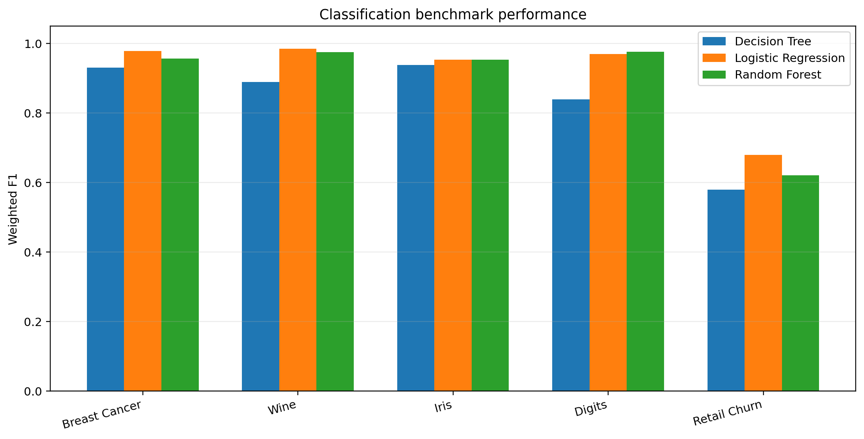
Fig. 2. Weighted F1 for the five classification datasets.

5.3 Regression Results
Linear Regression achieved the lowest RMSE on both regression datasets: 54.93 on Diabetes and 4656.44 on synthetic retail sales. Random Forest was second on both, while Decision Tree produced the highest RMSE. On Diabetes, Linear Regression achieved R²=0.4803; on synthetic retail sales, R²=0.5019. These results are benchmark observations and not evidence that linear models are universally superior.

Dataset | Model | RMSE | MAE | R²
Diabetes | Decision Tree | 76.73 | 59.86 | -0.0171
Diabetes | Linear Regression | 54.93 | 44.52 | 0.4803
Diabetes | Random Forest | 58.34 | 47.47 | 0.4148
Synthetic Retail Sales | Decision Tree | 6133.44 | 4917.14 | 0.1315
Synthetic Retail Sales | Linear Regression | 4656.44 | 3729.67 | 0.5019
Synthetic Retail Sales | Random Forest | 4955.16 | 3986.93 | 0.4354
Table 4. Regression benchmark results.
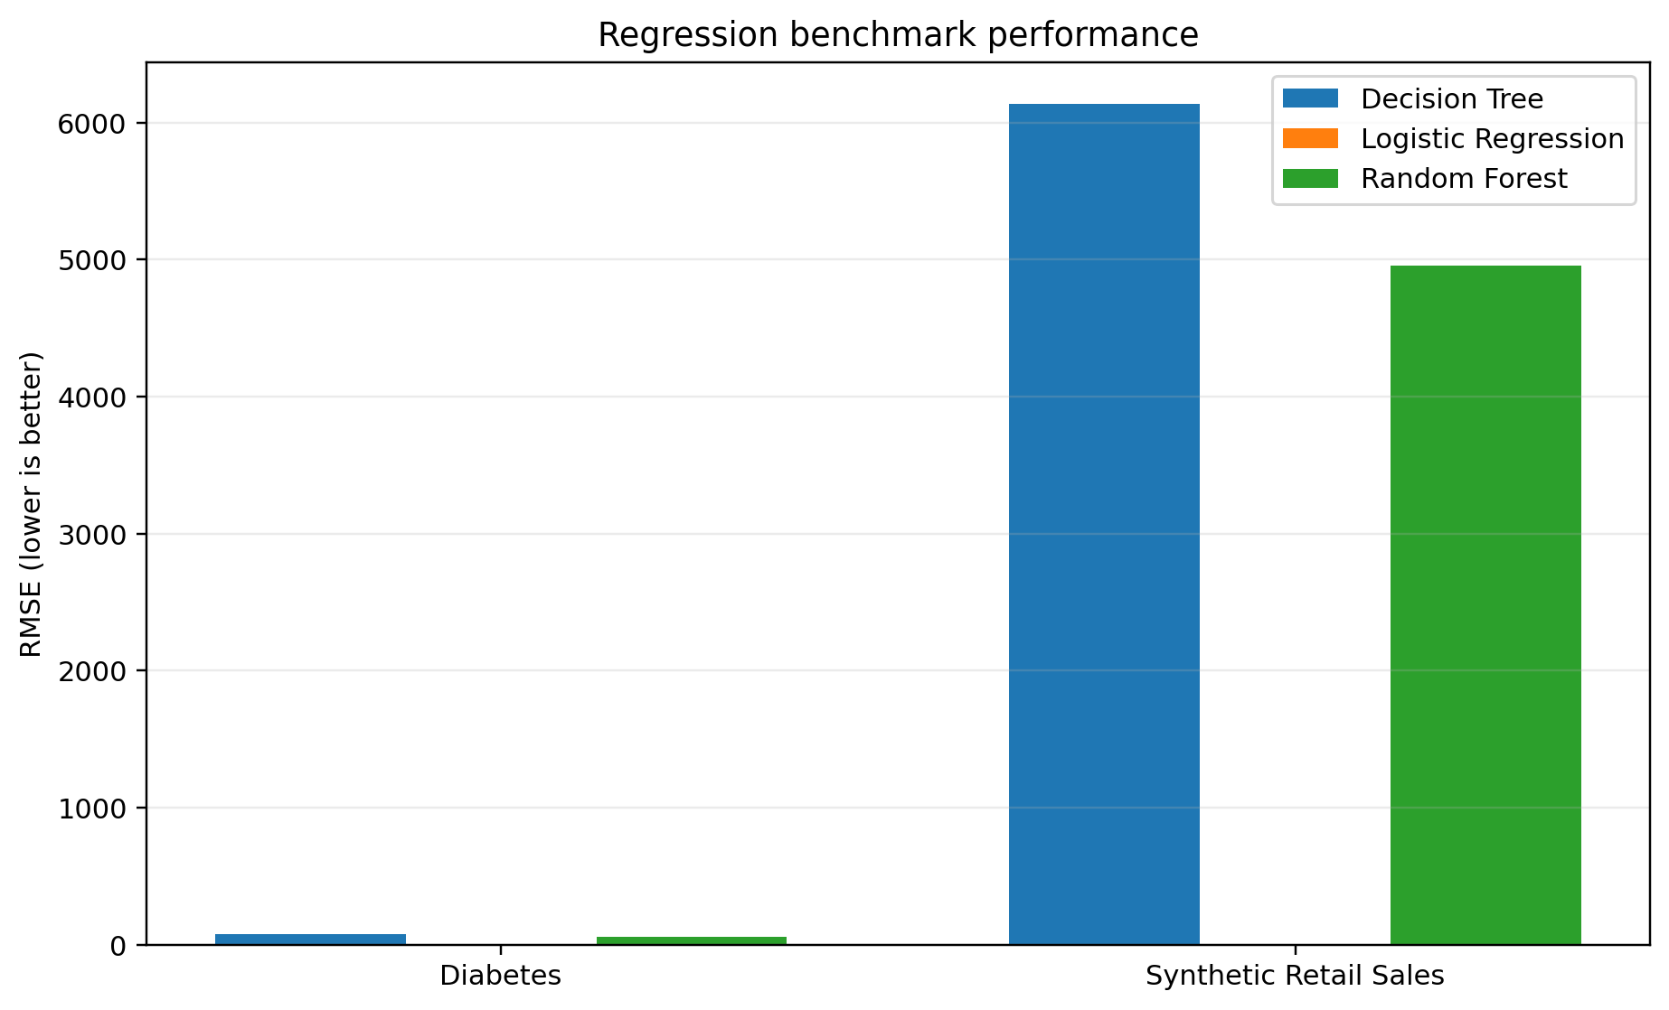
Fig. 3. RMSE comparison for the two regression datasets.

5.4 Unsupervised Results
For Iris, K=2 produced the highest silhouette score (0.5818). For Wine, K=3 produced the highest silhouette score (0.2849). Digits showed low and relatively flat silhouette values across K=2–6, with the highest value at K=2 (0.1056). This illustrates dataset-dependent clustering structure and supports reporting multiple clustering metrics rather than selecting K from a single universal rule.

Dataset | Best K | Silhouette | Davies–Bouldin | Calinski–Harabasz
Iris Unsupervised | 2 | 0.5818 | 0.5933 | 251.35
Wine Unsupervised | 3 | 0.2849 | 1.3892 | 70.94
Digits Unsupervised | 2 | 0.1056 | 2.9643 | 164.32
Table 5. Best unsupervised clustering configuration by silhouette score.
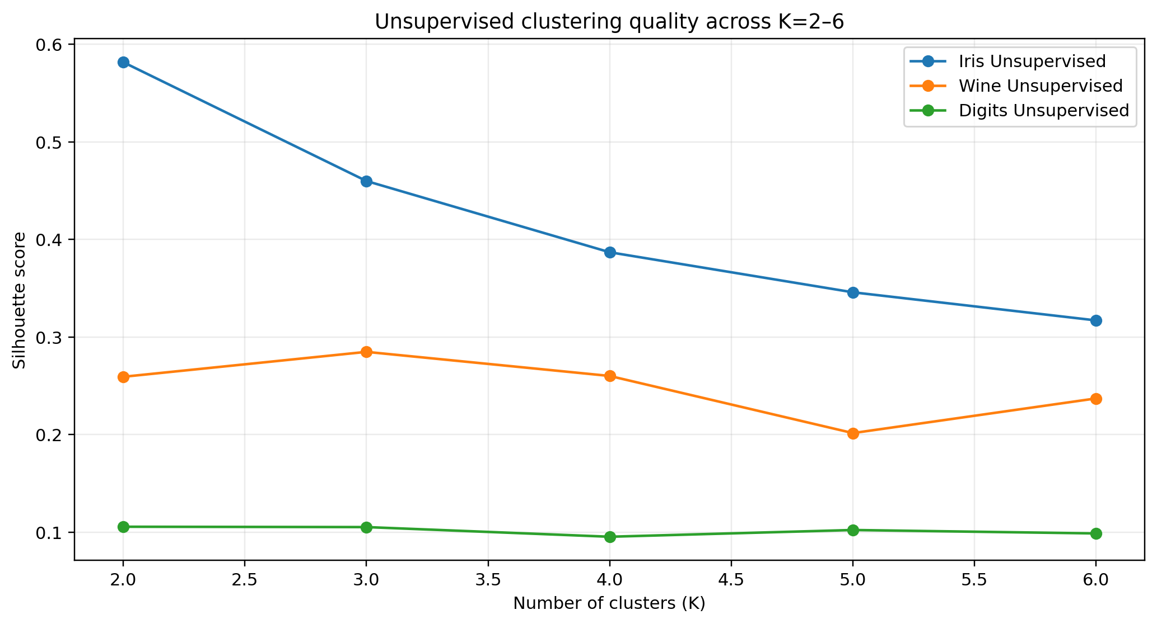
Fig. 4. Silhouette scores for K-Means across K=2–6.

5.5 Statistical Results
Friedman tests were significant for Breast Cancer (p≈2.55×10⁻⁹), Wine (p≈4.20×10⁻¹⁰), Digits (p≈1.33×10⁻⁹), Diabetes (p≈1.95×10⁻¹⁰), synthetic retail churn (p≈1.56×10⁻⁹), synthetic retail sales (p≈3.63×10⁻¹¹), and Iris classification (p≈0.0429). Holm-adjusted Wilcoxon comparisons further identified significant pairwise differences on most datasets. These tests compare the baseline algorithms; they do not establish superiority of RetailIQ as a framework.

Dataset | Friedman statistic | p-value | Interpretation
Breast Cancer | 39.5714 | 2.554e-09 | Significant
Diabetes Regression | 44.7200 | 1.946e-10 | Significant
Digits Classification | 40.8800 | 1.327e-09 | Significant
Iris Classification | 6.2979 | 4.290e-02 | Significant
Synthetic Retail Churn | 40.5600 | 1.558e-09 | Significant
Synthetic Retail Sales | 48.0800 | 3.627e-11 | Significant
Wine | 43.1818 | 4.199e-10 | Significant
Table 6. Statistical significance summary.

5.6 Runtime and Reproducibility
Total research-suite runtime was recorded for each dataset, ranging from approximately 0.04 seconds for unsupervised Wine to approximately 7.08 seconds for Digits classification in the recorded execution. Runtime is reported as an engineering observation rather than a primary scientific objective.
6. DISCUSSION
6.1 Interpretation of Findings
The results indicate that RetailIQ can route a heterogeneous benchmark suite correctly while exposing standard analytical baselines through one workflow. The model results are strongly dataset-dependent: linear models perform well on the two regression benchmarks, Logistic Regression dominates several compact classification datasets, and Random Forest becomes strongest on the high-dimensional Digits task. Such variation is consistent with the framework's decision to retain multiple analytical options instead of embedding a single fixed model.
6.2 Comparison With Previous Studies
The framework complements rather than replaces specialized prior systems. Data-cleaning literature emphasizes correctness, scalability and repair quality [3]–[8], while visualization systems focus on view construction and recommendation [9]–[15]. Automated EDA systems such as QUIS move toward question-driven insight generation [16]. RetailIQ occupies a different design point: it integrates lightweight profiling, conservative cleaning, interactive analytics, recommendation rules and reproducible ML benchmarking in a single application.
6.3 Theoretical Implications
The central implication is architectural rather than algorithmic. Early-stage analytics can be treated as a routing and orchestration problem in which schema evidence, data-quality signals and analytical characteristics determine which operations are appropriate. This makes automation possible without requiring every decision to be learned from a large training corpus.
6.4 Practical Implications
For analysts receiving an unfamiliar CSV or spreadsheet, RetailIQ can shorten the initial setup phase by immediately showing schema, quality signals, summary measures, visual relationships and suggested next steps. The ML layer can then provide baseline evidence when a credible target exists. Because the framework keeps transformations and routing rules visible, analysts can inspect and override decisions rather than accepting an opaque automated conclusion.
6.5 Unexpected Findings
The most notable result is the contrast between high performance on several public benchmark datasets and substantially lower F1 on the synthetic retail churn dataset. This is useful rather than problematic: it demonstrates that the evaluation is sensitive to dataset structure and does not simply produce uniformly high scores.
7. LIMITATIONS
7.1 Scope of Validation
The ten-dataset suite is a benchmark sample rather than evidence of universal performance. Public datasets are largely small-to-medium benchmark datasets, and the two retail-domain datasets are synthetic.
7.2 Framework-Level Quantification
Current results quantitatively validate routing, ML baselines and clustering, but the recommendation engine and data-quality detector have not yet been evaluated against independently labeled ground truth. These experiments are planned as the next development stage.
7.3 Model Scope
Only a small set of transparent baselines is evaluated. The study does not compare against AutoML systems, gradient boosting libraries, deep learning models, or large-scale commercial analytics platforms.
7.4 Generalizability
Real enterprise data may contain semantic ambiguity, severe class imbalance, complex temporal structure, domain-specific identifiers, and data-quality problems that are not represented by the current suite.
8. CONCLUSION AND FUTURE WORK
8.1 Conclusion
This paper presented RetailIQ, an adaptive data analytics framework that integrates dataset profiling, conservative cleaning, data-quality diagnostics, exploratory analytics, visualization, recommendations, export and an ML evaluation layer. On the current ten-dataset research suite, the framework achieved 100% automatic routing accuracy and produced reproducible baseline comparisons using five repeats of five-fold cross-validation. The results demonstrate that model behavior varies substantially across datasets, supporting a multi-baseline and adaptive design rather than a single fixed analytical model. The framework therefore provides a practical foundation for automated early-stage tabular analytics while maintaining transparent boundaries around what has and has not been experimentally established.
8.2 Future Work
Future work will add controlled data-quality injection tests, routing stress tests using ambiguous target names, quantitative evaluation of recommendation accuracy, anomaly detection benchmarks, broader real-world retail datasets, stronger model families, SQL/database connectivity, natural-language analytics and automated business-insight generation.
DECLARATIONS
Funding
No external funding was received for this work.
Conflict of Interest
The author declares no conflict of interest.
Ethics Statement
The benchmark datasets are public or synthetic and no human subjects were recruited for this study.
Data Availability
The research suite, dataset manifest, experiment scripts and generated result CSVs are maintained with the RetailIQ research project. Public benchmark datasets are distributed through scikit-learn; synthetic datasets are reproducibly generated with seed 42.
Author Contributions
The author designed and implemented RetailIQ, developed the research evaluation suite, conducted the experiments, analyzed the results, and prepared the manuscript.
Acknowledgements
The author acknowledges the academic guidance and institutional support associated with the project.
REFERENCES
[1] R. Y. Wang and D. M. Strong, “Beyond Accuracy: What Data Quality Means to Data Consumers,” Journal of Management Information Systems, vol. 12, no. 4, pp. 5–33, 1996, doi: 10.1080/07421222.1996.11518099.
[2] L. S. Pipino, Y. W. Lee, and R. Y. Wang, “Data Quality Assessment,” Communications of the ACM, vol. 45, no. 4, pp. 211–218, 2002.
[3] E. Rahm and H. H. Do, “Data Cleaning: Problems and Current Approaches,” IEEE Data Engineering Bulletin, vol. 23, no. 4, pp. 3–13, 2000.
[4] S. Kandel, A. Paepcke, J. Hellerstein, and J. Heer, “Wrangler: Interactive Visual Specification of Data Transformation Scripts,” in Proc. CHI, pp. 3363–3372, 2011, doi: 10.1145/1978942.1979444.
[5] Z. Khayyat, I. F. Ilyas, A. Jindal, S. Madden, M. Ouzzani, P. Papotti, J. A. Quiané-Ruiz, N. Tang, and S. Yin, “BigDansing: A System for Big Data Cleansing,” in Proc. ACM SIGMOD, pp. 1215–1230, 2015, doi: 10.1145/2723372.2747646.
[6] S. Krishnan, J. Wang, M. J. Franklin, K. Goldberg, T. Kraska, T. Milo, and E. Wu, “SampleClean: Fast and Reliable Analytics on Dirty Data,” IEEE Data Engineering Bulletin, vol. 38, no. 3, pp. 59–75, 2015.
[7] S. Krishnan, J. Wang, E. Wu, M. J. Franklin, and K. Goldberg, “ActiveClean: Interactive Data Cleaning for Statistical Modeling,” Proc. VLDB Endowment, vol. 9, no. 12, pp. 948–959, 2016, doi: 10.14778/2994509.2994514.
[8] T. Rekatsinas, X. Chu, I. F. Ilyas, and C. Ré, “HoloClean: Holistic Data Repairs with Probabilistic Inference,” Proc. VLDB Endowment, vol. 10, no. 11, pp. 1190–1201, 2017, doi: 10.14778/3137628.3137631.
[9] J. Mackinlay, P. Hanrahan, and C. Stolte, “Show Me: Automatic Presentation for Visual Analysis,” IEEE Transactions on Visualization and Computer Graphics, vol. 13, no. 6, pp. 1137–1144, 2007, doi: 10.1109/TVCG.2007.70594.
[10] C. Stolte, D. Tang, and P. Hanrahan, “Polaris: A System for Query, Analysis, and Visualization of Multidimensional Relational Databases,” IEEE Transactions on Visualization and Computer Graphics, vol. 8, no. 1, pp. 52–65, 2002, doi: 10.1109/2945.981851.
[11] M. Vartak, S. Rahman, S. Madden, A. Parameswaran, and N. Polyzotis, “SEEDB: Efficient Data-Driven Visualization Recommendations to Support Visual Analytics,” Proc. VLDB Endowment, vol. 8, no. 13, pp. 2182–2193, 2015.
[12] K. Wongsuphasawat, D. Moritz, A. Anand, J. Mackinlay, B. Howe, and J. Heer, “Voyager: Exploratory Analysis via Faceted Browsing of Visualization Recommendations,” IEEE Transactions on Visualization and Computer Graphics, vol. 22, no. 1, pp. 649–658, 2016, doi: 10.1109/TVCG.2015.2467191.
[13] Y. Luo, X. Qin, N. Tang, and G. Li, “DeepEye: Towards Automatic Data Visualization,” in Proc. IEEE ICDE, pp. 101–112, 2018, doi: 10.1109/ICDE.2018.00019.
[14] J. Heer and B. Shneiderman, “Interactive Dynamics for Visual Analysis,” Communications of the ACM, vol. 55, no. 4, pp. 45–54, 2012, doi: 10.1145/2133416.2146416.
[15] X. Qian, R. A. Rossi, F. Du, S. Kim, E. Koh, S. Malik, T. Y. Lee, and J. Chan, “Learning to Recommend Visualizations from Data,” in Proc. ACM SIGKDD, pp. 1359–1369, 2021, doi: 10.1145/3447548.3467224.
[16] A. Manatkar, A. Akella, P. Gupta, and K. Narayanam, “QUIS: Question-guided Insights Generation for Automated Exploratory Data Analysis,” in Proc. EMNLP Industry Track, pp. 1523–1535, 2024, doi: 10.18653/v1/2024.emnlp-industry.111.
[17] L. Breiman, “Random Forests,” Machine Learning, vol. 45, pp. 5–32, 2001, doi: 10.1023/A:1010933404324.
[18] F. Pedregosa et al., “Scikit-learn: Machine Learning in Python,” Journal of Machine Learning Research, vol. 12, pp. 2825–2830, 2011.
[19] P. J. Rousseeuw, “Silhouettes: A Graphical Aid to the Interpretation and Validation of Cluster Analysis,” Journal of Computational and Applied Mathematics, vol. 20, pp. 53–65, 1987, doi: 10.1016/0377-0427(87)90125-7.
[20] J. MacQueen, “Some Methods for Classification and Analysis of Multivariate Observations,” in Proc. Fifth Berkeley Symposium on Mathematical Statistics and Probability, vol. 1, pp. 281–297, 1967.
[21] T. Hastie, R. Tibshirani, and J. Friedman, The Elements of Statistical Learning, 2nd ed. Springer, 2009.
[22] J. W. Tukey, Exploratory Data Analysis. Addison-Wesley, 1977.
[23] L. Wilkinson, The Grammar of Graphics, 2nd ed. Springer, 2005.
[24] M. Bostock, V. Ogievetsky, and J. Heer, “D3: Data-Driven Documents,” IEEE Transactions on Visualization and Computer Graphics, vol. 17, no. 12, pp. 2301–2309, 2011, doi: 10.1109/TVCG.2011.185.
[25] W. McKinney, “Data Structures for Statistical Computing in Python,” in Proc. 9th Python in Science Conference, pp. 51–56, 2010.
[26] J. D. Hunter, “Matplotlib: A 2D Graphics Environment,” Computing in Science & Engineering, vol. 9, no. 3, pp. 90–95, 2007, doi: 10.1109/MCSE.2007.55.
[27] P. Virtanen et al., “SciPy 1.0: Fundamental Algorithms for Scientific Computing in Python,” Nature Methods, vol. 17, pp. 261–272, 2020, doi: 10.1038/s41592-019-0686-2.
[28] C. R. Harris et al., “Array Programming with NumPy,” Nature, vol. 585, pp. 357–362, 2020, doi: 10.1038/s41586-020-2649-2.
[29] P. Domingos, “A Few Useful Things to Know About Machine Learning,” Communications of the ACM, vol. 55, no. 10, pp. 78–87, 2012, doi: 10.1145/2347736.2347755.
[30] F. Provost and T. Fawcett, Data Science for Business. O’Reilly Media, 2013.
[31] J. Han, M. Kamber, and J. Pei, Data Mining: Concepts and Techniques, 3rd ed. Morgan Kaufmann, 2011.
[32] I. H. Witten, E. Frank, M. A. Hall, and C. J. Pal, Data Mining: Practical Machine Learning Tools and Techniques, 4th ed. Morgan Kaufmann, 2016.

