SOFTWARE REQUIREMENTS SPECIFICATION

Peer to Peer Skill Exchange Platform

1. Introduction
The Peer to Peer Skill Exchange Platform is a web-based platform designed to connect users based on skills they can offer and skills they wish to learn. It supports peer learning, collaboration, and knowledge sharing, and includes a feedback and rating feature.

1.1 Purpose
This SRS document specifies the functional and non-functional requirements of the Peer Skill Matchmaker system for developers and evaluators.

1.2 Scope
The system enables users to register, manage skills, find matching peers, communicate, and provide feedback. Admins manage users and system data.

1.3 Definitions and Acronyms
DFD – Data Flow Diagram
Admin – System Administrator
User – Registered system user

1.4 References
Bhagya Meena Sri, M., Sai Madhavi, B., Mani Sankar, C. H., & Neeraja, S.
Peer-to-Peer Skills and Knowledge Exchange Platform, International Journal of Scientific Research in Engineering and Management (IJSREM), Vol. 9, Issue 2, Feb. 2025, ISSN: 2582-3930, DOI: 10.55041/IJSREM41629.

2. Overall Description

2.1 Product Perspective
Peer Skill Matchmaker is a standalone web application following a client-server architecture.

2.2 Product Functions
- User registration and login
- Skill management
- Peer skill matching
- Messaging
- Feedback and rating
- Admin management

2.3 User Classes
Users:
Users are students or professionals with basic computer knowledge who use the system to manage skills, find peers, communicate, and provide feedback. They interact with the system through a simple web interface.
Admin:
Admin is an authorized user responsible for managing users, monitoring activities, and moderating skills and feedback. Admin has higher privileges than normal users.

2.4 Operating Environment
The system is a web-based application.
Client: Web browsers such as Chrome, Firefox, or Edge
Server: Application server with database
Operating System: Platform independent (Windows, Linux, macOS)

2.5 Constraints
Requires internet connectivity
Must follow data privacy and security regulations
Performance depends on server capacity and network conditions

3. Functional Requirements

3.1 User Authentication
The system shall allow users to register and log in securely.

3.2 Skill Management
The system shall allow users to add, update, and delete skills.

3.3 Skill Matching
The system shall match users based on skills offered and required.

3.4 Communication
The system shall allow messaging between matched users.

3.5 Feedback and Rating
The system shall allow users to submit feedback and ratings after interactions.

3.6 Admin Functions
The system shall allow admin to manage users and moderate feedback.

4. Technology Stack

4.1 Frontend
- React, HTML5, CSS3, JavaScript,,TalkJS
- Responsive user interface for desktop
- Secure session handling using JWT
- User-friendly interface for skill management, matching, and communication

4.2 Backend
- Node.js with Express.js
- RESTful APIs for user, skill, match, and feedback management
- Authentication and authorization services
- Business logic for skill matching and peer recommendation
- Admin management and moderation services

4.3 Matching and Logic Layer
- Rule-based skill matching algorithm
- Skill comparison and ranking logic
- Feedback and rating integration to improve match quality
- Session handling for user communication

4.4 Database
- MongoDB as the primary database for users, skills, matches, and feedback

5. System Models
Data Flow Diagrams describe system data flow.
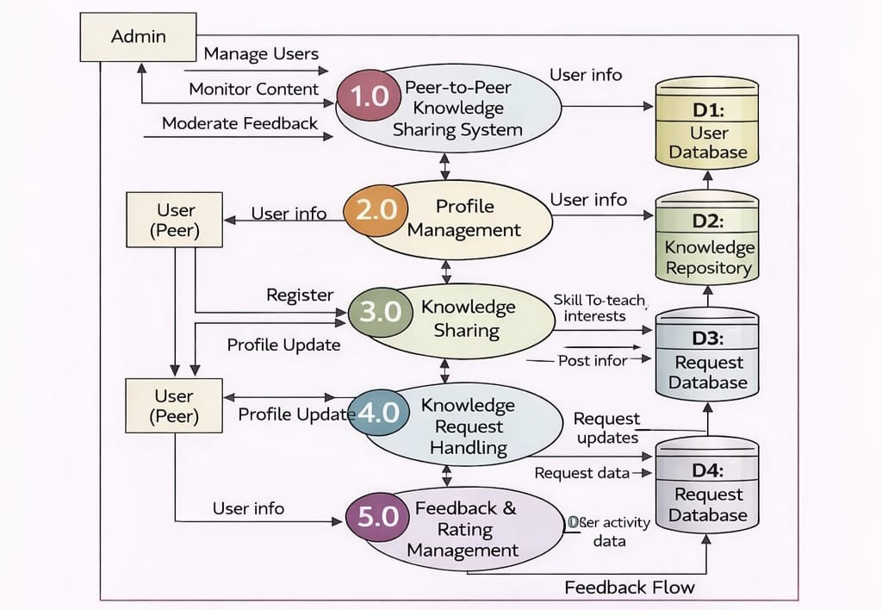

6. Non-Functional Requirements
Performance, security, usability, reliability, and scalability requirements apply.

7. System Flow
User----> Register / Login / Manage Skills / Search Peers ---->System
System ----> Peer Matches / Notifications---->User
Admin ----> Manage Users / Monitor System ----> System
System----> Reports ---->Admin

