Project Development Phase
Workflow Automation Verification
Date | 14-10-2026
Team ID | Individual participant - 323103312150@gvpce.ac.in
Project Name | Metro Ticket Generating System - ServiceNow
Maximum Marks | As specified by template

Automation Summary
The project uses rule-based ServiceNow configuration and client-side scripting. No artificial-intelligence model, training pipeline or AI-generated decision is part of it. The fare comes from configured logic and the QR code is generated from the selected journey details. The relevant verification target is therefore the behaviour of the form logic, the UI Policy, the QR widget and the checkout flow.
Area | Expected behaviour | Verification evidence to capture
Catalog intake | Starting From, Going To, Type of journey, No of Passengers and Mode of Payment are collected and required. | Catalog item form (Fig 2).
Fare calculation | Catalog Client Scripts fill Amount for single journey and Amount including return from the selection. | Filled form showing a calculated amount (Fig 3).
Payment UI Policy | Selecting Others shows and requires Enter payment mode. | Form with Others selected (Fig 4) and the policy record (Fig 10).
QR generation | A QR code containing the journey details is shown in a modal. | QR modal (Fig 5).
Checkout | Order Now opens Order Confirmation and Checkout creates the request. | Order Confirmation dialog and Request Summary.
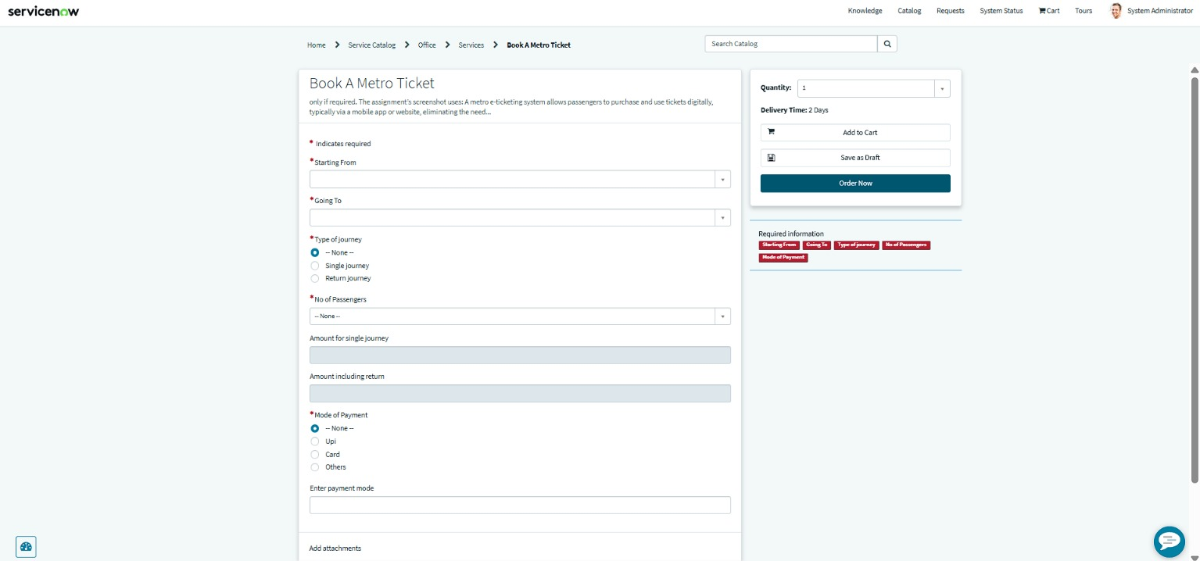
Figure 2. Catalog item intake: required fields before any selection.
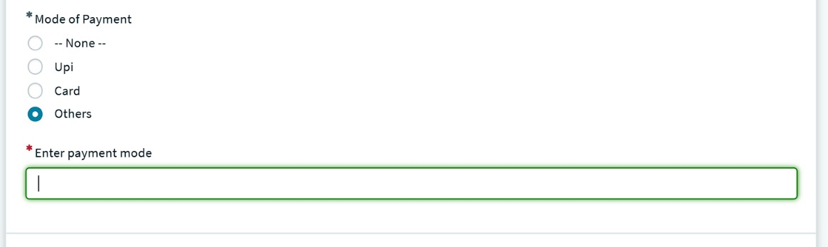
Figure 4. Others selected: Enter payment mode is shown as a required field.
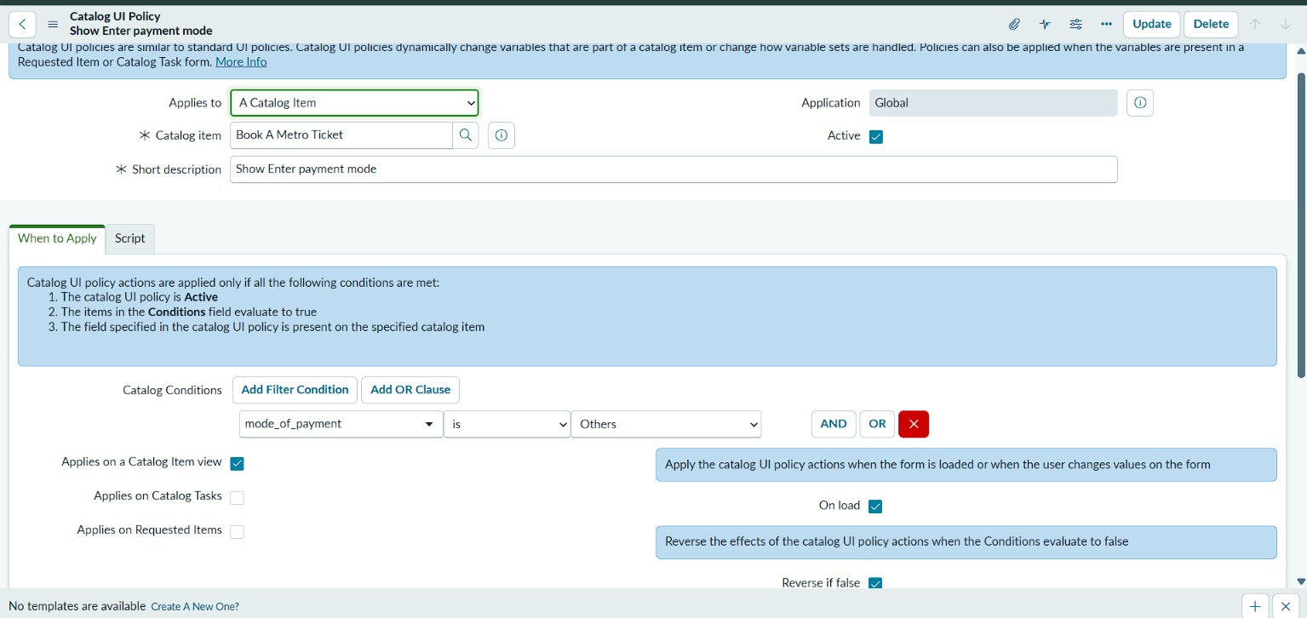
Figure 10. Catalog UI Policy Show Enter payment mode: when mode_of_payment is Others, applied on the Catalog Item view, On load, Reverse if false.
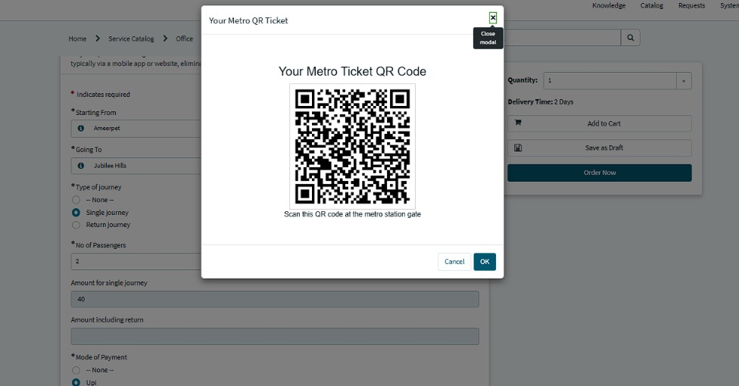
Figure 5. QR ticket modal generated by the portal widget.

AI-specific fields from the source template
Template field | Project-specific value
Model summary | Not applicable - no AI model is part of this project.
Training / validation accuracy | Not applicable - there is no model training or labelled evaluation dataset.
Fine-tuning result | Not applicable - no fine-tuning is performed.

Evidence note
Figure numbers follow the project's full set of output screenshots. The Catalog Client Script source is not included in the supplied evidence; attach the script records here if a code-level review is required.

