Project Development Phase
Functional & Performance Testing
Date | 14-10-2026
Team ID | Individual participant - 323103312150@gvpce.ac.in
Project Name | Metro Ticket Generating System - ServiceNow
Maximum Marks | As specified by template

Functional Test Scenarios
Tests were run in the project's ServiceNow personal developer instance. Results below reflect the screenshots supplied and the project owner's testing summary.
ID | Scenario | Steps | Expected result | Actual status
FT-01 | Station selection and required fields | Open the form; leave Starting From / Going To empty, then select stations from the drop-downs. | Required fields are marked; stations come from the Metro Station Details table. | Passed (Figs 2, 3, 9)
FT-02 | Fare - single journey | Select Ameerpet to Jubilee Hills, Single journey, 2 passengers. | Amount for single journey is calculated and shown (observed: 40). | Passed (Fig 3)
FT-03 | Fare - return journey and passenger count | Change journey type to Return and vary the passenger count. | Amount including return and totals update with the selection. | Passed (owner-reported; no screenshot attached)
FT-04 | Payment mode field visibility | Select Others under Mode of Payment. | Enter payment mode appears and is mandatory. | Passed (Figs 4, 10)
FT-05 | QR ticket generation | Complete the form and trigger the ticket. | A modal shows Your Metro Ticket QR Code with the scan instruction. | Passed (Fig 5)
FT-06 | Order confirmation | Select Order Now. | Order Confirmation dialog opens with Request for, optional sections and Checkout. | Passed (Fig 6)
FT-07 | Request submission | Select Checkout. | A request is created; Request Summary shows REQ number, item, stage. | Passed (Figs 7, 8)
FT-08 | Request tracking | Open the REQ record and its requested item. | REQ shows approval and state; RITM is linked. | Passed (Fig 8)

Test evidence
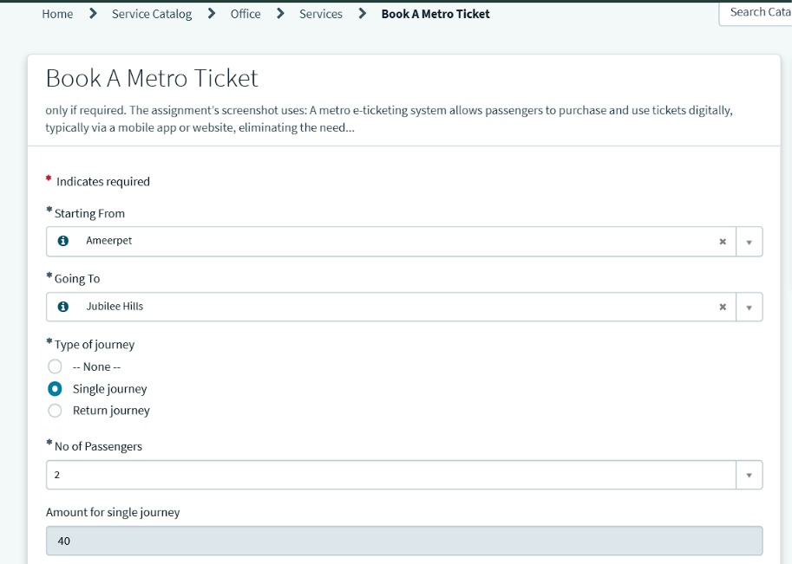
Figure 3. FT-01, FT-02: Ameerpet to Jubilee Hills, Single journey, 2 passengers; amount for single journey = 40.
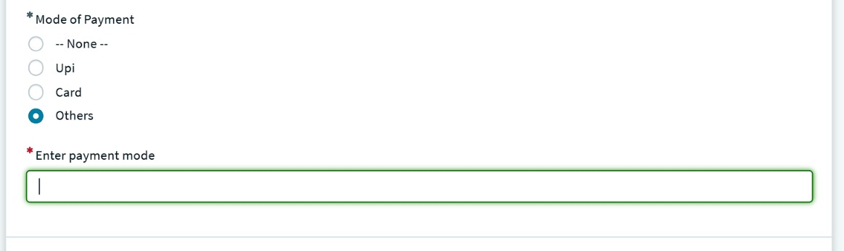
Figure 4. FT-04: Mode of Payment = Others reveals Enter payment mode as a required field.
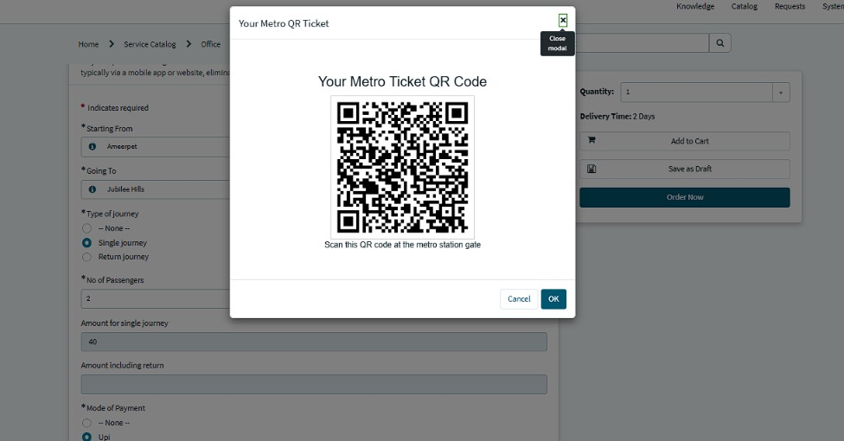
Figure 5. FT-05: Your Metro QR Ticket modal.
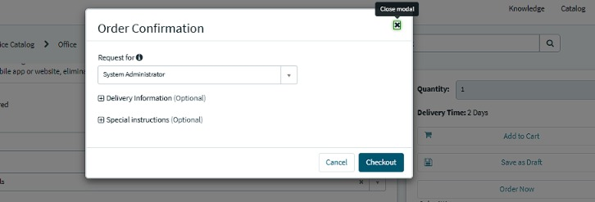
Figure 6. FT-06: Order Confirmation dialog.
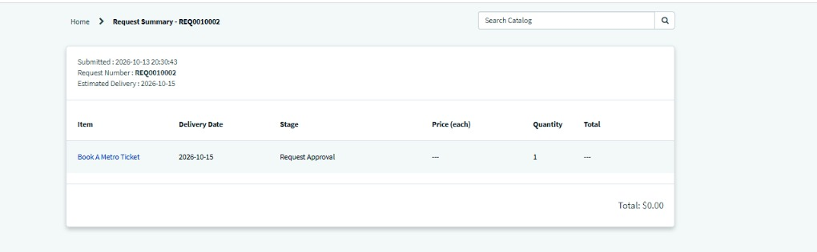
Figure 7. FT-07, FT-08: Request Summary for REQ0010002 showing stage Request Approval.

Performance Testing Plan
Test | Method | Metrics to record | Current evidence
Response time | Repeat fare calculation and QR generation under controlled conditions. | Median, average and maximum time; timestamp and environment. | No measured timings supplied.
Concurrent submissions | Submit several test bookings in a non-production instance. | Successful requests, errors, delays. | No load-test evidence supplied.
QR reliability | Generate the QR repeatedly and decode each code. | Decode success rate and content match. | Decoding not yet evidenced.
Checkout reliability | Complete many bookings end to end. | Duplicate or missing requests, errors. | One successful request (REQ0010002) recorded.

Note
No numeric performance target is asserted. Record observed measurements before drawing performance conclusions.

