Project Development Phase
Workflow Validation Metrics
Date | 14-10-2026
Team ID | Individual participant - 323103312150@gvpce.ac.in
Project Name | Metro Ticket Generating System - ServiceNow
Maximum Marks | As specified by template

Applicability
The source template asks for machine-learning metrics. This project has no ML model, so MAE, MSE, RMSE, R-squared, confusion matrices, classifier accuracy and hyperparameter tuning do not apply. The equivalent quality evidence is functional correctness and the integrity of the booking records.
Validation dimension | Acceptance check | Evidence / measurement
Input validation | Required fields are enforced and submitted values persist. | Catalog form with required markers (Fig 2).
Station correctness | Stations come from the Metro Station Details table. | Station table (Fig 9) and form drop-downs.
Fare correctness | Amounts follow the selected route, journey type and passengers. | Calculated amount of 40 for the recorded example (Fig 3).
Conditional field correctness | Enter payment mode is required when Others is selected. | Form and UI Policy (Figs 4, 10).
QR correctness | QR is generated and contains the selected journey details. | QR modal (Fig 5); decoded content not yet verified.
Record integrity | Request and requested item exist and are linked. | REQ0010002 and RITM0010002 (Fig 8).

Metrics from executed tests
Counts come from the eight functional test cases FT-01 to FT-08 listed in the functional testing document.
Metric | Calculation | Result
Functional pass rate | Passed test cases / executed test cases x 100 | 8 / 8 = 100%
Evidence coverage | Test cases with a screenshot / executed test cases x 100 | 7 / 8 = 87.5% (FT-03 owner-reported)
Record-linkage success | Requests with a correctly linked RITM / requests tested x 100 | 1 / 1 = 100% (single request tested)
Fare accuracy across all routes | Correct fares / route-journey combinations tested x 100 | Not yet measured
QR decode success rate | Codes decoded with correct content / codes generated x 100 | Not yet measured
Notification success rate | Notifications generated / notifications expected x 100 | Not applicable - no notification is part of the documented scope

How to read these figures
A 100% pass rate over eight cases confirms the documented behaviour works for the cases tested. It is not evidence of coverage across every station pair, and record linkage was checked on a single request.
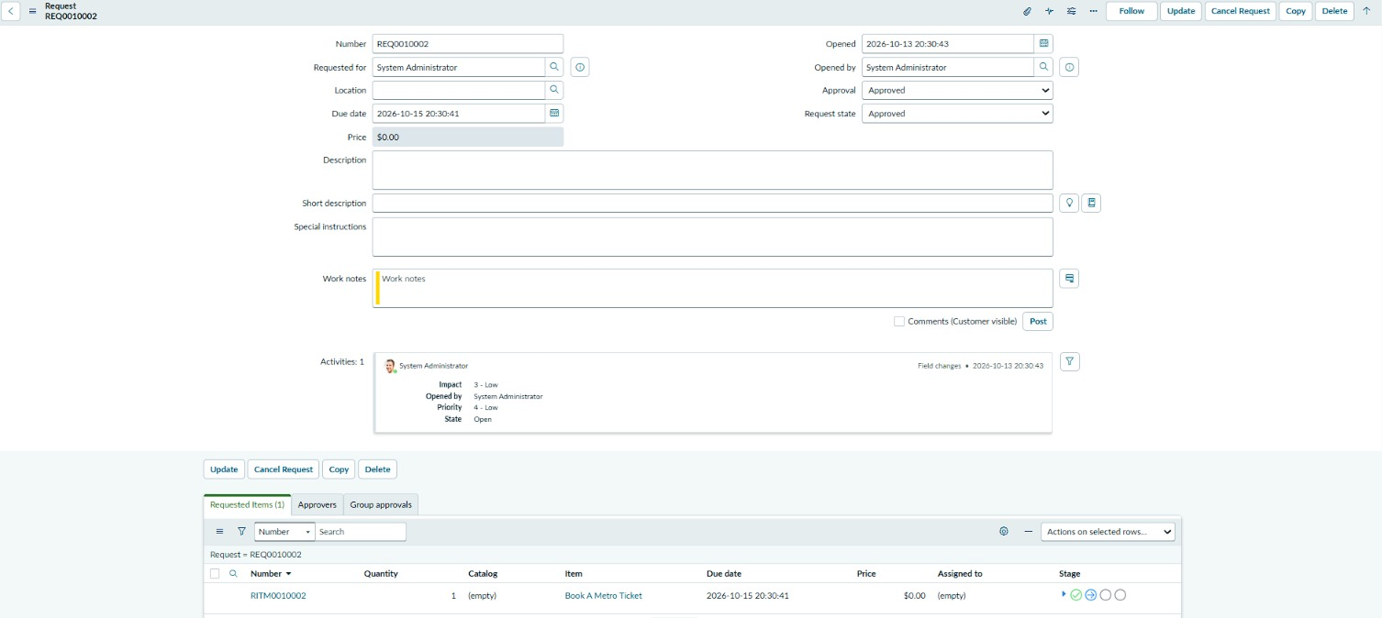
Figure 8. REQ0010002 with linked requested item RITM0010002 (Item: Book A Metro Ticket).

