Project Development Phase
Request Data & Reporting Review
Date | 14-10-2026
Team ID | Individual participant - 323103312150@gvpce.ac.in
Project Name | Metro Ticket Generating System - ServiceNow
Maximum Marks | As specified by template

Reporting / Data Review
No Power BI report or dashboard is evidenced in the project materials. This document maps the original template's data-rendering and reporting fields to the existing ServiceNow request screens and records without claiming a separate BI implementation.
Template parameter | Project-specific assessment | Evidence
Data rendered | The Request Summary and the REQ record display the booking: number, submitted time, item, stage, approval and state. | Figs 7 and 8.
Data preprocessing | No Power Query pipeline is documented. Station names come from the station table and the form validates required inputs. | Fig 9 and the catalog form.
Filters | No BI slicers are documented. The station fields are searchable drop-downs and the station list can be searched by Station Name. | Figs 3 and 9.
DAX queries | Not applicable - no Power BI semantic model. | None supplied.
Dashboard design | No dashboard is evidenced. | Do not invent visuals.
Report design | Reporting is limited to the request and list views of the platform. | Platform UI only.
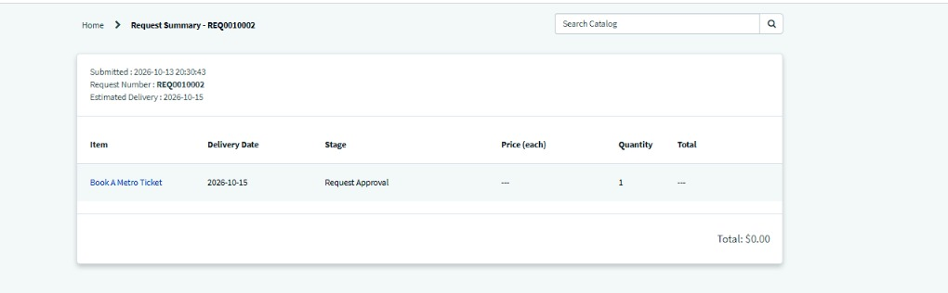
Figure 7. Request Summary for REQ0010002: submitted 2026-10-13 20:30:43, item Book A Metro Ticket, stage Request Approval.
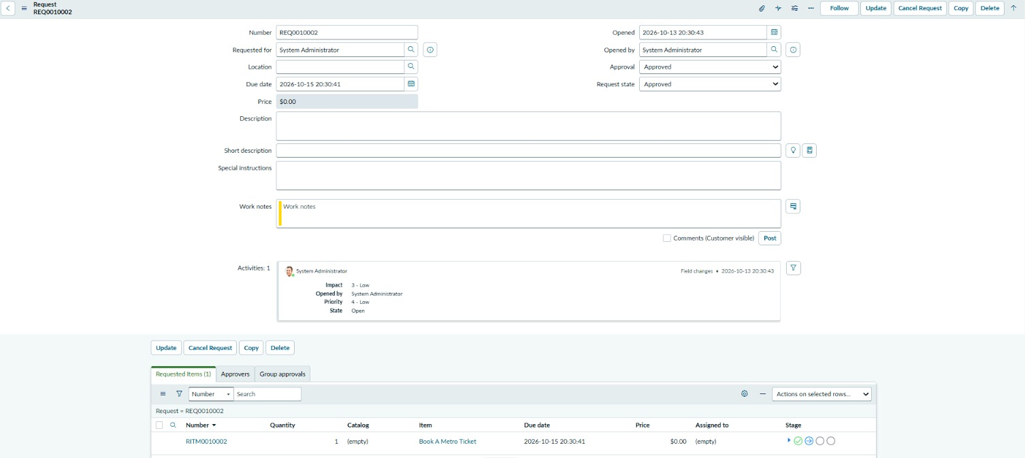
Figure 8. Request record REQ0010002: Approval and Request state both Approved; requested item RITM0010002.
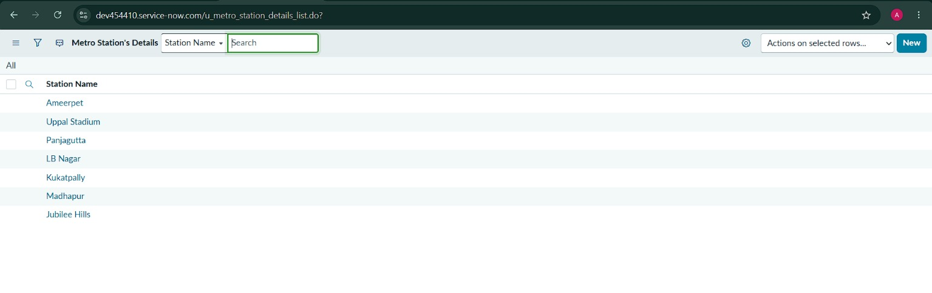
Figure 9. List view of Metro Station's Details (Station Name) in the ServiceNow instance.

Possible future reporting (not current scope)
If authorised reporting is added later, useful measures could include bookings per route, share of single versus return journeys, passengers per booking and payment-mode mix. These are recommendations only and must not be presented as implemented dashboards.

