Project Development Phase
Platform Configuration & Integration Verification
Date | 14-10-2026
Team ID | Individual participant - 323103312150@gvpce.ac.in
Project Name | Metro Ticket Generating System - ServiceNow
Maximum Marks | As specified by template

Platform Summary
The implementation platform is ServiceNow. Salesforce is not part of the project. The integration points are the Service Catalog and Service Portal, the Metro Station Details table, Catalog Client Scripts, a Catalog UI Policy, the QR widget, the native checkout and the standard request records.
Verification area | Expected result | Evidence to retain
Catalog variables | Starting From, Going To, Type of journey, No of Passengers, amount fields, Mode of Payment and Enter payment mode exist on Book A Metro Ticket. | Catalog form (Fig 2).
Station table | u_metro_station_details holds the stations used by the drop-downs. | Table list (Fig 9): Ameerpet, Uppal Stadium, Panjagutta, LB Nagar, Kukatpally, Madhapur, Jubilee Hills.
Client scripts | Fare fields update from the selection. | Calculated amount (Fig 3); script records to be attached.
UI Policy | Show Enter payment mode runs when mode_of_payment is Others. | Policy record (Fig 10).
QR widget | QR modal opens with the journey QR. | Fig 5.
Checkout and records | Order creates REQ and RITM. | Figs 6 to 8.
Update Set | Configuration can be moved between instances. | Not evidenced; export an update set before the instance is reclaimed.
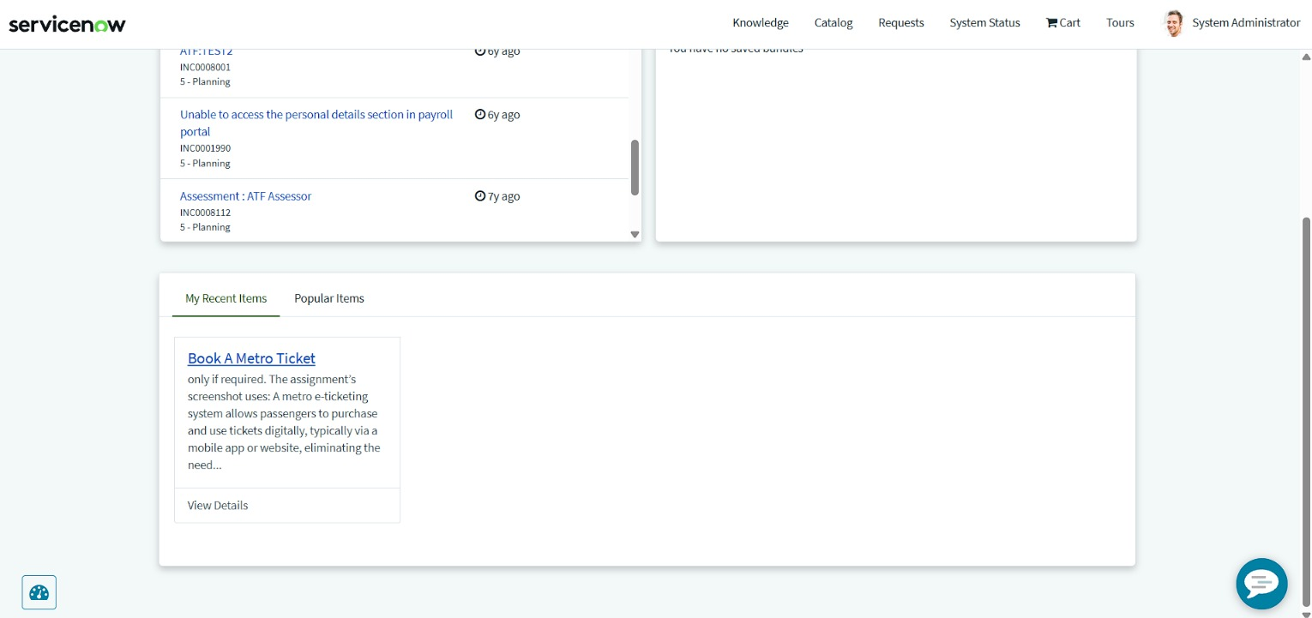
Figure 1. Service Portal home showing Book A Metro Ticket under My Recent Items.
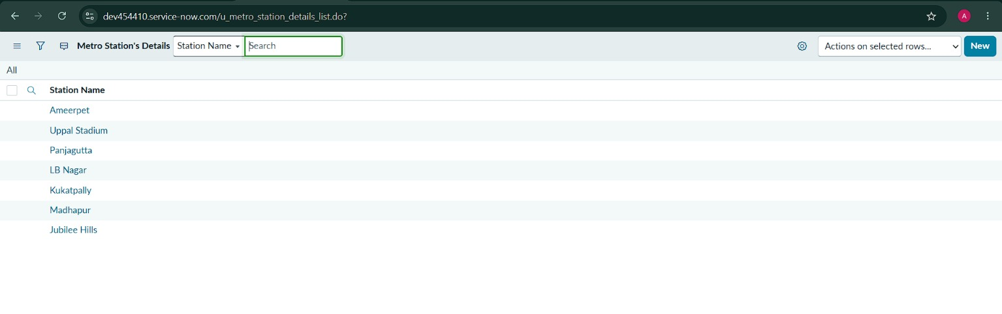
Figure 9. u_metro_station_details list (seven stations).
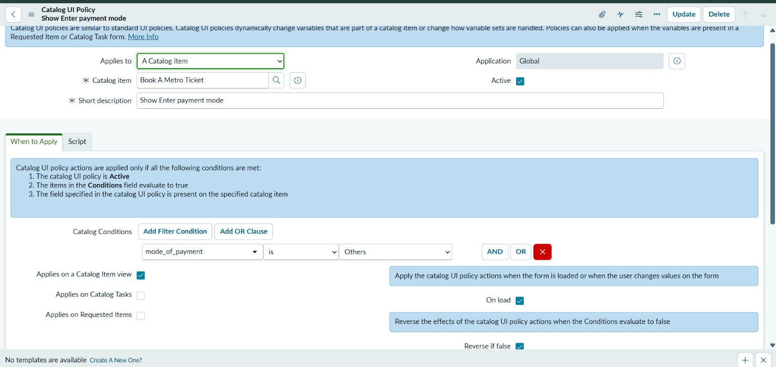
Figure 10. Catalog UI Policy configuration (Applies to: A Catalog Item; Catalog item: Book A Metro Ticket; Application: Global; Active).
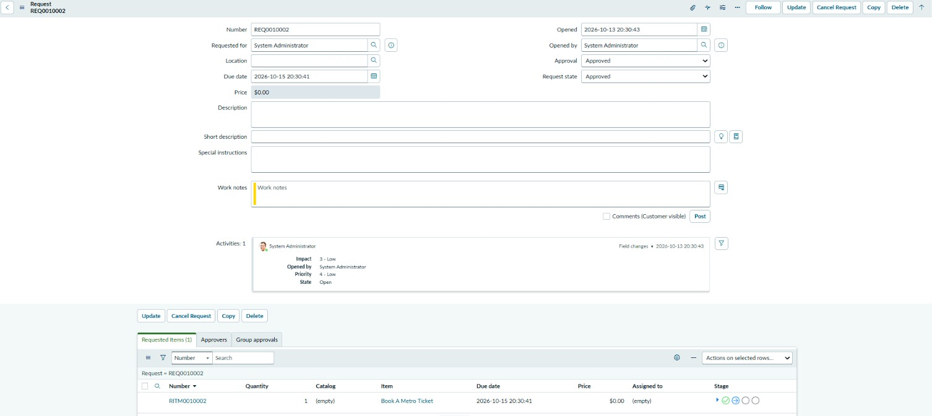
Figure 8. Request and requested item records created by the booking.

Accuracy / confidence fields from the source template
Training accuracy, validation accuracy and YOLO confidence scores are not applicable. Correctness should be reported from executed functional tests, not an invented model-accuracy percentage.

