Project Development Phase
Request Status & Usability Review
Date | 14-10-2026
Team ID | Individual participant - 323103312150@gvpce.ac.in
Project Name | Metro Ticket Generating System - ServiceNow
Maximum Marks | As specified by template

UI / Status Review
No Tableau workbook, dashboard or story is identified in the project materials. The equivalent review covers the ServiceNow catalog form, the QR ticket, the request summary and the clarity of the booking steps.
Review area | Expected behaviour | Review evidence
Data displayed | The Request Summary shows the request number, item, delivery date and stage. | Fig 7.
Input preparation | Labels, required markers and a Required information panel help the passenger complete the form. | Fig 2.
Search / navigation | The passenger can reach the item from My Recent Items or the catalog search. | Fig 1.
Calculated fields | Amount fields are read-only and calculated. | Fig 3.
Dashboard / story | Not applicable. | None.
Usability | The passenger understands what to enter and sees a ticket. | Observations below; user feedback to be collected.
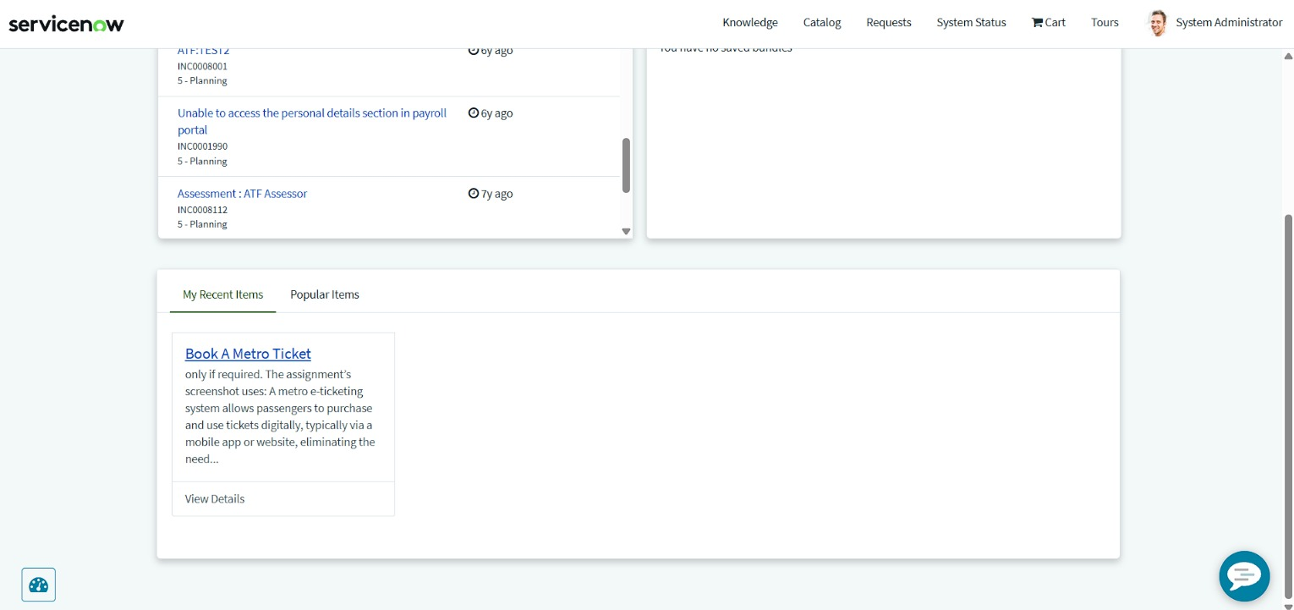
Figure 1. Entry point: Book A Metro Ticket card under My Recent Items.
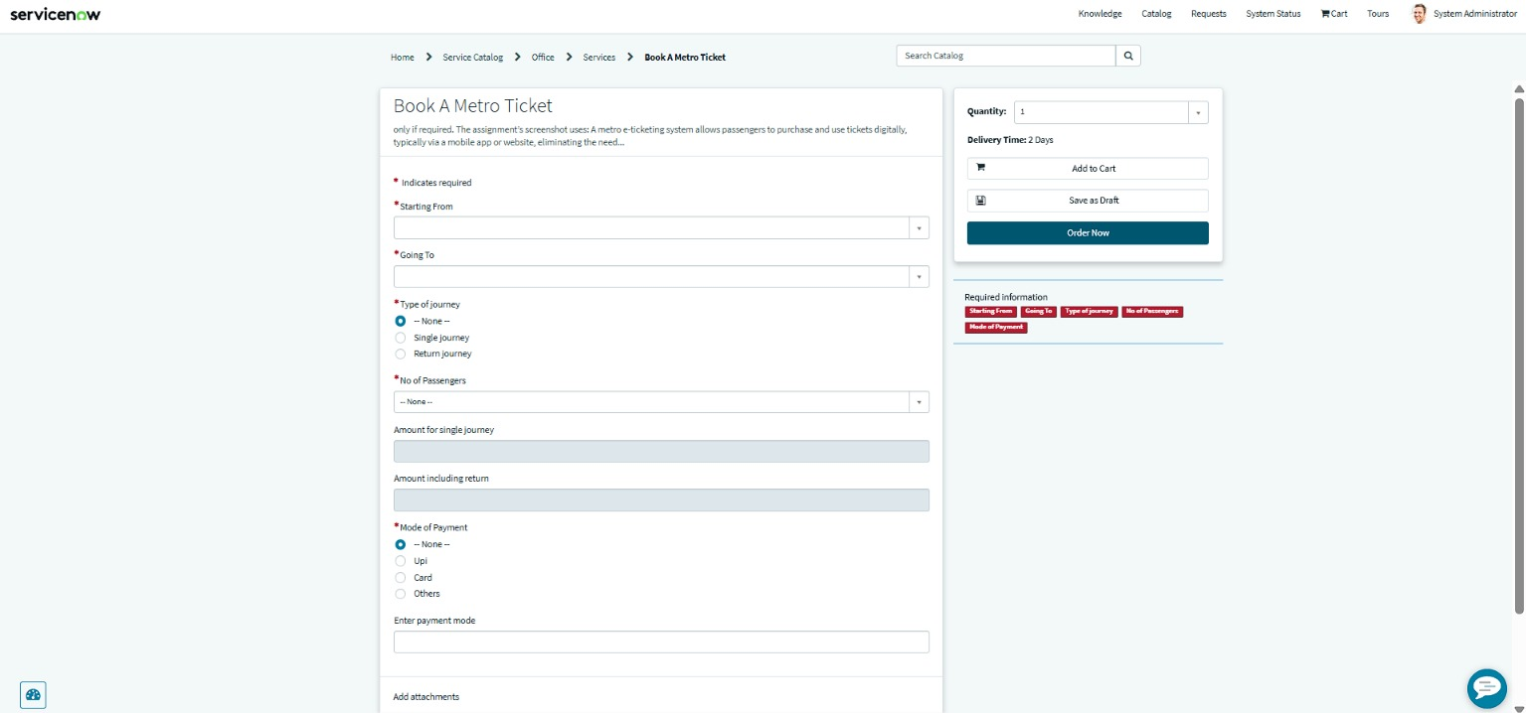
Figure 2. Catalog form with the Required information panel listing the five mandatory fields.
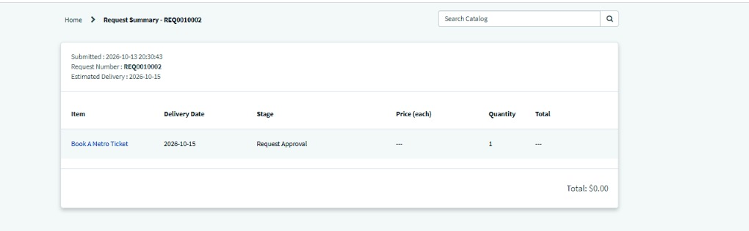
Figure 7. Request Summary after checkout.

Review checklist
- Labels are understandable and consistent.
- Required fields are clear before submission.
- The QR modal tells the passenger what to do with the code.
- Confirmation exposes a usable request reference (REQ0010002).
- Status wording (Request Approval) is understandable to a passenger.

Observations from the review
ID | Observation | Suggested action
O-1 | The item description under the title contains stray draft text that does not describe the service (visible in Figs 2 and 3). | Replace it with a short, passenger-friendly description.
O-2 | Enter payment mode is already visible, without a required marker, when Mode of Payment is None (Fig 2). It becomes mandatory when Others is selected (Fig 4). | Confirm whether the field should stay hidden until Others is chosen and adjust the UI Policy actions if so.
O-3 | The Request Summary shows price and total as $0.00 although a fare is calculated on the form (Fig 7). | Decide whether the fare should feed the catalog item price.

