Project Development Phase
User Acceptance Testing - Test Specification
Date | 14-10-2026
Team ID | Individual participant - 323103312150@gvpce.ac.in
Project Name | Metro Ticket Generating System - ServiceNow
Maximum Marks | As specified by template

Project Overview
Purpose: verify that a passenger can choose stations and journey details, see the correct fare, receive a QR ticket and complete the order so that the booking is saved as a request.

Scope
- Catalog item access and required-field validation.
- Station selection from the Metro Station Details table.
- Fare calculation for single and return journeys and passenger counts.
- Payment mode selection and the conditional Enter payment mode field.
- QR ticket generation.
- Order Confirmation, checkout and request creation.
- Request tracking through the Request Summary and the REQ/RITM records.

UAT Test Cases
ID | Scenario | Steps | Expected result | Execution status
UAT-01 | Locate catalog item | Open the Service Portal home and find Book A Metro Ticket. | Item card is visible and opens the form. | Executed - Passed
UAT-02 | Required fields | Open the form without entering data. | Five required fields are marked. | Executed - Passed
UAT-03 | Station selection | Choose Starting From and Going To. | Stations come from the Metro Station Details table. | Executed - Passed
UAT-04 | Fare - single journey | Choose a route, Single journey, 2 passengers. | Amount for single journey is calculated. | Executed - Passed
UAT-05 | Fare - return and passengers | Choose Return journey and vary passengers. | Amount including return updates. | Executed - Passed (owner-reported)
UAT-06 | Payment mode | Choose Others. | Enter payment mode is shown and mandatory. | Executed - Passed
UAT-07 | QR generation | Trigger the ticket. | QR modal opens with the scan instruction. | Executed - Passed
UAT-08 | Order Confirmation and checkout | Select Order Now, then Checkout. | Dialog opens; checkout completes. | Executed - Passed
UAT-09 | Request submission | Open the Request Summary. | REQ number, item and stage are shown. | Executed - Passed
UAT-10 | Record linkage | Open the REQ record and requested item. | REQ and RITM are linked. | Executed - Passed
UAT-11 | QR content check | Scan or decode the generated QR. | Decoded content matches the selected journey. | Not yet executed
UAT-12 | Station maintenance | Add or edit a station and reopen the form. | Drop-downs reflect the change. | Not yet executed
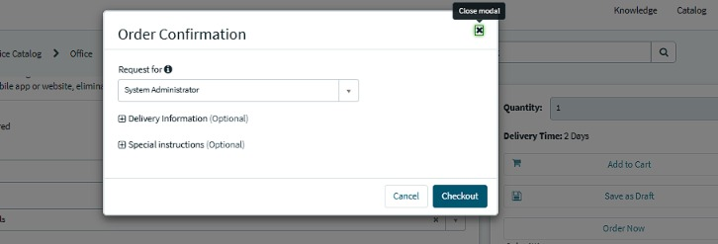
Figure 6. Evidence for UAT-08: Order Confirmation dialog.

Defect and Sign-off
Log only reproducible defects found during execution with defect ID, severity, steps, owner, status and resolution. Observations raised so far are listed in the UAT Execution Report. Complete the sign-off table after the remaining cases are executed.
Tester | Execution date | Result summary | Sign-off
________________ | ________________ | ________________________ | ________________

