Requirement Analysis
Customer Journey Map
Date | 14-10-2026
Team ID | Individual participant - 323103312150@gvpce.ac.in
Project Name | Metro Ticket Generating System - ServiceNow
Maximum Marks | As per template / not specified

Scenario
A passenger wants to travel between two metro stations and uses the ServiceNow Service Portal to book a ticket, see the fare, pay, receive a QR code and confirm that the request was saved. This journey map is a design synthesis based on the project build and screenshots; it is not based on new customer interviews.

Journey stages and key needs
Stage | User action | Touchpoint | User need | System response (intended)
Access | Open the portal and find Book A Metro Ticket. | Service Portal home, My Recent Items | Find the booking item quickly. | Show the catalog item as a card with View Details.
Choose route | Pick Starting From and Going To. | Catalog item form | Use valid station names. | Load stations from the Metro Station Details table.
Journey details | Choose single or return and the number of passengers. | Radio buttons, drop-down | Get the right fare for the group. | Calculate and display the amount fields.
Payment | Choose UPI, Card or Others. | Mode of Payment options | State how I will pay. | Show Enter payment mode when Others is chosen.
Ticket | View the QR code. | QR modal | Receive a usable ticket. | Display a QR with the instruction to scan at the gate.
Confirm | Order Now, then Checkout. | Order Confirmation dialog | Complete the booking. | Create the request and show the Request Summary.
Track | Open the request. | Request Summary, REQ record | Know the booking was saved. | Show REQ number, stage and approval state.

Evidence for each stage
The screenshots below come from the project's ServiceNow personal developer instance and match the stages above.
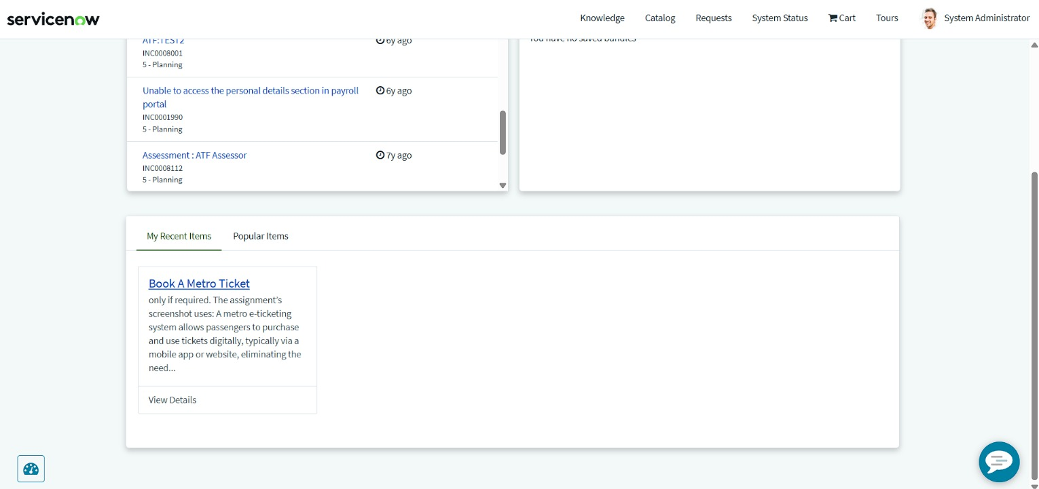  Access: Book A Metro Ticket in My Recent Items | 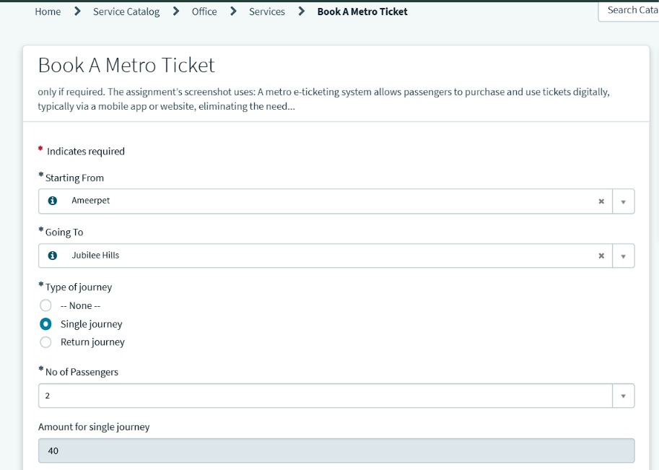  Choose route and journey: Ameerpet to Jubilee Hills, single, 2 passengers
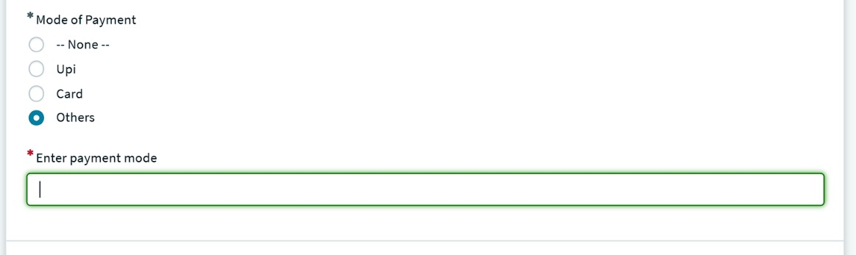  Payment: Others reveals a mandatory Enter payment mode field | 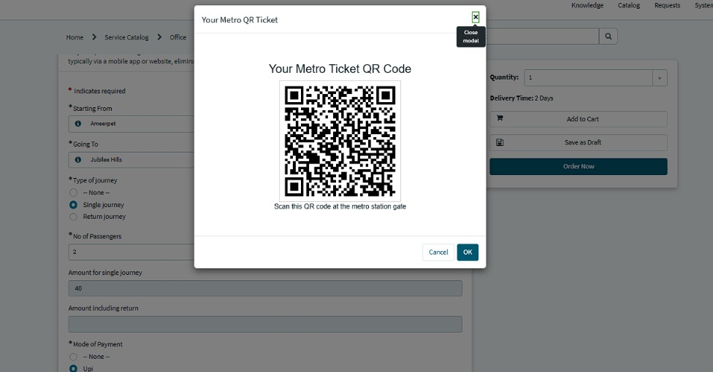  Ticket: Your Metro QR Ticket modal
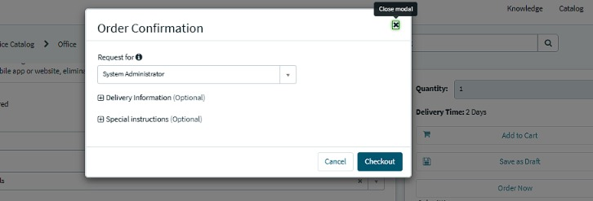  Confirm: Order Confirmation dialog | 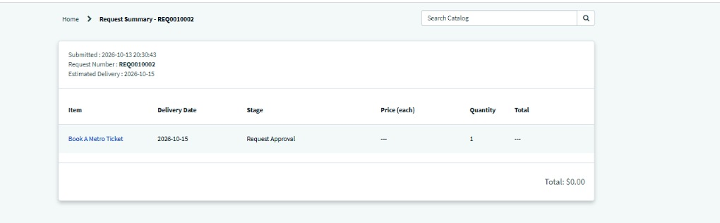  Track: Request Summary for REQ0010002

Priority opportunities
- Keep every required field clearly marked so passengers do not submit incomplete bookings.
- Keep the fare calculation instant and visible, so the passenger can decide before paying.
- Make the QR modal the clear end of the booking step, with an unmistakable instruction.
- Carry the fare through to the request price so the Request Summary does not show a total of $0.00 (observed in the current build).
- Add a notification to the passenger when the request is created (future scope).

Evidence note
This document adapts a one-page journey-map structure (stages, steps, interactions, goals, positive and negative moments, opportunities) to the metro booking flow. Pain points are plausible design risks to validate, not measured findings.

