Project Design Phase-II
Data Flow Diagram & User Stories
Date | 14-10-2026
Team ID | Individual participant - 323103312150@gvpce.ac.in
Project Name | Metro Ticket Generating System - ServiceNow
Maximum Marks | 4 Marks

Data Flow Diagrams:
A Data Flow Diagram (DFD) describes how information enters the booking system, how it is processed, where records are stored, and what is returned to the passenger.
Example: DFD Level 0 (Metro Ticket Booking)
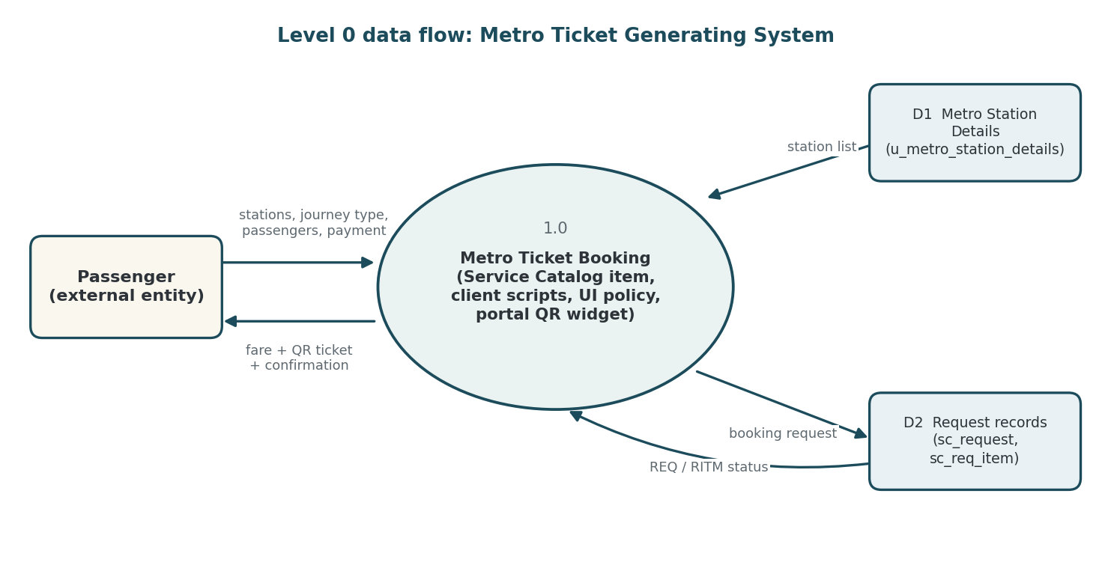
Figure 1. Level 0 data flow for the Metro Ticket Generating System.
The passenger submits stations, journey type, passenger count and payment mode. The booking process reads the station list from the Metro Station Details table, calculates the fare, generates the QR code and, on checkout, saves the booking in the request records. The passenger receives the fare, the QR ticket, the confirmation and the request status.

Data stores and key records
Record / table | Role in the flow | Key information
Metro Station Details - u_metro_station_details | Source of valid stations | Station Name (7 stations in the current build)
Catalog item - Book A Metro Ticket | Booking form definition | Variables: Starting From, Going To, Type of journey, No of Passengers, amount fields, Mode of Payment, Enter payment mode
Request - sc_request | Parent request record | Requested for, opened date, approval, request state (example: REQ0010002)
Requested Item - sc_req_item | Catalog item instance | Item, due date, stage (example: RITM0010002)
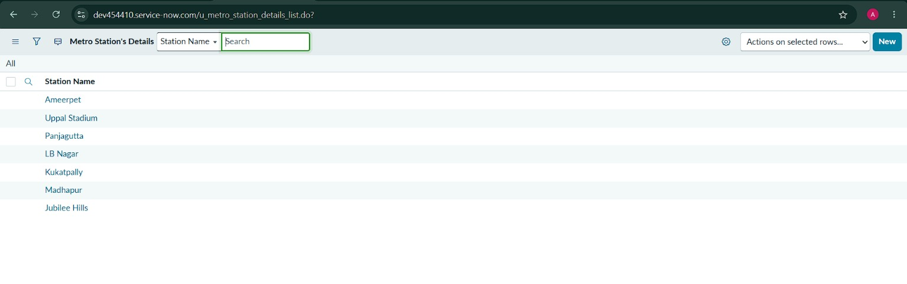
Figure 2. Metro Station's Details table (u_metro_station_details) holding the seven stations.

User Stories
The user stories translate the booking workflow into user-focused requirements. Acceptance criteria describe expected behaviour; test results are reported separately in the testing documents.
User Type | Functional Requirement (Epic) | Story No. | User Story / Task | Acceptance Criteria | Priority
Passenger | Station selection | USN-1 | As a passenger, I want to choose my starting and destination stations from a list so that I enter valid stations. | Both fields are mandatory and list the stations from the station table. | High
Passenger | Journey details | USN-2 | As a passenger, I want to choose single or return and the number of passengers so that the fare fits my trip. | Journey type and passenger count are required before submission. | High
Passenger | Fare calculation | USN-3 | As a passenger, I want the fare calculated automatically so that I know the cost before paying. | Amount fields update from route, journey type and passengers. | High
Passenger | Payment mode | USN-4 | As a passenger, I want to choose how I will pay and describe it if it is not UPI or Card. | Enter payment mode appears and is mandatory when Others is selected. | Medium
Passenger | QR ticket | USN-5 | As a passenger, I want a QR code with my journey details so that I can scan it at the gate. | A QR modal opens with the journey QR and a scan instruction. | High
Passenger | Order and tracking | USN-6 | As a passenger, I want to confirm my order and see my request so that I know the booking was saved. | Order Confirmation completes; Request Summary shows a REQ number and stage. | High
Administrator | Station data | USN-7 | As an administrator, I want stations stored in a table so that I can add or correct stations without editing scripts. | Station records appear in the form drop-downs. | Medium
Tester | Validation | USN-8 | As a tester, I want to verify fares, validation, payment field, QR and request creation so that the workflow behaves as designed. | Each area has a recorded test result and evidence. | High

Priority and release note
Priority labels are proposed for planning: High items establish the core book, calculate and ticket path; Medium items improve flexibility and maintainability. All stories are grouped as Release 1, which is a suggested grouping and not a verified sprint commitment.

