Ideation Phase
Empathize & Discover
Date | 14-10-2026
Team ID | Individual participant - 323103312150@gvpce.ac.in
Project Name | Metro Ticket Generating System - ServiceNow
Maximum Marks | 4 Marks

Empathy Map Canvas
An empathy map organises a user's likely behaviours, attitudes, goals and barriers so the design can start from the user's perspective. This canvas focuses on the passenger booking a metro ticket through the ServiceNow Service Portal. It is a design hypothesis based on the documented workflow and is not presented as interview data.

Primary persona: Passenger booking a metro ticket
Goal: choose a route, know the exact fare, and get a ticket that works at the gate with as few steps as possible.
THINKS & FEELS  • "What will this trip cost for all of us?"  • "Is a return ticket cheaper than two singles?"  • Wants confidence that the booking went through. | SEES  • The Book A Metro Ticket form with Starting From, Going To, journey type and passenger fields.  • Amount fields that fill in by themselves.  • A QR code in a pop-up window.
HEARS  • Friends and family comparing routes and fares.  • Station staff asking to scan the ticket at the gate. | SAYS & DOES  • Picks the two stations and the journey type.  • Chooses how many people are travelling.  • Chooses a payment mode and completes checkout.

PAIN  • Not knowing the fare until the counter.  • Working out group and return totals by hand.  • Queueing to buy a paper ticket. | GAIN  • Fare shown before paying.  • One form for single or return, any group size.  • A QR ticket and a request reference to prove the booking.
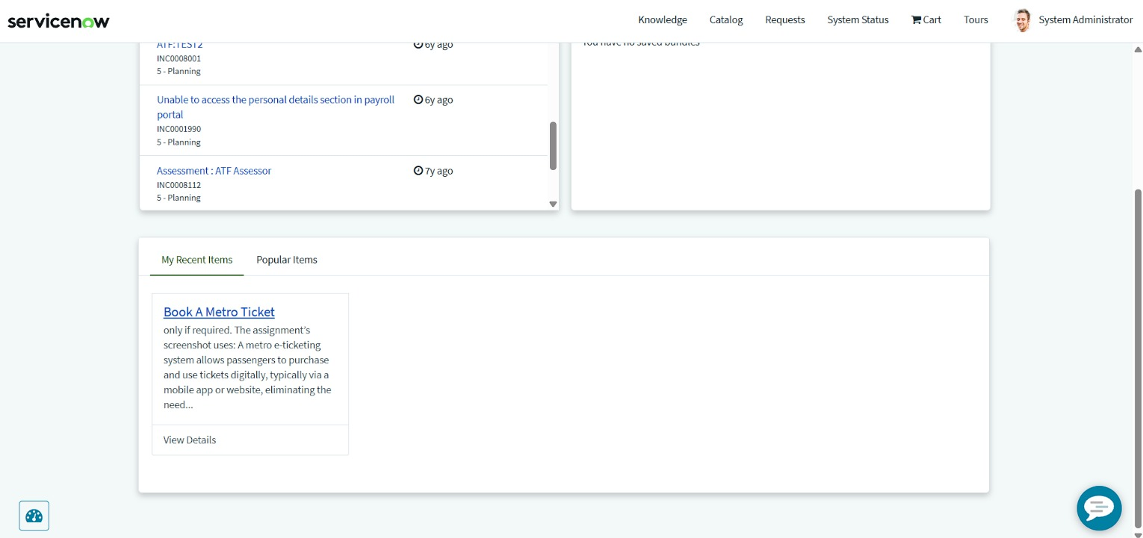
Figure 1. The passenger's starting point: Book A Metro Ticket under My Recent Items in the Service Portal.

Supporting persona: Station gate staff
The second perspective is the person who checks tickets at the gate. The notes below are hypotheses to guide design and testing, not measured feedback.
THINKS & FEELS  • "Can I validate this quickly?"  • Wants the journey details to be readable from the code. | SEES  • A QR code on the passenger's device or printout.  • The passenger waiting in a queue.
HEARS  • Passengers asking whether the ticket is valid.  • Operations guidance on accepted tickets. | SAYS & DOES  • Scans the code at the gate.  • Lets valid passengers through.

PAIN  • Unreadable or incomplete codes.  • Disputes about what was paid. | GAIN  • One code with the journey details.  • A matching request record to check against.

Design opportunities derived from the empathy maps
- Keep the form short, with clear labels and a visible asterisk on every required field.
- Show the fare automatically so the passenger never has to calculate it.
- Show the extra payment field only when it is needed (Others).
- Present the QR code in a clear modal with a plain instruction to scan it at the gate.
- Leave a request record the passenger can open to confirm the booking.

Evidence note
The maps synthesise the project's catalog form, fare calculation, QR ticket and request-tracking concepts. Thoughts and feelings are design hypotheses and should be validated with real passengers if user research is carried out.

