PROJECT REPORT
METRO TICKET GENERATING SYSTEM
using ServiceNow
Final Project Documentation
Project information | Details
Project name | Metro Ticket Generating System - ServiceNow
Participant | Individual participant - 323103312150@gvpce.ac.in
Report date | 14 October 2026
Platform | ServiceNow: Service Catalog, Catalog Client Scripts, Catalog UI Policy, Service Portal widget
Instance | ServiceNow personal developer instance (dev454410)
Repository | https://github.com/akhil111891/metro-ticket-generating-system
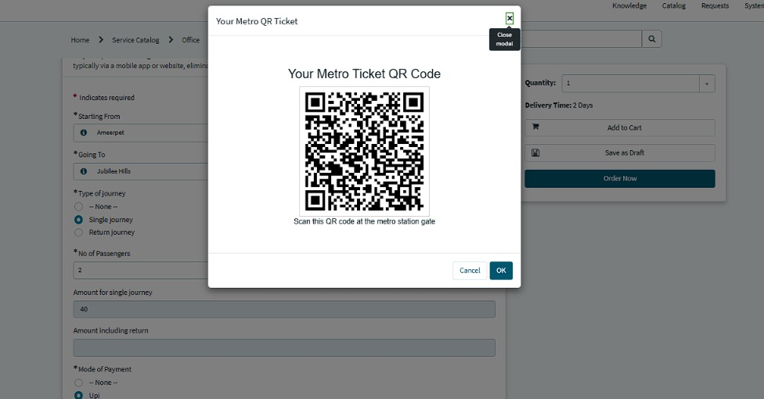
The generated Metro QR ticket (project output)

CONTENTS
1. Introduction 1
1.1 Project Overview 1
1.2 Purpose 1
2. Ideation Phase 1
2.1 Problem Statement 1
2.2 Empathy Map Canvas 1
2.3 Brainstorming 1
3. Requirement Analysis 1
3.1 Customer Journey Map 1
3.2 Solution Requirements 1
3.3 Data Flow Diagram 1
3.4 Technology Stack 1
4. Project Design 1
4.1 Problem-Solution Fit 1
4.2 Proposed Solution 1
4.3 Solution Architecture 1
5. Project Planning and Scheduling 1
5.1 Project Planning 1
6. Functional and Performance Testing 1
6.1 Performance Testing 1
7. Results 1
7.1 Output Screenshots 1
8. Advantages and Disadvantages 1
9. Conclusion 1
10. Future Scope 1
11. Appendix 1
A. Source Code (Configuration Artifact) 1
B. Dataset Link 1
C. GitHub and Project Demo Link 1
D. Glossary 1

1. Introduction

1.1 Project Overview
The Metro Ticket Generating System is a ServiceNow-based application designed to simplify metro ticket booking through a Service Portal. Passengers select a starting station and a destination, choose a single or return journey, enter the number of passengers, see the fare calculated automatically, and receive a QR code that contains their journey details.
The project uses ServiceNow Service Catalog, Catalog Client Scripts, Catalog UI Policies, a Service Portal widget and a metro station table to implement the booking workflow. The booking then continues through the native ServiceNow Order Confirmation and Checkout flow and is saved as a request that can be checked in ServiceNow. The work is configuration and scripting on the platform rather than a separate application.
Item | Detail
Catalog item | Book A Metro Ticket (Service Catalog > Office > Services)
Variables | Starting From, Going To, Type of journey, No of Passengers, Amount for single journey, Amount including return, Mode of Payment, Enter payment mode
Journey types | Single journey; Return journey
Payment modes | UPI; Card; Others (Others reveals Enter payment mode)
Station data | Metro Station Details table (u_metro_station_details) with seven stations
Form logic | Catalog Client Scripts (fare calculation) and a Catalog UI Policy (Show Enter payment mode)
Ticket | QR code in a Service Portal modal: Your Metro Ticket QR Code
Order and tracking | Native Order Confirmation and Checkout; Request Summary; REQ and RITM records

Key features
- Station selection: choose the starting and destination metro stations.
- Automatic fare calculation: total fare based on the route, journey type and passenger count.
- Payment mode selection: the additional payment-details field is shown when Others is selected.
- QR ticket generation: a QR code containing the selected journey details.
- Order confirmation: continue through the native ServiceNow Order Confirmation and Checkout flow.
- Request tracking: save the booking request and verify its status in ServiceNow.

1.2 Purpose
This report documents the project from problem definition through design, build, testing and results. It separates what the project demonstrates (screenshots, a recorded request, the station data and the UI Policy) from behaviour that still needs wider testing, such as decoding the QR code and checking every route.

Project objectives
- Give passengers one guided entry point for booking a metro ticket.
- Offer stations from a maintained table so station names are always valid.
- Calculate the fare automatically from the route, journey type and passenger count.
- Collect the payment mode and an extra detail when Others is chosen.
- Generate a QR ticket that carries the journey details.
- Complete the booking through native checkout and keep a request record for tracking.

2. Ideation Phase

2.1 Problem Statement
How might we let passengers book a metro ticket in one step, with the correct fare shown automatically and a QR ticket produced, while the booking is stored as a trackable record?
The project tackles the booking process: selecting stations, working out the fare for the journey type and group size, and delivering a usable ticket.
Stakeholder | Problem today | Desired outcome
Passenger | Does not know the fare until the counter; must calculate return and group totals. | A guided form with an automatic fare and a QR ticket.
Gate staff | Needs a quick way to check a ticket. | A QR code carrying the journey details.
ServiceNow administrator | Needs station data and form logic that are easy to maintain. | A station table, reusable variables and scripts, standard request records.

2.2 Empathy Map Canvas
The map describes the likely experience of the passenger and what each point means for the design. It is a design aid based on the project scope, not interview data.
Dimension | Passenger perspective | Design response
Says | "What will this trip cost for two of us?" | Fare shown on the form before payment.
Thinks | "Is the return fare different? Will the ticket work?" | Separate single and return amount fields; QR with scan instruction.
Does | Picks stations, journey type and passengers, then pays. | Short form with required fields marked.
Feels | Uncertain when costs or tickets are unclear. | Immediate fare and a confirmation request number.
Pain points | Manual calculation, queues, no proof of booking. | Automatic calculation, QR ticket, REQ record.
Needs | A simple form and a ticket that works at the gate. | Native checkout and QR modal.

2.3 Brainstorming
Four ways of delivering the booking were compared on consistency, ease of use and feasibility.
Option | Strength | Limitation | Decision
Counter / paper tickets | Familiar. | Slow; fare worked out manually. | Not the target of this project.
Spreadsheet fare chart | Simple to maintain. | No booking, no ticket, no tracking. | Useful only as a data source.
Custom standalone app | Full control. | Needs separate hosting, security and support. | More effort than the problem needs.
ServiceNow catalog + portal widget | Uses platform forms, scripts, checkout and request records. | Depends on correct scripts and data. | Selected.
The core design principle is to build the ticket from exactly what the passenger selected: stations, journey type and passenger count drive the fare, and the same selections drive the QR code.

3. Requirement Analysis

3.1 Customer Journey Map
The journey starts when a passenger opens the portal to book a ticket and ends when the request is confirmed. Figure numbers refer to the screenshots in Section 7.1.
Stage | Steps | Touchpoints | User goal | Opportunity
Access | Open the portal and the catalog item (Fig 1). | Service Portal home | Find the booking item. | Clear title and a descriptive summary.
Choose route | Select Starting From and Going To (Figs 2, 3). | Catalog form | Use valid stations. | Searchable drop-downs from the station table.
Journey | Choose single or return and passengers (Fig 3). | Radio buttons; drop-down | Right fare for the group. | Show the amount immediately.
Payment | Choose UPI, Card or Others (Fig 4). | Mode of Payment | State how to pay. | Show extra detail only when needed.
Ticket | View the QR code (Fig 5). | QR modal | A usable ticket. | Clear scan instruction.
Confirm | Order Now and Checkout (Fig 6). | Order Confirmation | Complete the booking. | Keep the native flow.
Track | Open the request (Figs 7, 8). | Request Summary; REQ | Know the booking is saved. | Carry the fare into the request price.

3.2 Solution Requirements

Functional requirements
ID | Requirement | How it is checked
FR-01 | Offer a Service Catalog item for booking a metro ticket. | Item is visible in the portal (Fig 1).
FR-02 | Provide Starting From and Going To drop-downs fed by the Metro Station Details table; both required. | Fig 2 and Fig 9.
FR-03 | Let the passenger choose Single or Return journey and the number of passengers. | Fig 3.
FR-04 | Calculate and display the fare from route, journey type and passengers. | Fig 3 (amount 40 in the recorded example).
FR-05 | Offer UPI, Card and Others; show a mandatory Enter payment mode when Others is chosen. | Figs 4 and 10.
FR-06 | Generate a QR code containing the journey details and show it in a modal. | Fig 5.
FR-07 | Complete the order through Order Confirmation and Checkout. | Fig 6.
FR-08 | Save the booking as a request and let the passenger see its status. | Figs 7 and 8.

Non-functional requirements
ID | Area | Requirement
NFR-01 | Usability | Clear labels, required markers and an automatic fare on the booking form.
NFR-02 | Security | Platform roles and ACLs limit record access to authorised users.
NFR-03 | Reliability | Fare and QR content must match the selected route, journey type and passengers.
NFR-04 | Performance | Fare calculation and QR generation respond immediately; targets to be measured in testing.
NFR-05 | Availability | Follows the availability of the hosted ServiceNow instance.
NFR-06 | Scalability | New stations and fare rules are added through records and configuration.

User stories
ID | User | Story
USN-1 | Passenger | Choose my starting and destination stations from a list.
USN-2 | Passenger | Choose single or return and the number of passengers.
USN-3 | Passenger | See the fare calculated automatically before paying.
USN-4 | Passenger | Choose a payment mode and describe it if it is Others.
USN-5 | Passenger | Receive a QR code with my journey details to scan at the gate.
USN-6 | Passenger | Confirm the order and see my request status.
USN-7 | Administrator | Maintain stations in a table without editing scripts.
USN-8 | Tester | Verify fares, validation, payment field, QR and request creation.

3.3 Data Flow Diagram
Passenger inputs flow into the booking process, which reads the station list, calculates the fare, generates the QR code and, on checkout, stores the request. The passenger receives the fare, the ticket, the confirmation and the request status.
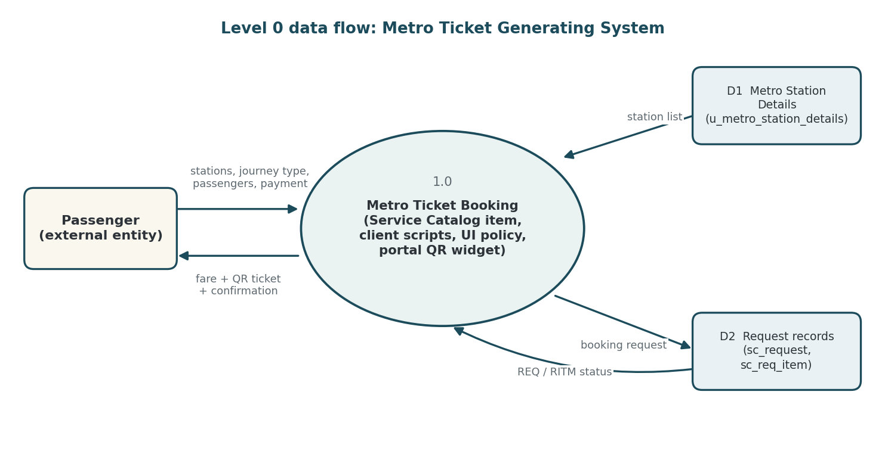
Diagram 1. Level 0 data flow for the Metro Ticket Generating System.
Data store | Role in the flow | Key information
Metro Station Details (u_metro_station_details) | Source of valid stations | Station Name (7 stations)
Request (sc_request) | Parent request record | Requested for, approval, state (REQ0010002)
Requested Item (sc_req_item) | Catalog item instance | Item, due date, stage (RITM0010002)

3.4 Technology Stack
The solution is built entirely on ServiceNow platform capabilities. No separate server, external API or machine-learning component is used.
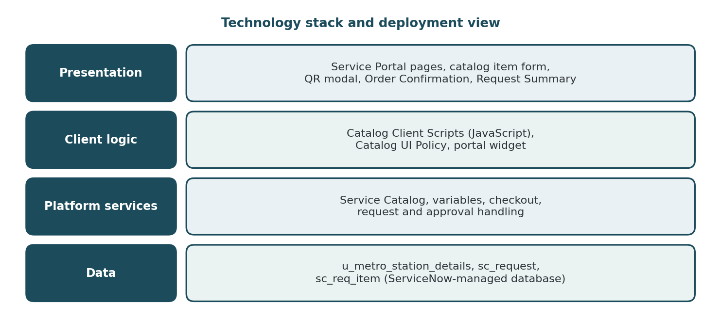
Diagram 2. Technology stack of the Metro Ticket Generating System.
Component | Technology | Role
User interface | Service Catalog, Service Portal, web browser | Booking form, QR modal, checkout, request status.
Form logic | Catalog Client Scripts (JavaScript) | Fare calculation and form behaviour.
Conditional field | Catalog UI Policy | Shows and requires Enter payment mode for Others.
Ticket | Service Portal widget | Generates and displays the QR code.
Data | u_metro_station_details, sc_request, sc_req_item | Stations and booking records in platform-managed tables.
Security | Roles and ACLs | Restrict who can view and manage records.

4. Project Design

4.1 Problem-Solution Fit
The difficulty is working out and proving a fare quickly, not printing a ticket. A guided form improves accuracy, automatic calculation removes manual arithmetic, a QR ticket gives the passenger something usable, and the request record gives proof of the booking.
1 TARGET USERS  Passengers booking metro tickets  • Need a quick, clear route.  • Travel alone or in groups.  • Choose single or return. | 2 PROBLEM / FRICTION  Fares and tickets are hard to work out  • Fare unknown until the counter.  • Manual totals for groups and returns.  • No instant proof of booking.
3 PROPOSED SERVICE  Book A Metro Ticket  • Stations from a validated table.  • Automatic fare.  • QR ticket and request record. | 4 VALUE  A visible, trackable booking  • Fare known before paying.  • One form for all trip types.  • Request record to verify.
5 RISKS AND VALIDATION  Value depends on correct configuration  • Test every route and journey type.  • Decode the QR content.  • Keep station data current. | NEXT STEP  Validate with passengers  • Run the booking with real users.  • Collect feedback.
Figure: Problem-solution fit canvas for the metro ticket booking workflow.

4.2 Proposed Solution
Parameter | Description
Problem to solve | Passengers need a fast, clear way to book metro tickets with the correct fare and a ticket that works at the gate.
Solution | A ServiceNow catalog item collects stations, journey type, passenger count and payment mode; client scripts calculate the fare; a UI Policy controls the payment-detail field; a widget generates the QR code; native checkout saves the request.
What is distinctive | Integration rather than a new algorithm: station data, fare logic, ticket and request tracking run in one platform process.
Benefit to users | Fare visible before paying, a QR ticket and a request reference. These are expected benefits to be confirmed by user feedback.
Business value | A demonstration of a digital ticketing workflow; no revenue model is specified.
Scalability | More stations, routes, fare rules and payment modes can be added through records and configuration, within instance capacity.

4.3 Solution Architecture
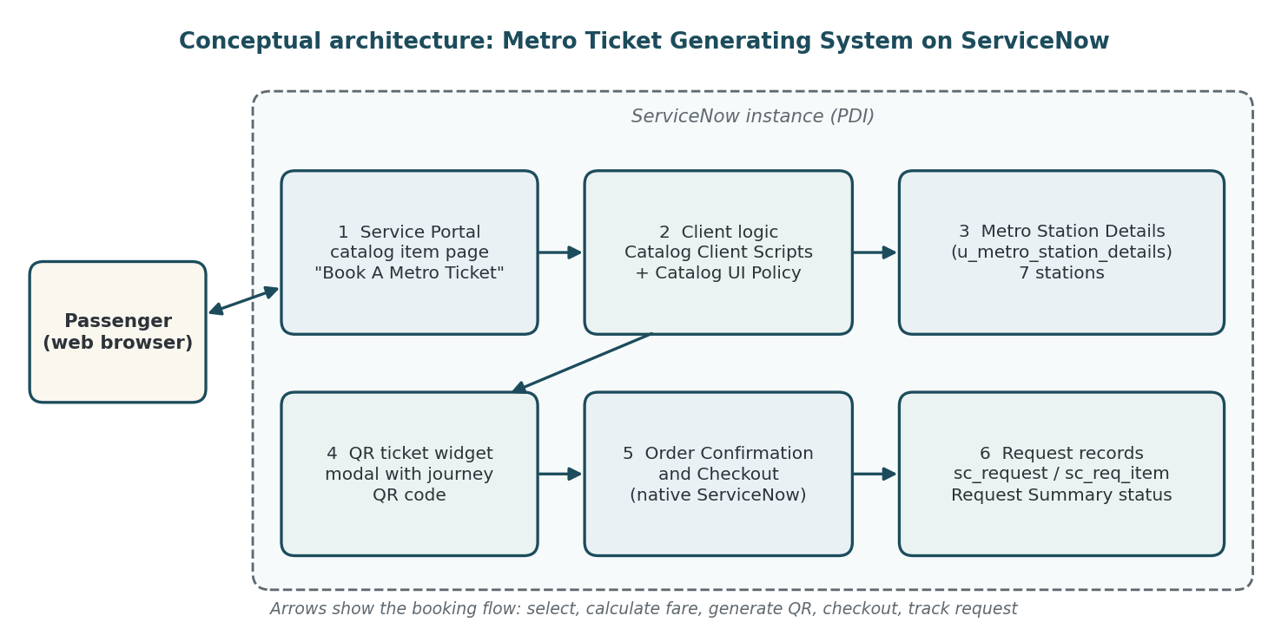
Diagram 3. Conceptual architecture of the Metro Ticket Generating System.
- The passenger opens Book A Metro Ticket and selects the stations from the station table.
- The passenger chooses journey type and passenger count; the client scripts show the amounts.
- The passenger chooses a payment mode; Others reveals Enter payment mode.
- The widget generates the QR code from the selected details.
- The passenger completes Order Confirmation and Checkout; the request and requested item are created.
- The passenger checks the Request Summary for the REQ number and stage.

5. Project Planning and Scheduling

5.1 Project Planning
The plan follows the build order of the project. Story points are planning estimates; no recorded velocity is available.
Phase | Work package | Exit condition | Story points
Phase 1 | Requirements, scope and the Metro Station Details table with station records. | Stations available. | 4
Phase 2 | Catalog item, variables and mandatory-field validation. | Form opens and submits. | 5
Phase 3 | Fare calculation (client scripts) and payment-mode UI Policy. | Fare and field behaviour verified. | 7
Phase 4 | QR ticket widget; Order Confirmation, checkout and request creation. | QR and REQ number produced. | 8
Phase 5 | Testing in the developer instance; documentation and screenshots. | Results recorded. | 7
Total |  |  | 31

6. Functional and Performance Testing
Testing was carried out in the project's ServiceNow personal developer instance and covered fare calculations, station validation, payment field behaviour, QR generation and request submission. Results are summarised below; evidence figures are in Section 7.1.
ID | Scenario | Expected result | Status
FT-01 | Station selection and required fields | Required fields marked; stations from the station table. | Passed (Figs 2, 3, 9)
FT-02 | Fare - single journey | Amount calculated (observed 40 for Ameerpet to Jubilee Hills, 2 passengers). | Passed (Fig 3)
FT-03 | Fare - return and passenger count | Amounts update with the selection. | Passed (owner-reported)
FT-04 | Payment field visibility | Enter payment mode shown and mandatory for Others. | Passed (Figs 4, 10)
FT-05 | QR ticket generation | QR modal with scan instruction. | Passed (Fig 5)
FT-06 | Order confirmation | Order Confirmation dialog with Checkout. | Passed (Fig 6)
FT-07 | Request submission | REQ created; Request Summary shown. | Passed (Figs 7, 8)
FT-08 | Request tracking | REQ and linked RITM visible. | Passed (Fig 8)
Eight of eight executed functional cases passed. Seven of the eight have a screenshot; FT-03 is based on the project owner's report.

6.1 Performance Testing
No response-time, concurrency or load measurements were recorded. Fare calculation and QR generation appear immediate in use, but no timing has been measured, so no performance figure is claimed. Recommended checks are repeated fare calculations, repeated QR generation with decoding, and several bookings in a non-production instance.

Observations from testing
ID | Observation | Suggested action
O-1 | The item description under the form title contains stray draft text (Figs 2, 3). | Replace with a short passenger-friendly description.
O-2 | Enter payment mode is visible before Others is selected (Fig 2) and becomes mandatory for Others (Fig 4). | Confirm intended visibility and adjust the UI Policy actions if needed.
O-3 | Request Summary price and total show $0.00 although a fare is calculated (Fig 7). | Decide whether the fare should feed the catalog item price.

7. Results

7.1 Output Screenshots
The screenshots below were captured from the ServiceNow personal developer instance and follow the booking from start to finish.
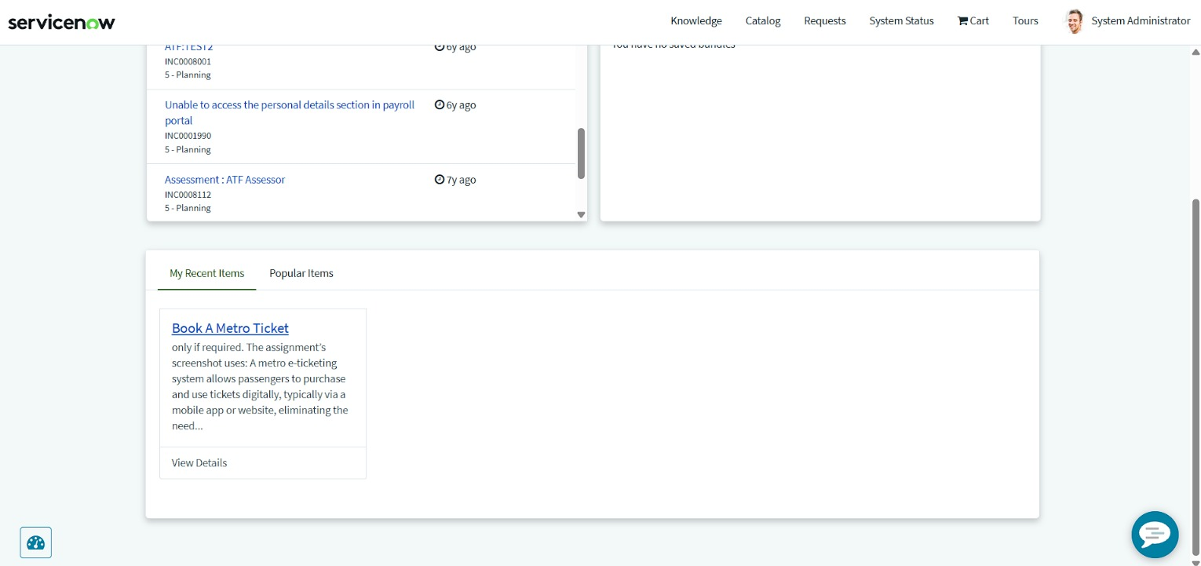
Figure 1. Service Portal home: Book A Metro Ticket appears under My Recent Items.
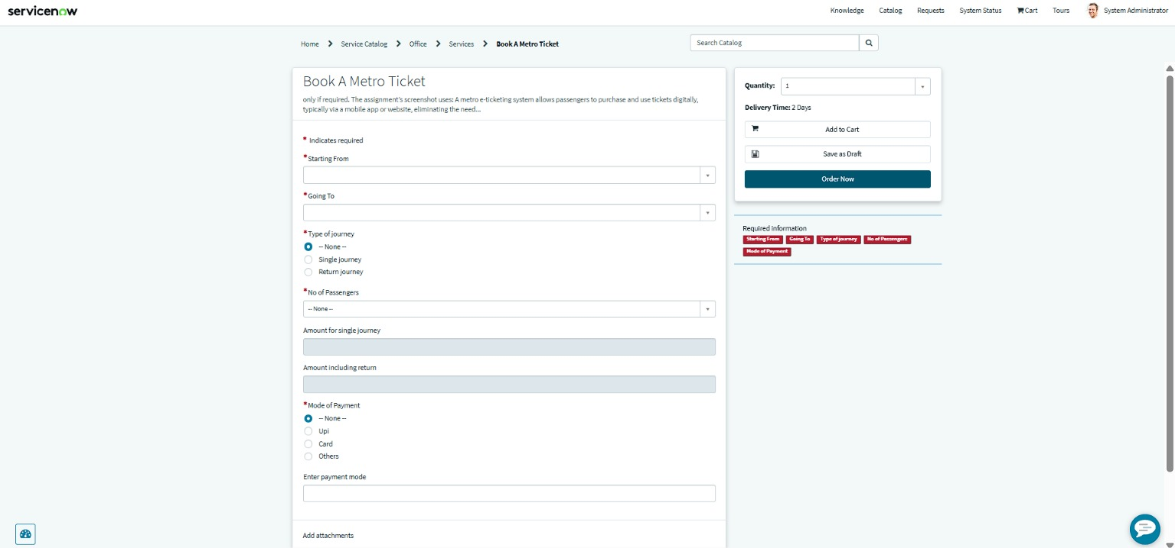
Figure 2. Book A Metro Ticket form: Starting From, Going To, Type of journey, No of Passengers, amount fields, Mode of Payment and Enter payment mode.
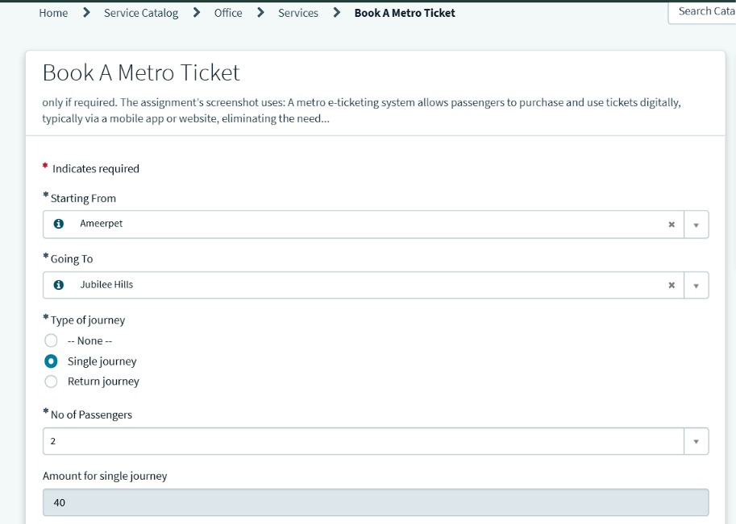
Figure 3. Starting From Ameerpet, Going To Jubilee Hills, Single journey, 2 passengers: Amount for single journey = 40.
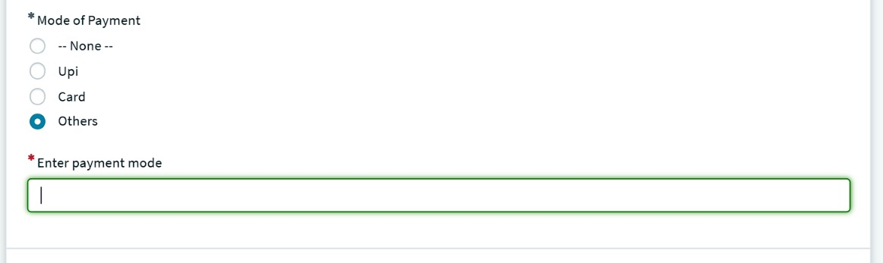
Figure 4. Mode of Payment = Others: Enter payment mode appears as a required field.
Figure 5. Your Metro Ticket QR Code modal with the instruction to scan the code at the metro station gate.
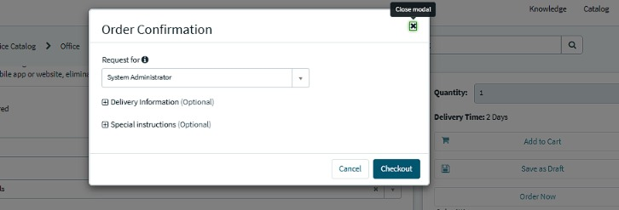
Figure 6. Order Confirmation dialog (Request for: System Administrator; Delivery Information and Special instructions optional).
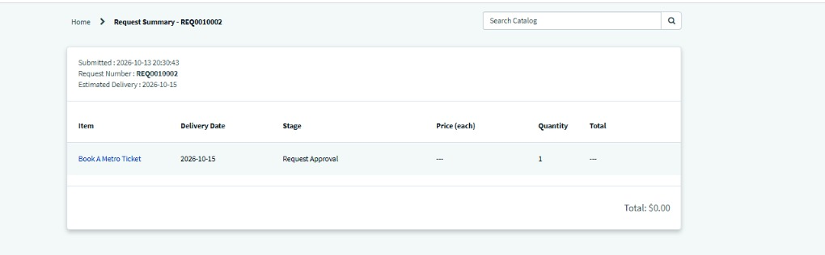
Figure 7. Request Summary REQ0010002: submitted 2026-10-13 20:30:43, item Book A Metro Ticket, stage Request Approval.
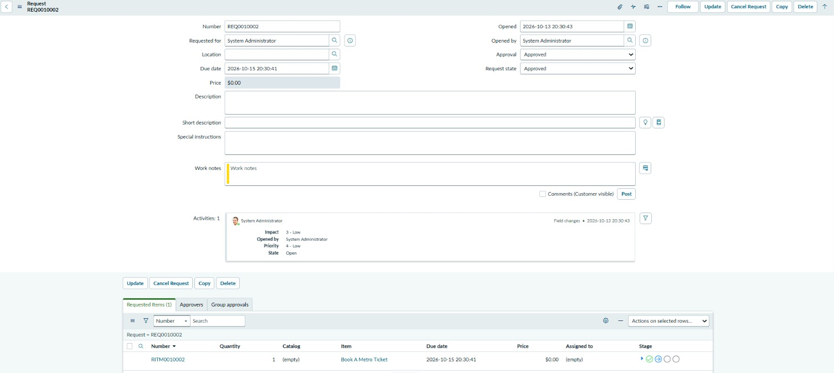
Figure 8. Request record REQ0010002: Approval = Approved, Request state = Approved; requested item RITM0010002.
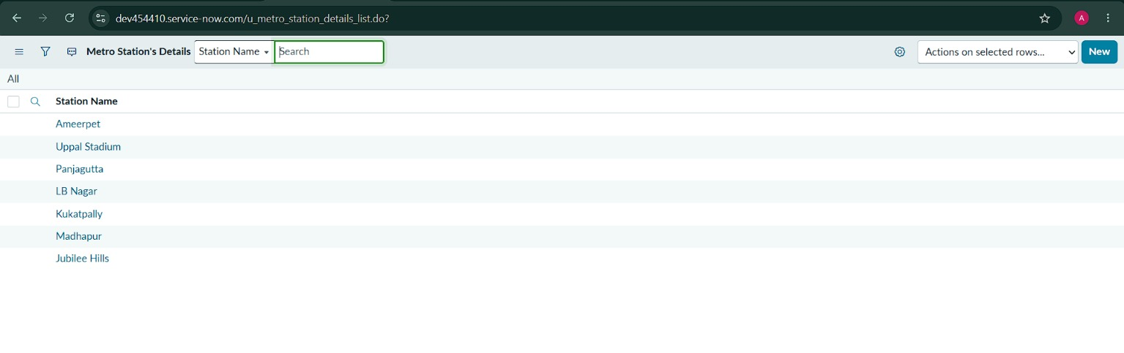
Figure 9. Metro Station's Details (u_metro_station_details): seven stations.
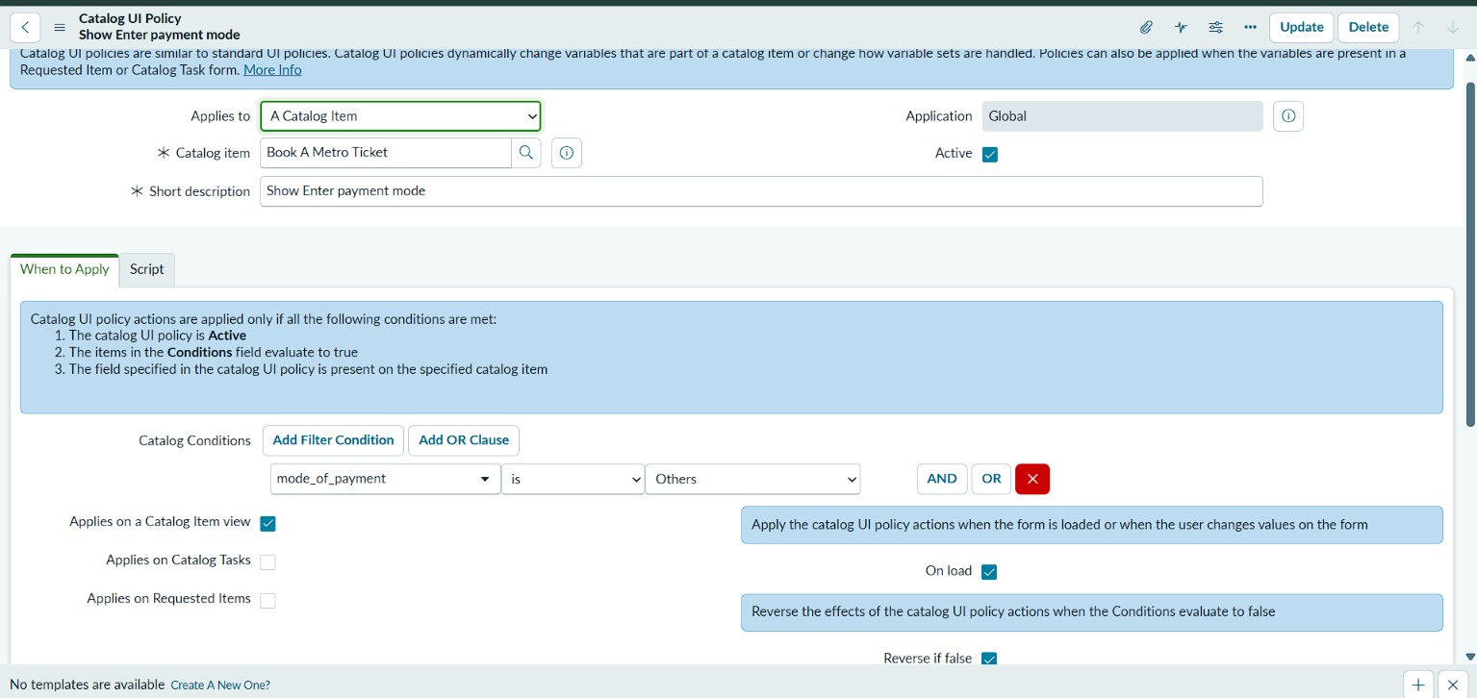
Figure 10. Catalog UI Policy Show Enter payment mode: Catalog item Book A Metro Ticket; condition mode_of_payment is Others.

8. Advantages and Disadvantages

Advantages
- Passengers see the fare before paying and do not have to calculate it.
- One form covers single and return journeys and any group size.
- A QR ticket and a request record give proof of the booking.
- Stations are kept in one table and can be updated without changing scripts.
- The solution reuses native ServiceNow checkout and request records, so no separate system is needed.

Disadvantages and limitations
- Fare logic and QR content have been tested on a limited set of cases; full route coverage and QR decoding are not yet evidenced.
- The fare is not carried into the request price, so the Request Summary shows $0.00.
- No payment gateway is integrated; Mode of Payment records the passenger's choice only.
- No notifications are part of the documented scope.
- The solution runs in a personal developer instance, which has no production availability commitment.

9. Conclusion
The Metro Ticket Generating System shows that a complete booking journey, from station selection and automatic fare calculation to a QR ticket and a tracked request, can be built with native ServiceNow capabilities. Testing in the developer instance confirmed fare calculation, station selection, the conditional payment field, QR generation and request submission, with one recorded request (REQ0010002) as end-to-end evidence. The remaining work is to widen route coverage, verify the QR content with a scanner and resolve the three observations.

10. Future Scope
- Decode and verify the QR content, and add a gate-validation check.
- Feed the calculated fare into the catalog item price so the request total is accurate.
- Integrate a real payment gateway for UPI and card payments.
- Add confirmation notifications with the ticket details.
- Extend the station table and fare rules to a full metro network, including multiple lines.
- Add reporting on bookings by route, journey type and payment mode.
- Export the configuration as an update set for transfer between instances.

11. Appendix

A. Source Code (Configuration Artifact)
The solution is configuration on the ServiceNow platform. The artifacts below make up the build; export them as an update set to keep a transferable copy. Script source is not included in the supplied evidence.
Artifact | Detail
Catalog item | Book A Metro Ticket (Service Catalog > Office > Services)
Catalog variables | Starting From, Going To, Type of journey, No of Passengers, Amount for single journey, Amount including return, Mode of Payment, Enter payment mode (mode_of_payment is the variable name referenced by the UI Policy)
Catalog Client Scripts | Fare calculation and form behaviour (script records to be attached)
Catalog UI Policy | Show Enter payment mode: condition mode_of_payment is Others; applies on the Catalog Item view; On load; Reverse if false
Service Portal widget | QR ticket modal (widget record to be attached)
Table | Metro Station's Details (u_metro_station_details), field Station Name

B. Dataset Link
The station dataset is held in the Metro Station Details table in the ServiceNow instance.
No. | Station Name
1 | Ameerpet
2 | Uppal Stadium
3 | Panjagutta
4 | LB Nagar
5 | Kukatpally
6 | Madhapur
7 | Jubilee Hills
Fare data point recorded: Ameerpet to Jubilee Hills, single journey, 2 passengers, amount 40. The complete fare matrix is held in the project's fare logic and is not part of the supplied evidence.

C. GitHub and Project Demo Link
Item | Link
ServiceNow instance | dev454410.service-now.com (personal developer instance)
GitHub repository | To be added by the project owner
Demo video | To be added by the project owner

D. Glossary
Term | Meaning
Service Catalog | ServiceNow module that lets users order items and services through forms.
Catalog item | An orderable entry in the catalog; here, Book A Metro Ticket.
Catalog Client Script | Browser-side script that runs on a catalog item form.
Catalog UI Policy | Rule that shows, hides or requires catalog variables based on conditions.
Service Portal | ServiceNow's self-service web interface.
Widget | A reusable component of a Service Portal page.
REQ / RITM | Request and Requested Item records created when a catalog item is ordered.
PDI | Personal developer instance of ServiceNow.
QR code | Two-dimensional barcode that can store the journey details.

