Ideation Phase
Brainstorm & Idea PrioritizationTemplate
Date | 14-10-2026
Team ID | Individual participant - 323103312150@gvpce.ac.in
Project Name | Metro Ticket Generating System - ServiceNow
Maximum Marks | 4 Marks

This ideation document frames the problem and compares practical concepts for a ServiceNow-based metro ticket booking process. The aim is to let a passenger pick a route, see the fare immediately, and leave with a QR ticket, while the booking is saved as a standard ServiceNow request. The ideas are a structured design rationale based on the project build, not a record of a formal workshop or scoring exercise.

Step-1: Team Gathering, Collaboration and Select the Problem Statement

Problem statement
Buying a metro ticket at a counter or by working out fares by hand is slow and error-prone. Passengers need to know the fare before paying, groups need the total for several people, and return journeys need a different amount from single journeys. The project proposes a ServiceNow Service Catalog item, delivered through a Service Portal, that calculates the fare automatically, produces a QR code containing the journey details, and saves the booking as a trackable request.

Stakeholders and needs
Stakeholder | Primary need
Passenger / requester | Choose stations, journey type and passenger count; see the fare; receive a QR ticket.
Metro operations (gate / ticket check) | A QR code that carries the journey details so the ticket can be checked at the station gate.
ServiceNow administrator | Maintain the station list, fare logic, form behaviour and request records in one platform.

Solution direction
Use one Service Catalog form as the single entry point. Load stations from a dedicated Metro Station Details table, calculate the fare with Catalog Client Scripts, reveal the payment-details field with a Catalog UI Policy, generate the QR code in a Service Portal widget, and complete the booking through the native Order Confirmation and Checkout flow.
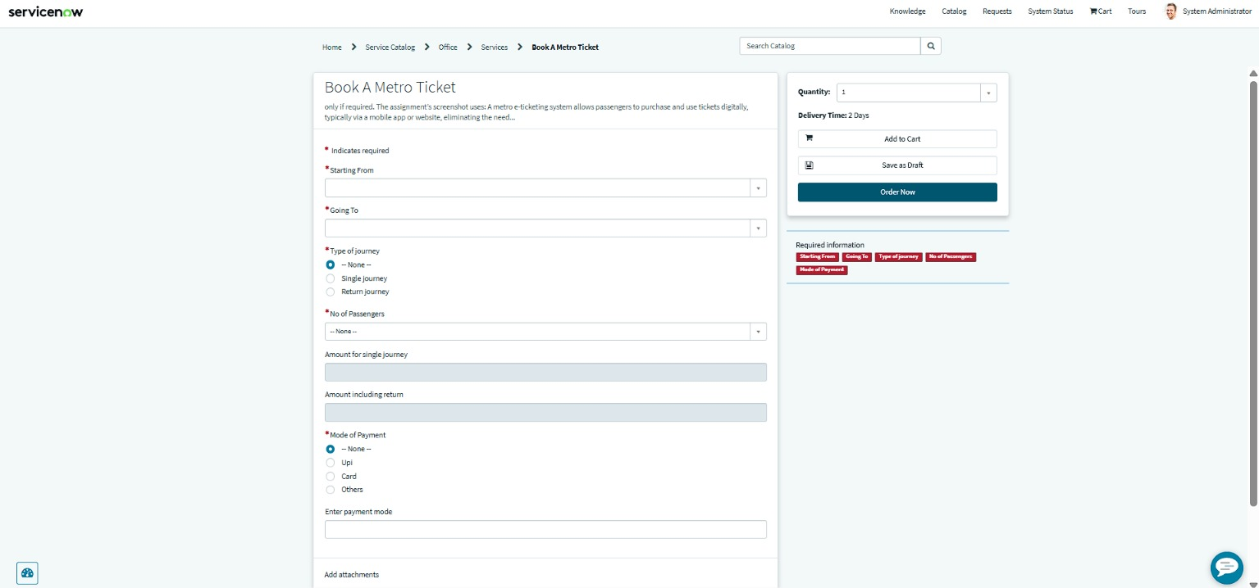
Figure 1. Book A Metro Ticket catalog item form in the Service Portal (project evidence).

Step-2: Brainstorm, Idea Listing and Grouping
The ideas are grouped by the part of the booking journey they improve.

A. Booking intake and data quality
Idea | Description
Guided booking form | One catalog item titled Book A Metro Ticket with clearly labelled fields and a red asterisk on every required field.
Station drop-downs | Starting From and Going To are chosen from the Metro Station Details table, so station names are always valid and consistent.
Journey type choice | Single journey or Return journey radio buttons decide which amount applies.
Passenger count | A drop-down for the number of passengers so the total fare covers the whole group.

B. Fare and payment
Idea | Description
Automatic fare calculation | Show Amount for single journey and Amount including return as read-only fields that update from the route, journey type and passenger count.
Payment mode selection | Offer UPI, Card and Others as Mode of Payment options.
Conditional payment detail | When Others is selected, show a mandatory Enter payment mode field so the passenger can state the method.

C. Ticket and confirmation
Idea | Description
QR ticket | Generate a QR code carrying the journey details and display it in a modal with the instruction to scan it at the station gate.
Native order confirmation | Continue through the standard Order Confirmation and Checkout dialog instead of building a separate payment screen.
Request tracking | Use the Request Summary page and the REQ and RITM records to confirm the booking and its stage.

D. Administration
Idea | Description
Reusable platform records | Use standard request and requested-item records rather than a separate booking database.
Editable station list | Keep stations in their own table so new stations can be added without changing scripts.

Step-3: Idea Prioritization
Idea | Impact | Effort | Decision
Station table + drop-downs | High | Low | Build first; every other feature depends on it.
Automatic fare calculation | High | Medium | Core value of the project.
QR ticket generation | High | Medium | Delivers the usable ticket.
Conditional payment field | Medium | Low | Quick win with a UI Policy.
Native checkout and tracking | Medium | Low | Reuse platform features.
Separate custom payment gateway | Medium | High | Out of scope for this build.
Impact and effort ratings are the author's planning judgement, not measured scores.

