Project Design Phase
Problem - Solution Fit Template
Date | 14-10-2026
Team ID | Individual participant - 323103312150@gvpce.ac.in
Project Name | Metro Ticket Generating System - ServiceNow
Maximum Marks | 2 Marks

Problem - Solution Fit Template:
Problem-Solution Fit means identifying a meaningful customer problem and proposing a solution that addresses the customer's needs and behaviour. For this project, the fit hypothesis is that one ServiceNow booking journey can connect station selection, automatic fare calculation, QR ticket generation and request tracking.

Purpose
- Solve the ticket-booking problem in a way that fits how passengers actually plan a trip.
- Use the familiar ServiceNow Service Catalog and Service Portal as the access channel.
- Show the fare and a QR ticket immediately so the passenger trusts the booking.
- Reduce manual fare calculation and counter queues by linking route, journey type, passengers and payment in one form.
- Understand current friction points and validate whether the proposed workflow improves them.

Problem - Solution Fit Canvas
The canvas below summarises the target users, problem, proposed solution, expected value and assumptions to validate.
1 TARGET USERS  Passengers booking metro tickets  • Need a quick, clear way to book.  • Travel alone or in groups.  • Choose single or return trips. | 2 PROBLEM / FRICTION  Fares and tickets are hard to work out  • Fare unknown until the counter.  • Group and return totals are calculated by hand.  • No immediate proof of booking.
3 PROPOSED SERVICE  Book A Metro Ticket catalog item  • Pick stations from a validated list.  • Fare calculated automatically.  • QR ticket and request record created. | 4 VALUE  A visible, trackable booking  • Fare known before paying.  • One form for single, return and groups.  • Request record to verify the booking.
5 RISKS AND VALIDATION  Value depends on correct configuration  • Check fares for every route and journey type.  • Decode the QR code and confirm its content.  • Confirm the station list stays current. | NEXT STEP  Validate with passengers  • Run the booking with real users.  • Collect feedback on clarity and speed.
Figure 1. Problem-solution fit canvas for the metro ticket booking workflow.

Fit hypothesis and validation
Fit dimension | Project hypothesis | How to validate
Problem | Passengers need to know the fare and carry a ticket without queuing; administrators need bookings in one system. | Walk through a booking and confirm every needed input is present.
Solution | A catalog item with client scripts, a UI policy and a QR widget can cover the booking journey. | Verify fare values, payment field behaviour, QR generation and request creation.
Value | An instant fare and a QR ticket should reduce uncertainty and counter time. | Check the Request Summary and collect user feedback.
Assumptions | Station data, fare rules and form validation are configured correctly. | Test several routes and both journey types; inspect the station table and request records.
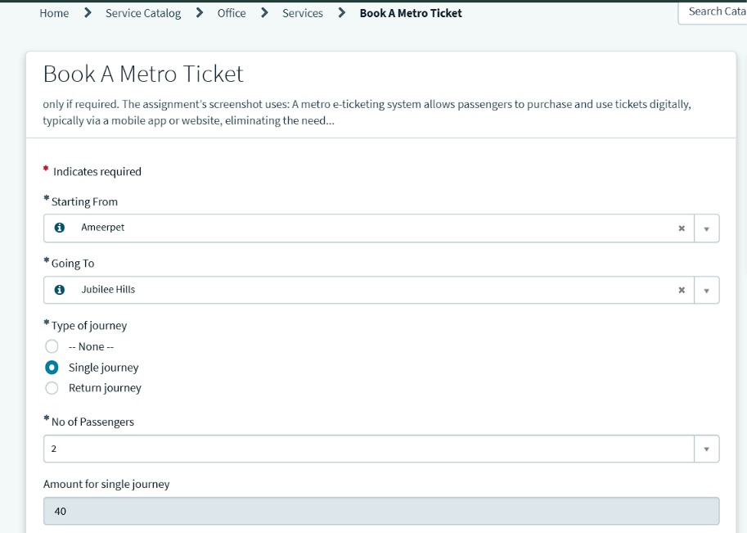
Figure 2. Fit in practice: route, journey type and passenger count produce a fare of 40 (Ameerpet to Jubilee Hills, single journey, 2 passengers).

Conclusion
The proposed solution has a plausible problem-solution fit because it uses native ServiceNow catalog, client-side logic and request records to connect station choice, fare, ticket and tracking. Fit remains a hypothesis until it is confirmed with real passenger feedback and wider route testing.

References
- https://www.ideahackers.network/problem-solution-fit-canvas/
- https://medium.com/@epicantus/problem-solution-fit-canvas-aa3dd59cb4fe

