Project Design Phase
Proposed Solution Template
Date | 14-10-2026
Team ID | Individual participant - 323103312150@gvpce.ac.in
Project Name | Metro Ticket Generating System - ServiceNow
Maximum Marks | 2 Marks

Project team shall fill the following information in the proposed solution template.
S.No. | Parameter | Description
1 | Problem Statement (Problem to be solved) | Passengers need a fast, clear way to book metro tickets: choose the route, know the exact fare for their journey type and group size, and receive a ticket they can scan at the gate. Counter purchase and manual fare calculation are slow and error-prone.
2 | Idea / Solution description | A ServiceNow Service Catalog item, Book A Metro Ticket, delivered through the Service Portal. Stations come from a Metro Station Details table; Catalog Client Scripts calculate the fare from the route, journey type and passenger count; a Catalog UI Policy shows the Enter payment mode field when Others is selected; a portal widget generates a QR code with the journey details; and the booking completes through the native Order Confirmation and Checkout flow and is saved as a request.
3 | Novelty / Uniqueness | The value is integration rather than a new algorithm: station data, fare calculation, conditional payment input, QR ticket and request tracking run in one ServiceNow process with no separate application or booking database.
4 | Social Impact / Customer Satisfaction | Passengers see the fare before paying and leave with a QR ticket and a request reference. This can shorten queues and reduce fare disputes. These are expected benefits and should be validated with user feedback.
5 | Business Model (Revenue Model) | The project is a demonstration of a digital ticketing workflow on ServiceNow, not a revenue-generating product. A real deployment could support operator revenue by collecting fares digitally; no revenue model is specified here.
6 | Scalability of the Solution | More stations are added as records in the station table. Additional routes, fare rules, payment modes or ticket types can be added by extending catalog variables, scripts and policies. Scalability depends on instance capacity, licensing and configuration quality.

Implementation principle
Keep selection, calculation and ticketing in clear steps: the passenger selects stations and journey details, the form calculates the fare, the QR code is generated from the chosen details, and the order is confirmed and saved as a request. The ticket is built from exactly what the passenger selected.
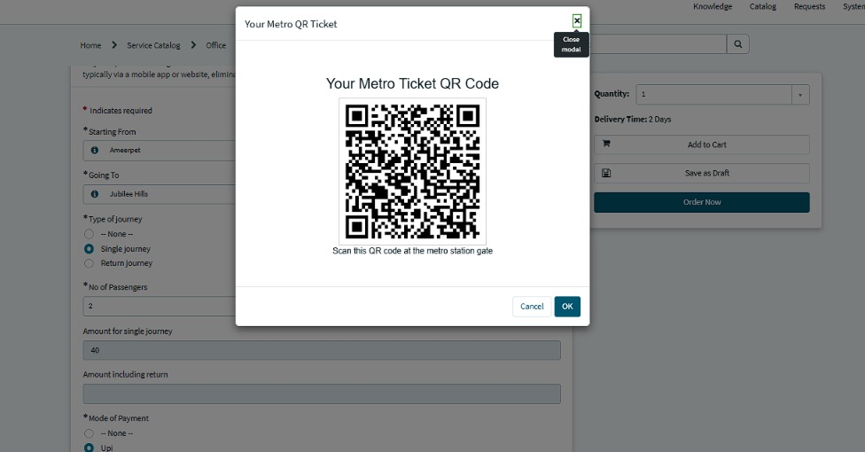
Figure 1. The generated ticket: Your Metro QR Ticket modal with the instruction to scan at the metro station gate.

Validation note
This document describes the proposed solution and expected value. It does not claim measured customer satisfaction, verified operational savings or a commercial revenue stream.

