Project Design Phase
Solution Architecture
Date | 14-10-2026
Team ID | Individual participant - 323103312150@gvpce.ac.in
Project Name | Metro Ticket Generating System - ServiceNow
Maximum Marks | 4 Marks

Solution Architecture
The solution architecture bridges the metro booking business need with ServiceNow platform capabilities. It defines the passenger, the catalog entry point, client-side logic, station data, ticket generation, order checkout and request records.
- Find the appropriate platform solution for self-service metro ticket booking.
- Describe the structure and behaviour of the catalog item, scripts, policy, widget and data tables.
- Define the booking lifecycle from station selection to a tracked request.
- Provide a clear conceptual design for configuration, testing and deployment.

Solution Architecture Diagram
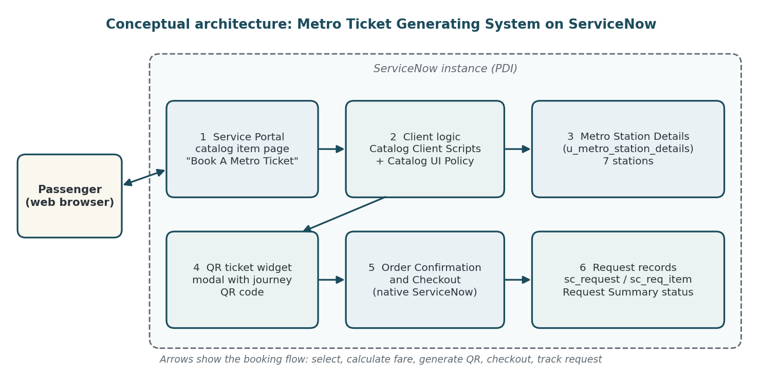
Figure 1. Conceptual architecture and data flow for the Metro Ticket Generating System.

Architecture Components
Component | Responsibility | Key artifacts / data
Passenger | Starts a booking and checks the resulting request. | Browser session; REQ number.
Service Portal catalog page | Presents the Book A Metro Ticket form. | Catalog item and variables (Starting From, Going To, Type of journey, No of Passengers, amounts, Mode of Payment).
Catalog Client Scripts | Calculate the fare and support station validation in the browser. | Fare logic using route, journey type and passenger count.
Catalog UI Policy | Controls the Enter payment mode field. | Policy Show Enter payment mode: mode_of_payment is Others.
Metro Station Details table | Provides valid station names. | u_metro_station_details, 7 stations.
QR ticket widget | Generates and displays the QR ticket. | Modal titled Your Metro Ticket QR Code.
Order Confirmation / Checkout | Completes the order. | Native dialog: Request for, Delivery Information, Special instructions.
Request records | Store the booking and its status. | sc_request, sc_req_item, Request Summary.
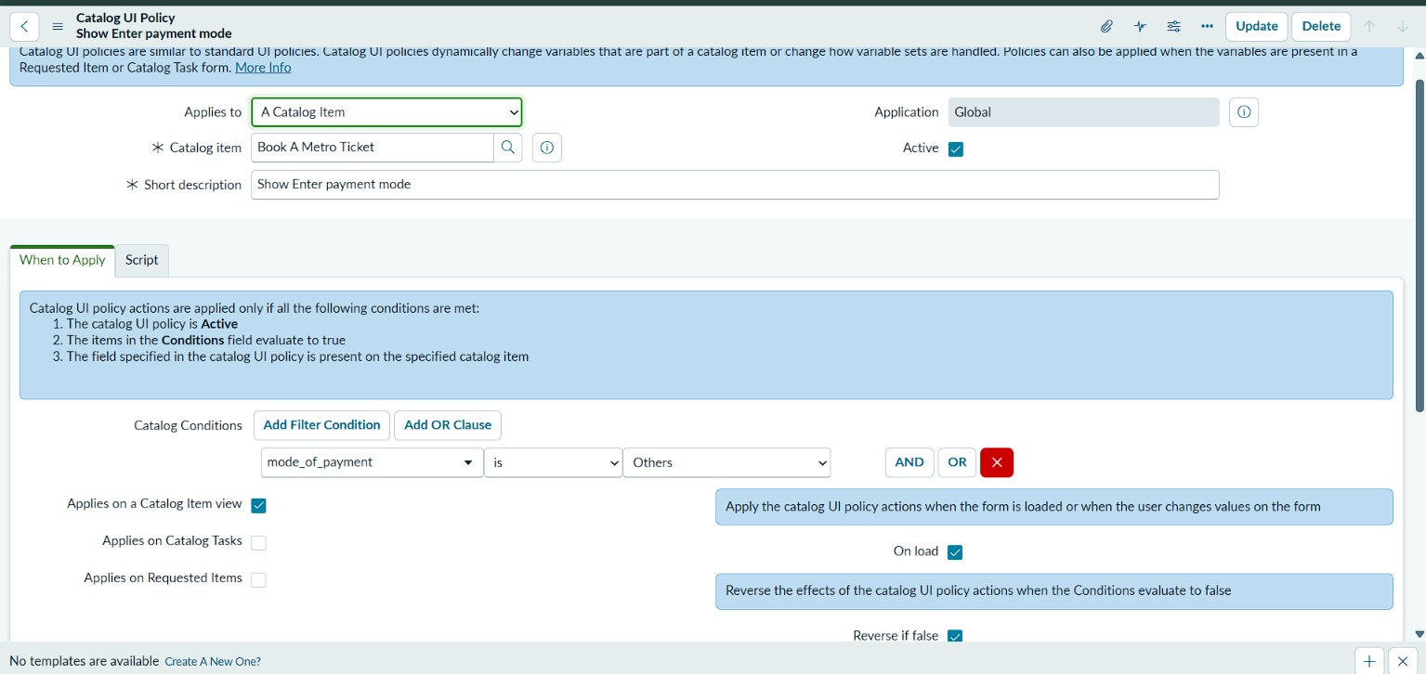
Figure 2. Catalog UI Policy Show Enter payment mode on the Book A Metro Ticket item (condition: mode_of_payment is Others).

Workflow and decision rules
- The passenger opens Book A Metro Ticket and selects Starting From and Going To from the station table.
- The passenger chooses Single or Return journey and the number of passengers; the client scripts calculate and show the amount fields.
- The passenger chooses a Mode of Payment; if Others is selected, Enter payment mode is shown and required.
- The QR widget generates a QR code containing the selected journey details and shows it in a modal.
- The passenger selects Order Now and completes Order Confirmation and Checkout; ServiceNow creates the request and requested item.
- The passenger opens the Request Summary to verify the REQ number, stage and approval state.

Architecture assumptions and validation
This is the intended target architecture, drawn from the build and the screenshots. Fare rules, the exact QR payload, roles and notification settings depend on instance configuration and should be verified during testing. The diagram is conceptual and does not claim that every connection has been validated beyond the tests reported in the testing documents.

