Project Design Phase-II
Solution Requirements (Functional & Non-functional)
Date | 14-10-2026
Team ID | Individual participant - 323103312150@gvpce.ac.in
Project Name | Metro Ticket Generating System - ServiceNow
Maximum Marks | 4 Marks

Functional Requirements:
Following are the functional requirements of the proposed solution.
FR No. | Functional Requirement (Epic) | Sub Requirement (Story / Sub-Task)
FR-1 | Station selection | Provide Starting From and Going To drop-downs populated from the Metro Station Details table.  Mark both fields as mandatory and validate the selection before submission.
FR-2 | Journey details | Let the passenger choose Single journey or Return journey.  Let the passenger choose the number of passengers.
FR-3 | Fare calculation | Calculate the fare automatically from the route, journey type and passenger count.  Show Amount for single journey and Amount including return as read-only fields.
FR-4 | Payment mode | Offer UPI, Card and Others as Mode of Payment.  Show a mandatory Enter payment mode field when Others is selected.
FR-5 | QR ticket | Generate a QR code that contains the selected journey details.  Display the QR code in a modal with an instruction to scan it at the station gate.
FR-6 | Order and tracking | Continue through the native Order Confirmation and Checkout flow.  Save the booking as a request and let the passenger verify its status in the Request Summary.
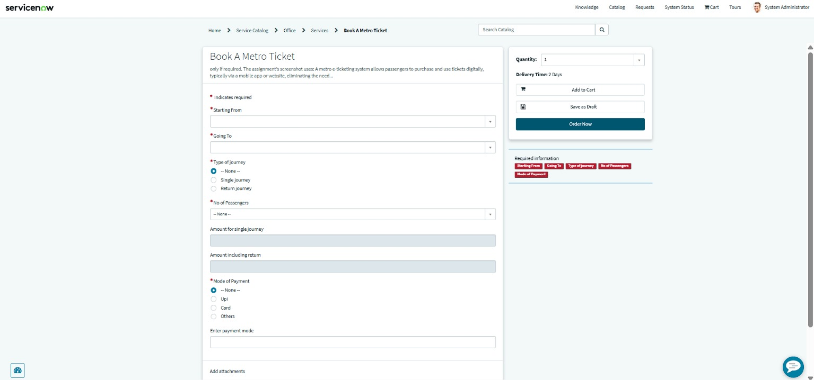
Figure 1. Catalog form showing the required fields that implement FR-1 to FR-4.

Non-functional Requirements:
Following are the non-functional requirements of the proposed solution.
NFR No. | Non-Functional Requirement | Description
NFR-1 | Usability | A clear, guided form with labelled fields, required-field markers and an automatic fare so passengers can book with minimal effort.
NFR-2 | Security | Use ServiceNow authentication, roles and record permissions so booking records are visible only to authorised users.
NFR-3 | Reliability | Fare values and QR content must match the selected route, journey type and passenger count every time.
NFR-4 | Performance | Fare calculation and QR generation should respond immediately in the browser; response-time targets are to be defined and measured in testing.
NFR-5 | Availability | The service is available when the underlying ServiceNow instance is available; platform SLA is environment-dependent.
NFR-6 | Scalability | New stations are added as records in the station table; additional fare rules are added through configuration.

Requirement note
These requirements describe the intended solution behaviour. Security controls, performance targets, availability and scalability must be validated against the configured ServiceNow instance; no unverified measurements are claimed.

