Project Design Phase-II
Technology Stack (Architecture & Stack)
Date | 14-10-2026
Team ID | Individual participant - 323103312150@gvpce.ac.in
Project Name | Metro Ticket Generating System - ServiceNow
Maximum Marks | 4 Marks

Technical Architecture:
The solution is built on the ServiceNow hosted platform. Passengers use the Service Portal and Service Catalog; Catalog Client Scripts and a Catalog UI Policy provide the form behaviour; a portal widget produces the QR ticket; and standard platform tables retain the booking and station data.
Architecture diagram: technology layers
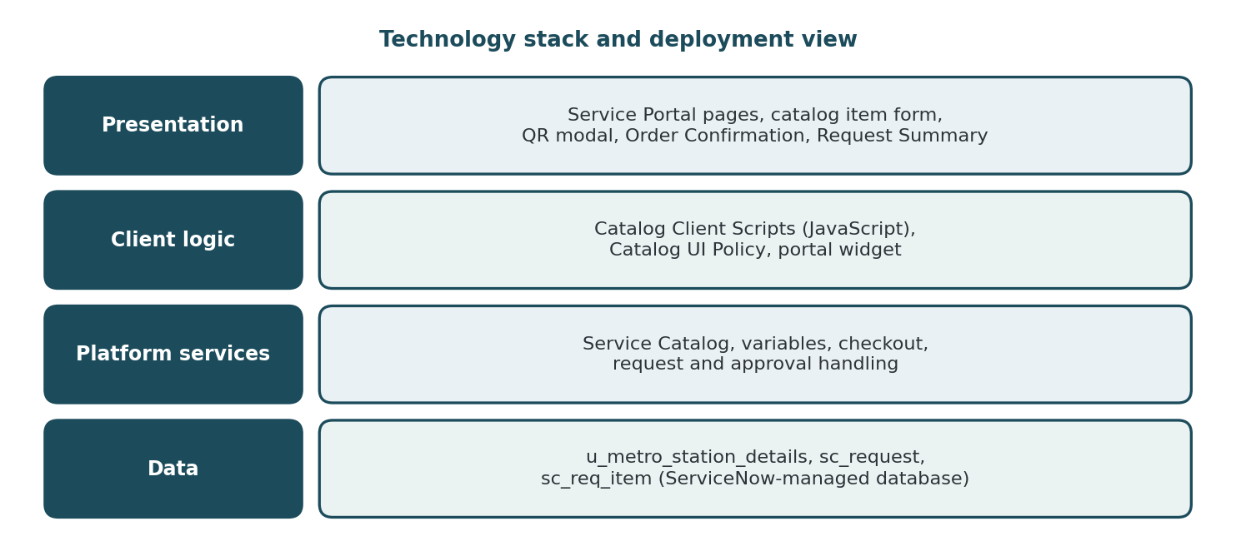
Figure 1. Technology stack of the Metro Ticket Generating System.
Infrastructure demarcation: users access a ServiceNow personal developer instance through a web browser. Station and request data are stored in ServiceNow-managed tables. No separate local server, external API or machine-learning model is part of the documented scope.

Table-1: Components & Technologies
S.No | Component | Description | Technology
1 | User Interface | Booking form, QR modal, Order Confirmation dialog and Request Summary. | ServiceNow Service Portal, Service Catalog; web browser
2 | Application Logic-1 | Fare calculation and form behaviour in the browser. | Catalog Client Scripts (JavaScript)
3 | Application Logic-2 | Conditional display of Enter payment mode. | Catalog UI Policy
4 | Application Logic-3 | QR code generation and display. | Service Portal widget
5 | Database | Stations, requests and requested items. | u_metro_station_details, sc_request, sc_req_item
6 | Cloud Database | Persistent storage managed by the hosted platform. | ServiceNow-managed data store (engine not specified)
7 | File Storage | No separate file-storage component is required by the documented workflow. | Not applicable
8 | External API-1 | No third-party API is identified in the project scope. | None specified
9 | External API-2 | No second external API is identified. | None specified
10 | Machine Learning Model | No ML model is used; fares come from configured logic. | Not applicable
11 | Infrastructure (Server / Cloud) | Hosted ServiceNow personal developer instance accessed through a browser. | ServiceNow PDI (cloud hosted)
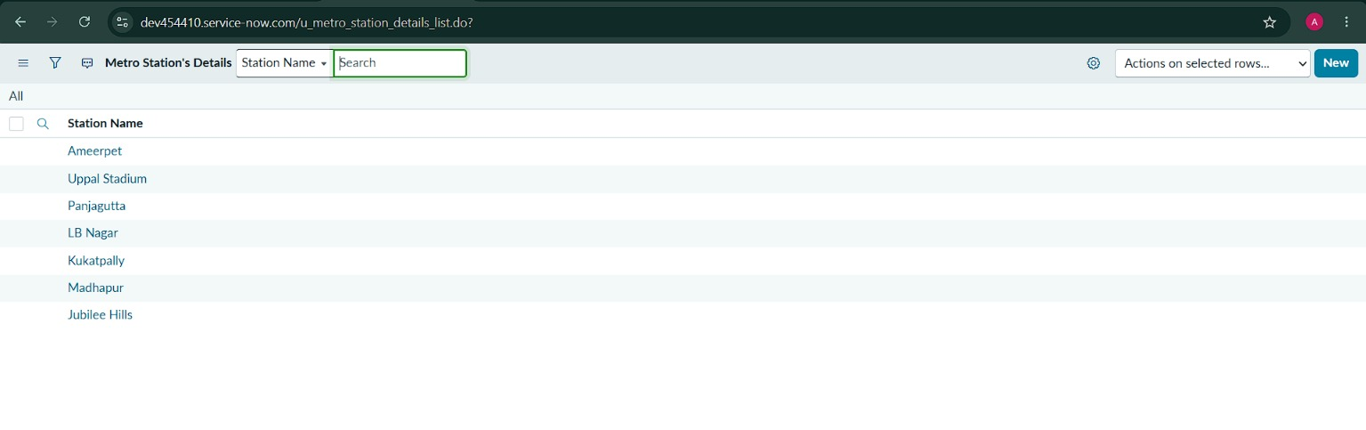
Figure 2. Platform data: the u_metro_station_details table in the ServiceNow instance.

Table-2: Application Characteristics
The characteristics below describe the architectural approach. Instance-specific security settings, availability commitments and performance limits must be confirmed in the target ServiceNow environment.
S.No | Characteristics | Description | Technology
1 | Open-Source Frameworks | No separate open-source application framework is identified; the solution uses native ServiceNow configuration and scripting. A QR code library may be used inside the widget (confirm in the widget source). | ServiceNow platform
2 | Security Implementations | Platform authentication, roles and access controls limit who can view and manage records. Exact roles and ACLs must be verified in the target instance. | ServiceNow roles / ACLs
3 | Scalable Architecture | New stations and fare rules are added through records and configuration rather than new infrastructure. | Hosted ServiceNow platform
4 | Availability | Depends on the ServiceNow service and the instance's commitments. A personal developer instance has no production SLA. | ServiceNow hosting
5 | Performance | Fare calculation runs in the browser, so results appear immediately; no measured response-time target is specified. | Client scripts; validate in testing

Architecture notes
- The diagram is a conceptual representation of the booking lifecycle, not a claim that every component has been load-tested.
- The underlying database engine is managed by ServiceNow and is not specified by the project.
- No third-party API or machine-learning model is necessary for the documented core workflow.

References
- ServiceNow Product Documentation: Service Catalog, Catalog Client Scripts, Catalog UI Policies and Service Portal widgets (docs.servicenow.com).

