Acceptance Testing
UAT Execution & Report Submission
Date | 14-10-2026
Team ID | Individual participant - 323103312150@gvpce.ac.in
Project Name | Metro Ticket Generating System - ServiceNow
Maximum Marks | 4 Marks

1. Purpose of Document
This report summarises UAT coverage and observations for the Metro Ticket Generating System: catalog access, station selection, fare calculation, payment mode, QR ticket generation, checkout and request tracking.
Status: EXECUTED - PARTIAL
Ten of twelve planned cases have been executed and passed, based on the screenshots captured on 13-14 October 2026 and the project owner's testing summary. Two cases (QR content check and station maintenance) have not yet been executed. No defects have been logged; three non-blocking observations are listed below. Tester and project-owner sign-off is still to be completed.

2. Defect Analysis
No blocking defects were found. Three observations were noted during review; all are open and none prevented a booking.
Resolution | Severity 1 | Severity 2 | Severity 3 | Severity 4 | Subtotal
Open | 0 | 0 | 1 | 2 | 3
Fixed | 0 | 0 | 0 | 0 | 0
By Design | 0 | 0 | 0 | 0 | 0
Duplicate | 0 | 0 | 0 | 0 | 0
Not Reproduced | 0 | 0 | 0 | 0 | 0
Won't Fix | 0 | 0 | 0 | 0 | 0
Totals | 0 | 0 | 1 | 2 | 3

ID | Observation | Severity | Status / owner
O-1 | Stray draft text appears as the item description on the form (Figs 2, 3). | 4 | Open - project owner
O-2 | Enter payment mode is visible before Others is selected; confirm intended behaviour (Fig 2). | 4 | Open - project owner
O-3 | Calculated fare is not reflected in the request price; Request Summary total is $0.00 (Fig 7). | 3 | Open - project owner

3. Test Case Analysis
Section | Total Cases | Not Tested | Fail | Pass
Catalog access & form validation (UAT-01, 02) | 2 | 0 | 0 | 2
Station selection & fare (UAT-03, 04, 05) | 3 | 0 | 0 | 3
Payment mode (UAT-06) | 1 | 0 | 0 | 1
QR ticket (UAT-07, 11) | 2 | 1 | 0 | 1
Checkout & request tracking (UAT-08, 09, 10) | 3 | 0 | 0 | 3
Station data maintenance (UAT-12) | 1 | 1 | 0 | 0
Totals | 12 | 2 | 0 | 10
Pass rate of executed cases: 10 / 10 = 100%. Pass rate of all planned cases: 10 / 12 = 83.3%. UAT-05 is based on the project owner's report and has no screenshot.

4. Execution evidence
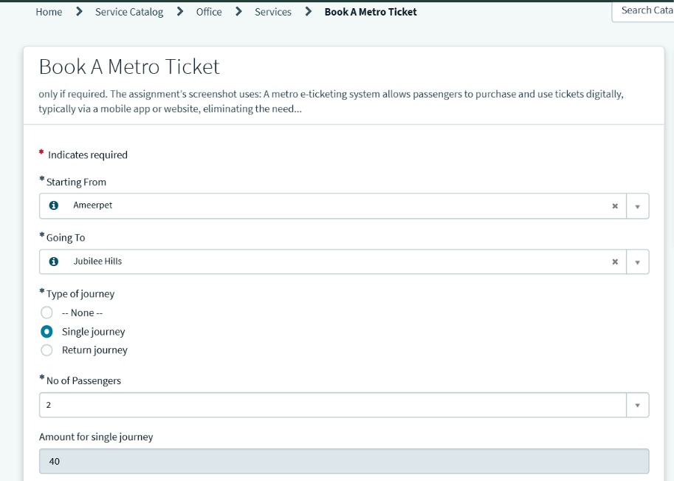  UAT-03/04: stations and fare | 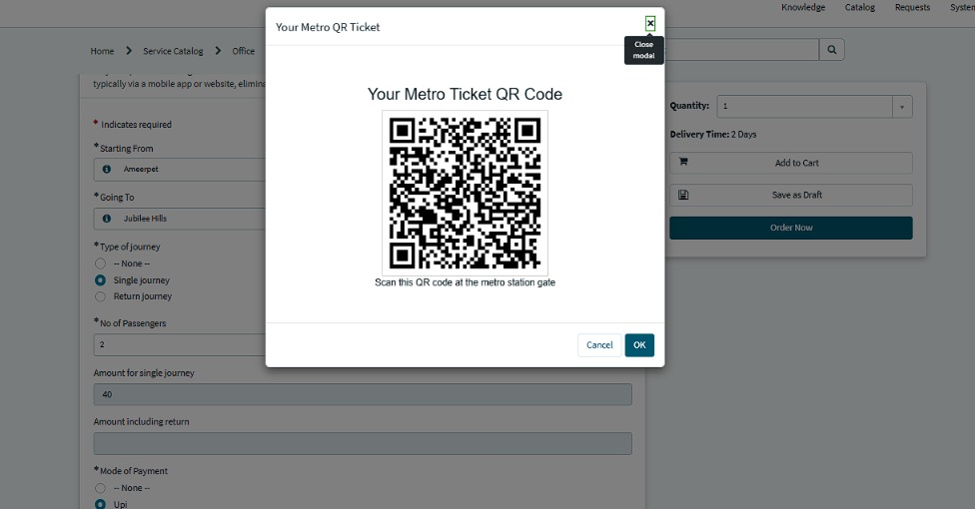  UAT-07: QR ticket
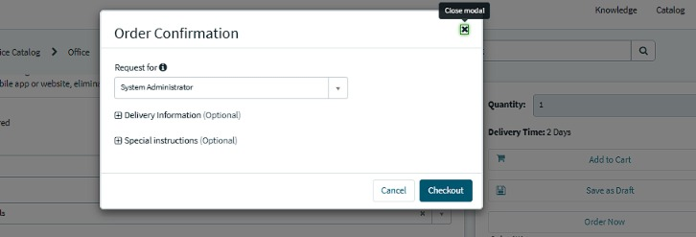  UAT-08: Order Confirmation | 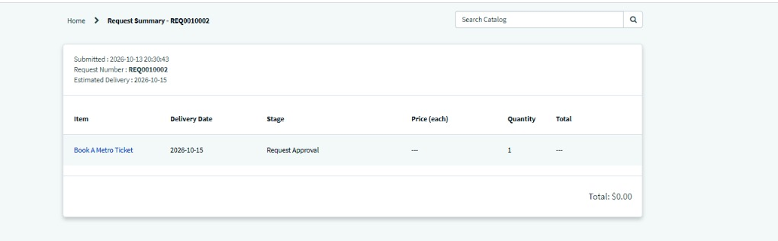  UAT-09: Request Summary REQ0010002

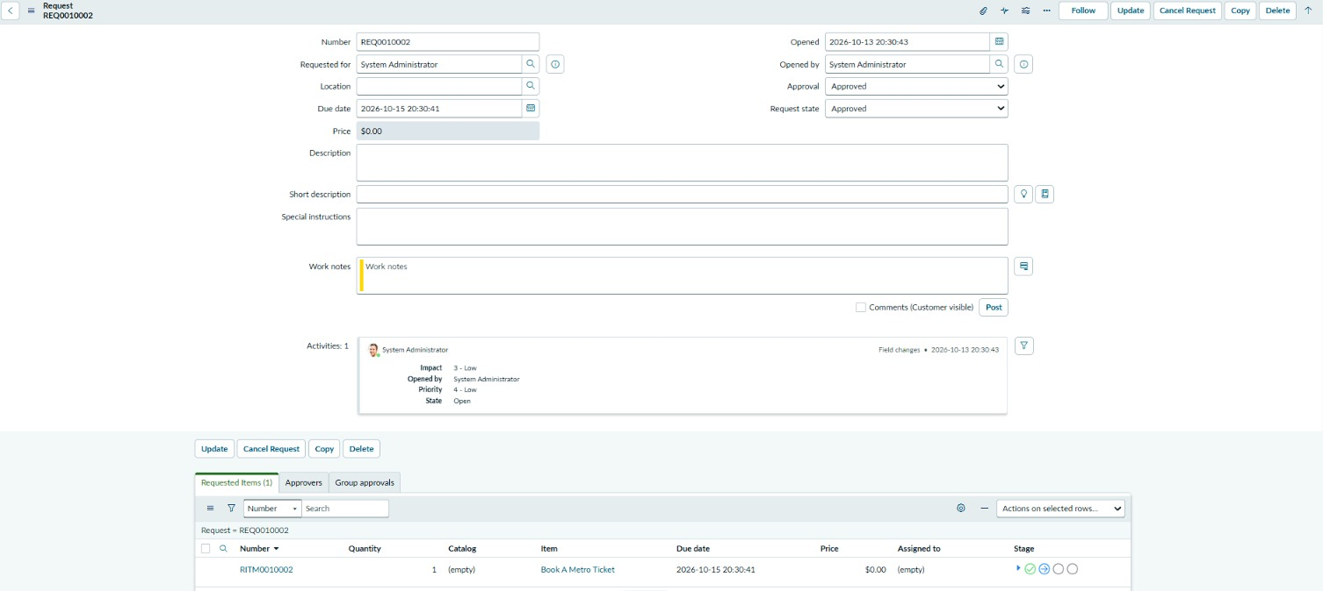
UAT-10: REQ0010002 and linked requested item RITM0010002.

5. Remaining before final sign-off
- Execute UAT-11 by decoding the generated QR and comparing it with the selected journey.
- Execute UAT-12 by adding a station and confirming it appears in the form.
- Resolve or accept observations O-1 to O-3.
- Record tester name and execution date for every case.
- Obtain tester and project-owner sign-off.
Tester | Execution date | Result summary | Sign-off
________________ | ________________ | ________________________ | ________________

