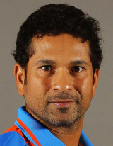

**Personal Information**

**Born:** Apr 24, 1973 (43 years)

**Birth Place:** Bombay (now Mumbai), Maharashtra

**Nickname:** Tendulkar

**Height:** 5 ft 5 in

**Role:** Batsman

**Batting Style:** Right Handed Bat

**Bowling Style:** Right-arm legbreak

**Batting Career Summary**

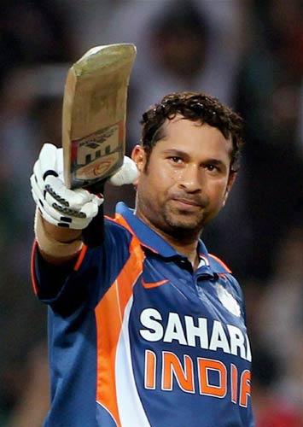

|  |  |  |  |  |  |  |  |  |  |  |  |  |  |  |
| --- | --- | --- | --- | --- | --- | --- | --- | --- | --- | --- | --- | --- | --- | --- |
|  | M | Inn | NO | Runs | HS | Avg | BF | SR | 100 | 200 | 50 | 4’s | 6’s | St |
| Tests | 200 | 329 | 33 | 15921 | 248 | 53.79 | 29437 | 54.08 | 51 | 6 | 68 | 2058 | 69 | 0 |
| ODI | 463 | 452 | 41 | 18426 | 200 | 44.83 | 21367 | 86.24 | 49 | 1 | 96 | 2016 | 195 | 0 |
| T20I | 1 | 1 | 0 | 10 | 10 | 10 | 12 | 83.33 | 0 | 0 | 0 | 2 | 0 | 0 |
| IPL | 78 | 78 | 9 | 2334 | 100 | 33.83 | 1948 | 119.82 | 1 | 0 | 13 | 295 | 29 | 0 |

**Bowling Career Summary**

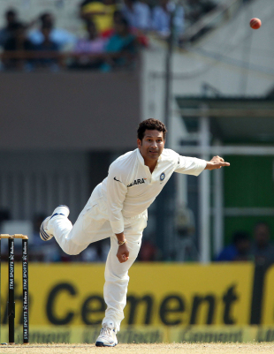

|  |  |  |  |  |  |  |  |  |  |  |  |  |
| --- | --- | --- | --- | --- | --- | --- | --- | --- | --- | --- | --- | --- |
|  | M | Inn | B | Runs | Wkts | BBI | BBM | Econ | Avg | SR | 5W | 10W |
| Tests | 200 | 145 | 4240 | 2492 | 46 | 10/3 | 14/3 | 3.53 | 54.17 | 92.17 | 0 | 0 |
| ODI | 463 | 270 | 8054 | 6850 | 154 | 32/5 | 32/5 | 5.1 | 44.48 | 52.3 | 2 | 0 |
| T20I | 1 | 1 | 15 | 12 | 1 | 12/1 | 12/1 | 6 | 12 | 15 | 0 | 0 |
| IPL | 78 | 4 | 36 | 58 | 0 | 7/0 | 7/0 | 9.67 | 0 | 0 | 0 | 0 |