AWS CI/CD Deployment Workflow – TravelApp
CodeCommit → CodeBuild → S3 → EC2 → RDS
Practical Implementation Documentation

Objective
To implement a controlled application and database deployment workflow for TravelApp using AWS IAM, EC2, RDS, S3, CodeCommit, and CodeBuild. The workflow builds the application, stores the release artifact in S3, deploys it to EC2, and applies a controlled database schema migration in RDS.

Implemented Architecture
Developer → CodeCommit → CodeBuild → S3 Artifact Storage → EC2/Nginx → RDS MySQL
Documentation note: The images in this document are AWS-console-style reconstructed proof visuals generated for the report. They are intended to illustrate the corresponding implementation step; the actual work was performed in the AWS console and EC2 terminal.

Step 1: Create IAM Roles

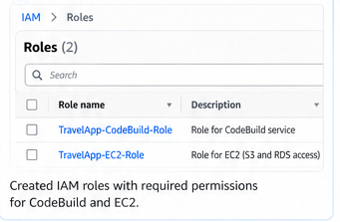

What was done
Created the IAM roles required for the workflow. The EC2 role, TravelApp-EC2-Role, provides the EC2 instance with AWS permissions such as S3 access and CloudWatch access. A separate CodeBuild service role was also created for the build service.

Outcome
IAM permissions were prepared for AWS services and the EC2 workload.

Step 2: Launch EC2 Instance

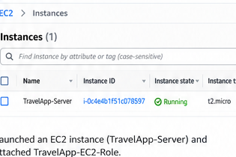

What was done
Launched the Ubuntu EC2 instance named TravelApp-Server. The instance was configured with a public IPv4 address, SSH access, HTTP access, and the TravelApp-EC2-Role IAM instance profile. Nginx was installed and started to serve the application.

Outcome
The application server was running on EC2 with Nginx.

Step 3: Create RDS Database

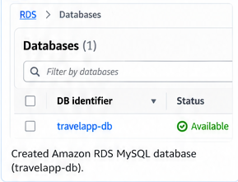

What was done
Created the Amazon RDS MySQL database named travelapp-db. The database uses MySQL, the travelapp database name, and port 3306. Public access was disabled, and access was restricted so the EC2 security group can connect to the database.

Outcome
The MySQL database was available in RDS and secured for EC2 access.

Step 4: Create S3 Artifact Bucket

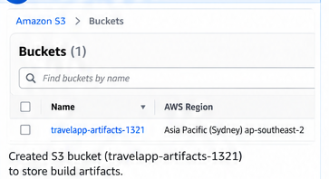

What was done
Created the S3 bucket travelapp-artifacts-1321 in the Asia Pacific (Sydney) region. The bucket was used for application artifacts and database migration files, with folders for application-artifacts/ and db-migrations/.

Outcome
S3 was ready to store application and migration artifacts.

Step 5: Create CodeCommit Repository

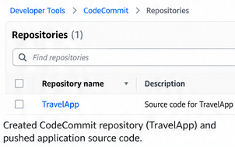

What was done
Created the CodeCommit repository TravelApp-Repo and pushed the TravelApp source files. The repository contains index.html, appspec.yml, deploy.sh, and the db-migrations directory containing the SQL migration script.

Outcome
The application source and deployment files were version-controlled in CodeCommit.

Step 6: Create CodeBuild Project

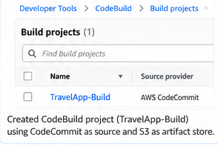

What was done
Created the CodeBuild project TravelApp-Build using AWS CodeCommit as the source. The build project validates the required files and produces the deployment artifact, with S3 configured as the artifact storage location.

Outcome
CodeBuild was configured to validate and package the release.

Step 7: Execute CodeBuild

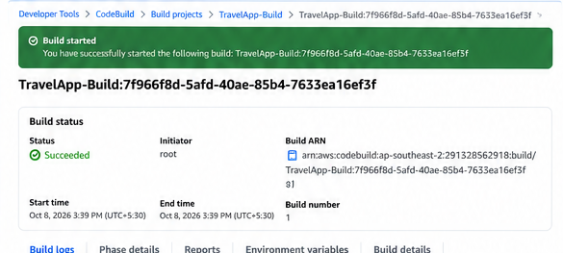

What was done
Started a CodeBuild execution. The build performed pre-build checks for the application and migration files, prepared the deployment package, and completed successfully. This demonstrates the build stage of the release workflow.

Outcome
The build completed successfully.

Step 8: Verify Build Artifacts in S3
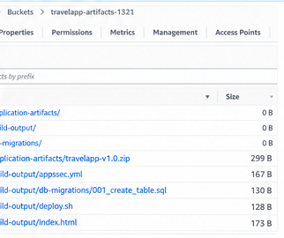

What was done
Verified that the CodeBuild output was stored in S3. The build-output location contains appspec.yml, deploy.sh, index.html, and db-migrations/001_create_table.sql, providing the complete release bundle.

Outcome
The complete release bundle was available in S3.

Step 9: Verify EC2 IAM Role with IMDSv2

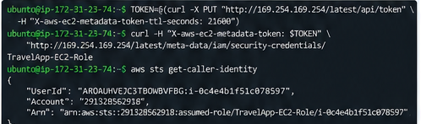

What was done
Verified that the EC2 instance could obtain its IAM role credentials using the EC2 Instance Metadata Service Version 2 (IMDSv2). The AWS CLI then confirmed the assumed TravelApp-EC2-Role identity. No long-lived AWS access keys were configured on the server.

Outcome
The EC2 instance successfully used its IAM role without static credentials.

Step 10: Download Build Artifacts to EC2

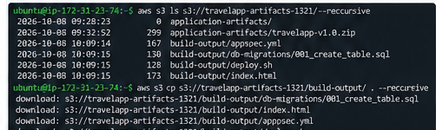

What was done
Downloaded the CodeBuild release artifact from S3 directly to the EC2 instance using the EC2 IAM role. The downloaded files were checked to confirm that the deployment package contains the application and database migration files.

Outcome
The release bundle was transferred from S3 to EC2.

Step 11: Deploy the Application to EC2

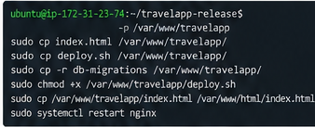

What was done
Deployed the application files to /var/www/travelapp and copied the application entry page into the Nginx web root. Nginx was restarted so the newly released TravelApp version became available through the EC2 public IP.

Outcome
The new TravelApp version was deployed to the Nginx web server.

Step 12: Access TravelApp in the Browser

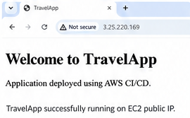

What was done
Opened the EC2 public IP address in a web browser and verified the deployed TravelApp. The page displayed 'Welcome to TravelApp' and confirmed that the application was successfully running on the EC2 server.

Outcome
The deployed application was accessible from the EC2 public IP.

Step 13: Apply and Verify the RDS Schema Update

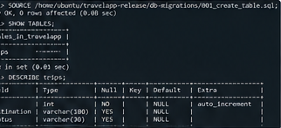

What was done
Connected from EC2 to the RDS MySQL database and executed db-migrations/001_create_table.sql. The migration created the trips table. SHOW TABLES and DESCRIBE trips verified the id, destination, and status columns and the auto-increment primary key.

Outcome
The controlled schema migration succeeded and the trips table was verified in RDS.

Final Result
The TravelApp deployment workflow was successfully implemented. CodeCommit stored the source, CodeBuild validated and generated the release artifact, S3 stored the build output, EC2 served the deployed application through Nginx, and RDS stored the application database. A controlled SQL migration was executed against RDS and the trips table was successfully created and verified.

Final Verification
- TravelApp webpage displayed successfully on the EC2 public IP.
- CodeBuild execution status was Successful.
- Build artifacts were present in S3.
- EC2 assumed the TravelApp-EC2-Role through IMDSv2.
- RDS MySQL connection from EC2 succeeded.
- The trips table was created using the migration script.
- DESCRIBE trips verified id, destination, and status columns.

Conclusion
The practical demonstrates how application release artifacts and database schema changes can be coordinated using AWS cloud services. The implementation provides a repeatable release flow and verifies both the application deployment and database update.

