eLECTRA
online Billing portal for electricity consumption

‘’eLECTRA is a light-weight php-based application for simplifying the work of bill management of electricity consumption.Bills can be downloaded in a portable document format”

Introduction to the New Website
- Adding new users
- A register page to add new users.
- Admin details are predefined.
- Login Forms
- login form for users
- login form for admins
- Payment of Bills online
- User can download bill in portable format
- Form for admins to add new bills
- Admins can update rate
Development

Built on : HTML, CSS, Bootstrap, PHP 7.0,Mysql
Framework used : Laravel 5.5
Programming Methodology : Object-Oriented
Softwares Used for development:Sublime text,LAMP stack,Composer package manager.

MODEL CLASSES
1. User
2. Admin
3. Bill

1.User

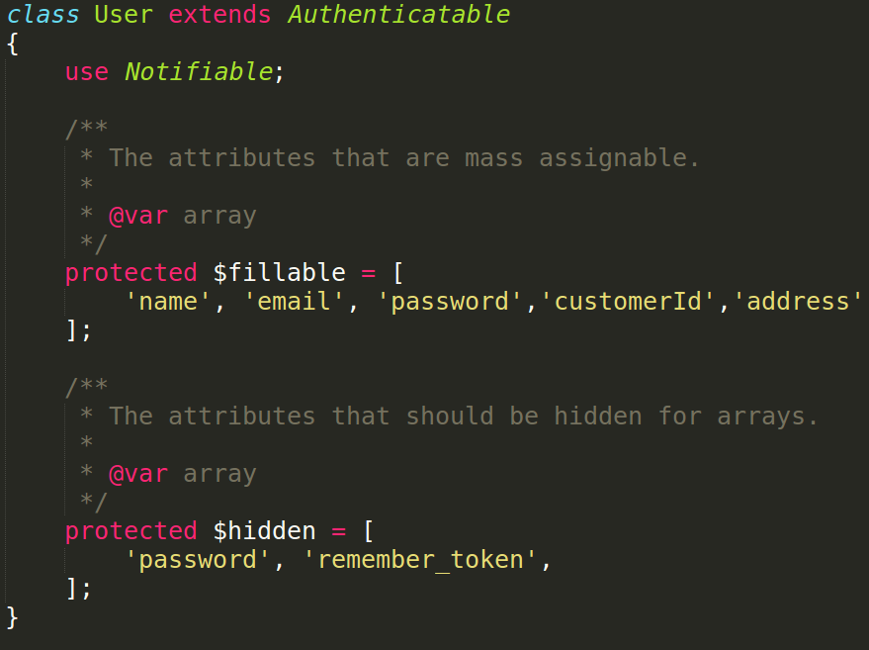
user model stores all the features of users as an object.

2.Admin

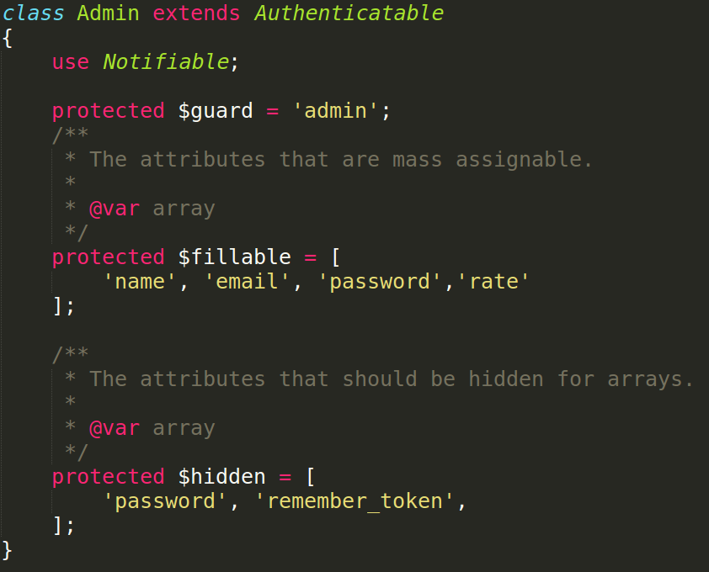

Admin model stores details for admins. Apart from that it also stores the rate at which the bill is charged.

Admin uses a admin guard to enable multi-authentication system.

3.Bill
Bill is defined as an eloquent model (derived from Laravel Framework) for easy interface with the database.

Database Migration Files

1.adding features to existing out of box user from the framework.

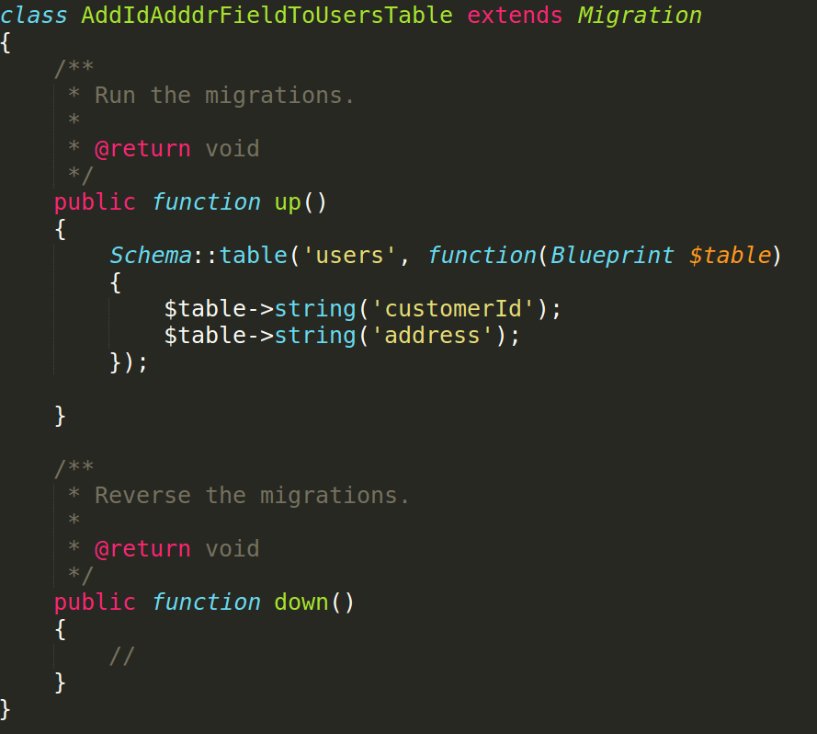
2.creating the admins database to store admin objects.

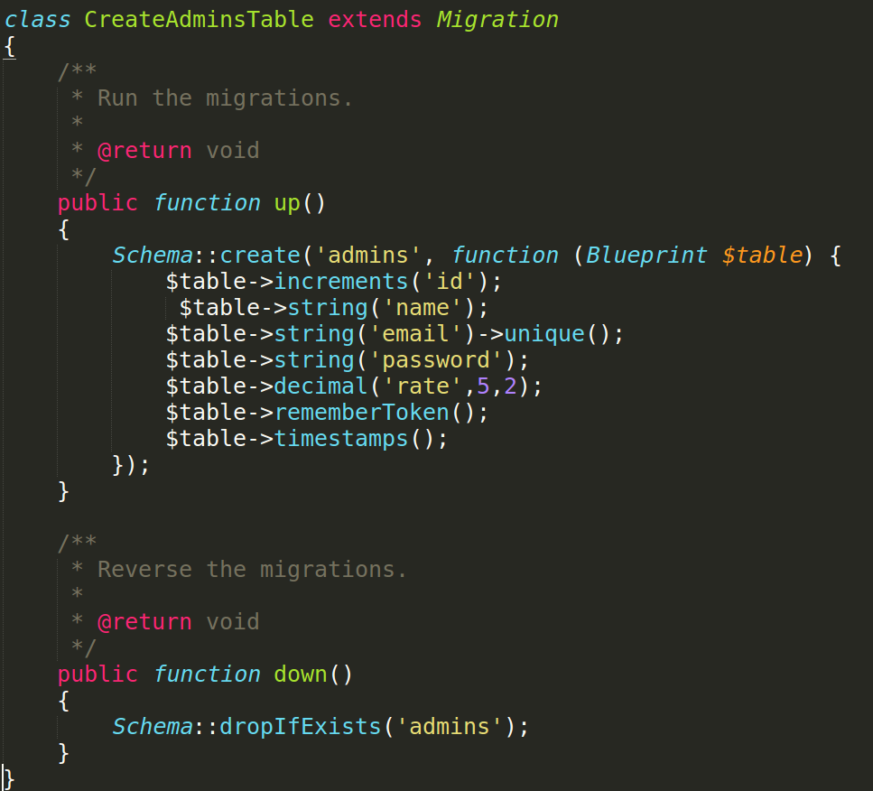
Running this migration automatically creates admin table with the given attributes. Rate has be declared as a decimal value of upto 5 places which is rounded off to 2 digits.
3.creating the bills database to interact with the bill objects.

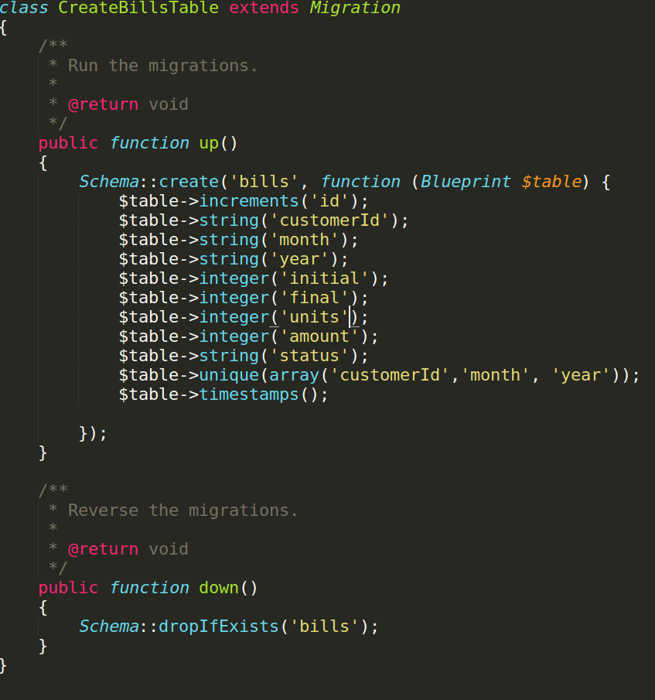
Running this migration results in creation of bills table. Notice that customer Id and month and year has been declared as unique to implement real life scenarions.
Database Structure
1.Admins
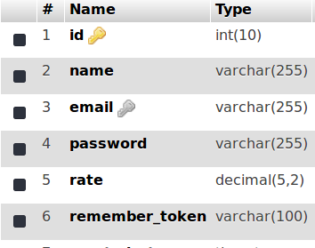

2.Users
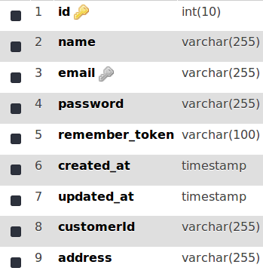

3.Bills
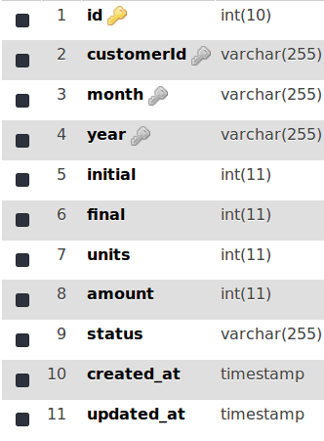

Routes Used

1.Route::get('/', function () {
return view('welcome');
});

Auth::routes();

2.Route::get('/home', 'HomeController@index')->name('home');

3.Route::get('/home/pay','billController@pay');

4.Route::get('/admin/login', 'Auth\AdminLoginController@showLoginForm')->name('admin.login');

5.Route::post('/admin/login', 'Auth\AdminLoginController@login')->name('admin.login.submit');

6.Route::get('/admin', 'AdminController@index')->name('admin.dashboard');

7.Route::post('/admin/store','billController@store')->name('admin.store');

8.Route::post('/admin/updaterate','billController@updaterate')->name('admin.updaterate');

9.Route::post('/home/pdf','billController@pdf')->name('home.pdf');
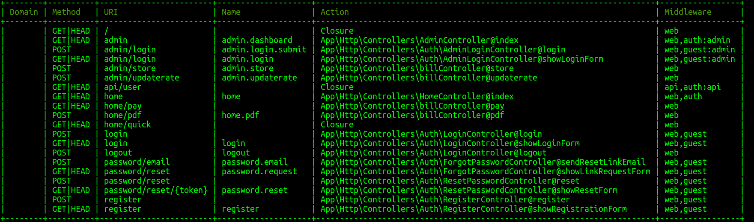
Controllers

1.Admin Controller
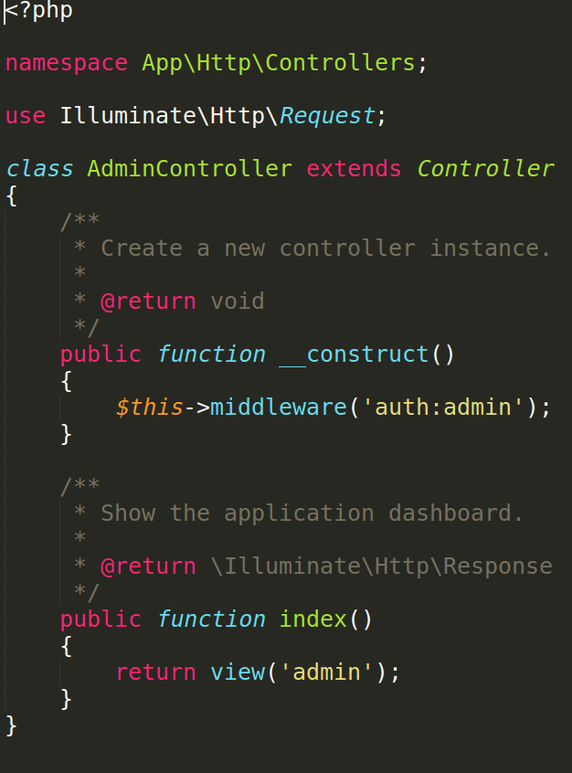

2.Home Controller
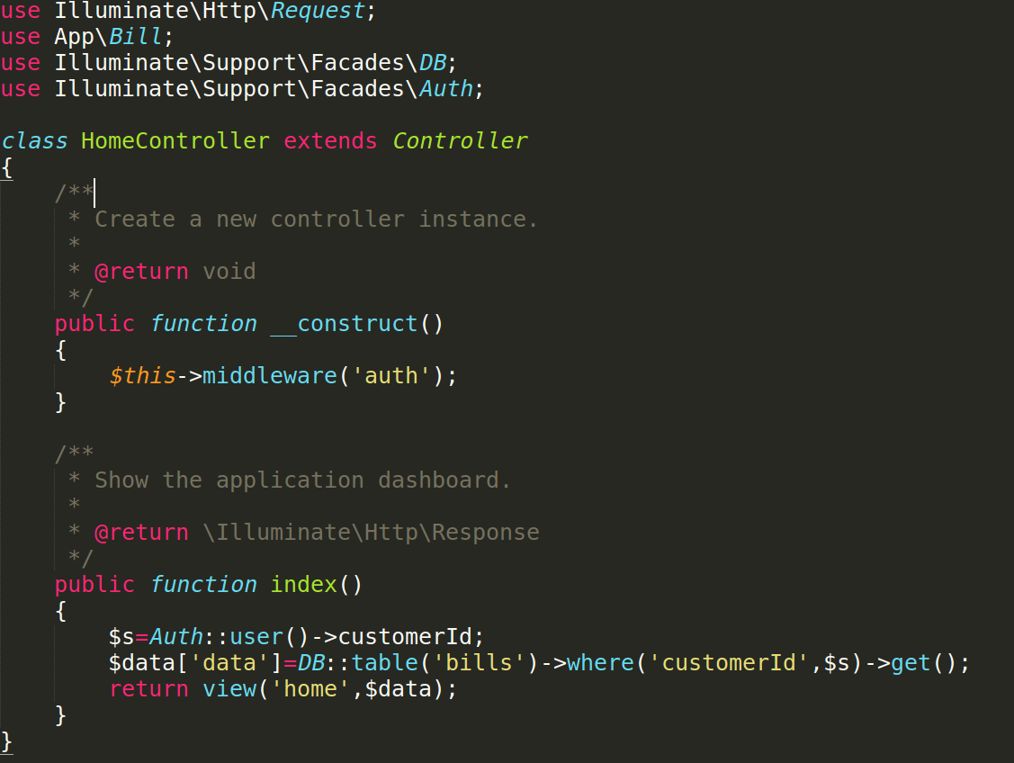

3.Bill Controller

payment function

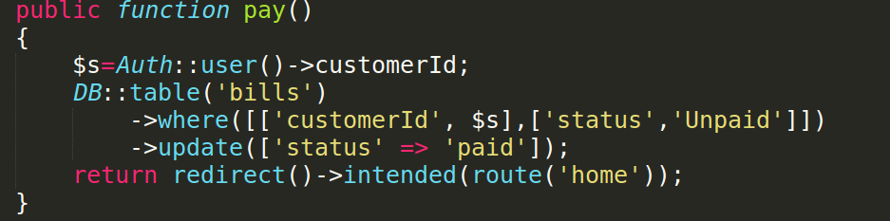
Store function

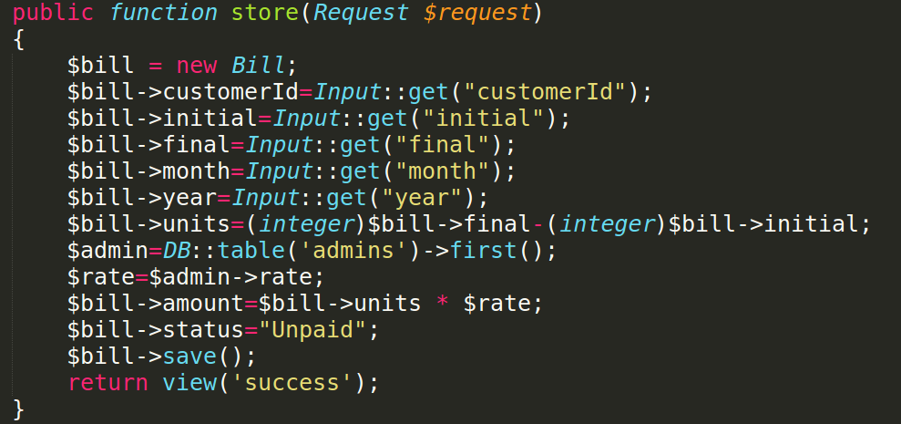

Input form accepts the input from admin and calculates the units consumed and amount and sets the payment status to ‘unpaid’ by default.
Update rate Calculate bill amount and generate pdf functions

update rate takes the new rate as argument and replaces the value in database

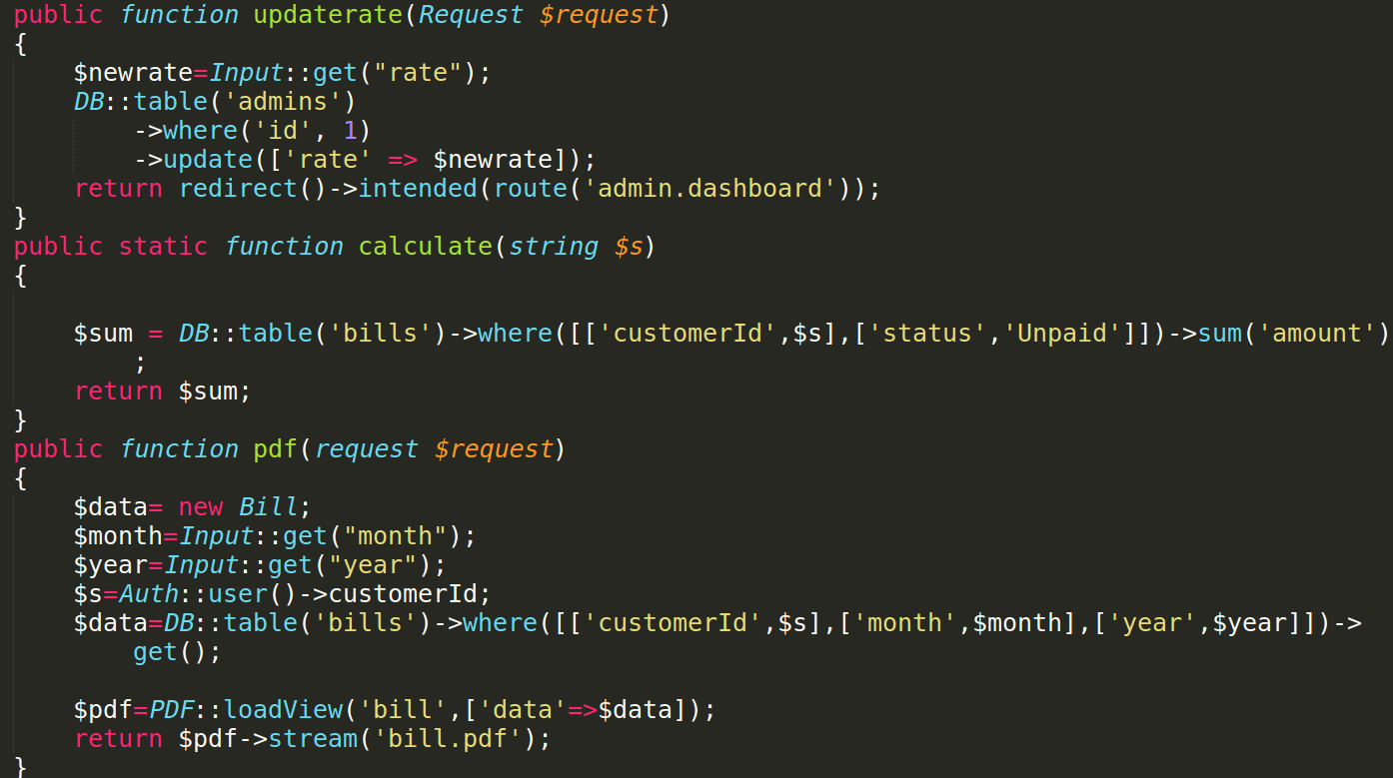
Views
Views are created on blade based php templates.
Landing page
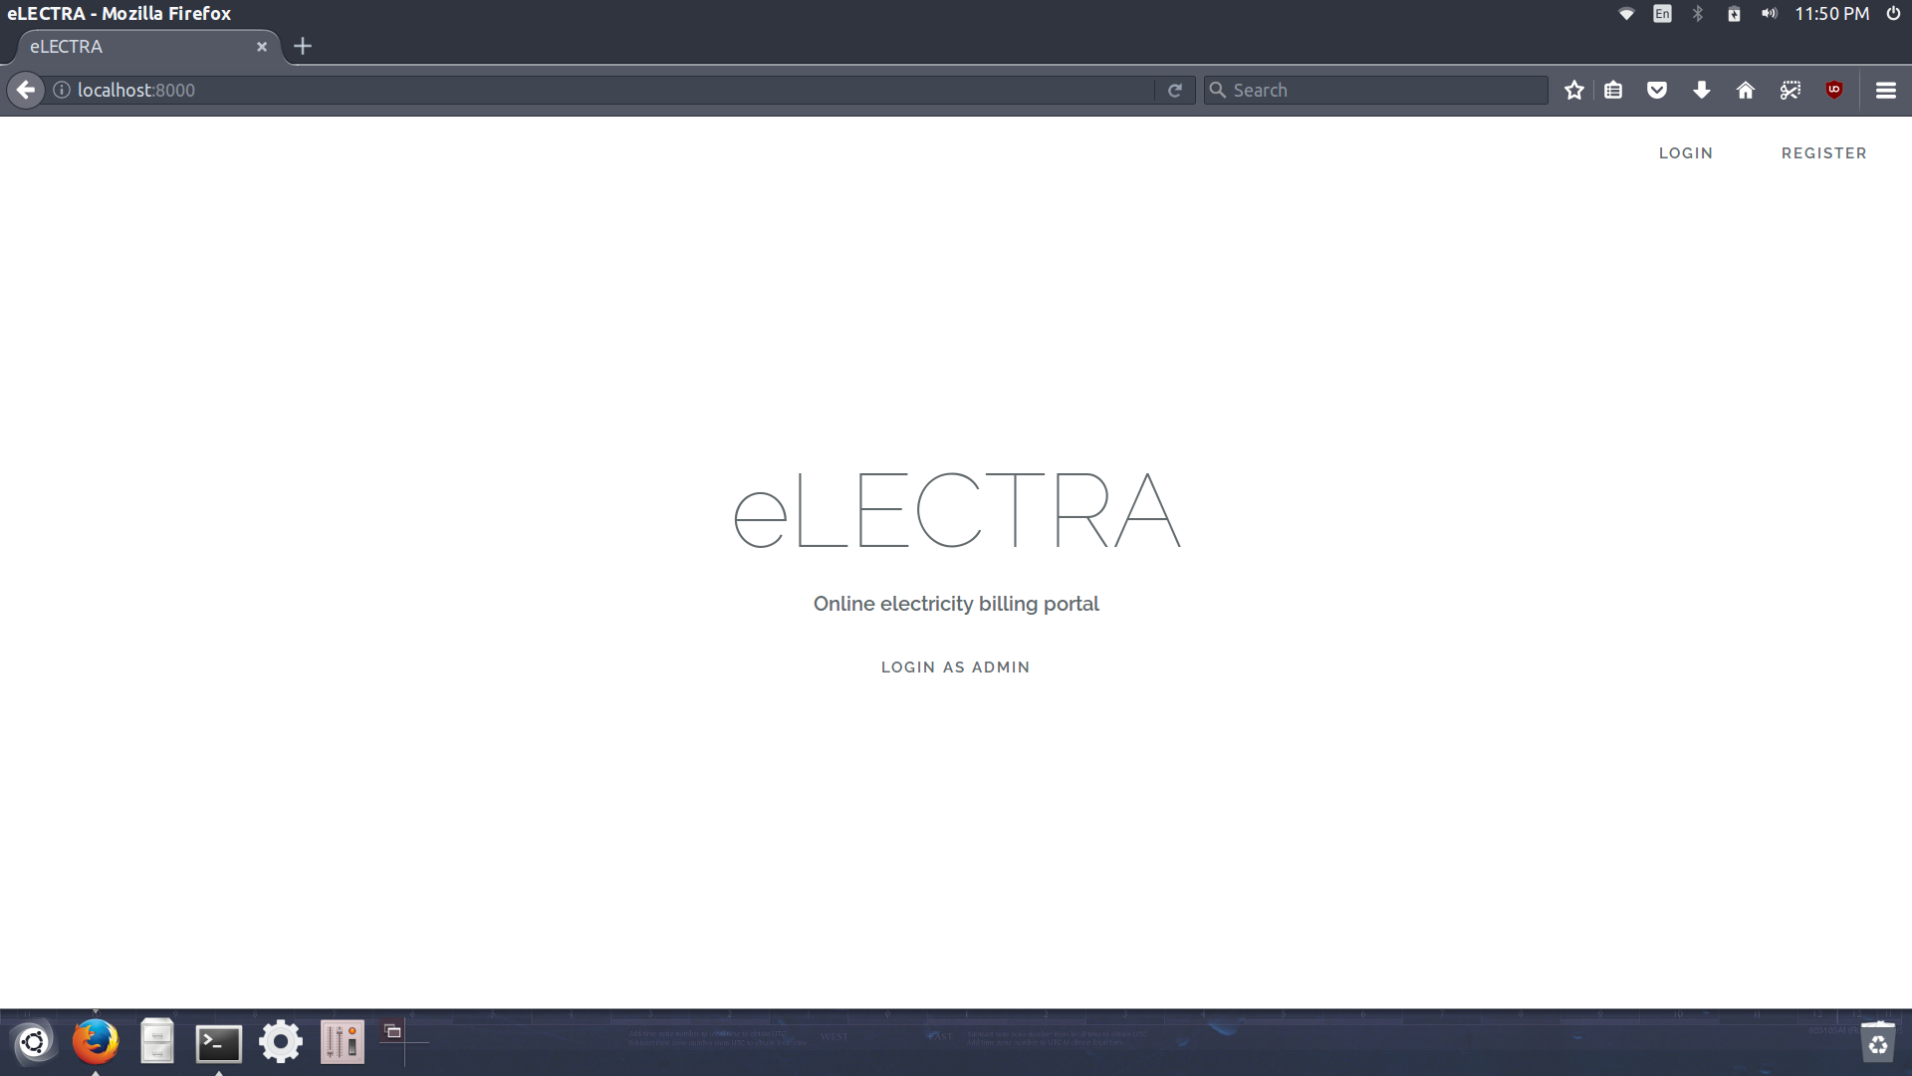
Login page
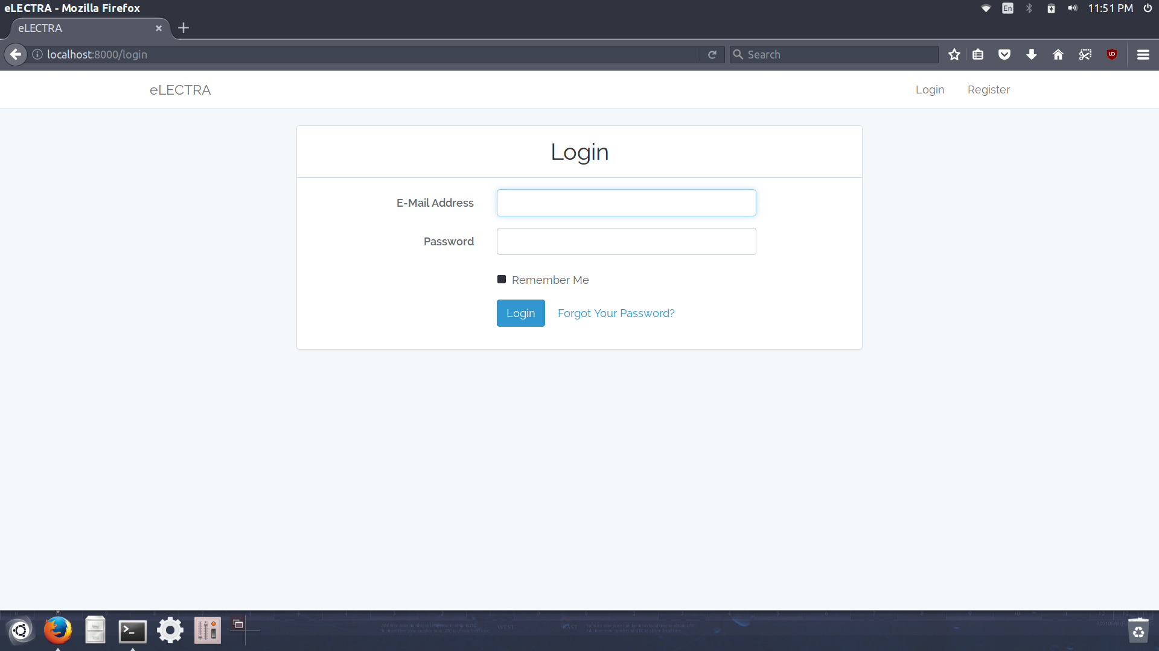

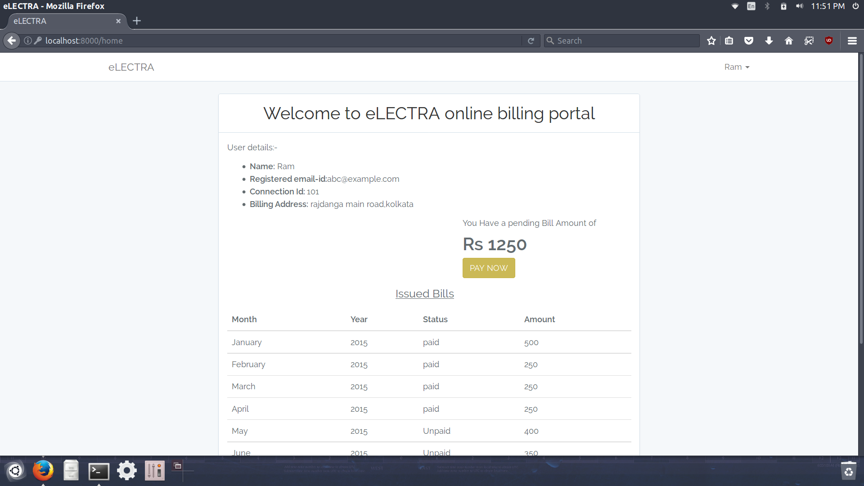
User Dashboard
Admin Dashboard
