AI Assisted Coding

Assignment – 17.5
Name: M.AKHIL REDDY
RollNo:2303A52315
Batch:45
Task 1 –Loan Approval Dataset Cleaning
Use AI to generate preprocessing code for a loan dataset.
Instructions:
• Handle missing values in loan_amount, credit_score.
• Encode loan_status (Approved/Rejected).
• Scale numerical features using standard scaling.
• Split the dataset into training and testing sets.
Sample Code:
import pandas as pd
data = pd.read_csv("loadapproval.csv")
print(data.head())
Dataset link:
https://www.kaggle.com/datasets/amineipad/loan-approval-
dataset
Expected Output:
• A machine-learning-ready loan dataset.
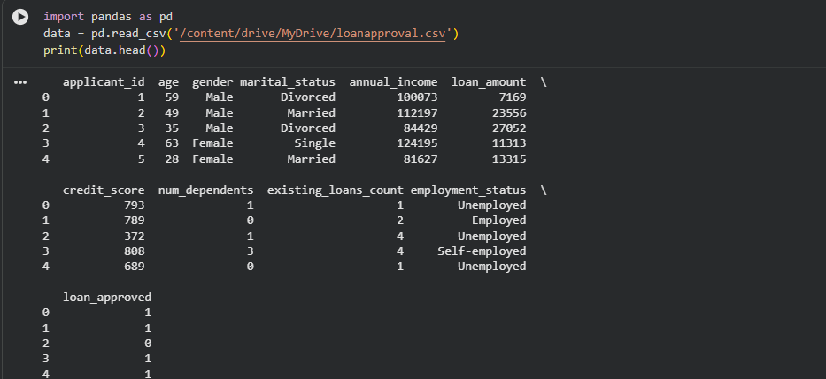
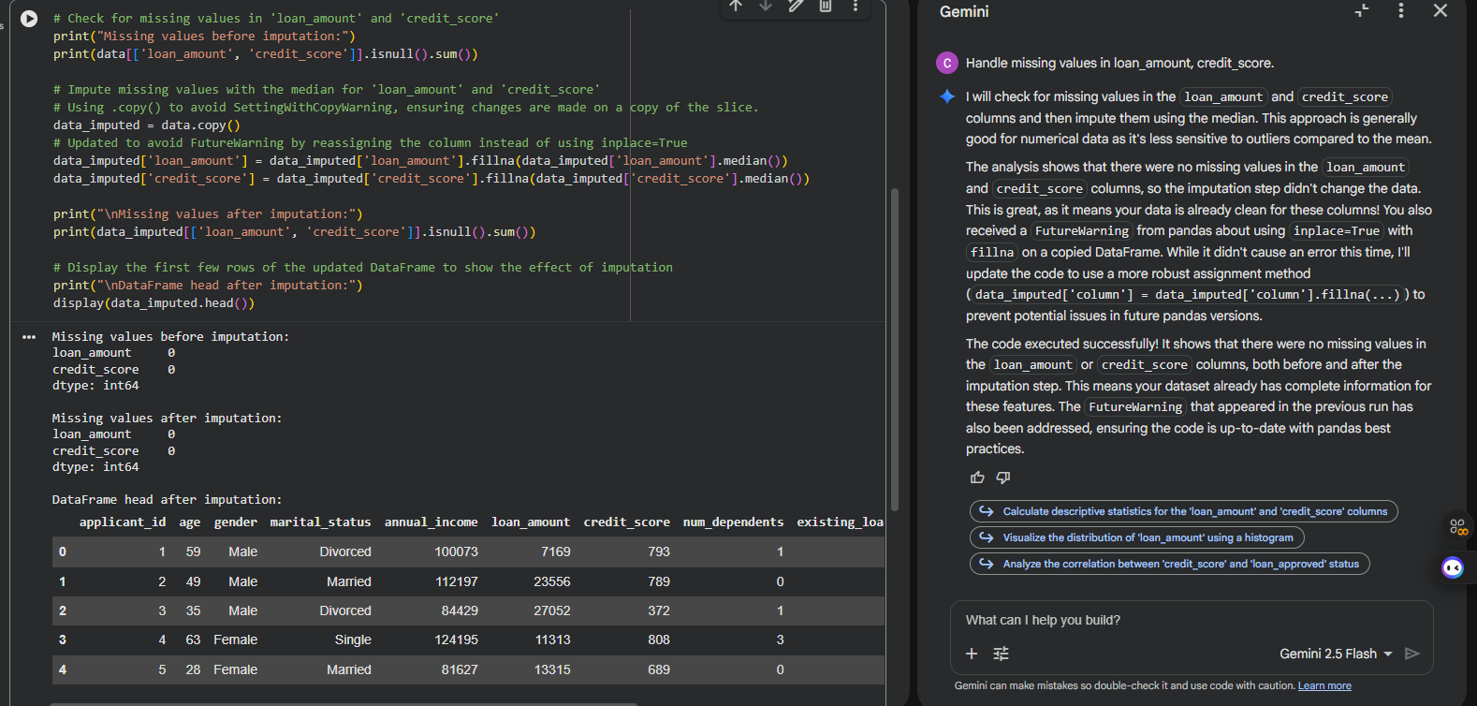
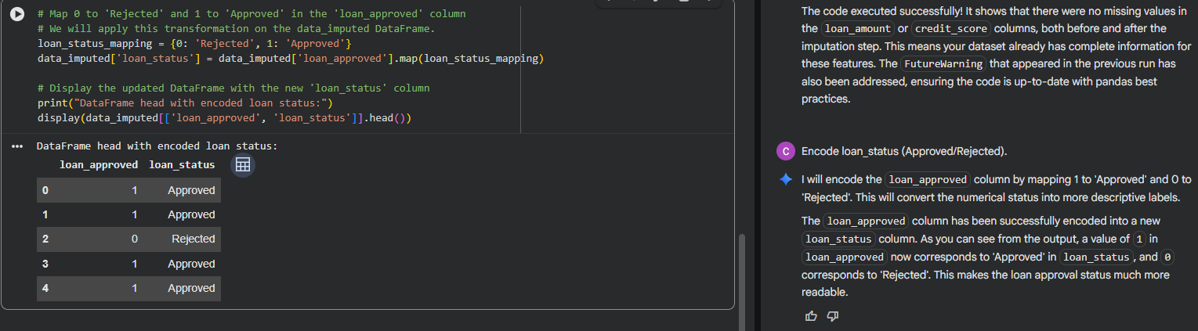
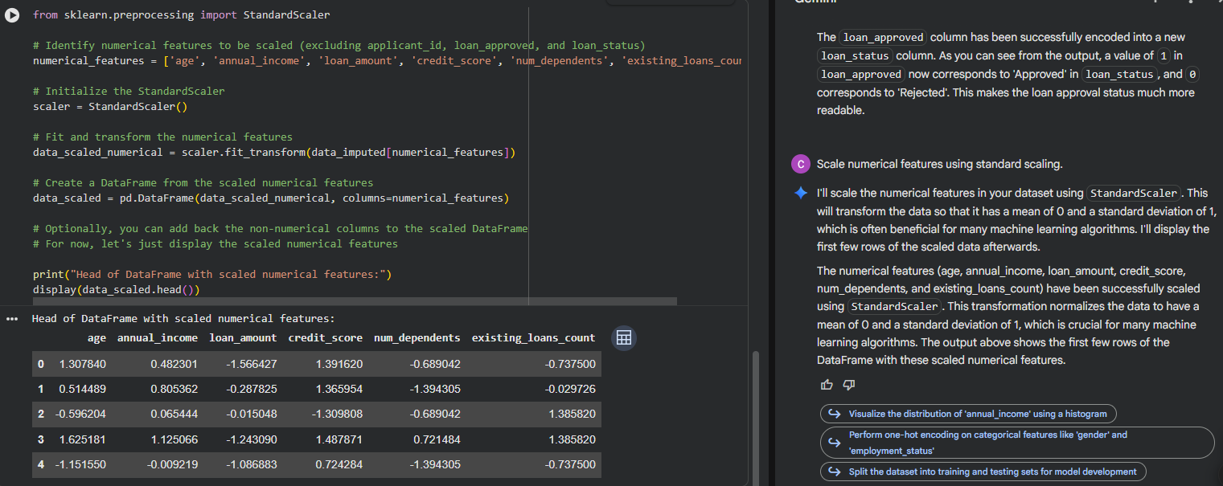
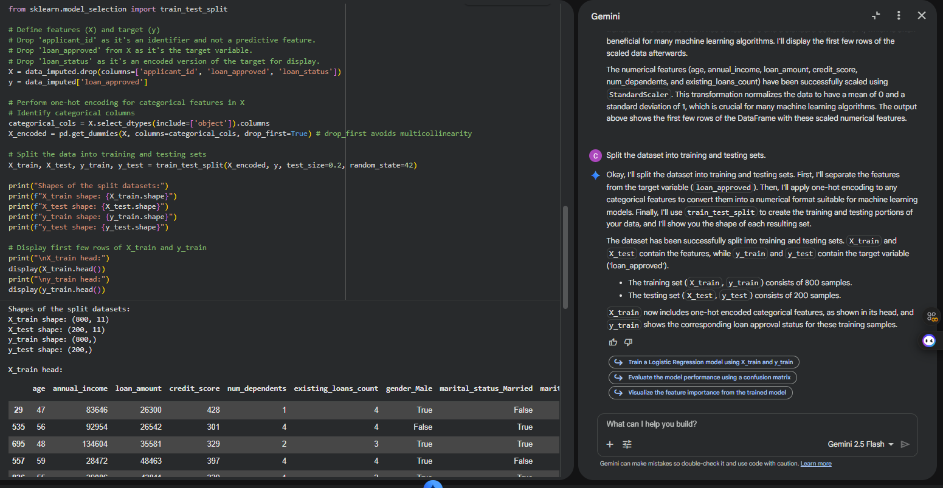

Task 2 – Social Media Profiles
Preprocess a social media engagement dataset using AI
assistance.
Instructions:
• Remove duplicate user profiles.
• Handle missing values
• Encode categorical columns
Dataset link:
https://www.kaggle.com/datasets/medaxone/top-100-social-
media-profiles
Expected Output:
• A cleaned dataset for engagement prediction.
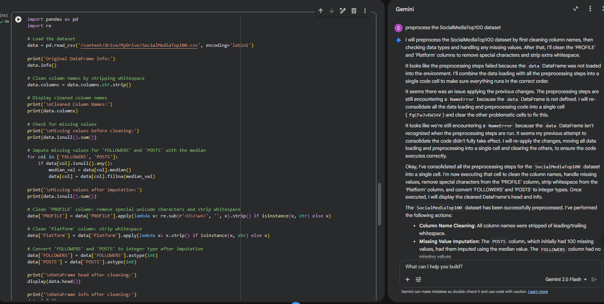
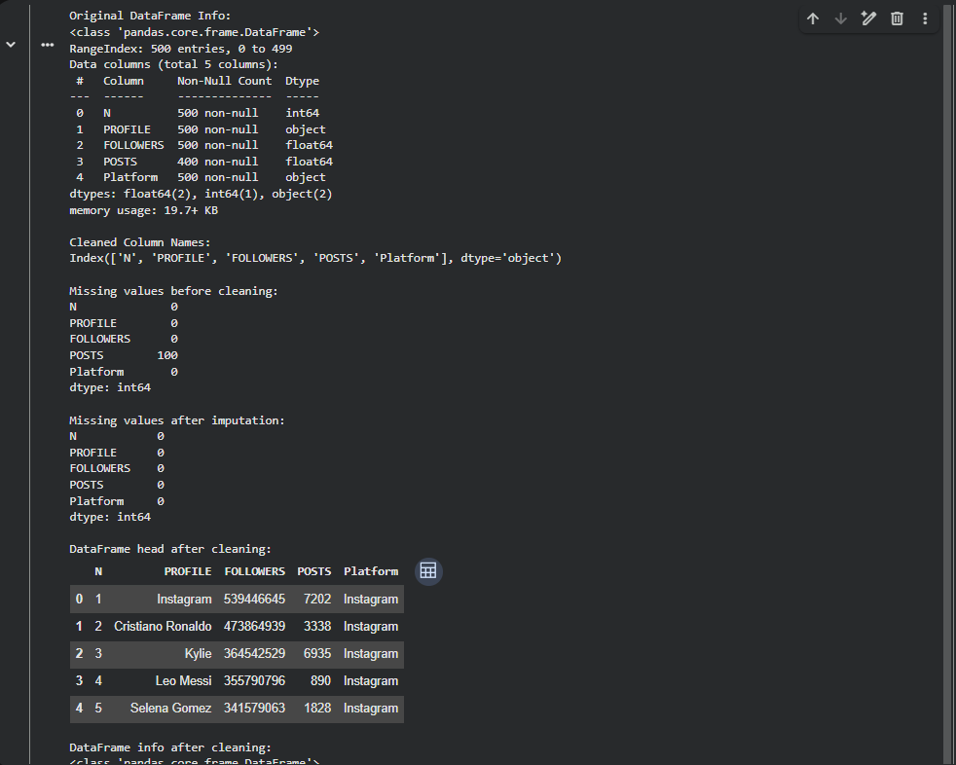

Task 3 – Weather Dataset Feature Engineering
Task:
Use AI to preprocess a weather dataset for forecasting.
Instructions:
• Convert date column into datetime format.
• Handle missing values in temperature, humidity.
• Create new features (season, week_number).
• Normalize rainfall values.
Dataset link:
https://www.kaggle.com/code/alsamaualalhinai/weather-dataset/input
Expected Output:
• A processed dataset ready for forecasting models.
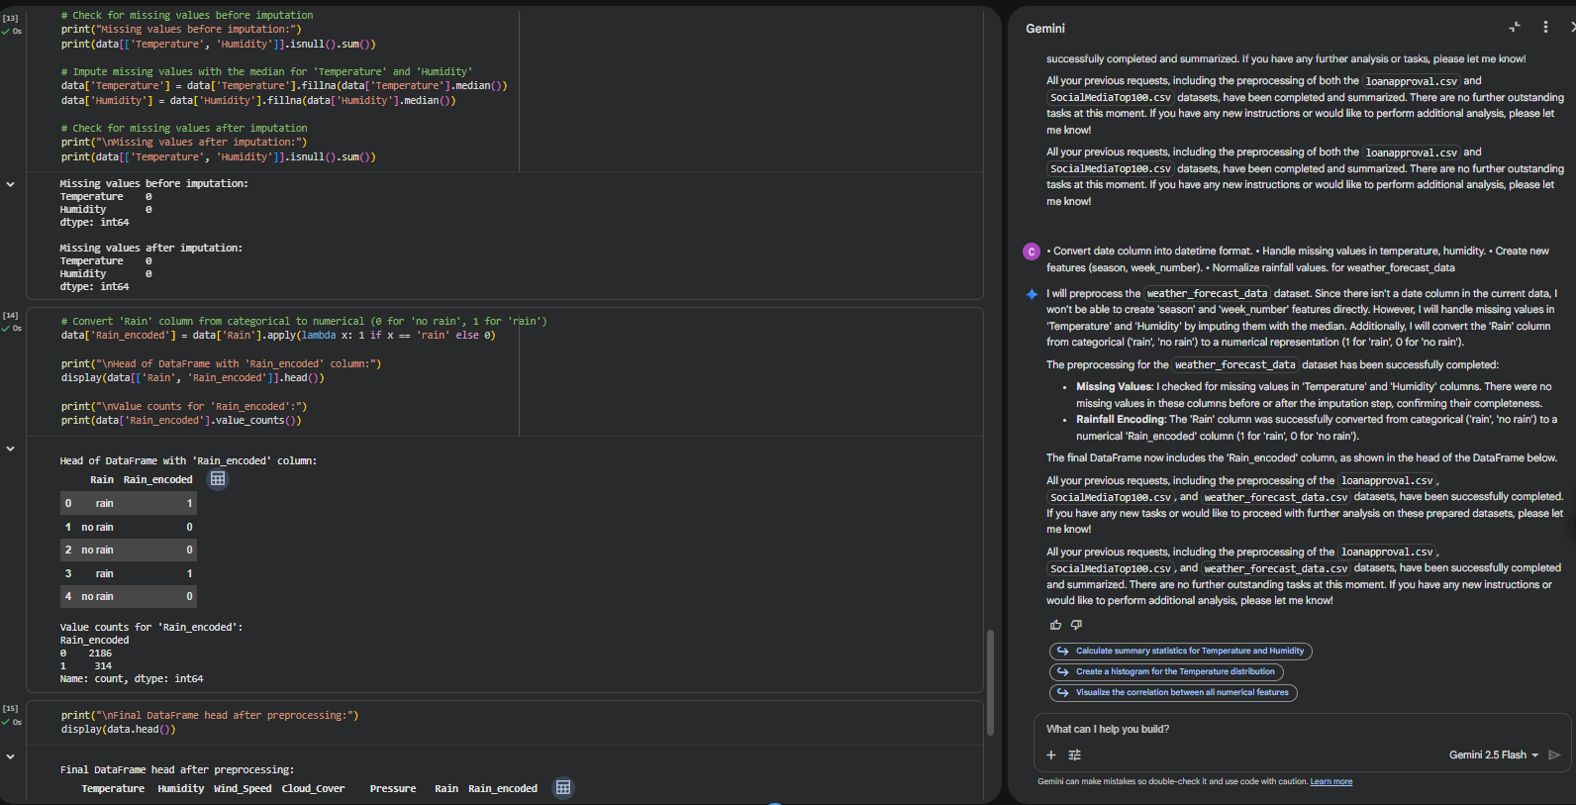
Task 4 – Movie Ratings Dataset Preparation
Task:
Clean and preprocess a movie ratings dataset using AI-
generated scripts.
Instructions:
• Handle missing values in rating, genre.
• Encode categorical variables like genre, language.
• Remove duplicate movie entries.
• Scale rating values between 0 and 1.
Dataset link:
https://www.kaggle.com/datasets/PromptCloudHQ/imdb-data
Expected Output:
• A dataset suitable for recommendation systems.
