**Characteristics of Telugu Alphabets**

Name : Akhil Babu Manam

Roll Number: 120102008

Telugu alphabets are divided into “Achhulu” (Vowels) and “Hallulu”(Consonants).

Representation in the folder are as following .wav format

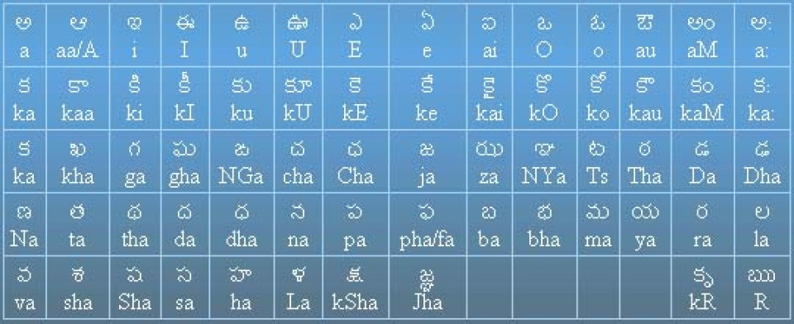

The recorded voices are named in this format.

Ex:- Vowels are named as, 1st letter is named k-a-k.wav, 2nd letter is named k-A-k.wav and so on. Ex:- Consonants are named as, 1st ka is named as a-ka-a.wav, 2nd kha is named as a-kha-a.wav.

The voices are recorded as ‘a-hallulu-a.wav’ and ‘k-achhulu-k.wav’ respectively.

**Achhulu (Vowels) :**

a A i I u U E e O o

**Dipthongs:**

ai au

**Hallulu (Consonants):**

**Stops:**

*UVUA *UVA * VUA *VA

* Velar: ka kha ga gha
* Palatal: cha Cha ja za
* Alveolar: Ts Tha Da Dha
* Dental: ta tha da dha
* Bilabial: pa pha ba bha

**Semivowels:**

ya, ra, la, La, va

**Sibilants(Fricatives):**

sha, Sha, sa, ha

**Affricates:**

KSha, Jha

**Nasals:**

* Velar: NGa
* Palatal: Nya
* Alveolar: Na
* Dental: na
* Bilabial: ma

*In this report, UVUA – Unvoiced Unaspirated, UVA – Unvoiced Aspirated, VUA – Voiced Unaspirated, VA – Voiced Aspirated