## Portals in React

A **portal** is a way to render an element outside of its component hierarchy, in a separate component

1->Create an another div

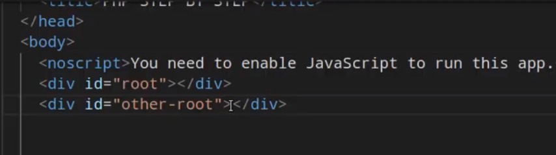

2->CREATE App.js and other .js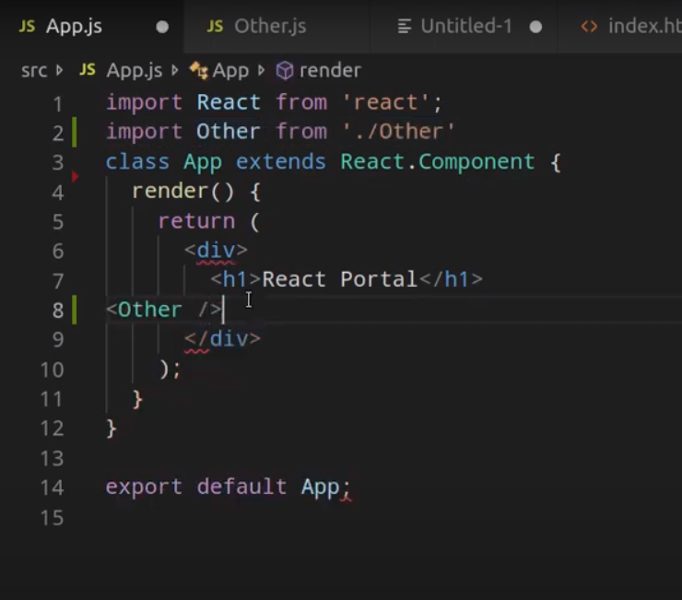

3->Other

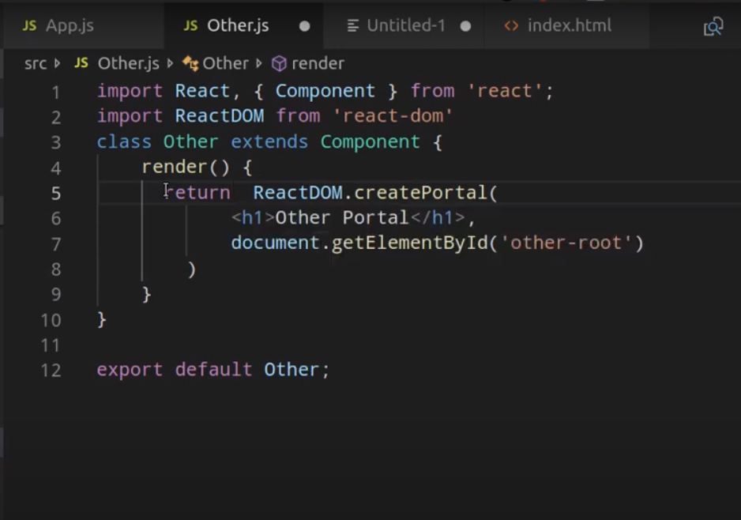

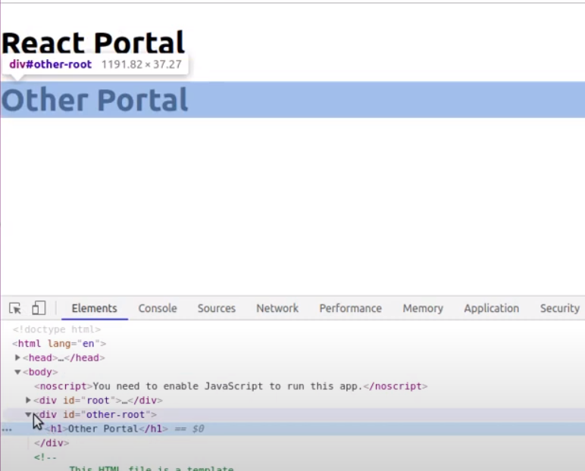They are occur in different different div