ARTIFICAL INTELLIGENCE LAB OUTPUTS

Akhil Metta

1BM17CS131

1. Tic Tac Toe

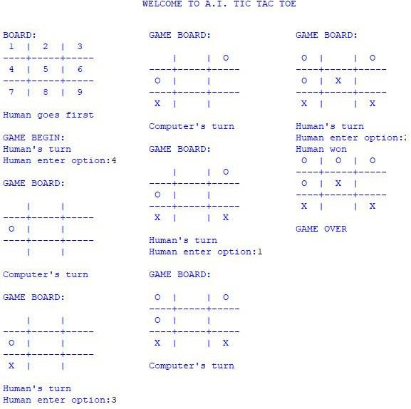

1. Vacuum Cleaner

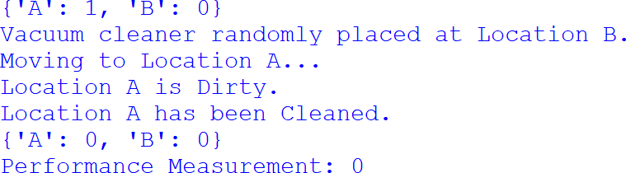

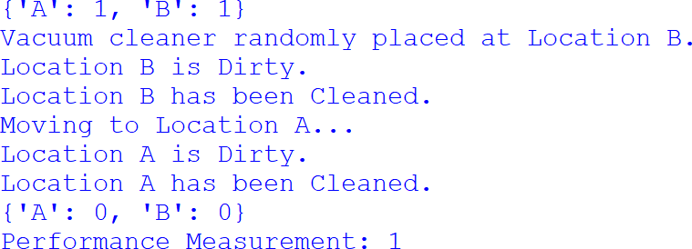

1. 8-Puzzle

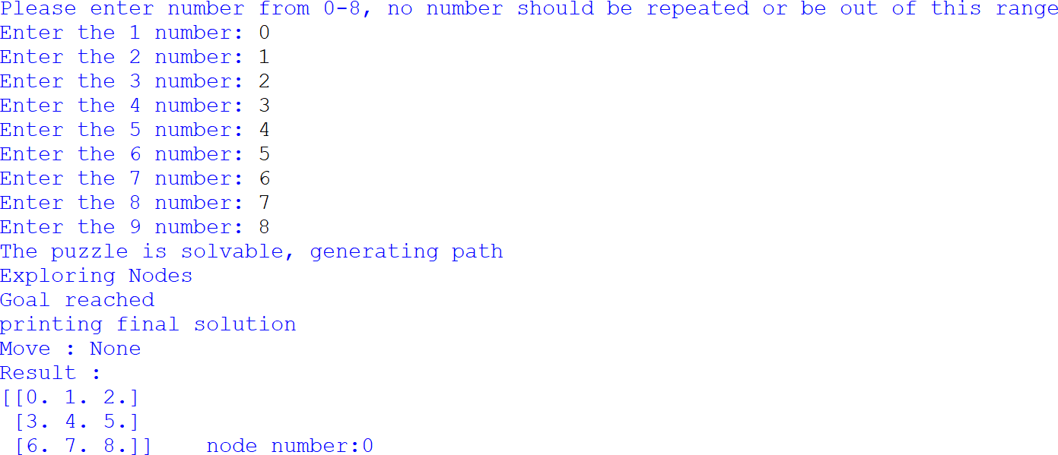

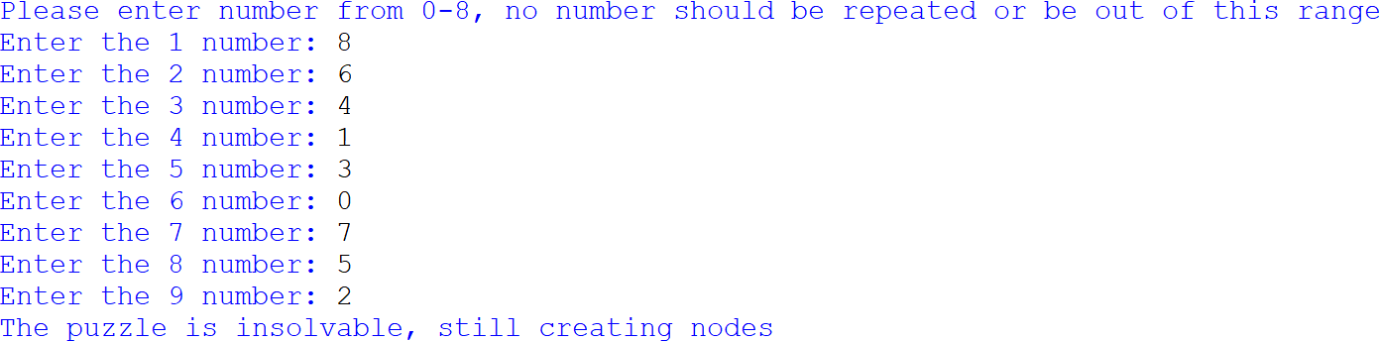

1. A-Star

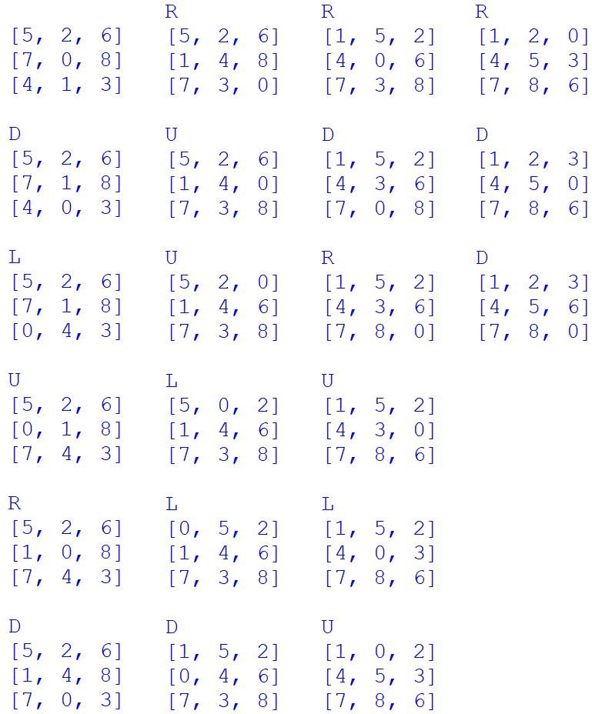

1. 8-Puzzle (Iterative)

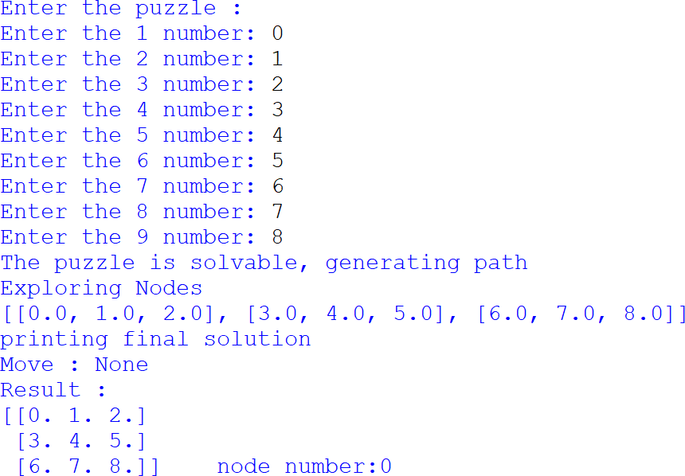

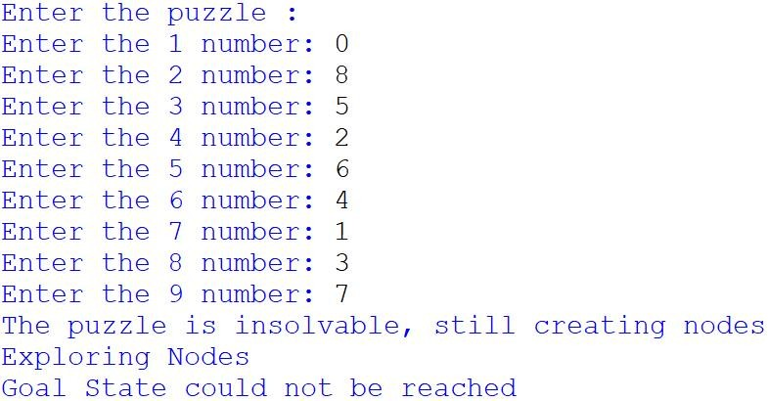

1. Knowledge base using Prepositional Logic (Entailment)

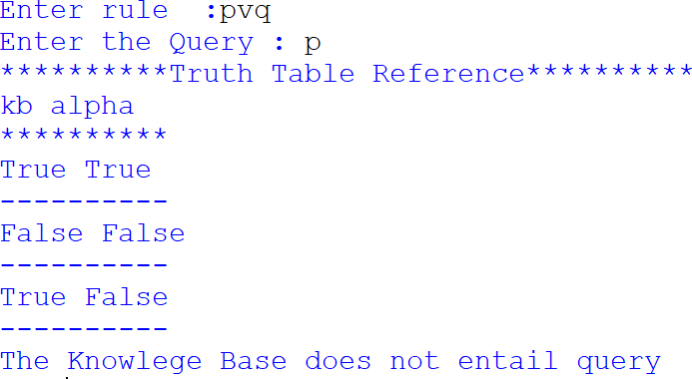

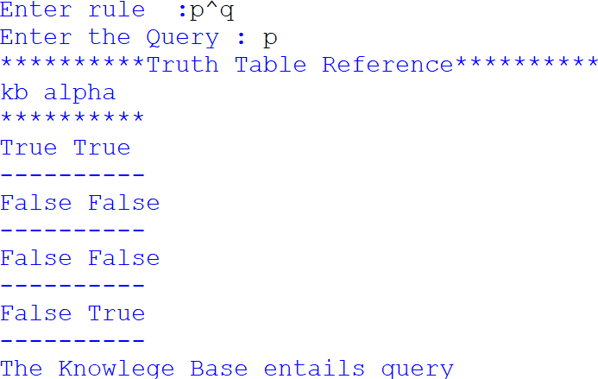

1. Conjunctive Normal Form (CNF)

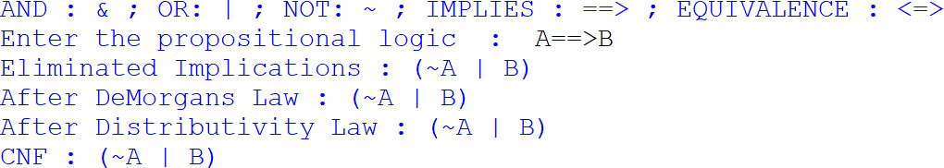

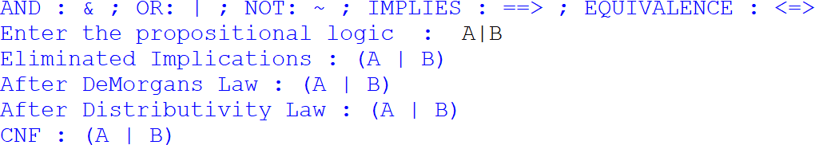

1. Unification in First Order Logic

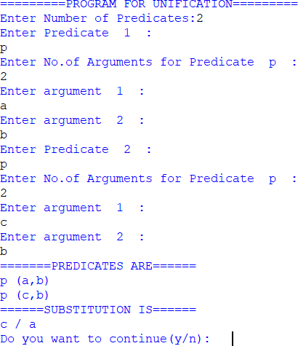

1. Forward Reasoning

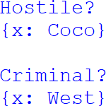

1. Decision Tree Learning

