DSA0601 • DATA HANDLING AND VISUALIZATION

Course Details | Information
Department | AIML
Course Code / Course Name | DSA0601 / Data Handling and Visualization
Programming / Visualization Tools | R
Student Name | K.Akhileswara Reddy
Register Number | 192325068
Date | 01-10-2026
SET 5: WEBSITE ANALYTICS
DSA0601 • DATA HANDLING AND VISUALIZATION
Experiment: Website Analytics

Aim
To analyze website traffic data using a line chart, bar chart, and stacked area chart, and to develop a Tableau dashboard for interactive exploration of website traffic.

Dataset: Website Traffic
Date | Page Views | Click-through Rate
2023-01-01 | 1500 | 2.3%
2023-01-02 | 1600 | 2.7%
2023-01-03 | 1400 | 2.0%
2023-01-04 | 1650 | 2.4%
2023-01-05 | 1800 | 2.6%

PROGRAM 1: Line Chart of Daily Page Views
Create a line chart to visualize the trend in daily page views over time. Label the axes and title the chart.
# Dataset
date <- as.Date(c("2023-01-01", "2023-01-02", "2023-01-03",
"2023-01-04", "2023-01-05"))
page_views <- c(1500, 1600, 1400, 1650, 1800)
# Line Chart
plot(date, page_views,
type = "o",
pch = 19,
col = "blue",
main = "Daily Website Page Views",
xlab = "Date",
ylab = "Page Views")
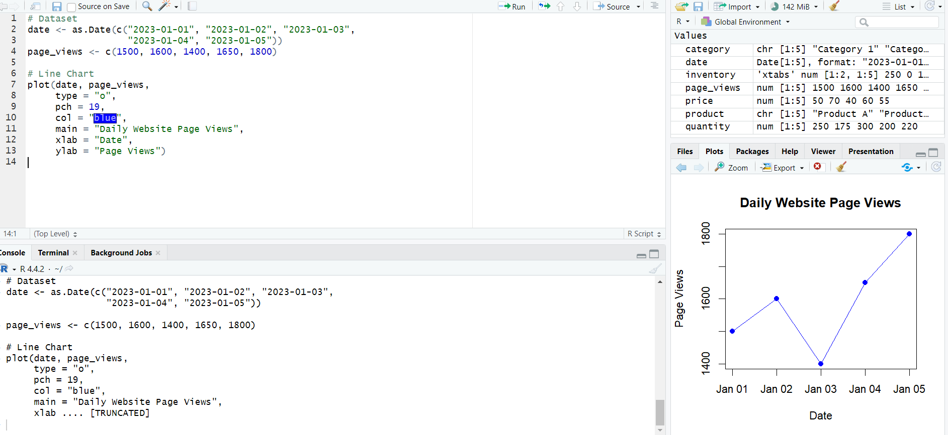Observation: Page views increase overall from 1,500 on January 1 to 1,800 on January 5, with a temporary decrease to 1,400 on January 3.

PROGRAM 2: Bar Chart of Top N Click-through Rates
Generate a bar chart showing the top N days with the highest click-through rates. Label the chart elements.
# Dataset
date <- as.Date(c("2023-01-01", "2023-01-02", "2023-01-03",
"2023-01-04", "2023-01-05"))
ctr <- c(2.3, 2.7, 2.0, 2.4, 2.6)
# Set N = 3
N <- 3
top <- order(ctr, decreasing = TRUE)[1:N]
# Top N Bar Chart
barplot(ctr[top],
names.arg = format(date[top], "%d-%b"),
xlab = "Date",
ylab = "Click-through Rate (%)",
main = paste("Top", N, "Days by Click-through Rate"),
col = "skyblue")
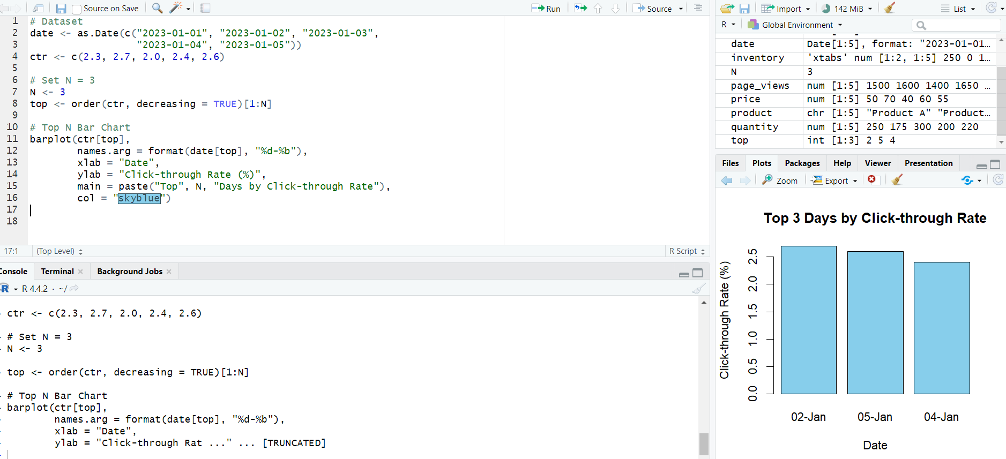Observation: The three highest click-through rates are January 2 (2.7%), January 5 (2.6%), and January 4 (2.4%).

PROGRAM 3: Stacked Area Chart of User Interactions
Develop a stacked area chart to display the distribution of user interactions such as likes, shares, and comments on a website.
# Illustrative interaction data
date <- as.Date(c("2023-01-01", "2023-01-02", "2023-01-03",
"2023-01-04", "2023-01-05"))
likes <- c(120, 140, 110, 150, 170)
shares <- c(50, 60, 45, 65, 70)
comments <- c(30, 35, 25, 40, 45)
interactions <- rbind(likes, shares, comments)
# Stacked Area Chart
matplot(date, t(interactions),
type = "l",
lty = 1,
lwd = 2,
col = c("blue", "green", "orange"),
main = "Distribution of User Interactions",
xlab = "Date",
ylab = "Number of Interactions")
# Create stacked polygons
cum <- apply(interactions, 2, cumsum)
lower <- rbind(rep(0, ncol(interactions)),
cum[-nrow(cum), , drop = FALSE])
plot(date, colSums(interactions),
type = "n",
main = "Stacked Area Chart of User Interactions",
xlab = "Date",
ylab = "Number of Interactions")
for (i in 1:nrow(interactions)) {
upper <- cum[i, ]
polygon(c(date, rev(date)),
c(lower[i, ], rev(upper)),
col = c("skyblue", "lightgreen", "orange")[i],
border = NA)
}
legend("topleft",
legend = c("Likes", "Shares", "Comments"),
fill = c("skyblue", "lightgreen", "orange"))
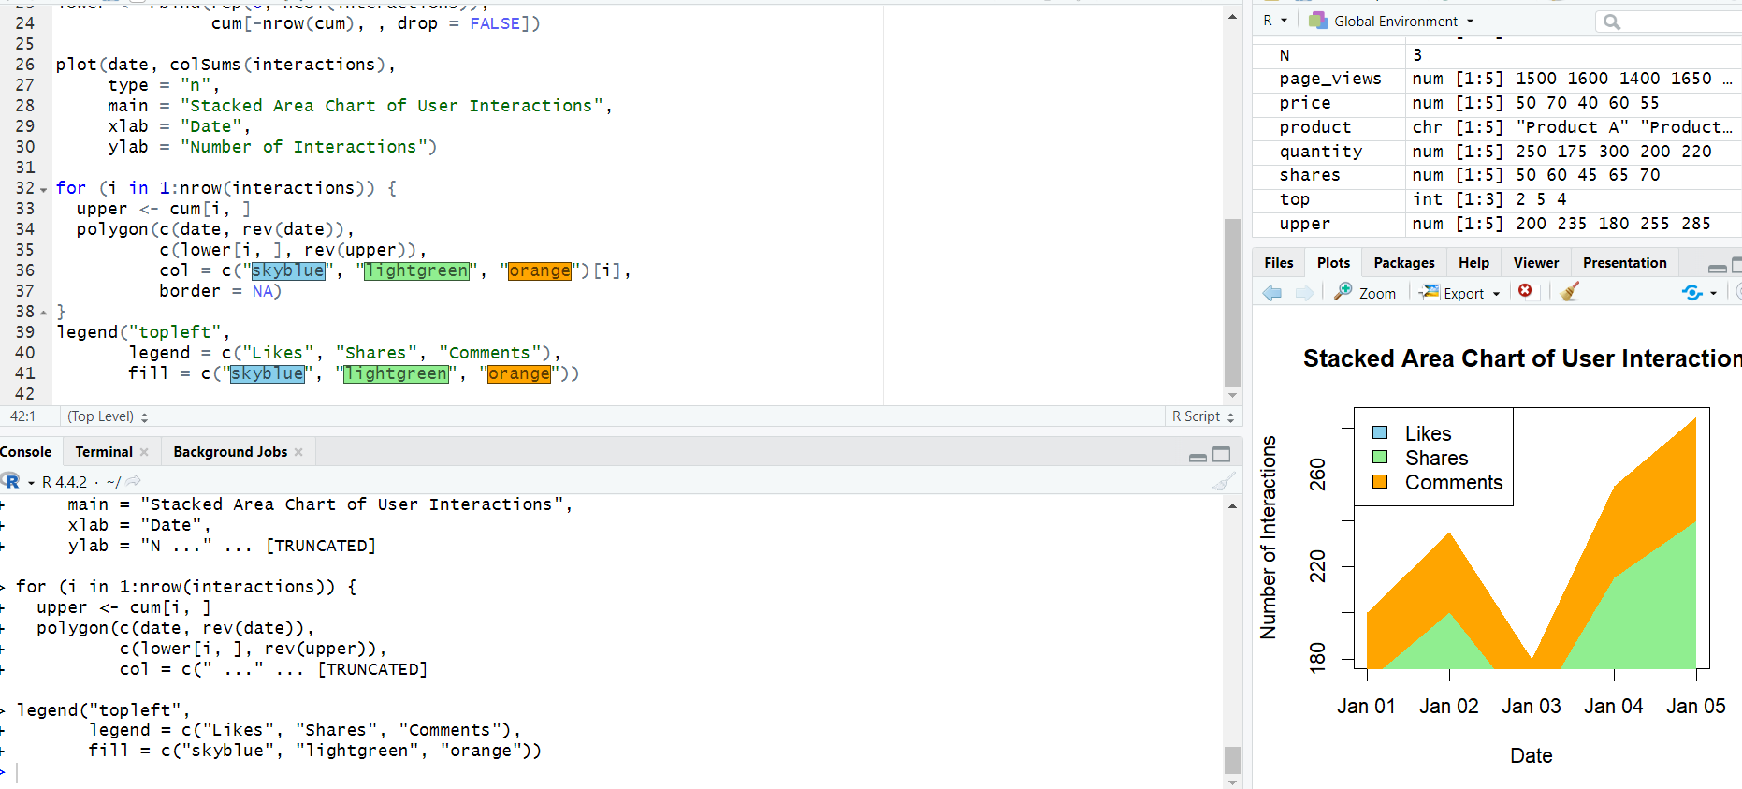Observation: The stacked area chart shows the relative contribution of likes, shares, and comments across the five dates. The interaction values are illustrative because the supplied dataset does not contain user-interaction counts.
Data Note: The supplied Website Traffic dataset contains only Date, Page Views, and Click-through Rate. It does not contain Likes, Shares, or Comments. Therefore, illustrative interaction values are used to demonstrate the required stacked area chart.

PROGRAM 4: Tableau Dashboard for Website Analytics
Build a Tableau dashboard with the line chart and bar chart for interactive exploration of website traffic data.
TABLEAU WORKFLOW
1. Connect Tableau to the Website Traffic dataset.
2. Worksheet 1 – Daily Page Views Line Chart:
• Drag Date to Columns.
• Drag Page Views to Rows.
• Set Marks to Line.
• Add Date and Page Views labels where required.
• Title: Daily Website Page Views.
3. Worksheet 2 – Top N Click-through Rate Bar Chart:
• Drag Date to Columns.
• Drag Click-through Rate to Rows.
• Sort in descending order.
• Create a Top N parameter/filter if required.
• Enable data labels.
• Title: Top Days by Click-through Rate.
4. Create a new Dashboard.
5. Place both worksheets on the dashboard.
6. Add Date and Top N filters/controls.
7. Add dashboard actions for interactive filtering or highlighting.
8. Add a dashboard title and save the Tableau workbook.
Observation: The dashboard combines the daily page-view trend with click-through-rate comparisons and allows users to interactively filter and explore the website traffic data.

Procedure
- Create Date, Page Views, and Click-through Rate vectors using the supplied dataset.
- Use plot() to visualize daily page views as a time-based line chart.
- Sort the click-through rates and use barplot() to display the selected top N days.
- Prepare illustrative likes, shares, and comments data and create a stacked area chart.
- In Tableau, create the line chart and bar chart worksheets.
- Combine both worksheets into a dashboard and add filters or dashboard actions.

Result
The website traffic data was successfully visualized using a daily page-view line chart and a top-N click-through-rate bar chart. A stacked area chart was demonstrated using illustrative user-interaction data, and a Tableau dashboard was developed for interactive exploration.

Key Functions / Tools Used
Function / Tool | Purpose
plot() | Creates the line chart and base plotting area for the stacked area chart.
barplot() | Creates the top-N click-through-rate bar chart.
order() | Sorts click-through rates to identify the top N days.
polygon() | Creates the stacked area regions.
legend() | Adds labels for interaction categories.
Tableau | Creates interactive worksheets and dashboards.
Filters / Dashboard Actions | Enable interactive website traffic exploration.

