SET 6: PRODUCT SALES ANALYSIS
DSA0601 • DATA HANDLING AND VISUALIZATION

Course Details | Information
Department | AIML
Course Code / Course Name | DSA0601 / Data Handling and Visualization
Programming / Visualization Tools | R
Student Name | K.Akhileswara Reddy
Register Number | 192325068
Date | 01-10-2026

Experiment: Product Sales Analysis

Aim
To analyze monthly product sales for the first quarter using a grouped bar chart, stacked area chart, and tabular representation, and to develop a Tableau dashboard for interactive exploration of the sales data.

Dataset: Monthly Product Sales
Product ID | Product Name | January Sales | February Sales | March Sales
1 | Product A | 2000 | 2200 | 2400
2 | Product B | 1500 | 1800 | 1600
3 | Product C | 1200 | 1400 | 1100

PROGRAM 1: Grouped Bar Chart of First-Quarter Sales
Create a grouped bar chart to visualize the sales of each product for January, February, and March. Label the chart elements.
# Dataset
product <- c("Product A", "Product B", "Product C")
jan <- c(2000, 1500, 1200)
feb <- c(2200, 1800, 1400)
mar <- c(2400, 1600, 1100)
# Combine monthly sales
sales <- rbind(jan, feb, mar)
colnames(sales) <- product
rownames(sales) <- c("January", "February", "March")
# Grouped Bar Chart
barplot(sales,
beside = TRUE,
names.arg = product,
xlab = "Product",
ylab = "Sales",
main = "First Quarter Product Sales",
col = c("skyblue", "lightgreen", "orange"),
legend.text = rownames(sales),
args.legend = list(x = "topright"))
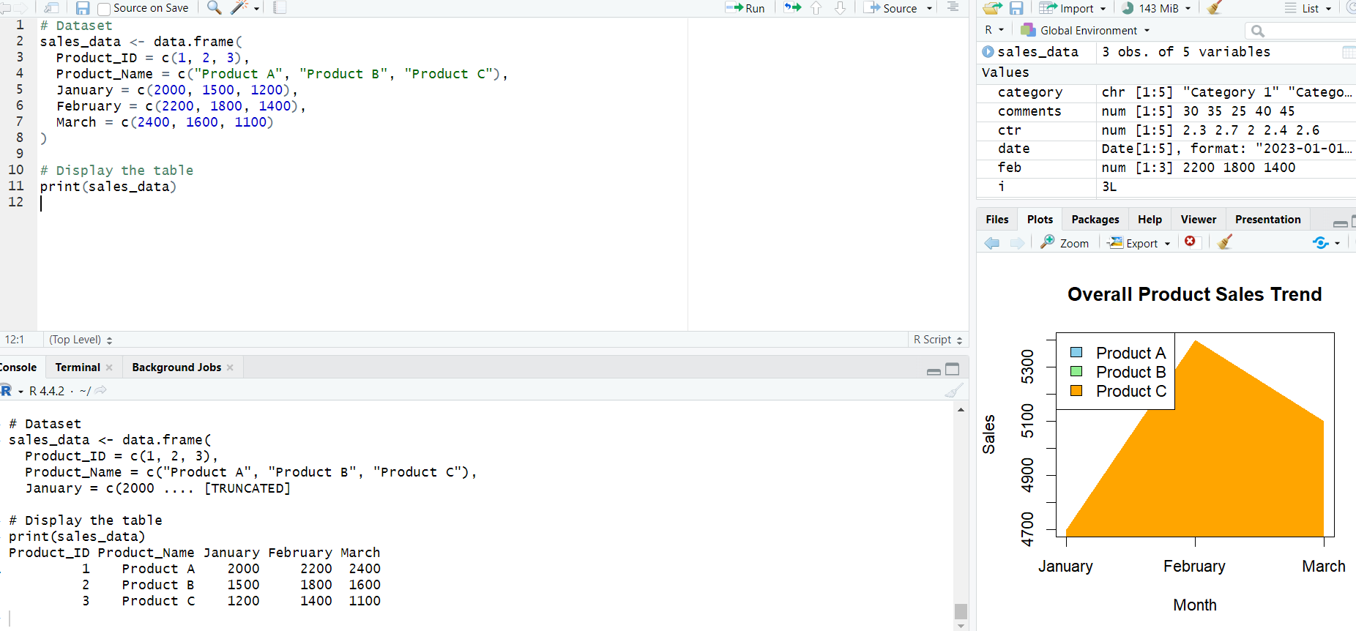Observation: Product A shows the highest sales in each of the three months. Product C has the lowest sales among the three products throughout the first quarter.

PROGRAM 2: Stacked Area Chart of Overall Sales Trend
Generate a stacked area chart to represent the overall sales trend for all products over the three months.
# Monthly sales data
months <- c("January", "February", "March")
product_a <- c(2000, 2200, 2400)
product_b <- c(1500, 1800, 1600)
product_c <- c(1200, 1400, 1100)
sales <- rbind(product_a, product_b, product_c)
# Cumulative totals for stacked areas
cum_sales <- apply(sales, 2, cumsum)
lower <- rbind(rep(0, ncol(sales)),
cum_sales[-nrow(cum_sales), , drop = FALSE])
x <- 1:3
plot(x, colSums(sales),
type = "n",
xaxt = "n",
xlab = "Month",
ylab = "Sales",
main = "Overall Product Sales Trend")
for (i in 1:nrow(sales)) {
polygon(c(x, rev(x)),
c(lower[i, ], rev(cum_sales[i, ])),
col = c("skyblue", "lightgreen", "orange")[i],
border = NA)
}
axis(1, at = x, labels = months)
legend("topleft",
legend = c("Product A", "Product B", "Product C"),
fill = c("skyblue", "lightgreen", "orange"))
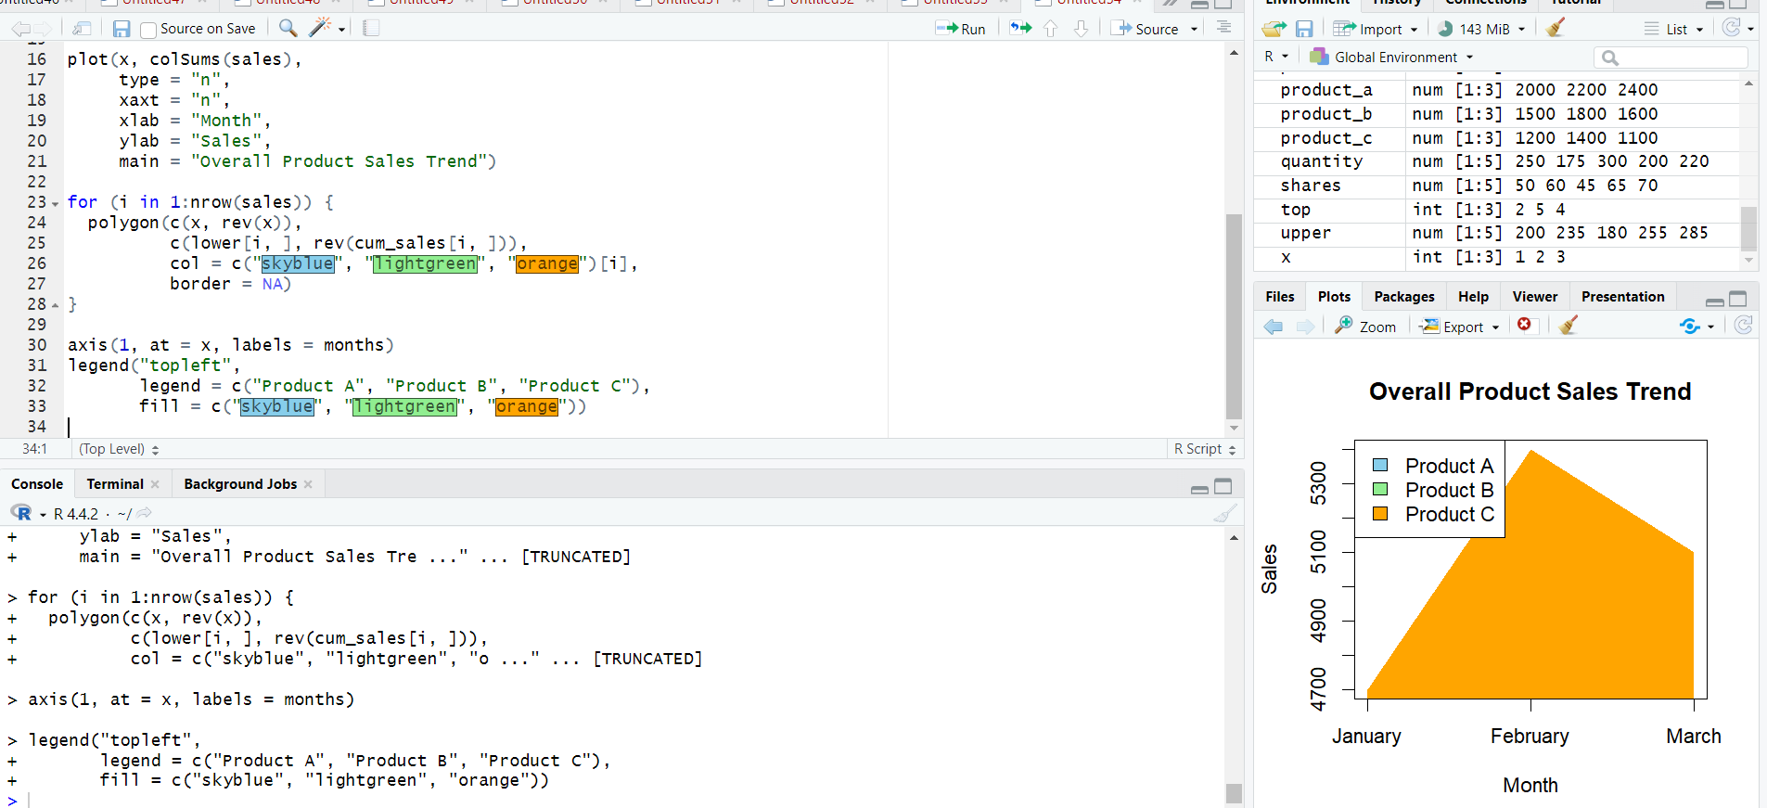Product A contributes the largest share of total sales in all three months.

PROGRAM 3: Monthly Sales Data Table
Build a table to show the monthly sales data for each product. Label the table elements.
# Dataset
sales_data <- data.frame(
Product_ID = c(1, 2, 3),
Product_Name = c("Product A", "Product B", "Product C"),
January = c(2000, 1500, 1200),
February = c(2200, 1800, 1400),
March = c(2400, 1600, 1100)
)
# Display the table
print(sales_data)

PROGRAM 4: Tableau Dashboard for Product Sales
Develop a Tableau dashboard combining the grouped bar chart, stacked area chart, and table for interactive exploration of sales data.
TABLEAU WORKFLOW
1. Connect Tableau to the Monthly Product Sales dataset.
2. Worksheet 1 – Grouped Bar Chart:
• Product Name → Columns.
• Month → Columns beside Product Name.
• Sales → Rows.
• Use side-by-side/grouped bars.
• Enable data labels.
3. Worksheet 2 – Stacked Area Chart:
• Month → Columns.
• Sales → Rows.
• Product Name → Color.
• Set Marks to Area.
• Keep the areas stacked.
4. Worksheet 3 – Sales Table:
• Product Name → Rows.
• Month → Columns.
• Sales → Text.
• Format as a readable table.
5. Create a new Dashboard.
6. Place all three worksheets on the dashboard.
7. Add Product Name and Month filters.
8. Add dashboard actions for interactive filtering/highlighting.
9. Add a suitable dashboard title and save the Tableau workbook.
Observation: The Tableau dashboard combines product-wise quarterly comparisons, the overall monthly sales trend, and exact sales values in a table. Filters allow users to explore selected products or months.

Procedure
- Create the product and monthly sales vectors using the supplied dataset.
- Use barplot() with beside = TRUE to create grouped bars for the three months.
- Calculate cumulative monthly sales and use polygon() to create the stacked area chart.
- Create a data frame and print it to display the monthly sales table.
- In Tableau, create the grouped bar chart, stacked area chart, and sales table.
- Combine the three worksheets into a dashboard and add filters or dashboard actions.

Result
The first-quarter product sales data was successfully visualized using a grouped bar chart, stacked area chart, and table. A Tableau dashboard was developed by combining all three views for interactive exploration of the product sales data.

Key Functions / Tools Used
Function / Tool | Purpose
barplot() | Creates the grouped bar chart.
rbind() | Combines monthly sales into a matrix.
apply() | Calculates cumulative values for the stacked area chart.
polygon() | Creates stacked area regions.
data.frame() | Creates the monthly sales table.
print() | Displays the sales table.
Tableau | Creates the interactive dashboard.
Filters / Dashboard Actions | Enable interactive exploration.

