LAB EXPERIMENT RECORD
DSA0601 • DATA HANDLING AND VISUALIZATION

Course Details | Information
Department | AIML
Course Code / Course Name | DSA0601 / Data Handling and Visualization
Experiments Included | Set 1: Monthly Sales Data  Set 2: Customer Feedback Analysis  Set 3: Employee Performance Evaluation
Programming / Visualization Tools | R, Shiny, Tableau
Student Name | K.Akhileswara Reddy
Register Number | 192325068
Date | 29 September 2026

SET 1: MONTHLY SALES DATA
Experiment: Dataset: Monthly Sales

Aim
To visualize monthly sales using a line chart, a bar chart, and a scatter plot, and to create an interactive dashboard that combines the line chart and bar chart.

Dataset: Monthly Sales
Month | Sales (in $)
January | 15000
February | 18000
March | 22000
April | 20000
May | 23000

PROGRAM 1: Line Chart of Monthly Sales
Create a line chart to visualize monthly sales. Label the axes and provide an appropriate title.
# Dataset
month <- c("January", "February", "March", "April", "May")
sales <- c(15000, 18000, 22000, 20000, 23000)
# Line Chart
plot(sales, type = "o", xaxt = "n",
xlab = "Month", ylab = "Sales ($)",
main = "Monthly Sales Trend", col = "blue")
axis(1, at = 1:5, labels = month)
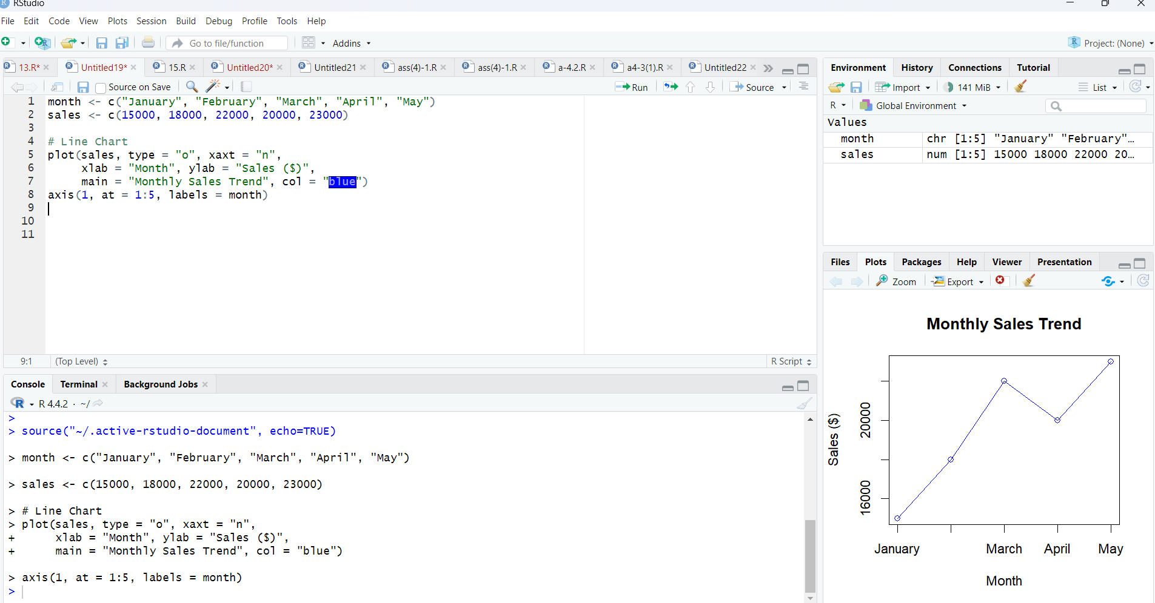
Output 1: Monthly Sales Line Chart

Observation: Sales rise from January to March, dip in April, and reach the highest value in May.

PROGRAM 2: Bar Chart of Sales
Generate a bar chart to compare the sales values for the available months.
# Dataset
month <- c("January", "February", "March", "April", "May")
sales <- c(15000, 18000, 22000, 20000, 23000)
# Bar Chart
barplot(sales, names.arg = month,
xlab = "Month", ylab = "Sales ($)",
main = "Monthly Sales by Month",
col = "skyblue")
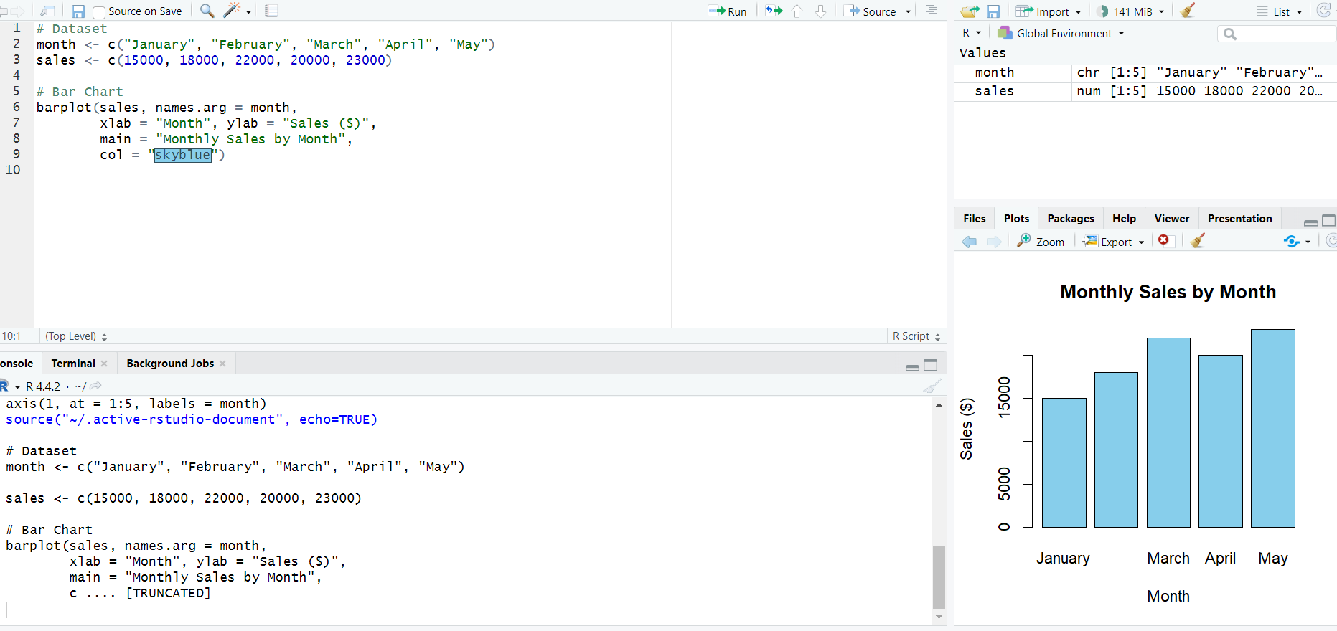
Output 2: Monthly Sales Bar Chart

Observation: May records the highest sales ($23,000), while January records the lowest ($15,000).

PROGRAM 3: Scatter Plot of Advertising Budget vs Monthly Sales
Explore the relationship between advertising budget and monthly sales using a scatter plot.
# Sales values from the given dataset
sales <- c(15000, 18000, 22000, 20000, 23000)
# Advertising budgets (illustrative values; not supplied in the dataset)
advertising <- c(5000, 6000, 7000, 8000, 9000)
# Scatter Plot
plot(advertising, sales, pch = 19, col = "red",
main = "Advertising Budget vs Monthly Sales",
xlab = "Advertising Budget ($)",
ylab = "Monthly Sales ($)")
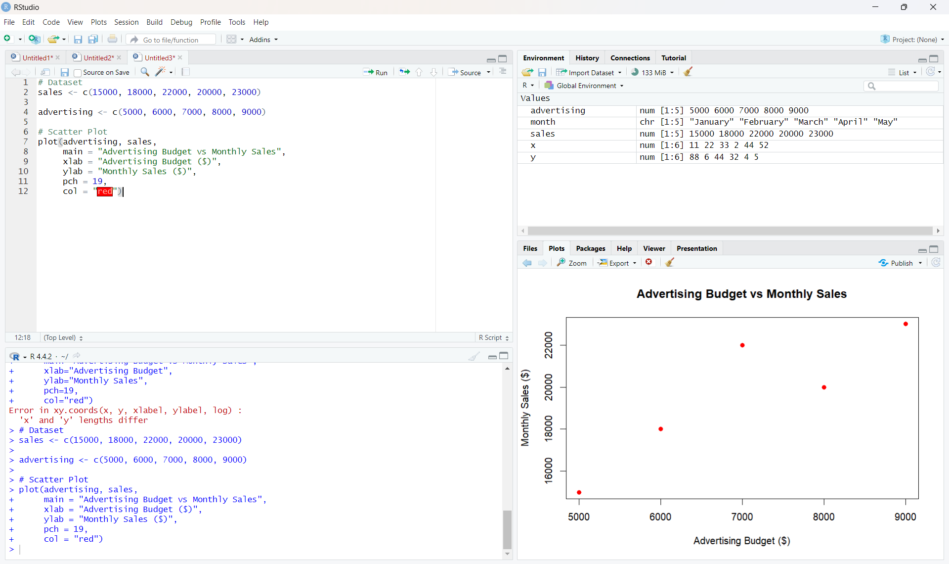
Output 3: Advertising Budget vs Monthly Sales Scatter Plot
Insight: The plotted values show a generally positive association: sales tend to be higher at larger advertising budgets. This is an association in the illustrative data, not proof that advertising caused the increase.
Data note: The supplied monthly-sales table does not include advertising budgets. The values $5,000, $6,000, $7,000, $8,000, and $9,000 are illustrative inputs used to demonstrate the scatter plot.

PROGRAM 4: Interactive Sales Dashboard Using Shiny
Build an interactive dashboard that lets users switch between the monthly sales line chart and bar chart.
library(shiny)
month <- c("January", "February", "March", "April", "May")
sales <- c(15000, 18000, 22000, 20000, 23000)
ui <- fluidPage(
titlePanel("Monthly Sales Dashboard"),
sidebarLayout(
sidebarPanel(
selectInput("chart", "Select Chart:",
choices = c("Line Chart", "Bar Chart"))
),
mainPanel(plotOutput("salesPlot"))
)
)
server <- function(input, output) {
output$salesPlot <- renderPlot({
if (input$chart == "Line Chart") {
plot(sales, type = "o", xaxt = "n",
xlab = "Month", ylab = "Sales ($)",
main = "Monthly Sales Trend")
axis(1, at = 1:5, labels = month)
} else {
barplot(sales, names.arg = month,
xlab = "Month", ylab = "Sales ($)",
main = "Monthly Sales by Month")
}
})
}
shinyApp(ui = ui, server = server)
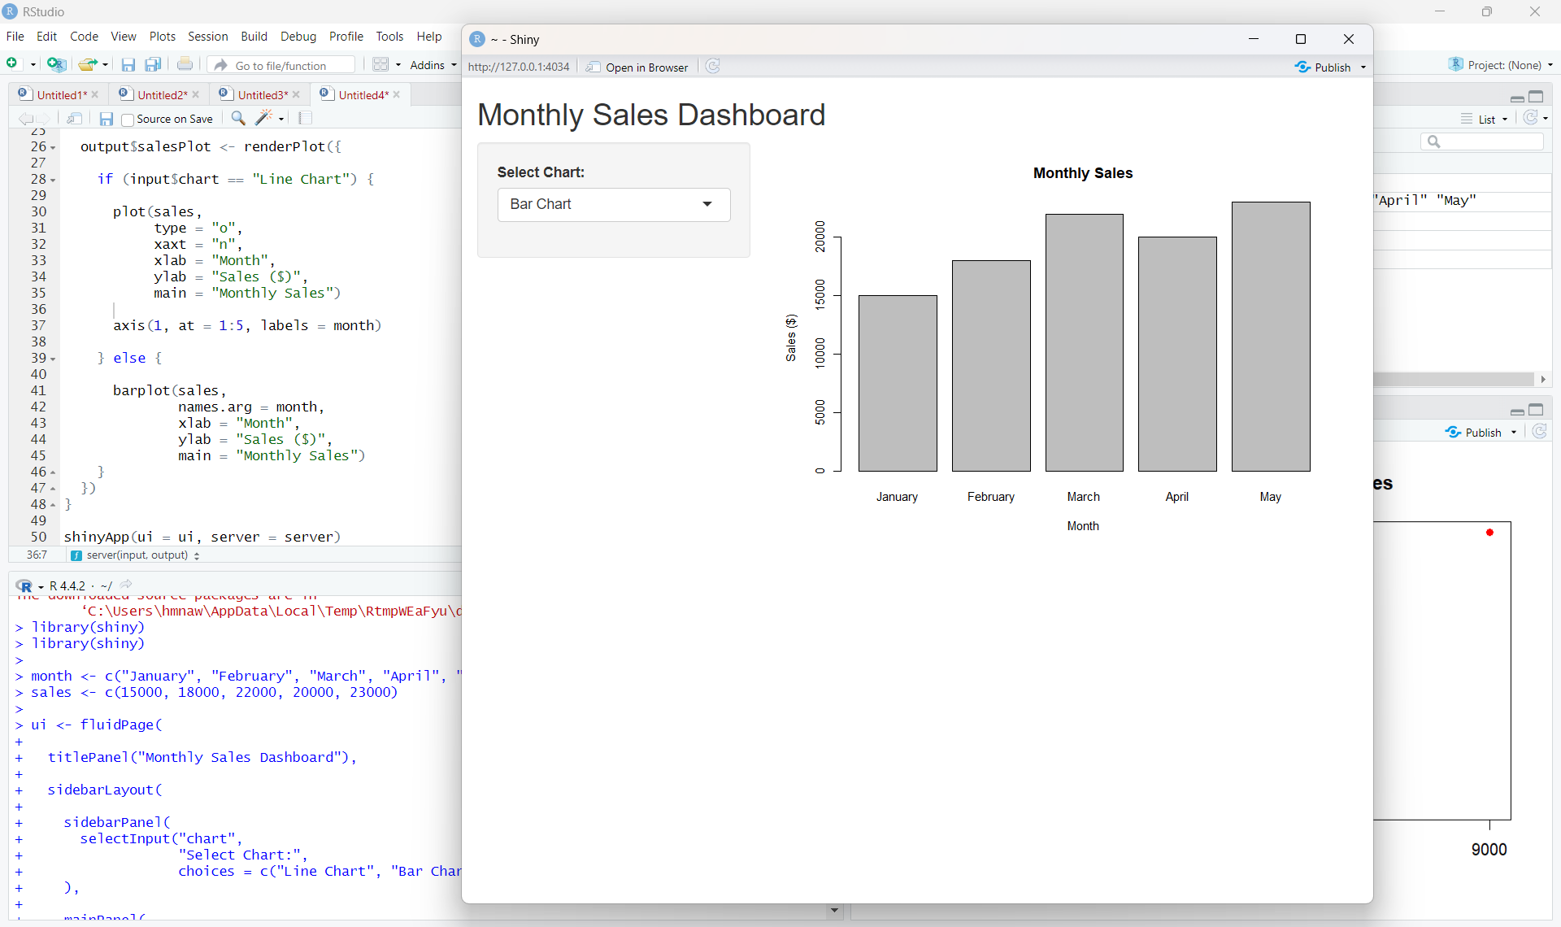
Output 4: Interactive Monthly Sales Dashboard
Observation: The dashboard uses a selection control to display either the monthly trend line chart or the sales comparison bar chart.
Procedure
- Create month and sales vectors in R using the values in the dataset.
- Use plot() and axis() to create the line chart with clear labels.
- Use barplot() to compare monthly sales.
- Run the Shiny app and switch between Line Chart and Bar Chart.

Result
Monthly sales were visualized using line, bar, and scatter charts. An interactive Shiny dashboard was created to switch between the line chart and bar chart.
Key R Functions Used
Function | Purpose
plot() | Creates line and scatter plots.
axis() | Adds custom axis labels.
barplot() | Creates a bar chart.
fluidPage() | Creates the Shiny page layout.
selectInput() | Provides a chart-selection control.
renderPlot() | Generates plots dynamically in Shiny.
shinyApp() | Runs the Shiny application.

SET 2: CUSTOMER FEEDBACK ANALYSIS
Experiment: Dataset: Customer Satisfaction

Aim
To analyze customer age and satisfaction data using a histogram, pie chart, stacked bar chart, and word cloud.

Dataset: Customer Satisfaction
Customer ID | Age | Satisfaction Score
1 | 25 | 4
2 | 30 | 5
3 | 35 | 3
4 | 28 | 4
5 | 40 | 5

PROGRAM 1: Histogram of Customer Ages
Create a histogram to represent the distribution of customer ages. Label the axes and title the chart.
# Dataset
age <- c(25, 30, 35, 28, 40)
# Histogram
hist(age, breaks = 5,
main = "Distribution of Customer Ages",
xlab = "Age (years)", ylab = "Frequency",
col = "skyblue")
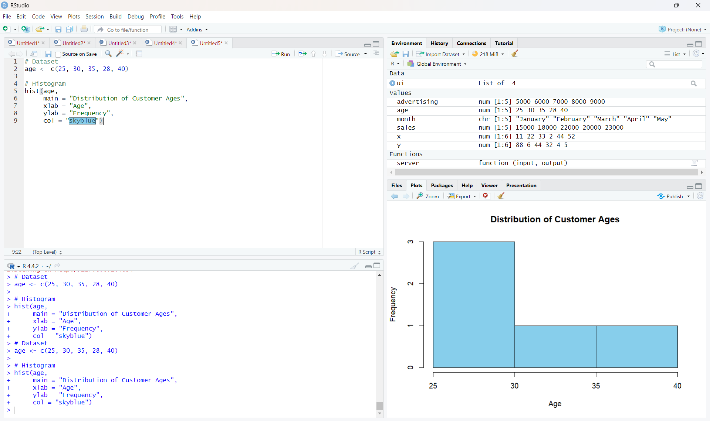
Output 1: Distribution of Customer Ages
Observation: The histogram displays the distribution of the five customer ages, ranging from 25 to 40 years.

PROGRAM 2: Pie Chart of Satisfaction Scores
Display the overall distribution of customer satisfaction scores using a labeled pie chart.
# Satisfaction scores
satisfaction <- c(4, 5, 3, 4, 5)
score_count <- table(satisfaction)
# Pie Chart
pie(score_count,
labels = paste(names(score_count), "Score (",
as.vector(score_count), ")", sep = ""),
main = "Customer Satisfaction Score Distribution")
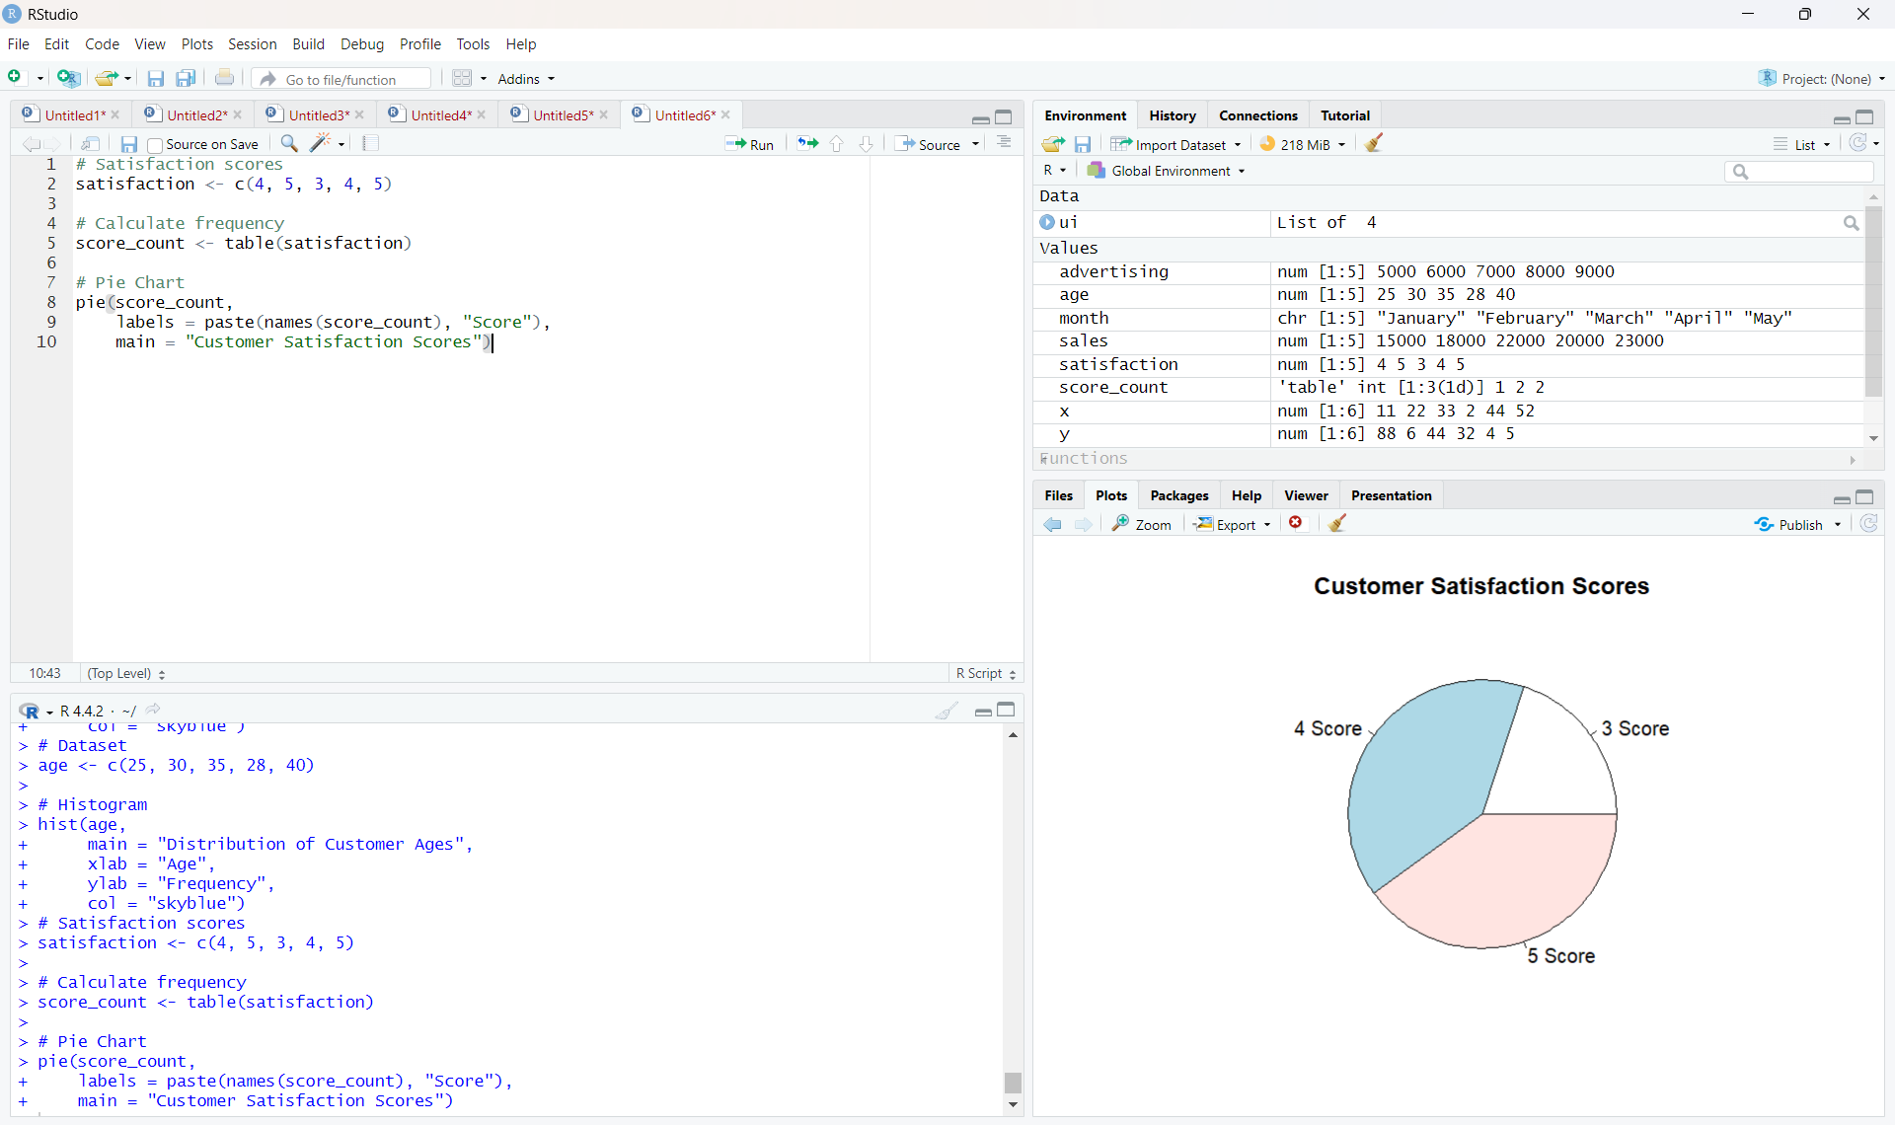
Output 2: Customer Satisfaction Scores Pie Chart
Observation: Scores 4 and 5 each occur twice (40% each); score 3 occurs once (20%).

PROGRAM 3: Stacked Bar Chart by Age Group
Visualize the distribution of satisfaction scores across customer age groups using a stacked bar chart.
age <- c(25, 30, 35, 28, 40)
satisfaction <- c(4, 5, 3, 4, 5)
# Create age groups
age_group <- cut(age, breaks = c(20, 29, 39, 49),
labels = c("20-29", "30-39", "40-49"),
include.lowest = TRUE)
# Frequency table and stacked bar chart
data <- table(age_group, satisfaction)
barplot(t(data), beside = FALSE,
main = "Satisfaction Scores by Age Group",
xlab = "Age Group", ylab = "Number of Customers",
col = c("skyblue", "lightgreen", "orange"),
legend.text = colnames(data))
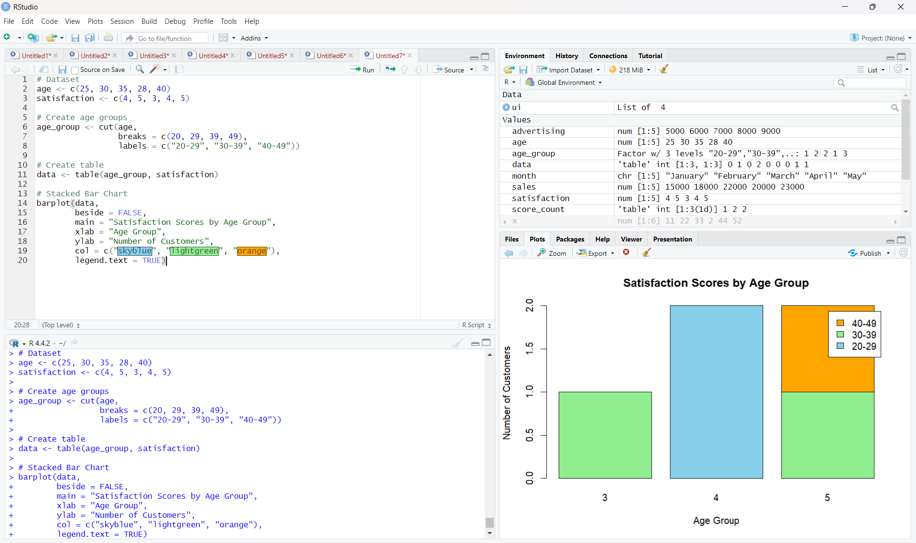
Output 3: Satisfaction Scores by Age Group
Observation: The chart groups customers into ages 20–29, 30–39, and 40–49, then stacks the frequency of each satisfaction score in each group.

PROGRAM 4: Word Cloud of Customer Feedback
Create a word cloud from sample open-ended feedback to identify frequently used terms and sentiments.
# Install packages once if required:
# install.packages(c("wordcloud", "RColorBrewer"))
library(wordcloud)
library(RColorBrewer)
# Sample feedback (the prompt does not provide verbatim comments)
feedback <- c(
"good service",
"excellent service",
"good experience",
"friendly staff",
"excellent service"
)
words <- unlist(strsplit(tolower(feedback), " "))
word_count <- table(words)
wordcloud(names(word_count), freq = as.numeric(word_count),
min.freq = 1, scale = c(3, 0.6),
colors = brewer.pal(8, "Dark2"),
random.order = FALSE)
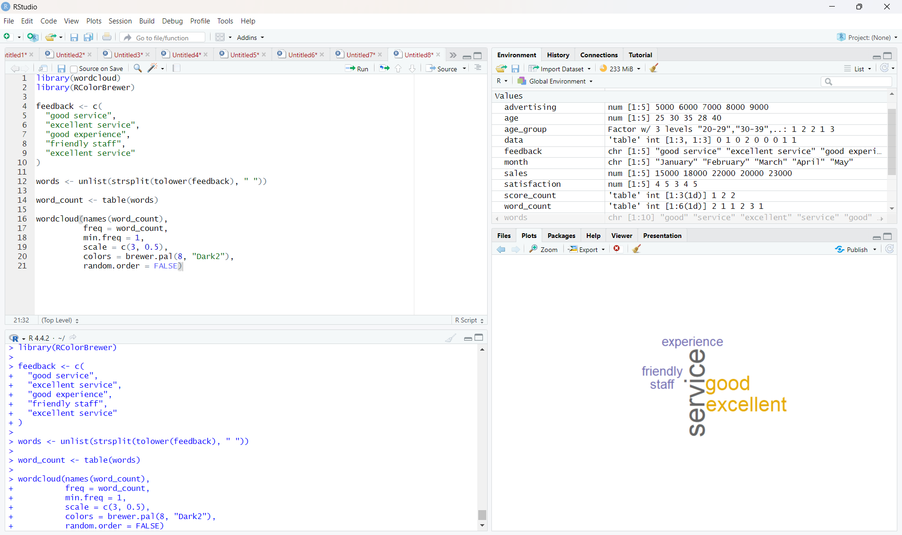
Output 4: Customer Feedback Word Cloud
Observation: The sample word cloud emphasizes recurring terms such as “service,” “excellent,” and “good.” Results depend on the sample comments used.
Data note: No open-ended customer comments were included in the prompt. The program uses a small illustrative feedback sample; replace it with actual customer comments for a real analysis.

Procedure
- Create vectors for customer age and satisfaction score.
- Use hist() to show the age distribution.
- Use table() and pie() to display the satisfaction-score distribution.
- Create age groups using cut(), build a frequency table, and use barplot() for the stacked chart.
- Enter feedback comments, count the words, and use wordcloud() to visualize frequent terms.

Result
Customer satisfaction data was represented using a histogram, pie chart, stacked bar chart, and word cloud. The word cloud uses illustrative feedback because original comments were not supplied.

SET 3: EMPLOYEE PERFORMANCE EVALUATION
Experiment: Dataset: Employee Performance

Aim
To visualize employee performance by years of service, compare employee counts across departments, examine the relationship between years of service and performance score, and create an interactive Tableau dashboard.

Dataset: Employee Performance
Employee ID | Department | Years of Service | Performance Score
1 | Sales | 5 | 85
2 | HR | 3 | 92
3 | Marketing | 7 | 78
4 | Sales | 4 | 90
5 | HR | 2 | 76

PROGRAM 1: Line Chart of Performance by Years of Service
Create a line chart to visualize performance scores across employees ordered by years of service. Include labels and a legend.
employee_id <- c(1, 2, 3, 4, 5)
years <- c(5, 3, 7, 4, 2)
score <- c(85, 92, 78, 90, 76)
# Sort employees by years of service
ord <- order(years)
plot(years[ord], score[ord], type = "o", pch = 19,
col = "blue",
main = "Performance Score by Years of Service",
xlab = "Years of Service", ylab = "Performance Score")
legend("topright", legend = "Performance Score",
col = "blue", lty = 1, pch = 19)
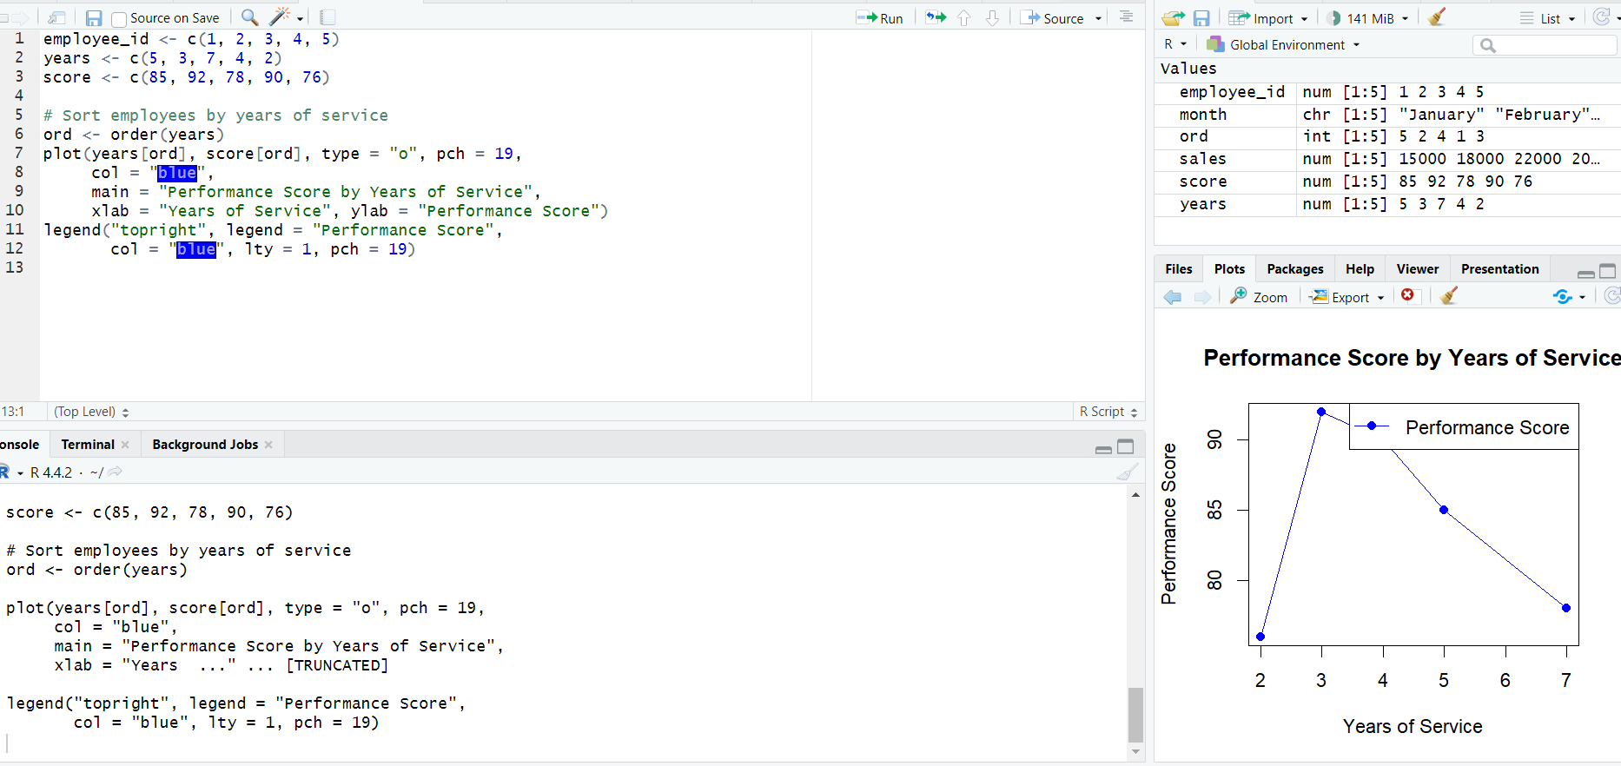
Output 1: Performance score by years
Observation: Performance scores vary across employees and do not increase consistently with years of service. The line connects individual observations ordered by service length.

PROGRAM 2: Bar Chart of Employees by Department
Generate a bar chart showing the number of employees in each department.
department <- c("Sales", "HR", "Marketing", "Sales", "HR")
dept_count <- table(department)
barplot(dept_count,
main = "Number of Employees by Department",
xlab = "Department", ylab = "Number of Employees",
col = "skyblue")
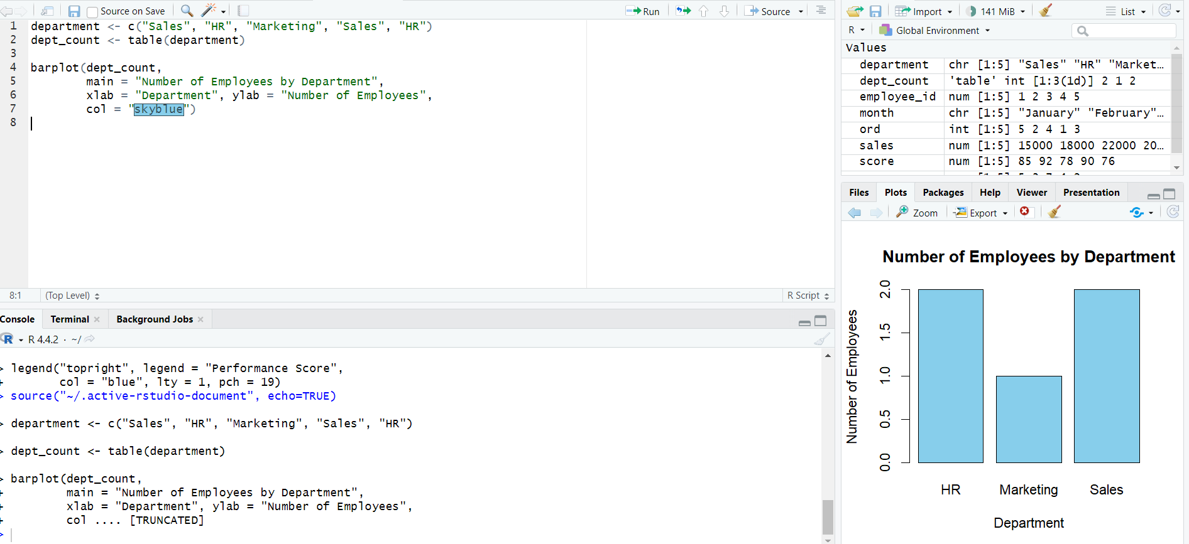 Output 2: Bar Chart of Employees
Observation: Sales has 2 employees, HR has 2 employees, and Marketing has 1 employee.

PROGRAM 3: Scatter Plot of Years of Service vs Performance Score
Use a scatter plot to explore the relationship between employee years of service and performance scores.
years <- c(5, 3, 7, 4, 2)
score <- c(85, 92, 78, 90, 76)
plot(years, score, pch = 19, col = "darkgreen",
main = "Years of Service vs Performance Score",
xlab = "Years of Service",
ylab = "Performance Score")
abline(lm(score ~ years), col = "red", lwd = 2)
# Optional numerical correlation
cor(years, score)
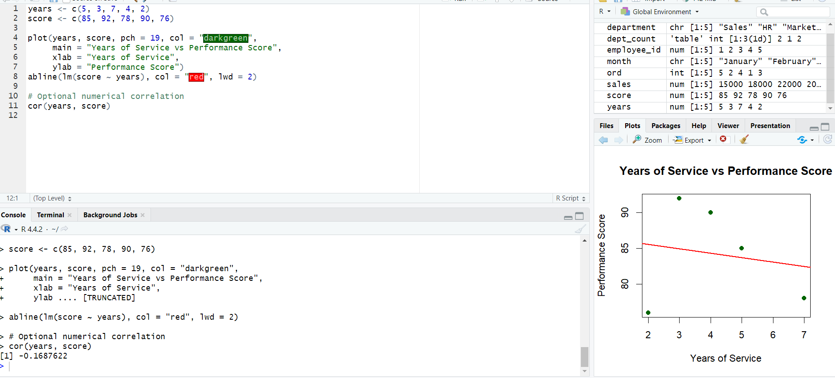 Output 3: Scatter Plot of years of service vs Performance score
Insight: The plotted data suggests a negative association in this small sample: employees with more years of service tend to have lower scores here. With only five employees, this pattern is not sufficient to generalize about all employees.

PROGRAM 4: Tableau Dashboard for Employee Performance
Create a Tableau dashboard containing the performance line chart and department bar chart for interactive exploration.
TABLEAU WORKFLOW (no R code required)
1. Open Tableau and connect to the Employee Performance dataset.
2. For the line chart:
• Drag Years of Service to Columns.
• Drag Performance Score to Rows.
• Set Marks to Line; add Employee ID to Detail or Label.
• Sort Years of Service in ascending order.
3. For the department bar chart:
• Drag Department to Columns.
• Drag Employee ID to Rows and change aggregation to COUNT.
• Sort the bars and show data labels.
4. Create a new Dashboard and place both worksheets on it.
5. Add a Department filter and apply it to both worksheets.
6. Add a dashboard title and save the workbook.
Observation: The dashboard combines the performance trend and department headcount views. A department filter can be used to explore the charts interactively.

Procedure
- Enter the employee dataset into R or import it from a CSV file.
- Sort years of service and use plot() to create the performance line chart.
- Use table() and barplot() to compare department headcounts.
- Use plot() and cor() to examine the association between service length and performance score.
- In Tableau, create the two worksheets, combine them in a dashboard, and add interactive filters.

Result
Employee performance was visualized using a line chart, department-wise bar chart, and scatter plot. A Tableau dashboard layout was specified to combine the line and bar charts for interactive exploration.

